CREATION OF COLOR PALETTE AND IMAGE LOADING
DATE:3.08.10

Aim:
To write a Applet program to create a color palette and create radio button for selecting the foreground and background colors.

Hardware requirements:
Intel pentium Processor IV
128mb RAM

Software requirements:
Jdk1.6.0

Algorithm:
- Create a color palette with a matrix of Buttons.
- Create a TextArea control.
- Create two Radiobutton for selecting the foreground and background colors.
- Set the foreground of the TextArea with color specified by the Button which is clicked only if the radiobutton selected is foreground
- Otherwise set the background color of the TexeArea with color clicked.

COLOR PALLETE
PROGRAM:

import java.net.*;
import java.awt.*;
import java.awt.event.*;
import java.applet.*;

/*<applet code="Cpdemo" width=500 height=600>
</applet>
*/
public class Cpdemo extends Applet implements ActionListener
{
Panel p1,p2,p3;
Checkbox c1,c2;
CheckboxGroup cbg;
TextArea ta;
Button b1,b2,b3;

public void init()
{
setLayout(new BorderLayout());

p1=new Panel(new FlowLayout());
p2=new Panel(new GridLayout(2,2));
p3=new Panel(new FlowLayout(FlowLayout.CENTER));

cbg=new CheckboxGroup();

c1=new Checkbox("FOREGROUND",cbg,true);
c2=new Checkbox("BACKGROUND",cbg,false);

p1.add(c1);
p1.add(c2);

add(p1,BorderLayout.NORTH);

b1=new Button("RED");
b2=new Button("BLUE");
b3=new Button("GREEN");

p2.add(b1);
p2.add(b2);
p2.add(b3);

add(p2,BorderLayout.CENTER);

ta=new TextArea("DEMO FOR COLOR PALETTE",5,20);

p2.add(ta);

add(p3,BorderLayout.SOUTH);

//c1.addItemListener(this);
//c2.addItemListener(this);

b1.addActionListener(this);
b2.addActionListener(this);
b3.addActionListener(this);
}
public void actionPerformed(ActionEvent ae)
{
String str=ae.getActionCommand();
String str1=cbg.getSelectedCheckbox().getLabel();
System.out.println(str1);

if(str1.equals("FOREGROUND"))
{

if(str=="RED")
ta.setForeground(Color.red);

if(str=="BLUE")
ta.setForeground(Color.blue);

if(str=="GREEN")
ta.setForeground(Color.green);
}

else
{
if(str=="RED")
ta.setBackground(Color.red);

if(str=="BLUE")
ta.setBackground(Color.blue);

if(str=="GREEN")
ta.setBackground(Color.green);
}
}
}
OUTPUT:

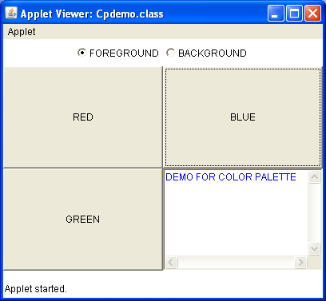
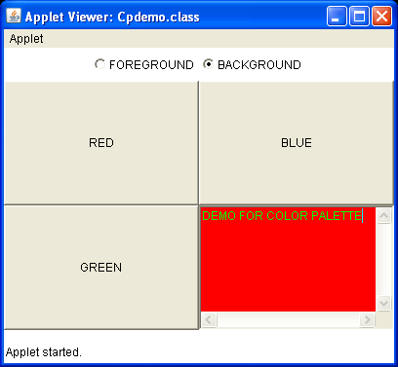

RESULT:
Thus the program to create color pallete was executed and the output was verified successfully.
IMAGE LOADING

PROGRAM:

import java.awt.*;
import java.applet.*;
import java.net.*;
/*
<applet code="ImageDemo" width=300 height=400>

</applet>
*/
public class ImageDemo extends Applet
{
Image img;
public void init()
{

img=getImage(getDocumentBase(),"Blue hills.jpg");

}
public void paint(Graphics g)
{
g.drawImage(img,0,0,this);

}
}

OUTPUT:

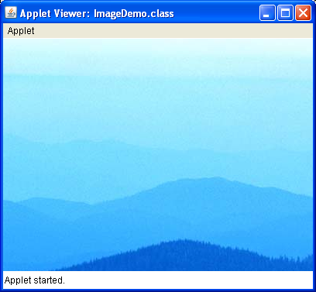

RESULT:
Thus the program to load an image was executed and the output was verified successfully.

