**WEB TECHNOLOGY LABORATORY RECORD**

*submitted in partial fulfillment of the*

*requirements for the award of the degree of*

**MASTER OF COMPUTER APPLICATIONS**

**by**

|  |  |
| --- | --- |
| **Akash Kumar Yadav** | **R271223114** |
|  |  |

***under the guidance of***

**Asst. Prof. Dhiviya Rose J.**



**School of Computer Science**

**University of Petroleum & Energy Studies**

**Bidholi, Via Prem Nagar, Dehradun, Uttarakhand**

**August - December – 2023**

**Index**

|  |  |  |  |  |
| --- | --- | --- | --- | --- |
| **Serial No** | **Experiment No** | **Page No** | **Date** | **Signature** |
| **1** | **Lab Experiment 1** | **3** | **24-Aug-2023** |  |
| **2** | **Lab Experiment 2** | **18** | **01-Sept-2023** |  |
| **3** | **Lab Experiment 3** | **30** | **29-Sept-2023** |  |
| **4** | **Lab Experiment 4** | **34** | **15-Sept-2023** |  |
| **5** | **Lab Experiment 5** | **39** | **03-Oct-2023** |  |
| **6** | **Lab Experiment 6** | **43** | **25-Oct-2023** |  |
| **7** | **Lab Experiment 7** | **47** | **01-Nov-2023** |  |
| **8** | **Lab Experiment 8** | **49** | **13-Nov-2023** |  |
| **9** | **Mini Project – HTML , CSS , JS** | **54** | **13-Oct-2023** |  |
| **10** | **Capstone Project – Library Management System** | **57** | **01-Dec-2023** |  |

**EXPERIMENT NO 1**

**Working with HTML and CSS**

**AIM: Learn to work with HTML tags and CSS properties.**

**Question (1): Develop a Profile Page.**

**SOURCE CODE:**

**HTML**

<!DOCTYPE html>

<html lang="en">

<head>

    <meta charset="UTF-8">

    <meta http-equiv="X-UA-Compatible" content="Chrome">

    <meta name="viewport" content="width=device-width, initial-scale=1.0">

    <title>My Profile</title>

    <link rel="stylesheet" href="../styles/profile.css">

    <style>

        body {

            background-repeat: no-repeat;

            background-position: center;

            background-size: cover;

        }

        div {

            text-align: center;

            align-items: center;

        }

    </style>

</head>

<body background="../images/pxfuel (1).jpg">

    <p align="right">

        <a href="../index.htm"><button onmouseover="this.style.color='red'">GO BACK TO INDEX</button></a>

    </p>

    <center>

        <div style="color: green;">

            <h1>My Profile Display</h1>

        </div>

        <div class="card"><img src='../images/profile.jpg' alt="Akash Kumar Yadav" width="auto" height="auto"></div><br>

        <div class="name">Akash Kumar Yadav</div><br>

        <div class="desg">MCA, BCA<br>UPES University</div><br>

        <div>

            <span><a href="https://www.linkedin.com/in/akashyadav6" target="_blank"><img src="../images/linkedin-icon.png"

                        alt="LinkedIn" width="20px" height="20px"></a></span>

            <span><a href="https://www.github.com/akashkumaryadav6" target="_blank"><img src="../images/github-icon.png"

                        alt="GitHub" width="20px" height="20px"></a></span>

        </div>

    </center>

</body>

</html>

**CSS**

.name{

    font-size: 28px;

    font-family: 'Verdana';

    font-style: bold;

    margin:auto;

    text-align: center;

    max-width: fit-content;

    max-height: fit-content;

    box-shadow: 0 3px 0 0 rgba(0, 0, 0, 0.2);

}

.desg{

    font-size: 20px;

    font-family: 'Lucida Sans', 'Lucida Sans Regular', 'Lucida Grande', 'Lucida Sans Unicode', Geneva, Verdana, sans-serif;

    font-style: oblique;

    font:bolder;

    max-width: fit-content;

    max-height: fit-content;

    margin:auto;

    text-align: center;

    box-shadow: 0 3px 0 0 rgba(0, 0, 0, 0.2);

}

.title {

    color: green;

    font-size: 22px;

}

.card {

    box-shadow: 0 4px 8px 0 rgba(0, 0, 0, 0.2);

    max-width: 30%;

    max-height: auto;

    margin:auto;

    text-align: center;

}

button {

    background-color: cyan;

    border: none;

    outline: 0;

    cursor: pointer;

    font-size: 14px;

}

span{

    cursor: pointer;

}

button:hover, a:hover {

    opacity: 0.7;

}

body{

    margin: 0;

    padding: 0;

}

**OUTPUT SCREENSHOT:**



**Question (2): Develop a Contact Us Form.**

**SOURCE CODE:**

**HTML**

<!DOCTYPE html>

<head>

    <meta http-equiv="X-UA-Compatible" content="Chrome">

    <title>Contact Us</title>

</head>

<body>

    <p align="right">

        <a href="../index.htm"><button onmouseover="this.style.color='red'">GO BACK TO INDEX</button></a>

    </p>

    <form>

        <fieldset>

            <legend>

                <h2>Contact Us</h2>

            </legend>

            <div>

                <label for="name">Name: </label>

                <input type="text" required placeholder="Enter your name" name="username" id="name">

            </div><br>

            <div>

                <label for="email">Email: </label>

                <input type="email" required placeholder="Enter your Email" name="useremail" id="email">

            </div><br>

            <div>Message:

                <textarea required name="usermessage" id="message" cols="17" rows="5"></textarea>

            </div><br>

            <div>Number:

                <input required name="usernumber" id="number" type="number">

            </div><br>

            <div>Gender:

                <select required name="usergender" id="gender" size="1">

                    <option value="male">Male</option>

                    <option value="female">Female</option>

                    <option value="space" selected> </option>

                </select>

            </div><br>

            <input type="submit" value="Submit">

            <br>

        </fieldset>

    </form>

</body>

</html>

**OUTPUT SCREENSHOT:**

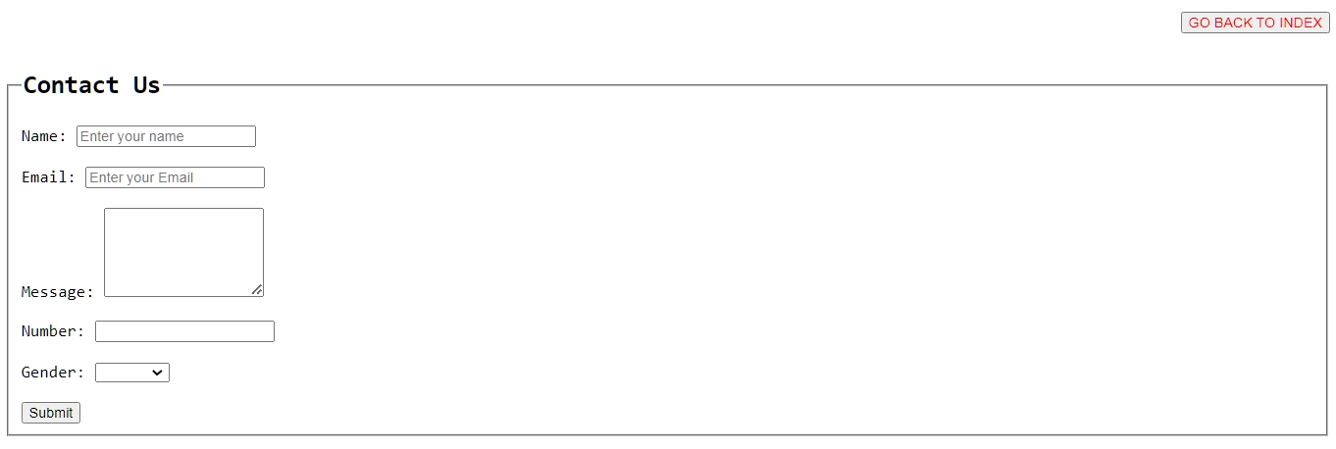

**Question (3): Design Class Timetable using HTML.**

**SOURCE CODE:**

**HTML**

<!DOCTYPE html>

<html lang="en">

<head>

    <meta charset="UTF-8">

    <meta http-equiv="X-UA-Compatible" content="Chrome">

    <meta name="viewport" content="width=device-width, initial-scale=1.0">

    <title>MCA TIME TABLE</title>

    <link rel="stylesheet" href="../styles/tt.css">

    <style>

        .tt {

            background-color: cyan;

            width: fit-content;

        }

        table,

        th {

            border-style: solid;

            border-width: 2px;

        }

        td {

            border-style: solid;

            border-width: 1px;

            text-align: center;

        }

        th {

            writing-mode: vertical-rl;

            text-orientation: sideways;

            text-transform: uppercase;

            text-decoration: solid;

            color: blue;

        }

    </style>

</head>

<body>

    <div align="right">

        <a href="../index.htm"><button onmouseover="this.style.color='red'">GO BACK TO INDEX</button></a>

    </div>

    <center>

        <div>

            <center>

                <h2 style="color:brown">ODD_JULY_DEC_2023</h2>

                <h3 style="color:green">Group Timetable - MCA-I-B3, 50077653 (Wks 1-30, 01-07-2023 - 20-01-2024)</h3>

            </center>

        </div>

        <hr>

        <div style="width:auto; height: 40%;">

            <table>

                <tr class="tt" style="font-style: oblique;">

                    <td></td>

                    <td>08:00AM</td>

                    <td>09:00AM</td>

                    <td>10:00AM</td>

                    <td>11:00AM</td>

                    <td>12:00PM</td>

                    <td>01:00PM</td>

                    <td>02:00PM</td>

                    <td>03:00PM</td>

                    <td>04:00PM</td>

                    <td>05:00PM</td>

                </tr>

                <tr>

                    <th>Sat</th>

                    <td></td>

                    <td></td>

                    <td></td>

                    <td></td>

                    <td></td>

                    <td></td>

                    <td></td>

                    <td></td>

                    <td></td>

                    <td></td>

                </tr>

                <tr>

                    <th>Sun</th>

                    <td></td>

                    <td></td>

                    <td></td>

                    <td></td>

                    <td></td>

                    <td></td>

                    <td></td>

                    <td></td>

                    <td></td>

                    <td></td>

                </tr>

                <tr>

                    <th>Monday</th>

                    <td></td>

                    <td style="border-color: red;" colspan="2"><b>Module: Data Structure Lab</b><br>

                        Groups: MCA-I-B3; MCA-I-B4<br>

                        Staff: Ambika Aggarwal<br>

                        Room: 4002</td>

                    <td style="border-color:black;" colspan="2"><b>Module: Python Programming</b><br>

                        Groups: MCA-I-B3; MCA-I-B4<br>

                        Staff: Anushree Sah<br>

                        Room: 4002</td>

                    <td></td>

                    <td style="border-color: yellow;" colspan=2><b>Module: Business Comm. & Ethics</b><br>

                        Groups: MCA-I-B3; MCA-I-B4<br>

                        Staff: Neeraja Sisodia<br>

                        Room: 4002</td>

                    <td></td>

                    <td></td>

                </tr>

                <tr>

                    <th>Tuesday</th>

                    <td></td>

                    <td style="border-color: yellow;"><b>Module: Web Technologies</b><br>

                        Groups: MCA-I-B3; MCA-I-B4<br>

                        Staff: Dhiviya Rose J<br>

                        Room: 4002</td>

                    <td style="border-color: black;"><b>Module: SOFTSKILLS</b><br>

                        Groups: MCA-I-B3; MCA-I-B4<br>

                        Staff: MUSKAN<br>

                        Room: 4003</td>

                    <td style="border-color:yellow;" colspan="2"><b>Module: Data Structure</b><br>

                        Groups: MCA-I-B3; MCA-I-B4<br>

                        Staff: Ambika Aggarwal<br>

                        Room: 4002</td>

                    <td></td>

                    <td style="border-color: yellow;"><b>Module: Business Comm. & Ethics</b><br>

                        Groups: MCA-I-B3; MCA-I-B4<br>

                        Staff: Neeraja Sisodia<br>

                        Room: 4002</td>

                    <td style="border-color:black;"><b>Module: Python Programming</b><br>

                        Groups: MCA-I-B3; MCA-I-B4<br>

                        Staff: Anushree Sah<br>

                        Room: 4002</td>

                    <td style="border-color:yellow;"><b>Module: Software Engineering</b><br>

                        Groups: MCA-I-B3; MCA-I-B4<br>

                        Staff: Sonali Vyas<br>

                        Room: 4002</td>

                    <td></td>

                </tr>

                <tr>

                    <th>Wednesday</th>

                    <td></td>

                    <td style="border-color: yellow;" colspan="2"><b>Module: Web Technologies</b><br>

                        Groups: MCA-I-B3; MCA-I-B4<br>

                        Staff: Dhiviya Rose J<br>

                        Room: 4002</td>

                    <td style="border-color:green;"><b>Module: AI</b><br>

                        Groups: MCA-I-B3; MCA-I-B4<br>

                        Staff: Mitali Chugh<br>

                        Room: 4001</td>

                    <td style="border-color: green;"><b>Module: Data Science</b><br>

                        Groups: MCA-I-B3; MCA-I-B4<br>

                        Staff: Sanoj Kumar<br>

                        Room: 6205</td>

                    <td style="border-color:yellow;" colspan="2"><b>Module: Data Structure</b><br>

                        Groups: MCA-I-B3; MCA-I-B4<br>

                        Staff: Ambika Aggarwal<br>

                        Room: 4002</td>

                    <td style="border-color: purple;"><b>Module: EDGE Aptitude</b><br>

                        Groups: MCA-I-B3; MCA-I-B4<br>

                        Staff: A<br>

                        Room: 4002</td>

                    <td></td>

                    <td></td>

                </tr>

                <tr>

                    <th>Thursday</th>

                    <td></td>

                    <td style="border-color: red;" colspan="2"><b>Module: Data Structure Lab</b><br>

                        Groups: MCA-I-B3; MCA-I-B4<br>

                        Staff: Ambika Aggarwal<br>

                        Room: 4002</td>

                    <td style="border-color:green;"><b>Module: AI</b><br>

                        Groups: MCA-I-B3; MCA-I-B4<br>

                        Staff: Mitali Chugh<br>

                        Room: 4001</td>

                    <td style="border-color: green;"><b>Module: Data Science</b><br>

                        Groups: MCA-I-B3; MCA-I-B4<br>

                        Staff: Sanoj Kumar<br>

                        Room: 6205</td>

                    <td></td>

                    <td style="border-color:yellow;"><b>Module: Software Engineering</b> <br>

                        Groups: MCA-I-B3; MCA-I-B4<br>

                        Staff: Sonali Vyas<br>

                        Room: 4002</td>

                    <td style="border-color: purple;"><b>Module: EDGE Aptitude</b><br>

                        Groups: MCA-I-B3; MCA-I-B4<br>

                        Staff: A<br>

                        Room: 4002</td>

                    <td></td>

                    <td></td>

                </tr>

                <tr>

                    <th>Friday</th>

                    <td></td>

                    <td style="border-color: red;" colspan="2"><b>Module: Python Programming</b><br>

                        Groups: MCA-I-B3; MCA-I-B4<br>

                        Staff: Anushree Sah<br>

                        Room: 4002</td>

                    <td style="border-color:green;"><b>Module: AI</b><br>

                        Groups: MCA-I-B3; MCA-I-B4<br>

                        Staff: Mitali Chugh<br>

                        Room: 4001</td>

                    <td style="border-color: green;"><b>Module: Data Science</b><br>

                        Groups: MCA-I-B3; MCA-I-B4<br>

                        Staff: Sanoj Kumar<br>

                        Room: 6205</td>

                    <td></td>

                    <td style="border-color:yellow;"><b>Module: Software Engineering</b> <br>

                        Groups: MCA-I-B3; MCA-I-B4<br>

                        Staff: Sonali Vyas<br>

                        Room: 4002</td>

                    <td style="border-color: yellow;" colspan="2"><b>Module: Web Technologies</b><br>

                        Groups: MCA-I-B3; MCA-I-B4<br>

                        Staff: Dhiviya Rose J<br>

                        Room: 4002</td>

                    <td></td>

                </tr>

            </table>

        </div>

    </center>

</body>

</html>

**OUTPUT SCREENSHOT:**

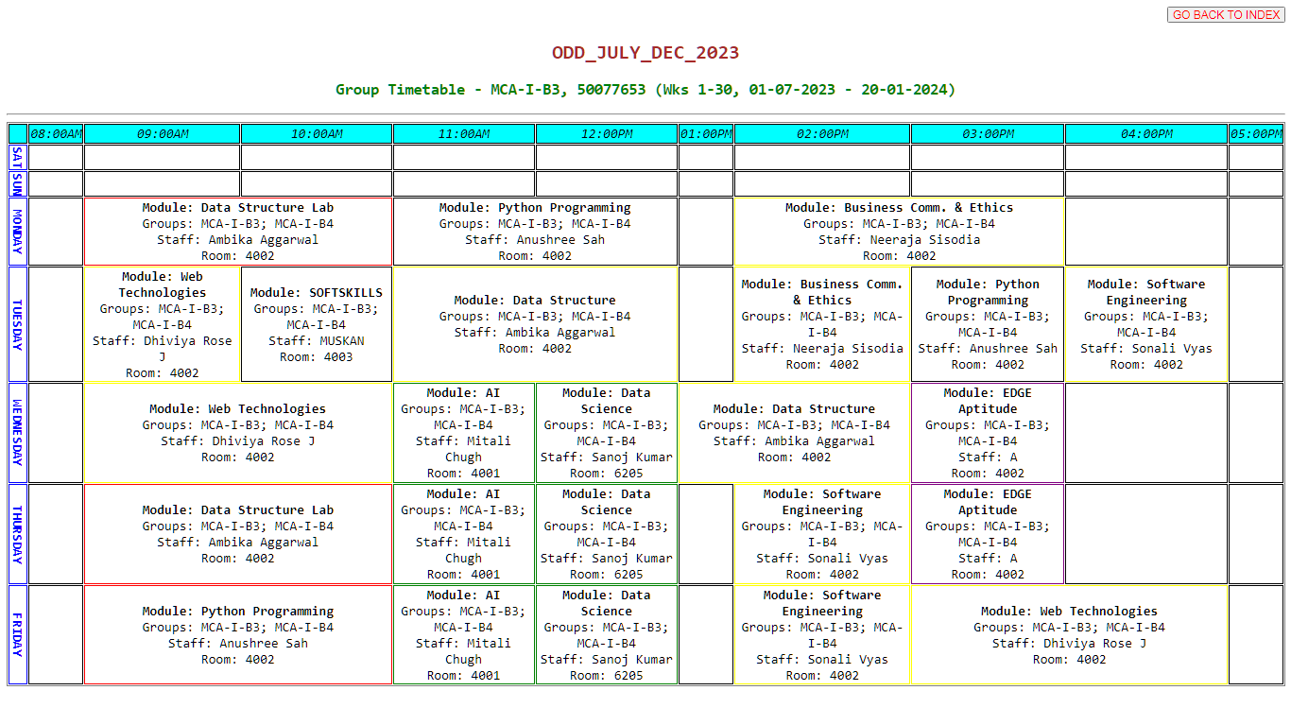

**Question (4). Design an Index Page.**

**SOURCE CODE:**

**HTML**

<html>

<head>

    <title>INDEX</title>

    <style>

        body {

            background-image: linear-gradient(to left, green, lightgreen, yellowgreen, darkgreen);

        }

        div {

            box-shadow: 2px 5px 20px greenyellow;

            max-width: fit-content;

            padding: 20px;

        }

        table {

            text-align: left;

            font-family: 'Verdana';

            display: inline;

            align-self: center;

            align-items: center;

            width: fit-content;

            box-shadow: 5px 5px 15px rgba(0, 0, 0, 0.2);

            border-collapse: collapse;

        }

        th {

            text-align: center;

            background-color: lavender;

            color: black;

            padding: 10px;

        }

        td {

            padding: 8px;

        }

        a:link {

            color: black;

            text-decoration: none;

        }

        a:visited {

            color: white;

            background-color: brown;

        }

        a:hover {

            color: red;

            text-decoration: none;

        }

    </style>

</head>

<body>

    <center><u>

            <h1>INDEX</h1>

        </u></center>

    <center>

        <div>

            <table>

                <tr>

                    <th>S.No.</th>

                    <th>Activity</th>

                    <th>Date</th>

                </tr>

                <tr>

                    <td>&nbsp;</td>

                    <td>&nbsp;</td>

                    <td>&nbsp;</td>

                </tr>

                <tr>

                    <td>01</td>

                    <td><a href="pages/table.htm" target="_blank">TABLE</a></td>

                    <td>16 AUGUST 2023</td>

                </tr>

                <tr>

                    <td>02</td>

                    <td><a href="pages/JavaScript_.htm" target="_blank">JAVASCRIPT</a></td>

                    <td>18 AUGUST 2023</td>

                </tr>

                <tr>

                    <td>03</td>

                    <td><a href="pages/JavaScript_2.htm" target="_blank">JAVASCRIPT</a></td>

                    <td>22 AUGUST 2023</td>

                </tr>

                <tr>

                    <td>04</td>

                    <td><a href="pages/JavaScript_3.htm" target="_blank">JAVASCRIPT</a></td>

                    <td>23 AUGUST 2023</td>

                </tr>

                <tr>

                    <td>05</td>

                    <td><a href="pages/basictags.htm" target="_blank">BASIC TAGS</a></td>

                    <td>24 AUGUST 2023</td>

                </tr>

                <tr>

                    <td>06</td>

                    <td><a href="pages/lists.htm" target="_blank">LISTS</a></td>

                    <td>24 AUGUST 2023</td>

                </tr>

                <tr>

                    <td>07</td>

                    <td><a href="pages/Profile.htm" target="_blank">#Lab Activity 1 (MY PROFILE)</a></td>

                    <td>24 AUGUST 2023</td>

                <tr>

                    <td>08</td>

                    <td><a href="pages/contact.htm" target="_blank">#Lab Activity 1 (CONTACT US)</a></td>

                    <td>24 AUGUST 2023</td>

                </tr>

                <tr>

                    <td>09</td>

                    <td><a href="pages/TimeTable.htm" target="_blank">#Lab Activity 1 (TIMETABLE)</a></td>

                    <td>24 AUGUST 2023</td>

                </tr>

                <tr>

                    <td>10</td>

                    <td><a href="pages/JavaScript_4.htm" target="_blank">JAVASCRIPT 'onmouseover' & 'onmouseout'</a></td>

                    <td>29 AUGUST 2023</td>

                </tr>

                <tr>

                    <td>11</td>

                    <td><a href="pages/ElectricityBill.htm" target="_blank">#Lab Activity 2 (ELECTRICITY BILL)</a></td>

                    <td>01 SEPTEMBER 2023</td>

                </tr>

                <tr>

                    <td>12</td>

                    <td><a href="pages/RollOverButtons.htm" target="_blank">#Lab Activity 2 (ROLL OVER BUTTONS)</a></td>

                    <td>01 SEPTEMBER 2023</td>

                </tr>

                <tr>

                    <td>13</td>

                    <td><a href="pages/FloatingIcons.htm" target="_blank">#Lab Activity 2 (FLOATING ICONS)</a></td>

                    <td>01 SEPTEMBER 2023</td>

                </tr>

                <tr>

                    <td>14</td>

                    <td><a href="pages/StopWatch.htm" target="_blank">#Lab Activity 2 (STOPWATCH)</a></td>

                    <td>01 SEPTEMBER 2023</td>

                </tr>

                <tr>

                    <td>15</td>

                    <td><a href="pages/OddEven.htm" target="_blank">JAVASCRIPT (Odd/Even)</a></td>

                    <td>05 SEPTEMBER 2023</td>

                </tr>

                <tr>

                    <td>16</td>

                    <td><a href="pages/SwapVariables.htm" target="_blank">JAVASCRIPT (Swap Variables)</a></td>

                    <td>06 SEPTEMBER 2023</td>

                </tr>

                <tr>

                    <td>17</td>

                    <td><a href="pages/Bonus.htm" target="_blank">JAVASCRIPT (Bonus)</a></td>

                    <td>06 SEPTEMBER 2023</td>

                </tr>

                <tr>

                    <td>18</td>

                    <td><a href="pages/CurrencyConverter.htm" target="_blank">JAVASCRIPT (Currency Converter)</a></td>

                    <td>06 SEPTEMBER 2023</td>

                </tr>

                <tr>

                    <td>19</td>

                    <td><a href="pages/ElectricityBill2.htm" target="_blank">#Lab Activity 2 VERSION 2 JAVASCRIPT (Electricity Bill) 2</a></td>

                    <td>08 SEPTEMBER 2023</td>

                </tr>

                <tr>

                    <td>20</td>

                    <td><a href="pages/FloatingIcons2.htm" target="_blank">#Lab Activity 2 VERSION 2 JAVASCRIPT (FLOATING ICONS) 2</a></td>

                    <td>08 SEPTEMBER 2023</td>

                </tr>

                <tr>

                    <td>21</td>

                    <td><a href="pages/StopWatch2.htm" target="_blank">#Lab Activity 2 VERSION 2 JAVASCRIPT (STOPWATCH) 2</a></td>

                    <td>08 SEPTEMBER 2023</td>

                </tr>

                <tr>

                    <td>22</td>

                    <td><a href="pages/Loop.htm" target="_blank">LOOP</a></td>

                    <td>13 SEPTEMBER 2023</td>

                </tr>

                <tr>

                    <td>23</td>

                    <td><a href="pages/Array.htm" target="_blank">Array</a></td>

                    <td>13 SEPTEMBER 2023</td>

                </tr>

                <tr>

                    <td>24</td>

                    <td><a href="pages/basiccal.htm" target="_blank">#Lab Activity 4 (Basic Calculator)</a></td>

                    <td>15 SEPTEMBER 2023</td>

                </tr>

                <tr>

                    <td>25</td>

                    <td><a href="pages/Array2.htm" target="_blank">Array</a></td>

                    <td>20 SEPTEMBER 2023</td>

                </tr>

                <tr>

                    <td>26</td>

                    <td><a href="pages/Audio.htm" target="_blank">Audio Tag</a></td>

                    <td>22 SEPTEMBER 2023</td>

                </tr>

                <tr>

                    <td>27</td>

                    <td><a href="pages/Armstrong_Number.htm" target="_blank">#Lab Activity 3 (Armstrong Number)</a></td>

                    <td>29 SEPTEMBER 2023</td>

                </tr>

                <tr>

                    <td>28</td>

                    <td><a href="pages/Toggle.htm" target="_blank">#Lab Activity 3 (Toggle Case)</a></td>

                    <td>29 SEPTEMBER 2023</td>

                </tr>

                <tr>

                    <td>29</td>

                    <td><a href="pages/Divideby7.htm" target="_blank">#Lab Activity 3 (Divisible By 7 & 2)</a></td>

                    <td>29 SEPTEMBER 2023</td>

                </tr>

                <tr>

                    <td>30</td>

                    <td><a href="pages/game.htm" target="_blank">GAME</a></td>

                    <td>12 OCTOBER 2023</td>

                </tr>

                <tr>

                    <td>31</td>

                    <td><a href="pages/PHPArray.htm" target="_blank">#Lab Activity 4 (PHP Array)</a></td>

                    <td>20 OCTOBER 2023</td>

                </tr>

            </table>

        </div>

    </center>

</body>

</html>

**OUTPUT SCREENSHOT:**

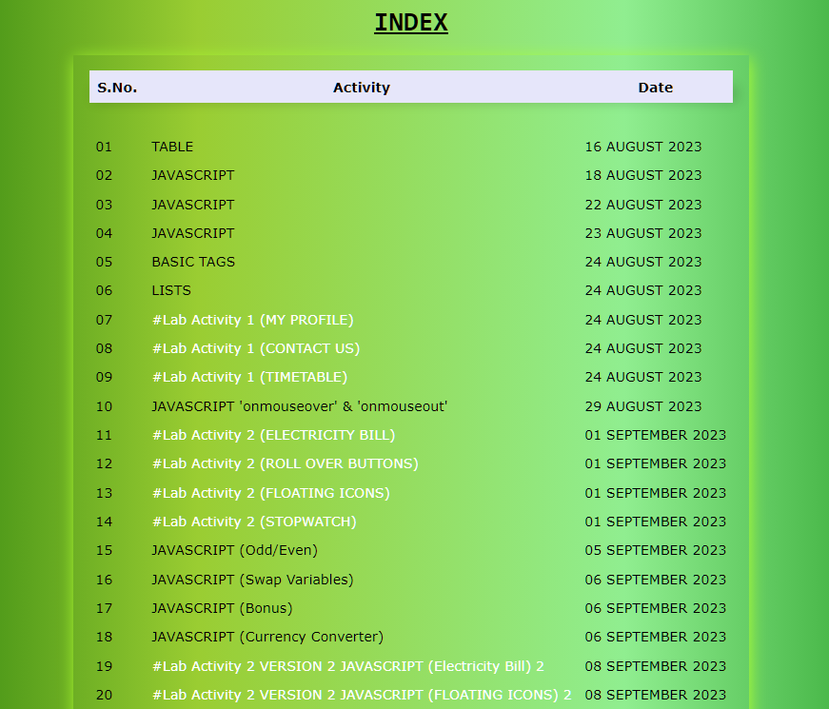

**EXPERIMENT NO 2**

**Working with JavaScript**

**AIM: To learn programming through JavaScript and develop dynamic webpages.**

**Question (1). Make an Electricity Bill Calculator in using JavaScript the conditional statements with the following conditions specified below. Create a form which has name, mobile number, emailID and number of units consumed. Perform form validation on the fields Name, Mobile Number and emailID.**

* **For the first 50 units – Rs. 3.50/unit**
* **For next 100 units – Rs. 4.00/unit**
* **For next 100 units – Rs. 5.20/unit**
* **For units above 250 – Rs. 6.50/unit**

**The application should generate the bill and inform the amount payable using confirm() box.**

**SOURCE CODE:**

**HTML**

<!DOCTYPE html>

<head>

        <title>Electricity Bill</title>

        <style>

            .center{

                text-align: center;

            }

        </style>

        <script type="text/javascript">

            function BILL(){

                var U=document.getElementById('units').value;

                var RES

                if (0<U<=50){

                    RES=U*3.50

                    document.getElementById("res").innerHTML="Total bill is: Rs. "+RES;

                }

                else if (50<U<=150){

                    first50=50*3.50

                    next100=(U-50)*4

                    RES=first50+next100

                    document.getElementById("res").innerHTML="Total bill is: Rs. "+RES;

                }

                else if (150<U<=250){

                    first50=50*3.50

                    next100=100*4

                    nextnext100=(U-150)*5.20

                    RES=first50+next100+nextnext100

                    document.getElementById("res").innerHTML="Total bill is: Rs. "+RES;

                }

                else if (U>250){

                    first50=50*3.50

                    next100=100*4

                    nextnext100=150*5.20

                    unit200=(U-250)*6.50

                    RES=first50+next100+nextnext100+unit200

                    document.getElementById("res").innerHTML="Total bill is: Rs. "+RES;

                }

                confirm("Total payable amount is Rs. "+RES);

            }

        </script>

    </head>

    <body>

        <div align="right">

            <a href="../index.htm"><button onmouseover="this.style.color='red'">GO BACK TO INDEX</button></a>

        </div>

        <div class="center" style="background-color: purple; color:white;"><h2>LAB ACTIVITY 2</h2></div>

        <span><u>ELECTRICITY BILL</u></span>

        <div>

            <form onsubmit="return VALIDATE()" name="myForm" method="post">

                <fieldset>

                    <legend>

                        <h2>Electricity Bill</h2>

                    </legend>

                    <table>

                        <tr>

                            <td>

                                <label for="name">Name: </label>

                            </td>

                            <td>

                                <input type="text" required placeholder="Name" name="username" id="name" required>

                            </td>

                        </tr>

                        <tr>

                            <td>

                                <label for="mobnumber">Mobile Number:</label>

                            </td>

                            <td>

                                <input type="number" required placeholder="Mobile Number" name="contact" id="mobnumber" required>

                            </td>

                        </tr>

                        <tr>

                            <td>

                                <label for="email">Email ID: </label>

                            </td>

                            <td>

                                <input type="email" required placeholder="Email ID" name="useremail" id="email" required>

                            </td>

                        </tr>

                        <tr>

                            <td>

                                <label for="units">Units Consumed: </label>

                            </td>

                            <td>

                                <input type="number" required placeholder="Unit Consumed" name="unitsconsumed" id="units">

                            </td>

                        </tr>

                        <tr><td>  </td><td>   </td></tr>

                        <tr>

                            <td></td>

                            <td style="text-align: right;">

                                <input type="submit" value="Submit" onclick=BILL()>

                            </td>

                        </tr>

                        <tr>

                            <td><p id="res">Amount here!</p></td>

                        </tr>

                    </table>

                </fieldset>

            </form>

        </div>

    </body>

</html>

**OUTPUT SCREENSHOT:**

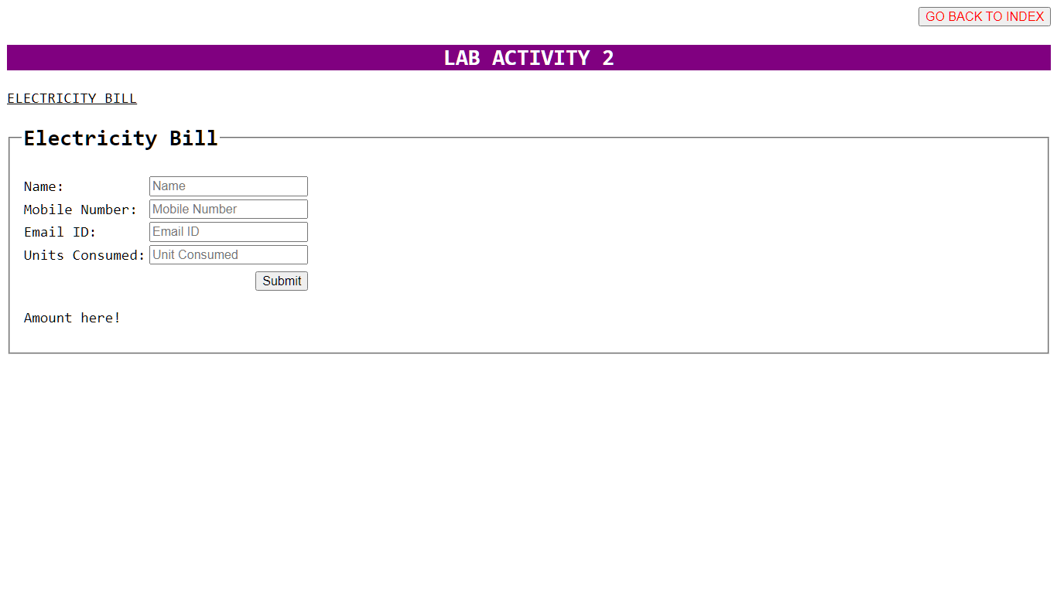

**Question (2). Develop web pages to demonstrate the effect of roll over buttons. When the user places his or her mouse pointer over text, listing the various tourist places in Dehradun, the corresponding image displaying the tourist spot to be shown. Also perform the zoom in and zoom out effect on an image for that image on a button click.**

**SOURCE CODE:**

<!DOCTYPE html>

<head>

<title>LAB ACTIVITY 2</title>

    <link rel="stylesheet" href="../css/float.css">

    <style>

        img {

            max-width: 60%;

            max-height: 50%;

            box-shadow: 8px 8px 15px 8px black;

        }

    </style>

</head>

<body>

    <div align="right">

        <a href="../index.htm"><button onmouseover="this.style.color='red'">GO BACK TO INDEX</button></a>

    </div>

    <center>

        <div class="div" style="text-align: center;">

            <h2>ROLL OVER BUTTONS</h2>

        </div>

    </center><br>

    <br>

    <div>

        <center><img src="../images/dehra.jpg" alt="Dehradun" name="s" id="s"></center>

    </div>

    <div>

        <ul>

            <li><span onmouseover="document.s.src='../images/FRI.jpg'"

                    onmouseout="document.s.src='../images/dehra.jpg'">FRI Dehradun</span></li>

            <li><span onmouseover="document.s.src='../images/TMM.jpg'"

                    onmouseout="document.s.src='../images/dehra.jpg'">Tapekeshwar Temple</span></li>

            <li><span onmouseover="document.s.src='../images/MM.jpg'"

                    onmouseout="document.s.src='../images/dehra.jpg'">Mindrolling Monastary</span></li>

            <li><span onmouseover="document.s.src='../images/RC.jpg'"

                    onmouseout="document.s.src='../images/dehra.jpg'">Robber's Cave</span></li>

            <li><span onmouseover="document.s.src='../images/DZ.jpg'"

                    onmouseout="document.s.src='../images/dehra.jpg'">Dehradun Zoo</span></li>

        </ul>

    </div>

</body>

</html>

**OUTPUT SCREENSHOT:**

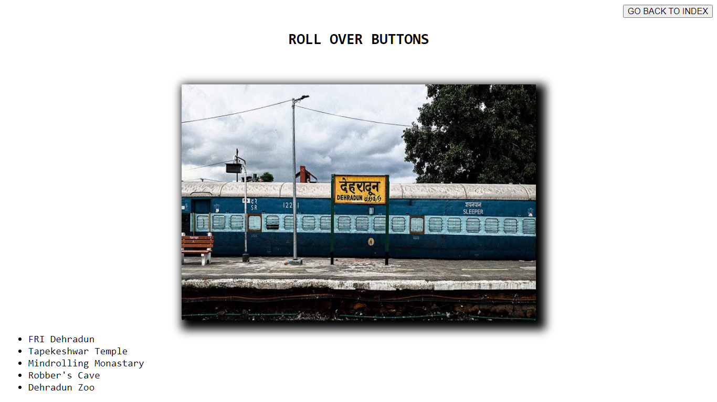

**Question (3). Design a Stopwatch in HTML using JavaScript.**

**SOURCE CODE:**

**HTML**

<!DOCTYPE html>

<head>

    <meta http-equiv="X-UA-Compatible" content="IE=edge">

    <meta name="viewport" content="width=device-width, initial-scale=1.0">

    <title>Design Stopwatch using HTML CSS and JavaScript</title>

    <link rel="stylesheet" href="../styles/clock.css">

</head>

<body>

    <div class="container2">

        <a href="../index.htm"><button onmouseover="this.style.color='red'">GO BACK TO INDEX</button></a>

    </div>

    <div class="container">

        <h1>Stop Watch</h1>

        <div id="time">

            <span class="digit" id="hr">

                00</span>

            <span class="txt">Hr</span>

            <span class="digit" id="min">

                00</span>

            <span class="txt">Min</span>

            <span class="digit" id="sec">

                00</span>

            <span class="txt">Sec</span>

            <span class="digit" id="count">

                00</span>

        </div>

        <div id="buttons">

            <button class="btn" id="start">

                Start</button>

            <button class="btn" id="stop">

                Stop</button>

            <button class="btn" id="reset">

                Reset</button>

        </div>

    </div>

    <script src="../scripts/js/clock.js"></script>

</body>

</html>

**JAVASCRIPT**

let startBtn = document.getElementById('start');

let stopBtn = document.getElementById('stop');

let resetBtn = document.getElementById('reset');

let hour = 00;

let minute = 00;

let second = 00;

let count = 00;

startBtn.addEventListener('click', function () {

    timer = true;

    stopWatch();

});

stopBtn.addEventListener('click', function () {

    timer = false;

});

resetBtn.addEventListener('click', function () {

    timer = false;

    hour = 0;

    minute = 0;

    second = 0;

    count = 0;

    document.getElementById('hr').innerHTML = "00";

    document.getElementById('min').innerHTML = "00";

    document.getElementById('sec').innerHTML = "00";

    document.getElementById('count').innerHTML = "00";

});

function stopWatch() {

    if (timer) {

        count++;

        if (count == 100) {

            second++;

            count = 0;

        }

        if (second == 60) {

            minute++;

            second = 0;

        }

        if (minute == 60) {

            hour++;

            minute = 0;

            second = 0;

        }

        let hrString = hour;

        let minString = minute;

        let secString = second;

        let countString = count;

        if (hour < 10) {

            hrString = "0" + hrString;

        }

        if (minute < 10) {

            minString = "0" + minString;

        }

        if (second < 10) {

            secString = "0" + secString;

        }

        if (count < 10) {

            countString = "0" + countString;

        }

        document.getElementById('hr').innerHTML = hrString;

        document.getElementById('min').innerHTML = minString;

        document.getElementById('sec').innerHTML = secString;

        document.getElementById('count').innerHTML = countString;

        setTimeout(stopWatch, 10);

}

}

**OUTPUT SCREENSHOT:**

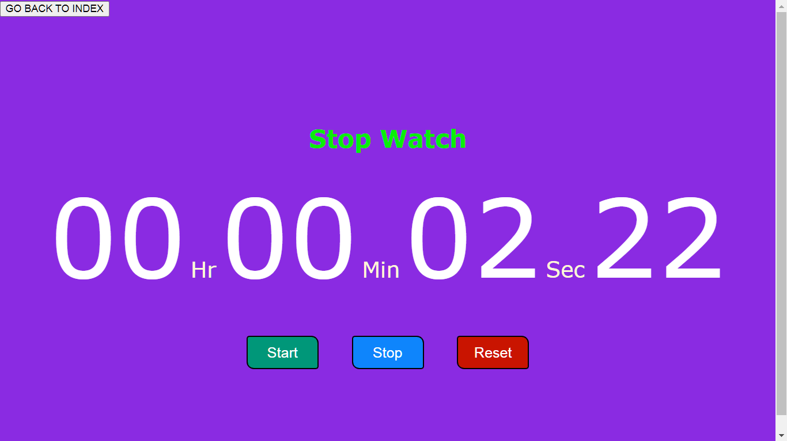

**Question (4). Validate the form given below using JavaScript. Also have floating logos in the forms.**

**SOURCE CODE:**

**HTML**

<!DOCTYPE html>

<html lang="en">

<head>

    <meta charset="UTF-8">

    <meta http-equiv="X-UA-Compatible"

        content="IE=edge">

    <meta name="viewport"

        content="width=device-width, initial-scale=1.0">

        <title>Floating Icons and Form Validation</title>

        <link rel="stylesheet" href="../styles/float.css">

    </head>

    <body>

        <div align="right">

            <a href="../index.htm"><button onmouseover="this.style.color='red'">GO BACK TO INDEX</button></a>

        </div>

        <div style="align-items:center; background-color:lightgray;">

            <form action="">

                <fieldset>

                    <legend>Contact Us</legend>

                    <div class="card">

                        <table>

                            <tr>

                                <td class="tright"><label for="firstName">First Name: </label></td>

                                <td><img src="../images/name-icon.png" class="img" style="float:left"><input class="input" type="text" name="userfname" id="firstName" required placeholder="First Name"></td>

                            </tr>

                            <tr>

                                <td class="tright"><label for="secondName">Last Name: </label></td>

                                <td><img src="../images/name-icon.png" class="img" style="float:left"><input class="input" type="text" name="userlname" id="secondName" required placeholder="Last Name"></td>

                            </tr>

                            <tr>

                                <td class="tright"><label for="email">Email ID: </label></td>

                                <td><img src="../images/email-icon.png" class="img" style="float:left"><input class="input" type="email" name="useremail" id="email" required placeholder="Email"></td>

                            </tr>

                            <tr>

                                <td class="tright"><label for="phone">Phone #: </label></td>

                                <td><img src="../images/phone-icon.png" class="img" style="float:left"><input class="input" type="tel" name="userphone" id="phone" required placeholder="Phone Number"></td>

                            </tr>

                            <tr>

                                <td class="tright"><label for="address">Address: </label></td>

                                <td><img src="../images/home-icon.png" class="img" style="float:left"><textarea rows="1" class="input" name="useraddress" id="address" required placeholder="Address"></textarea></td>

                            </tr>

                            <tr>

                                <td class="tright"><label for="city">City: </label></td>

                                <td><img src="../images/home-icon.png" class="img" style="float:left"><input class="input" type="text" name="usercity" id="city" required placeholder="City"></td>

                            </tr>

                            <tr>

                                <td class="tright"><label for="state">State: </label></td>

                                <td><img src="../images/list-icon.jpg" class="img" style="float:left">

                                    <select class="input" name="userstate" id="state" required>

                                        <option value="andhrapradesh">ANDHRA PRADESH</option>

                                        <option value="arunachalpradesh">ARUNACHAL PRADESH</option>

                                        <option value="assam">ASSAM</option>

                                        <option value="bihar">BIHAR</option>

                                        <option value="chattisgarh">CHATTISGARH</option>

                                        <option value="goa">GOA</option>

                                        <option value="gujarat">GUJARAT</option>

                                        <option value="haryana">HARYANA</option>

                                        <option value="himachalpradesh">HIMACHAL PRADESH</option>

                                        <option value="jharkhand">JHARKHAND</option>

                                        <option value="karnataka">KARNATAKA</option>

                                        <option value="kerala">KERALA</option>

                                        <option value="madhyapradesh">MADHYA PRADESH</option>

                                        <option value="maharashtra">MAHARASHTRA</option>

                                        <option value="manipur">MANIPUR</option>

                                        <option value="meghalaya">MEGHALAYA</option>

                                        <option value="mizoram">MIZORAM</option>

                                        <option value="nagaland">NAGALAND</option>

                                        <option value="odisha">ODISHA</option>

                                        <option value="punjab">PUNJAB</option>

                                        <option value="rajasthan">RAJASTHAN</option>

                                        <option value="sikkim">SIKKIM</option>

                                        <option value="tamilnadu">TAMIL NADU</option>

                                        <option value="telangana">TELANGANA</option>

                                        <option value="tripura">TRIPURA</option>

                                        <option value="uttarpradesh">UTTAR PRADESH</option>

                                        <option value="uttarakhand">UTTARAKHAND</option>

                                        <option value="westbengal">WEST BENGAL</option>

                                        <option value="FIRST" selected>Please select your State</option></select>

                                    </td>

                            </tr>

                            <tr>

                                <td class="tright"><label for="zipCode">Zip Code: </label></td>

                                <td><img src="../images/home-icon.png" class="img" style="float:left"><input class="input" type="number" maxlength=6 name="userzipcode" id="zipCode" required placeholder="Zip Code"></td>

                            </tr>

                            <tr>

                                <td class="tright"><label for="domain">Website or Domain Name: </label></td>

                                <td><img src="../images/web-icon.png" class="img" style="float:left"><input class="input" type="text" name="userdomain" id="domain" required placeholder="Website or Domain name"></td>

                            </tr>

                            <tr>

                                <td class="tright"><label for="hosting">Do you have hosting?: </label></td>

                                <td><input type="radio" name="userhost" id="yes" value="YES"><label for="yes">YES</label><br>

                                    <input type="radio" name="userhost" id="no" value="NO"><label for="no">NO</label></td>

                            </tr>

                            <tr>

                                <td class="tright"><label for="projDescrip">Project Description: </label></td>

                                <td><img src="../images/pen-icon.png" width="20px" height="40px" style="float:left;margin-top: 8px;"><textarea class="input" name="userproj" id="projDescrip" required placeholder="Project Description"></textarea></td>

                            </tr>

                            <tr>

                                <td></td>

                                <td><input class="btn" type="submit" value="Send"></td>

                            </tr>

                        </table>

                    </div>

                </fieldset>

            </form>

        </div>

    </body>

</html>

**CSS**

table {

    margin-top: 2rem;

    margin-bottom: 2rem;

}

.tright {

    text-align: right;

}

.card {

    margin-left: 20rem;

    margin-right: 20rem;

    align-items: center;

    justify-content: center;

}

.img {

    margin-top: 8px;

    border: 1px solid black;

    border-right: none;

    width: 20px;

    height: 20px;

}

.input {

    max-width: 15rem;

    width: 15rem;

    margin-top: 8px;

}

.btn {

    width: 5rem;

    height: 2rem;

    margin-top: 2rem;

    padding-top: 2px;

    padding-left: 2px;

    padding-right: 2px;

    padding-bottom: 2px;

    border: none;

    text-decoration-color: white;

    background-color: orange;

    color: aliceblue;

}

.div {

    max-width: 30%;

    max-height: 20%;

    align-items: center;

    align-self: center;

    color: cyan;

    background-color: orange;

}

**OUTPUT SCREENSHOT:**

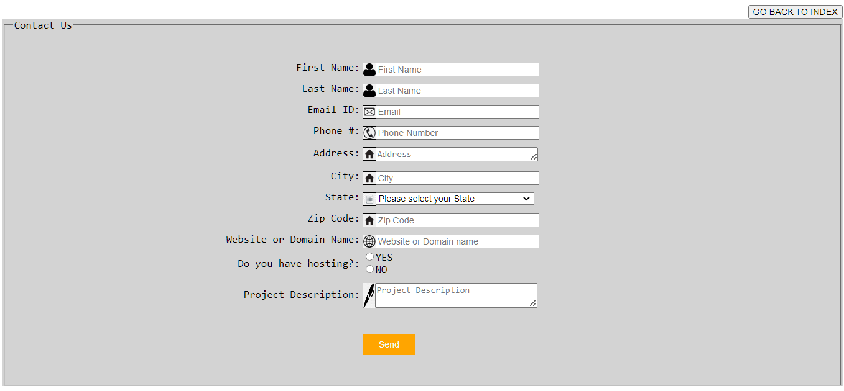

**EXPERIMENT NO 3**

**Working with JavaScript Arrays and Functions**

**AIM: To develop understanding of JavaScript Arrays and Functions.  
  
Question (1). Implement the below-given software design using JS. This algorithm finds all 3-digit Armstrong numbers.**

* **Step 1. [INITIALIZE N WITH THE FIRST 3-DIGIT NUMBER] N ← 100**
* **Step 2. REPEAT STEPS 3 THROUGH 10 UNTIL N > 999**
* **Step 3. [INITIALIZE S, WHICH HOLDS THE SUM OR THE CUBES] S ← 0**
* **Step 4. M ← N [THIS IS TO MAKE A COPY OR N]**
* **Step 5. REPEAT STEP 6 THROUGH STEP 8 WHILE M > 0**
* **Step 6. COMPUTE REM ← REMAINDER OF (M/10)**
* **Step 7. COMPUTE S ← S + REM*REM*REM**
* **Step 8. COMPUTE M ← INTEGER PART OF (M/10)**
* **Step 9. IF S = N THEN PRINT N END-IF**
* **Step 10. [INCREMENT N TO TAKE THE NEXT NUMBER] COMPUTE**

**N ←N+1 END-REPEAT**

* **Step 11. END**

**SOURCE CODE:**

**HTML**

<html>

<head>

    <title>Armstrong Number</title>

    <script>

        function isArmstrongNumber(N) {

            var M = N;

            var S = 0;

            while (M > 0) {

                var REM = M % 10;

                S += REM*REM*REM;

                M = Math.floor(M / 10);

            }

            return S === N;

        }

        function findArmstrongNumbers() {

            var lowerLimit = 100;

            var upperLimit = 999;

            for (var i = lowerLimit; i <= upperLimit; i++) {

                if (isArmstrongNumber(i)) {

                    console.log(i);

                }

            }

        }

        findArmstrongNumbers();

    </script>

</head>

<body>

    <div style="border: none;" class="container2">

        <a href="../index.htm"><button style="border: none;" onmouseover="this.style.color='red'">GO BACK TO INDEX</button></a>

    </div>

</body>

</html>

**OUTPUT SCREENSHOT:**

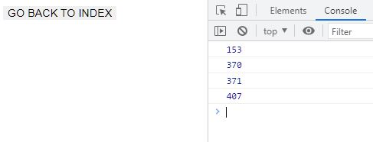

**Question (2). Develop a JS code to show how to find all even natural numbers that are divisible by 7 in a given range. Create suitable functions to achieve it.**

**SOURCE CODE:**

**HTML**

<html>

<head>

    <title>Divisibility by 7</title>

    <script>

        function DivisibleBy7(start, end) {

            const result = [];

            for (let i = start; i <= end; i++) {

                if (i % 2 === 0 && i % 7 === 0) {

                    result.push(i);

                }

            }

            return result;

        }

        const start = 1;

        const end = 100;

        const evenNumbersDivisibleBy7 = DivisibleBy7(start, end);

        console.log("Even natural numbers divisible by 7 in the range:");

        console.log(evenNumbersDivisibleBy7);

    </script>

</head>

<body>

    <div style="border: none;" class="container2">

        <a href="../index.htm"><button style="border: none;" onmouseover="this.style.color='red'">GO BACK TO INDEX</button></a>

    </div>

</body>

</html>

**OUTPUT SCREENSHOT:**

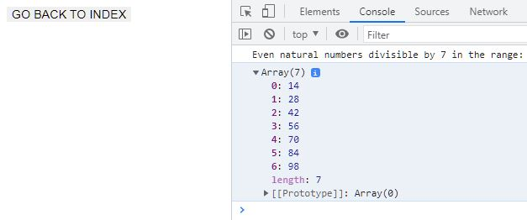

**Question (3). Write a JavaScript program that accepts a string as input and swaps the case of each character. For example if you input 'The Quick Brown Fox' the output should be 'tHE qUICK bROWN fOX'.**

**SOURCE CODE:**

**HTML**

<!DOCTYPE html>

<html>

<head>

    <title>Toggle Case</title>

    <script>

        function swapCase(inputString) {

            let swappedString = '';

            for (let i = 0; i < inputString.length; i++) {

                const char = inputString.charAt(i);

                if (char === char.toLowerCase()) {

                    swappedString += char.toUpperCase();

                } else {

                    swappedString += char.toLowerCase();

                }

            }

            return swappedString;

        }

        const input = 'The Quick Brown Fox';

        const swappedResult = swapCase(input);

        console.log(swappedResult);

    </script>

</head>

<body>

    <div style="border: none;" class="container2">

        <a href="../index.htm"><button style="border: none;" onmouseover="this.style.color='red'">GO BACK TO INDEX</button></a>

    </div>

</body>

</html>

**OUTPUT SCREENSHOT:**

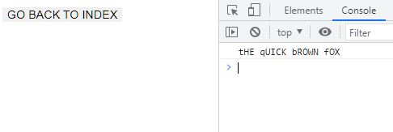

**EXPERIMENT NO 4**

**Working on Functions & Button Controls in JavaScript**

**AIM: Perform a CSS based Calculator.**

**Question (1). Develop a Calculator.**

**SOURCE CODE:**

**HTML**

<!DOCTYPE html>

<head>

    <meta http-equiv="X-UA-Compatible" content="Chrome">

    <title>Basic Calculator</title>

    <style>

        td{text-align: center;}

        input{text-align: center; max-height: 40%;max-width: 100%;border: none;background-

color: black;color: white;}

        button{ cursor: pointer; border: none;color: white;background-color: gray;max-width:

25px;max-height: 25px;box-shadow: 1px 1px 8px 2px honeydew;}

        .btn_gray{color: black;background-color: gainsboro;box-shadow: 1px 1px 8px 2px

gray;}

        .btn_yellow{color: white;background-color: orange;box-shadow: 1px 1px 8px 2px

yellow;}

        div{display:block;background-color: black;max-width: 20%;}

    </style>

</head>

<body>

    <p align="right">

        <a href="../index.htm"><button onmouseover="this.style.color='red'">R</button></a>

    </p>

    <br><center>

        <div><center>

            <table>

                <tr>

                    <td colspan=4 rowspan=3><input type="text" id="num"></td>

                </tr>

                <tr></tr>

                <tr></tr>

                <tr>

                    <td><button id="clear" class="btn_gray">AC</button></td>

                    <td><button id="neg" class="btn_gray">+/-</button></td>

                    <td><button id="percent" class="btn_gray">%</button></td>

                    <td><button id="div" class="btn_yellow">/</button></td>

                </tr>

                <tr>

                    <td><button id="7">7</button></td>

                    <td><button id="8">8</button></td>

                    <td><button id="9">9</button></td>

                    <td><button id="mul" class="btn_yellow">*</button></td>

                </tr>

                <tr>

                    <td><button id="4">4</button></td>

                    <td><button id="5">5</button></td>

                    <td><button id="6">6</button></td>

                    <td><button id="sub" class="btn_yellow">-</button></td>

                </tr>

                <tr>

                    <td><button id="1">1</button></td>

                    <td><button id="2">2</button></td>

                    <td><button id="3">3</button></td>

                    <td><button id="add" class="btn_yellow">+</button></td>

                </tr>

                <tr>

                    <td><button id="0">0</button></td>

                    <td><button id="00">00</button></td>

                    <td><button id="decimal">.</button></td>

                    <td><button id="equal" class="btn_yellow">=</button></td>

                </tr>

            </table><br>

        </center>

    </div></center>

    <script>

        var n1, n2, f1, f2, result, choice;

        let btn1 = document.getElementById('1');

        let btn2 = document.getElementById('2');

        let btn3 = document.getElementById('3');

        let btn4 = document.getElementById('4');

        let btn5 = document.getElementById('5');

        let btn6 = document.getElementById('6');

        let btn7 = document.getElementById('7');

        let btn8 = document.getElementById('8');

        let btn9 = document.getElementById('9');

        let btn0 = document.getElementById('0');

        let btn00 = document.getElementById('00');

        let btnclear = document.getElementById('clear');

        let btnneg = document.getElementById('neg');

        let btnpercent = document.getElementById('percent');

        let btndiv = document.getElementById('div');

        let btnmul = document.getElementById('mul');

        let btnadd = document.getElementById('add');

        let btnsub = document.getElementById('sub');

        let btnequal = document.getElementById('equal');

        let btndeci = document.getElementById('decimal');

        btn1.addEventListener('click', function () {

            document.getElementById("num").value = document.getElementById("num").value +

"1";

        });

        btn2.addEventListener('click', function () {

            document.getElementById("num").value = document.getElementById("num").value +

"2";

        });

        btn3.addEventListener('click', function () {

            document.getElementById("num").value = document.getElementById("num").value +

"3";

        });

        btn4.addEventListener('click', function () {

            document.getElementById("num").value = document.getElementById("num").value +

"4";

        });

        btn5.addEventListener('click', function () {

            document.getElementById("num").value = document.getElementById("num").value +

"5";

        });

        btn6.addEventListener('click', function () {

            document.getElementById("num").value = document.getElementById("num").value +

"6";

        });

        btn7.addEventListener('click', function () {

            document.getElementById("num").value = document.getElementById("num").value +

"7";

        });

        btn8.addEventListener('click', function () {

            document.getElementById("num").value = document.getElementById("num").value +

"8";

        });

        btn9.addEventListener('click', function () {

            document.getElementById("num").value = document.getElementById("num").value +

"9";

        });

        btn0.addEventListener('click', function () {

            document.getElementById("num").value = document.getElementById("num").value +

"0";

        });

        btn00.addEventListener('click', function () {

            document.getElementById("num").value = document.getElementById("num").value +

"00";

        });

        btnadd.addEventListener('click', function() {

            n1 = parseInt(document.getElementById("num").value);

            document.getElementById("num").value = " ";

            choice = 1

        })

        btnsub.addEventListener('click', function() {

            n1 = parseInt(document.getElementById("num").value);

            document.getElementById("num").value = " ";

            choice = 2

        })

        btnmul.addEventListener('click', function() {

            n1 = parseInt(document.getElementById("num").value);

            document.getElementById("num").value = " ";

            choice = 3

        })

        btndiv.addEventListener('click', function() {

            n1 = parseInt(document.getElementById("num").value);

            document.getElementById("num").value = " ";

            choice = 4

        })

        btnneg.addEventListener('click', function() {

            n1 = 0 - parseInt(document.getElementById("num").value);

            document.getElementById("num").value = n1;

        })

        btnpercent.addEventListener('click', function() {

            n1 = parseInt(document.getElementById("num").value);

            document.getElementById("num").value = n1/100;

        })

        btndeci.addEventListener('click', function() {

            document.getElementById("num").value = document.getElementById("num").value+".";

            f1 = parseFloat(document.getElementById("num").value);

            choice = 5

        })

        btnequal.addEventListener('click', function() {

            n2 = parseInt(document.getElementById("num").value);

            document.getElementById("num").value = " ";

            if (choice == 1) {

                result = n1 + n2;

            }

            else if (choice == 2) {

                result = n1 - n2;

            }

            else if (choice == 3) {

                result = n1 * n2;

            }

            else if (choice == 5) {

                alert(f1,f2)

                if (choice == 1){

                    result = f1 + f2;

                    alert(choice,f1,f2)

                }

                else if (choice == 2){

                    result = f1 - f2;

                    alert(choice,f1,f2)

                }

                else if (choice == 3){

                    result = f1 * f2;

                    alert(choice,f1,f2)

                }

                else {

                    result = f1 / f2;

                    alert(choice,f1,f2)

                }

            }

            else {

                result = n1 / n2;

            }

            document.getElementById("num").value = result;

        })

        btnclear.addEventListener('click', function() {

            document.getElementById("num").value = "";

        })

    </script>

</body>

</html>

**OUTPUT SCREENSHOT:**

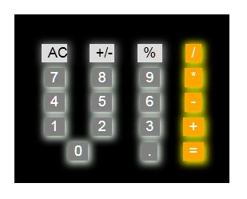

**EXPERIMENT NO 5**

**Working on PHP Basic Controls**

**AIM: To create simple PHP applications using the various Control Structures like sequence, decision, loop and switch cases.**

**Question (1). Make an Electricity Bill Calculator in PHP using the conditional statements with the following conditions specified below.**

* **For the first 50 units – Rs. 3.50/unit**
* **For next 100 units – Rs. 4.00/unit**
* **For next 100 units – Rs. 5.20/unit**

**For units above 50 – Rs. 6.50/unit**

**SOURCE CODE:**

**PHP**

<html>

    <head>

        <title>Electricity Bill in PHP</title>

    </head>

    <body>

    <p align="right">

        <a href="http://localhost/phpScripts/"><button

onmouseover="this.style.color='red'">INDEX</button></a>

    </p>

        <center>

        <h2>Electricity Bill in PHP</h2>

        <form method="post">

        <div>

            <label for="funits">Enter your electricity units: </label>

            <input type="number" name="units">

        </div>

        <div>

            <input type="submit" value="Submit">

        </div>

        </form>

        </center>

        <?php

        $U=$_POST["units"];

        $RES;

        if (0<$U && $U<=50){

            $RES=$U*3.50;

            echo "Electricity Bill for ".$U." units is: Rs. ".$RES;

        }

        else if (50<$U && $U<=150){

            $first50=50*3.50;

            $next100=($U-50)*4;

            $RES=$first50+$next100;

            echo "Electricity Bill for ".$U." units is: Rs. ".$RES;

        }

        else if (150<$U && $U<=250){

            $first50=50*3.50;

            $next100=100*4;

            $nextnext100=($U-150)*5.20;

            $RES=$first50+$next100+$nextnext100;

            echo "Electricity Bill for ".$U." units is: Rs. ".$RES;

        }

        else if ($U>250){

            $first50=50*3.50;

            $next100=100*4;

            $nextnext100=150*5.20;

            $Unit200=($U-250)*6.50;

            $RES=$first50+$next100+$nextnext100+$Unit200;

            echo "Electricity Bill for ".$U." units is: Rs. ".$RES;

        }

        echo "<br><hr>";

    ?>

    </body>

</html>

**OUTPUT SCREENSHOT:**

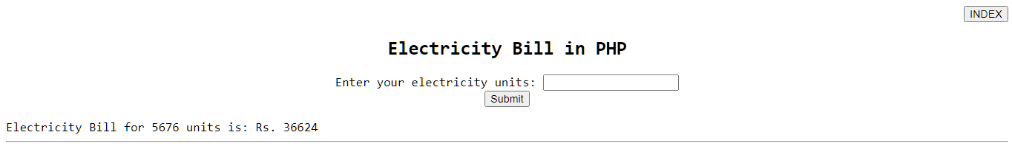

**Question (2). Implement the below-given software design using PHP. This algorithm finds all 3-digit Armstrong numbers.**

* **Step 1. [INITIALIZE N WITH THE FIRST 3-DIGIT NUMBER] N ← 100**
* **Step 2. REPEAT STEPS 3 THROUGH 10 UNTIL N > 999**
* **Step 3. [INITIALIZE S, WHICH HOLDS THE SUM OR THE CUBES] S ← 0**
* **Step 4. M ← N [THIS IS TO MAKE A COPY OR N]**
* **Step 5. REPEAT STEP 6 THROUGH STEP 8 WHILE M > 0**
* **Step 6. COMPUTE REM ← REMAINDER OF (M/10)**
* **Step 7. COMPUTE S ← S + REM*REM*REM**
* **Step 8. COMPUTE M ← INTEGER PART OF (M/10)**
* **Step 9. IF S = N THEN PRINT N END-IF**
* **Step 10. [INCREMENT N TO TAKE THE NEXT NUMBER] COMPUTE N ← N + 1 END-REPEAT**
* **Step 11. END**

**SOURCE CODE:**

**PHP**

<?php

$N = 100;

while ($N <= 999) {

    $S = 0;

    $M = $N;

    while ($M > 0) {

        $REM = $M % 10;

        $S += $REM * $REM * $REM;

        $M = (int)($M / 10);

    }

    if ($S == $N) {

        echo $N . " is an Armstrong number.<br>";

    }

    $N++;

}

**OUTPUT SCREENSHOT:**

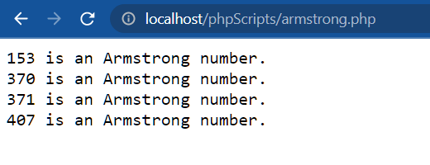

**Question (3). Determine the difference between the two given dates. Construct a flowchart to show how to do it.**

**SOURCE CODE:**

**PHP**

<?php

$sd = date_create(date('Y-m-d'));

$ed = date_create('2025-04-08');

$time = date_diff($sd, $ed);

echo "No. of days left till April 8, 2025 is: " . $time->format("%y years %m months %d days") . "<br><hr>";

?>

**OUTPUT SCREENSHOT:**



**EXPERIMENT NO. 6**

**Working with String Manipulation, Numbers, and Math Functions in PHP**

**AIM: To develop web pages to perform String Manipulations, Numbers and Math functions in PHP.**

**Question (1). Implement an similar program to create an calculator that has the functionality like 1-Add,2-Subtract,3-Multiply,4-Divide,5- Modulus as various options as buttons in the HTML Page. Format the web page similar to a calculator using various borders and colors using CSS**

**SOURCE CODE:**

**PHP**

<!DOCTYPE html>

<html>

<head>

    <title>Activity 2</title>

</head>

<body>

<p align="right">

        <a href="http://localhost/phpScripts/"><button

onmouseover="this.style.color='red'">INDEX</button></a>

    </p>

    <form method="GET">

        First Number: <input type="text" name="first"><br>

        Second Number: <input type="text" name="second"><br>

        Operator:

        <select name="operator">

            <option value="Add">Add</option>

            <option value="Sub">Subtract</option>

            <option value="Mul">Multiply</option>

            <option value="Div">Divide</option>

        </select>

        <input type="submit" value="Calculate">

    </form>

    <?php

    if (isset($_GET['first']) && isset($_GET['second']) && isset($_GET['operator'])) {

        class myclass {

            public $f, $s, $r;

            public function __construct($first, $second, $operator) {

                $this->f = $first;

                $this->s = $second;

                if ($operator == "Add") {

                    $this->add();

                } elseif ($operator == "Sub") {

                    $this->sub();

                } elseif ($operator == "Mul") {

                    $this->mul();

                } elseif ($operator == "Div") {

                    $this->div();

                }

            }

            public function add() {

                $this->r = $this->f + $this->s;

                echo "Result: " . $this->r;

            }

            public function sub() {

                $this->r = $this->f - $this->s;

                echo "Result: " . $this->r;

            }

            public function mul() {

                $this->r = $this->f * $this->s;

                echo "Result: " . $this->r;

            }

            public function div() {

                $this->r = $this->f / $this->s;

                echo "Result: " . $this->r;

            }

        }

        $neww = new myclass($_GET['first'], $_GET['second'], $_GET['operator']);

    }

    ?>

</body>

</html>

**OUTPUT SCREENSHOT:**

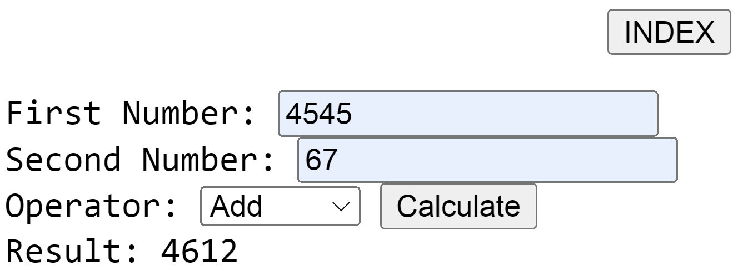

**Question (2). Write a PHP program to perform an transpose on 2-D matrices using Indexed Array**

**SOURCE CODE:**

**PHP**

<!DOCTYPE html>

<head>

    <title>Matrix Transpose</title>

</head>

<body>

<h2>Matrix Transpose</h2>

<form method="post" action="">

    <label for="matrix">Enter Matrix (comma-separated values): </label>

    <input type="text" name="matrix" id="matrix" required>

    <button type="submit">Transpose</button>

</form>

<?php

if ($_SERVER["REQUEST_METHOD"] == "POST") {

    $matrixInput = $_POST["matrix"];

    $rows = explode("\n", $matrixInput);

    $matrix = array_map(function($row) {

        return explode(",", $row);

    }, $rows);

    $transposedArray = transposeMatrix($matrix);

    echo "<h3>Original Matrix:</h3>";

    printMatrix($matrix);

    echo "<h3>Transposed Matrix:</h3>";

    printMatrix($transposedArray);

}

function transposeMatrix($matrix) {

    $transposedArray = [];

    foreach ($matrix as $rowIndex => $row) {

        foreach ($row as $colIndex => $value) {

            $transposedArray[$colIndex][$rowIndex] = $value;

        }

    }

    return $transposedArray;

}

function printMatrix($matrix) {

    echo "<pre>";

    foreach ($matrix as $row) {

        echo implode(" ", $row) . "<br>";

    }

    echo "</pre>";

}

?>

</body>

</html>

**OUTPUT SCREENSHOT:**

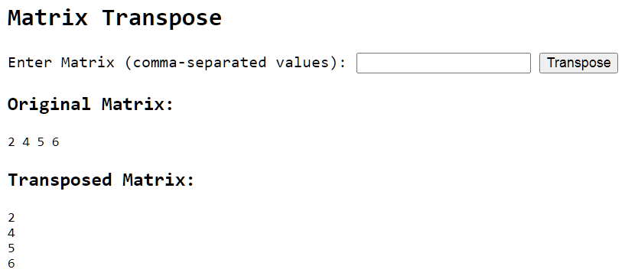

**EXPERIMENT NO. 7**

**Working with Files in PHP**

**AIM: To develop web apps in understanding the use of Files in PHP**

**Question (1). Study how JSON format looks like.**

**Develop a web application using PHP to work with files, reading data from a file and writing user data into file.**

1. **Create a Page to enter student data using form controls.**
2. **Have a SUBMIT button, when clicked the message has to be saved at the backend in a JSON format text file.**
3. **Add the Timestamp along with the file when it’s saved.**
4. **In another PHP page have a text box, while entering a specific student ID(To address) on it and a submit button clicked it should show the student details as the output in PHP file**

**SOURCE CODE:**

<html>

    <head>

        <title>PHP File Handling</title>

        <style>

            fieldset{

                border: 2px solid;

                margin-left: 15rem;

                margin-right: 15rem;

            }

            table, td, tr{

                margin-left:8%;

                margin-right:8%;

                border-collapse:collapse;

            }

        </style>

        <script>

            document.addEventListener("DOMContentLoaded", function () {

                const btn = document.getElementById("btn");

                const msg = document.getElementById("msg");

                btn.addEventListener("click", function (event) {

                    event.preventDefault();

                    msg.textContent = "File Created!";

                });

            });

        </script>

    </head>

    <body>

        <div>

            <form method="post">

                <fieldset>

                    <table>

                        <tr>

                            <td>Enter your Name: </td>

                            <td><input type="text" name="fname"></td>

                        </tr>

                        <tr>

                            <td>Enter your Roll No.: </td>

                            <td><input type="number" name="roll"></td>

                        </tr>

                        <tr>

                            <td>Enter your Course: </td>

                            <td><input type="text" name="course"></td>

                        </tr>

                        <tr>

                            <td></td>

                            <td> <input type="submit" value="Click to Save!" id="btn"></td>

                        </tr>

                        <tr>

                            <td></td>

                            <td id="msg"></td>

                        </tr>

                    </table>

                </fieldset>

            </form>

        </div>

    </body>

    <?php

    $StudentData = ["Name" => $_POST['fname'],

                    "Roll No." => $_POST['roll'],

                    "course" => $_POST["course"],

                    "Timestamp" => date('y-m-d H:i:s')

                ];

    $jsondata = json_encode($StudentData);

    $filename = "data_".time().".json";

    file_put_contents($filename, $jsondata);

    ?>

</html>

**OUTPUT SCREENSHOT:**

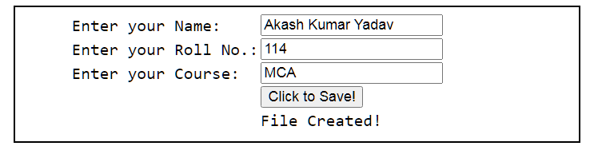

**EXPERIMENT NO. 8**

**Working with OOPs concepts in PHP**

**AIM: To develop understanding of implementing OOPs concepts in PHP.**

**Question (1). Write programs to implement OOPs concepts.**

**SOURCE CODE:**

**PHP**

<?php

echo "<b>Classes and Objects</b><br>";

class User{

    public $firstname;

    public $lastname;

    public function hello($firstname, $lastname){

        echo "hello, ". $firstname. " ". $lastname. "<br>";

    }

}

$user1 = new User();

$user2 = new User();

$user1->hello("John", "Doe");

$user2->hello("Jane", "Doe");

echo "<hr>";

echo "<b>Using <i>\$this</i> Keyword</b><br>";

class User2{

    public $firstname;

    public $lastname;

    public function hello(){

        echo "hello, ". $this->firstname. " ". $this->lastname. "<br>";

    }

}

$user3 = new User2();

$user3->firstname="Jonnie";

$user3->lastname="Roe";

$user3->hello();

echo "<hr>";

echo "<b>Chaining Methods and Properties</b><br>";

class User3{

    public $firstName;

    public function hello()

    {

      echo "hello, " .  $this -> firstName;

      return $this;

    }

    public function register()

    {

      echo " >> registered";

      return $this;

    }

    public function mail()

    {

      echo " >> email sent";

    }

  }

  $user4 = new User3();

  $user4 -> firstName = "Jane";

  $user4 -> hello() -> register() -> mail();

  echo "<hr>";

  echo "<b>Public v/s Private</b><br>";

  class User4{

    private $firstName;

    public function set($str)

    {

      $this -> firstName = $str;

    }

    public function get()

    {

      return $this -> firstName;

    }

  }

  $user5 = new User4();

  $user5 -> set("Joe");

  echo $user5 -> get();

  echo "<hr>";

  echo "<b>Magic Methods and Constants</b><br>";

  class User5{

    private $firstName;

    private $lastName;

    public function __construct($firstName,$lastName)

    {

      $this -> firstName = $firstName;

      $this -> lastName = $lastName;

    }

    public function getName()

    {

        echo $this -> firstName . " " . $this -> lastName;

    }

  }

  $user6 = new User5("John", "Doe");

  echo $user6->getName();

  echo "<hr>";

  echo "<b>Inheritance</b><br>";

  class User6{

    protected $username;

    public function set($name)

    {

      $this -> username = $name;

    }

  }

  class Admin extends User6{

    public function expressYourRole()

    {

      return strtolower(__CLASS__);

    }

    public function sayHello()

    {

      return "Hello admin, " . $this -> username;

    }

  }

  $admin1 = new Admin();

  $admin1 -> set("Balthazar");

  echo $admin1 -> sayHello();

  echo "<hr>";

  echo "<b>Abstract Classes and Methods</b><br>";

  abstract class User7{

    protected $username;

    public function set($name){

        return $this->username=$name;

    }

    public function get(){

        echo $this->username;

    }

    abstract function stateYourRole();

  }

  class Admin2 extends User7{

    public function stateYourRole(){

        echo "admin";

    }

  }

  class Viewer extends User7{

    public function stateYourRole(){

        echo "viewer";

    }

  }

  $admin2 = new Admin2();

$admin2 -> set("Balthazar");

echo $admin2 -> stateYourRole();

echo "<hr>";

echo "<b>Interface</b><br>";

class User8{

    protected $username;

    public function set($name){

        return $this->username=$name;

    }

    public function get(){

        return $this->username;

    }

}

interface Author{

    public function setAuthorPrivileges($array);

    public function getAuthorPrivileges();

}

interface Editor{

    public function setEditorPrivileges($array);

    public function getEditorPrivileges();

}

class AuthorEditor extends User8 implements Author, Editor{

    private $authorPrivilegesArray = array();

    private $editorPrivilegesArray = array();

    public function setAuthorPrivileges($array){

        $this->authorPrivilegesArray = $array;

    }

    public function getAuthorPrivileges(){

        return $this->authorPrivilegesArray;

    }

    public function setEditorPrivileges($array){

        $this->editorPrivilegesArray = $array;

    }

    public function getEditorPrivileges(){

        return $this->editorPrivilegesArray;

    }

}

$user9 = new AuthorEditor();

$user9 -> set("Balthazar");

$user9 -> setAuthorPrivileges(array("write text","add punctuation"));

$user9 -> setEditorPrivileges(array("edit text","edit punctuation"));

$userName  = $user9 -> get();

$userPrivileges = array_merge($user9 -> getAuthorPrivileges(),

  $user9 -> getEditorPrivileges());

echo $userName . " has the following privileges: ";

echo implode(", ", $userPrivileges);

echo ".";

echo "<hr>";

echo "<b>Polymorphism</b><br>";

abstract class User9{

    protected $scores           = 0;

    protected $numberOfArticles = 0;

    public function setNumberOfArticles($int)

    {

      $numberOfArticles = (int)$int;

      $this -> numberOfArticles = $numberOfArticles;

    }

    public function getNumberOfArticles()

    {

      return $this -> numberOfArticles;

    }

    abstract public function calcScores();

  }

  class Author2 extends User9{

    public function calcScores()

    {

      return $this -> scores = $this -> numberOfArticles * 10 + 20;

    }

  }

  class Editor2 extends User9{

    public function calcScores()

    {

      return $this -> scores = $this -> numberOfArticles * 6 + 15;

    }

  }

  $author2 = new Author2();

$author2 -> setNumberOfArticles(8);

echo $author2 -> calcScores();

echo "<br>";

$author3 = new Editor2();

$author3 -> setNumberOfArticles(15);

echo $author3 -> calcScores();

echo "<hr>";

?>

**OUTPUT SCREENSHOT:**

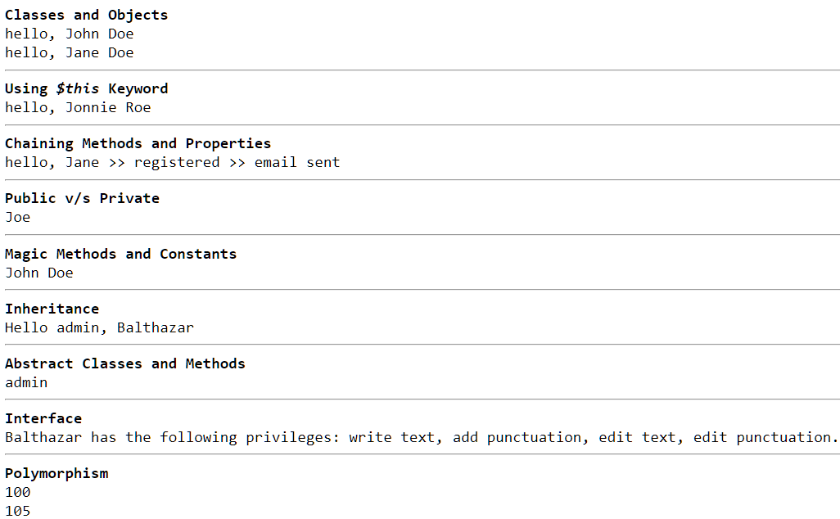

**PROJECT NO 1**

**Mini Project using HTML, CSS and JavaScript**

**AIM: To develop a dynamic game using HTML, CSS, and JavaScript.**

**SOURCE CODE:**

**HTML**

<!DOCTYPE html>

<html>

<head>

    <meta name="viewport" content="width=device-width, initial-scale=1.0" />

    <script src="./scripts/js/game.js"></script>

    <style>

        canvas {

            border: 1px solid blue;

            background-color: lightsalmon;

        }

    </style>

</head>

<body onload="startGame()">

    <br><br>

    <button onmousedown="accelerate(-0.3)" onmouseup="accelerate(0.05)">ACCELERATE</button>

    <p>Use the ACCELERATE button to stay in the air</p>

    <p>How long can you stay alive?</p>

</body>

</html>

**JAVASCRIPT**

var myGamePiece;

var myObstacles = [];

var myScore;

function startGame() {

    myGamePiece = new component(30, 30, "red", 10, 120);

    myGamePiece.gravity = 0.05;

    myScore = new component("30px", "Consolas", "black", 280, 40, "text");

    myGameArea.start();

}

var myGameArea = {

    canvas : document.createElement("canvas"),

    start : function() {

        this.canvas.width = 1050;

        this.canvas.height =400 ;

        this.context = this.canvas.getContext("2d");

        document.body.insertBefore(this.canvas, document.body.childNodes[0]);

        this.frameNo = 0;

        this.interval = setInterval(updateGameArea, 20);

        },

    clear : function() {

        this.context.clearRect(0, 0, this.canvas.width, this.canvas.height);

    }

}

function component(width, height, color, x, y, type) {

    this.type = type;

    this.score = 0;

    this.width = width;

    this.height = height;

    this.speedX = 0;

    this.speedY = 0;

    this.x = x;

    this.y = y;

    this.gravity = 0;

    this.gravitySpeed = 0;

    this.update = function() {

        ctx = myGameArea.context;

        if (this.type == "text") {

            ctx.font = this.width + " " + this.height;

            ctx.fillStyle = color;

            ctx.fillText(this.text, this.x, this.y);

        } else {

            ctx.fillStyle = color;

            ctx.fillRect(this.x, this.y, this.width, this.height);

        }

    }

    this.newPos = function() {

        this.gravitySpeed += this.gravity;

        this.x += this.speedX;

        this.y += this.speedY + this.gravitySpeed;

        this.hitBottom();

    }

    this.hitBottom = function() {

        var rockbottom = myGameArea.canvas.height - this.height;

        if (this.y > rockbottom) {

            this.y = rockbottom;

            this.gravitySpeed = 0;

        }

    }

    this.crashWith = function(otherobj) {

        var myleft = this.x;

        var myright = this.x + (this.width);

        var mytop = this.y;

        var mybottom = this.y + (this.height);

        var otherleft = otherobj.x;

        var otherright = otherobj.x + (otherobj.width);

        var othertop = otherobj.y;

        var otherbottom = otherobj.y + (otherobj.height);

        var crash = true;

        if ((mybottom < othertop) || (mytop > otherbottom) || (myright < otherleft) || (myleft > otherright)) {

            crash = false;

        }

        return crash;

    }

}

function updateGameArea() {

    var x, height, gap, minHeight, maxHeight, minGap, maxGap;

    for (i = 0; i < myObstacles.length; i += 1) {

        if (myGamePiece.crashWith(myObstacles[i])) {

            return;

        }

    }

    myGameArea.clear();

    myGameArea.frameNo += 1;

    if (myGameArea.frameNo == 1 || everyinterval(150)) {

        x = myGameArea.canvas.width;

        minHeight = 20;

        maxHeight = 200;

        height = Math.floor(Math.random()*(maxHeight-minHeight+1)+minHeight);

        minGap = 50;

        maxGap = 200;

        gap = Math.floor(Math.random()*(maxGap-minGap+1)+minGap);

        myObstacles.push(new component(10, height, "green", x, 0));

        myObstacles.push(new component(10, x - height - gap, "purple", x, height + gap));

    }

    for (i = 0; i < myObstacles.length; i += 1) {

        myObstacles[i].x += -1;

        myObstacles[i].update();

    }

    myScore.text="SCORE: " + myGameArea.frameNo;

    myScore.update();

    myGamePiece.newPos();

    myGamePiece.update();

}

function everyinterval(n) {

    if ((myGameArea.frameNo / n) % 1 == 0) {return true;}

    return false;

}

function accelerate(n) {

    myGamePiece.gravity = n;

}

**OUTPUT SCREENSHOT:**

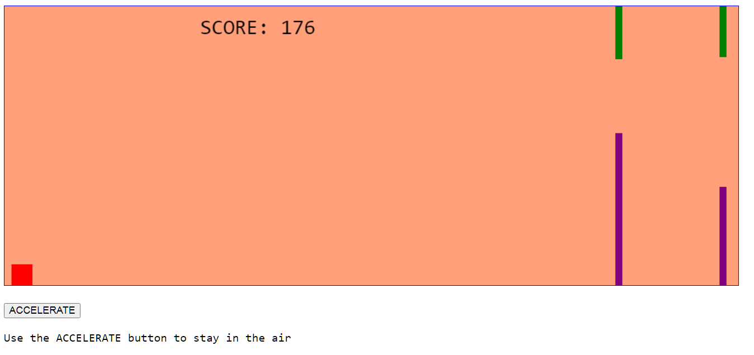

**PROJECT NO 2**

**CAPSTONE PROJECT – Library Management System**

**AIM: Database Connectivity: To develop simple programs to connect the webpages with the database.**

**SOURCE CODE:**

**Library Index**

<!DOCTYPE html>

<html lang="en">

<head>

    <meta charset="UTF-8">

    <meta name="viewport" content="width=device-width, initial-scale=1.0">

    <style>

        @import url('https://fonts.googleapis.com/css2?family=Open+Sans:wght@400;700&display=swap');

    body {

        font-family: 'Open Sans', sans-serif;

        margin: 0;

        padding: 0;

        justify-content: center;

        align-items: center;

        height: 100vh;

        margin: 0;

        display: flex;

        background-color: rgb(70, 17, 73);}

    .navbar {

        font-family: 'Open Sans', sans-serif;

        display: flex;

        background-color: rgb(70, 17, 73);

        overflow: hidden;

        padding-right:2%;

        padding-left:6%;

        font-size:18px;

        width: 20%;

        box-shadow: 0 14px 6px rgba(0, 0, 0, 0.12), 0 10px 3px rgba(0, 0, 0, 0.12);

        border-radius: 35px;

        text-align: center;

        align-items: center;

    }

    .navbar a {

        float: center;

        display: block;

        color:white;

        text-align: center;

        align-items: center;

        padding: 10px 15px;

        text-decoration: none;

    }

    .navbar a:hover {

        display: block;

        background: radial-gradient(ellipse at center, rgb(100, 37, 187), rgb(134, 47, 244));

        box-shadow:0 5px 5px 0px rgb(134, 47, 244);

        color: white;

        font-size:20px;

        border-radius: 55px;

        text-align: center;

    }

    .text {

        text-align: center;

        color: white;

    }

</style>

    <title>Library Management System</title>

</head>

<body>

    <div class="navbar">

        <center>

        <a href="searchdb.php">Search Database</a>

            <a href="catalogue.php">Get Catalogue</a>

            <a href="registermember.php">Register Member</a>

            <a href="deleterecord.php">Delete Member</a>

            <a href="registerbook.php">Add Books</a>

            <a href="deletebook.php">Delete Books</a>

            <a href="searchbook.php">Search Books</a>

            <a href="availbooks.php">Available Books</a>

            <a href="borrowedby.php">Borrow Records</a>

        </center>

    </div>

    <center>

    <div style="display:inline block;">

        <h1 class="text">&nbsp&nbsp&nbspWelcome!</h1>

        <h3>

            <p class="text">&nbsp&nbsp&nbspLibrary Management System</p>

        </h3>

        <p class="text">&nbsp&nbsp&nbspUse the navigation bar to operate!</p>

    </div>

    </center>

</body>

</html>

**Catalogue**

 <html>

    <head>

        <title>Books</title>

        <link rel="stylesheet" href="./style.css">

        <style>

        </style>

    </head>

    <body>

        <div align="right"><br><a href="./library.php"><input style='background-color:purple; color:white;' type='submit' value='Back' class='border'></a>&nbsp</div>

        <br>

        <div align="center">Every book in the library is displayed below:</div><br>

    </body>

    <?php

    $conn = mysqli_connect("localhost", "root", "", "library");

    if (!$conn) {

        die("<div class='message error'><center><br>Connection Failed!</center><hr></div>" . mysqli_connect_error());

    }

    $sql = "SELECT * FROM books";

    $result=$conn->query($sql);

    if ($result->num_rows>0){

        echo "<table class='table border' style='margin-left:15%; margin-right:15%; width:69%; display:block;'>";

        echo "<tr>

        <th class='th'>Book_Id</th>

        <th class='th'>Title</th>

        <th class='th'>Author</th>

        <th class='th'>Publisher</th>

        <th class='th'>Price</th>

        <th class='th'>Available</th>

        </tr><tr></tr>";

        while($row=$result->fetch_assoc()){

            echo "<tr>

            <td class='td'>".$row['Book_Id']."</td>

            <td class='td'>".$row['Title']."</td>

            <td class='td'>".$row['Author']."</td>

            <td class='td'>".$row['Publisher']."</td>

            <td class='td'>".$row['Price']."</td>

            <td class='td'>".$row['Available']."</td>

            </tr>";

        }

        echo "</table>";

    }

    else{

        echo '<div class="message error">No books have added as of yet!</div>';

    }

    if (mysqli_query($conn, $sql)) {

        echo '<div class="message success"></div>';

    }

    else {

        echo '<div class="message error">Error: ' . $sql . '<br>' . mysqli_error($conn) . '</div>';

    }

    mysqli_close($conn);

    ?>

 </html>

**Search Database**

<html>

<head>

    <title>Search Database</title>

    <link rel="stylesheet" href="./style.css">

</head>

<body>

<div align="right"><br><a href="./library.php"><input style='background-color:purple; color:white;' type='submit' value='Back' class='border'></a>&nbsp</div>

<center>

    <form action="" method="post">

        <legend>SEARCH DATABASE</legend>

        <table>

            <tr>

                <td><labelclass='border' >Select by Table:</label></td>

                <td><select class='border' name="table"onchange="showOptions()">

                        <option class='border' value=books selected>Book Records</option>

                        <option class='border' value=members>Member Records</option>

                        <option class='border' value=borrowed_by>Borrow Records</option>

                    </select></td>

            </tr>

            <tr>

                <td></td>

                <td colspan=2><input class='border'  type="submit" value="Search"></td>

            </tr>

        </table>

    </form>

    </center>

</body>

<?php

$servername = "localhost";

$username = "root";

$password = "";

$dbname = "library";

$conn = mysqli_connect($servername, $username, $password, $dbname);

if (!$conn) {

    die("<div class='message error'><center><br>Connection Failed!</center><hr></div>" . mysqli_connect_error());

}

if ($_SERVER["REQUEST_METHOD"] == "POST"){

    $table = mysqli_real_escape_string($conn, $_POST['table']);

if ($table=="books"){

    $sql = "SELECT * FROM books";

$result=$conn->query($sql);

if($result->num_rows>0){

    echo "<br><center><table class='table border' style='width:75%; display:block;'>";

echo "<tr>

<th class='th'>Book_Id</th>

<th class='th'>Title</th>

<th class='th'>Author</th>

<th class='th'>Publisher</th>

<th class='th'>Price</th>

<th class='th'>Available</th>

</tr><tr></tr>";

while($row=$result->fetch_assoc()){

    echo "<tr>

    <td class='td'>".$row['Book_Id']."</td>

    <td class='td'>".$row['Title']."</td>

    <td class='td'>".$row['Author']."</td>

    <td class='td'>".$row['Publisher']."</td>

    <td class='td'>".$row['Price']."</td>

    <td class='td'>".$row['Available']."</td>

    </tr>";

}

echo "</table></center>";

}

else{

    echo '<div class="message error">No records as of yet!</div>';

}

    }

else if ($table=="members"){

    $sql = "SELECT * FROM members";

$result=$conn->query($sql);

if($result->num_rows>0){

    echo "<br><center><table class='table border' style='width:47%; display:block;'>";

        echo "<tr>

        <th class='th'>Member_Id</th>

        <th class='th'>Name</th>

        <th class='th'>Address</th>

        <th class='th'>DOB</th>

        </tr><tr></tr>";

        while($row=$result->fetch_assoc()){

            echo "<tr>

            <td class='td'>".$row['Member_Id']."</td>

            <td class='td'>".$row['Name']."</td>

            <td class='td'>".$row['Address']."</td>

            <td class='td'>".$row['DOB']."</td>

            </tr>";

        }

        echo "</table></center>";

}else{

    echo '<div class="message error">No records as of yet!</div>';

}

    }

else if ($table=="borrowed_by"){

    $sql = "SELECT * FROM borrowed_by";

$result=$conn->query($sql);

    if($result->num_rows>0){

        echo "<br><center><table class='table border' style='width:46%; display:block;'>";

        echo "<tr>

        <th class='th'>Issue_Id</th>

        <th class='th'>Issue Date</th>

        <th class='th'>Return Date</th>

        <th class='th'>Due Date</th>

        </tr><tr></tr>";

        while($row=$result->fetch_assoc()){

            echo "<tr>

            <td class='td'>".$row['Issue_Id']."</td>

            <td class='td'>".$row['Issue_Date']."</td>

            <td class='td'>".$row['Return_Date']."</td>

            <td class='td'>".$row['Due_Date']."</td>

            </tr>";

        }

        echo "</table></center>";

    }else{

        echo '<div class="message error">No records as of yet!</div>';

    }

}

if ($_SERVER["REQUEST_METHOD"] == "POST") {

    if (mysqli_query($conn, $sql)) {

        echo ' ';

    }

    else {

        echo '<div class="message error">Error: ' . $sql . '<br>' . mysqli_error($conn) . '</div>';

    }

}

}

mysqli_close($conn);

?>

</html>

**Add Member**

<!DOCTYPE html>

<html lang="en">

<head>

    <meta charset="UTF-8">

    <meta name="viewport" content="width=device-width, initial-scale=1.0">

    <title>Registration Form</title>

    <link rel="stylesheet" href="./style.css">

</head>

<body>

<div align="right"><br><a href="./library.php"><input style='background-color:purple; color:white;' type='submit' value='Back' class='border'></a>&nbsp</div>

    <center>

    <form action="" method="post">

            <legend>REGISTER YOURSELF</legend>

            <table>

                <tr>

                    <td><label class='border' for="Name">Name: </label></td>

                    <td><input class='border' type="text" name="mname"></td>

                </tr>

                <tr>

                    <td><label class='border' for="Address">Address: </label></td>

                    <td><textarea class='border' name="address" cols="30" rows="10"></textarea></td>

                </tr>

                <tr>

                    <td><label class='border' for="DOR">DOB: </label></td>

                    <td><input class='border' type="date" name="dor"></td>

                </tr>

                <tr>

                    <td></td>

                    <td colspan="2" align="center"><input class='border' type="submit" value="Register"></td>

                </tr>

            </table>

    </form>

    </center>

    <?php

    $servername = "localhost";

    $username = "root";

    $password = "";

    $dbname = "library";

$conn = mysqli_connect($servername, $username, $password, $dbname);

if (!$conn) {

        die("<div class='message error'><center><br>Connection Failed!</center><hr></div>" . mysqli_connect_error());

    }

    if ($_SERVER["REQUEST_METHOD"] == "POST") {

        $name = mysqli_real_escape_string($conn, $_POST['mname']);

        $address = mysqli_real_escape_string($conn, $_POST['address']);

        $dor = mysqli_real_escape_string($conn, $_POST['dor']);

        $sql = "INSERT INTO members (Name, Address, DOB)

        VALUES ('$name', '$address', '$dor')";

        if (mysqli_query($conn, $sql)) {

            echo '<div class="message success">New member added successfully!</div>';

        } else {

            echo '<div class="message error">Error: ' . $sql . '<br>' . mysqli_error($conn) . '</div>';

        }

        $result=$conn->query("SELECT Member_Id FROM members WHERE members.name = '$name' AND members.dob = '$dor'");

        if ($result->num_rows>0){

            while($row=$result->fetch_assoc()){

                echo "<center><div class='message2 success'>Your Member ID is: ".$row['Member_Id']."</div></center>";

            }

        }

        else{

            echo "0 results";

        }

    }

    mysqli_close($conn);

    ?>

</body>

</html>

**Remove Member**

<!DOCTYPE html>

<html lang="en">

<head>

    <meta charset="UTF-8">

    <meta name="viewport" content="width=device-width, initial-scale=1.0">

    <title>Delete Member</title>

    <link rel="stylesheet" href="./style.css">

    <script>

        function updateLabel() {

            var search = document.getElementById("search");

            var selectedOption = search.options[search.selectedIndex].text;

            document.getElementById("message").textContent = selectedOption+":";

        }

        function onSubmit() {

            return true;

        }

    </script>

</head>

<body>

    <div align="right"><br><a href="./library.php"><input style='background-color:purple; color:white;' type='submit' value='Back' class='border'></a>&nbsp</div>

    <center>

    <div>

    <form action="" method="post" onsubmit="return onSubmit()">

            <legend>DELETE A MEMBER RECORD</legend>

            <table>

                <tr>

                    <td><label class='border'>Delete by: </label></td>

                    <td><select class='border' name="search" id="search" onchange="updateLabel()">

                        <option class='border' value=Member_Id selected>Member ID</option>

                        <option class='border' value=Name>Name</option>

                    </select></td>

                </tr>

                <tr>

                    <td><label class='border' id="message">Member ID:</label></td>

                    <td><input class='border' type="" name="book"></td>

                </tr>

                <tr>

                    <td></td>

                    <td colspan=2><input class='border' type="submit" value="Delete"></td>

                </tr>

            </table>

    </form>

    </div>

    </center>

    <?php

    $servername = "localhost";

    $username = "root";

    $password = "";

    $dbname = "library";

    $conn = mysqli_connect($servername, $username, $password, $dbname);

    if (!$conn) {

        die("<div class='message error'><center><br>Connection Failed!</center><hr></div>" . mysqli_connect_error());

    }

    if ($_SERVER["REQUEST_METHOD"] == "POST") {

        $search = mysqli_real_escape_string($conn, $_POST['search']);

        $book = mysqli_real_escape_string($conn, $_POST['book']);

        $sql= "DELETE FROM members WHERE members.$search = '$book';";

        if (mysqli_query($conn, $sql)) {

            echo '<div class="message success">Record deleted successfully &nbsp</div>';

        } else {

            echo '<div class="message error">No such member exists!</div>';

        }

    }

    mysqli_close($conn);

    ?>

</body>

</html>

**Add Book**

<!DOCTYPE html>

<html lang="en">

<head>

    <meta charset="UTF-8">

    <meta name="viewport" content="width=device-width, initial-scale=1.0">

    <title>BOOK RECORDS</title>

    <link rel="stylesheet" href="./style.css">

</head>

<body>

<div align="right"><br><a href="./library.php"><input style='background-color:purple; color:white;' type='submit' value='Back' class='border'></a>&nbsp</div>

    <center>

    <form action="" method="post">

            <legend>INSERT A NEW BOOK</legend>

            <table>

                <tr>

                    <td><label class='border' for="Title">Title: </label></td>

                    <td><input class='border' type="text" name="title"></td>

                </tr>

                <tr>

                    <td><label class='border' for="Author">Author: </label></td>

                    <td><input class='border' type="text" name="author"></td>

                </tr>

                <tr>

                    <td><label class='border' for="Publisher">Publisher: </label></td>

                    <td><input class='border' type="text" name="pub"></td>

                </tr>

                <tr>

                    <td><label class='border' for="Price">Price: </label></td>

                    <td><input class='border' type="number" name="price"></td>

                </tr>

                <tr>

                    <td><label class='border'>Available: </label></td>

                    <td><input type="radio" value=Yes name="avail"><label>Yes</label>

                    <input type="radio" value=No name="avail"><label>No</label></td>

                </tr>

                <tr>

                    <td></td>

                    <td colspan="2" align="center"><input class='border' type="submit" value="Add"></td>

                </tr>

            </table>

    </form>

    </center>

    <?php

    $servername = "localhost";

    $username = "root";

    $password = "";

    $dbname = "library";

    $conn = mysqli_connect($servername, $username, $password, $dbname);

    if (!$conn) {

        die("<div class='message error'><center><br>Connection Failed!</center><hr></div>" . mysqli_connect_error());

    }

    if ($_SERVER["REQUEST_METHOD"] == "POST") {

        $pub = mysqli_real_escape_string($conn, $_POST['pub']);

        $author = mysqli_real_escape_string($conn, $_POST['author']);

        $price = mysqli_real_escape_string($conn, $_POST['price']);

        $title = mysqli_real_escape_string($conn, $_POST['title']);

        $avail = mysqli_real_escape_string($conn, $_POST['avail']);

        $sql = "INSERT INTO books (publisher, Available, Price, Title, Author)

        VALUES ('$pub', '$avail', '$price', '$title', '$author')";

        if (mysqli_query($conn, $sql)) {

            echo '<div class="message success">New book added successfully!</div>';

        } else {

            echo '<div class="message error">Error: ' . $sql . '<br>' . mysqli_error($conn) . '</div>';

        }

        $result=$conn->query("SELECT Book_Id FROM books WHERE books.title = '$title' AND books.author = '$author'");

        if ($result->num_rows>0){

            while($row=$result->fetch_assoc()){

                echo "<center><div class='messages success'>The Book ID is: ".$row['Book_Id']."</div></center>";

            }

        }

    }

    mysqli_close($conn);

    ?>

</body>

</html>

**Remove Book**

<!DOCTYPE html>

<html lang="en">

<head>

    <meta charset="UTF-8">

    <meta name="viewport" content="width=device-width, initial-scale=1.0">

    <title>Registration Form</title>

    <link rel="stylesheet" href="./style.css">

    <script>

        function updateLabel() {

            var search = document.getElementById("search");

            var selectedOption = search.options[search.selectedIndex].text;

            document.getElementById("message").textContent = selectedOption+":";

        }

        function onSubmit() {

            return true;

        }

    </script>

</head>

<body>

    <div align="right"><br><a href="./library.php"><input style='background-color:purple; color:white;' type='submit' value='Back' class='border'></a>&nbsp</div>

    <center>

    <form action="" method="post" onsubmit="return onSubmit()">

            <legend>DELETE A BOOK</legend>

            <table>

                <tr>

                    <td><label class='border'>Delete by: </label></td>

                    <td><select class='border' name="search" id="search" onchange="updateLabel()">

                        <option class='border' value=Title onClick=return select() selected>Title</option>

                        <option class='border' value=Author>Author</option>

                        <option class='border' value=Publisher>Publisher</option>

                    </select></td>

                </tr>

                <tr>

                    <td><label class='border' id="message">Title:</label></td>

                    <td><input class='border' type="text" name="book"></td>

                </tr>

                <tr>

                    <td></td>

                    <td colspan=2><input class='border' type="submit" value="Delete"></td>

                </tr>

            </table>

    </form>

    </center>

    <?php

    $servername = "localhost";

    $username = "root";

    $password = "";

    $dbname = "library";

    // Create connection

    $conn = mysqli_connect($servername, $username, $password, $dbname);

    // Check connection

    if (!$conn) {

        die("<div class='message error'><center><br>Connection Failed!</center><hr></div>" . mysqli_connect_error());

    }

    if ($_SERVER["REQUEST_METHOD"] == "POST") {

        $search = mysqli_real_escape_string($conn, $_POST['search']);

        $book = mysqli_real_escape_string($conn, $_POST['book']);

        $sql= "DELETE FROM books WHERE books.$search = '$book'";

        if (mysqli_query($conn, $sql)) {

            echo '<div class="message success">Record deleted successfully &nbsp</div>';

        } else {

        echo '<div class="message error">No such book exists!</div>';

        }

    }

    mysqli_close($conn);

    ?>

</body>

</html>

**Search Books**

<!DOCTYPE html>

<html lang="en">

<head>

    <meta charset="UTF-8">

    <meta name="viewport" content="width=device-width, initial-scale=1.0">

    <title>Search books</title>

    <link rel="stylesheet" href="./style.css">

</head>

<body>

<div align="right"><br><a href="./library.php"><input style='background-color:purple; color:white;' type='submit' value='Back' class='border'></a>&nbsp</div>

    <center>

    <form action="" method="post">

        <legend>SEARCH THE BOOKS RECORD</legend>

            <table>

                <tr>

                    <td><label class='border'>Search by: </label></td>

                    <td><select class='border' name="search">

                    <option class='border' value=Book_Id>Book ID</option>

                        <option class='border' value=Title selected>Title</option>

                        <option class='border' value=Author>Author</option>

                        <option class='border' value=Publisher>Publisher</option>

                    </select></td>

                </tr>

                <tr>

                    <td></td>

                    <td colspan=2><input class='border' type="submit" value="Search"></td>

                </tr>

            </table>

    </form>

    </center>

    <?php

$servername = "localhost";

$username = "root";

$password = "";

$dbname = "library";

// Create connection

$conn = mysqli_connect($servername, $username, $password, $dbname);

// Check connection

if (!$conn) {

    die("<div class='message error'><center><br>Connection Failed!</center><hr></div>" . mysqli_connect_error());

}

if ($_SERVER["REQUEST_METHOD"] == "POST") {

    $search = mysqli_real_escape_string($conn, $_POST['search']);

        if ($search=="Title"){

            $sql = "SELECT Book_Id, Title, Available FROM books";

            $result = $conn->query($sql);

            if($result->num_rows>0)

            {

                echo "<br><center><table class='table' style='width:41%; display:block;'><tr>

                <th style='font-weight:bold;font-size:20px;'>Book_ID</th>

                <th style='font-weight:bold;font-size:20px;'>Title</th>

                <th style='font-weight:bold;font-size:20px;'>Available</th></tr>";

                while ($row = $result->fetch_assoc())

                {

                    echo "<tr>

                    <td style='color:white;'>".$row['Book_Id']."</td>

                    <td style='color:white;'>".$row['Title']."</td>

                    <td style='color:white;'>".$row['Available']."</td>

                    </tr>";

                }

                echo "</table>";

            }

            else

            {

                echo '<div class="message error">No records as of yet!</div>';

            }

        }

        else if ($search=="Author"){

            $sql = "SELECT Book_Id, Author, Available FROM books";

            $result = $conn->query($sql);

            if($result->num_rows>0)

            {

                echo "<br><center><table style='width:40%; display:block;'><tr>

                <th style='font-weight:bold;font-size:20px;'>Book_ID</th>

                <th style='font-weight:bold;font-size:20px;'>Author</th>

                <th style='font-weight:bold;font-size:20px;'>Available</th></tr>";

                while ($row = $result->fetch_assoc())

                {

                    echo "<tr>

                    <td style='color:white;'>".$row['Book_Id']."</td>

                    <td style='color:white;'>".$row['Author']."</td>

                    <td style='color:white;'>".$row['Available']."</td>

                    </tr>";

                }

                echo "</table>";

            }

            else

            {

                echo '<div class="message error">No records as of yet!</div>';

            }

        }

        elseif ($search=="Publisher"){

            $sql = "SELECT Book_Id, Publisher, Available FROM books";

            $result = $conn->query($sql);

            if($result->num_rows>0)

            {

                echo "<br><center><table style='width:40%; display:block;'><tr>

                <th class ='th'>Book_ID</th>

                <th class ='th'>Publisher</th>

                <th class ='th'>Available</th></tr>";

                while ($row = $result->fetch_assoc())

                {

                    echo "<tr>

                    <td class='td'>".$row['Book_Id']."</td>

                    <td class='td'>".$row['Publisher']."</td>

                    <td class='td'>".$row['Available']."</td>

                    </tr>";

                }

                echo "</table>";

            }

            else

            {

                echo '<div class="message error">No records as of yet!</div>';

            }

        }

        elseif ($search=="Book_Id"){

            $sql = "SELECT Title, Book_Id, Publisher, Author, Available FROM books";

            $result = $conn->query($sql);

            if($result->num_rows>0)

            {

                echo "<br><center><table style='width:70%; display:block;'><tr>

                <th class ='th'>Book_ID</th>

                <th class ='th'>Title</th>

                <th class ='th'>Author</th>

                <th class ='th'>Publisher</th>

                <th class ='th'>Available</th></tr>";

                while ($row = $result->fetch_assoc())

                {

                    echo "<tr>

                    <td class='td'>".$row['Book_Id']."</td>

                    <td class='td'>".$row['Title']."</td>

                    <td class='td'>".$row['Author']."</td>

                    <td class='td'>".$row['Publisher']."</td>

                    <td class='td'>".$row['Available']."</td>

                    </tr>";

                }

                echo "</table>";

            }

            else

            {

                echo '<div class="message error">No records as of yet!</div>';

            }

        }

        else{

            echo "<div class='message error'>Error</div>";

        }

    if (mysqli_query($conn, $sql)) {

        echo ' ';

    } else {

        echo '<div class="message error">No such book exists!</div>';

    }

}

mysqli_close($conn);

?>

</body>

</html>

**Available Books**

   <html>

    <head>

        <title>Books</title>

        <link rel="stylesheet" href="./style.css">

        <style>

            div{

                font-weight:bold;

            }

        </style>

    </head>

    <body>

        <div align="right"><br><a href="./library.php"><input style='background-color:purple; color:white;' type='submit' value='Back' class='border'></a>&nbsp</div>

        <br>

        <div align="center">All the available books:</div><br>

    </body>

    <?php

    $conn = mysqli_connect("localhost", "root", "", "library");

    if (!$conn) {

        die("<div class='message error'><center><br>Connection Failed!</center><hr></div>" . mysqli_connect_error());

    }

    $sql = "SELECT * FROM books WHERE books.Available='Yes'";

    $result=$conn->query($sql);

    if ($result->num_rows>0){

        echo "<center><table class='table border' style='width:60%; display:block;'>";

        echo "<tr>

        <th class='th'>Book_Id</th>

        <th class='th'>Title</th>

        <th class='th'>Author</th>

        <th class='th'>Publisher</th>

        <th class='th'>Price</th>

        </tr><tr></tr>";

        while($row=$result->fetch_assoc()){

            echo "<tr>

            <td class='td'>".$row['Book_Id']."</td>

            <td class='td'>".$row['Title']."</td>

            <td class='td'>".$row['Author']."</td>

            <td class='td'>".$row['Publisher']."</td>

            <td class='td'>".$row['Price']."</td>

            </tr>";

        }

        echo "</table></center>";

    }

    else{

        echo '<div class="message error">No books are available as of now!</div>';

    }

    if (mysqli_query($conn, $sql)) {

        echo '<div class="message success"></div>';

    }

    else {

        echo '<div class="message error">Error: ' . $sql . '<br>' . mysqli_error($conn) . '</div>';

    }

    mysqli_close($conn);

    ?>

 </html>

**Borrow Record**

<!DOCTYPE html>

<html lang="en">

<head>

    <meta charset="UTF-8">

    <meta name="viewport" content="width=device-width, initial-scale=1.0">

    <title>Borrow book</title>

    <link rel="stylesheet" href="./style.css">

    <script>

        function updateDate(){

            var date = document.getElementById('idate').value;

            const resultDate = new Date(date);

            resultDate.setDate(resultDate.getDate() + 30);

            document.getElementById('dd').innerHTML=resultDate;

        }

    </script>

</head>

<body>

<div align="right"><br><a href="./library.php"><input style='background-color:purple; color:white;' type="submit" value='Back' class='border'>&nbsp</a></div>

    <center>

    <form action="" method="post">

            <legend>BORROW RECORD</legend>

            <table>

            <tr>

                    <td><label class='border'>Book ID: </label></td>

                    <td><input class='border' type="number" name="bookid"></td>

                </tr>

                <tr>

                    <td><label class='border'>Member ID: </label></td>

                    <td><input class='border' type="number" name="memberid"></td>

                </tr>

                <tr>

                    <td><label class='border'>Issue Date: </label></td>

                    <td><input class='border' type="date" name="idate" id="'idate" onselect=updateDate()></td>

                </tr>

                <tr>

                    <td><label class='border'>Return Date: </label></td>

                    <td><input class='border' type="date" name="rd"></td>

                </tr>

                <tr>

                    <td></td>

                    <td colspan="2" align="center"><input class='border' type="submit" value="Submit"></td>

                </tr>

            </table>

    </form>

    </center>

    <?php

    $servername = "localhost";

    $username = "root";

    $password = "";

    $dbname = "library";

    $conn = mysqli_connect($servername, $username, $password, $dbname);

    if (!$conn) {

        die("<div class='message error'><center><br>Connection Failed!</center><hr></div>" . mysqli_connect_error());

    }

    if ($_SERVER["REQUEST_METHOD"] == "POST") {

        $rd = mysqli_real_escape_string($conn, $_POST['rd']);

        $idate = mysqli_real_escape_string($conn, $_POST['idate']);

        $bookid = mysqli_real_escape_string($conn, $_POST['bookid']);

        $memberid = mysqli_real_escape_string($conn, $_POST['memberid']);

        $sql = "INSERT INTO borrowed_by (Issue_Date, Return_Date, Due_Date, Book_Id, Member_Id)

        VALUES ('$idate', '$rd', DATE_ADD('$idate', INTERVAL 15 DAY), $bookid, $memberid)";

        if (mysqli_query($conn, $sql)) {

            echo '<div class="message success">New record created successfully &nbsp</div>';

        } else {

            echo '<div class="message error">Error: ' . $sql . '<br>' . mysqli_error($conn) . '</div>';

        }

        $result=$conn->query("SELECT borrowed_by.Due_Date, borrowed_by.Issue_Id FROM borrowed_by JOIN books ON borrowed_by.book_id = books.book_id JOIN members ON borrowed_by.member_id = members.member_id WHERE borrowed_by.book_id='$bookid' AND borrowed_by.member_id='$memberid'");

        if ($result->num_rows>0){

            while($row=$result->fetch_assoc()){

                echo "<center><div class='message2 success'>Your Due Date is: ".$row['Due_Date']." with Issue ID: ".$row['Issue_Id']."</div></center>";

            }

        }

        else{

        echo '<div class="message error">No such record of such Book or the Member!</div>';

        }

    }

    mysqli_close($conn);

    ?>

</body>

</html>

**CSS**

@import url('https://fonts.googleapis.com/css2?family=Poppins:wght@400;700&display=swap');

body {

    font-family: 'Poppins', sans-serif;

    justify-content: center;

    align-items: center;

    margin: 0;

    background: linear-gradient(to bottom, rgb(231, 166, 53), rgb(235, 187, 105), rgb(235, 187, 105), rgb(235, 187, 105), rgb(231, 166, 53));

    height: 100vh;

}

form {

    width: 100%;

    max-width: 600px;

    margin: auto;

    background-color: rgb(235, 187, 105);

    box-shadow: 3px 8px rgb(215, 146, 42), 5px 10px 3px rgb(215, 146, 42);

    align-items: center;

    border-radius: 35px;

}

fieldset {

    border: 1px solid #ccc;

    padding: 10px;

    margin: 0;

}

legend {

    font-weight: bold;

    padding-bottom: 10px;

    padding-top: 10px;

    background-color: white;

    border-top-right-radius: 35px;

    font-family: 'Poppins', sans-serif;

}

table {

    width: 100%;

    box-shadow: 0px 4px rgb(215, 146, 42), 5px 10px 3px rgb(215, 146, 42);

    background-color: rgb(235, 187, 105);

    border-bottom-left-radius: 35px;

    border-bottom-right-radius: 35px;

}

.table {

    width: 100%;

    box-shadow: 0px 4px rgb(215, 146, 42), 5px 10px 3px rgb(215, 146, 42);

    background-color: rgb(235, 187, 105);

}

th,

td,

tr {

    padding: 8px;

    text-align: left;

    background-color: rgb(235, 187, 105);

    border-radius: 35px;

    font-family: 'Poppins', sans-serif;

}

input[type="text"],

input[type="number"],

textarea,

select,

label,

option,

input[type="date"],

input[type=""] {

    width: 100%;

    color: black;

    padding: 8px;

    margin-bottom: 10px;

    box-sizing: border-box;

    background-color: rgb(241, 187, 94);

    font-family: 'Poppins', sans-serif;

}

input[type="radio"] {

    color: black;

    box-sizing: border-box;

    background-color: rgb(241, 187, 94);

}

input[type="submit"] {

    background-color: orange;

    color: black;

    padding: 10px 15px;

    border: none;

    cursor: pointer;

}

.message {

    margin-top: 20px;

    text-align: center;

    font-weight: bold;

}

.messages {

    font-size: 25px;

    text-align: center;

    font-weight: bold;

}

.success {

    color: green;

}

.error {

    color: red;

}

.title {

    color: purple;

    font-weight: bold;

}

button {

    background-color: purple;

    color: white;

    padding: 10px 15px;

    border: none;

    border-radius: 35px;

    cursor: pointer;

    margin-right: 1.2rem;

    border-bottom-left-radius: 35px;

    border-bottom-right-radius: 35px;

    border-top-right-radius: 35px;

    font-family: 'Poppins', sans-serif;

}

div {

    border-radius: 35px;

}

.th {

    font-weight: bold;

    font-size: 20px;

}

.td {

    color: white;

    font-size: 15px;

}

.border {

    border-bottom-left-radius: 35px;

    border-bottom-right-radius: 35px;

    border-top-right-radius: 35px;

    font-size: 20px;

    font-weight: bold;

}

**OUTPUT SCREENSHOT:**

