**EXPERIMENT 01**

**Introduction to Java Environment**

**Task 1: Demonstrate the sequential procedure for installing the JDK.**

**Step 1**: Search for Java Development Kit (JDK).

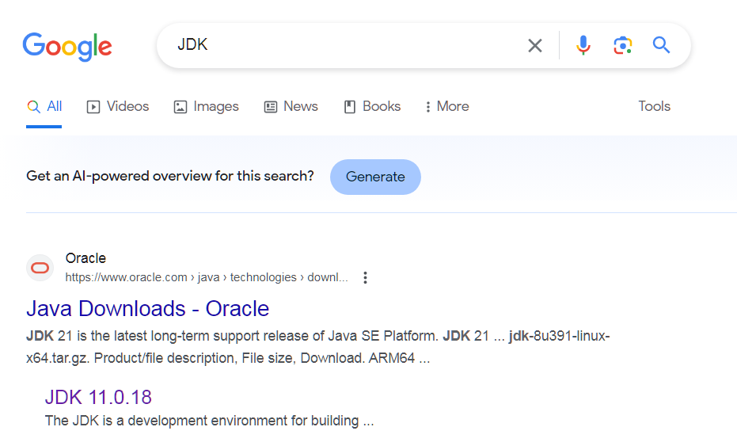

**Step 2:** Go to the Oracle website to download the authentic JDK.

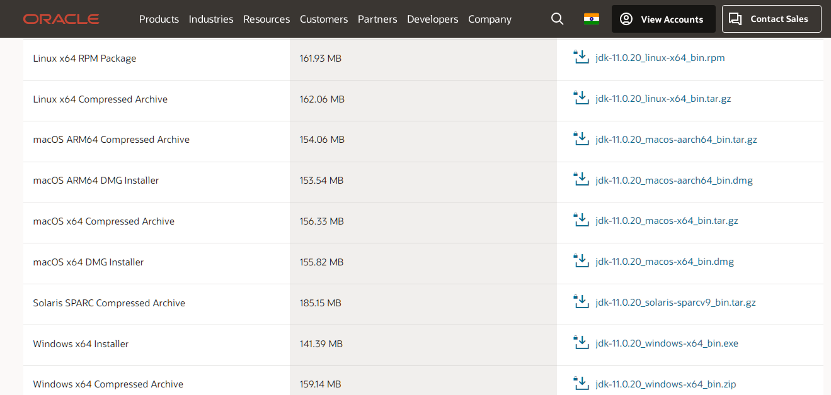

**Step 3:** Select a suitable executable file as per the operating system to start downloading.

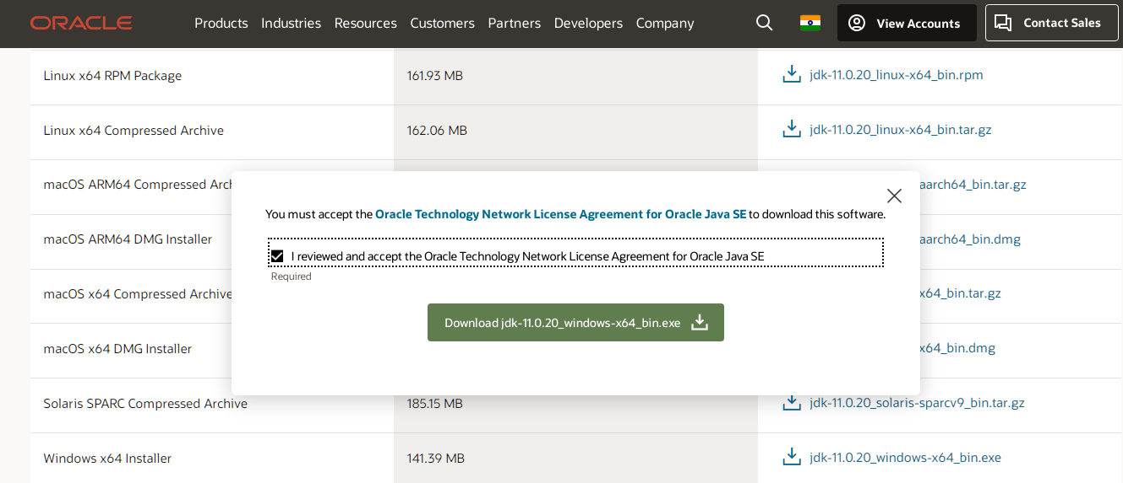

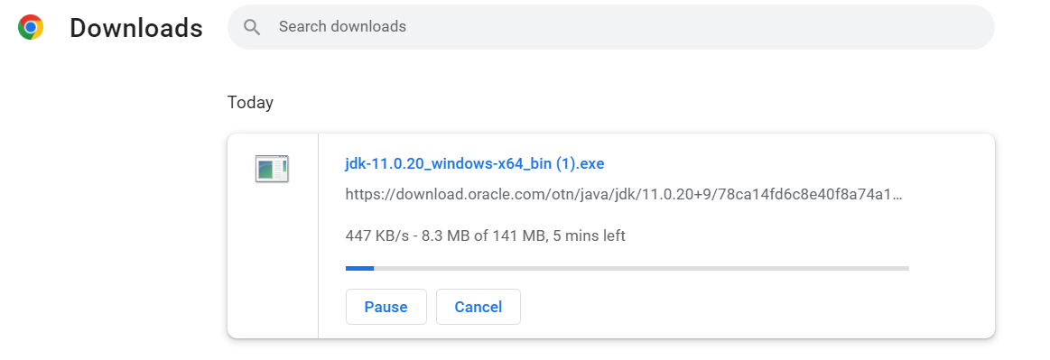

**Step 4:** Click the downloaded file to start installing the JDK.

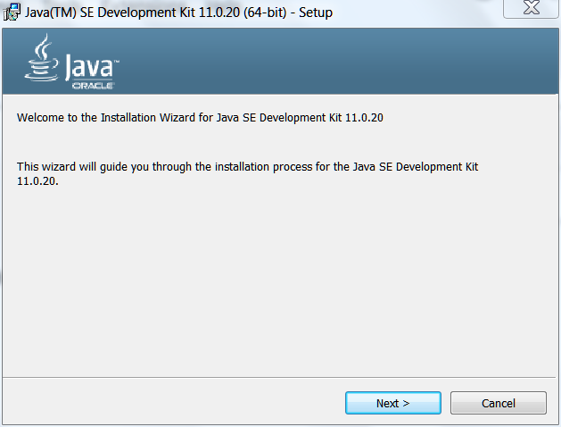

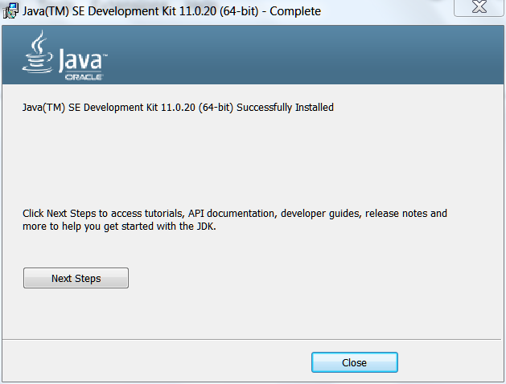

**Task 2: Illustrate how to set the Path Variables both temporarily and permanently.**

***To set the Path Variable permanently***

**Step 1:** Right-click on ‘My Computer’ or ‘This PC’ and select ‘Properties’.

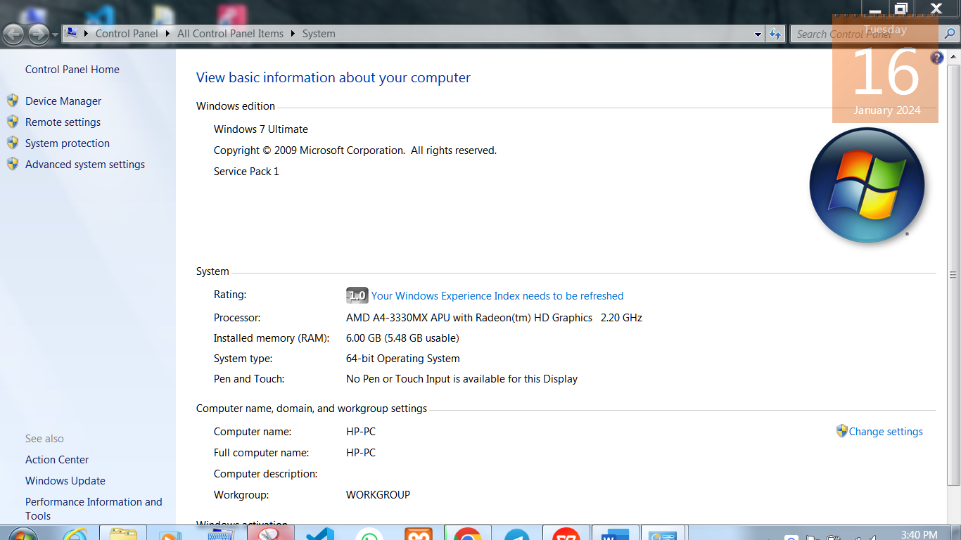

**Step 2:** Click on ‘Change Settings’ and select the ‘Advanced Tab’ from the pop-up menu.

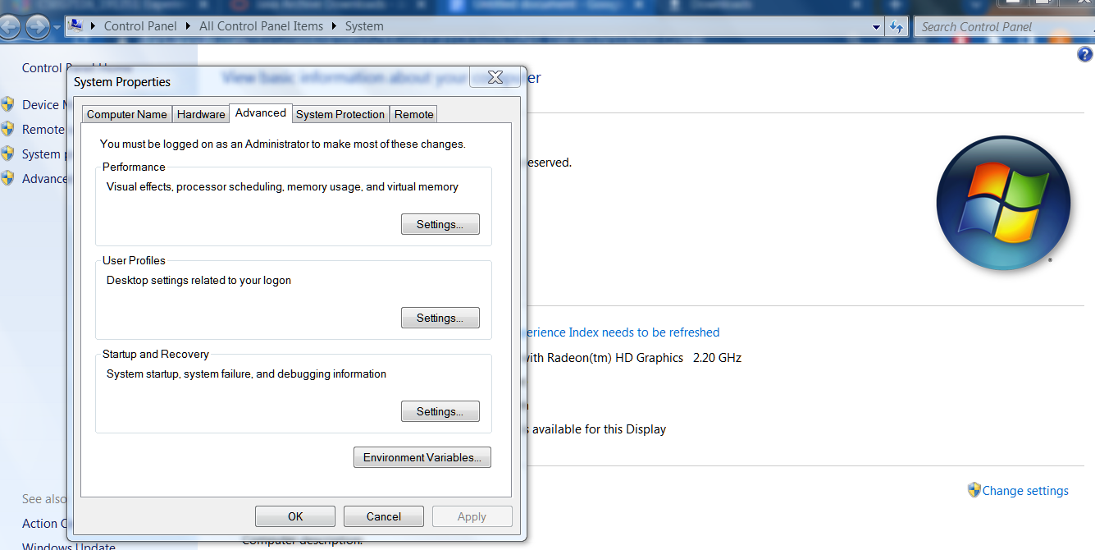

**Step 3:** Next, click the ‘Environment Variables’ button.

Click on the ‘New’ button.

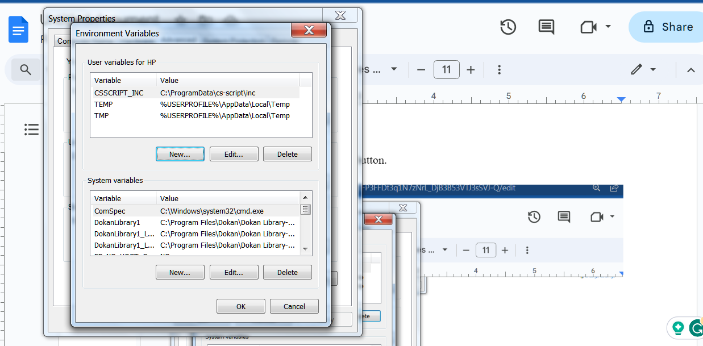

**Step 4:** Set the Variable Name to ‘path’ and Variable Value to the path copied from the D:\ repository.

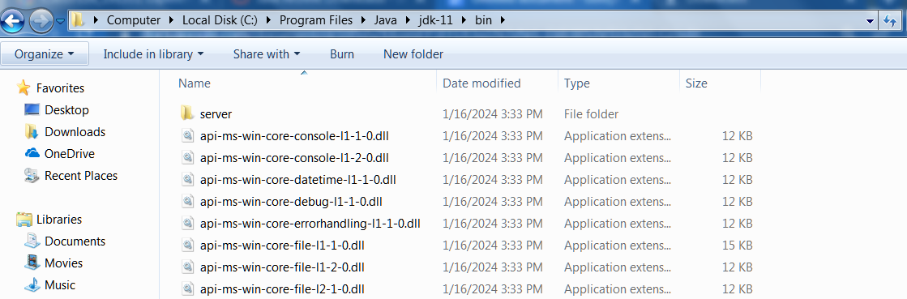

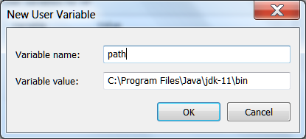

Click ‘OK’**.**

**Step 5:** Follow with all OK and OK to complete setting the path**.**

***To set the Path Variable temporarily.***

**Step 1:** Search for the Command Prompt in windows search and open it.

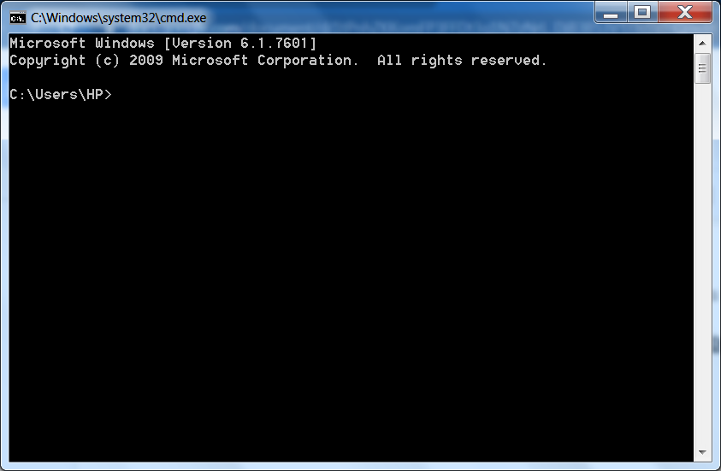

**Step 2:** Type the following command to set the path.

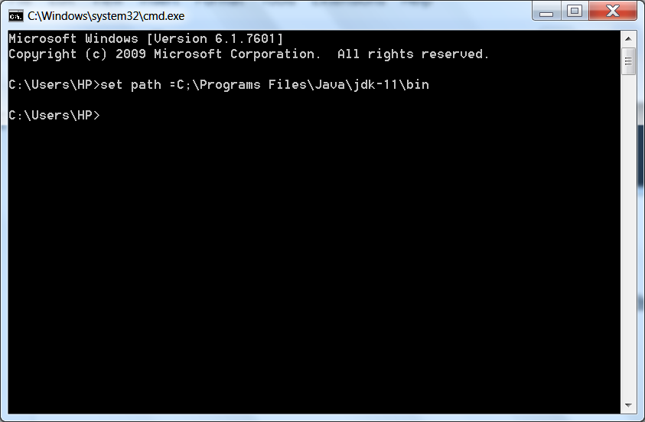

**Step 3:** If there is no error the path is successfully set.

If not, try again setting up the path.

**Task 3: Provide information on five widely used Java Integrated Development Environments (IDEs).**

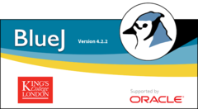

**BlueJ:** BlueJ, mentioned earlier, is worth noting again as it's designed specifically for teaching and learning Java programming. It provides a visual environment to help beginners understand object-oriented concepts.



**JDeveloper:** JDeveloper is Oracle's integrated development environment for Java and other languages. It's particularly well-suited for Oracle development.

**Eclipse:** Eclipse is a widely used open-source IDE for Java development. It supports a rich set of features, plugins, and has a large and active community.

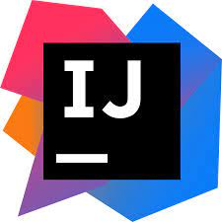

**IntelliJ IDEA:** Developed by JetBrains, IntelliJ IDEA is a powerful and feature-rich IDE for Java development. It offers a smart code editor, advanced navigation, and excellent support for various frameworks.

**Dr Java:** Dr Java is a lightweight, open-source IDE primarily designed for educational purposes. It's simple and easy to use, making it a good choice for beginners and educators.