**EXPERIMENT 02**

**Working with Java Loops**

**Task 1:** Write a program to print the Fibonacci series using Java loop. (up to 10 numbers).

**Algorithm:**

1. Start
2. Initialize variables first and second to 0 and 1, respectively.
3. Initialize some terms (range) for the Fibonacci series.
4. Loop from i = 0 to range:

a. Calculate temp = first + second.

b. Print temp.

c. Update first = second, second = temp.

1. End

**Source Code:**

public class FibonacciSeries {

public static void main(String[] args) {

int first = 0;

int second = 1;

int range = 10;

System.out.println("\nName: AKASH KUMAR YADAV\nSAP ID:

500124804\nRoll No.: R271223114\n");

System.out.println("Fibonacci Series up to " + range + "

numbers:");

for (int i = 0; i < range; i++) {

System.out.print(first+" ");

int temp = first + second;

first = second;

second = temp;

}

System.out.print("\n");

}

}

**Output:**

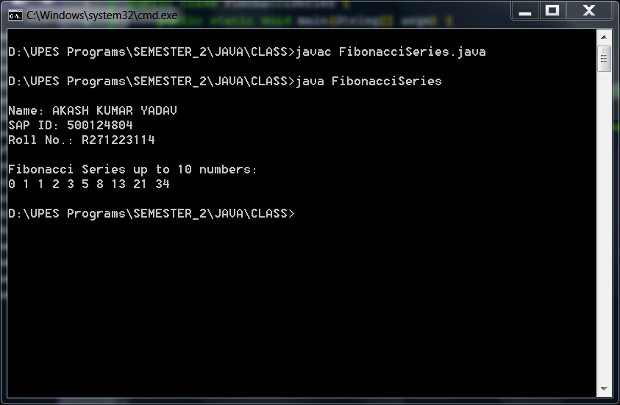

**Task 2:** Write a program to find the sum of all integers greater than 40 and less than 250 that are divisible by 5.

**Algorithm:**

1. Start
2. Initialize sum = 0.
3. Loop from i = 41 to 250:

a. If i % 5 == 0, add i to sum.

b. Else, skip the term.

1. End

**Source Code:**

class Sum{

public static void main(String[] args){

System.out.println("\nName: AKASH KUMAR YADAV\nSAP ID: 500124804\nRoll No.: R271223114\n");

System.out.println("Sum of all integers greater than 40 and less than 250 that are divisible by 5:\n");

int sum = 0;

for (int i=41; i<250; i++){

if (i%5==0){

sum = sum + i;

}

else{

continue;

}

}

System.out.println(sum);

}

}

**Output:**

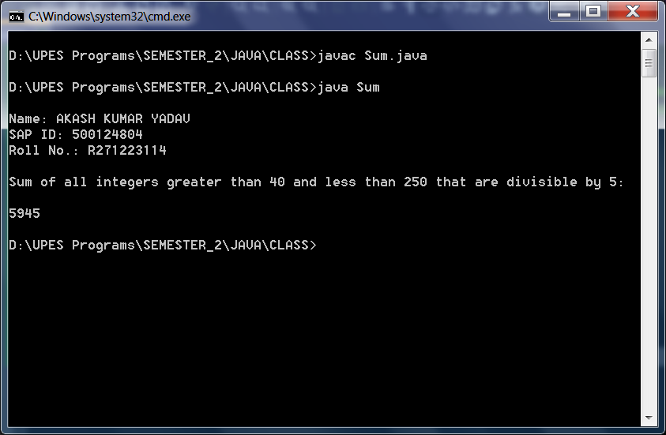

**Task 3:** Create a Java program that calculates and displays the simple interest for a given principal amount, rate of interest, and time.

**Algorithm:**

1. Start
2. Create a Scanner object to read from the console.
3. Prompt the user for the principal amount. Read the principal amount using the Scanner.
4. Prompt the user for the rate of interest. Read the rate of interest using the Scanner.
5. Prompt the user for the time in years. Read the time using the Scanner.
6. Calculate the simple interest using the formula: simpleInterest = (principal * rate * time) / 100.
7. Display the calculated simple interest.
8. Close the Scanner to release resources.
9. End

**Source Code:**

import java.util.Scanner;

public class SimpleInterest{

public static void main(String[] args) {

System.out.println("\nName: AKASH KUMAR YADAV\nSAP ID: 500124804\nRoll No.: R271223114\n");

System.out.println("Simple Interest for given principal amount, interest, and time.\n");

Scanner scanner = new Scanner(System.in);

System.out.print("Enter the principal amount: ");

double principal = scanner.nextDouble();

System.out.print("Enter the rate of interest (in percentage): ");

double rateOfInterest = scanner.nextDouble();

System.out.print("Enter the time (in years): ");

double time = scanner.nextDouble();

double simpleInterest = (principal * rateOfInterest * time) / 100;

System.out.println("Simple Interest: " + simpleInterest);

scanner.close();

}

}

**Output:**

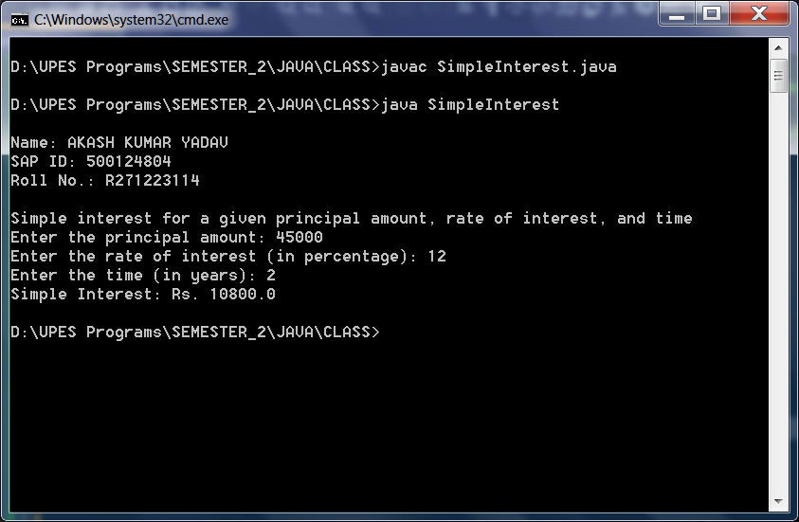

**Task 4:** Develop a Java program that prints the following pyramid pattern using asterisks.

**Algorithm:**

1. Start
2. Set the variable 'rows' to 10 (or any desired number).
3. Loop over rows from 2 to (rows - 1):
   1. Nested loop over columns from 'rows' to 1:
      1. If the current row index 'i' is greater than the column index 'j':
         1. Print "* ".
      2. Else:
         1. Print a space.
4. Move to the next line after each row.
5. End

**Source Code:**

public class Pyramid {

public static void main(String[] args) {

System.out.println("\nName: AKASH KUMAR YADAV\nSAP ID: 500124804\nRoll No.: R271223114\n");

System.out.println("Pattern\n");

int rows = 10;

for(int i=2;i<rows;i++){

for(int j=rows;j>0;j--){

if(i>j){

System.out.print("* ");

}

else{

System.out.print(" ");

}

}

System.out.println();

}

}

}

**Output:**

