**EXPERIMENT 03**

**Basic Java Programming**

**Task 1:** Write a program to take input (a number) of a month (1 - 12) and print its equivalent name of the month. (e.g. 1 to Jan, 2 to Feb. 12 to Dec.) Use Scanner class for user input( Hint-use switch case)

**Source Code:**

import java.util.Scanner;

class Month{

public static void main(String[] args){

System.out.println("\nName: AKASH KUMAR YADAV\nSAP ID: 500124804\nRoll No.: R271223114\n");

Scanner scanner = new Scanner(System.in);

System.out.print("Enter a number for the month (1 - 12): ");

int month_num = scanner.nextInt();

scanner.close();

System.out.print("The month is: ");

switch(month_num){

case 1: System.out.print("January");

break;

case 2: System.out.print("February");

break;

case 3: System.out.print("March");

break;

case 4: System.out.print("April");

break;

case 5: System.out.print("May");

break;

case 6: System.out.print("June");

break;

case 7: System.out.print("July");

break;

case 8: System.out.print("August");

break;

case 9: System.out.print("September");

break;

case 10: System.out.print("October");

break;

case 11: System.out.print("November");

break;

case 12: System.out.print("December");

break;

default: System.out.print("Invalid Number");

}

}

}

**Output:**

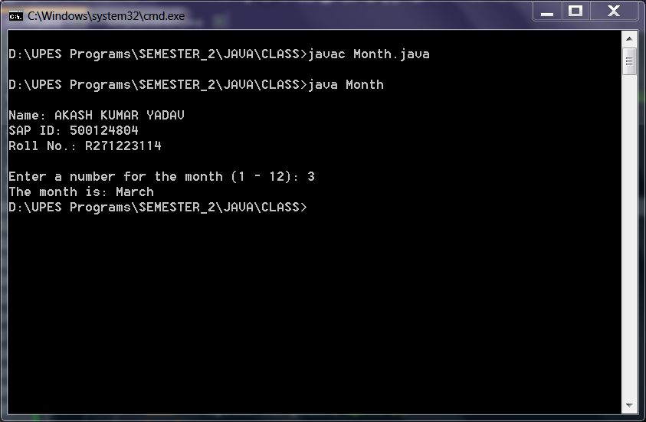

**Task 2:** Write a program to add two numbers using command line arguments.

**Source Code:**

class AddLine{

public static void main(String[] args){

System.out.println("\nName: AKASH KUMAR YADAV\nSAP ID: 500124804\nRoll No.: R271223114\n");

double a = Double.parseDouble(args[0]);

double b = Double.parseDouble(args[1]);

double sum = a+b;

System.out.println("Sum is: "+sum);

}

}

**Output:**

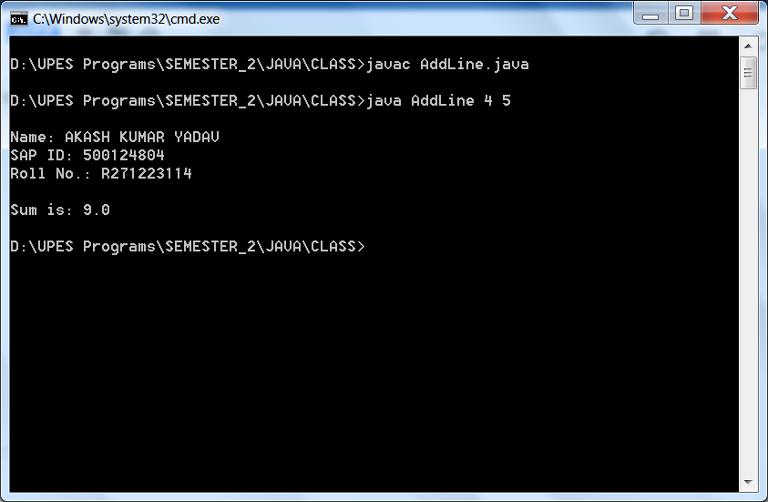

**Task 3:** Write a program to implement a command line calculator.

**Source Code:**

class LineCalc {

public static void main(String[] args) {

System.out.println("\nName: AKASH KUMAR YADAV\nSAP ID: 500124804\nRoll No.: R271223114\n");

char op = args[0].charAt(0);

double a = Double.parseDouble(args[1]);

double b = Double.parseDouble(args[2]);

double opr;

switch (op) {

case 'a':

opr = a + b;

System.out.println("Sum is: " + opr);

break;

case 's':

opr = a - b;

System.out.println("Difference is: " + opr);

break;

case 'd':

if (b != 0) {

opr = a / b;

System.out.println("Division result is: " + opr);

} else {

System.out.println("Error: Division by zero is not allowed.");

}

break;

case 'm':

opr = a * b;

System.out.println("Product is: " + opr);

break;

default:

System.out.println("Invalid Operator");

}

}

}

**Output:**

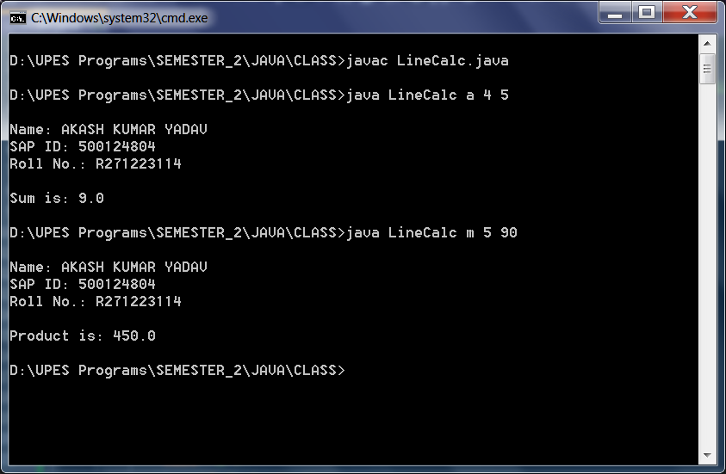

**Task 4:** Write a program that takes students’ info from the user (using Scanner class) and displays output on a black screen.

**Source Code:**

import java.util.Scanner;

public class StudentInfo {

public static void main(String[] args) {

Scanner scanner = new Scanner(System.in);

System.out.print("Enter student name: ");

String name = scanner.nextLine();

System.out.print("Enter student ID: ");

int sap = scanner.nextInt();

System.out.print("Enter student age: ");

int age = scanner.nextInt();

scanner.nextLine();

System.out.println("\nStudent Information:");

System.out.println("Name: " + name);

System.out.println("Student ID: " + sap);

System.out.println("Age: " + age);

scanner.close();

}

}

**Output:**

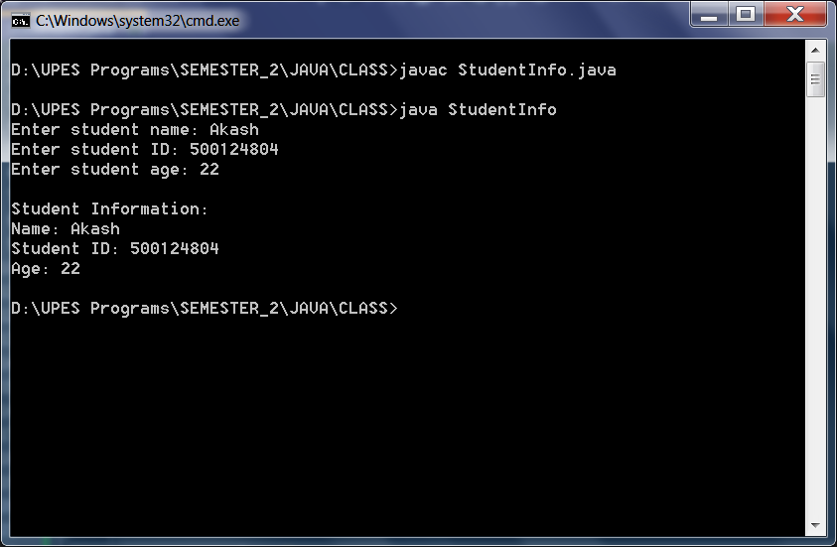

**Task 5:** Write a Java program that takes input about customers from the user, and then displays the collected data on a console interface.

**Source Code:**

import java.util.Scanner;

public class CustomerInfo {

public static void main(String[] args) {

Scanner scanner = new Scanner(System.in);

System.out.print("Enter customer name: ");

String name = scanner.nextLine();

System.out.print("Enter customer ID: ");

int cid = scanner.nextInt();

System.out.print("Enter customer age: ");

int age = scanner.nextInt();

scanner.nextLine();

System.out.print("Enter customer gender: ");

String gender = scanner.nextLine();

System.out.println("\nCustomer Information:");

System.out.println("Name: " + name);

System.out.println("Customer ID: " + cid);

System.out.println("Age: " + age);

System.out.println("Gender: " + gender);

scanner.close();

}

}

**Output:**

