LOW LEVEL DESIGN DOCUMENT
Multimodal Education Creator
(Text + Image Generation using Free APIs)
A Python-based CLI Application for Educational Content Generation
Technology Stack:
Python • Gemini API • Hugging Face • Stable Diffusion

Table of Contents
- System Architecture Diagram
- Class Diagram (UML)
- Use Case Diagram (UML)
- Sequence Diagram (UML)
- Activity Diagram (UML)
- Component Diagram
- Design Justification
- Error Handling & Reliability
- Security Design
- Conclusion

1. System Architecture Diagram (LLD Level)
The system follows a layered architecture pattern with clear separation of concerns. The architecture is divided into five main modules that interact through well-defined interfaces.
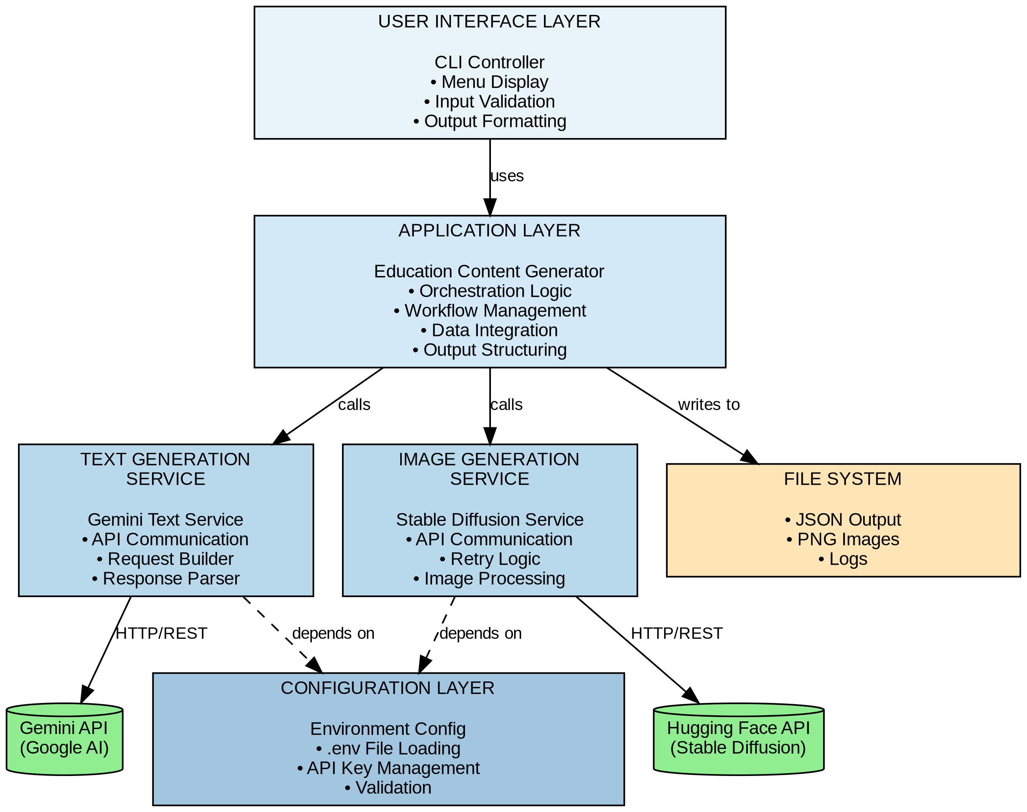
Figure 1: System Architecture Diagram

1.1 Module Description

CLI Interface Module
- Handles user interaction through command-line interface
- Displays menu options and captures user input
- Validates user commands and routes requests
- Responsible for: CLIController class

Text Generation Module
- Processes educational content generation requests
- Communicates with Gemini API service layer
- Formats and validates text responses
- Part of: EducationContentGenerator class

Image Generation Module
- Manages image creation through Stable Diffusion
- Implements retry logic for failed requests
- Handles image data processing and validation
- Part of: EducationContentGenerator class

API Layer
- Encapsulates external API communication
- Manages authentication and request formatting
- Handles API-specific error responses
- Classes: GeminiTextService, StableDiffusionService

Output Handler
- Saves generated content to file system
- Creates JSON structured output
- Manages file naming and directory structure
- Integrated in: EducationContentGenerator class

1.2 Data Flow Description
- User Input: User selects an option from CLI menu (generate text, image, or both)
- Command Processing: CLIController validates input and invokes appropriate methods in EducationContentGenerator
- Service Layer Call: Application layer calls GeminiTextService or StableDiffusionService based on request type
- API Communication: Service classes make HTTP requests to external APIs with proper authentication
- Response Processing: API responses are validated, parsed, and transformed into application objects
- Output Generation: Content is formatted into JSON structure and saved to file system
- User Feedback: Success/failure messages and file paths are displayed to user through CLI

2. Class Diagram (UML)
The class diagram illustrates the object-oriented structure of the application, showing all classes with their attributes, methods, and relationships.
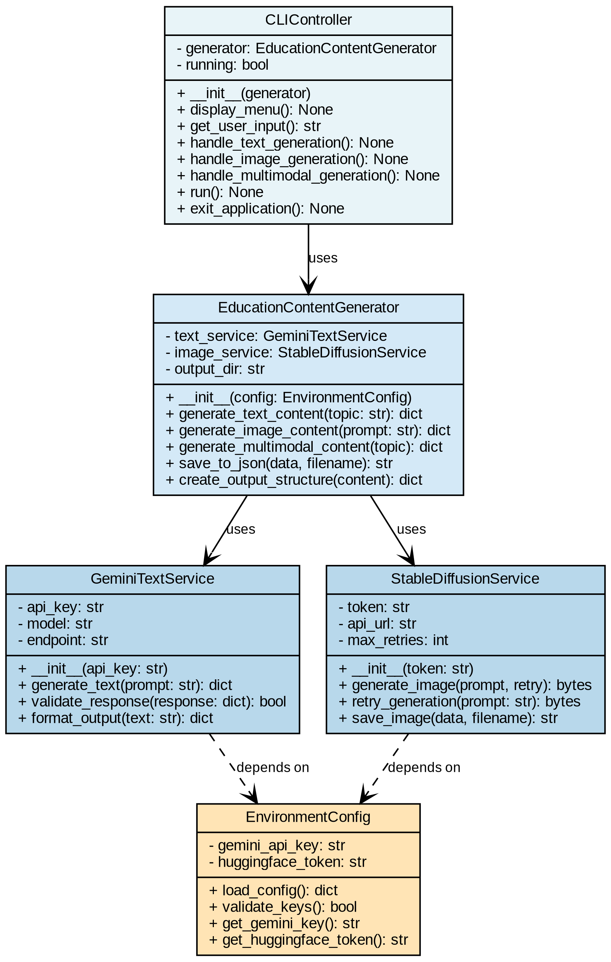
Figure 2: Class Diagram

2.1 Class Descriptions

EnvironmentConfig
Purpose: Manages configuration and environment variables securely
Responsibilities:
- Load API keys from .env file
- Validate presence of required credentials
- Provide secure access to sensitive data

GeminiTextService
Purpose: Handles text generation using Google Gemini API
Responsibilities:
- Construct and send API requests to Gemini
- Parse and validate API responses
- Format text content for application use

StableDiffusionService
Purpose: Manages image generation through Hugging Face API
Responsibilities:
- Send image generation requests to Stable Diffusion model
- Implement retry mechanism for failed requests
- Process and save image binary data

EducationContentGenerator
Purpose: Core business logic coordinator for content generation
Responsibilities:
- Orchestrate text and image generation workflows
- Combine multimodal outputs into structured format
- Manage output directory and file operations
- Create JSON-formatted results

CLIController
Purpose: User interface controller for command-line interaction
Responsibilities:
- Display interactive menu to user
- Capture and validate user input
- Route commands to appropriate generator methods
- Display results and error messages to user

3. Use Case Diagram (UML)
The use case diagram shows the functional requirements from the user's perspective, illustrating what actions the user can perform with the system.
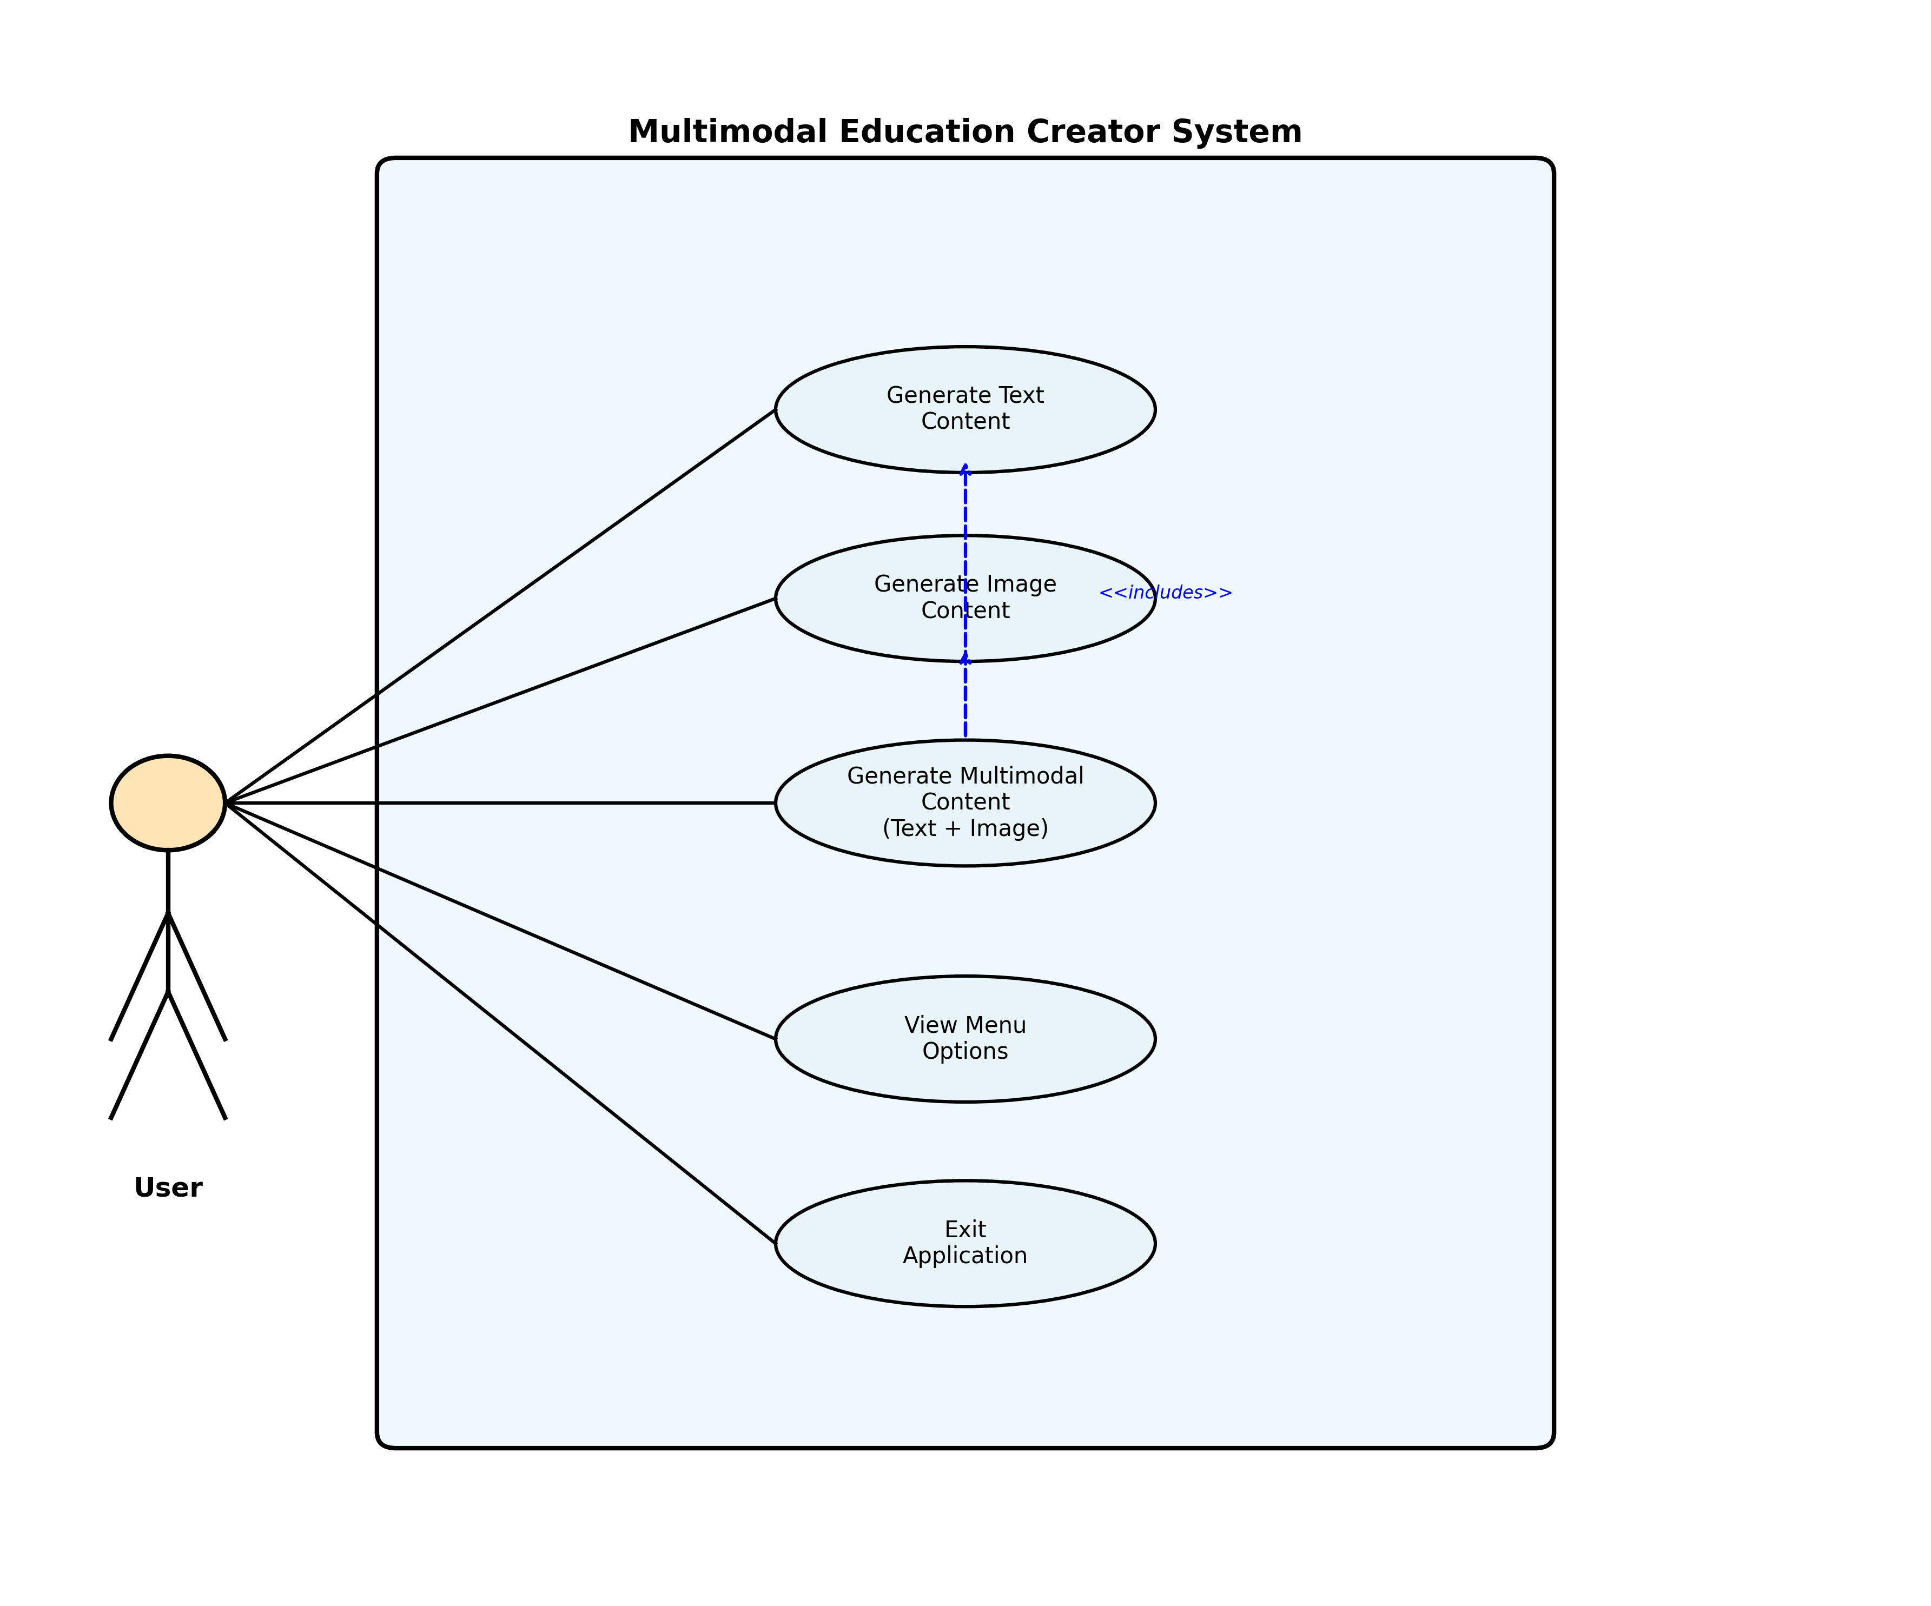
Figure 3: Use Case Diagram

3.1 Use Case Descriptions

UC1: Generate Text Content
- Actor: User
- Precondition: Valid Gemini API key configured
- Main Flow: User enters topic → System generates educational text → Content saved as JSON
- Postcondition: Text content stored in file system

UC2: Generate Image Content
- Actor: User
- Precondition: Valid Hugging Face token configured
- Main Flow: User enters prompt → System generates image via Stable Diffusion → Image saved as PNG
- Alternate Flow: Generation fails → System retries up to max attempts
- Postcondition: Image file and metadata stored

UC3: Generate Multimodal Content
- Actor: User
- Precondition: Both API keys configured
- Main Flow: User enters topic → System generates text → System creates image based on text → Combined content saved
- Includes: UC1 (Generate Text), UC2 (Generate Image)
- Postcondition: JSON file with text content and image reference created

UC4: View Menu Options
- Actor: User
- Precondition: Application running
- Main Flow: System displays available options → User selects option
- Postcondition: Selected operation executed

UC5: Exit Application
- Actor: User
- Precondition: Application running
- Main Flow: User selects exit option → System terminates gracefully
- Postcondition: Application closed

4. Sequence Diagram (UML)
The sequence diagram shows the detailed interaction flow for multimodal content generation (text + image), illustrating the temporal sequence of messages between objects.
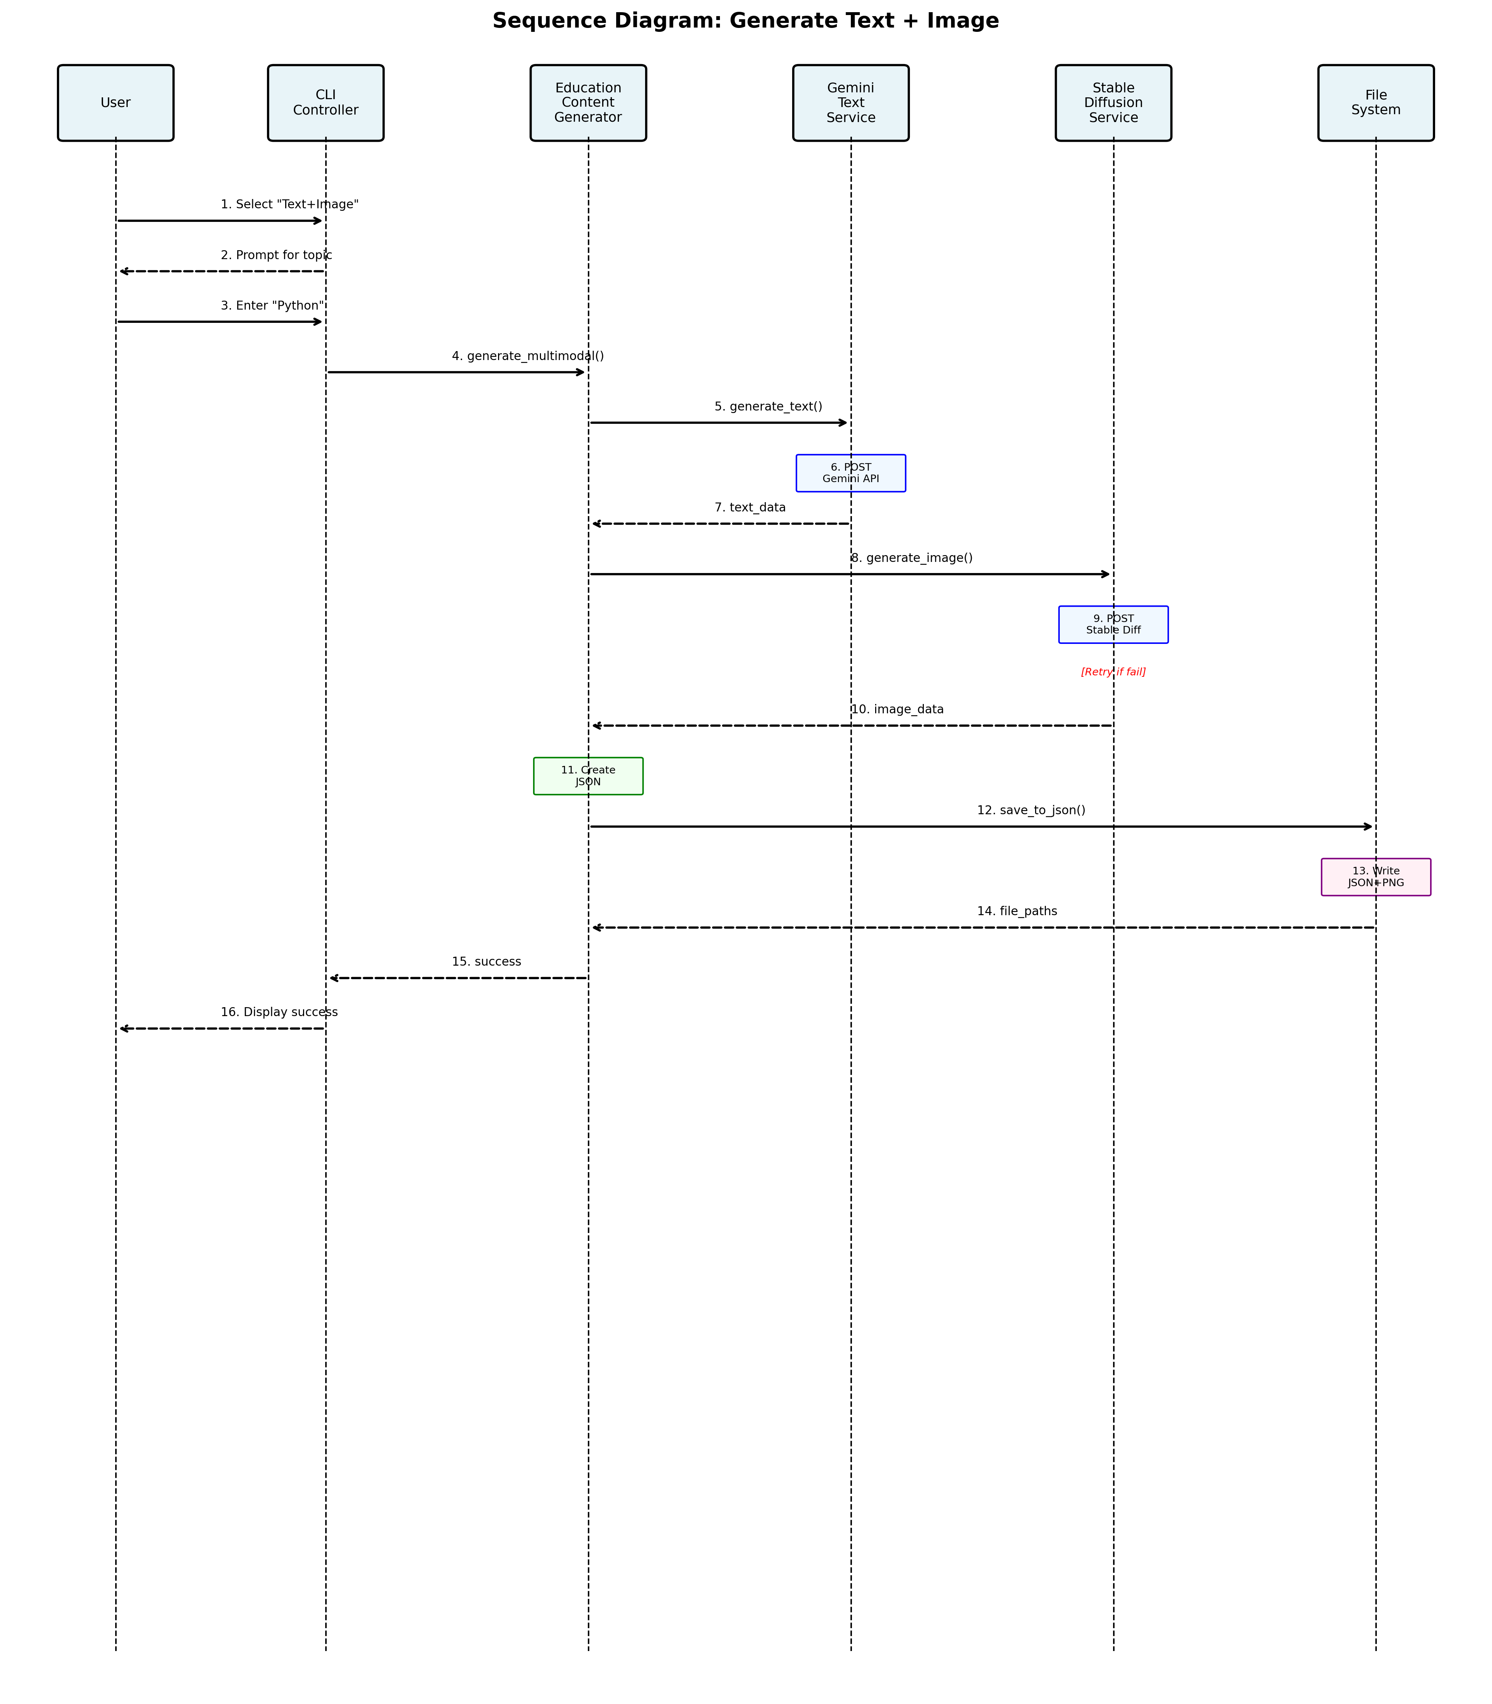
Figure 4: Sequence Diagram - Generate Text + Image

4.1 Sequence Flow Description
- User selects multimodal generation option from CLI menu
- CLI Controller prompts user to enter educational topic
- User provides topic input (example: Python Basics)
- CLI Controller calls generate_multimodal_content() on EducationContentGenerator
- EducationContentGenerator invokes GeminiTextService.generate_text()
- GeminiTextService sends HTTP POST request to Gemini API endpoint
- Gemini API returns JSON response containing generated educational text
- GeminiTextService validates and returns text data to generator
- EducationContentGenerator calls StableDiffusionService.generate_image()
- StableDiffusionService sends POST request to Hugging Face Stable Diffusion API
- If generation fails, retry mechanism attempts up to 3 times
- Hugging Face API returns binary image data on success
- EducationContentGenerator creates structured output combining text and image metadata
- Generator calls save_to_json() to persist data
- JSON and PNG files written to file system
- File paths returned to EducationContentGenerator
- CLI Controller displays success message with file locations to user

5. Activity Diagram (UML)
The activity diagram illustrates the workflow of the application, showing the step-by-step process flow including decision points, parallel activities, and error handling.
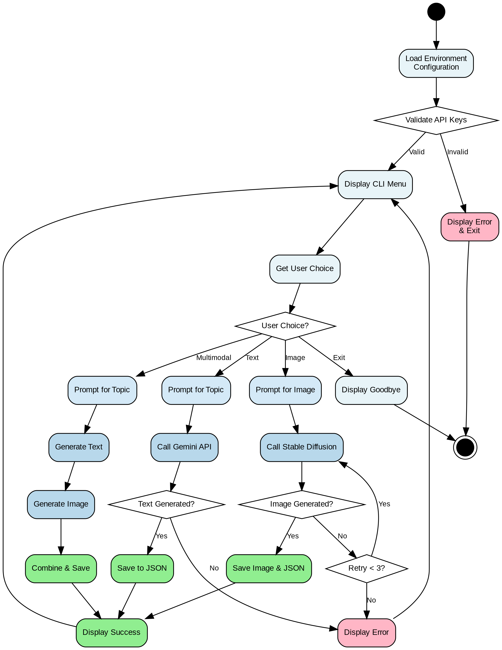
Figure 5: Activity Diagram

5.1 Activity Flow Description

Initialization Phase
- Application starts and loads environment configuration
- System validates API keys from .env file
- If validation fails, error displayed and application exits
- If validation succeeds, proceed to main menu

Main Menu Loop
- Display menu with four options: Text, Image, Multimodal, Exit
- Capture user choice input
- Route to appropriate generation workflow based on choice

Generation Workflows
- Text Path: Prompt → Call Gemini API → Validate → Save JSON
- Image Path: Prompt → Call Stable Diffusion → Retry if needed → Save PNG
- Multimodal Path: Generate Text → Generate Image → Combine → Save
- Exit Path: Display goodbye → Terminate

Error Handling
- Failed generations trigger error display
- Image generation implements retry mechanism (max 3 attempts)
- All paths return to main menu after completion

6. Component Diagram
The component diagram shows the high-level logical components of the system and their dependencies. This provides a more abstract view than the class diagram, focusing on major subsystems.
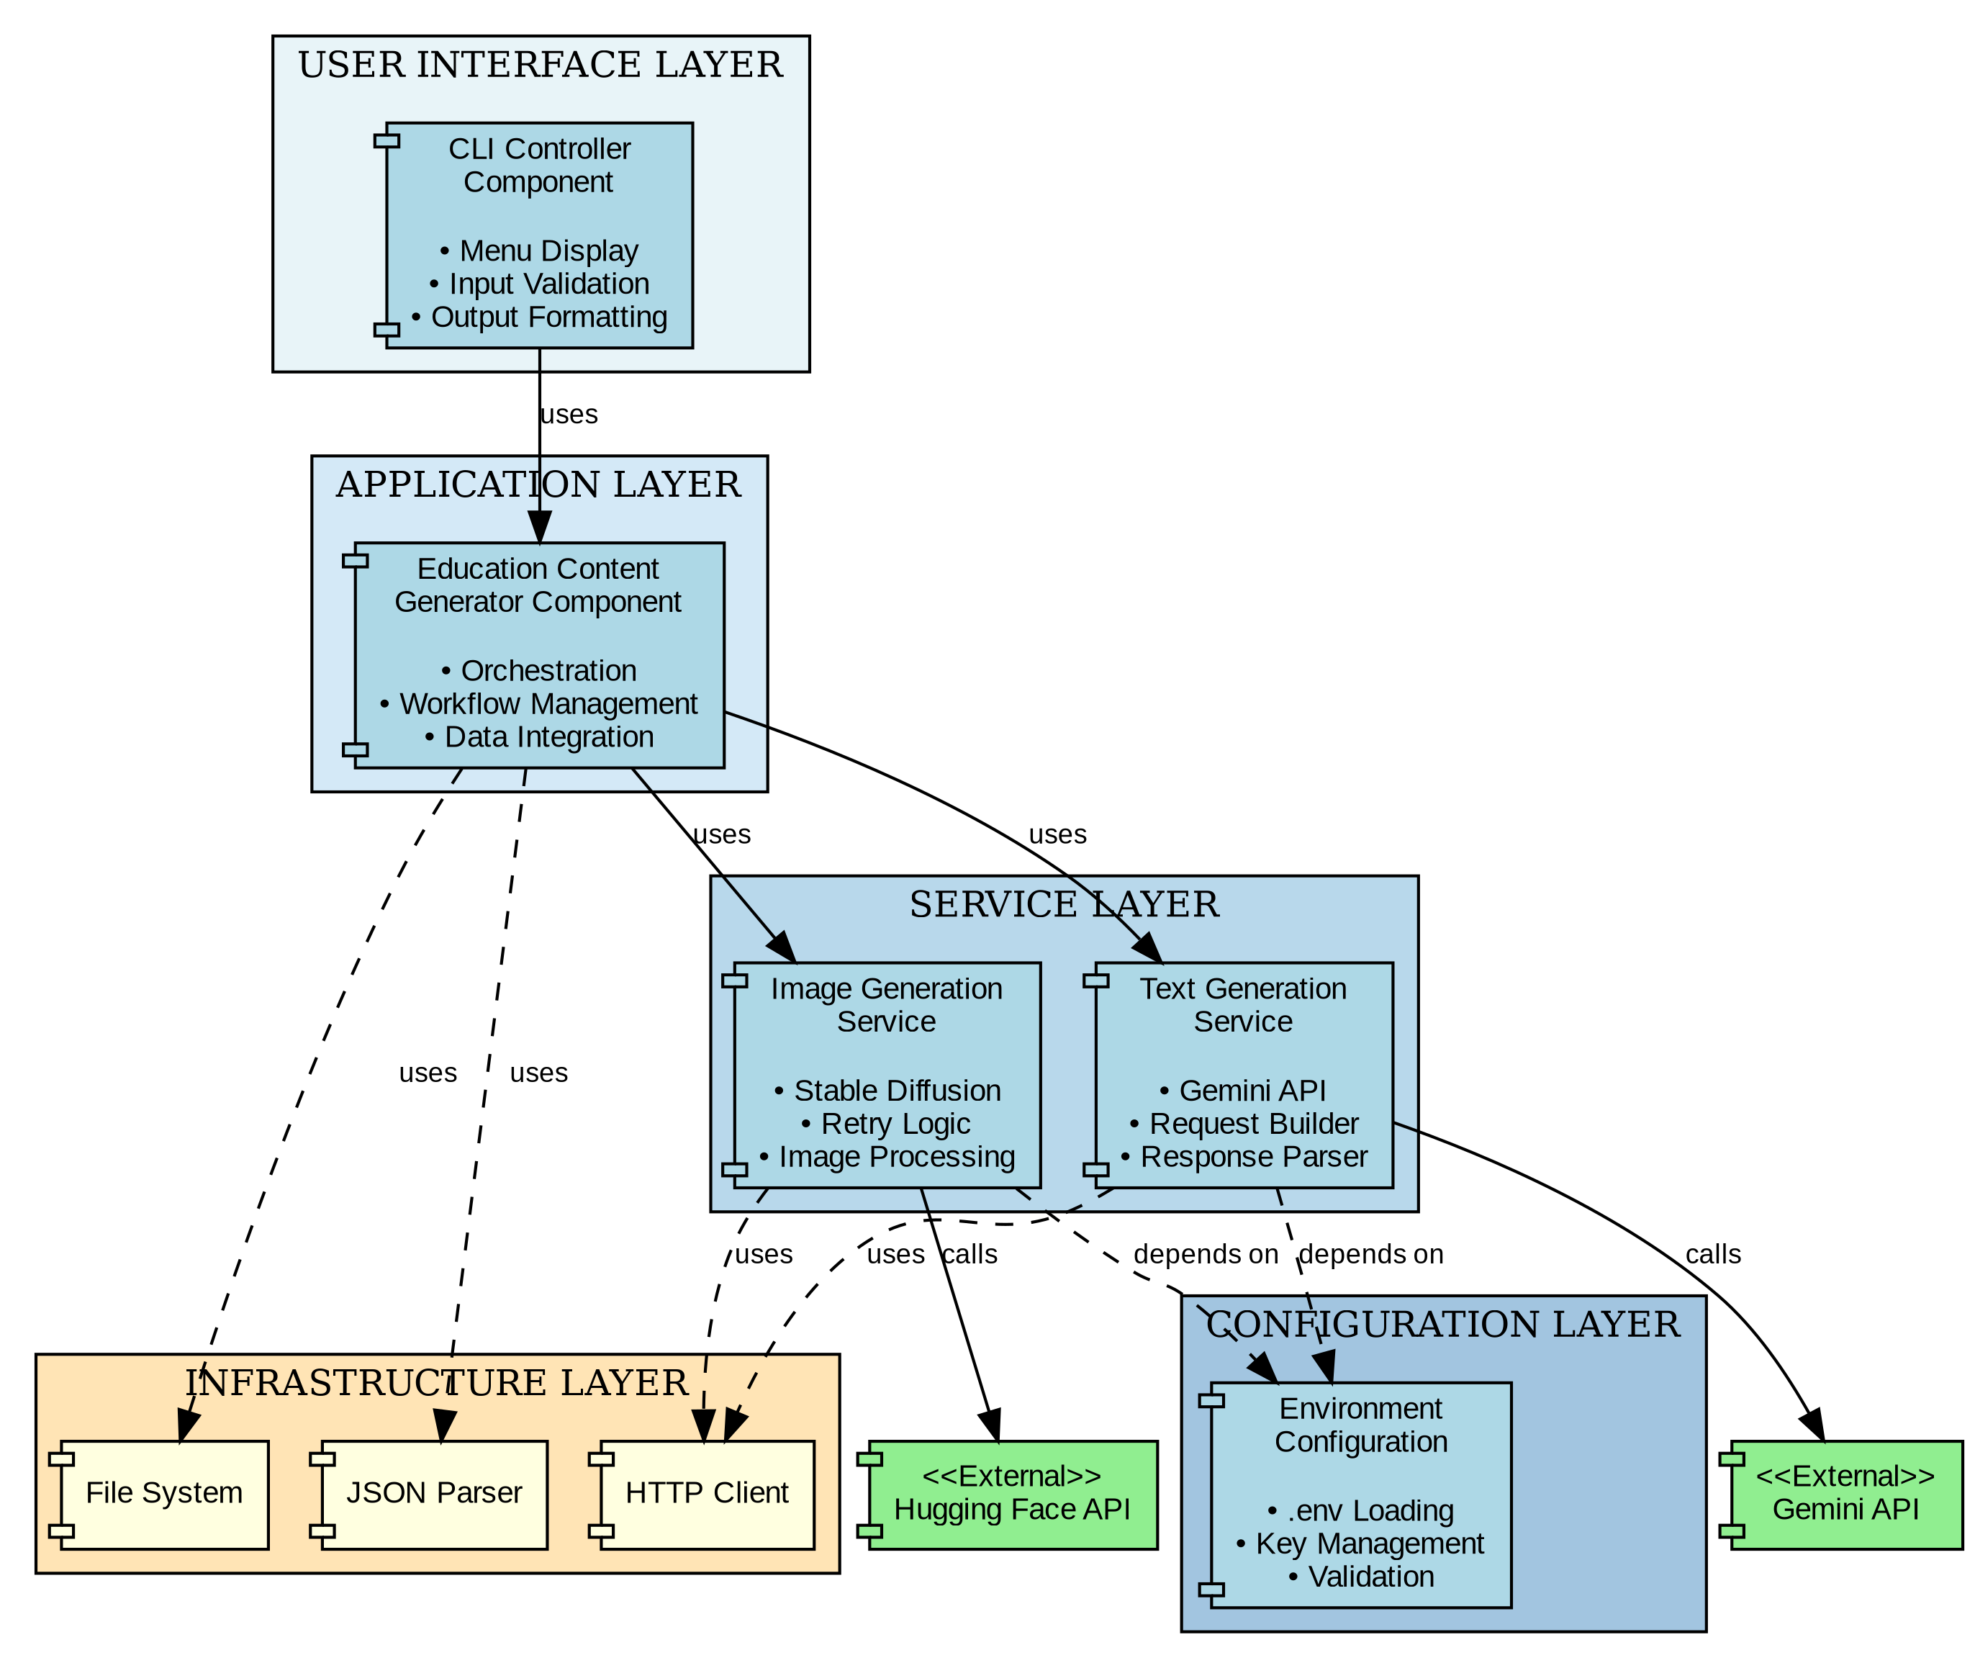
Figure 6: Component Diagram

6.1 Component Descriptions

CLI Controller Component
Responsibilities:
- Presents user interface through command line
- Handles all user input and output operations
- Validates user choices before processing

Service Layer Components
- Text Generation Service: Encapsulates Gemini API communication
- Image Generation Service: Manages Stable Diffusion API with retry logic

Infrastructure Components
- File System: Handles all file I/O operations
- HTTP Client: Manages network requests to external APIs
- JSON Parser: Serializes and deserializes JSON data

10. Conclusion

10.1 Summary of LLD
The Multimodal Education Creator is a well-architected Python CLI application that demonstrates best practices in software design. The low-level design encompasses:
- Layered Architecture: Clear separation between UI, business logic, services, and infrastructure
- Modular Components: Five distinct modules with single responsibilities and loose coupling
- Service-Oriented Design: API interactions encapsulated in dedicated service classes
- Robust Error Handling: Comprehensive coverage of failure scenarios with graceful degradation
- Security First: Environment-based credential management and controlled API access

10.2 Key Benefits
- Scalability: Architecture supports horizontal scaling and feature additions
- Maintainability: Clear module boundaries and consistent design patterns
- Testability: Independent testing of services with mock objects
- Extensibility: New AI models and modalities easily integrated
The design principles demonstrated here provide a solid foundation for building scalable, reliable, and secure AI-powered applications suitable for educational and production environments.
--- END OF DOCUMENT ---

