Summary:

Overview
The MultiADC_Div VHDL project is designed to collect real-time data from two independent external ADCs interfaced with the Arty A7-35T FPGA board. Each ADC acquires data from a different analog source. The digitized signals are processed by the FPGA and then streamed to a host PC for real-time data visualization. The project implements VHDL-based control and communication logic, and uses UART for data transmission.
Objective
- Interface two independent ADC modules with the FPGA using SPI protocol.
- Implement a FIFO buffer to store acquired samples.
- Control data flow using UART and AXI4 stream interfaces.
- Stream real-time data from the FPGA to a PC monitor for acquisition analysis.
FPGA Target
- Board: Digilent Arty A7-35T
- Family: Xilinx Artix-7
- Tool Used: Xilinx Vivado (simulation and synthesis)

Block diagram of data flow:

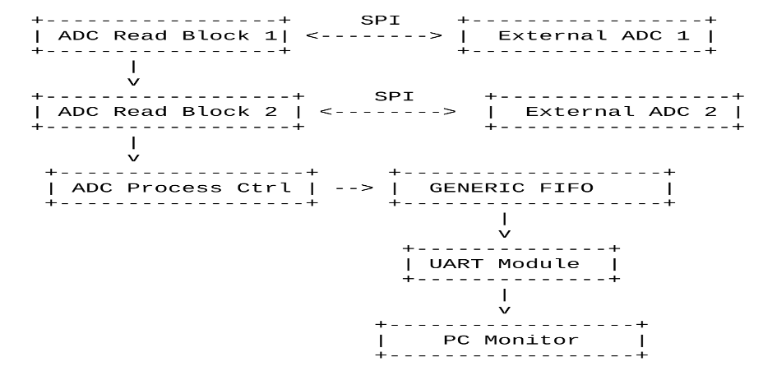
=> ADC Read Modules fetch data via SPI from ADC1 and ADC2. Data from each ADC is pushed into a generic FIFO. A UART interface reads FIFO data and sends it to a PC. The Top Module synchronizes all submodules.

Architecture:

- TOP Module: this module coordinates the full design. It: Instantiates the UartCommand module for PC communication, Interfaces with ADC drivers, Controls read/write operations for continuous streaming.
- ADC Control (Control_process): This process alternate between ADC1 and ADC2, reading from one ADC at a time:
- When data_ready is high, it checks which ADC is active using stateActive.
- Captures DataTime, DeviceID, DataType, and TransmitData.
Asserts readActive to trigger transmission.
- Deglitching Inputs (deglitch):
- Synchronizes asynchronous inputs like reset and UART RX to the system clock to prevent metastability.
- Timestamp Generator (timestampProcess):
- Generates a time counter (TimeCounter) using a prescaler (ReduceSpeed) to scale down the 100 MHz clock to 1 Hz. The counter is used to timestamp ADC data.
- Receiving Process (ReceiveProcess): Handles USB UART RX data:
- Decodes commands (x"31", x"32", x"33").
Routes data to transmit FIFOs for each path.
Dual channel support with toggling signals (sendLogic, sendLogic1).
- Transmit Process (transmitProcess): Sequentially transmits the data frame through UART:
- Waits for readActive to start.
Sends fields like DataType, DataTime, DeviceID, TransmitData byte-by-byte.
Ends with a newline character.
- UartCommand Module: This module instantiates the uart and GENERIC_FIFO modules and create a loopback process:
Reset : Clears all control and data signals on reset.
UART Receive → FIFO Store: If uart_data_out_stb = '1' and FIFO is not full, the received UART byte is stored in FIFO.
UART Transmit Acknowledge: Clears the uart_data_in_stb flag when transmission is acknowledged (uart_data_in_ack = '1').
FIFO Read → UART Send: If FIFO is not empty and UART is ready, a byte is read from FIFO and passed to UART for transmission.
- FIFO Module:
1. Reset: On reset, write_pointer and read_pointer are set to 0, fifo_memory is cleared, fifo_empty is '1', and fifo_full is '0'.
2. Write Operation: When write_en = '1' and the FIFO is not full, data is written to the memory at write_pointer, and write_pointer advances. If write_pointer reaches FIFO_DEPTH - 1, it wraps around to 0.
3. Read Operation: When read_en = '1' and the FIFO is not empty, read_pointer advances, and the data at read_pointer is output via read_data. If read_pointer reaches FIFO_DEPTH - 1, it wraps around to 0.
4. Status Updates: The FIFO_FLAGS process continuously monitors write_pointer and read_pointer to update full, empty, and level. The FIFO is considered full when level = FIFO_DEPTH - 1 to avoid ambiguity with the empty state (both pointers equal).
- ADC module: The adc_read module implements a serial communication protocol to read 16-bit data from an ADC:
• Idle State: When startConv = '0', the module waits with cs = '1', data_ready = '0', and count = 16.
• Start Conversion: When startConv = '1', cs_int is set to '0', activating the ADC. The module counts down from 16 to 0 over 16 clock cycles, shifting in one bit of sdata per falling edge into shift_reg.
• Data Completion: When count reaches -1, the 16-bit data is complete in shift_reg. cs_int is set to '1', data_ready is set to '1', and out_data is assigned shift_reg. count is set to 17 to allow a brief pause before the next conversion.
• Reset: A reset clears all signals and returns the module to the idle state.

PMOD\PIN Configuration:

- Pmod Header JA
Signal Name Pin Description
sclk2 D13 Serial Clock 2
sdata2 B18 Serial Data 2
cs2 A18 Chip Select 2
- Pmod Header JB
Signal Name Pin Description
tx_1 E15 UART Transmit 1
rx_1 E16 UART Receive 1
rx_2 J17 UART Receive 2
tx_2 J18 UART Transmit 2
- Pmod Header JC
Signal Name Pin Description
sclk1 U14 Serial Clock 1
sdata1 V14 Serial Data 1
cs1 T13 Chip Select 1
- USB-UART Interface (Onboard)
Signal Name Pin Description
usb_rs232_txd D10 Transmit from FPGA to PC
usb_rs232_rxd A9 Receive from PC to FPGA

Reference:

Digilent Arty A7-35T Reference Manual
Xilinx Vivado Design Suite Documentation
UART and SPI Communication Protocols
VHDL 2008 Language Reference

