Name: Akash Lalwani

Roll no : A035

Sap Id : 86062300024

CLOUD COMPUTING PRAC 1

Go to AWS Management Console and sign in to your account

Navigate to the EC2 dashboard and go to instances.

Click on "Launch Instance"

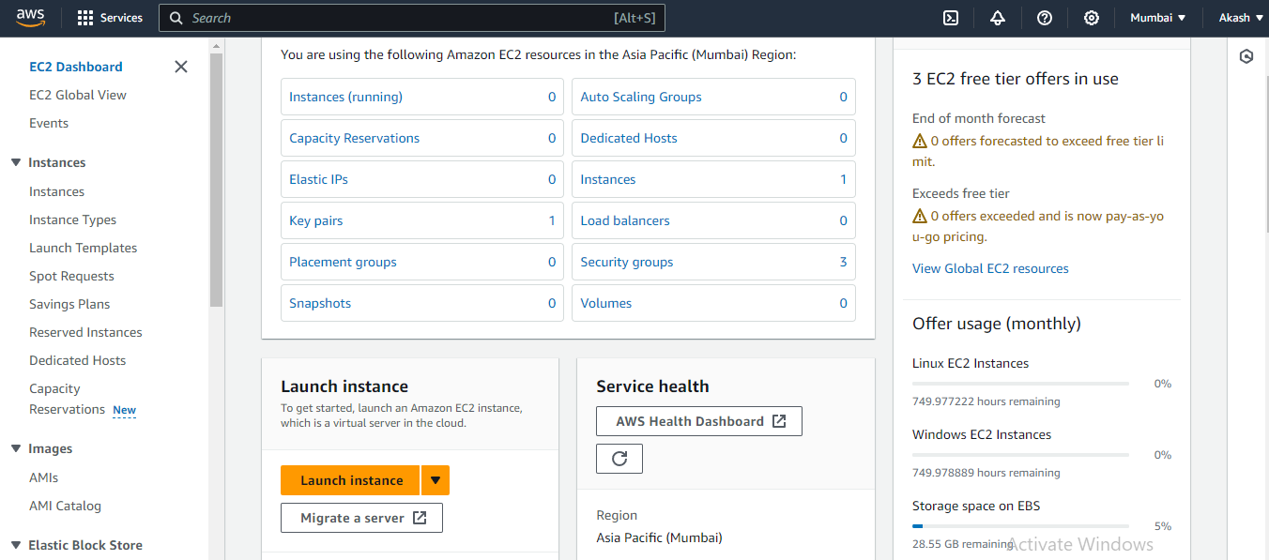

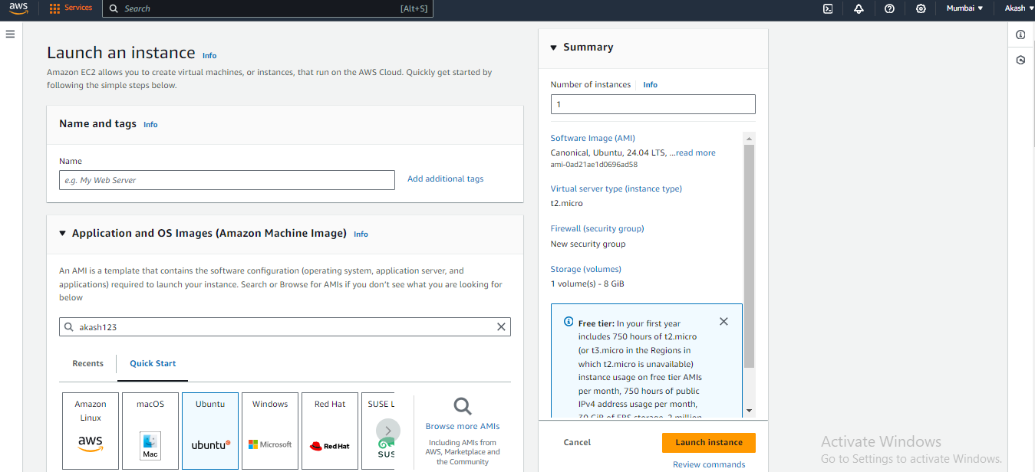

**Choose AMI-** Select "Amazon Machine Image (AMI)" -ubuntu

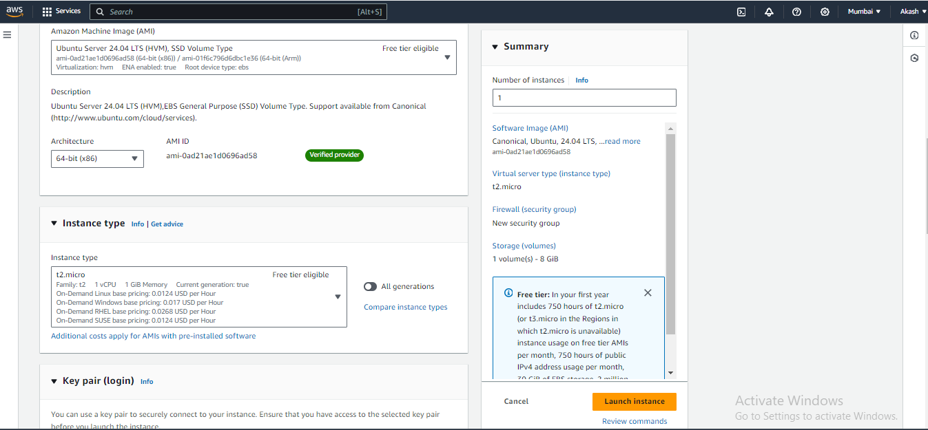

Select allow SSH traffic in network settings.

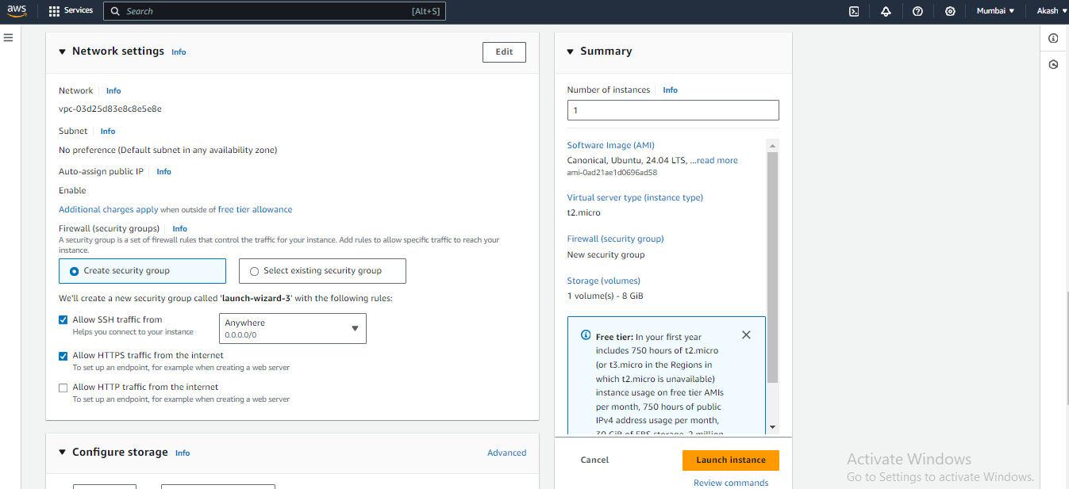

Click on "Launch" if everything looks good

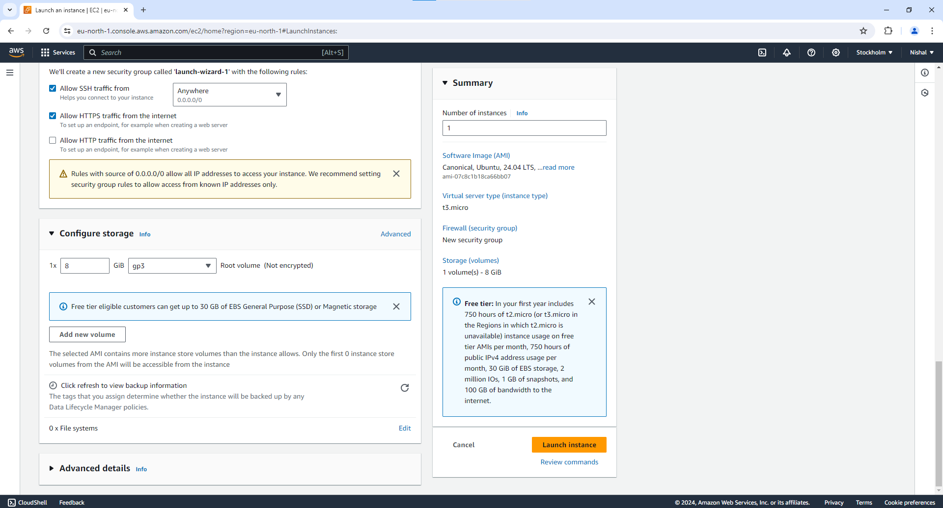

Once the instance is running, go to the EC2 dashboard and select "Instances" from the left-hand menu.

Select the instance you just launched.

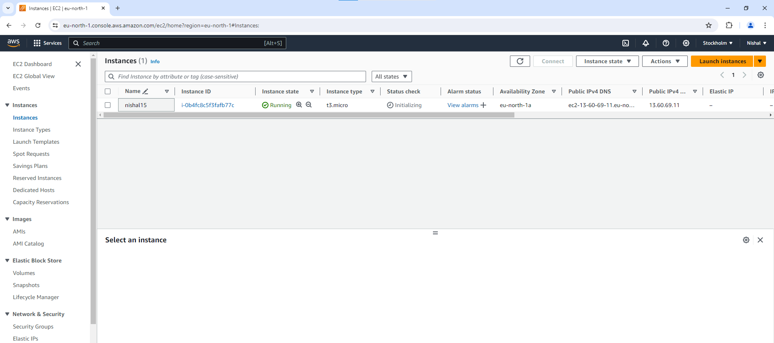

Click on the "Connect" button at the top of the screen.Use ec2 connect

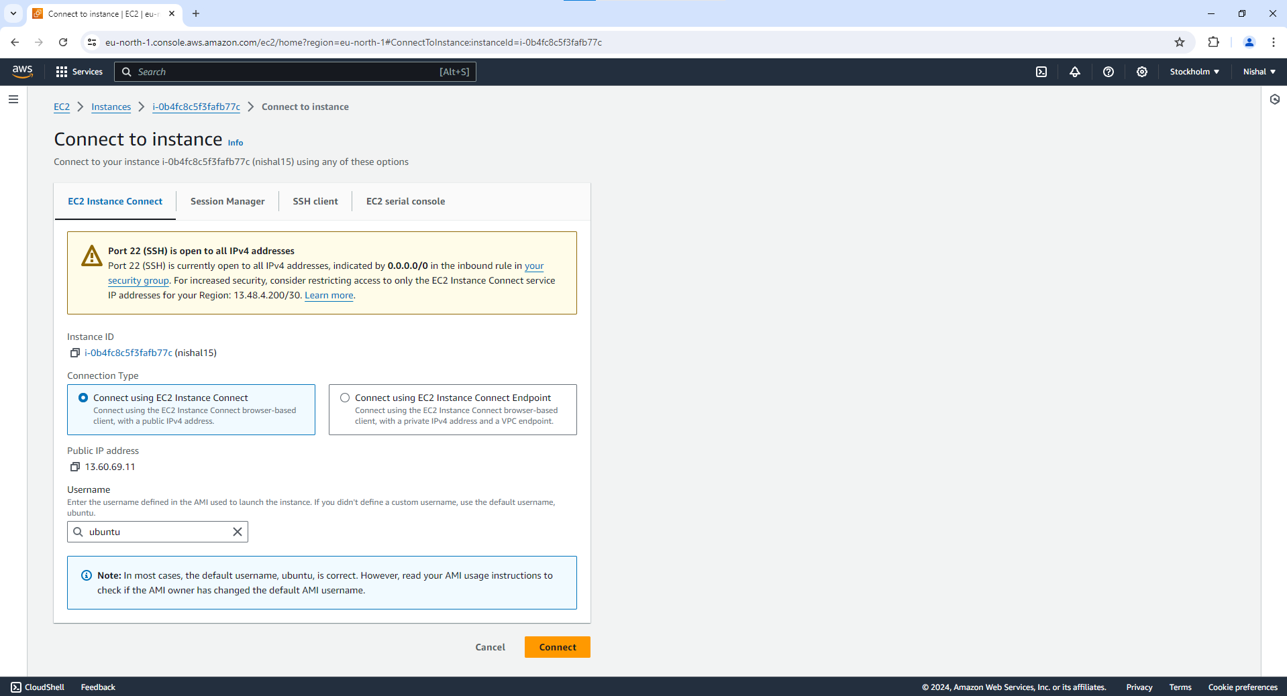

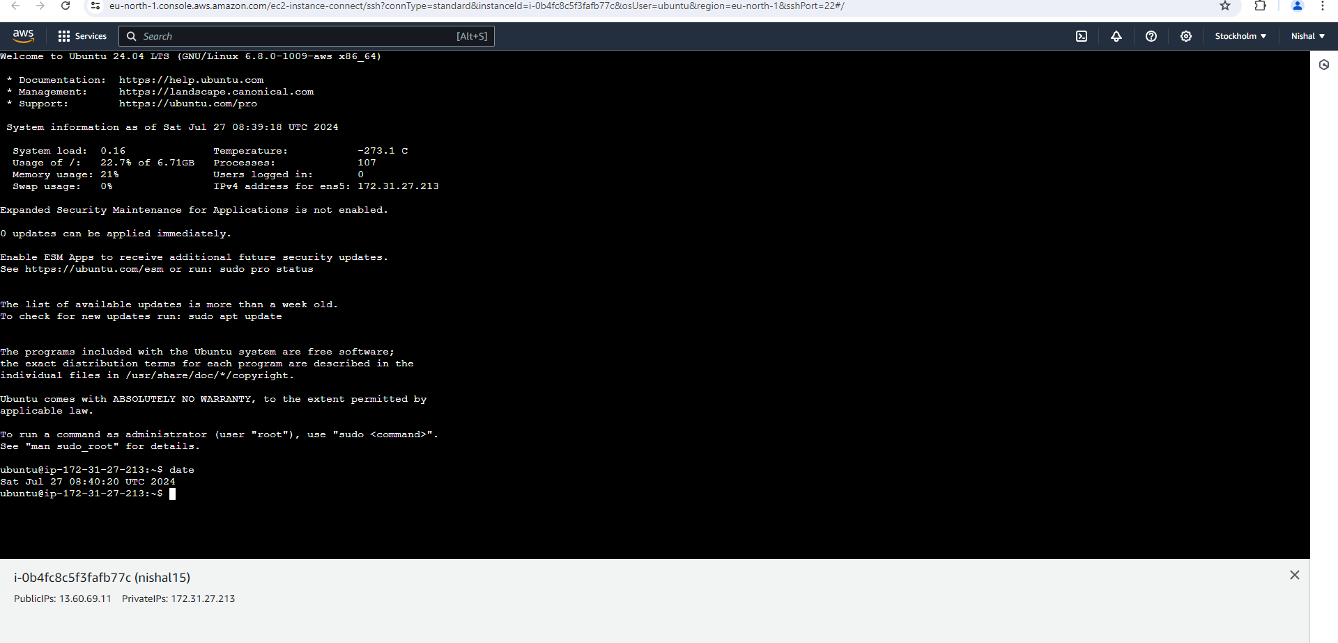

Connected

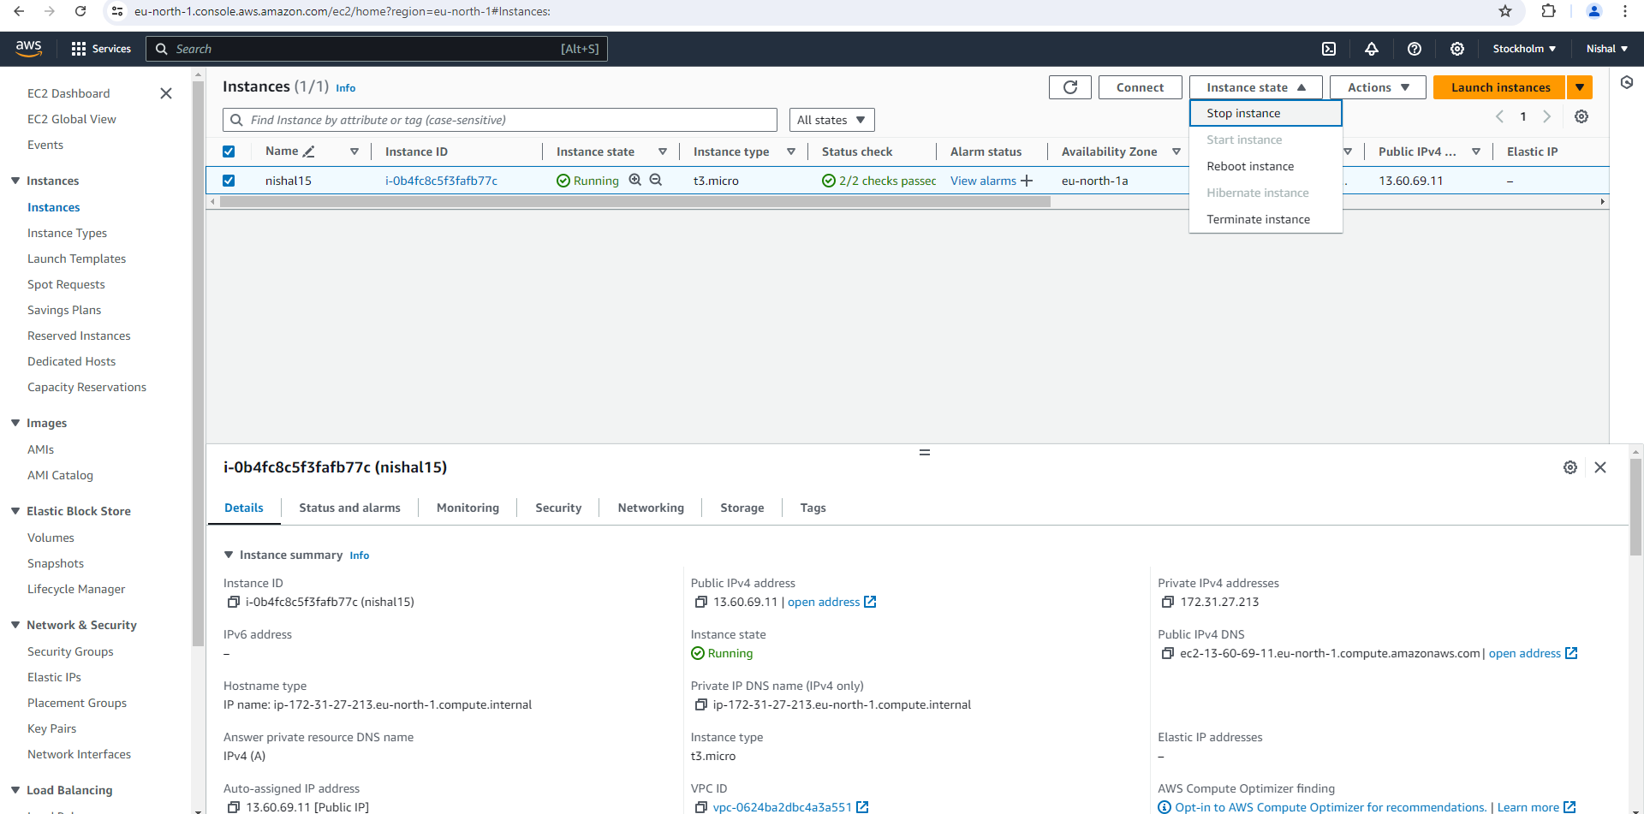

In the EC2 dashboard, click on "Instances" in the left-hand menu to see a list of your running

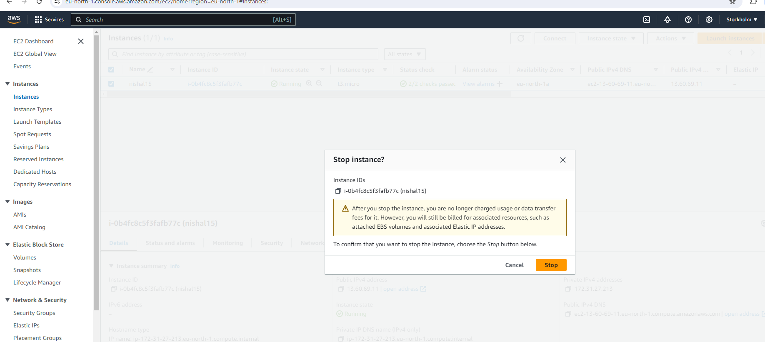

With the instance selected, click on the "Instance State" dropdown menu at the top of the screen.

Select "Stop Instance" from the dropdown options.

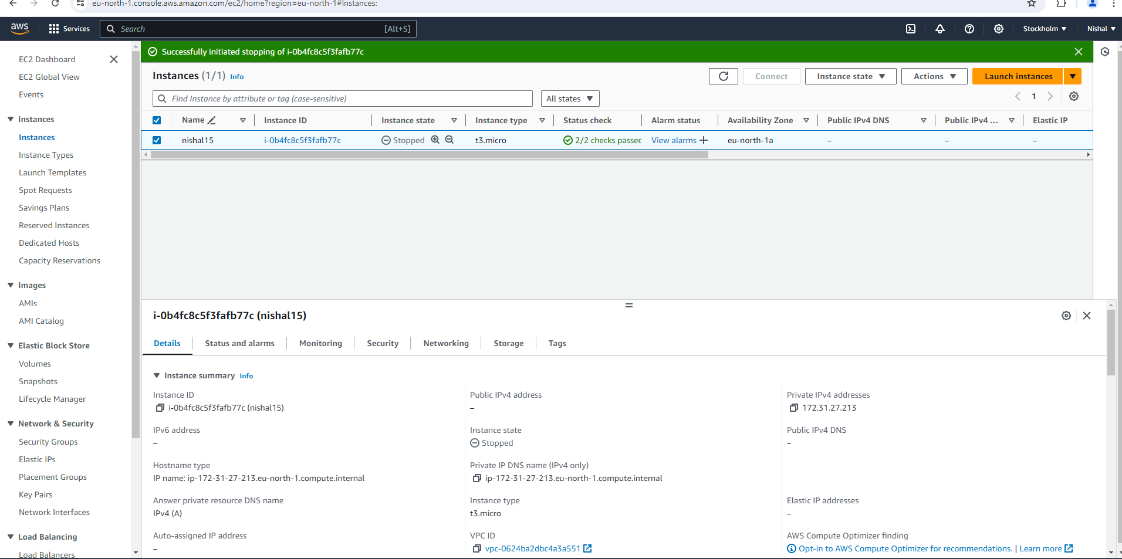

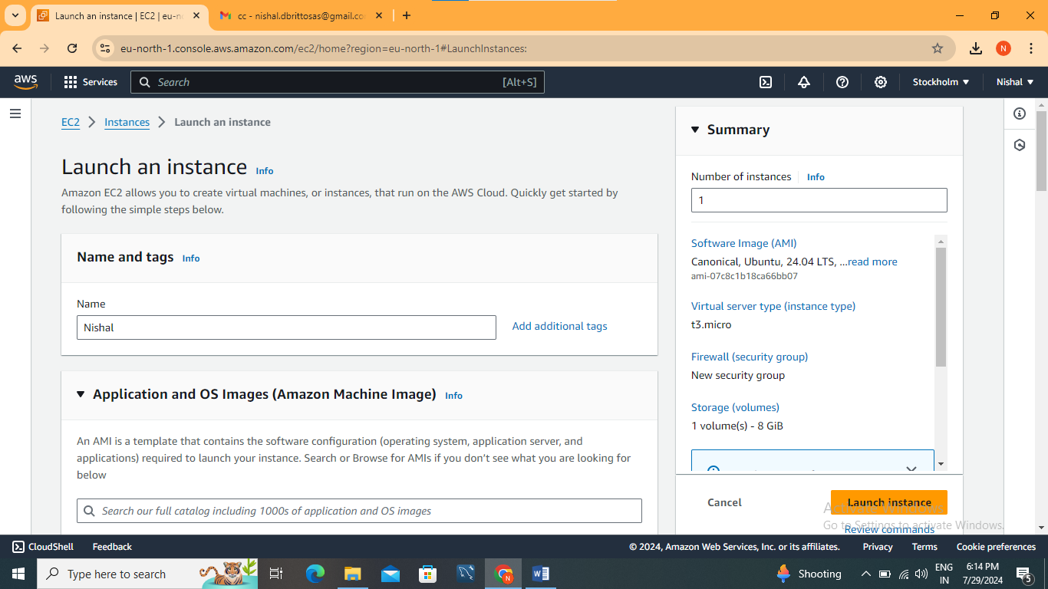

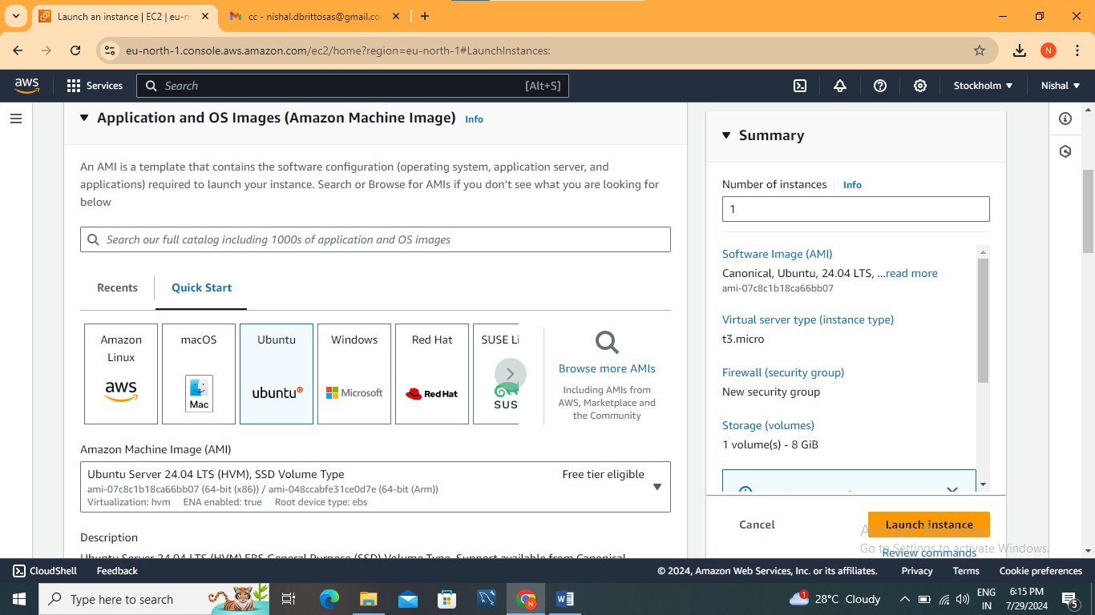

Create a new instance and download the key pair in .ppk format for putty.

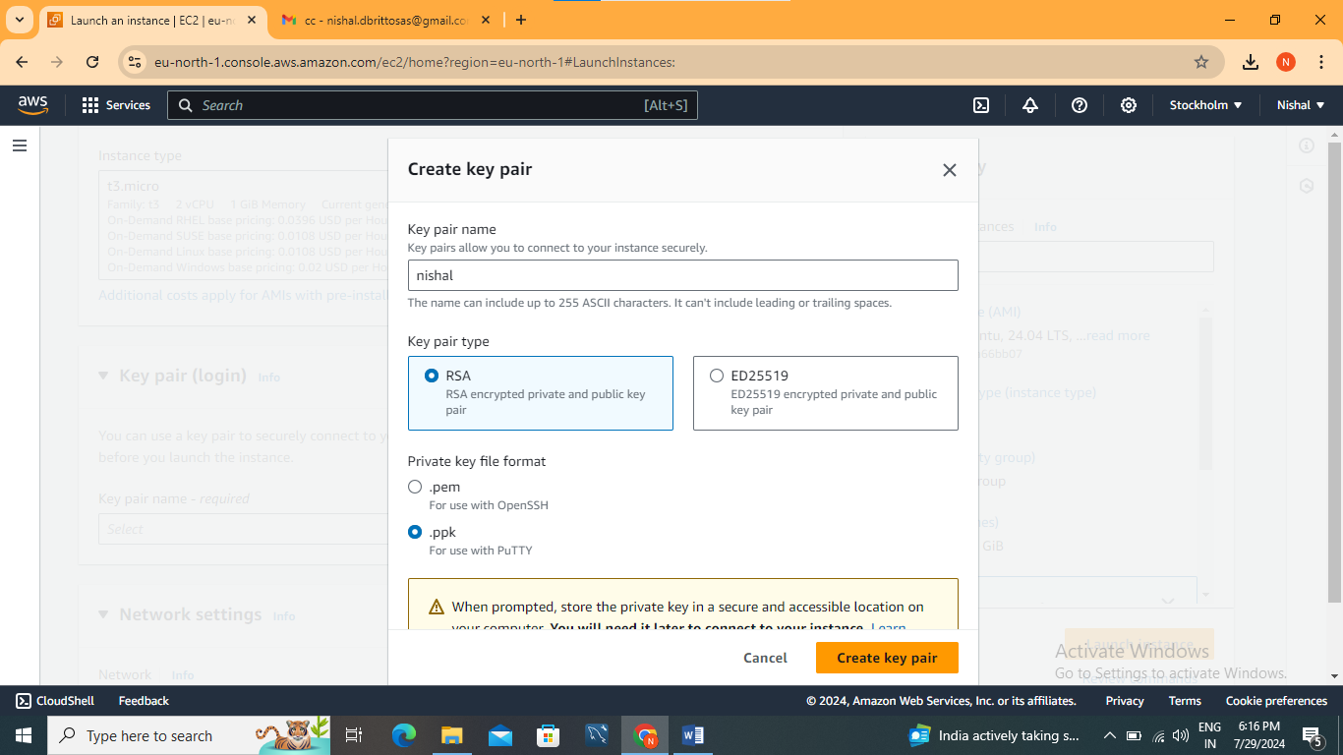

Download putty (exe file)

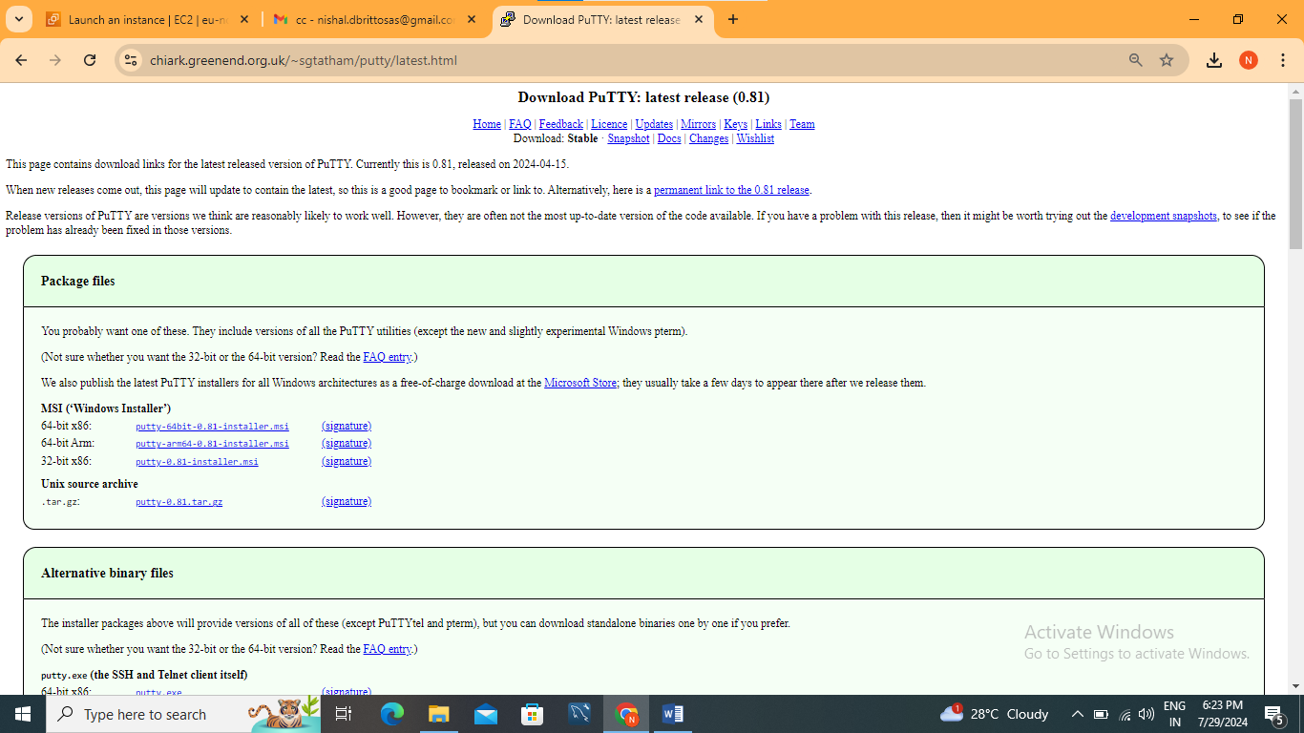

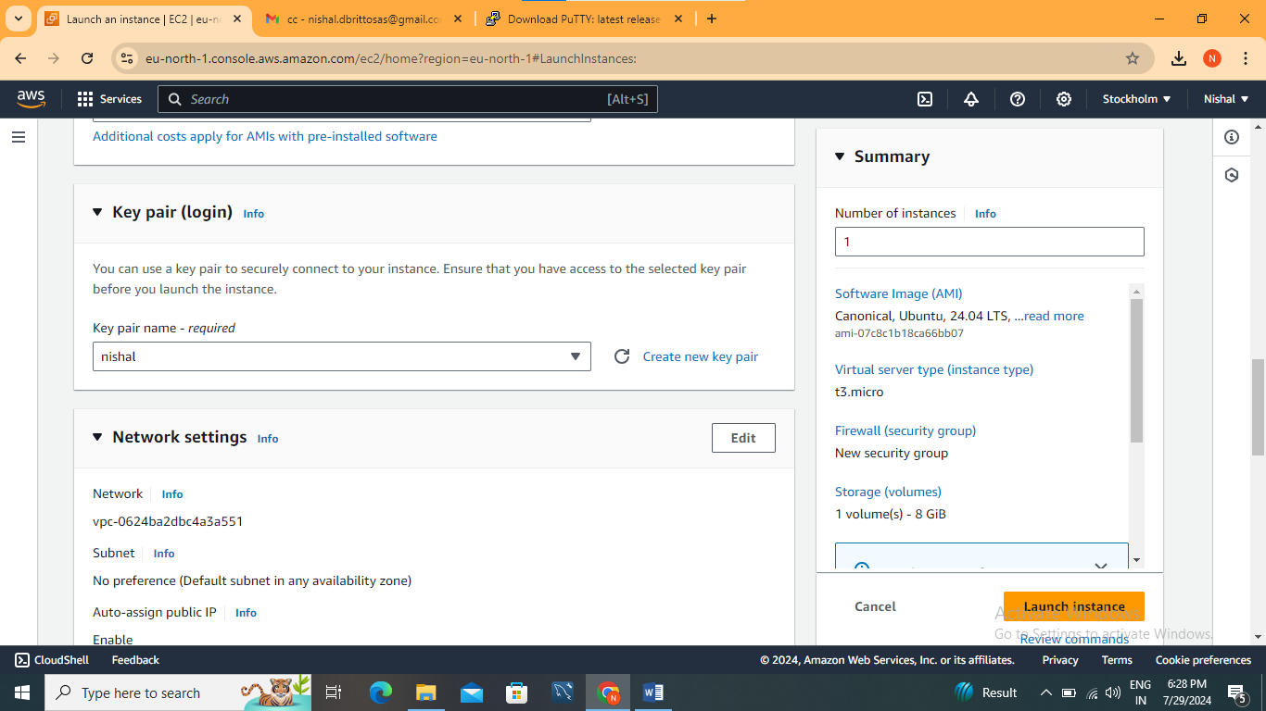

Create and connect to your instance. (Using ec2 connect)

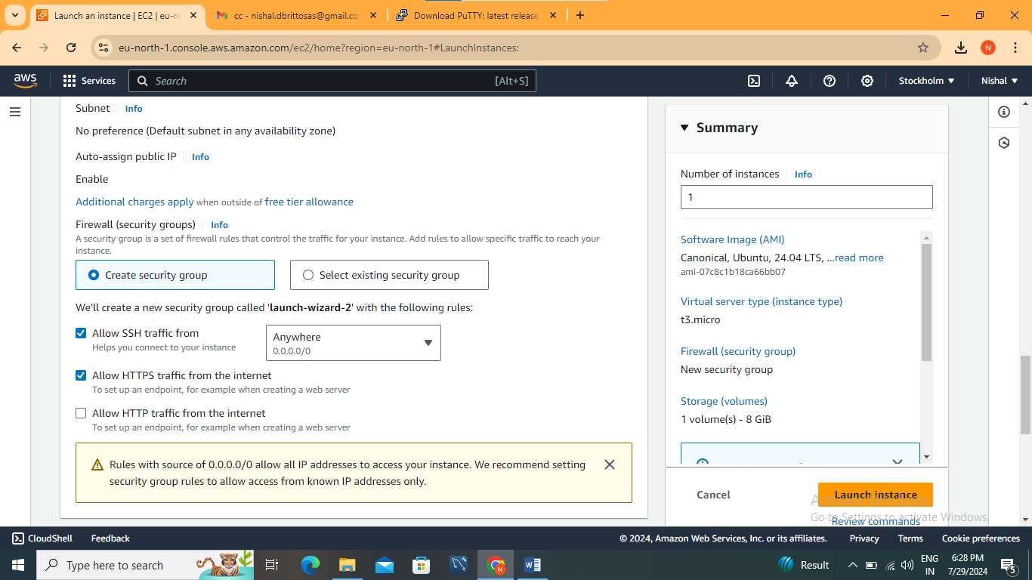

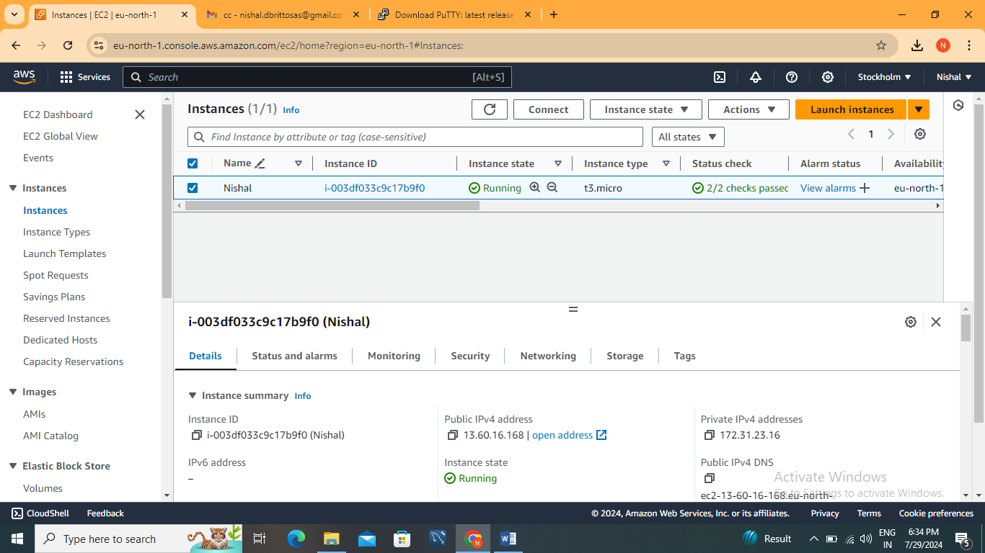

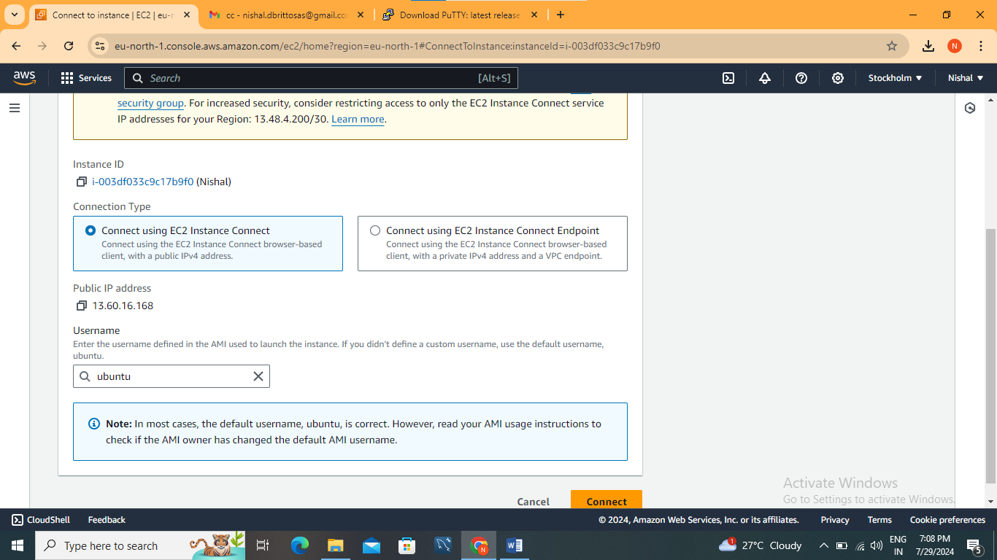

Executing Linux Commands

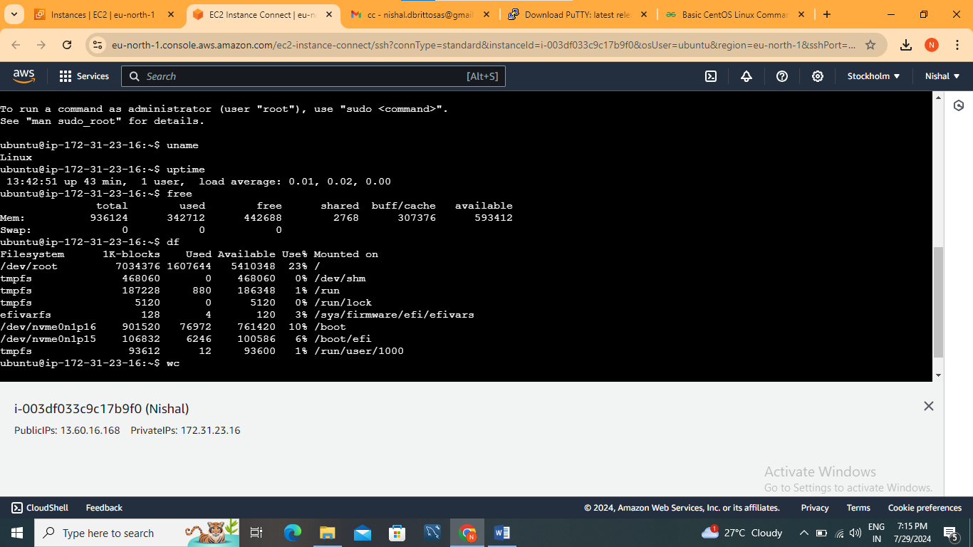

Go to instance id



Public iv4 address

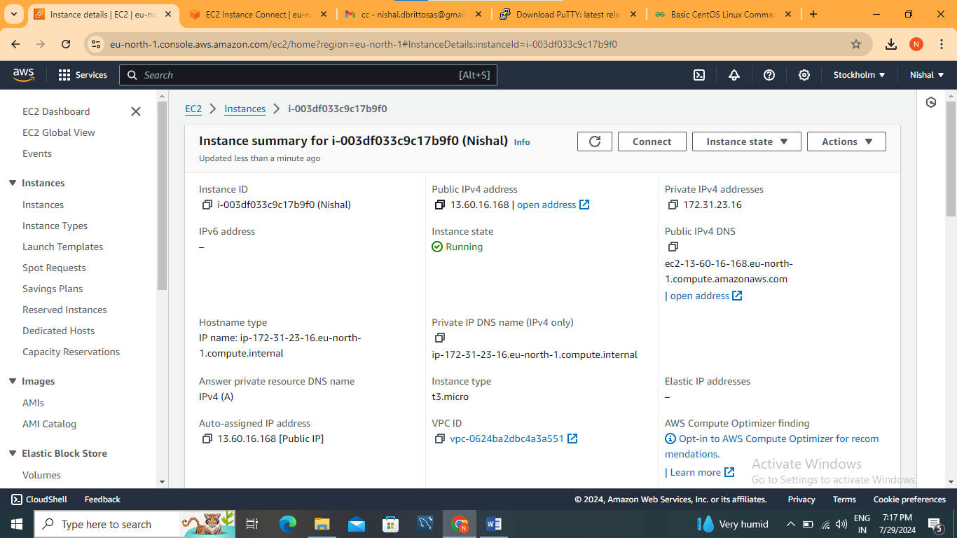

**Configure PuTTY Session:**

* In the "Host Name (or IP address)" field, enter the public DNS or IP address of your EC2 instance.
* In the "Category" section on the left, navigate to Connection > SSH > Auth.
* Click on "Browse" and select the .ppk file you saved earlier.

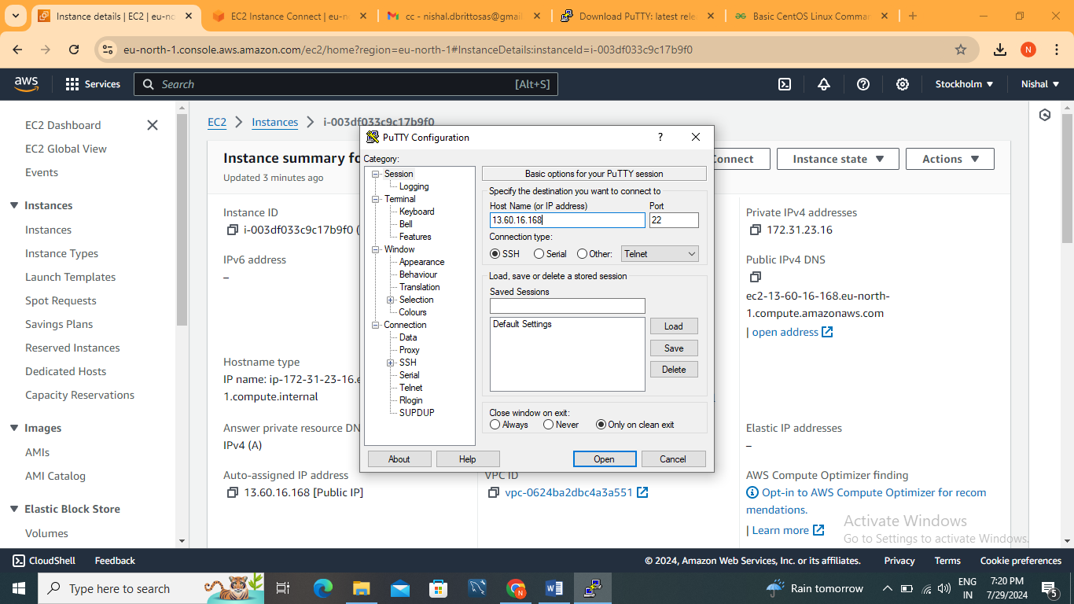

Upload private key

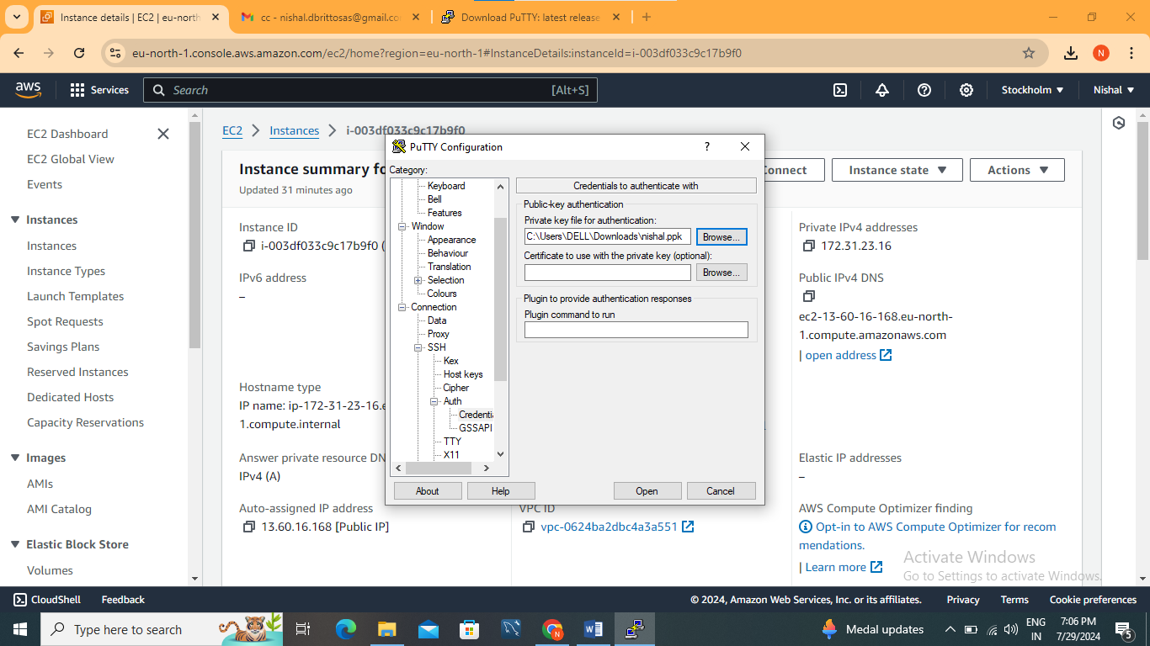

And Open.