Name: Akash Lalwani

Roll No: A035

Sap Id: 86062300024

Cloud Computing Prac 2

In the AWS Management Console, type “S3” in the search bar and select “S3” from the dropdown

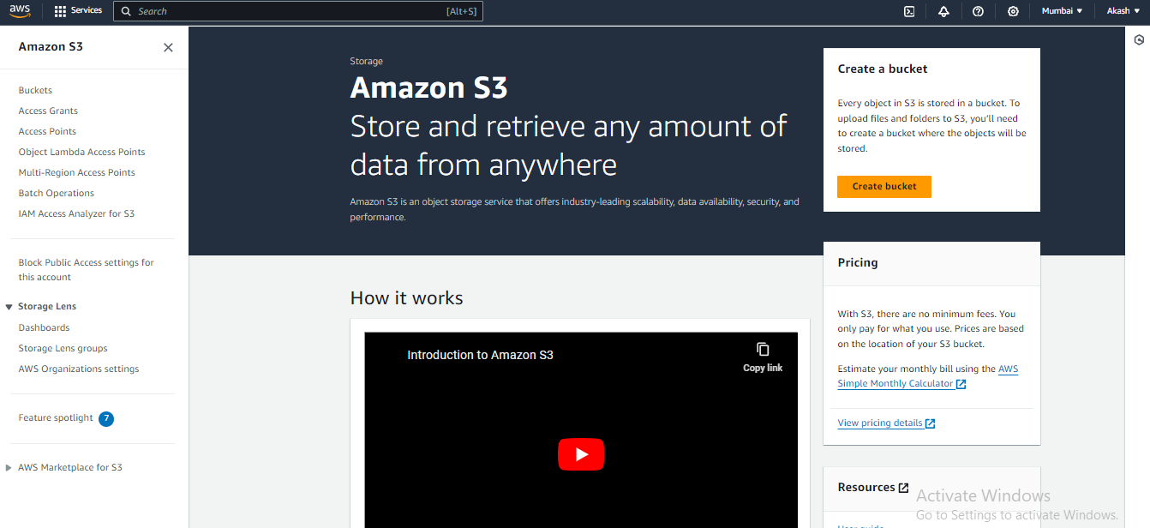

To create a new bucket, click on the “Create bucket” button.

* **Bucket Name**: Enter a globally unique name for your bucket.

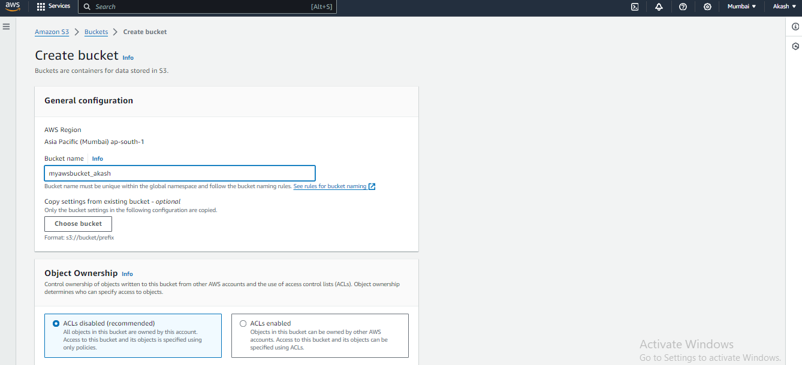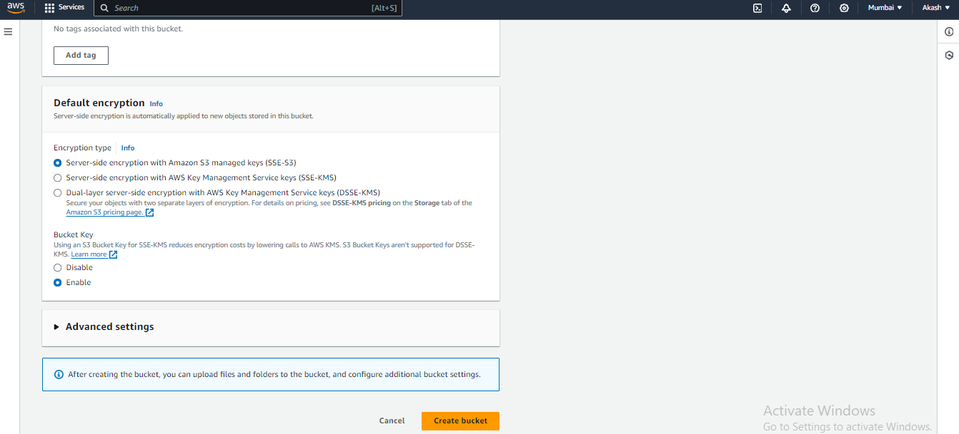

Click on “Create bucket” at the bottom.

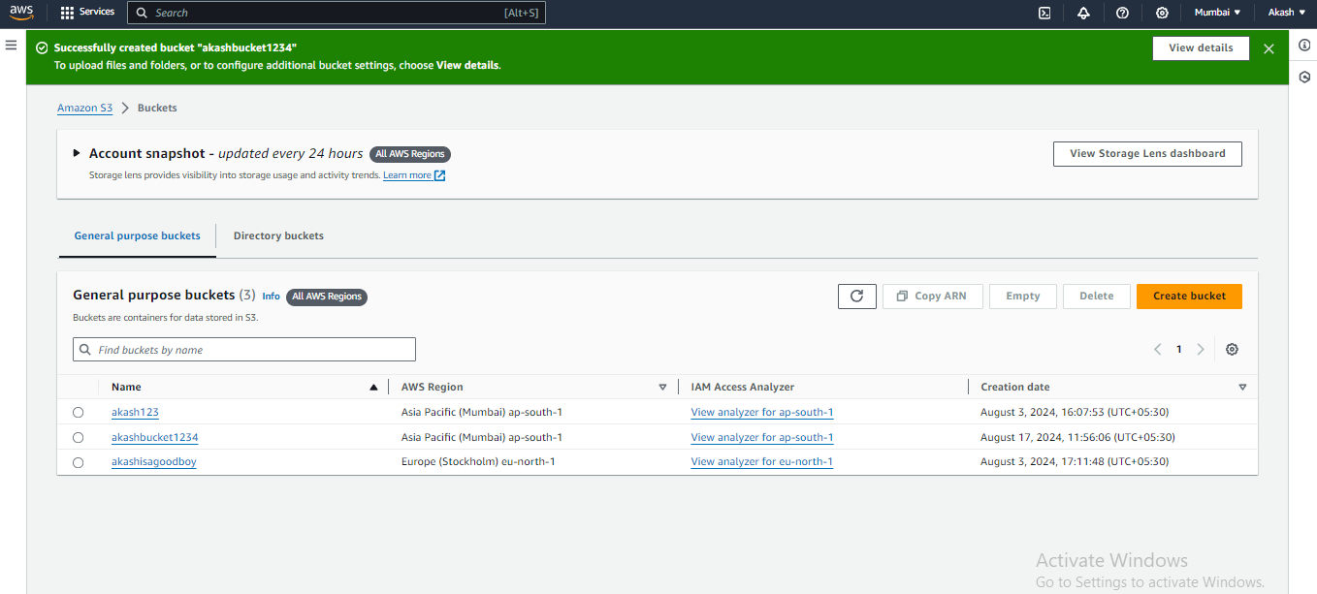

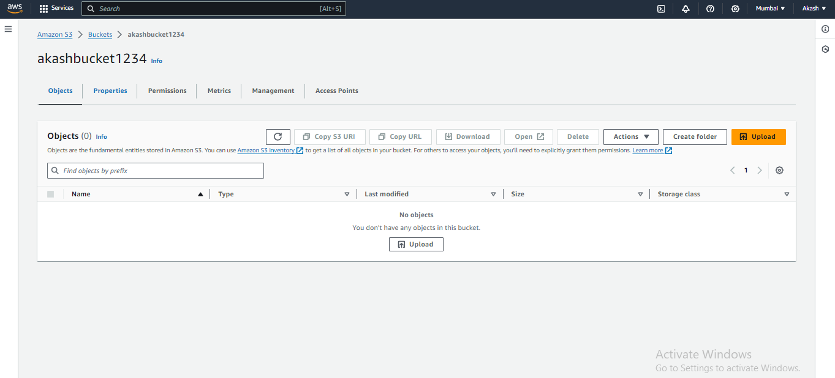

Bucket is created.

• Go to the **Objects** tab in your bucket.

• Click on the “Upload” button.

• Drag and drop your file or use the “Add files” button to select it.

• Click on “Upload” to start the upload process.

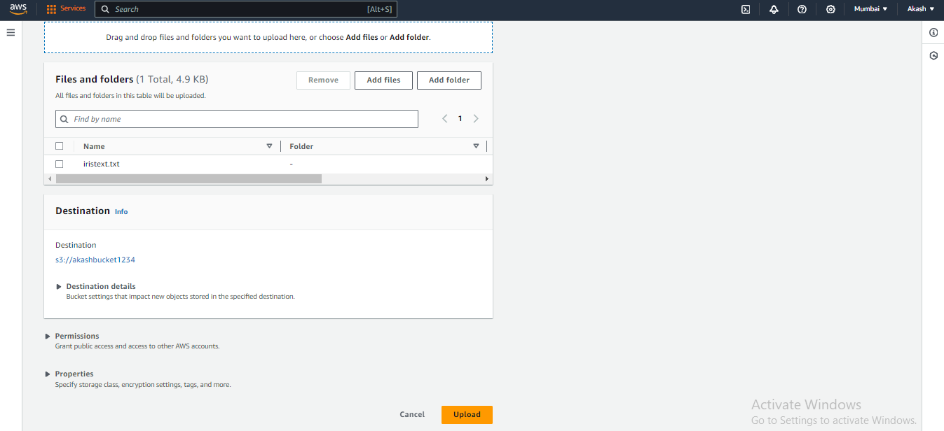

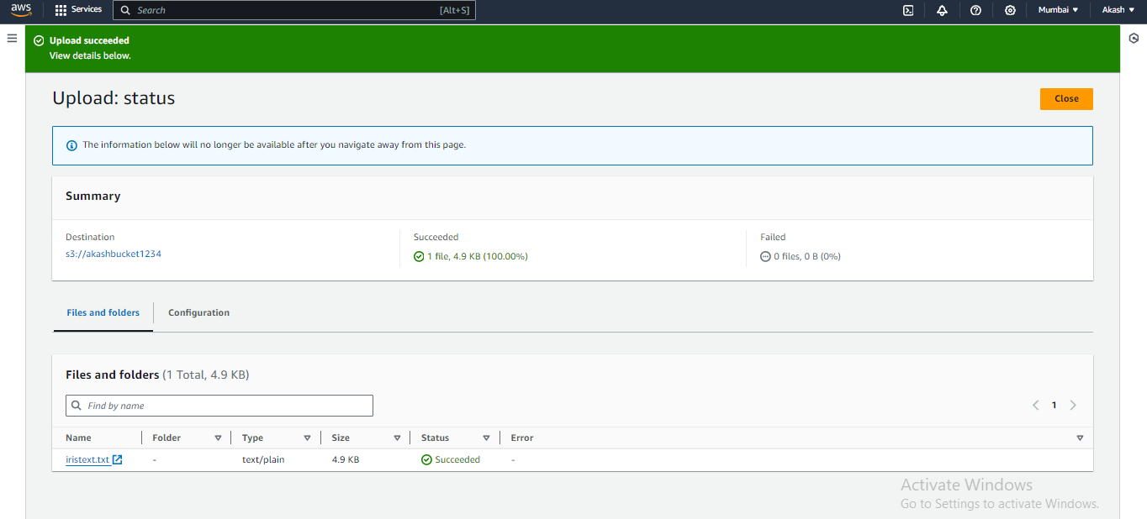

Upload successful.

• Once the file is uploaded, click on its name in the S3 console.

• In the **Object details** section, you’ll see an **Object URL**.

• Click on the URL or copy and paste it into your browser to access the file.

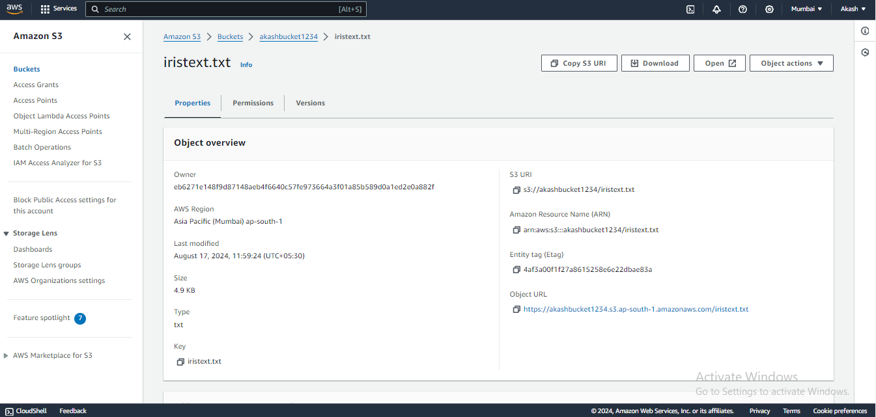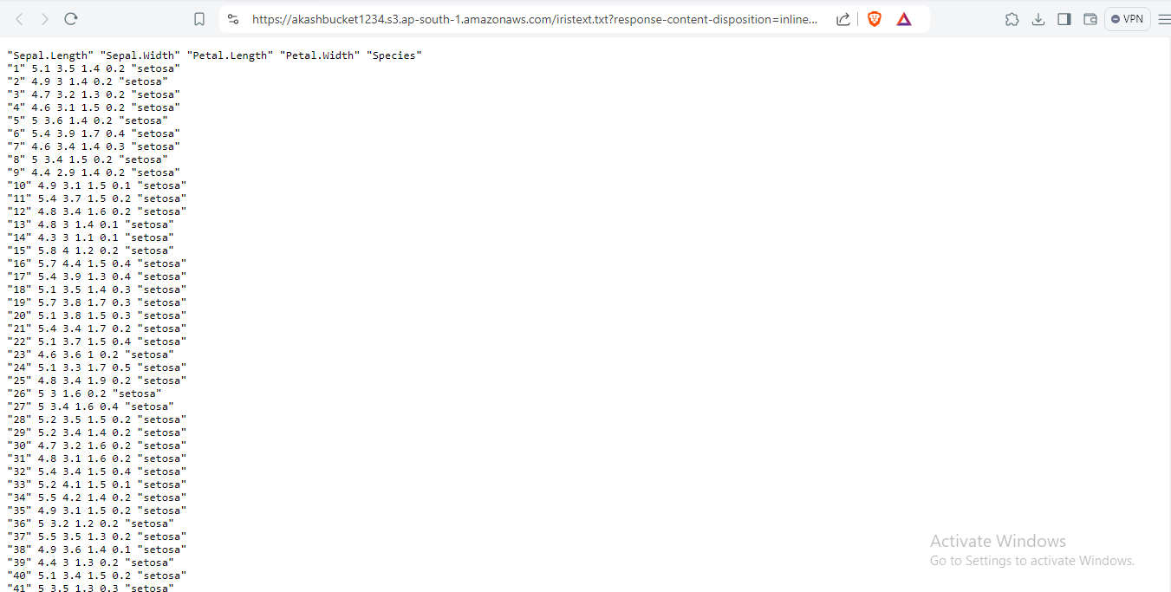

#####2

Go to javatpoint and copy the code paste it into notepad and save as a html extension. Now upload that into s3

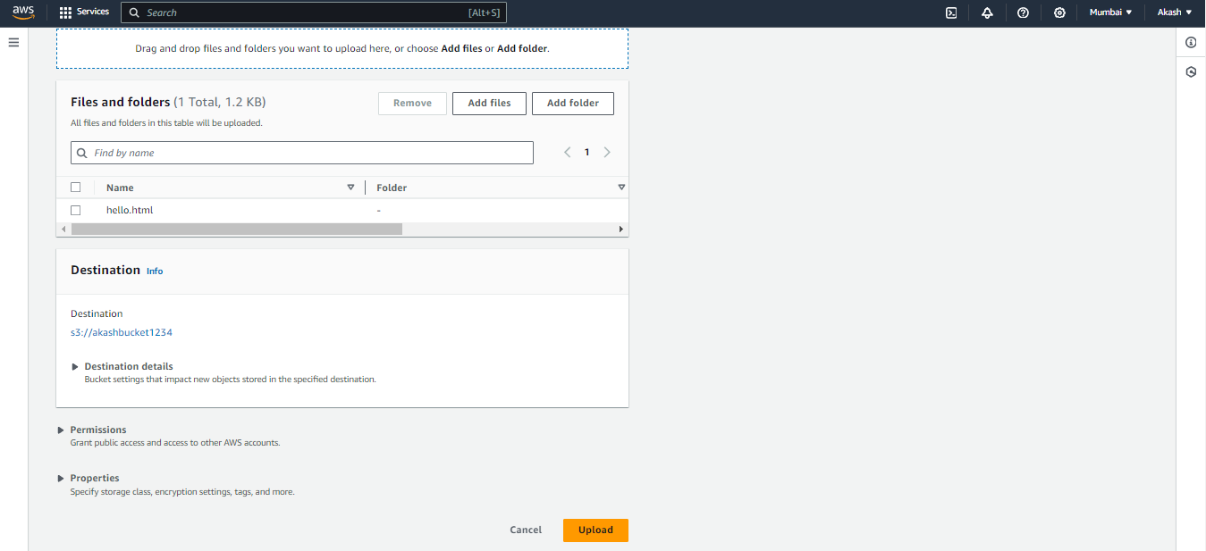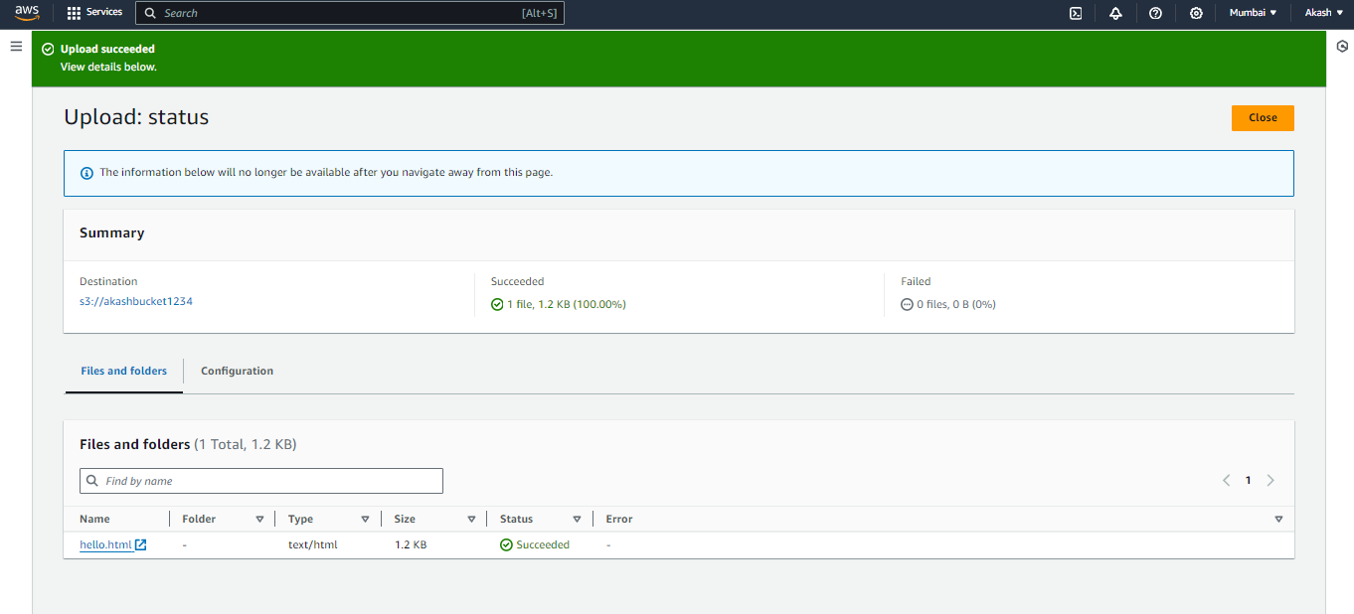

Now open the file by clicking on -open

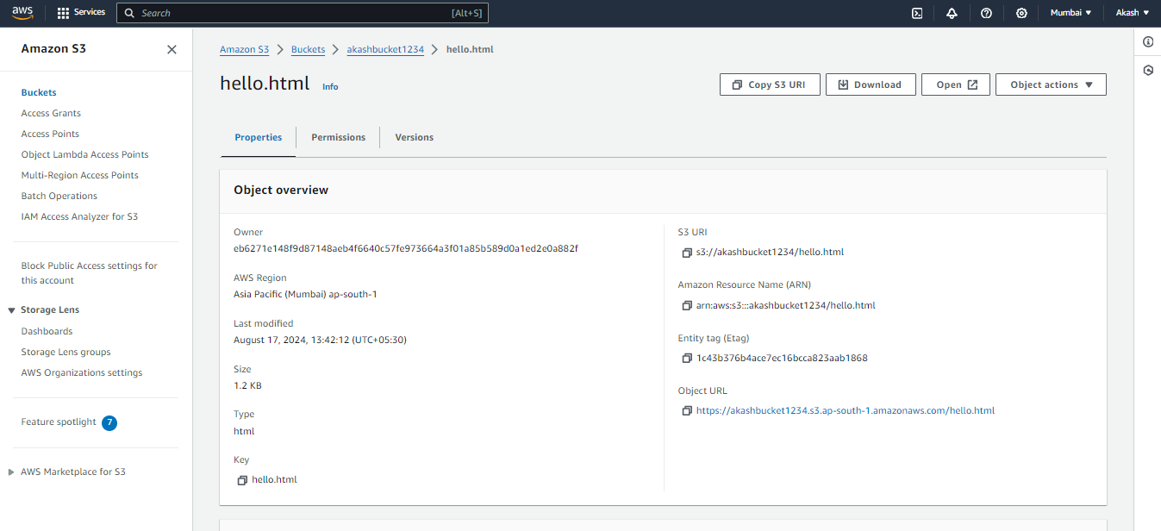

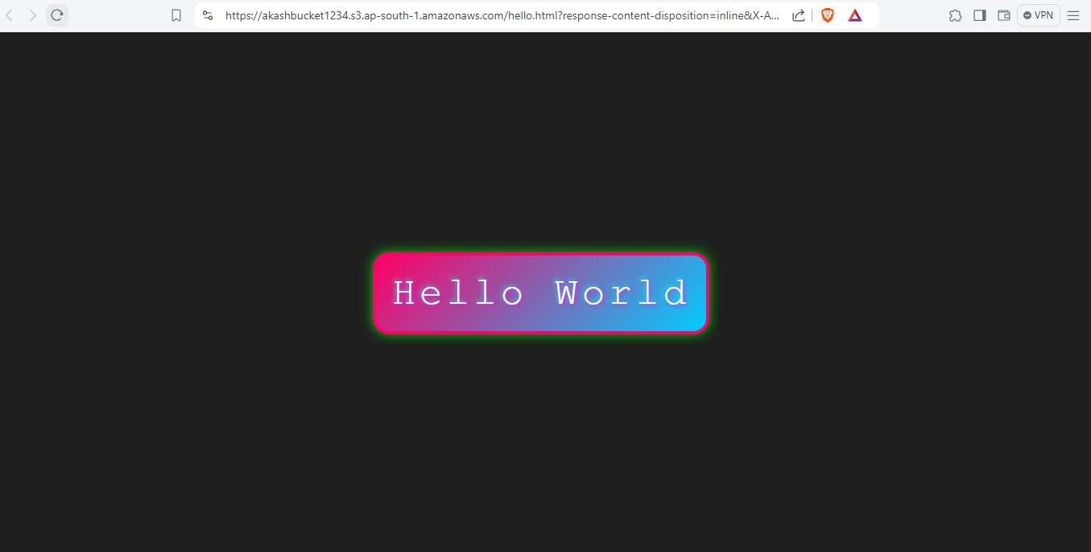

Webpage opens