Akash Malla

CS164 Project

Intro

The goal of my project is to simulate a N-body system with moons, planets, and a sun using the Forward Euler method. This code would randomly select a planet to have one to three moons. The moons would orbit around the planet and the planets would orbit around the sun.

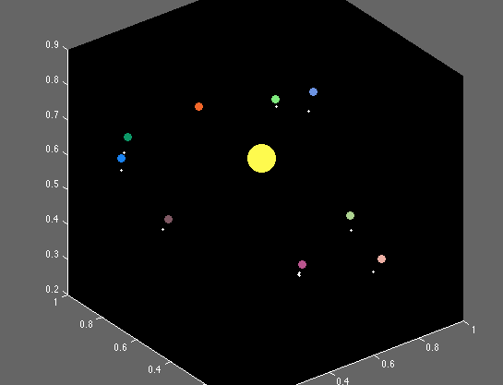

The colors of all the moons are white and the planets are randomly colored. The color of the sun is yellow. All of the planet’s size is the same. The moons are smaller but all of them are also of the same size. Initially, we set the sun at a fixed position in the center. The planets are randomly positioned around the sun and the moons are randomly positioned around the planets. However, the moon is initially .003 units away from the planet it is orbiting. In this example, I chose the code to have a planetary system with 1 sun, 9 planets and 10 moons. But the amounts of each of them can be increased or decreased.

Method

There is only one force function, which calculates the position and velocity of the sun, planet, and moon. To do this, we used three matrixes: p, v, and m.



P is position. V is velocity. M is mass. P and V have N rows and 3 columns because there are a total of N bodies and the values of x, y, z component values are placed in the 3 columns. P and V are vectors. Mass of sun is set as 100, planets as 1, and moon as .01. I initially thought of using actual numbers for the mass of each body but that leads to some problems finding the right distances such that moons rotate around the sun and with respect to its planet (although planets were rotating around the sun). These three matrices consist of all the data needed for the N-body system.

There is a size array used to determine size of a planet, sun, and moon when shown in the scatter plot. Initially, when I used m matrix, which consists of the masses of each object, as part of the scatter plot, moons were too tiny to be visible because their mass is set to a very small number relative to a sun and a planet’s mass. In order for the objects to be distinguishable and visible, sun is set with a size of 1000, planets are set to 80, and size of moon is 10. Below code shows how the size array looks like.



In the code, N equals to 20, which means there are a total of 20 objects/bodies in the system. I assigned the first position in the matrix p (position matrix) to be the sun. The next nine values in the p matrix represent position of each of the planets. Rest of the values in p matrix represents the position of each moon. As you can see in the below code, position is calculated in a way that moons stick with their planets. There may be around 0 to 5 moons that revolve for each planet depending on the randomness and the availability of moons.

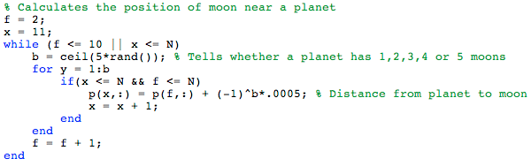

Forward Euler

This is the method used to calculate forces between the sun, planets, and moons. The code first picks one body and calculates the force it exerts on all the other bodies in the system. That force then is used to calculate the new velocity and position of this body. This process continues until the forces for all the bodies are calculated.



Plotting

We used scatter3 function to plot the n-body system. The Background is set to black color to look like space.