How it works:

The three major components involved in the transaction are the user, merchant and bank servers. The user uses an android application (*Phoenix*) to communicate with merchant and bank servers.

Client, merchant, bank and certificate authority (CA) each have their RSA 512-bit private and public keys. Each entity’s (client, merchant and bank) X509v1 certificates were generated using *Bouncy Castle Library*. These certificates were then signed with CA’s private key. *Keystore* was used to safely store these certificates and key pairs. We have assumed that each entity has access to other’s certificate to retrieve the public key.

Merchant and bank maintain a shared database (*PhoenixDatabase*). This database comprises of four tables:

|  |  |
| --- | --- |
| Table Name | Fields |
| USERS | ID, NAME, EMAIL, PASSWORD, SALT, PHONE |
| SESSION | ID, EMAIL, SESSION_CTOM, SESSION_MTOB |
| PRODUCTS | ID, NAME, PRICE |
| OTP | ID, SESSION_MTOB, PHONE, OTP |

Database functions:

|  |  |
| --- | --- |
| Function | Usage |
| insert_users | Function inserts a new user in the *Users* table |
| getSaltString | Function retrieves salt from *Users* table |
| check_user | Function checks if username, email or phone number is already present in *Users* table |
| login_activity | Function used during login to verify the details |
| get_phone_users | Function to retrieve phone number from *Users* table |
| insert_session | Function to insert *session_ctom* when user logs in |
| update_session_pay | Function to insert *session_mtob* |
| get_phone | Function to get phone number from *Users* table using *Session* table |
| get_session_mtob | Function to get *session_mtob* from *OTP* table |
| get_mail | Function to get email from *Session* table |
| insert_OTP | Function to insert details in *OTP* table |
| get_OTP | Function to get OTP from *OTP* table |

The actual process is preceded by four steps:

* Key and certificate generation.
* Storage and distribution of keys and certificates.
* Tables’ generation.
* Populating the Products Table.

When the user opens *Phoenix* application on his Android phone, he is directed to the *LoginActivity* page. The login page has the following fields:

* Username
* Email
* Password
* Link to Registration Page

If the user has an account, he fills in the details and hits the login button; else he hits the link to registration screen button and gets directed to the registration page. If any of the fields is empty, a toast appears asking him to furnish all the details. If all the fields are given, a session key (*session_ctom*) is generated along with a timestamp. This session key is unique and will be used for all message exchanges between merchant and client in this transaction. A message is created E(Km+ ,[Identifier, Username, Password, Email, TimeStamp, *session_ctom*]) and sent to merchant server.

Merchant on receiving this message:

* Decrypts the information and checks the timestamp (a 30 second window is allowed)
* If timestamp is valid, it calls the *login_activity* function. (function checks if the details supplied are correct in the *Users* table)
* The function raises a flag, and accordingly a verification message is created. (successful/unsuccessful)
* If the login is successful, an entry in *Sessions* table is created.
* A message is then created: E(Kc+ , [Verification Message, TimeStamp, *session_ctom*, Phone Number]) and then sent to client.

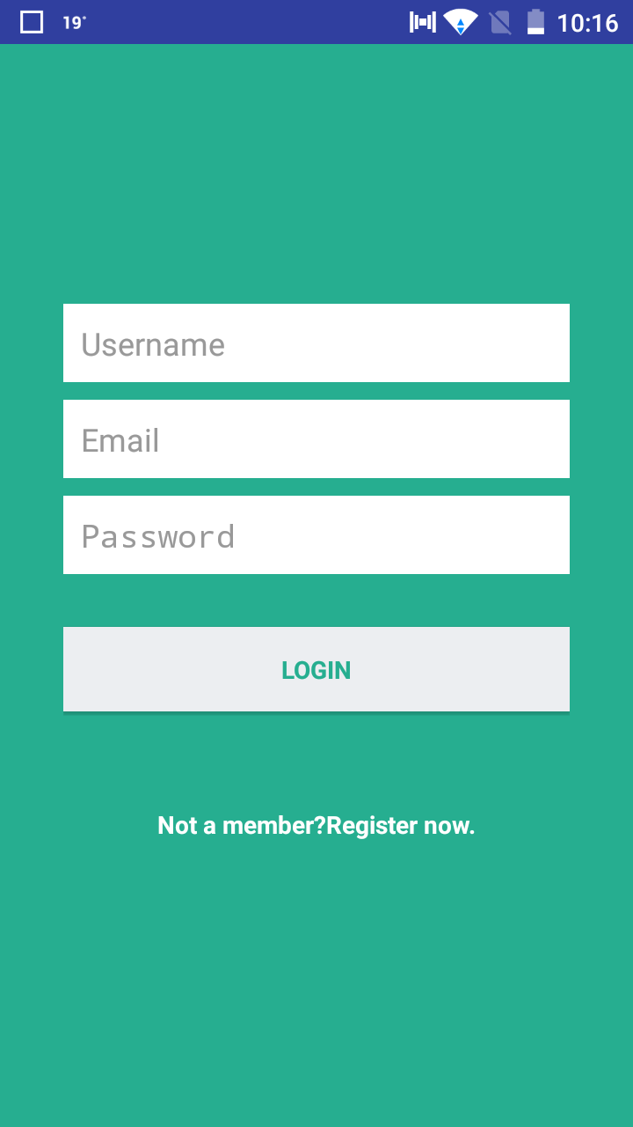

Fig E.2 User Login Page

Client on receiving this message:

* Verifies timestamp.
* Launches *ProductsActivity* for successful login and stores the phone number received in its own *Users* table.
* For an unsuccessful login, it generates a login failure toast message.

If the user doesn’t have an account, he can register himself from *Phoenix’s* Registration Page. The registration page has the following fields:

* Username
* Email
* Phone number
* Password

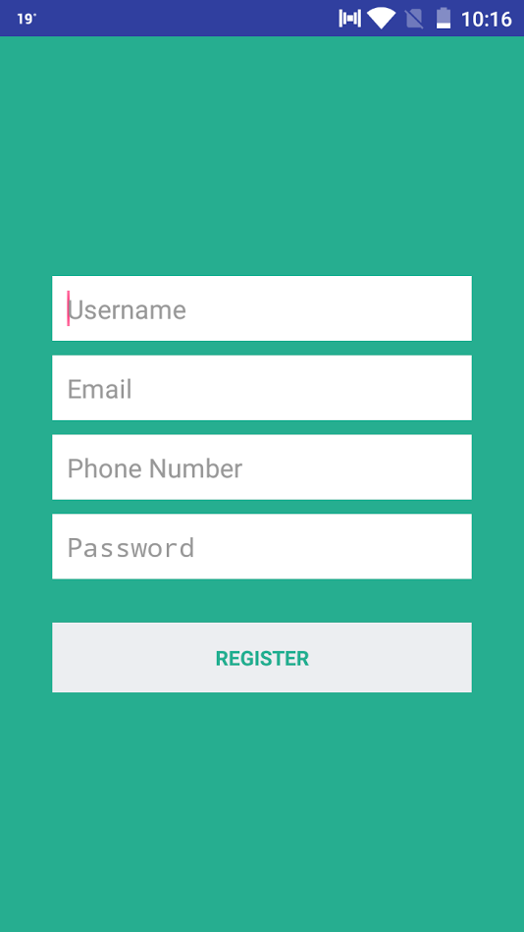

Fig E.3 User Registration Page

If any of the fields is empty, a toast appears asking him to furnish all the details. A message is created: E(Km+ ,[Identifier, Username, Password, Email, Phone Number] and sent to merchant server.

The server on receiving it:

* Decrypts the message and passes the fields to *insert_users* functions.
* The function in turn uses a *check_user* function to check if a user exists with the same parameters.
* If the user is new, a salt is created. New password is created concatenating *secret*, username, password and the salt generated, hashed using *HmacSHA1* and stored in the *Users* table.
* Accordinglya flag is generated; an encrypted message is drafted and then sent with the fields: verification message and timestamp.

Client on receiving the message verifies the timestamp and directs user to the Login page for successful login or displays a toast for unsuccessful login.

After a successful login, the user is directed to *ProductsActivity* page in the application. The application creates a message: E(Km+ , [Identifier, TimeStamp, *session_ctom*] and sends it to merchant server. The server verifies the time stamp and sends back the list of products along with a concatenated hash of products and *session_ctom* (MD-5)*.*

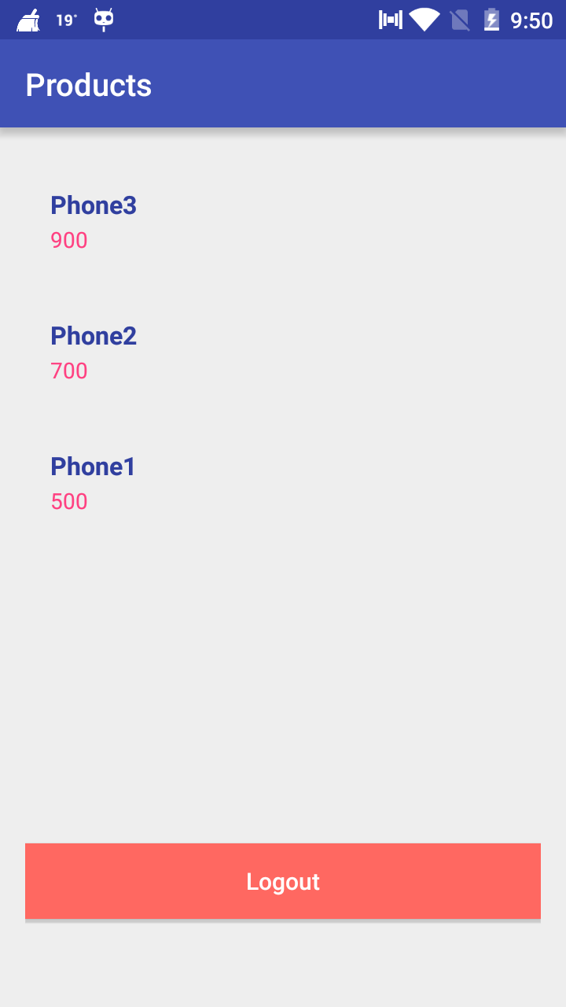

Fig E.4 Products List

Client on receiving this verifies the hash and displays the product list. The user then chooses a product and is directed to *PaymentActivity* page.

This page has the following fields:

* Card type
* Card number
* Expiration date
* CVV

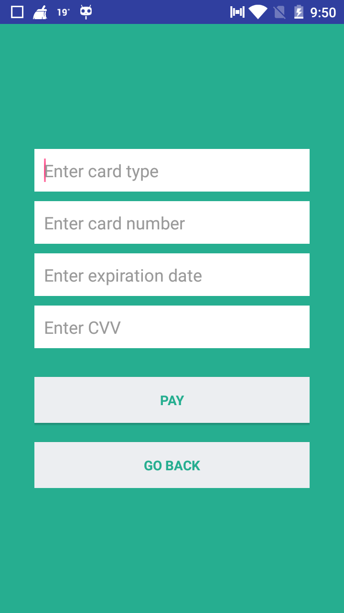

Fig E.5 Payment Details

The user fills all the details and hits the pay button. Upon hitting this button a message is created: E(Kb+ , [Card Number]), E(Km+ , [Product], Hash[Card Number],Hash[Product], Dual Signature), E(Km+ , [TimeStamp and *session_ctom*]) and sent to merchant server. The server:

* Decrypts TimeStamp, *session_ctom* and Product.
* Verifies TimeStamp, hash of Product and dual signature.
* Creates a session key *session_mtob* and a new TimeStamp.
* Stores *session_mtob* in Sessions table.
* Replaces the session key and TimeStamp in the original message, and forwards the new message to the Bank server.
* Generates a message: E(Kc+ , [Verification Message, TimeStamp and *session_ctom*] and sends it to the client.

The bank server then:

* Decrypts TimeStamp, *session.n_mtob* and Card Number
* Verifies TimeStamp, hash of Card Number and dual signature.
* Accordingly generates a One Time Password (OTP) or a failure message.
* Stores the OTP in the OTP table.
* Uses Twilio’s API to send the message to client.

The user after receiving the verification from merchant server is directed to the *OTPActivity* page. When he receives the OTP in message, he enters it and hits the send button. A message is created: E(K**b**+ , [Identifier, TimeStamp, OTP and Phone Number]) and sent to bank server.

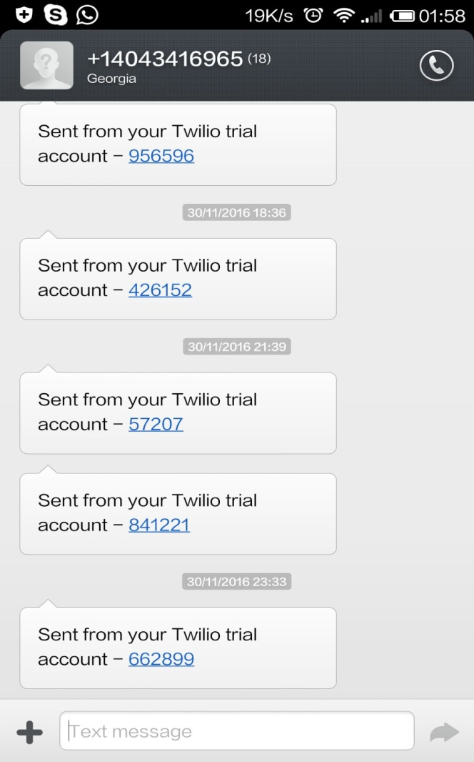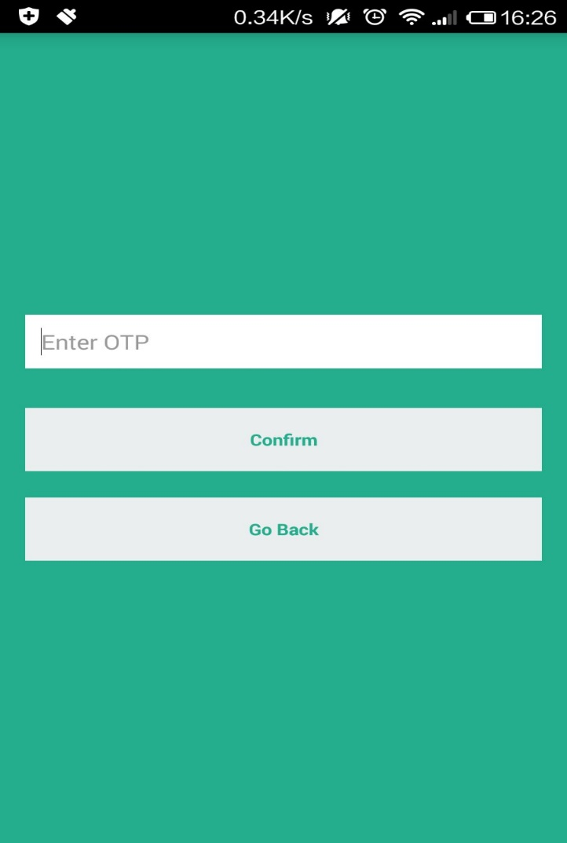

Fig E.6 OTP Page

Bank on receiving this message verifies the time stamp and matches the OTP with the one it sent. It according creates verification message (successful/unsuccessful) and then generates a message: E(Kb+ , [Identifier, TimeStamp, Session_MtoB and the message]) and sends it to merchant server.

Merchant server verifies the timestamp and sends client a successful/unsuccessful mail using the JavaMail API.

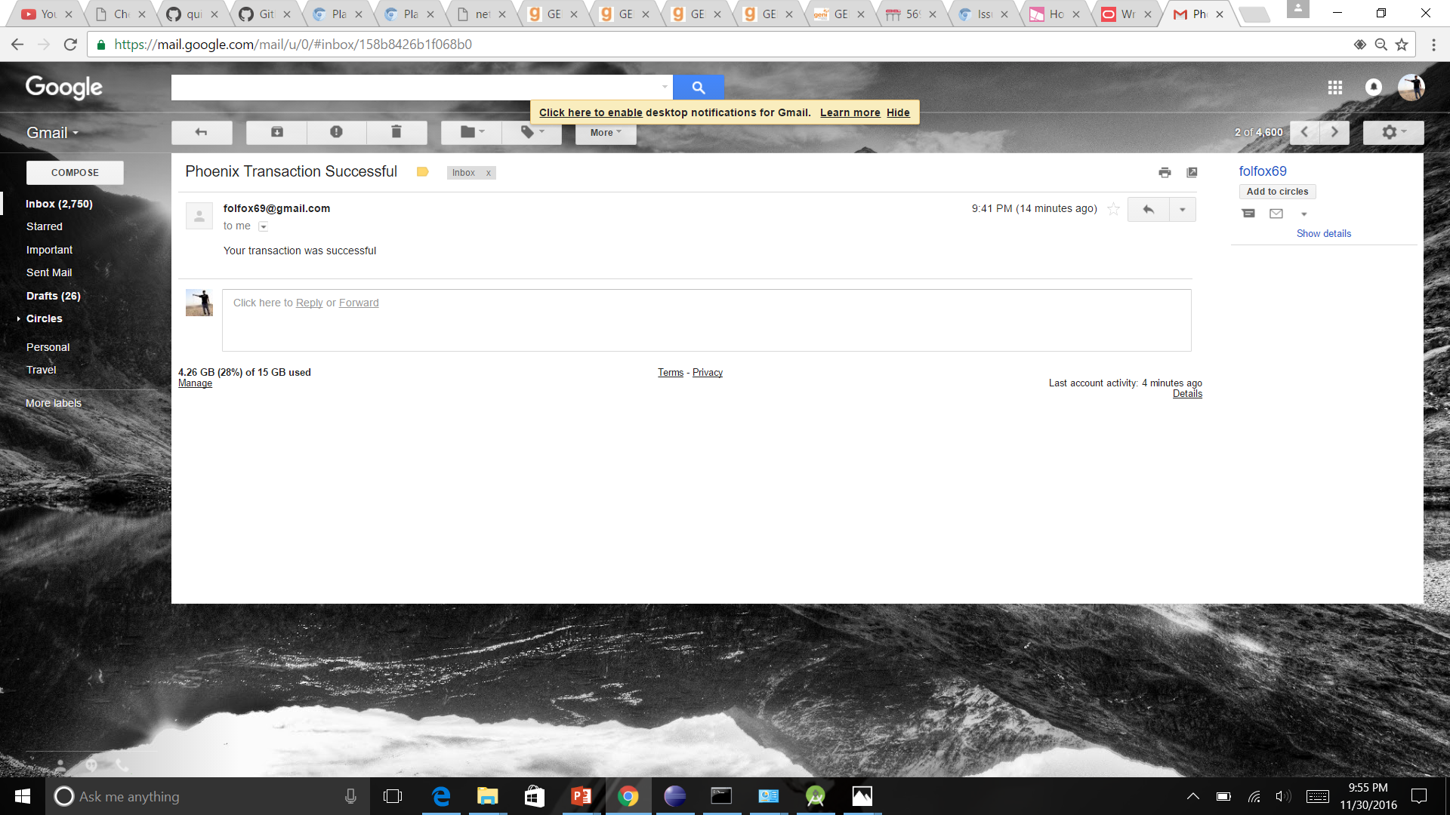

Fig E.7 Successful Email Notification

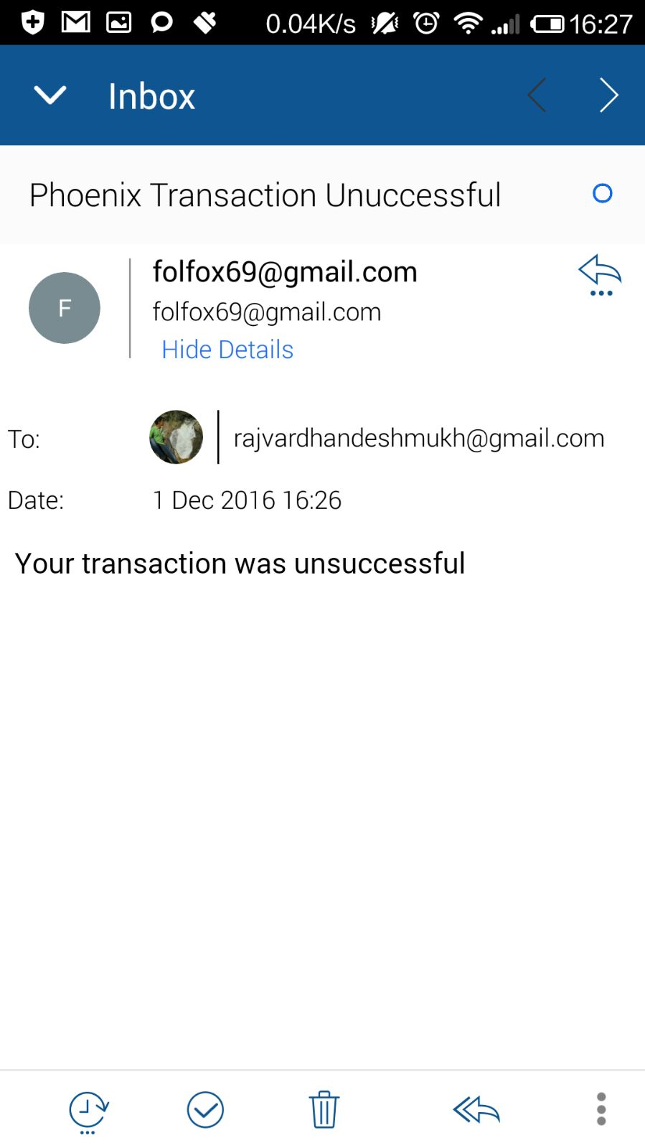

Fig E.8 Unsuccessful Email Notification

Possible improvements and extensions:

* Use of a better API than Twilio so that messages can be sent to everyone.
* Better threading in merchant and bank server to reduce code complexity.
* Use of larger keys.
* Improved storage of certificate and keys in android application.
* Creation of a credit card database, and matching the details when user enters it.
* Use of regular expression in application’s input fields. (email and username length)