1. INTRODUCTION
   1. Overview

Retail management is the process of running and managing retail outlets' day-to-day activities surrounding the selling of goods and services to customers.

* 1. Purpose

A retail management system (RMS) is a platform that combines several modules to aid in the day-to-day operation of a retail store or chain, such as managing and buying inventory, checking out customers, scheduling employee shifts, keeping track of finances, etc.

2Problem Definition & Design Thinking

* 1. Empathy Map

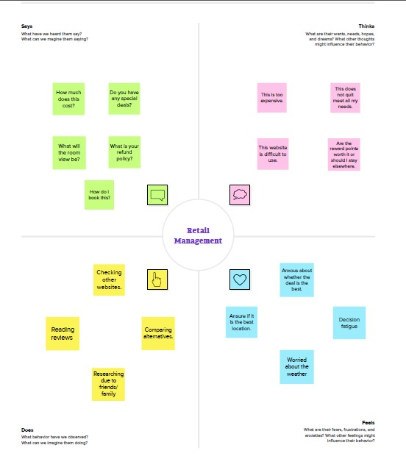

* 1. Ideation & Brainstorming Map

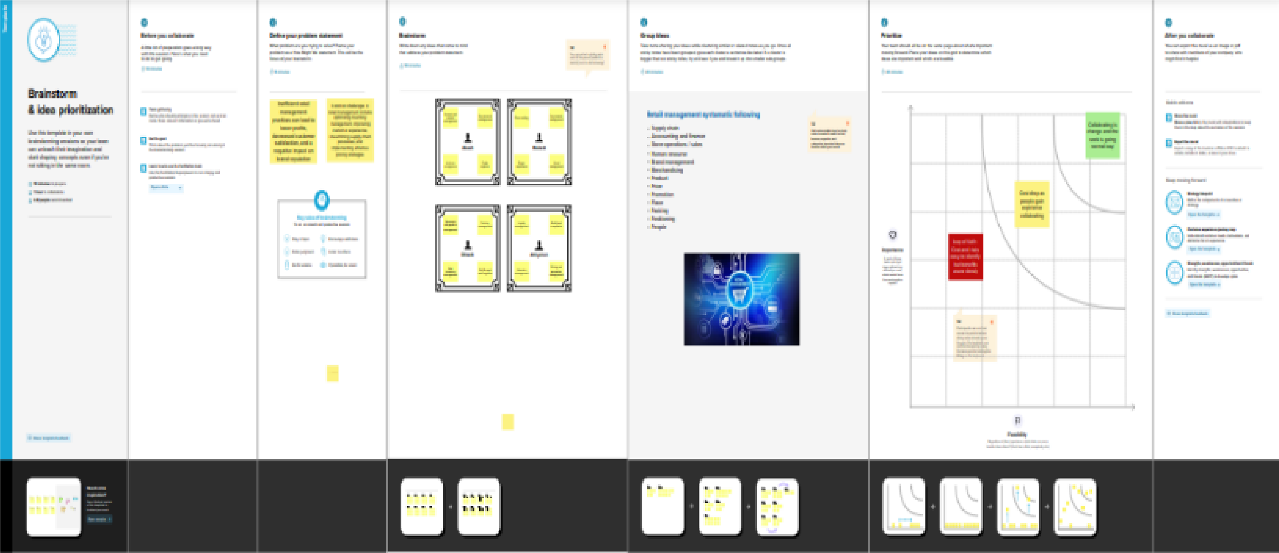3RESULT

* 1. Data Model:

|  |  |
| --- | --- |
| App | Object |
| Sales app | |  |  | | --- | --- | | Field label | Data type | | Campaign | text | | Leads | date | |
| Service app | |  |  | | --- | --- | | Field label | Data type | | Cases |  | | Acccounts |  | |

* 1. Activity & Screenshot

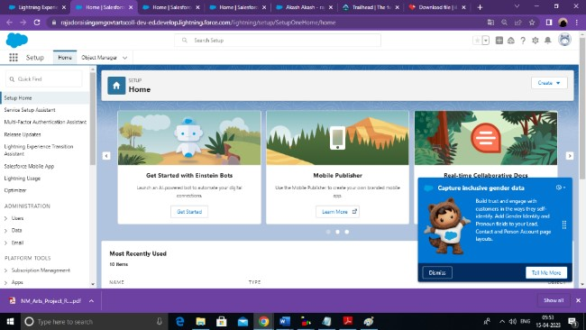

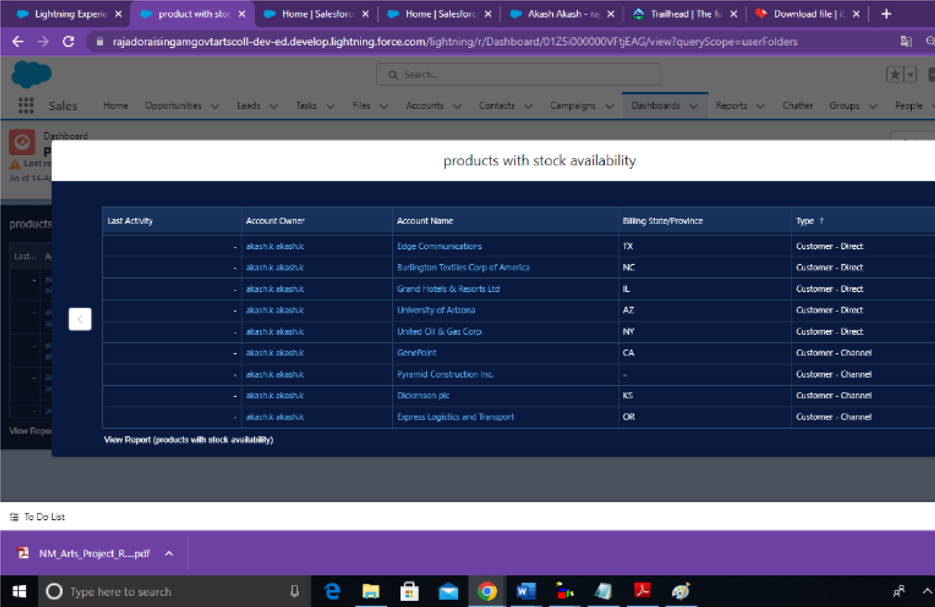 3.3 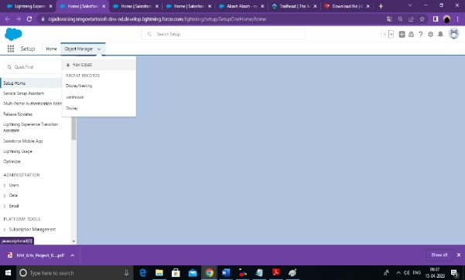

3.4

4Trailhead Profile Public URL

Team Leader ;

https://trailblazer.me/id/aakash365

Team Member 1 -http://trailblazer.me/id/ddinesh59

Team Member 2 -https://trailblazer.me/id/aathiyaman

## Team Member3 -https://trailblazer.me/id/mukesh73

5.ADVANDAGES;

Less capital requirement

More profit margin

Credit facility

Better customer relation

No liability

DISADVANTAGES;

High marketing cost

Selling skill required

Very high competition

No economies of buying

It requires proper location

6APPLICATIONS

Set up

Sales

Service Trailhead github

7CONCLUSION

8Whether you have a small shop for a big store if you are running a retail business, then retail management is must

to run it efficiently.Either you are seller or a cudtomer, everybody has 24 hours in a day and the time is very important for all.

1. FUTURE SCOPE
2. The retail sector in the country is currently booming, providing plenty of career prospects fgor people with a passion for sales marketingplaces, business,diversification, campaigning, ADVERTISING, MARKETTING, RESEARCH and segmentation.