CA 3 (Photoshop)

Name Aman Singh

Roll no 30

Q1 – LPU animated logo by use of gradient overlay :-

Step 1 = first we Start With contrast  
Step 2 = then we Colorize a selection of the logo

Step 3 = we Choose your palette  
Step 4 = Make it your own  
Step 5 = See it thought

Step 6 = after that we make a smooth transition in the logo   
Step 7 = then we refine the logo   
step 8 = after that we use the colour to Grade the Composition  
step 9 = Now LPU animated logo created.

LPU animated logo by using Outer Glow and Drop Shadow

Step 1 = Select an object or group

Step 2 = Choose

Effect >

Style >

Effect>

Style>

Outer Glow  
Step 3 = Click the color preview square next to the blending mode menu to specify Color for the Glow.

Step 4 = Click Ok

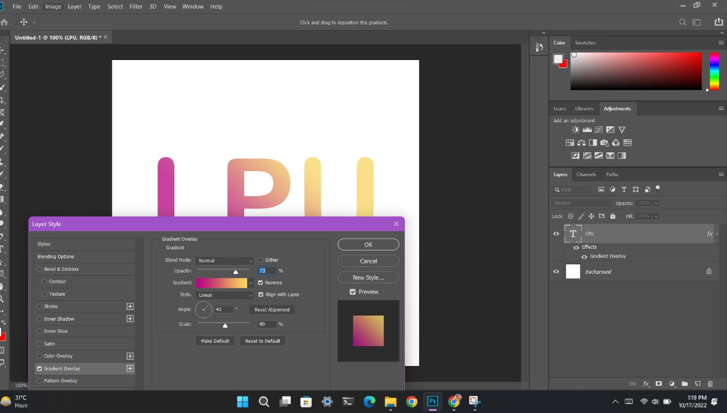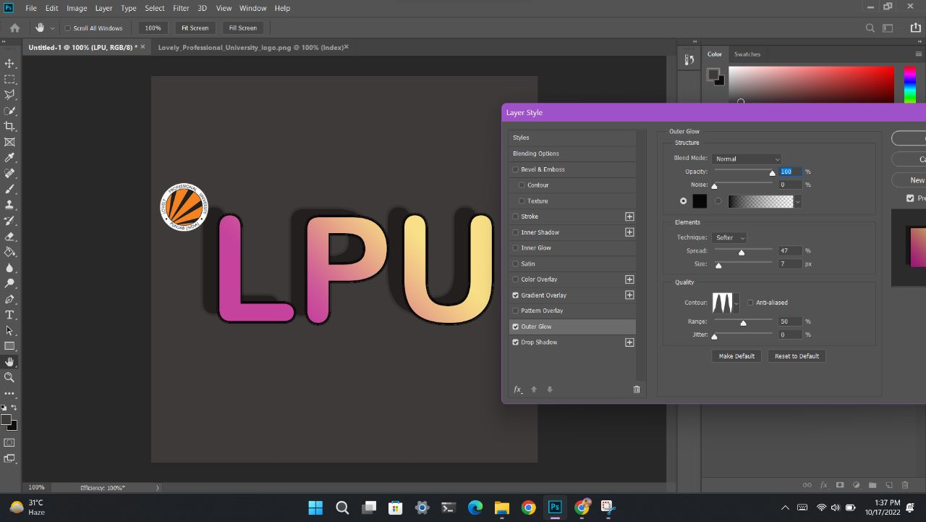

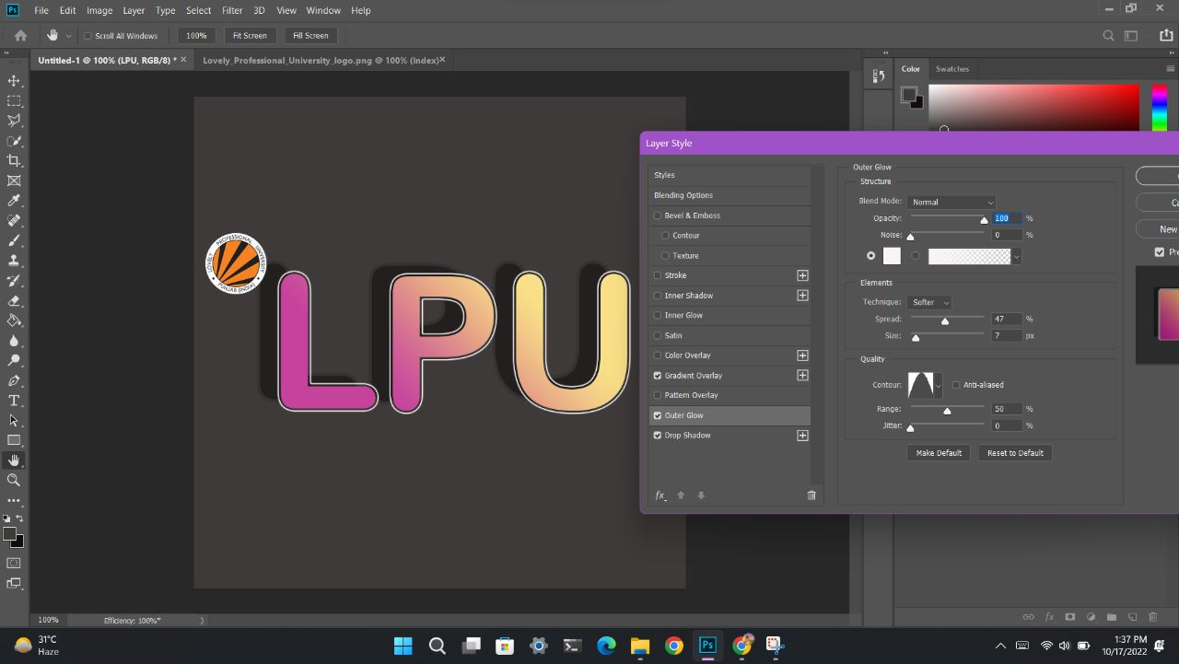

Q2 – Design a banner for pormotion of annual function of your university by use of different photoshop tools.

Step 1 = Add a product image into the banner  
Step 2 = Resize image to fit the banner  
Step 3 = Change Background color

Step 4 = Color the Background  
Step 5 = Add some text to the banner  
Step 6 = Add a button to the banner  
Step 7 = Save the banner of promotion in JPG File and Banner design Template