Data Acquisition System

Power Supply : A 12 V Li ion (or li po. Not sure) rechargeable battery is used. The battery can power t Data acquisition system for up to 7 hours continuously with full charge. The battery was incorporated to keep the DAQ an independent unit on the car.

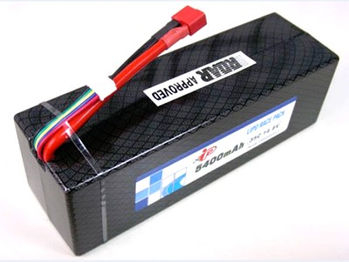

Power Card: The output of the power card is 3.3 V and 5 V. The voltages were chosen because

1. The dspic controller works on 3.3V
2. The ICs work on 5V supply

All the sensors are given 3.3V as supply voltage.

Parallel Port connectors are used to make the wiring and connections neater and less troublesome.

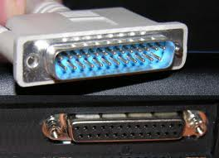

The Main Control board:

DAQ uses Dspic microcontroller. Some specification of the controller is shown below

Dspic33fj128gp706a

**Device Pins: 64**

**Program : 128Kb**

**Flash:**

**Memory**

**(Kbyte)**

**RAM**

**(Kbyte)(1)**

**16-bit Timer**

**Input Capture**

**Output Compare**

**Std. PWM**

**Codec**

**Interface**

**ADC**

**UART**

**SPI**

**I2C™**

**Enhanced**

**CAN**

**I/O Pins (Max)(2)**

**Packages**

The data collected from the sensors is analog in nature. The data is then converted into digital data using the ADC. The resolution of the system is 0.8mV.The data is then calibrated using equations which are acquired using Matlab. The data is then stored in Flash drive and is also seen on hyper terminal wirelessly.

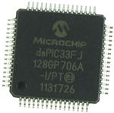

Modes of Logging Data:

1. USB Flash Drive using VINCULUM V Drive 2

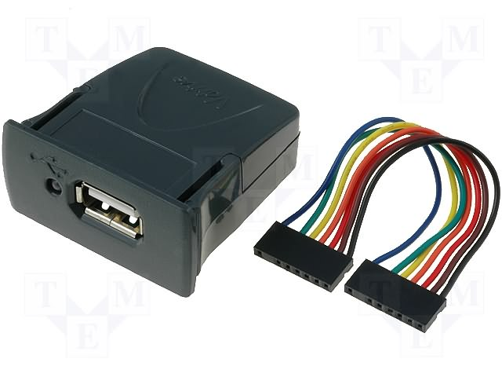

The Data from the Adc is stored in the Vdrive using Uart protocol. The baud rate for data transmission was set at 230400 for 4 channels. For the channels to be increased from 4 to 18 the baud rate was sacrificed and brought down to 38400.

The data acquired is stored in the USB flash drive in the form of an excel sheet in .xls format which can be easily viewed and analyzed.

2)Telemetry using X bee.

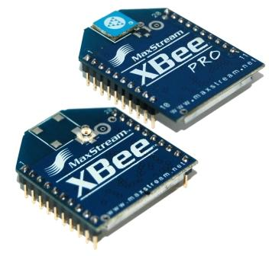

The data is seen live on the hyper terminal using xbee and the baud rate of the xbee was kept at 57600 even after changing the number of channels.

Indoor/Urban Range Up to 100 ft (30 m) Up to 300 ft. (90 m), up to 200 ft (60 m) International

variant

Outdoor RF line-of-sight Range Up to 300 ft (90 m) Up to 1 mile (1600 m), up to 2500 ft (750 m)

international variant

Transmit Power Output

(software selectable) 1mW (0 dBm) 63mW (18dBm)*

10mW (10 dBm) for International variant.

The data is also seen on the GUIs which are made on Labview. They are used for the ease of Analyzing.