**CHAPTER 2: BATTERY**

**System Needs**

**ECU MoTec M400**

* The power is distributed among the fuel pump, ignition coils and injectors, and ignition module.
* The fuel pump consumes 8 amps @ 12 Volts to maintain fuel pressure at 50 psi.
* The injectors’ ohm values lie between 11.9 to 12.1 ohms. Considering 12.1 ohms resistance and battery voltage of 13.7 volts at idle, the average current consumed will be 1.13 amps.
* The ignition coils consumes 6 amps of current at every spark cycles.
* Total 15.13 amps of current is required.

**Cooling System**

* The cooling system consists of 2 motors; one used for the radiator fan and the second used as a water pump.
* The water pump motor is run at 5.7amps.
* The radiator fan motor consumes 5.5 amps
* Total 11 .2 amps of current is required.

The current required for gear position system and SLM consumes maximum 3 amps of current.

The cranking current is typical 35 amps of current, but this much current is needed only at the time of cranking. Therefore of 35 amps of current is required for 2 to 3 seconds.

Total maximum of 29.33 amps of current is needed for all systems to work properly.

During the testing sessions once the alternator was failed. Testing logs are as shown in fig.1

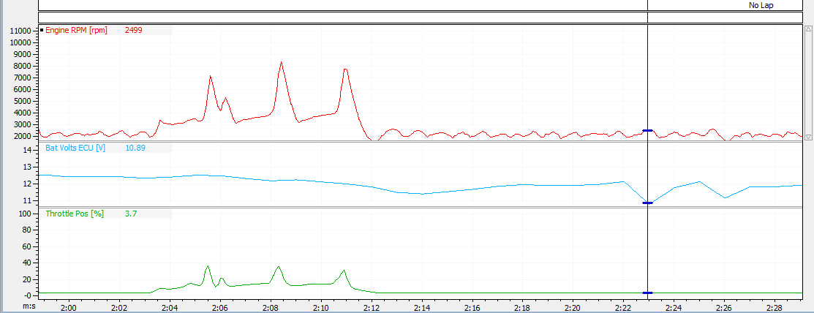

Fig.2.1

In case of accidental improper function of alternator, battery is supposed to provide 29.33 amps of current. Considering 96 seconds for one lap, 18 laps will takes 1728 seconds that is 28.8 minutes to complete the event. So battery is supposed to give at least 29.33 amps of current. Therefore we decided to use a 21 Ah battery which will be able to supply 42 ampere of current which will ensure the event gets completed with alternator failure.

The battery is placed between primary and secondary fire wall, and we have provision to remove the secondary fire wall as shown in the fig.2. Hence the battery can be easily accessed from outside after the removal of driver seat.

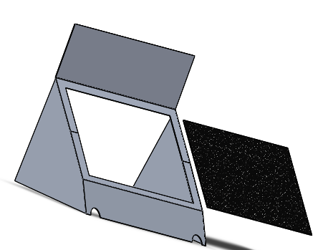

Fig.2.2

By giving the easy access to the battery, the debugging is also easy. So the debugging time gets reduced.

**THE DECISION OF SELECTING LITHIUM ION BATTERY**

The battery used in most cars is lead acid batteries but these prove to be too heavy for a formula student race car. Batteries need to be lighter and compact for better weight reduction and still provide the needed performance. The batteries need to be rechargeable through a rectifier connected to the alternator of the engine. Hence to justify our battery selection various decision and analysis were made.

**Battery Selection Criteria**

* Battery Weight : **Lesser the better**
* Battery Capacity (AH) : **More the better**
* Battery Discharge rate (Amp) : **Less the Better**
* Battery Cost : **Less the better**
* Battery Size (Volume) : **Less the better**

The Ah number indicates how many amps (how much current) a battery can supply over a given period of time. It's sort of the gas gauge of a battery's fuel tank. The higher the number, the more likely the battery will deliver prolonged performance.

We made a decision matrix as shown below to give weightages to the parameters which were more important than the other.

|  |  |  |  |  |  |
| --- | --- | --- | --- | --- | --- |
|  | weight | Discharge | cost | size |  |
| Weight | 1 | 1 | 1 | 0 |  |
| discharge | 1 | 1 | 0 | 0 |  |
| Cost | 1 | 0 | 1 | 0 |  |
| Size | 0 | 0 | 0 | 1 |  |
| Total | 3 | 2 | 2 | 1 |  |
| weightage | 37.5 | 25 | 25 | 12.5 |  |
|  |  | Table.2.1 |  |  |  |
|  |  |  |  |  |  |
| Chemistry | weight | Discharge | cost | size |  |
| Lead Acid | 0 | 0 | 1 | 0 |  |
| Lithium-iron | 1 | 1 | 0 | 1 |  |
|  |  |  |  |  |  |
| Weighted | Weight | Discharge | Cost | Size | Total Score |
| Lead acid | 0 | 0 | 25 | 0 | 25 |
| Lithium-iron | 37.5 | 25 | 0 | 12.5 | 75 |

Table.2.2

Here in table.1 we gave weightages to the parameters. The weightage points have been normalizes to a total of 100 points.

In table.2 we have compared Lead Acid Battery with the Lithium-ion battery. These batteries were found suitable by us for automotive use.

Adding up the scores from table one and two, we can see that the weightage total of the scores for Lithium-iron is higher than lead acid battery by 50 points. Advanced chemistry batteries include LiFePO4 batteries and Li Ion batteries. Batteries of these chemistries were found suitable by us for automotive use. Adding up the scores from table one and two, we can see that the weightage total of the scores for advanced chemistry is higher than lead acid battery by 50 points. Thus we justified the use of Advanced Chemistry batteries.

Shorai and braille were the two reliable batteries which we found suitable for automotive use. A comparison of shorai with the braille battery is as shown below. We have represented advanced chemistry batteries with the braille battery.

|  |  |  |  |  |  |  |  |
| --- | --- | --- | --- | --- | --- | --- | --- |
| battery chemistries | Weight | discharge | | cost | size |  | |
| LiFePO4 (Shorai) | 1 | 0 | | 1 | 1 |  | |
| Li Ion (Braille) | 0 | 1 | | 0 | 0 |  | |
| TOTAL | 1 | 1 | | 1 | 1 |  | |
| WEIGHTAGE | 25 | 25 | | 25 | 25 |  | |
|  |  | Table2.3 | |  |  |  | |
|  |  |  | |  |  |  | |
| Weighted | Weight | Discharge | Cost | | Size | Weighted Score |
| LiFePO4 (Shorai) | 25 | 0 | 25 | | 25 | 75 |
| Li Ion (Braille) | 0 | 25 | 0 | | 0 | 25 |

Table.2.4

Thus we have selected SHORAI LFX21A6-BS12. This battery weighs 1410 grams which is 740 grams higher than previous year’s battery. This was the compromise made in the battery selection procedure.

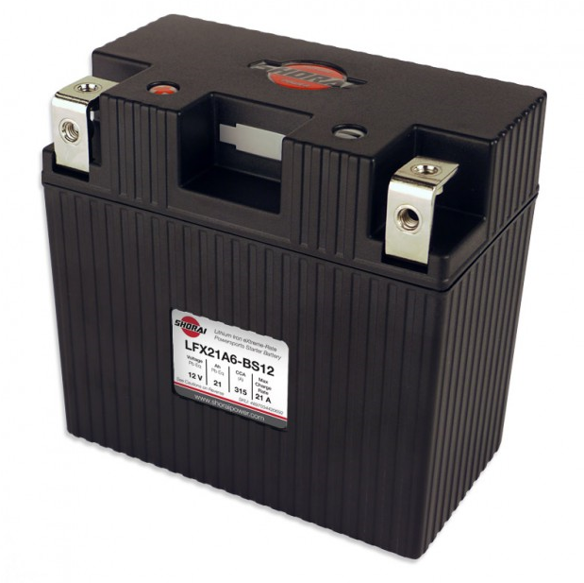

Advantages of using the selected battery:

* Ultra-light. One Fifth the weight of convectional batteries on average (1.41 kg/7.11kg)
* Zero sulfation, for longer service life
* More current for burst: (315 Amps)
* Military spec Carbon Composite Case
* Fast charging for better cranking
* No explosive gasses during charge
* No need of using a BMS