**Chapter 5**

**Sensors and Calibration**

**List Of Sensors on the car:**

- Accelerometer

- Air temperature sensor

- Brake pressure

- Engine temperature

- Exhaust gas temperature

- Fuel pressure sensor

- Lambda sensor

- Magnetic Sensor

- Oil pressure sensor

- Shock Travel Sensor

- Throttle position sensor

- Tire temperature

- Wheel Speed sensor

**1. Accelerometer (Capacitive 3 - axis):**

By virtue of its dimensions, characteristics and compatibility with gyroscopes, this 3 axis accelerometer allows the dynamic behaviour of the vehicle to be interpreted and checked.

The temperature compensation between - 20°C and 100°C allows the accelerometer to be used in extreme conditions.

This capacitive type 3 axis accelerometer, with a frequency range of up to 100 Hz, allows measurement of the acceleration of the constituent parts of the vehicle. The measuring range is from -5g to +5g.

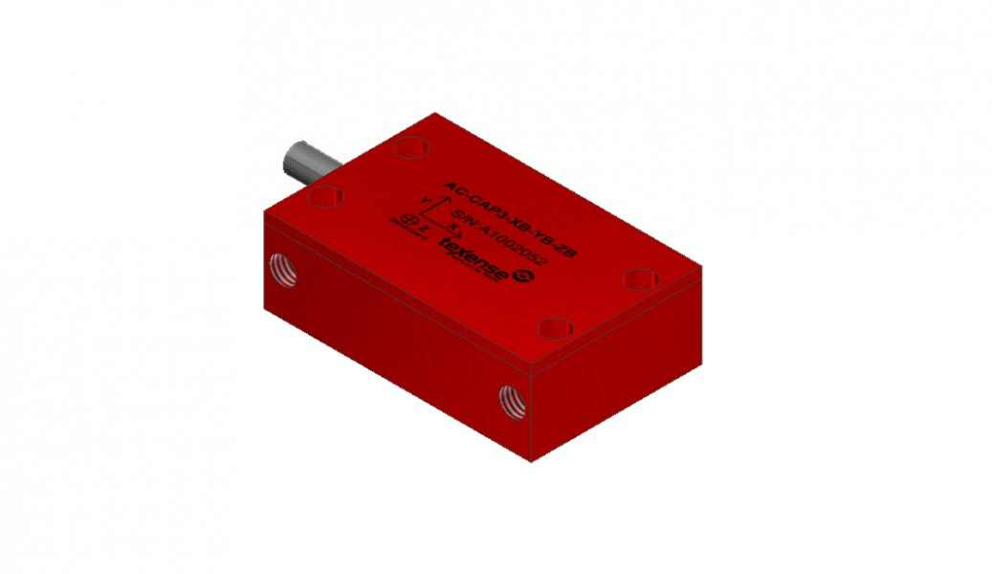

**Fig 5.1.a**

**3-axis Accelerometer**

**Calibration:**

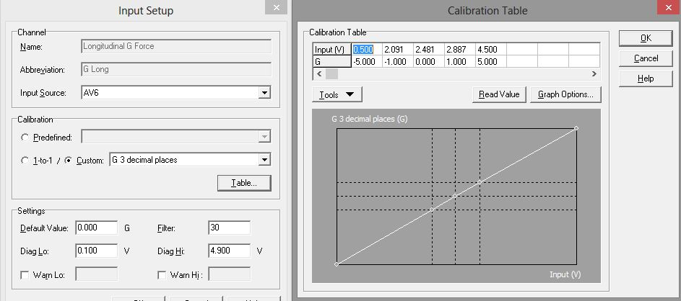

**Fig 5.1.b**

**Longitudinal G Force Calibration**

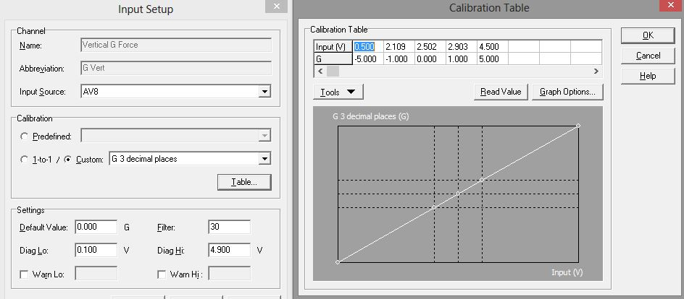

**Fig 5.1.c**

**Vertical G Force Calibration**

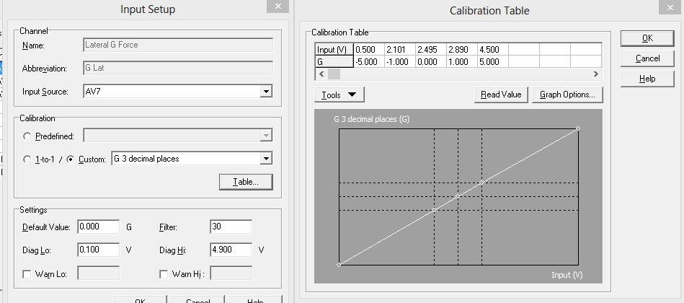

**Fig 5.1.d**

**Lateral G Force Calibration**

**Logged Data:**

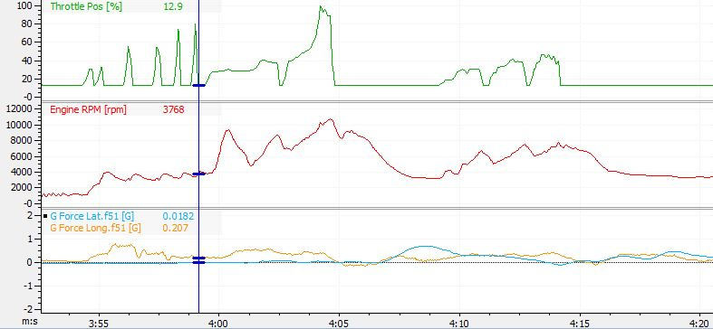

**Fig 5.1.e**

**Lateral & longitudinal G logged data**

**2. Air Temperature Sensor:**

Air temperature sensor is a part of the AIE (air intake & exhaust) system on a car and is used to convert the engine intake air temperature into a voltage, which it then inputs into the engine control unit (ECU).

The engine control unit then uses this data to correct the rate of fuel injection to ensure the optimal use of fuel.

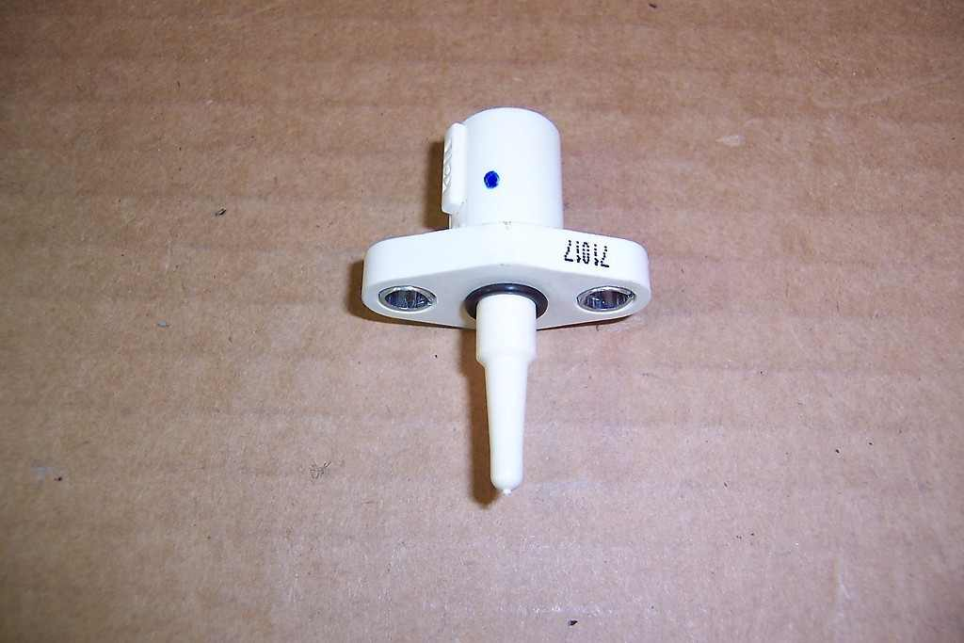

**Fig 5.2.a**

**Inlet Air Temperature Sensor**

**Calibration:**

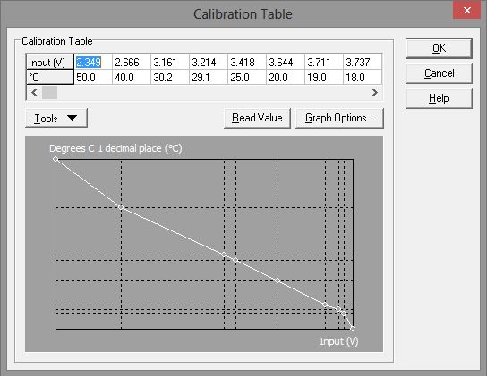

**Fig 5.2.b**

**Air Temperature Sensor calibration table**

**Logged Data:**

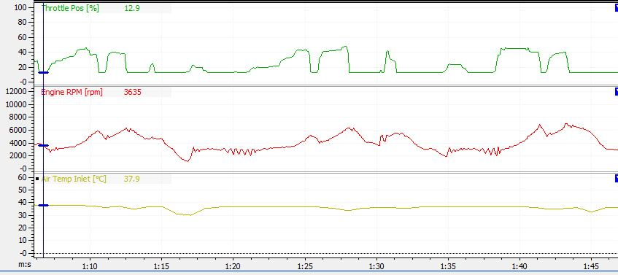

**Fig 5.2.c**

**Air Temperature Sensor logged data**

**3. Fluid Pressure Sensor (Brake/Fuel/Oil):**

The pressure sensor gives voltage change with a change in fluid pressure. This sensor is used a brake pressure sensor, fuel pressure sensor and oil pressure sensor. The sensor used for different purposes is calibrated in the ECU.

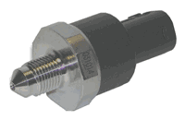

**Fig 5.3.a**

**Pressure Sensor**

**Calibration:**

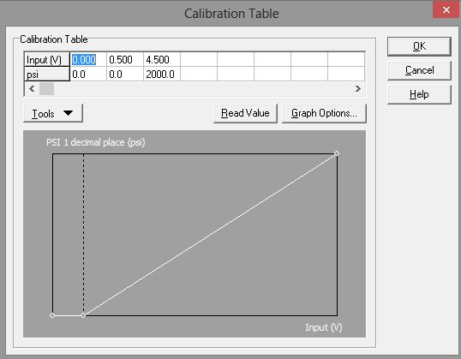

**Fig 5.3.b**

**Brake Pressure Calibration**

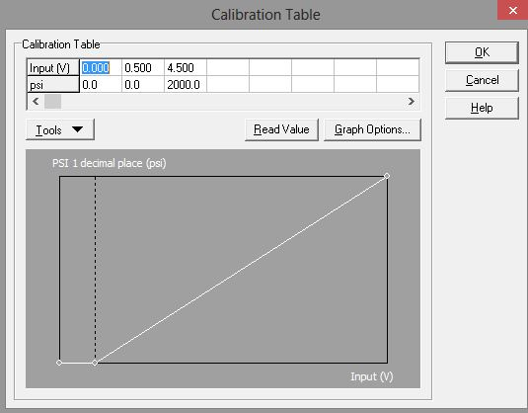

**Fig 5.3.c**

**Fuel Pressure Calibration**

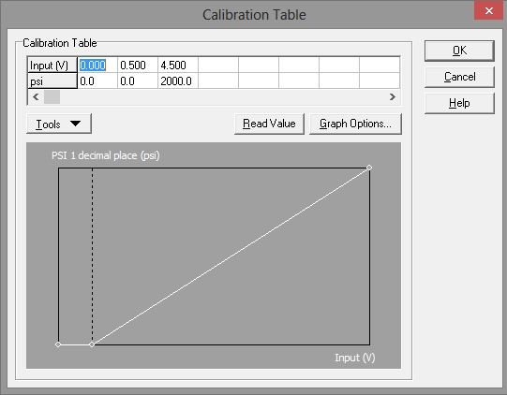

**Fig 5.3.d**

**Oil Pressure Calibration**

**Logged Data:**

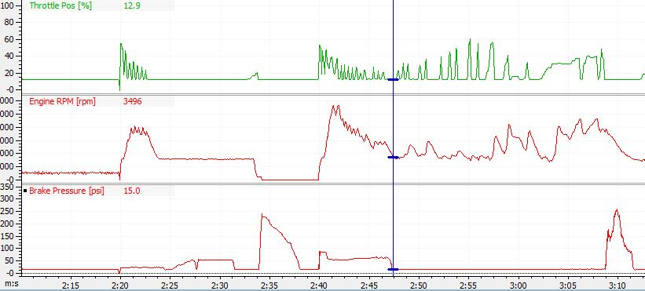

**Fig 5.3.e**

**Brake Pressure Sensor logged data**

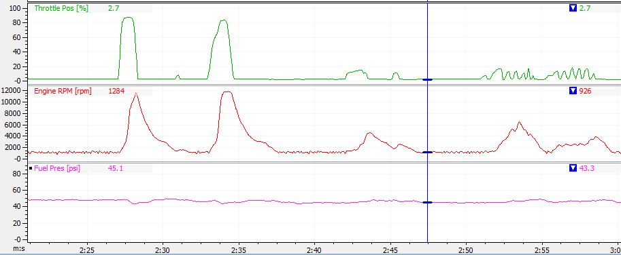

**Fig 5.3.f**

**Fuel Pressure Sensor logged data**

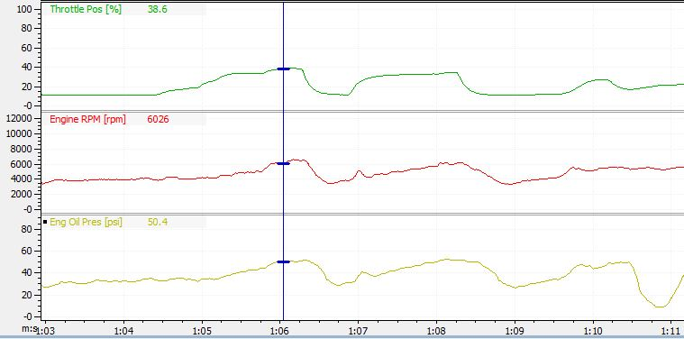

**Fig 5.3.g**

**Oil Pressure logged data**

**4. Engine Temperature Sensor:**

An Engine Temperature Sensor (ETS) is a sensor that is screwed into the engine's block or cylinder head and is used to determine the temperature of the engine coolant. The sensor is basically a thermistor that changes resistance with temperature.

When the ETS is high (hotter), the resistance is low, and when the ETS is low (cooler) the resistance is high. This resistance reading is sent to the vehicle's ECU and can be used to activate emission controls or turn the engine's cooling fan on. The ETS sensor is usually a two wire sensor that uses a 5 volt reference from the ECU with a ground signal back to the ECU.

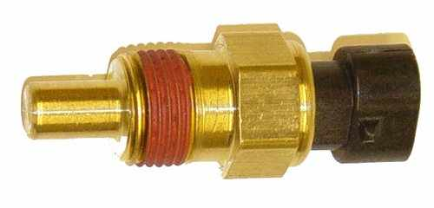

**Fig 5.4.a**

**Engine Temperature Sensor**

**Calibration:**

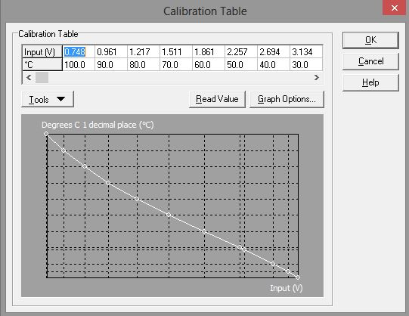

**Fig 5.4.b**

**Engine Temperature Sensor Calibration**

**Logged Data:**

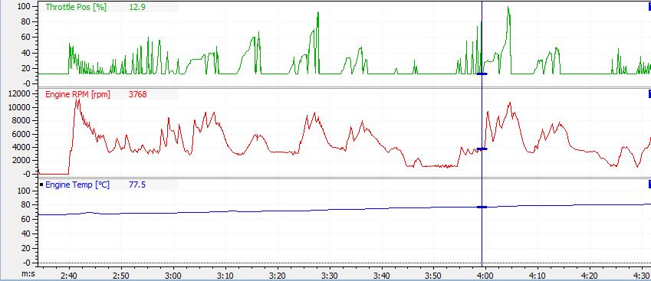

**Fig 5.4.c**

**Engine Temperature logged data**

**5. Exhaust Gas Temperature:**

EGTs are resistance sensors whose resistance changes with change in temperature.

The resistance change cause voltage change and this voltage is calibrated in terms of temperature.

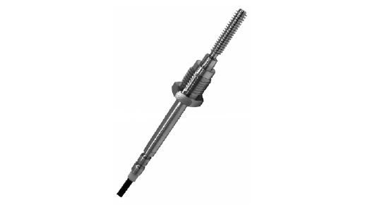

**Fig 5.5.a**

**Exhaust Gas Temperature Sensor**

**Calibration:**

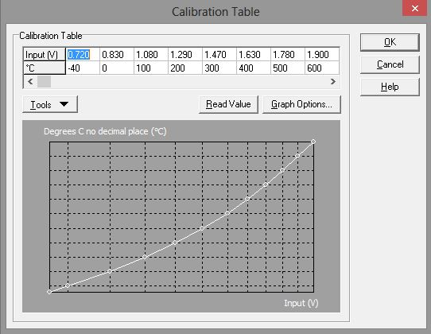

**Fig 5.5.b**

**EGT Calibration**

**Logged Data:**

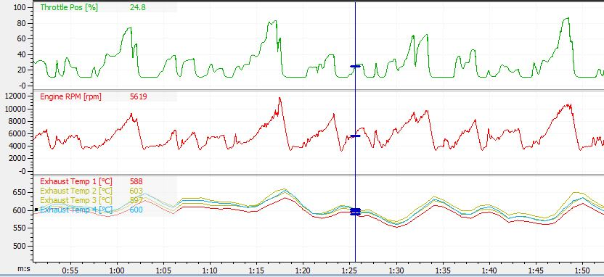

**Fig 5.5.c**

**EGT logged data**

**6. Lambda Sensor:**

A lambda sensor is an electronic device that measures the proportion of oxygen (O2) in the liquid being analysed. It is generally used for Air Fuel Ratio measurement, which may be used for data logging or closed loop control of the Air Fuel Ratio.

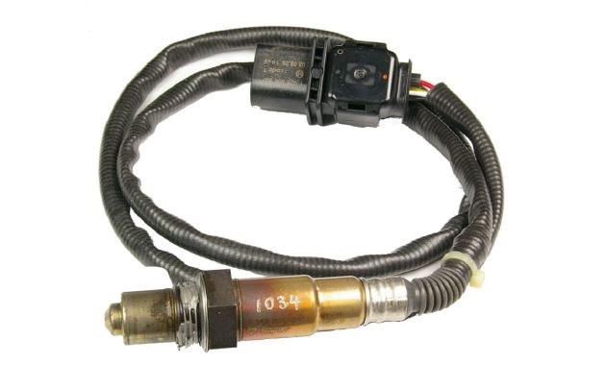

**Fig 5.6.a**

**Lambda Sensor**

**Logged Data:**

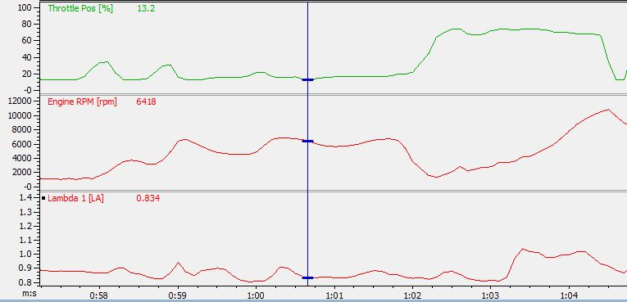

**Fig 5.6.b**

**Lambda Sensor logged data**

**7. Magnetic Sensor:**

The Main Engine Sensors are required for correct operation of the ECU.

The engine RPM is derived from the REF trigger sensor.

The SYNC trigger sensor is required to synchronise the Fuel and Ignition to

the correct engine cycle for sequential injection and correct firing of multicoil

ignition systems.

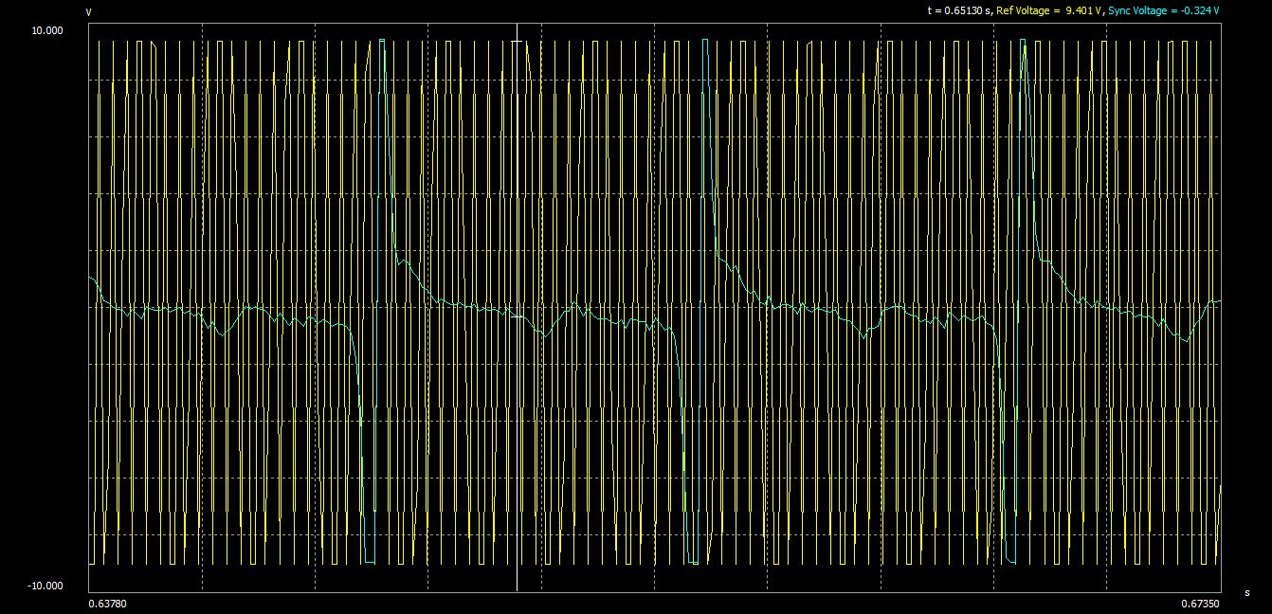

**Fig 5.7.a**

**Ref & Sync Capture**

**8. STS (Shock Travel Sensor):**

Shock travel sensors are linear potentiometers with very high sensitivity and accuracy. The shock is measured by the change in voltage produced by the sensor.

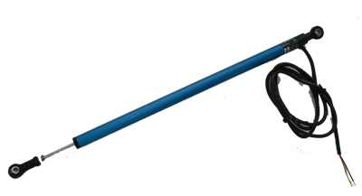

**Fig 5.8.a**

**Shock Travel Sensor**

**Calibration:**

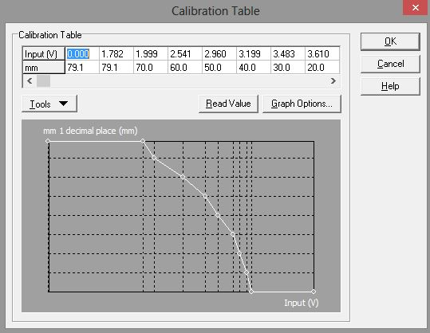

**Fig 5.8.b**

**STS Calibration**

**Logged Data:**

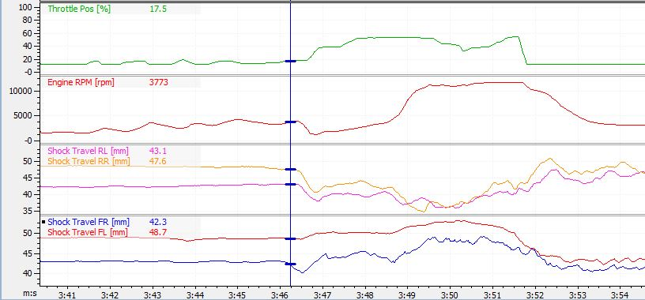

**Fig 5.8.c**

**STS logged data**

**9. Throttle Position Sensor (TPS):**

A throttle position sensor is used to monitor the position of the throttle in the car. The throttle position sensor acts as a load efficiency point for fuel map tuning.

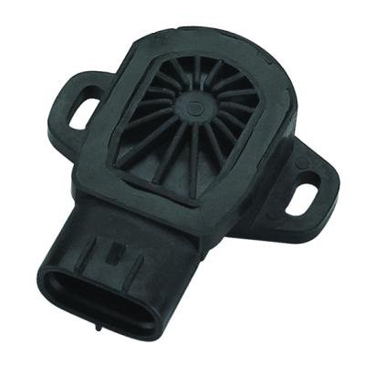

**Fig 5.9.a**

**Throttle Position Sensor**

**10. Tire Temperature sensor:**

In order to measure the temperature of the surface of the tire, without affecting the tire, a non‐contact temperature sensor was needed. Many tire temperature sensor arrays are available commercially, which are designed for use with commercial Data Acquisition systems, costing over 200 dollars per sensor. A more cost effective solution was found from Melexis. The MLX90614 infrared temperature sensor has a built in 16‐bit ADC, in a package that is less than 10 mm in diameter. The standard model measures surface temperatures in a 90 degree cone emanating from its center. By placing the sensors approximately 1.5 to 2 inches away from the surface of the tire, three MLX90614 sensors can be aimed at the surface of the tire with no overlap in order to measure the temperature in three radial bands around the inside, middle, and outside of the tire surface.

The MLX90614 an I2C interface to communicate with the microcontroller. This method of interface requires only two wires in addition to the power and ground wires for the sensor. Additionally, the two communication wires are common to all sensors on the I2C bus, which allows the sensors to be daisy chained in line, whereas the SPI interface on the MCP320X ADC chips requires a chip select signal unique to each chip in addition to its 3 common communication lines. The MLX90614 is precise to ±0.02 Celsius, which is more than necessary for noting the difference in temperature on the tire.



**Fig 5.10.a**

**Tire Temperature Sensor**

**Calibration:**

The MLX90614 infrared temperature sensors report their values in a 16‐bit unsigned value. Each tick here is the equivalent of 0.02 Kelvin. In order to scale the value from the raw data form into Celsius degrees the following operation is performed:

Temperature Sensor scaling calculation

[(unsigned reading) ∗ 0.02] − 272.0 = Celsius degrees

This allows the temperature gradient across the tire to be easily seen as differences as slight at 0.02 degrees Celsius are recorded.

**Logged Data:**

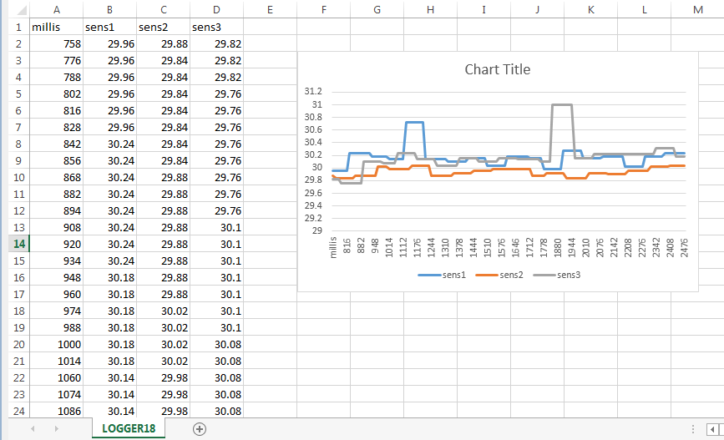

**Fig 5.10.2**

**Tire Temperature Logged Data**

**11. Wheel Speed Sensor:**

A wheel speed sensor or vehicle speed sensor (VSS) is a type of tachometer. These sensors are mounted 1.5mm away from the tires to monitor the wheel speed.

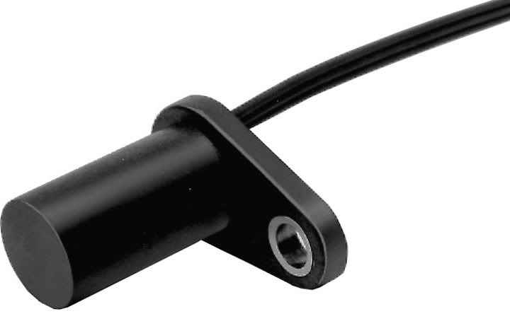

**Fig 5.11.a**

**Wheel Speed Sensor**

**Calibration:**

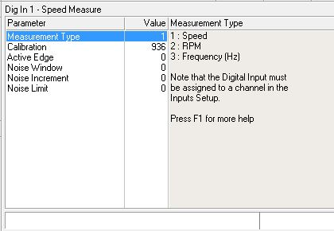

**Fig 5.11.b**

**Wheel Speed sensor calibration**

**Logged Data:**

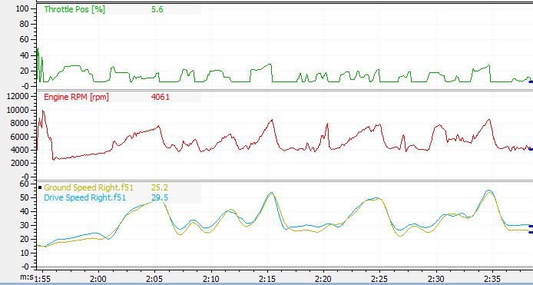

**Fig 5.11.c**

**Wheel Speed sensor logged data**