**CHAPTER 1: ECU AND WIRING**

**1.1 Introduction and scope:**

This report discusses the entire engine and sensor wiring of the car. It includes entire electrical system of the car, their design methodology, selection, wiring loom fabrication and final implementation on the car.

**1.2 Goals:**

The main and primary goal was to ensure that the wiring does not hamper the performance of the car in any way. Whilst ensuring this, important factors such as wiring weight, cost and volume had to be controlled. Also, the system needed to be designed to ensure easy and quick trouble shooting, especially on field fixing of faults during testing.

**1.3 Custom Wiring Harness:**

The wiring harness to be used was determined on the ECU to be used. A MoTeC M400 ECU is used on the car and thus a completely custom wiring harness was needed to be designed. The custom harness was designed keeping in mind the specifications of the ECU.

**1.4 Electronic casing:**

The engine control unit along with the sensor hub and the power distribution module is placed in an enclose box like structure. The decision of shifting the system behind the firewall was taken to provide better ventilation and avoid overheating of the ECU and other electronics components. The temperature of the casing internally during testing was measured to be about 70 degrees under a hot summer sun and the car running for over an hour. The electronics casing made it possible to make sub harnesses as we would have to use connectors to pass wires through the casing wall. This avoided the sub-harnesses to be directly wired. Sub harness greatly simplify replacing faulty/damaged harness without having to make changes to the main harness without adding too much weight. The wiring inside the case interfaced the ECU pins with the connectors located on the surface of the casing. Thus the composite team helped us by manufacturing a glass fibre casing. This was made of fibre-glass so as to avoid any possibility of the casing conducting if it was made of carbon fibre.

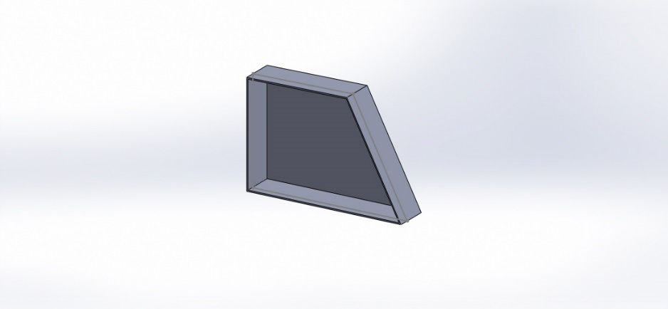

Figure: 1.1: Electronic Casing

The position of the electronic casing was very carefully decided keeping the factors in mind such as ease of access, keeping the entire casing near the shoulder level of the driver also gives easy access to all of the electronics from the car again and again. Also the casing is placed such that the wire lengths are kept minimum so as to reduce the losses if any, ideally the ECU is to be kept near to the engine. And lowest position possible to keep the centre of gravity as low as possible, thus the casing is placed behind the fire wall in the main roll hoop bracing as shown in the figure.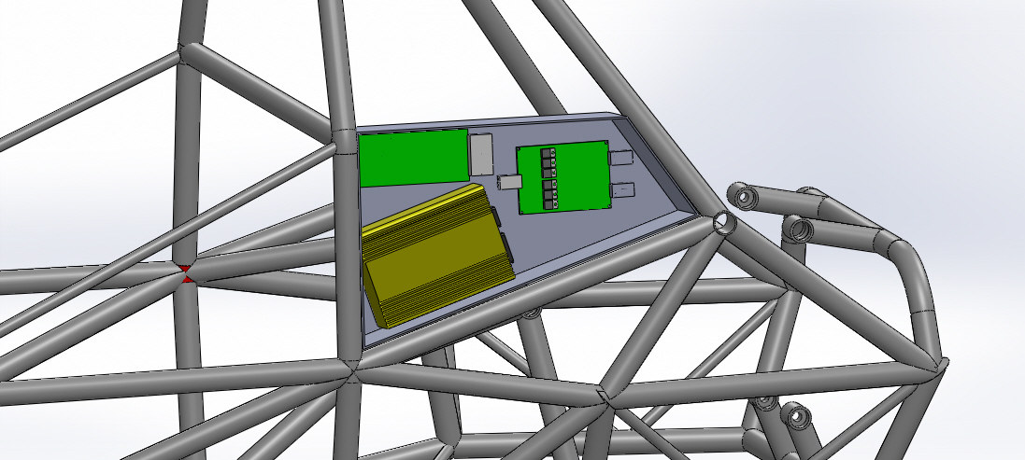

Figure 1.2: Electronic casing position

**1.5 Components inside the casing:**

**1.5.1 ECU:**

We use a MOTEC M400 engine management system as it provides a very advanced, simple and user friendly interface. This helps to make changes to current file or make entirely new file containing the custom fuel map and ignition map which can be easily modified.

M400 is capable of logging data up to 512MB of memory. It can log 64 channels at maximum speed of 200Hz. It also give 8 auxillary outputs, which are used to control the components such as cooling fan and pump, fuel pump and lambda heater. We also use the engine temperature compensation for cold starting.

**1.5.2 SENSOR HUB:**

A printed circuit board based sensor hub is developed so that the process of interfacing various sensors to the ECU becomes easy. ECU has 8 analog voltage channel inputs, 6 analog temperature inputs and four digital inputs which are used extensively for interfacing sensors such as shock travel sensor, steering angle, throttle position sensor, gear position sensor, fluid pressure sensors and accelerometer on the analog voltage channel; engine temperature and exhaust gas temperature sensors in analog temperature channel and wheel speed sensors in digital channel.

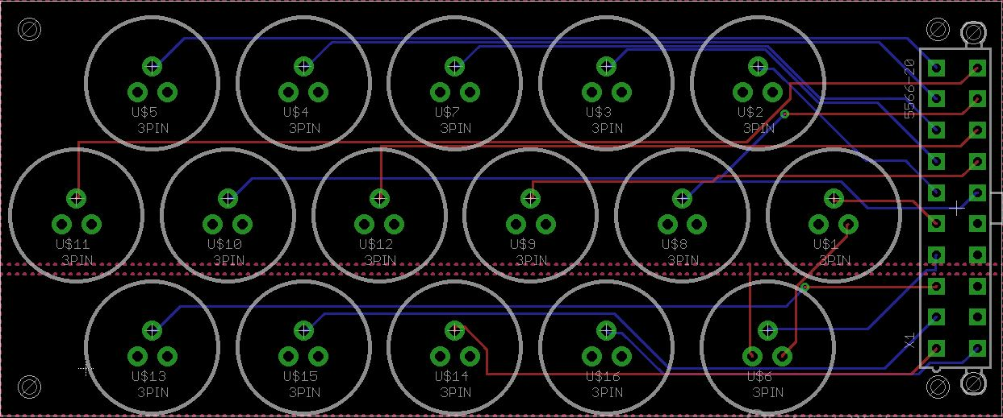

Figure:1.3: Sensor hub board file

All these sensors can be selectively interfaced with the ECU as and when needed. The sensor hub is made in a panel form so that the connectors can be installed easily and are easy to recognize.

**1.6 Connectors:**

The connectors which we decided to use on the car were high quality Deutsch connectors which are light weight, sturdy, water proof and also easy to install. We selected the connectors based on various criteria like the number of wires to be carried by the connectors and also the current rating of the connector and the type and size of crimps the connectors accepts.

The Deutsch connectors have a propriety crimping tool and crimps which are sized for different gauges of wires connectors. The crimps get punched from four sides by the crimper, thus ensuring reliable connectivity at all times.

**1.7 Wires:**

The entire wiring harness was divided into sub harness which can be easily disconnected. These sub harnesses include

* Ignition
* Injector
* Lambda
* Primary Sensors
* Dashboard
* Auxiliary Outputs
* PDM Signals and Outputs
* UTC (CAN-USB)

The selection of wires was done keeping in mind the colour coding and naming to be done. Also the amount of current they will carry is taken into consideration. All the wires are named as well as colour coded. The wiring of the car is divided into three groups – ECU wiring, dash board + wiring and power wiring. The table below shows the wire name, its colour, gauge and the current carrying capacity.

**1.7.1 ECU wiring:**

|  |  |  |  |
| --- | --- | --- | --- |
| NAME /FUNCTION | COLOUR | GAUGE | CURRENT CAPACITY |
| A1 /AUX-2 | ORANGE | 22 | 5 |
| A2 / 5V ENG | RED | 22 | 5 |
| A3 / IGN-1 | YELLOW | 22 | 5 |
| A4 / IGN-2 | ORANGE | 22 | 5 |
| A5 / IGN-3 | WHITE | 22 | 5 |
| A6 / IGN-4 | PURPLE | 22 | 5 |
| A13 / 8V AUX POWER | RED | 22 | 5 |
| A14 / AV1 | BLUE | 22 | 5 |
| A15 / AV2 | GREEN | 22 | 5 |
| A16 / AV3 | GREEN | 22 | 5 |
| A17 / AV4 | GREEN | 22 | 5 |
| A18 / AUX-1 | WHITE | 22 | 5 |
| A19 / INJ-1 | WHITE-BROWN | 18 | 9 |
| A20 / INJ-2 | WHITE-RED | 18 | 9 |
| A21 / INJ-3 | WHITE-BLUE | 18 | 9 |
| A22 / INJ-4 | WHITE-GREEN | 18 | 9 |
| A23 / AUX-3 | ORANGE | 22 | 5 |
| A24 / AUX-4 | ORANGE | 22 | 5 |
| A25 / AV5 | GREEN | 22 | 5 |
| A26 / 12V | WHITE-RED | 20 | 6 |
| A31 / AUX-5 | ORANGE | 22 | 5 |
| A32 / AUX-6 | ORANGE | 22 | 5 |
| A33 / AUX-7 | ORANGE | 22 | 5 |
| A34 / AUX-8 | ORANGE | 22 | 5 |
| B1 / REF | BLUE | 22 | 5 |
| B2 / SYNC | PURPLE | 22 | 5 |
| B3 / AT1 | GREY | 22 | 5 |
| B4 / AT2 | PURPLE | 22 | 5 |
| B5 / AT3 | YELLOW | 22 | 5 |
| B6 / AT4 | YELLOW | 22 | 5 |
| B7 / AT5 | YELLOW | 22 | 5 |
| B8 / DIG1 | BROWN | 22 | 5 |
| B9 / DIG2 | BROWN | 22 | 5 |
| B10 / DIG3 | BROWN | 22 | 5 |
| B11 / DIG4 | BROWN | 22 | 5 |
| B15 / 0V AUX POWER | BLACK | 22 | 5 |
| B16 / 0V ENGINE | BLACK | 22 | 5 |
| B19 / AT6 | YELLOW | 22 | 5 |
| B20 / AV6 | GREEN | 22 | 5 |
| B21 / AV7 | GREEN | 22 | 5 |
| B22 / AV8 | GREEN | 22 | 5 |
| B23 / CAN HI | WHITE | 22 | 5 |
| B24 / CAN LO | GREEN | 22 | 5 |
| B25 / LA 1S | BLACK | 22 | 5 |
| B26 / LA 1P | RED | 22 | 5 |
| INJECTOR SUPPLY | RED-WHITE | 18 | 9 |
| IGN1-CYL1 | GREEN | 18 | 9 |
| IGN2-CYL2 | WHITE | 18 | 9 |
| IGN4-CYL3 | YELLOW | 18 | 9 |
| IGN3-CYL4 | BROWN | 18 | 9 |

Table 1.1: ECU wiring

**1.7.2 DASH BOARD WIRING:**

|  |  |  |  |  |  |
| --- | --- | --- | --- | --- | --- |
| CONNECTOR PIN NO. | NAME / FUNCTION | FEMALE SIDE COLOUR | MALE SIDE COLOUR | GAUGE | CURRENT CAPACITY (AMP) |
| 1 | FAN ECU | BLUE | BLUE | 22 | 5 |
| 2 | FAN | BLUE/BLACK | BLUE | 22 | 5 |
| 3 | STARTOR | BLACK |  | 22 | 5 |
| 4 | IGNITION LED | YELLOW/BLACK |  | 22 | 5 |
| 5 | CAN HI | WHITE | WHITE | 22 | 5 |
| 6 | BRAKE LIGHT SIG | GREEN/BLACK | GREEN | 22 | 5 |
| 7 | B16 / 0V ENGINE | YELLOW/BLACK | YELLOW | 22 | 5 |
| 13 | PUMP ECU | PURPLE | PURPLE | 22 | 5 |
| 14 | PUMP | PURPLE/BLACK | PURPLE | 22 | 5 |
| 15 | COCKPIT KILL | ORANGE | ORANGE | 22 | 5 |
| 16 | 12 V SUPPLY | RED | RED | 22 | 5 |
| 17 | CAN LO | GREEN` | GREEN | 22 | 5 |
| 18 | GPS SIGNAL | PINK | ORANGE | 22 | 5 |
| 19 | 5 VOLT | RED / BLACK | BLACK | 22 | 5 |
|  | BOT | YELLOW |  | 22 | 5 |
|  | BOT CHASSIS GND | BLACK |  | 22 | 5 |
|  | BRAKE LIGHT GND | RED |  | 22 | 5 |

Table 1.2: Dashboard wiring

**1.7.3 Power wiring:**

|  |  |  |  |
| --- | --- | --- | --- |
| NAME / FUNCTION | COLOUR | GAUGE | CURRENT CAPACITY |
| BATTERY POSITIVE | RED | 6 | 37 |
| BATTERY NEGATIVE | BLACK | 6 | 37 |
| FUEL PUMP | BLUE | 16 | 12 |
| COOLING PUMP | BLUE | 18 | 9 |
| COOLING FAN | WHITE BLUE | 18 | 9 |
| STARTOR WIRE | BLACK | 4 | 60 |

Table 1.3: Power wiring