MyStreeT
Capstone demo guide (.NET Edition)
A step-by-step script for presenting the sneaker shopping application, mapped to the capstone requirements.
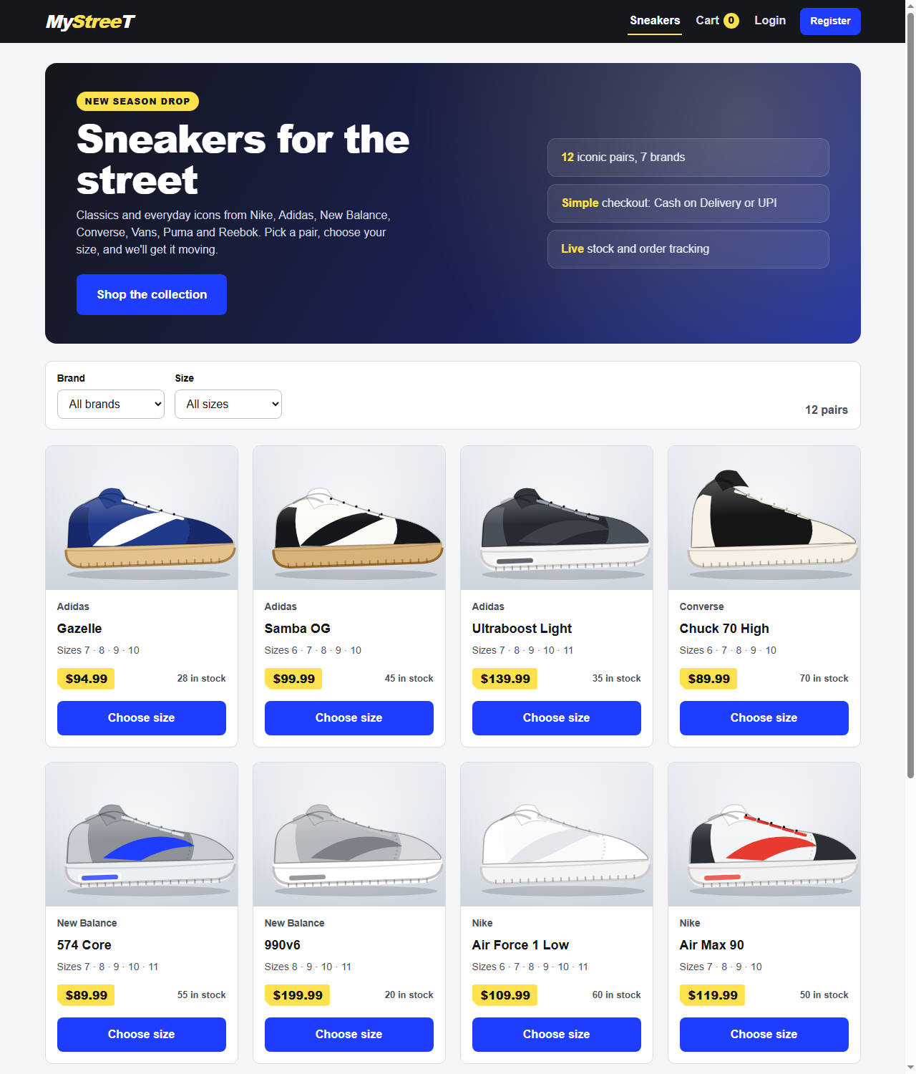

1. What you are demonstrating
MyStreeT is a full-stack sneaker store: a React + TypeScript + Vite single-page app talking to an ASP.NET Core 8 Web API with Entity Framework Core. Locally it runs on SQLite; SQL Server is supported by configuration.
- Shopper flow: browse, filter by brand and size, pick a size, cart, register or login, checkout (Cash on Delivery or Mock UPI), order confirmation, order history.
- Admin flow: log in as admin and create, edit and delete products.
- Engineering: controllers, services, DTOs, dependency injection, BCrypt, JWT, structured errors, xUnit/Moq/FluentAssertions tests, Swagger, Postman.

Architecture in 30 seconds
React UI (Context API for auth, cart and toasts; cart in localStorage) > HTTP/JSON with JWT > ASP.NET Core controllers > services > EF Core DbContext > SQLite / SQL Server.

2. Before the demo (do this 15 minutes early)
# | Check
1 | Install prerequisites: .NET 8 SDK and Node.js 20+. No database server is needed.
2 | In mystreet-api run dotnet restore; in mystreet-ui run npm install.
3 | Run dotnet test once (expect 90 passed) and npm test (expect 16 passed) so you have fresh evidence.
4 | To start from clean data, delete mystreet-api/mystreet.dev.db. It is recreated and seeded on startup.
5 | Open two terminals (API and UI), one browser window, and Swagger in a second tab.
6 | Import the Postman collection (postman/MyStreeT.postman_collection.json).

Demo accounts
Role | Email | Password
Admin | admin@mystreet.com | Admin@12345
Customer | demo@mystreet.com | Demo@12345
New user (you register) | me@test.com | Password123

3. Requirement coverage at a glance
Requirement | What is covered | Shown in | Status
A. Authentication | Register, login, logout, BCrypt, JWT | Steps 14, 18, 19 | Done
B. Product catalog | List with name, price, thumbnail; filter by brand and size; detail page | Steps 3, 5, 6, 7 | Done
C. Shopping cart | Add/remove, update quantity, total, localStorage, empty state | Steps 9 to 12 | Done
D. Checkout | Shipping form, COD / Mock UPI, payment always succeeds, status PLACED | Steps 13, 15, 16 | Done
E. Admin | CRUD: name, description, price, sizes, stock, image URL; admin-only | Steps 19 to 23 | Done
Order history, confirmation | Confirmation shows Order ID; My Orders | Steps 16, 17 | Done
Consistent error response | {timestamp, path, error, message} | Steps 15, 23 | Done
Architecture | Controllers, Services, EF Core, DTOs, DI; React hooks + Context | Steps 1, 4 | Done
Database | SQLite for local setup (allowed by the brief); SQL Server supported | Step 1 | Done
Testing | xUnit + Moq + FluentAssertions, 60% or more coverage | Step 24 | 90 tests; 81% methods, 69% lines
Documentation | README, Swagger, Postman collection, setup, trade-offs, AI notes | Sections 6 and 8 | Done
Concurrency (manual) | 5 to 10 concurrent requests, multiple tabs | Section 5 | Manual exercise

4. Demo script (follow in order, about 15 minutes)
# | Action | Expected result | Talking point
1 | Start the API: cd mystreet-api then dotnet run --launch-profile http | Console shows listening on :5080. SQLite file mystreet.dev.db is created and seeded (50 products, admin, demo user). | EF Core, idempotent seeding, per-environment config. SQLite locally; SQL Server is a config switch.
2 | Start the UI: cd mystreet-ui then npm run dev | Vite serves http://localhost:5173. | React SPA with a separate API; CORS allow-list.
3 | Open http://localhost:5173 | Hero banner and 50 sneakers (10 brands) with image, name, price, sizes, stock. | Data comes from GET /api/products (requirement: at least 8 seeded products).
4 | Open http://localhost:5080/swagger briefly | Swagger lists Auth, Products and Orders endpoints. | Controllers, Services, DTOs, DI; Swagger/OpenAPI docs.
5 | Brand filter: Nike | 9 Nike pairs; URL contains ?brand=Nike. | Server-side filter; URL as state.
6 | Brand = All, size filter: 11 | Only pairs offering size 11. | SizesCsv matched as ,11, so size 1 never matches 10.
7 | Open Air Max 90 | Large image, brand, description, price, size selector. | Route params; loading and not-found states.
8 | Click Add to cart without choosing a size | Friendly message asking for a size. | Client-side validation.
9 | Choose size 9, quantity 2, Add to cart | Toast shown; header cart badge = 2. | Context API with useReducer.
10 | Add Ultraboost size 8, open Cart, press + on a line | Line and grand totals update instantly. | Pure, unit-tested cart reducer.
11 | Refresh the browser | Cart and totals unchanged. | Cart persisted in localStorage.
12 | Remove all items, then add one back | Empty-cart state shown. | Empty-state acceptance criterion.
13 | Click Checkout while logged out | Redirected to Login; cart is kept. | Protected route with redirect-back.
14 | Register: me@test.com / Password123 | Signed in and returned to checkout. Refresh keeps you signed in. | BCrypt password hash, JWT, persisted session.
15 | Press Place order with an empty form | Field errors; nothing created. | Client and server validation.
16 | Fill shipping details, choose Mock UPI (or Cash on Delivery), Place order | Confirmation page with Order ID and status PLACED; cart badge back to 0. | Server recalculates prices; payment always succeeds (mock).
17 | My Orders, then open the order | Same order, items, shipping, total. | Ownership check on /api/orders/mine and /api/orders/{id}.
18 | Logout | Header shows Login and Register again. | Stateless JWT logout; POST /api/auth/logout.
19 | Login as admin: admin@mystreet.com / Admin@12345 | Admin menu appears. | IsAdmin flag mapped to an Admin role claim.
20 | Admin: Add product (save empty to show errors, then create Demo Runner, Nike, 129.50, sizes 8,9,10, stock 7) | Product appears in the admin table and in the public catalog. | Admin CRUD with validation.
21 | Edit the product: price 99 | Catalog shows $99.00 immediately. | PUT endpoint.
22 | Delete the product | Gone from admin table and catalog. | DELETE (soft delete if it already appears in an order).
23 | In Swagger, Authorize with a normal-user token and call POST /api/products | 403 with {timestamp, path, error, message}. | Backend authorization is enforced, not just hidden UI.
24 | Run dotnet test and npm test | 90 backend tests and 16 frontend tests pass. | xUnit, Moq, FluentAssertions; 81% method coverage.

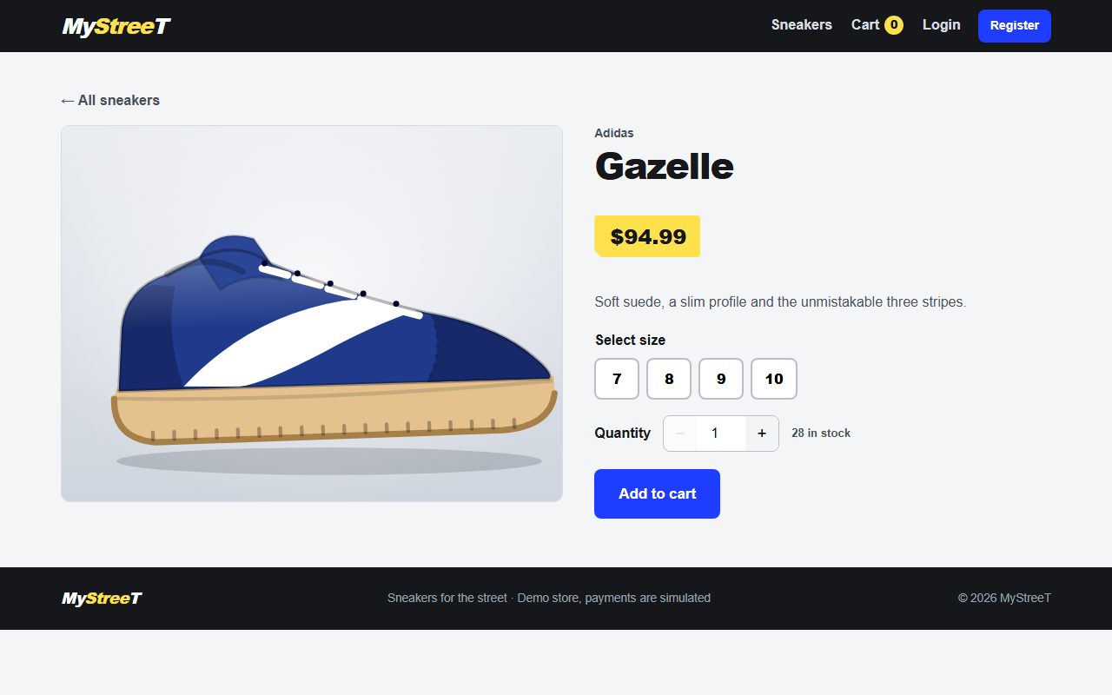
Product detail page: image, brand, price, size selector, quantity and Add to cart.

5. Concurrency and API checks (optional)
- Open two browser tabs, add the same item in both and place orders at the same time; stock is validated and decremented per order.
- Run the Postman collection with the Collection Runner in order (positive and negative requests, tokens saved automatically).
- Send 5 to 10 concurrent POST /api/orders requests from the Runner and show that every response is either a created order or a structured error.

6. Test evidence
Check | Command | Result
Backend build | dotnet build | 0 errors, 0 warnings
Backend tests | dotnet test | 90 passed, 0 failed
Backend coverage | dotnet test --collect:"XPlat Code Coverage" | 81% method, 69% line (target 60%)
Frontend tests | npm test | 16 passed
Frontend build | npm run build | Succeeded
Live API on SQLite | register, filter, order, 401, 403, validation | All behaved as expected

7. Questions you may be asked
Question | Answer
Why JWT? | Stateless and simple for a SPA plus API; works with Swagger and Postman. Trade-off: no server-side revocation and the token sits in localStorage, so tokens are short-lived (2 h) and issuer, audience, signature and lifetime are validated. Cookies would need CSRF protection.
Why BCrypt? | Salted, slow, adaptive hash designed for passwords. Plain text is never stored.
Why DTOs? | They decouple the API contract from the DB model, prevent over-posting (a client cannot set IsAdmin, price or total) and keep PasswordHash out of responses.
Why a service layer? | Controllers stay thin; pricing, stock and ownership rules are reusable and unit-testable.
Why is the cart in localStorage? | Required by the brief; works for guests. The server never trusts it: prices are recomputed from the database.
Why backend authorization if the UI hides Admin? | Anyone can call the API directly. The API returns 403 regardless of the UI.
Why SQLite here? | No SQL Server on the demo machine; the brief allows SQLite. The provider is switched with Database:Provider; the queries used work on both.
What would you improve next? | Pagination and search, stock reservation and concurrency control, refresh tokens, Docker and Azure deployment, a real payment gateway.

8. AI-assisted development
The capstone rubric asks for appropriate, disclosed use of AI tools. State plainly how AI was used and what you did yourself; the README has a section with the prompts used.
- AI was used for boilerplate, tests, UI polish, debugging and documentation, with the output reviewed, compiled and tested.
- Be ready to explain any part of the code in your own words: the order service (server-side pricing and stock), the JWT setup in Program.cs, the cart reducer and the admin authorization.
- A good example to mention: the test project initially failed to compile because of a missing Xunit using; it was fixed and all 90 tests now pass.

9. Troubleshooting during the demo
Symptom | Fix
UI shows "Cannot reach the server" | API is not running, or VITE_API_URL is wrong. Start the API on port 5080.
Logged out after restarting the API | Expected in Development: the JWT key is generated per run. Log in again.
Catalog empty | Seeding adds any missing products at startup; if data looks wrong, delete mystreet.dev.db and restart the API.
Port 5173 busy | Close the other Vite instance; the CORS list expects 5173.

10. Evaluation rubric: coverage and how to explain it
The rubric below is how the project is scored. For each area: what the project contains, where to show it, and what to say. Total weight is 100%.
Area | Weight | Covered by | Verdict
Frontend | 25% | React + TypeScript, React Router, Context API, Axios API client, form validation | Covered
Backend | 25% | Controllers, services, EF Core entities, DTOs, validation, exception middleware | Covered
Common skills | 20% | C#, LINQ, SQL, SOLID are in the code. Git hygiene needs action. | Mostly covered. Gap: the folder is not a Git repository yet.
Testing | 15% | xUnit, Moq, FluentAssertions, Postman collection, 81% method coverage | Covered
Generative AI usage | 10% | README section with AI notes and sample prompts | Covered. Keep it honest and specific.
Documentation | 5% | README, setup guide, API table, Swagger, this guide | Covered

Frontend (25%)
- Show: the React app running; src/App.tsx for routes; src/context for Auth, Cart and Toast; src/api/client.ts.
- Say: "Routing is React Router with a protected-route wrapper for checkout, orders and admin. State is Context plus useReducer; the cart reducer is pure and unit-tested, and the cart is persisted in localStorage. All API calls go through one Axios client that attaches the JWT and maps errors to friendly messages. Forms are validated on the client and again on the server."
- Demo steps: 3 to 14, 16 to 21.

Backend (25%)
- Show: Controllers/, Services/, Entities/, DTOs/, Data/AppDbContext.cs, Common/ExceptionHandlingMiddleware, and Swagger.
- Say: "Controllers are thin and delegate to services registered by interface in Program.cs. EF Core entities are configured in AppDbContext with keys, lengths, indexes and relationships: User to Order to OrderItem, and Product to OrderItem. DTOs stop over-posting and hide the password hash. Validation is server-side, and every error returns the same {timestamp, path, error, message} shape."
- Demo steps: 4, 15, 16, 23.

Common skills (20%)
- C#: records and DTO mapping (DTOs/Mappings.cs), async/await with EF Core, nullable reference types, dependency injection.
- LINQ: open Services/OrderService.cs. GroupBy merges duplicate cart lines, Select projects them, Where(... Contains ...) loads products in one query, and Include plus OrderByDescending builds order history. ProductService filters by brand and size.
- SQL: EF Core generates parameterised SQL (safe from SQL injection). database/schema.sql is the hand-written T-SQL schema. To show real SQL, run the API with the EF command logging level set to Information, or open mystreet.dev.db in any SQLite viewer and show the Users, Products, Orders and OrderItems tables with their foreign keys.
- SOLID: single responsibility (controller, service, validator, middleware); open/closed and Liskov through interfaces such as IProductService; interface segregation with small interfaces ITokenService and IPasswordHasher; dependency inversion because services depend on abstractions that are wired in Program.cs and replaced with Moq in tests.
- Git hygiene (action needed): the project folder is not under Git yet. Before the demo, run the commands below so you can show real history, a main branch, feature branches and pull requests. Do not pretend there is history that does not exist.
Git setup
git init -b main then git add . then git commit -m "Initial commit: MyStreeT API, UI and tests"
git checkout -b feature/sqlite-and-seed-data then commit, push to GitHub and open a pull request into main
.gitignore already excludes node_modules, bin, obj, .env and *.db, so secrets and build output are not committed.

Testing (15%)
- Show: run dotnet test (90 passed) and open tests/MyStreeT.Tests; import postman/MyStreeT.postman_collection.json (37 requests, positive and negative) and run it with the Collection Runner.
- Say: "Tests target the business logic: auth, product and order services, JWT creation, validators and the error middleware. Moq replaces the password hasher and token service; EF Core InMemory replaces the database; FluentAssertions keeps assertions readable. Coverage is 81% of methods and 69% of lines, above the 60% target. The frontend has Vitest tests for the cart reducer and validation."
- Coverage command: dotnet test --collect:"XPlat Code Coverage".

Generative AI usage (10%)
- Show: the "AI-assisted development notes" section of README.md, which lists the prompts used.
- Say: "I used an AI assistant as a pair programmer for boilerplate, test generation, UI polish, debugging and documentation. I reviewed the output, compiled and tested it, and fixed what was wrong; for example the test project did not compile until a missing Xunit using was added. I can explain every part of the code."
- Only say what is true for you. If you also used Copilot or ChatGPT, add those prompts to the README before the demo.

Documentation (5%)
- Show: README.md (setup, SQLite and SQL Server options, API table, trade-offs), Swagger at /swagger, docs/ARCHITECTURE.md, docs/TEST-REPORT.md and this guide.

