MyStreeT
Capstone demo guide (.NET Edition)
A step-by-step script for presenting the sneaker shopping application, mapped to the capstone requirements.
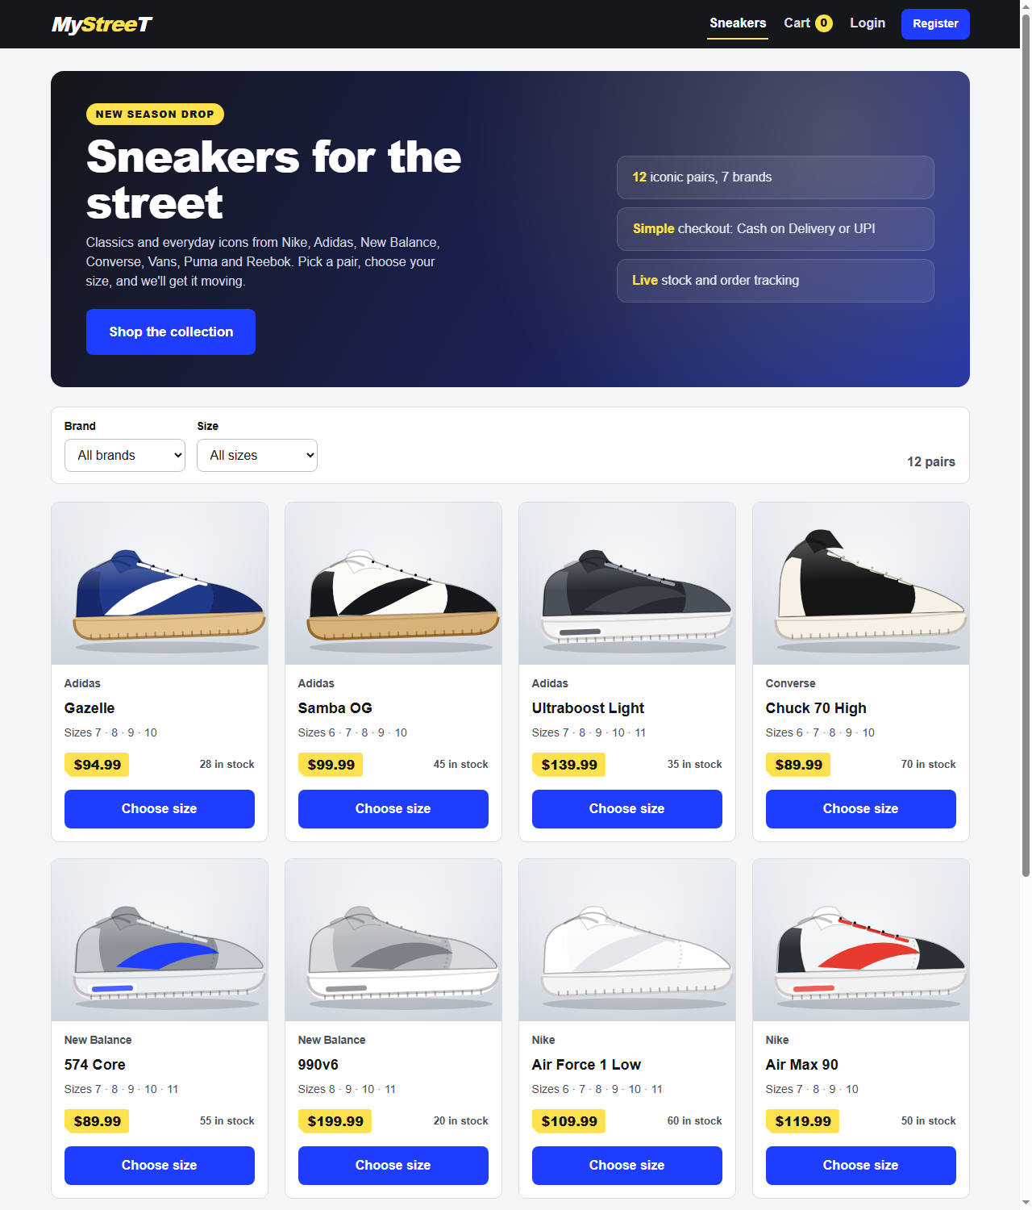

1. What you are demonstrating
MyStreeT is a full-stack sneaker store: a React + TypeScript + Vite single-page app talking to an ASP.NET Core 8 Web API with Entity Framework Core. Locally it runs on SQLite; SQL Server is supported by configuration.
- Shopper flow: browse, filter by brand and size, pick a size, cart, register or login, checkout (Cash on Delivery or Mock UPI), order confirmation, order history.
- Admin flow: log in as admin and create, edit and delete products.
- Engineering: controllers, services, DTOs, dependency injection, BCrypt, JWT, structured errors, xUnit/Moq/FluentAssertions tests, Swagger, Postman.

Architecture in 30 seconds
React UI (Context API for auth, cart and toasts; cart in localStorage) > HTTP/JSON with JWT > ASP.NET Core controllers > services > EF Core DbContext > SQLite / SQL Server.

2. Before the demo (do this 15 minutes early)
# | Check
1 | Install prerequisites: .NET 8 SDK and Node.js 20+. No database server is needed.
2 | In mystreet-api run dotnet restore; in mystreet-ui run npm install.
3 | Run dotnet test once (expect 90 passed) and npm test (expect 16 passed) so you have fresh evidence.
4 | To start from clean data, delete mystreet-api/mystreet.dev.db. It is recreated and seeded on startup.
5 | Open two terminals (API and UI), one browser window, and Swagger in a second tab.
6 | Import the Postman collection (postman/MyStreeT.postman_collection.json).

Demo accounts
Role | Email | Password
Admin | admin@mystreet.com | Admin@12345
Customer | demo@mystreet.com | Demo@12345
New user (you register) | me@test.com | Password123

3. Requirement coverage at a glance
Requirement | What is covered | Shown in | Status
A. Authentication | Register, login, logout, BCrypt, JWT | Steps 14, 18, 19 | Done
B. Product catalog | List with name, price, thumbnail; filter by brand and size; detail page | Steps 3, 5, 6, 7 | Done
C. Shopping cart | Add/remove, update quantity, total, localStorage, empty state | Steps 9 to 12 | Done
D. Checkout | Shipping form, COD / Mock UPI, payment always succeeds, status PLACED | Steps 13, 15, 16 | Done
E. Admin | CRUD: name, description, price, sizes, stock, image URL; admin-only | Steps 19 to 23 | Done
Order history, confirmation | Confirmation shows Order ID; My Orders | Steps 16, 17 | Done
Consistent error response | {timestamp, path, error, message} | Steps 15, 23 | Done
Architecture | Controllers, Services, EF Core, DTOs, DI; React hooks + Context | Steps 1, 4 | Done
Database | SQLite for local setup (allowed by the brief); SQL Server supported | Step 1 | Done
Testing | xUnit + Moq + FluentAssertions, 60% or more coverage | Step 24 | 90 tests; 81% methods, 69% lines
Documentation | README, Swagger, Postman collection, setup, trade-offs, AI notes | Sections 6 and 8 | Done
Concurrency (manual) | 5 to 10 concurrent requests, multiple tabs | Section 5 | Manual exercise

4. Demo script (follow in order, about 15 minutes)
# | Action | Expected result | Talking point
1 | Start the API: cd mystreet-api then dotnet run --launch-profile http | Console shows listening on :5080. SQLite file mystreet.dev.db is created and seeded (12 products, admin, demo user). | EF Core, idempotent seeding, per-environment config. SQLite locally; SQL Server is a config switch.
2 | Start the UI: cd mystreet-ui then npm run dev | Vite serves http://localhost:5173. | React SPA with a separate API; CORS allow-list.
3 | Open http://localhost:5173 | Hero banner and 12 sneakers with image, name, price, sizes, stock. | Data comes from GET /api/products (requirement: at least 8 seeded products).
4 | Open http://localhost:5080/swagger briefly | Swagger lists Auth, Products and Orders endpoints. | Controllers, Services, DTOs, DI; Swagger/OpenAPI docs.
5 | Brand filter: Nike | 3 Nike pairs; URL contains ?brand=Nike. | Server-side filter; URL as state.
6 | Brand = All, size filter: 11 | Only pairs offering size 11. | SizesCsv matched as ,11, so size 1 never matches 10.
7 | Open Air Max 90 | Large image, brand, description, price, size selector. | Route params; loading and not-found states.
8 | Click Add to cart without choosing a size | Friendly message asking for a size. | Client-side validation.
9 | Choose size 9, quantity 2, Add to cart | Toast shown; header cart badge = 2. | Context API with useReducer.
10 | Add Ultraboost size 8, open Cart, press + on a line | Line and grand totals update instantly. | Pure, unit-tested cart reducer.
11 | Refresh the browser | Cart and totals unchanged. | Cart persisted in localStorage.
12 | Remove all items, then add one back | Empty-cart state shown. | Empty-state acceptance criterion.
13 | Click Checkout while logged out | Redirected to Login; cart is kept. | Protected route with redirect-back.
14 | Register: me@test.com / Password123 | Signed in and returned to checkout. Refresh keeps you signed in. | BCrypt password hash, JWT, persisted session.
15 | Press Place order with an empty form | Field errors; nothing created. | Client and server validation.
16 | Fill shipping details, choose Mock UPI (or Cash on Delivery), Place order | Confirmation page with Order ID and status PLACED; cart badge back to 0. | Server recalculates prices; payment always succeeds (mock).
17 | My Orders, then open the order | Same order, items, shipping, total. | Ownership check on /api/orders/mine and /api/orders/{id}.
18 | Logout | Header shows Login and Register again. | Stateless JWT logout; POST /api/auth/logout.
19 | Login as admin: admin@mystreet.com / Admin@12345 | Admin menu appears. | IsAdmin flag mapped to an Admin role claim.
20 | Admin: Add product (save empty to show errors, then create Demo Runner, Nike, 129.50, sizes 8,9,10, stock 7) | Product appears in the admin table and in the public catalog. | Admin CRUD with validation.
21 | Edit the product: price 99 | Catalog shows $99.00 immediately. | PUT endpoint.
22 | Delete the product | Gone from admin table and catalog. | DELETE (soft delete if it already appears in an order).
23 | In Swagger, Authorize with a normal-user token and call POST /api/products | 403 with {timestamp, path, error, message}. | Backend authorization is enforced, not just hidden UI.
24 | Run dotnet test and npm test | 90 backend tests and 16 frontend tests pass. | xUnit, Moq, FluentAssertions; 81% method coverage.

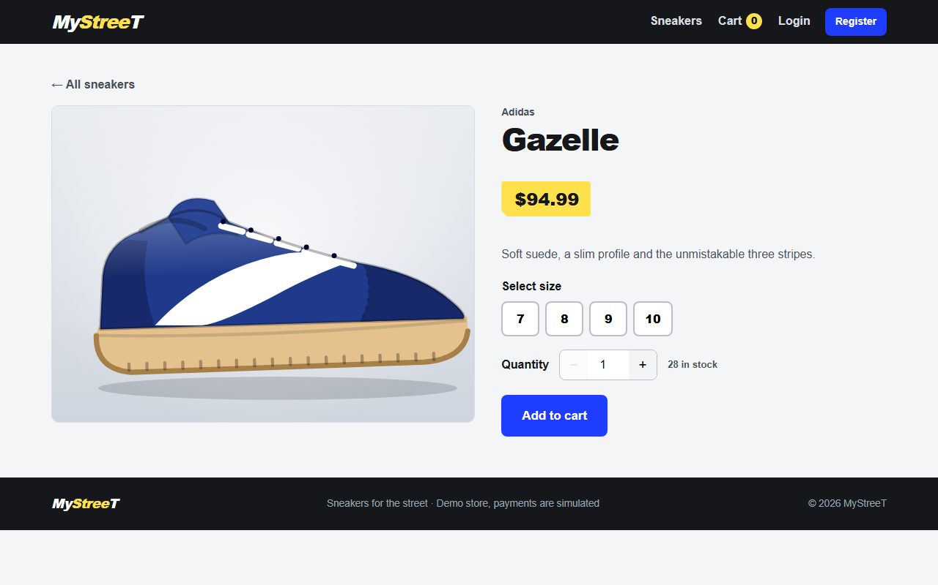
Product detail page: image, brand, price, size selector, quantity and Add to cart.

5. Concurrency and API checks (optional)
- Open two browser tabs, add the same item in both and place orders at the same time; stock is validated and decremented per order.
- Run the Postman collection with the Collection Runner in order (positive and negative requests, tokens saved automatically).
- Send 5 to 10 concurrent POST /api/orders requests from the Runner and show that every response is either a created order or a structured error.

6. Test evidence
Check | Command | Result
Backend build | dotnet build | 0 errors, 0 warnings
Backend tests | dotnet test | 90 passed, 0 failed
Backend coverage | dotnet test --collect:"XPlat Code Coverage" | 81% method, 69% line (target 60%)
Frontend tests | npm test | 16 passed
Frontend build | npm run build | Succeeded
Live API on SQLite | register, filter, order, 401, 403, validation | All behaved as expected

7. Questions you may be asked
Question | Answer
Why JWT? | Stateless and simple for a SPA plus API; works with Swagger and Postman. Trade-off: no server-side revocation and the token sits in localStorage, so tokens are short-lived (2 h) and issuer, audience, signature and lifetime are validated. Cookies would need CSRF protection.
Why BCrypt? | Salted, slow, adaptive hash designed for passwords. Plain text is never stored.
Why DTOs? | They decouple the API contract from the DB model, prevent over-posting (a client cannot set IsAdmin, price or total) and keep PasswordHash out of responses.
Why a service layer? | Controllers stay thin; pricing, stock and ownership rules are reusable and unit-testable.
Why is the cart in localStorage? | Required by the brief; works for guests. The server never trusts it: prices are recomputed from the database.
Why backend authorization if the UI hides Admin? | Anyone can call the API directly. The API returns 403 regardless of the UI.
Why SQLite here? | No SQL Server on the demo machine; the brief allows SQLite. The provider is switched with Database:Provider; the queries used work on both.
What would you improve next? | Pagination and search, stock reservation and concurrency control, refresh tokens, Docker and Azure deployment, a real payment gateway.

8. AI-assisted development
The capstone rubric asks for appropriate, disclosed use of AI tools. State plainly how AI was used and what you did yourself; the README has a section with the prompts used.
- AI was used for boilerplate, tests, UI polish, debugging and documentation, with the output reviewed, compiled and tested.
- Be ready to explain any part of the code in your own words: the order service (server-side pricing and stock), the JWT setup in Program.cs, the cart reducer and the admin authorization.
- A good example to mention: the test project initially failed to compile because of a missing Xunit using; it was fixed and all 90 tests now pass.

9. Troubleshooting during the demo
Symptom | Fix
UI shows "Cannot reach the server" | API is not running, or VITE_API_URL is wrong. Start the API on port 5080.
Logged out after restarting the API | Expected in Development: the JWT key is generated per run. Log in again.
Catalog empty | Seeding runs when the Products table is empty; delete mystreet.dev.db and restart the API.
Port 5173 busy | Close the other Vite instance; the CORS list expects 5173.

