Hospital Management System

A PROJECT REPORT ON

Project Title
Submitted in partial fulfillment of requirements
For the award of the degree of
Bachelor in Computer Application

By
M.AKASH (160701)
M.ALEKYA (160707)
J.CHANDRIKA (160729)



Department of Computer Science
PARVATHANENI BRAHMAYYA
SIDDHARTHA COLLEGE OF ARTS & SCIENCE
Vijayawada – 10
An Autonomous College under the Jurisdiction of Krishna University
College with Potential for Excellence (Awarded by UGC)
Twice accredited at the Level ‘A’ by the NAAC

2016 – 2019

BONAFIDE CERTIFICATE

PARVATHANENI BRAHMAYYA
SIDDHARTHA COLLEGE OF ARTS & SCIENCE
Vijayawada – 10
An Autonomous College under the Jurisdiction of Krishna University
College with Potential for excellence (Awarded by UGC)
Twice accredited at the Level ‘A’ by the NAAC



Department of Computer Science

Certified that this project work titled “HOSPITAL MANAGEMENT SYSTEM” is a bonafied work of “M. AKASH(160701), M. ALEKYA (160707), J. Chandrika (160729)” under my supervision and submitted in partial fulfillment of the requirements for the award of the degree of Bachelor in Computer Application, during the year 2018-2019.

Sri. K. Sridhar

Project Guide Head, Dept of CSE

External Examiner

ACKNOWLEDGMENT

I am very much thankful to Dr. Ramesh Meka, principal of P. B. Siddhartha College of Arts & Science, Vijayawada for allowing us to carry on this Project.

I am extremely grateful to Sri. K. Sridhar M.Sc., M.Tech, Dy. Head of the Department, Computer Science, for his able guidance and useful suggestions. I sincerely thank him for his motivation, encouragement and moral support throughout the course of our project work.

I express my profound sense of gratitude to my guide Name of the Guide with Qualification, lecturer, department of Computer Science, for his support and guidance for the successful completion of this project.

I express my thanks to all the staff members in department of Computer Science, P. B. Siddhartha College of Arts & Science, Vijayawada for their valuable support throughout this project.

M.AKASH (160701)
M.ALEKYA (160707)
J.CHANDRIKA (160729)

INTRODUCTION

INTRODUCTION
The project Hospital Management system includes registration of patients, storing their details into the system, and also computerized billing in the pharmacy, and labs. The software has the facility to give a unique id for every patient and stores the details of every patient and the staff automatically. It includes a search facility to know the current status of each room. User can search availability of a doctor and the details of a patient using the id. The Hospital Management System can be entered using a username and password. It is accessible either by an administrator or receptionist. Only they can add data into the database. The data can be retrieved easily. The interface is very user-friendly. The data are well protected for personal use and makes the data processing very fast. Hospital Management System is powerful, flexible, and easy to use and is designed and developed to deliver real conceivable benefits to hospitals. Hospital Management System is designed for multispeciality hospitals, to cover a wide range of hospital administration and management processes. It is an integrated end-to-end Hospital Management System that provides relevant information across the hospital to support effective decision making for patient care, hospital administration and critical financial accounting, in a seamless flow. Hospital Management System is a software product suite designed to improve the quality and management of hospital management.
EXISTING SYSTEM
The Existing system is following manually every thing is recorded manually obviously there are many problems in the existing system.
DISADVANTAGES
- Lack of immediate retrievals
- Lack of immediate information storage
- Error prone manual calculation
PROPOSING SYSTEM
Information about Patients is done by just writing the Patients name, age and gender. Whenever the Patient comes up his information is stored freshly it saves lot of time to the patient to check the patient exists or not and it is useful to check the patient history in well format.
ADVANTAGES OF SECURE FILE ACCESS
- Every thing is recorded on a system
- The patient will clearly knows when is his appointment with out standing on waiting queue for the doctor appointment.
- Patient clearly understand which patient is . details or going to record.

MODULES

Doctor Module
The Doctor Module can view all the patient appointments clearly so that he can spend sufficient time and parallel fix all his appointment base on the crowed. And the doctor can change his /her personal information. And he can also the appointment of the patients.

Patient Module
In the Patient Module the he need to first register once his registration done then he can go for login once the login Is success the can go to manage his account like he can see how many doctor or available and patient take appointment

Admin Module
The Admin Module Once the login is done then he can check the appointment of patients to the doctors and patient logs and doctor logs then he can easily check the details in different forms

Software Requirement Specification

SOFTWARE REQUIREMENTS

Operating System : Windows XP/2003/07/8/10 Linux/Solaris
User Interface : Css, Html, Mdb Bootstrap
Client-side Scripting : JavaScript
Programming Language : Python
Database : SQLite
Server Deployment : WSGI

HARDWARE REQUIREMENTS
Processor : Pentium IV
Hard Disk : 40GB
RAM : 256MB

Introduction

Python Programming Language
Python is a high-level, interpreted, interactive and object-oriented scripting language. Python is designed to be highly readable. It uses English keywords frequently where as other languages use punctuation, and it has fewer syntactical constructions than other languages.
- Python is Interpreted − Python is processed at runtime by the interpreter. You do not need to compile your program before executing it. This is similar to PERL and PHP.
- Python is Interactive − You can actually sit at a Python prompt and interact with the interpreter directly to write your programs.
- Python is Object-Oriented − Python supports Object-Oriented style or technique of programming that encapsulates code within objects.
- Python is a Beginner's Language − Python is a great language for the beginner-level programmers and supports the development of a wide range of applications from simple text processing to WWW browsers to games.

History of Python
Python was developed by Guido van Rossum in the late eighties and early nineties at the National Research Institute for Mathematics and Computer Science in the Netherlands.
Python is derived from many other languages, including ABC, Modula-3, C, C++, Algol-68, SmallTalk, and Unix shell and other scripting languages.
Python is copyrighted. Like Perl, Python source code is now available under the GNU General Public License (GPL).
Python is now maintained by a core development team at the institute, although Guido van Rossum still holds a vital role in directing its progress.

Python Features
Python's features include −
- Easy-to-learn − Python has few keywords, simple structure, and a clearly defined syntax. This allows the student to pick up the language quickly.
- Easy-to-read − Python code is more clearly defined and visible to the eyes.
- Easy-to-maintain − Python's source code is fairly easy-to-maintain.
- A broad standard library − Python's bulk of the library is very portable and cross-platform compatible on UNIX, Windows, and Macintosh.
- Interactive Mode − Python has support for an interactive mode which allows interactive testing and debugging of snippets of code.
- Portable − Python can run on a wide variety of hardware platforms and has the same interface on all platforms.
- Extendable − You can add low-level modules to the Python interpreter. These modules enable programmers to add to or customize their tools to be more efficient.
- Databases − Python provides interfaces to all major commercial databases.
- GUI Programming − Python supports GUI applications that can be created and ported to many system calls, libraries and windows systems, such as Windows MFC, Macintosh, and the X Window system of Unix.
- Scalable − Python provides a better structure and support for large programs than shell scripting.
Apart from the above-mentioned features, Python has a big list of good features, few are listed below −
- It supports functional and structured programming methods as well as OOP.
- It can be used as a scripting language or can be compiled to byte-code for building large applications.
- It provides very high-level dynamic data types and supports dynamic type checking.
- It supports automatic garbage collection.
- It can be easily integrated with C, C++, COM, ActiveX, CORBA, and Java.

OOPS CONCEPTS
Python has been an object-oriented language since it existed. Because of this, creating and using classes and objects are downright easy. This chapter helps you become an expert in using Python's object-oriented programming support.
If you do not have any previous experience with object-oriented (OO) programming, you may want to consult an introductory course on it or at least a tutorial of some sort so that you have a grasp of the basic concepts.
However, here is small introduction of Object-Oriented Programming (OOP) to bring you at speed .

Overview of OOP Terminology
- Class − A user-defined prototype for an object that defines a set of attributes that characterize any object of the class. The attributes are data members (class variables and instance variables) and methods, accessed via dot notation.
- Class variable − A variable that is shared by all instances of a class. Class variables are defined within a class but outside any of the class's methods. Class variables are not used as frequently as instance variables are.
- Data member − A class variable or instance variable that holds data associated with a class and its objects.
- Function overloading − The assignment of more than one behavior to a particular function. The operation performed varies by the types of objects or arguments involved.
- Instance variable − A variable that is defined inside a method and belongs only to the current instance of a class.
- Inheritance − The transfer of the characteristics of a class to other classes that are derived from it.
- Instance − An individual object of a certain class. An object obj that belongs to a class Circle, for example, is an instance of the class Circle.
- Instantiation − The creation of an instance of a class.
- Method − A special kind of function that is defined in a class definition.
- Object − A unique instance of a data structure that's defined by its class. An object comprises both data members (class variables and instance variables) and methods.
- Operator overloading − The assignment of more than one function to a particular operator.

How Python interpreter works
Step 1 : The interpreter reads a python code or instruction. Then it verifies that the instruction is well formatted, i.e. it checks the syntax of each line.If it encounters any error, it immediately halts the translation and shows an error message.
Step 2 : If there is no error, i.e. if the python instruction or code is well formatted then the interpreter translates it into its equivalent form in intermediate language called “Byte code”.Thus, after successful execution of Python script or code, it is completely translated into Byte code.
Step 3 : Byte code is sent to the Python Virtual Machine(PVM).Here again the byte code is executed on PVM.If an error occurs during this execution then the execution is halted with an error message.
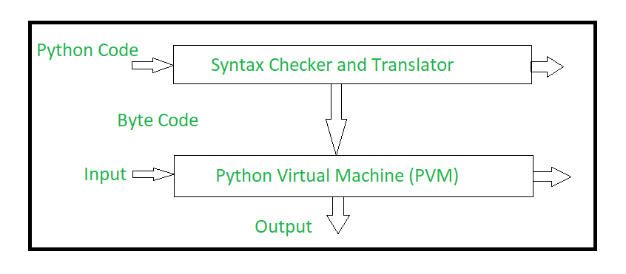

Django Web Development

Definition of a “web framework”
A “framework” is a set of tools that helps you to achieve a task easily and quickly without too much hassle. A “web framework” is then a framework that allows a developer to build websites and web apps iteratively and quickly without needing to re-create everything from the beginning. For example, when you are developing a web app with a login page for users, you need to go through some steps, but with Django it is straight. Login and users functionalities are already built with it.

Why do I need to use a web framework?
First of all, you must know that you are not obliged to use a web framework in order to build your website or web app. You can develop what you want and the way you want. You can choose to start from scratch, you are free. But developing with a framework will save you a lot of time and is iterative.

What is Django Framework?
Django is a high-level Python Web Framework that helps to make a clean development with a pragmatic design. It is free and open source. It has been built by experienced developers so you won’t encounter any problem when writing your app.
Django helps developers to not make common security mistakes when developing. It is the fastest framework we have ever used and it helps us a lot in many of our apps at Razor Theory.
Django has a lot of built-in functionalities for registration, sessions, security, forms, users and others. In addition it is very easy to learn.

How to install Django and start development?
You have got three options for the installation of Django. They are all easy. So you can try to:
- Install an official release, which is good for users who want a stable version and don’t care if it is old or not
- Install the latest development version, which is the best choice for users who want the last features
- Install a version provided by the operating system you are using. It is a simple and fast option for those who has OS that distribute Django.
How to verify Django is installed?
You have to verify if Django can be seen by Python. You just have to type “python” from your shell. Then try to import Django at the Python prompt.

Django Web application tools
Django offers a set of tools needed to develop web applications:
- Authentication
- Caching
- Data validation
- Logging
- Messages framework
- Pagination
- Sending emails
- Sessions
- Sitemaps
- Serialization
- Static files management
- Syndication feeds
- Django is really powerful and is free. It is written in Python and uses the model MVC which is a way to break an app into three parts: the model, the view and the controller. It is open source and even used by Google. So if you didn’t have an idea of the power of this framework now I think you do. We used it to build many websites and web app at Razor Theory and we recommend it to every developer who want to save time and work more by writing less.

Quick install guide
Before you can use Django, you’ll need to get it installed. We have a complete installation guide that covers all the possibilities; this guide will guide you to a simple, minimal installation that’ll work while you walk through the introduction.

Install Python
Being a Python Web framework, Django requires Python. See What Python version can I use with Django? for details. Python includes a lightweight database called SQLite so you won’t need to set up a database just yet.
Get the latest version of Python at https://www.python.org/downloads/ or with your operating system’s package manager.
You can verify that Python is installed by typing python from your shell; you should see something like:
Python 3.x.y
[GCC 4.x] on Linux
Type "help", "copyright", "credits" or "license" for more information.
>>>

Set up a database
This step is only necessary if you’d like to work with a “large” database engine like PostgreSQL, MySQL, or Oracle. To install such a database, consult the database installation information.

Install Django
You’ve got three easy options to install Django:
- Install an official release. This is the best approach for most users.
- Install a version of Django provided by your operating system distribution.
- Install the latest development version. This option is for enthusiasts who want the latest-and-greatest features and aren’t afraid of running brand new code. You might encounter new bugs in the development version, but reporting them helps the development of Django. Also, releases of third-party packages are less likely to be compatible with the development version than with the latest stable release.
Always refer to the documentation that corresponds to the version of Django you’re using!
If you do either of the first two steps, keep an eye out for parts of the documentation marked new in development version. That phrase flags features that are only available in development versions of Django, and they likely won’t work with an official release.

Verifying
To verify that Django can be seen by Python, type python from your shell. Then at the Python prompt, try to import Django:
>>> import django
>>> print(django.get_version())
2.1
You may have another version of Django installed.

That’s it!
That’s it – you can now move onto the tutorial.

Intro to Django

Object-relational mapper
Deﬁne your data models entirely in Python. You get a rich, dynamic database-access API for free — but you can still write SQL if needed.
class Band(models.Model)
"""A model of a rock band."""
name = models.CharField(max_length=200)
can_rock = models.BooleanField(default=True)

class Member(models.Model):
"""A model of a rock band member."""
name = models.CharField("Member's name", max_length=200)
instrument = models.CharField(choices=(
('g', "Guitar"),
('b', "Bass"),
('d', "Drums"),
),
max_length=1
)
band = models.ForeignKey("Band")

URLs and views
A clean, elegant URL scheme is an important detail in a high-quality Web application. Django encourages beautiful URL design and doesn’t put any cruft in URLs, like .php or .asp.
To design URLs for an application, you create a Python module called a URLconf. Like a table of contents for your app, it contains a simple mapping between URL patterns and your views.

from django.urls import path

from . import views

urlpatterns = [
path('bands/', views.band_listing, name='band-list'),
path('bands/<int:band_id>/', views.band_detail, name='band-detail'),
path('bands/search/', views.band_search, name='band-search'),
]

from django.shortcuts import render

def band_listing(request):
"""A view of all bands."""
bands = models.Band.objects.all()
return render(request, 'bands/band_listing.html', {'bands': bands})

Templates
Django’s template language is designed to strike a balance between power and ease. It’s designed to feel comfortable and easy-to-learn to those used to working with HTML, like designers and front-end developers. But it is also flexible and highly extensible, allowing developers to augment the template language as needed.
<html>
<head>
<title>Band Listing</title>
</head>
<body>
<h1>All Bands</h1>
<ul>
{% for band in bands %}
<li>
<h2><a href="{{ band.get_absolute_url }}">{{ band.name }}</a></h2>
{% if band.can_rock %}<p>This band can rock!</p>{% endif %}
</li>
{% endfor %}
</ul>
</body>
</html>

Forms
Django provides a powerful form library that handles rendering forms as HTML, validating user-submitted data, and converting that data to native Python types. Django also provides a way to generate forms from your existing models and use those forms to create and update data.
from django import forms

class BandContactForm(forms.Form):
subject = forms.CharField(max_length=100)
message = forms.CharField()
sender = forms.EmailField()
cc_myself = forms.BooleanField(required=False)

Authentication
Django comes with a full-featured and secure authentication system. It handles user accounts, groups, permissions and cookie-based user sessions. This lets you easily build sites that let users to create accounts and safely log in/out.
from django.contrib.auth.decorators import login_required
from django.shortcuts import render

@login_required
def my_protected_view(request):
"""A view that can only be accessed by logged-in users"""
return render(request, 'protected.html', {'current_user': request.user})

Admin
One of the most powerful parts of Django is its automatic admin interface. It reads metadata in your models to provide a powerful and production-ready interface that content producers can immediately use to start managing content on your site. It’s easy to set up and provides many hooks for customization.
from django.contrib import admin
from bands.models import Band, Member

class MemberAdmin(admin.ModelAdmin):
"""Customize the look of the auto-generated admin for the Member model"""
list_display = ('name', 'instrument')
list_filter = ('band',)

admin.site.register(Band) # Use the default options
admin.site.register(Member, MemberAdmin) # Use the customized options

Internationalization
Django offers full support for translating text into different languages, plus locale-specific formatting of dates, times, numbers and time zones. It lets developers and template authors specify which parts of their apps should be translated or formatted for local languages and cultures, and it uses these hooks to localize Web applications for particular users according to their preferences.
from django.shortcuts import render
from django.utils.translation import ugettext

def homepage(request):
"""
Shows the homepage with a welcome message that is translated in the
user's language.
"""
message = ugettext('Welcome to our site!')
return render(request, 'homepage.html', {'message': message})

{% load i18n %}
<html>
<head>
<title>{% trans 'Homepage - Hall of Fame' %}</title>
</head>
<body>
{# Translated in the view: #}
<h1>{{ message }}</h1>
<p>
{% blocktrans count member_count=bands.count %}
Here is the only band in the hall of fame:
{% plural %}
Here are all the {{ member_count }} bands in the hall of fame:
{% endblocktrans %}
</p>

Security in Django

Cross site scripting (XSS) protection
XSS attacks allow a user to inject client side scripts into the browsers of other users. This is usually achieved by storing the malicious scripts in the database where it will be retrieved and displayed to other users, or by getting users to click a link which will cause the attacker’s JavaScript to be executed by the user’s browser. However, XSS attacks can originate from any untrusted source of data, such as cookies or Web services, whenever the data is not sufficiently sanitized before including in a page.
Using Django templates protects you against the majority of XSS attacks. However, it is important to understand what protections it provides and its limitations.
Django templates escape specific characters which are particularly dangerous to HTML. While this protects users from most malicious input, it is not entirely foolproof. For example, it will not protect the following:
<style class={{ var }}>...</style>
If var is set to 'class1 onmouseover=javascript:func()', this can result in unauthorized JavaScript execution, depending on how the browser renders imperfect HTML. (Quoting the attribute value would fix this case.)
It is also important to be particularly careful when using is_safe with custom template tags, the safe template tag, mark_safe, and when autoescape is turned off.
In addition, if you are using the template system to output something other than HTML, there may be entirely separate characters and words which require escaping.You should also be very careful when storing HTML in the database, especially when that HTML is retrieved and displayed.

Cross site request forgery (CSRF) protection
CSRF attacks allow a malicious user to execute actions using the credentials of another user without that user’s knowledge or consent.
Django has built-in protection against most types of CSRF attacks, providing you have enabled and used it where appropriate. However, as with any mitigation technique, there are limitations. For example, it is possible to disable the CSRF module globally or for particular views. You should only do this if you know what you are doing. There are other limitations if your site has subdomains that are outside of your controlCSRF protection works by checking for a secret in each POST request. This ensures that a malicious user cannot simply “replay” a form POST to your website and have another logged in user unwittingly submit that form. The malicious user would have to know the secret, which is user specific (using a cookie).
When deployed with HTTPS, CsrfViewMiddleware will check that the HTTP referer header is set to a URL on the same origin (including subdomain and port). Because HTTPS provides additional security, it is imperative to ensure connections use HTTPS where it is available by forwarding insecure connection requests and using HSTS for supported browsers.
Be very careful with marking views with the csrf_exempt decorator unless it is absolutely necessary.

SQL injection protection
SQL injection is a type of attack where a malicious user is able to execute arbitrary SQL code on a database. This can result in records being deleted or data leakage.
Django’s querysets are protected from SQL injection since their queries are constructed using query parameterization. A query’s SQL code is defined separately from the query’s parameters. Since parameters may be user-provided and therefore unsafe, they are escaped by the underlying database driver.
Django also gives developers power to write raw queries or execute custom sql. These capabilities should be used sparingly and you should always be careful to properly escape any parameters that the user can control. In addition, you should exercise caution when using extra() and RawSQL.

Clickjacking protection
Clickjacking is a type of attack where a malicious site wraps another site in a frame. This attack can result in an unsuspecting user being tricked into performing unintended actions on the target site.
Django contains clickjacking protection in the form of the X-Frame-Options middleware which in a supporting browser can prevent a site from being rendered inside a frame. It is possible to disable the protection on a per view basis or to configure the exact header value sent.
The middleware is strongly recommended for any site that does not need to have its pages wrapped in a frame by third party sites, or only needs to allow that for a small section of the site.

SSL/HTTPS
It is always better for security to deploy your site behind HTTPS. Without this, it is possible for malicious network users to sniff authentication credentials or any other information transferred between client and server, and in some cases – active network attackers – to alter data that is sent in either direction.
If you want the protection that HTTPS provides, and have enabled it on your server, there are some additional steps you may need:
- If necessary, set SECURE_PROXY_SSL_HEADER, ensuring that you have understood the warnings there thoroughly. Failure to do this can result in CSRF vulnerabilities, and failure to do it correctly can also be dangerous!
- Set SECURE_SSL_REDIRECT to True, so that requests over HTTP are redirected to HTTPS.Please note the caveats under SECURE_PROXY_SSL_HEADER. For the case of a reverse proxy, it may be easier or more secure to configure the main Web server to do the redirect to HTTPS.
- Use ‘secure’ cookies.
If a browser connects initially via HTTP, which is the default for most browsers, it is possible for existing cookies to be leaked. For this reason, you should set your SESSION_COOKIE_SECURE and CSRF_COOKIE_SECURE settings to True. This instructs the browser to only send these cookies over HTTPS connections. Note that this will mean that sessions will not work over HTTP, and the CSRF protection will prevent any POST data being accepted over HTTP (which will be fine if you are redirecting all HTTP traffic to HTTPS).
- Use HTTP Strict Transport Security (HSTS)
HSTS is an HTTP header that informs a browser that all future connections to a particular site should always use HTTPS. Combined with redirecting requests over HTTP to HTTPS, this will ensure that connections always enjoy the added security of SSL provided one successful connection has occurred. HSTS may either be configured with SECURE_HSTS_SECONDS, SECURE_HSTS_INCLUDE_SUBDOMAINS, and SECURE_HSTS_PRELOAD, or on the Web server.

Host header validation
Django uses the Host header provided by the client to construct URLs in certain cases. While these values are sanitized to prevent Cross Site Scripting attacks, a fake Host value can be used for Cross-Site Request Forgery, cache poisoning attacks, and poisoning links in emails.
Because even seemingly-secure web server configurations are susceptible to fake Host headers, Django validates Host headers against the ALLOWED_HOSTS setting in the django.http.HttpRequest.get_host() method.
This validation only applies via get_host(); if your code accesses the Host header directly from request.META you are bypassing this security protection.
For more details see the full ALLOWED_HOSTS documentation.
Warning
Previous versions of this document recommended configuring your web server to ensure it validates incoming HTTP Host headers. While this is still recommended, in many common web servers a configuration that seems to validate the Host header may not in fact do so. For instance, even if Apache is configured such that your Django site is served from a non-default virtual host with the ServerName set, it is still possible for an HTTP request to match this virtual host and supply a fake Host header. Thus, Django now requires that you set ALLOWED_HOSTS explicitly rather than relying on web server configuration.Ad ditionally, Django requires you to explicitly enable support for the X-Forwarded-Host header (via the USE_X_FORWARDED_HOST setting) if your configuration requires it.

Session security
Similar to the CSRF limitations requiring a site to be deployed such that untrusted users don’t have access to any subdomains, django.contrib.sessions also has limitations. See the session topic guide section on security for details.

User-uploaded content
Note
Consider serving static files from a cloud service or CDN to avoid some of these issues.
- If your site accepts file uploads, it is strongly advised that you limit these uploads in your Web server configuration to a reasonable size in order to prevent denial of service (DOS) attacks. In Apache, this can be easily set using the LimitRequestBody directive.
- If you are serving your own static files, be sure that handlers like Apache’s mod_php, which would execute static files as code, are disabled. You don’t want users to be able to execute arbitrary code by uploading and requesting a specially crafted file.
- Django’s media upload handling poses some vulnerabilities when that media is served in ways that do not follow security best practices. Specifically, an HTML file can be uploaded as an image if that file contains a valid PNG header followed by malicious HTML. This file will pass verification of the library that Django uses for ImageField image processing (Pillow). When this file is subsequently displayed to a user, it may be displayed as HTML depending on the type and configuration of your web server.
No bulletproof technical solution exists at the framework level to safely validate all user uploaded file content, however, there are some other steps you can take to mitigate these attacks:
  - One class of attacks can be prevented by always serving user uploaded content from a distinct top-level or second-level domain. This prevents any exploit blocked by same-origin policy protections such as cross site scripting. For example, if your site runs on example.com, you would want to serve uploaded content (the MEDIA_URL setting) from something like usercontent-example.com. It’s not sufficient to serve content from a subdomain like usercontent.example.com.
  - Beyond this, applications may choose to define a whitelist of allowable file extensions for user uploaded files and configure the web server to only serve such files.

Additional security topics
While Django provides good security protection out of the box, it is still important to properly deploy your application and take advantage of the security protection of the Web server, operating system and other components.
- Make sure that your Python code is outside of the Web server’s root. This will ensure that your Python code is not accidentally served as plain text (or accidentally executed).
- Take care with any user uploaded files.
- Django does not throttle requests to authenticate users. To protect against brute-force attacks against the authentication system, you may consider deploying a Django plugin or Web server module to throttle these requests.
- Keep your SECRET_KEY a secret.
- It is a good idea to limit the accessibility of your caching system and database using a firewall.
- Take a look at the Open Web Application Security Project (OWASP) Top 10 list which identifies some common vulnerabilities in web applications. While Django has tools to address some of the issues, other issues must be accounted for in the design of your project.

BASICS OF DJANGO
Let’s learn by example.
Throughout this tutorial, we’ll walk you through the creation of a basic poll application.
It’ll consist of two parts:
- A public site that lets people view polls and vote in them.
- An admin site that lets you add, change, and delete polls.
We’ll assume you have Django installed already. You can tell Django is installed and which version by running the following command in a shell prompt (indicated by the $ prefix):
/ 
$ python -m django --version
If Django is installed, you should see the version of your installation. If it isn’t, you’ll get an error telling “No module named django”.
This tutorial is written for Django 2.1, which supports Python 3.5 and later. If the Django version doesn’t match, you can refer to the tutorial for your version of Django by using the version switcher at the bottom right corner of this page, or update Django to the newest version. If you’re using an older version of Python, check What Python version can I use with Django? to find a compatible version of Django.
See How to install Django for advice on how to remove older versions of Django and install a newer one.
Where to get help:
If you’re having trouble going through this tutorial, please post a message to django-users or drop by #django on irc.freenode.net to chat with other Django users who might be able to help.

Creating a project
If this is your first time using Django, you’ll have to take care of some initial setup. Namely, you’ll need to auto-generate some code that establishes a Django project – a collection of settings for an instance of Django, including database configuration, Django-specific options and application-specific settings.
From the command line, cd into a directory where you’d like to store your code, then run the following command:
/ 
$ django-admin startproject mysite
This will create a mysite directory in your current directory. If it didn’t work, see Problems running django-admin.
Note
You’ll need to avoid naming projects after built-in Python or Django components. In particular, this means you should avoid using names like django (which will conflict with Django itself) or test (which conflicts with a built-in Python package).
Where should this code live?
If your background is in plain old PHP (with no use of modern frameworks), you’re probably used to putting code under the Web server’s document root (in a place such as /var/www). With Django, you don’t do that. It’s not a good idea to put any of this Python code within your Web server’s document root, because it risks the possibility that people may be able to view your code over the Web. That’s not good for security.
Put your code in some directory outside of the document root, such as /home/mycode.
Let’s look at what startproject created:
mysite/
manage.py
mysite/
__init__.py
settings.py
urls.py
wsgi.py
These files are:
- The outer mysite/ root directory is just a container for your project. Its name doesn’t matter to Django; you can rename it to anything you like.
- manage.py: A command-line utility that lets you interact with this Django project in various ways. You can read all the details about manage.py in django-admin and manage.py.
- The inner mysite/ directory is the actual Python package for your project. Its name is the Python package name you’ll need to use to import anything inside it (e.g. mysite.urls).
- mysite/__init__.py: An empty file that tells Python that this directory should be considered a Python package. If you’re a Python beginner, read more about packages in the official Python docs.
- mysite/settings.py: Settings/configuration for this Django project. Django settings will tell you all about how settings work.
- mysite/urls.py: The URL declarations for this Django project; a “table of contents” of your Django-powered site. You can read more about URLs in URL dispatcher.
- mysite/wsgi.py: An entry-point for WSGI-compatible web servers to serve your project. See How to deploy with WSGI for more details.

The development server
Let’s verify your Django project works. Change into the outer mysite directory, if you haven’t already, and run the following commands:
/ 
$ python manage.py runserver
You’ll see the following output on the command line:
Performing system checks...

System check identified no issues (0 silenced).

You have unapplied migrations; your app may not work properly until they are applied.
Run 'python manage.py migrate' to apply them.

February 28, 2019 - 15:50:53
Django version 2.1, using settings 'mysite.settings'
Starting development server at http://127.0.0.1:8000/
Quit the server with CONTROL-C.
Note
Ignore the warning about unapplied database migrations for now; we’ll deal with the database shortly.
You’ve started the Django development server, a lightweight Web server written purely in Python. We’ve included this with Django so you can develop things rapidly, without having to deal with configuring a production server – such as Apache – until you’re ready for production.
Now’s a good time to note: don’t use this server in anything resembling a production environment. It’s intended only for use while developing. (We’re in the business of making Web frameworks, not Web servers.)
Now that the server’s running, visit http://127.0.0.1:8000/ with your Web browser. You’ll see a “Congratulations!” page, with a rocket taking off. It worked!
Changing the port
By default, the runserver command starts the development server on the internal IP at port 8000.
If you want to change the server’s port, pass it as a command-line argument. For instance, this command starts the server on port 8080:
/ 
$ python manage.py runserver 8080
If you want to change the server’s IP, pass it along with the port. For example, to listen on all available public IPs (which is useful if you are running Vagrant or want to show off your work on other computers on the network), use:
/ 
$ python manage.py runserver 0:8000
0 is a shortcut for 0.0.0.0. Full docs for the development server can be found in the runserver reference.
Automatic reloading of runserver
The development server automatically reloads Python code for each request as needed. You don’t need to restart the server for code changes to take effect. However, some actions like adding files don’t trigger a restart, so you’ll have to restart the server in these cases.

Requirement Analysis

Requirements Analysis
Requirements Analysis is the process of defining the expectations of the users for an application that is to be built or modified. Requirements analysis involves all the tasks that are conducted to identify the needs of different stakeholders. Therefore requirements analysis means to analyze, document, validate and manage software or system requirements. High-quality requirements are documented, actionable, measurable, testable, traceable, helps to identify business opportunities, and are defined to a facilitate system design.

Requirements analysis process
The requirements analysis process involves the following steps:

Eliciting requirements
The process of gathering requirements by communicating with the customers is known as eliciting requirements.

Analyzing requirements
This step helps to determine the quality of the requirements. It involves identifying whether the requirements are unclear, incomplete, ambiguous, and contradictory. These issues resolved before moving to the next step.

Requirements modeling
In Requirements modeling, the requirements are usually documented in different formats such as use cases, user stories, natural-language documents, or process specification.

Review and retrospective
This step is conducted to reflect on the previous iterations of requirements gathering in a bid to make improvements in the process going forward.

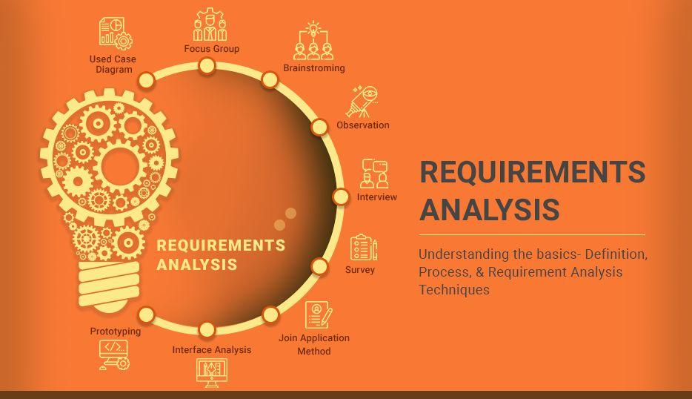

Requirements Analysis Techniques
There are different techniques used for Requirements Analysis. Below is a list of different Requirements Analysis Techniques:

Business process modeling notation (BPMN)
This technique is similar to creating process flowcharts, although BPMN has its own symbols and elements. Business process modeling and notation is used to create graphs for the business process. These graphs simplify understanding the business process. BPMN is widely popular as a process improvement methodology.

UML (Unified Modeling Language)
UML consists of an integrated set of diagrams that are created to specify, visualize, construct and document the artifacts of a software system. UML is a useful technique while creating object-oriented software and working with the software development process. In UML, graphical notations are used to represent the design of a software project. UML also help in validating the architectural design of the software.

Flowchart technique
A flowchart depicts the sequential flow and control logic of a set of activities that are related. Flowcharts are in different formats such as linear, cross-functional, and top-down. The flowchart can represent system interactions, data flows, etc. Flow charts are easy to understand and can be used by both the technical and non-technical team members. Flowchart technique helps in showcasing the critical attributes of a process.

Data flow diagram
This technique is used to visually represent systems and processes that are complex and difficult to describe in text. Data flow diagrams represent the flow of information through a process or a system. It also includes the data inputs and outputs, data stores, and the various subprocess through which the data moves. DFD describes various entities and their relationships with the help of standardized notations and symbols. By visualizing all the elements of the system it is easier to identify any shortcomings. These shortcomings are then eliminated in a bid to create a robust solution.

Role Activity Diagrams (RAD)
Role-activity diagram (RAD) is a role-oriented process model that represents role-activity diagrams. Role activity diagrams are a high-level view that captures the dynamics and role structure of an organization. Roles are used to grouping together activities into units of responsibilities. Activities are the basic parts of a role. An activity may be either carried out in isolation or it may require coordination with other activities within the role.

Summary
For the success of a project, it is utmost important to analyze project requirements when they are gathered as well as throughout the lifecycle of the project. Requirements analysis helps to keep the requirements in line with the need of the business. A good requirements analysis process will render a software application that caters to the objectives of the business set forth.

System Design

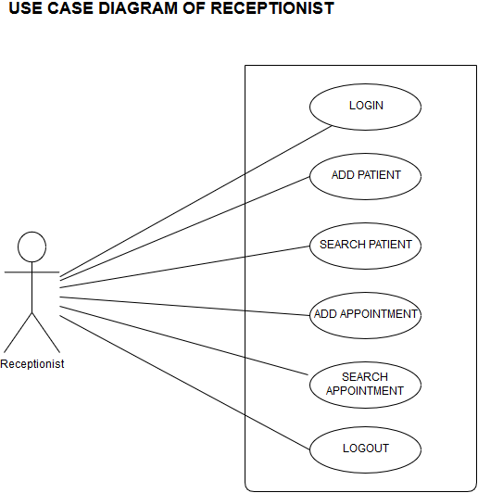

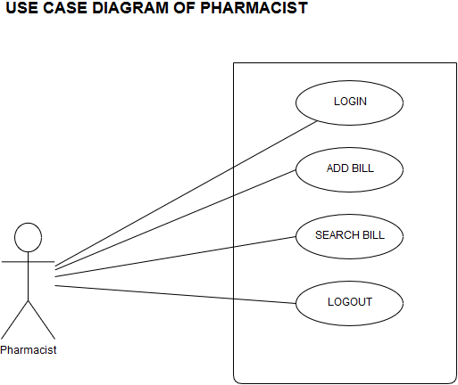

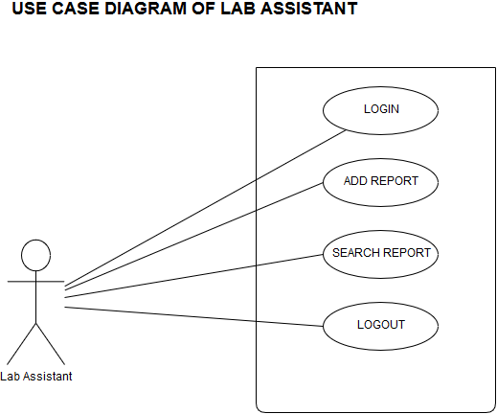
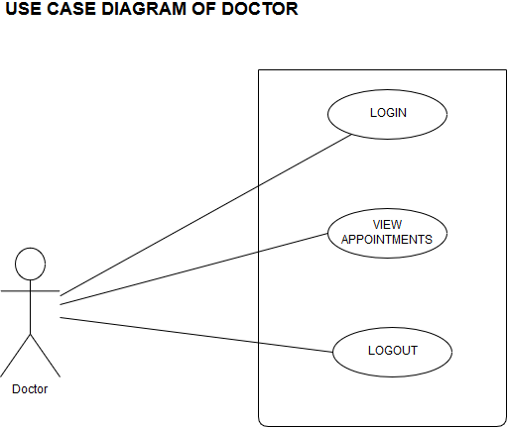

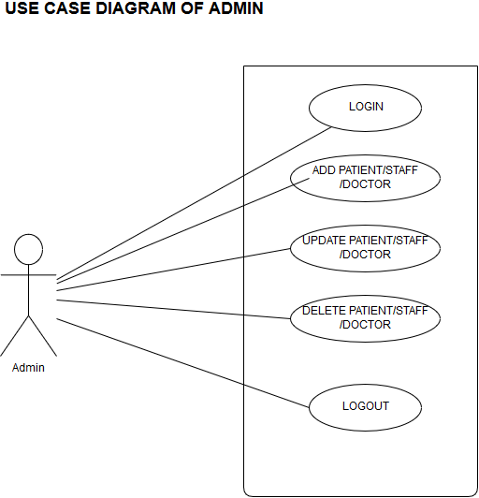

Testing and Implementation

Stage 1: Prototype Evaluation by Decision Matrix
While creating prototypes, innovators may discover that a seemingly successful brainstorm is not adaptable to concrete design. Although this simplifies the process of narrowing down brainstorms to an ideal solution, there may still be a handful of substantial prototypes to consider. As such, another decision matrix is employed.
This matrix should use the same design criteria previously identified, and should give the same weight of significance to each element. Maintaining this consistency in evaluation is critical for the validity of the design process. After completing the matrix, total scores can be compared for objective ranking among prototype options.
In this stage, it is possible that, despite the results of the decision matrix method, innovators or other stakeholders in the technology have predetermined preferences for a particular idea. In many cases, these preferences are not aligned with the highest scoring option from the decision matrix. Whether other factors will override the analysis presented by the decision matrix is to be determined on a case-by-case basis. In some cases, decisions in development may be guided by donor interest or investment by stakeholders in public-private partnerships. To avoid barriers to the development of appropriate designs, there are various precautions that can be taken to ensure compatible interests among innovators and stakeholders. For instance, donors should demonstrate an understanding of the global health challenge, technology performance specifications that would meet needs, a commitment to providing available resources, potential obstacles to design, and the realistic value of benefits offered by the technology-in-development.(1) Although the prototype chosen for continuation at this stage is not the be-all, end-all of the design process, a carefully selected idea (ideally with appropriate justification) can prevent future delays in technology implementation and delivery.

Stage 2: Testing Design Criteria
Although the decision matrix methodology assesses how well the idea or prototype fulfills each design criterion, further development requires evidence-based measures of success. In a way, the testing phase serves to justify scores achieved in decision matrix evaluation. Accordingly, each criterion should incorporate a system of quantitative testing – made possible since criteria are measurable.
Plans for testing vary according to the criterion under consideration. Testing may involve physical testing of technology hardware or components, as well as the administration of surveys to assess technology interface with human factors. The only requirement is that descriptions or instructions should be standardized to maintain consistency and control during experimentation. Regardless of the testing style chosen for this phase, the goal of testing is to determine if the selected design has weaknesses that may be improved upon.
Examples of testing plans for measurable design criteria include:
- Accuracy of intervention in prevention, diagnosis, or treatment
  - Run trials of the technological intervention and traditional standard of care. Compare results.
- Economic feasibility
  - Conduct cost-effectiveness analyses, comparing costs of development (including required consumables) and consequences against the valued benefits.
- Durability
  - Test operation of device or intervention before and after representative environmental conditions, i.e. exposure to heat, water, or turbulence.
- Sustainability
  - Assess the maximum length of time that a device can continue operation until necessary replacement or new parts, i.e. battery life or count of consumable parts.
- Ease of use
  - Administer surveys to sample demographic. Use a scale (0 to 10) to provide quantitative results of measurement.
- Adherence to quality and safety standards
  - Compare features of use to existing standards from regulatory institutions.

Stage 3: Re-iterations
Using findings from the testing phase, adapt prototype designs accordingly. In this process of developing new or improved iterations of design, it may be beneficial to draw from previously eliminated ideas (in the brainstorming or decision matrix stages) for creative ways to re-iterate.
The opportunity to create new iterations of a design also may be used to elicit more feedback. For instance, it may be easier to find weaknesses in technology design by comparing and contrasting the iterations along tests outlined in the previous stage. Findings from this process would support the creation of even more iterations in technology.

Stage 4: Implementation, in Phases
Technology implementation is the application of the innovation to real-life settings of use. It is suggested that implementation occur in phases, beginning with small pilots prior to broad scale-up. Pilots may vary in location of use, age of user, or gender of user, providing insight beyond simply whether the technology is appropriate in practice. By using this step-wise progression, it is possible to continue the “positive-feedback loop” of assessment and modification. The goal is to develop the most appropriate technology design, which requires different perspectives and settings for fine-tuning.
For each pilot, it is recommended to consider the application of use in terms of context (i.e., What questions can we answer from this constituent group? What can we discover in [x] weeks?), resources (i.e., Are allocated people and funds representative of actual use?), questions to answer (i.e., Do key issues arise about this concept and its desirability?), and how to measure success (i.e., What are the key expectations in the various phases of implementation?).(2) These questions are intended to make innovators mindful of the limitations imposed by implementation; this process is only the first step to bringing a technology to scale. At this stage, phases of implementation are still trials in a continuous process of technology design and development.

Stage 5: Gathering Empirical Data
In this stage of development, all data is crucial to the success of the chosen technology. It is best to integrate both qualitative and quantitative methods of learning in an approach that will best collect information about the device or program, as viewed from various stakeholders’ perspectives.
IDEO suggests a “Learning Loop,” shown below. At this point, the focus is on Indicators, to track progress, choose ideas, iterate solutions, and identify unintended consequences.(3)
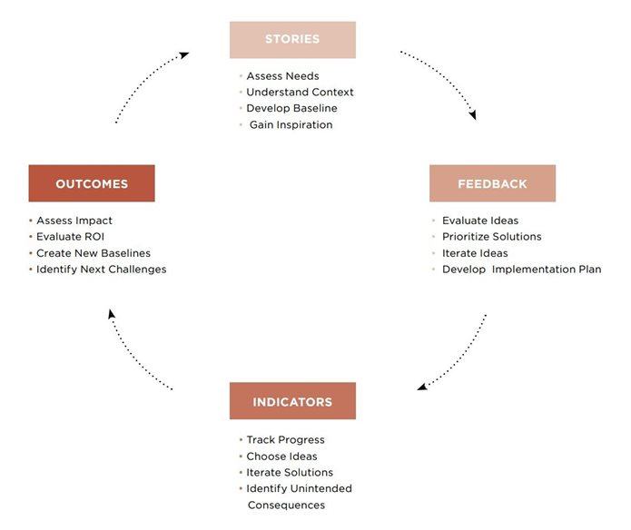
Specifically, these indicators may be positive or negative, and intended or unintended. It is important to view all categories to determine the full scale of impact. The following chart lists types, descriptions, and examples of indicators, as taken from the IDEO Toolkit:
Type of Indicator | Use when… | Example
Leading | Impacts take time to appear | Goal: Increase farmer income  Indicator: Number of farmers growing high-value crops this season
Analogous | Impacts are not direct | Goal: Improve trust of healthcare providers  Indicator: Number of questions people ask doctors/nurses
Awareness | Impacts require people to engage or adopt something new | Goal: Uptake of new technology  Indicator: Number or level of awareness to new solution or design
Engagement | Impacts require people to engage or adopt something new | Goal: Increase program participant income  Indicator: Number of people actively seeking out and participating in program activities
Dynamic Changes | Any new solution is introduced | Goal: Promote change  Indicator: Track differences within community, households, and environment prior to and following introduction of new technology
Focus on each stakeholder and ask for feedback regarding each type of indicator: Are there leading indicators that we should be tracking? Are there analogous indicators that we can track? How can we measure awareness and engagement? How will we track and understand the dynamics of transformations that are occurring?(4) If it is difficult to immediately jump into these types of indicators, it is helpful to begin simply with the broad question: What can I expect to see happen if solutions are improving people’s lives?
Although the importance of gathering feedback is highlighted explicitly in this stage, the learning process is ongoing. Design does not end with implementation; implementation is simply another phase of the development cycle. Additional methods of evaluating program success are outlined in the Course on Evaluation.

Stage 6: Re-iterate, Re-iterate, Re-iterate
It is never too late to make improvements to design. Although this module followed the selection of an idea for prototyping through testing, re-iteration, implementation, and data collection, modifications or new iterations from this point forward are to be expected in the development process. Feedback in the form of success or failure is informative to the creation of appropriate and effective technology, and innovators of global health technology should welcome continued opportunities to improve upon their designs.

SAMPLE CODE

home.html
{%load static%} {% block content %} {%include 'includes/navbar.html'%}
<div class="elegant-color-dark teal-text px-5 py-3">
<h1 class="h1-responsive font-weight-bold text-center teal-text my-3">
Glimpse of MyHome Hospital</h1>
<hr className="my-3" />

<div class="row">
<div class="col-4">
<div class="view overlay rounded z-depth-2 mb-lg-0 my-3 unique-color-dark">
<img class="img-fluid" src="{% static 'wc1.JPG' %}" alt="Sample image" />
<a>
<div class="mask rgba-black-slight"></div>
</a>
</div>
</div>
<div class="col-8">
<a href="#!" class="green-text">
<h6 class="font-weight-bold mb-3 my-3">Extended Special Rooms</h6>
</a>
<p class="mb-3 my-3 teal-text">
Experience our hospital and accommodations at MyHome Hospital by
Akash’s. Our Hospital is fully wheelchair accessible and our rooms are
designed to accommodate all of our valued patients. My Hospital by
Akash’s is equipped with a wide array of modern amenities to make your
stay comfortable and feel free .
</p>
</div>
</div>
<hr class="my-5" />
<div class="row">
<div class="col-8">
<a href="#!" class="pink-text">
<h6 class="font-weight-bold mb-3">Specialized Doctors</h6>
</a>

<p class="mb-3 my-3 teal-text">
MyHome's Pulmonary experts have experience diagnosing and treating all
types of diseases and conditions that affect the lungs and breathing,
including very rare conditions. They use the latest equipment and
minimally invasive techniques.Each year, more than 25,000 people with
severe and chronic lung conditions are treated.
</p>
</div>
<div class="col-4">
<div class="view overlay rounded z-depth-2 mb-lg-0 my-3 unique-color-dark">
<img class="img-fluid imgscale" src="{% static 'spec.jpg' %}" alt="Sample image" />
<a>
<div class="mask rgba-black-slight"></div>
</a>
</div>
</div>
</div>
<hr class="my-3" />
<div class="row">
<div class="col-4">
<div class="view overlay rounded z-depth-2 mb-lg-0 my-3 unique-color-dark">
<img class="img-fluid imgscale" src="{% static 'room.jpg' %}" alt="Sample image" />
<a>
<div class="mask rgba-black-slight"></div>
</a>
</div>
</div>
<div class="col-8">
<a href="#!" class="indigo-text">
<h6 class="font-weight-bold mb-3 my-3">24 / 7 Services</h6>
</a>
<p class="mb-3 my-3 teal-text">
My Hospital is known for providing advanced emergency services with
rapid response for any kind of treatment. Our emergency department is
always ready for these services. The department has state of the art
equipment and advanced patient monitoring systems to respond to any
medical emergency.
</p>
</div>
</div>
<hr class="my-3" />
<div class="row">
<div class="col-8">
<a href="#!" class="purple-text">
<h6 class="font-weight-bold mb-3">Collaborative care, focused on you</h6>
</a>

<p class="mb-3 my-3 teal-text">
Pulmonologists also collaborate with experts in nearly every specialty
to deliver effective, personalized care. The pulmonary medicine team
works closely with colleagues who specialize in thoracic surgery, sleep
medicine, transplant, internal medicine, radiology, radiation oncology,
pathology, ear, nose and throat allergy and immunology, neurology, lung
transplant, and others areas
</p>
</div>
<div class="col-4">
<div class="view overlay rounded z-depth-2 mb-lg-0 my-3 unique-color-dark">
<img class="img-fluid imgscale" src="{% static 'collab.jpg' %}" alt="Sample image" />
<a>
<div class="mask rgba-black-slight"></div>
</a>
</div>
</div>
</div>
<hr class="my-3" />
<div class="row">
<div class="col-4">
<div class="view overlay rounded z-depth-2 mb-lg-0 my-3 unique-color-dark">
<img class="img-fluid imgscale" src="{% static '31.jpg' %}" alt="Sample image" />
<a>
<div class="mask rgba-black-slight"></div>
</a>
</div>
</div>
<div class="col-8">
<a href="#!" class="red-text">
<h6 class="font-weight-bold mb-3 my-3">Research and innovation</h6>
</a>
<p class="mb-3 my-3 teal-text">
MyHome's pulmonary, critical care and sleep medicine researchers are
committed to improving the care of people with diseases and conditions
that affect the lungs and breathing. They are at the forefront of
innovation in advanced diagnostic and treatment technology, including
critical care sonography, bronchoscopy techniques and a healthy
lifestyle program for managing chronic lung conditions.
</p>
</div>
</div>
<hr class="my-3" />
<div class="row">
<div class="col-3">
</div>
<div class="col-6">
<h2 class="h1-responsive font-weight-bold text-center teal-text">Our Mission!</h2>
<p class="text-center w-responsive mx-auto teal-text">
To improve the health and healing of the people and communities we serve.</p>
</div>
</div>
</div>
{%endblock %}

about.html
{%load static%} {% block content %} {%include 'includes/navbar.html'%}

<div class="Jumbotron elegant-color-dark px-5 py-3">
<h1 class="h1-responsive font-weight-bold text-center teal-text my-3">
About our Doctors</h1>
<hr className="my-3" />
<div class="card-columns">
<div class="card">
<div class="card-header special-color-dark teal-text"><b>Pulmonologist</b></div>
<div class="cardbody"><img class="photo" src="{%static 'alekya.jpg'%}" /></div>
<div class="card-footer unique-color-dark teal-text text-center"><b>DR. M.ALEKYA</b></div>
</div>
<div class="card">
<div class="card-header special-color-dark teal-text"><b>Pulmonologist</b></div>
<div class="cardbody"><img class="photo" src="{%static 'akash.jpg'%}" /></div>
<div class="card-footer unique-color-dark teal-text text-center"><b>DR. M.AKASH</b></div>
</div>
<div class="card">
<div class="card-header special-color-dark teal-text"><b>Pulmonologist</b></div>
<div class="cardbody"><img class="photo" src="{%static 'chandrika.jpeg'%}" /></div>
<div class="card-footer unique-color-dark teal-text text-center"><b>DR. CHANDRIKA</b></div>
</div>
</div>
<hr class="my-5" />

<p class="teal-text"><b>OverView</b></p>
<p class="teal-text">
Pulmonology is an area of medicine that focuses on the health of the
respiratory system. Pulmonologists treat everything from asthma to
tuberculosis.
</p>
<p class="teal-text">
<b>What is the respiratory system?</b>
</p>
<p class="teal-text">
The respiratory system includes the organs that help you breathe. The three
major parts of this system are the airway, the lungs, and the respiratory
muscles.
</p>

<ul class="teal-text">
<li>Nose</li>
<li>Mouth</li>
<li>Pharynx</li>
<li>Treachea</li>
<li>Bronchi</li>
<li>Bronchioles</li>
<li>Alveoli</li>
</ul>

<p class="teal-text">
You use several muscles during respiration. The most notable is the
diaphragm. The other muscles are categorized in groups, including:
</p>

<ul class="teal-text">
<li>intercostal muscles, which help with inhalation</li>
<li>
accessory muscles, which help with inhalation but don’t play a primary
role
</li>
<li>exhalation muscles, which help with forceful or active exhalation</li>
</ul>
<p class="teal-text">
<b>What is a pulmonologist?</b>
</p>

<p class="teal-text">
These specialists diagnose and treat conditions that affect the respiratory
system in men and women, as well as children. Pulmonologists have expertise
in the following types of respiratory disorders:
</p>
<ul class="teal-text">
<li>infectious</li>
<li>structural</li>
<li>inflammatory</li>
<li>autoimmune</li>
<li>neoplastic</li>
</ul>

<p class="teal-text">
In some instances, this extends to the cardiovascular system. Certain
conditions, such as pulmonary vascular disease, can first affect the
respiratory system but go on to affect other organs in the body.
</p>

<p class="teal-text">
A pulmonologist may work in their own office or as part of a
multidisciplinary practice. They can also work in hospital settings,
particularly in intensive care units.
</p>

<p class="teal-text"><b>What is pulmonology?</b></p>

<p class="teal-text">
Pulmonology is a field of medicine that focuses specifically on diagnosing
and treating disorders of the respiratory system. Subspecialties of
pulmonology include:
</p>
<p class="teal-text">
Subspecialties of pulmonology include:
</p>
<ul class="teal-text">
<li>
interstitial lung disease, which focuses on lung diseases marked by
persistent inflammation and scarring
</li>

<li>
interventional pulmonology, which employs multidisciplinary care to treat
airway disorders, lung cancer, and pleural diseases
</li>

<li>Lung transplantation, management before and after surgery</li>

<li>
neuromuscular disease, which refers to conditions that occur due to
respiratory muscle failure
</li>

<li>
obstructive lung disease, which involves airway narrowing or obstruction
</li>

<li>sleep-disordered breathing</li>
</ul>

<p class="teal-text">
<b>What conditions do pulmonologists treat?</b>
</p>
<p class="teal-text">
Conditions pulmonologists commonly treat include:
</p>

<ul class="teal-text">
<li>asthma</li>
<li>
bronchiectasis, a condition that involves inflammation and excess mucus
</li>
<li>bronchitis, which happens when you have inflamed lower airways</li>
<li>
chronic obstructive pulmonary disease (COPD), which causes an airflow
blockage
</li>
<li>emphysema, which happens when the alveoli in your lungs are damaged</li>
<li>
interstitial lung diseases, which affect the space and tissue within the
lung
</li>
<li>
occupational lung diseases, which can occur due to the inhalation of
dusts, chemicals, or proteins
</li>
<li>
obstructive sleep apnea, which causes your breathing to slow or stop
entirely when you’re sleeping
</li>
</ul>

<p class="teal-text">
<b>What procedures do pulmonologists use?</b>
</p>

<p class="teal-text">
Pulmonologists can use and interpret exams and tests to help determine a
lung-related diagnosis. These may include the following:
</p>

<ul class="teal-text">
<li>
CT scan to get detailed images of the bones, muscles, fat organs, and
blood vessels in your chest
</li>
<li>
chest fluoroscopy, an X-ray test to see how well your lungs are
functioning
</li>
<li>chest ultrasound to examine the organs and other chest structures</li>
<li>
pleural biopsy to remove a small tissue sample from the pleura, which is
the membrane that surrounds your lungs
</li>
<li>
pulmonary function test, a breathing test to see how well your lungs are
working
</li>
<li>
pulse oximetry test to determine the oxygen saturation level in your blood
</li>
<li>thoracentesis to remove and sample fluid from around your lungs</li>
<li>chest tube to remove air or fluid from around your lungs</li>
<li>
bronchoscopy to examine your airway and determine if you have any issues
in your trachea, lower airways, throat, or larynx
</li>
<li>sleep study to help diagnose sleep disorders, such as sleep apnea</li>
</ul>

<p class="teal-text">
In the case of more serious lung diseases and conditions, a pulmonologist
may refer you to a chest surgeon for procedures, such as a lobectomy to
remove a portion of a diseased lung or a lung transplant.
</p>

<p class="teal-text">
<b>When should you see a pulmonologist?</b>
</p>

<p class="teal-text">
If you’re having any unusual symptoms, you should meet with your primary
care doctor. They will perform a medical exam and assess your overall
condition. They may refer you to a pulmonologist if you:
</p>
<ul class="teal-text">
<li>have difficulty breathing</li>
<li>have a persistent cough</li>
<li>regularly cough up blood or mucus</li>
<li>smoke</li>
<li>have unexplained weight loss</li>
<li>have trouble exercising due to breathing problems</li>
</ul>
</div>

</div>
{% endblock %}

contact.html
{%load static%} {%block content%} {%include 'includes/navbar.html'%}
<div class="Jumbotron elegant-color-dark px-5 py-3">
<h1 class="h1-responsive font-weight-bold text-center teal-text my-3">
Contact us</h1>
<hr className="my-3" />
<section>
<div class="row px-5">
<p class="text-center w-responsive mx-auto pb-5 teal-text">
Our hospital located in Vijayawada which is a city in the Andhra Pradesh Capital Region, on the banks
of
River Krishna in Krishna district of the Indian state of Andhra Pradesh</p>
<div class="col-6">
<div class="Jumbotron unique-color-dark px-5 py-5">
<div class="card-body">
<h3 class="mt-2 teal-text"><i class="fas fa-envelope teal-text"></i> Write to us:</h3>
</div>
<p class="teal-text">We'll write rarely, but only the best content.</p>

<form id="myForm" action="." class="md-form" method="POST">
{%csrf_token%}
<div class="md-form">
<i class="fas fa-user prefix grey-text"></i>
<input type="text" name="name" placeholder="your name" class="form-control" />
</div>

<div class="md-form">
<i class="fas fa-envelope prefix grey-text"></i>
<input type="text" name="email" placeholder="your email" class="form-control" />
</div>

<div class="md-form">
<i class="fas fa-tag prefix grey-text"></i>
<textarea type="text" name="subject" placeholder="your suggestion" class="form-control md-textarea"
rows="3"></textarea>
</div>

<div class="md-form">
<i class="fas fa-pencil prefix grey-text"></i>
</div>
<div class="text-center">
<input type="submit" class="btn unique-color black-text" value="SUMBIT" />
</div>
</form>
</div>
</div>

<div class="col-6">
<div id="map-container-section" class="z-depth-1 map-container-section mb-4 cuform">
<iframe style="height: 670px; width: 500px;" src="https://www.google.com/maps/embed?pb=!1m18!1m12!1m3!1d3824.9729542719047!2d80.63921331486458!3d16.527462988599243!2m3!1f0!2f0!3f0!3m2!1i1024!2i768!4f13.1!3m3!1m2!1s0x0%3A0x2558529c74ded9b5!2sMyHome+Hospital!5e0!3m2!1sen!2sin!4v1548664108142"></iframe>
</div>
</dib>
</div>
</section>
</div>

{%endblock%}

form.html
{%load static%} {%block content%} {%include 'includes/navbar.html'%}
<center>
<div class="Jumbotron elegant-color-dark">
<div class="card-columns white-text">
<div class="card unique-color-dark" style="border:15px; border-style:groove; border-radius:45px;">
<img src="{% static 'staff.svg' %}" class="card-img-top">
<a href="{%url 'staff_menu'%}" style="width:250px; font-weight: bolder; border-radius:45px;"
class="btn btn-primary">STAFF</a>
</div>

<div class="card unique-color-dark" style="border:15px; border-style:groove; border-radius:45px;">
<img src="
{% static 'doc.svg' %}" class="card-img-top">
<a href="{%url 'doctor_menu'%}" style="width:250px; font-weight: bolder; border-radius:45px;"
class="btn btn-primary">DOCTOR</a>
</div>

<div class="card unique-color-dark" style="border:15px; border-style:groove; border-radius:45px;">
<img src="
{% static 'pat.svg' %}" class="card-img-top">
<a href="{%url 'admin_auth'%}" style="width:250px; font-weight: bolder; border-radius:45px;"
class="btn btn-primary">ADMIN</a>
</div>

</div>
</div>
</center>
{%endblock%}

SCREENSHOTS

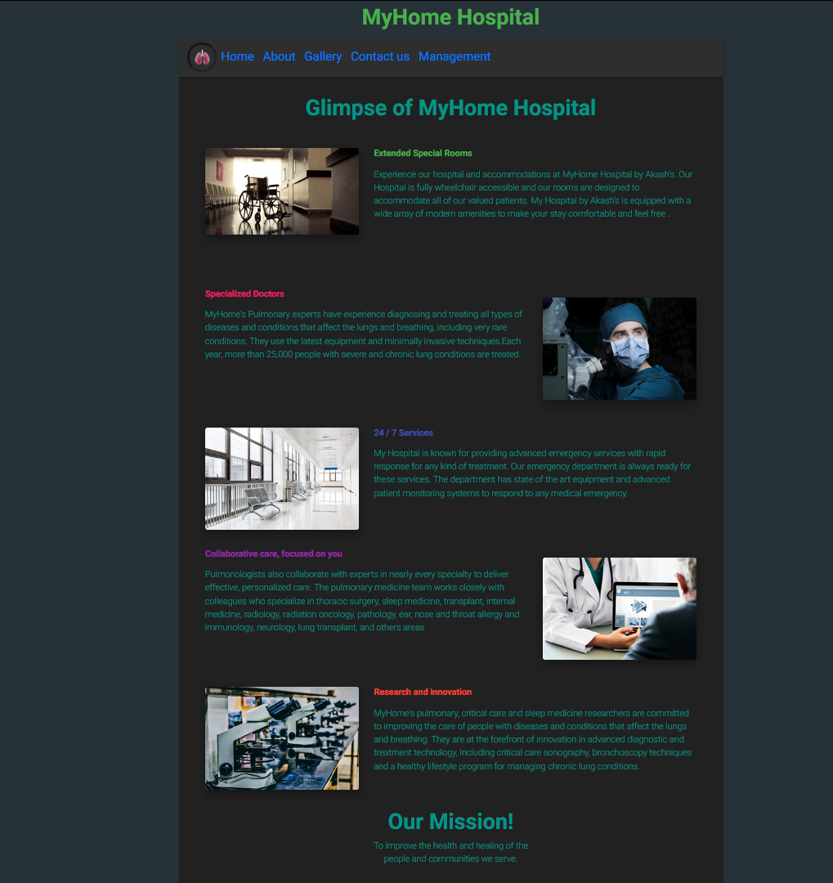

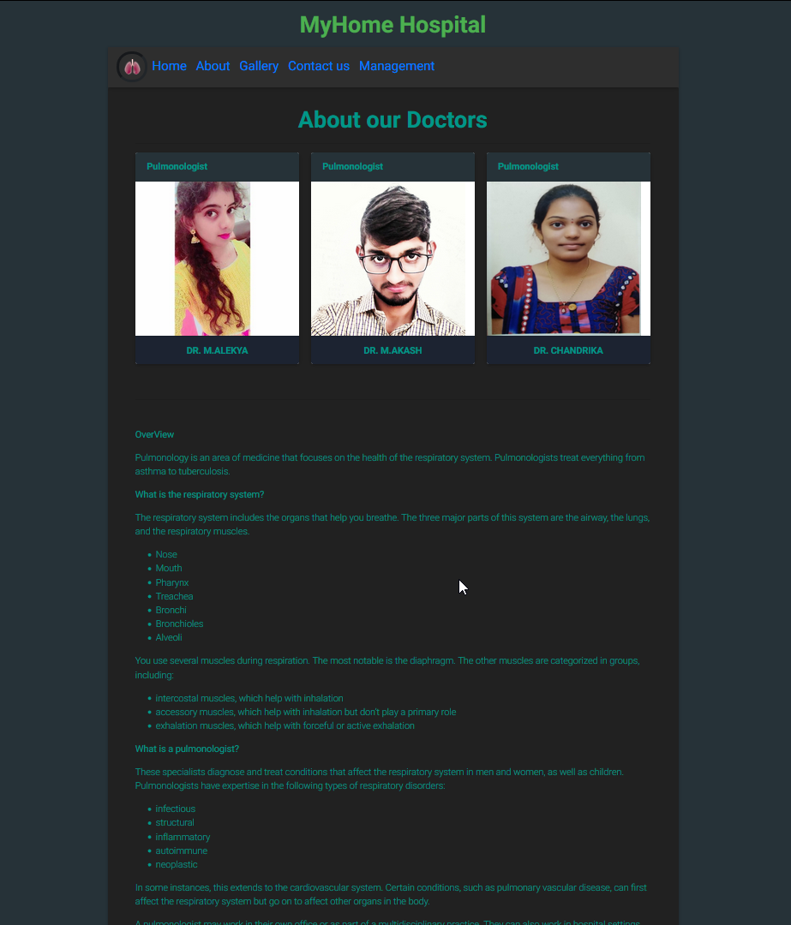

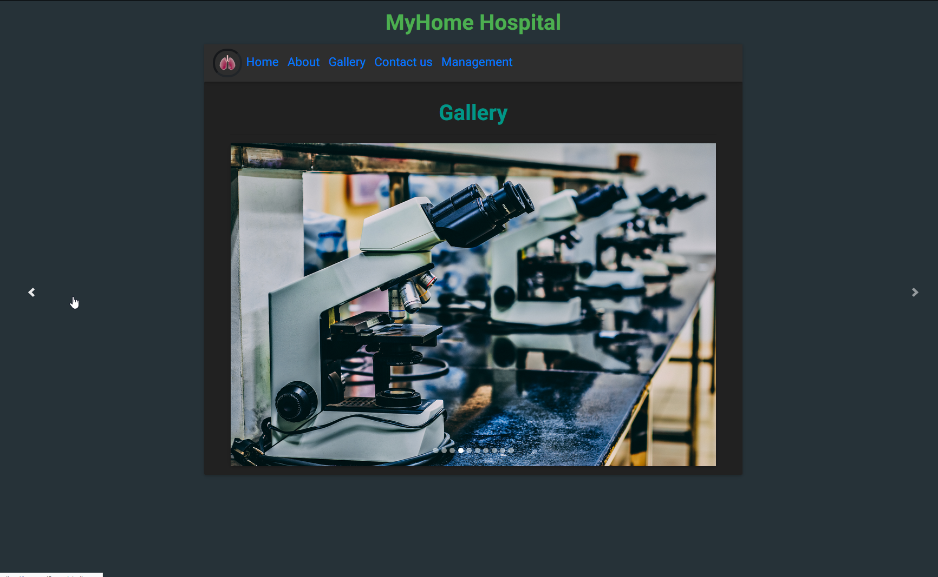

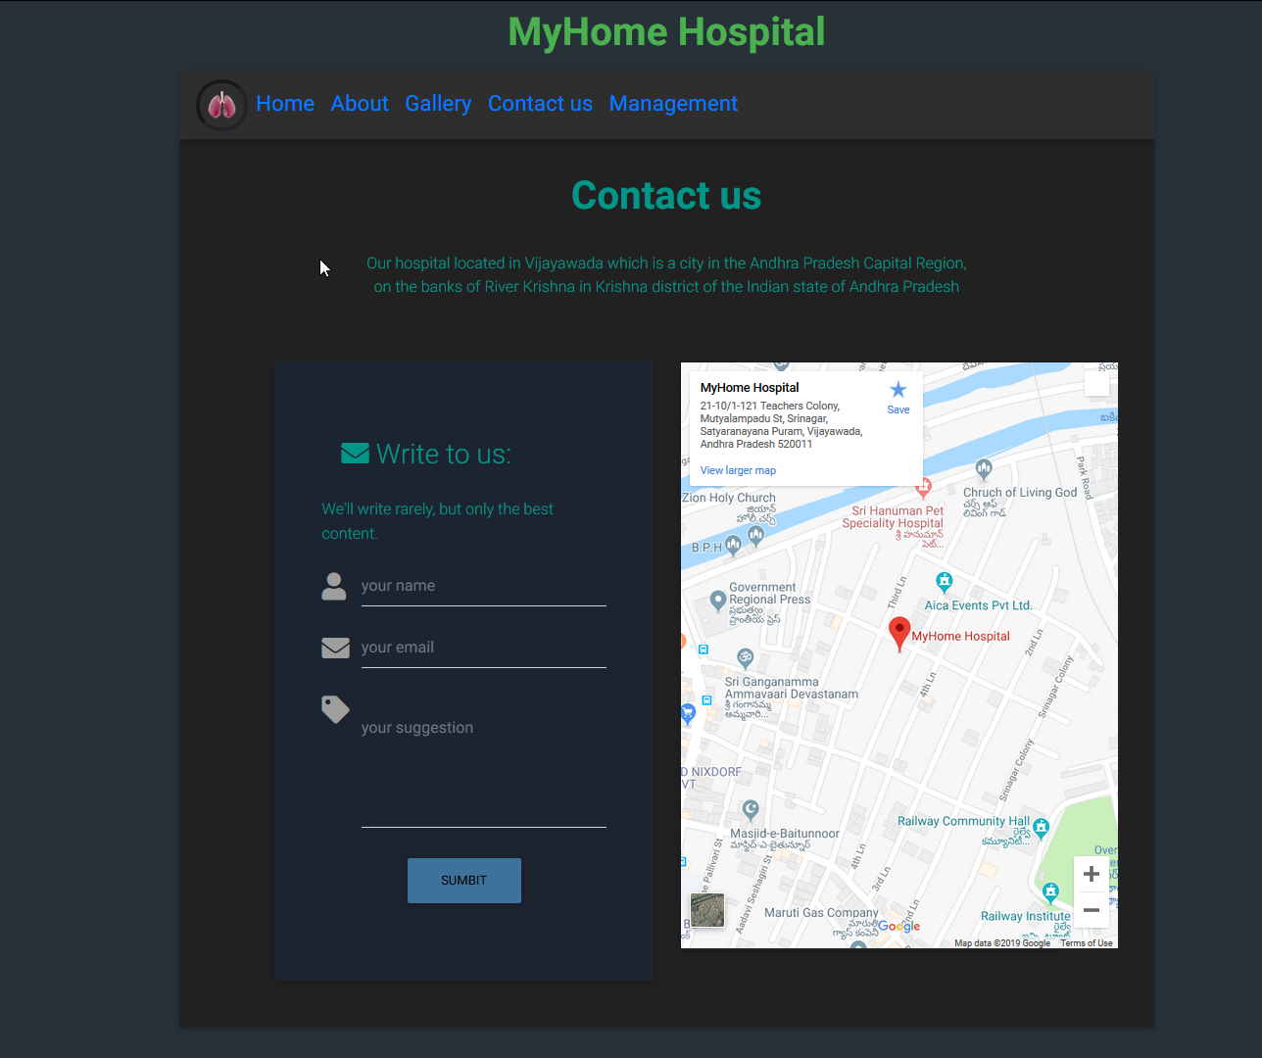

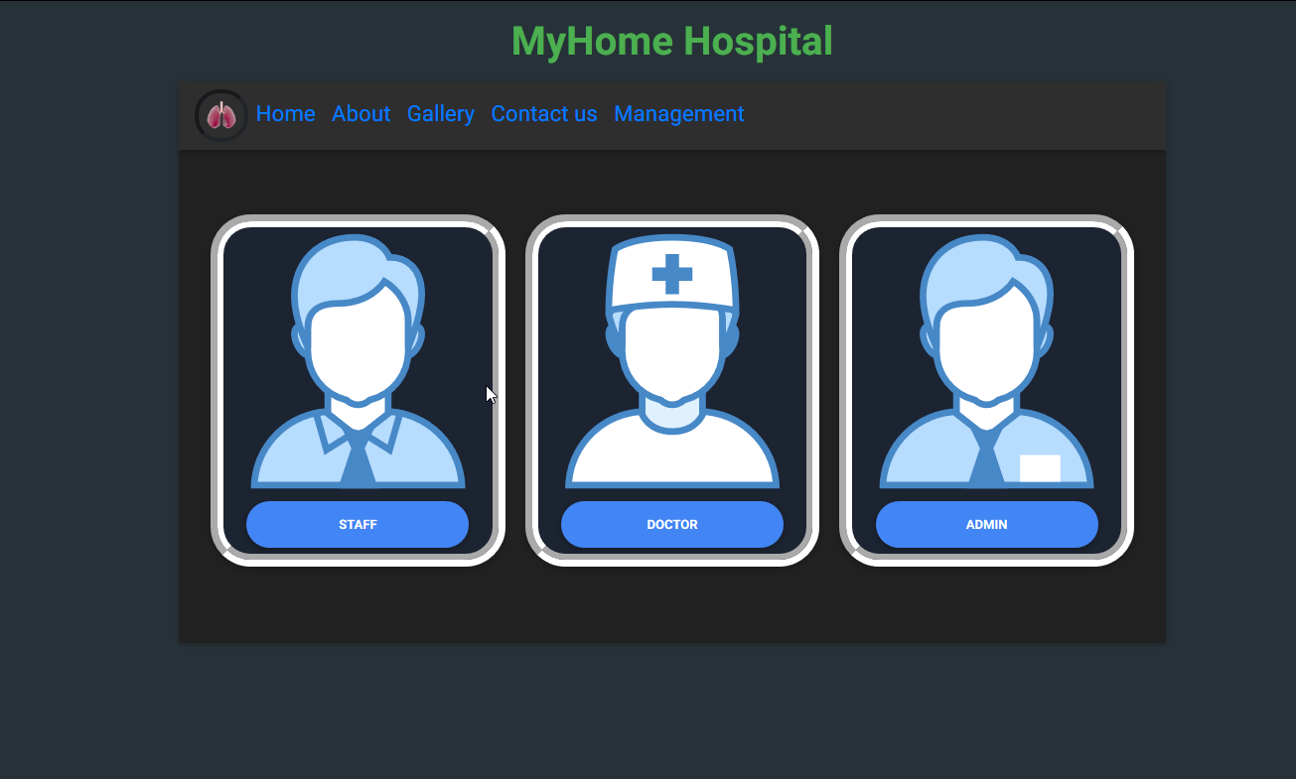

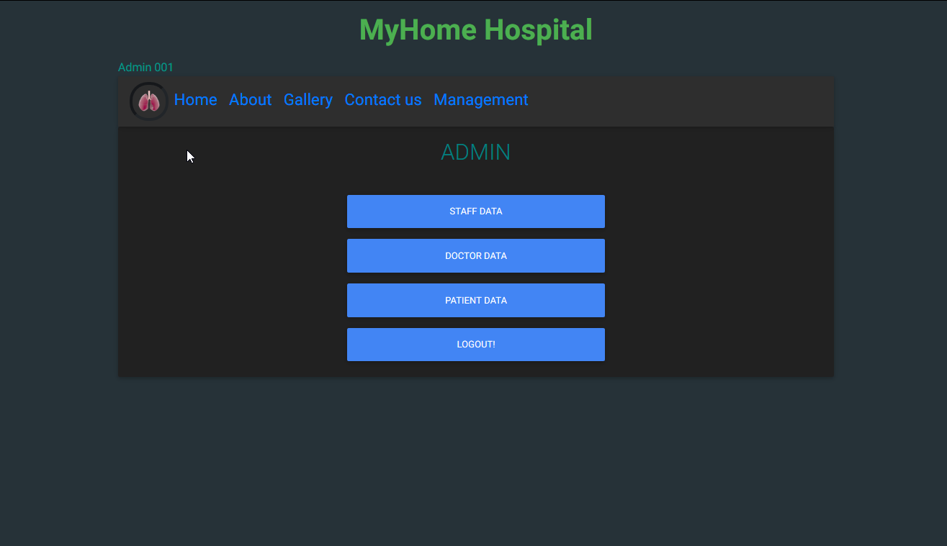

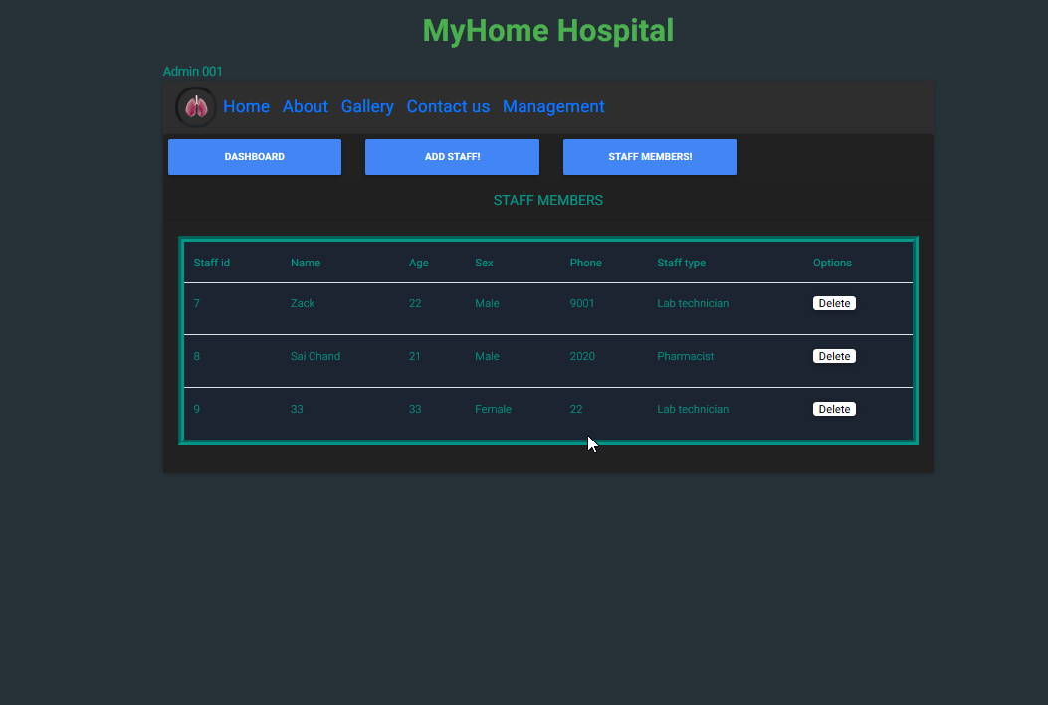

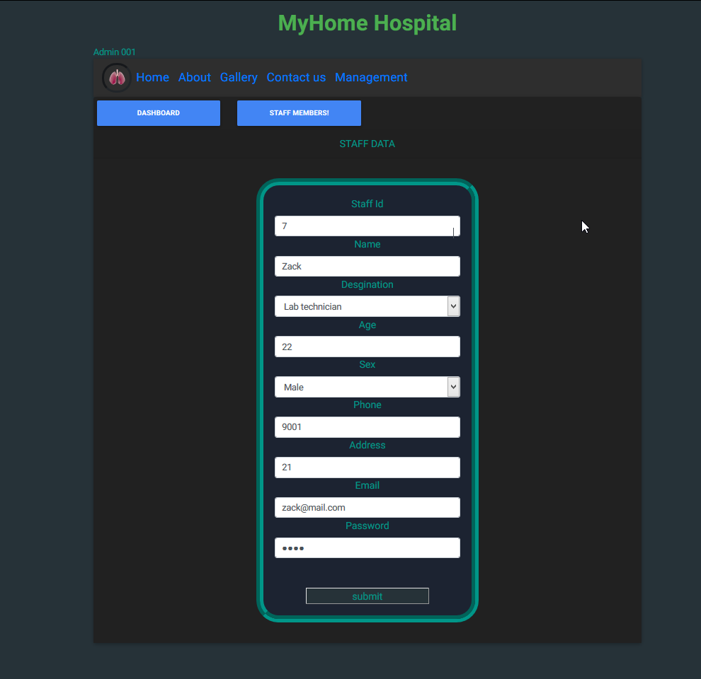

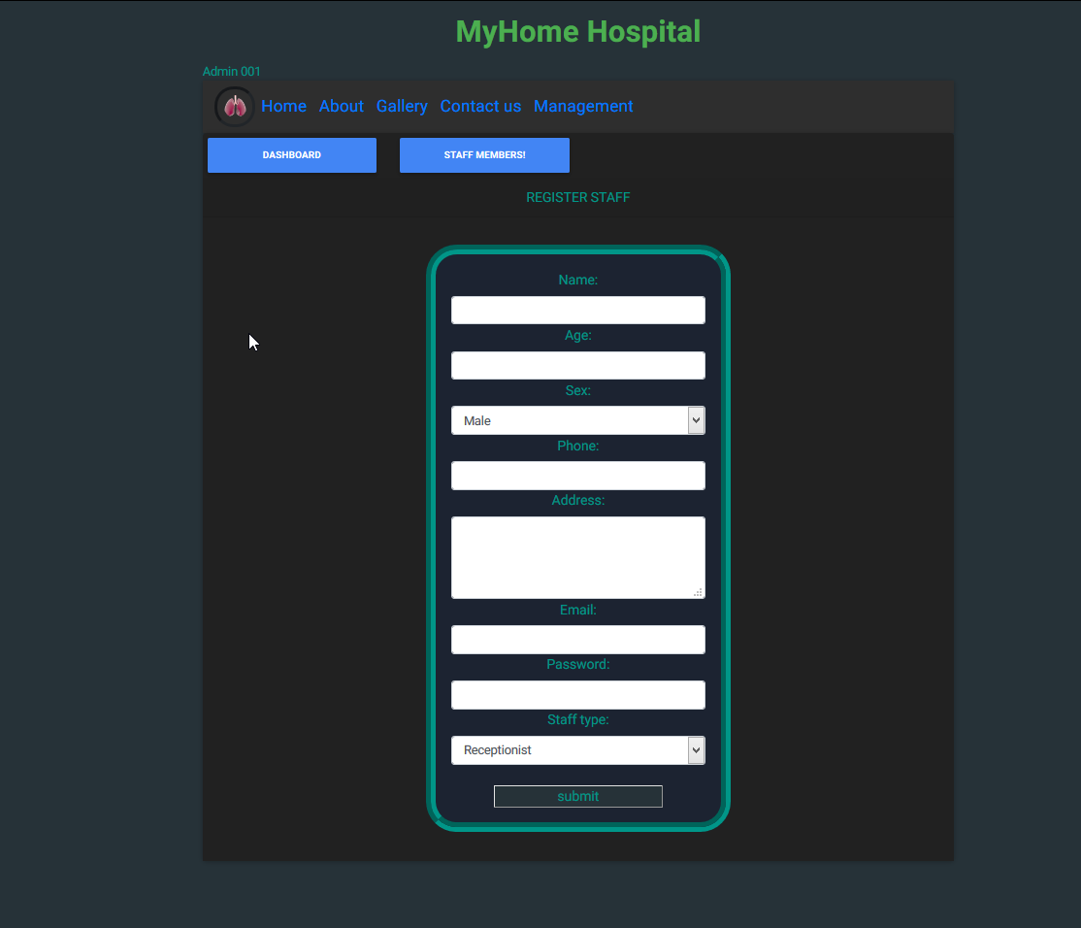

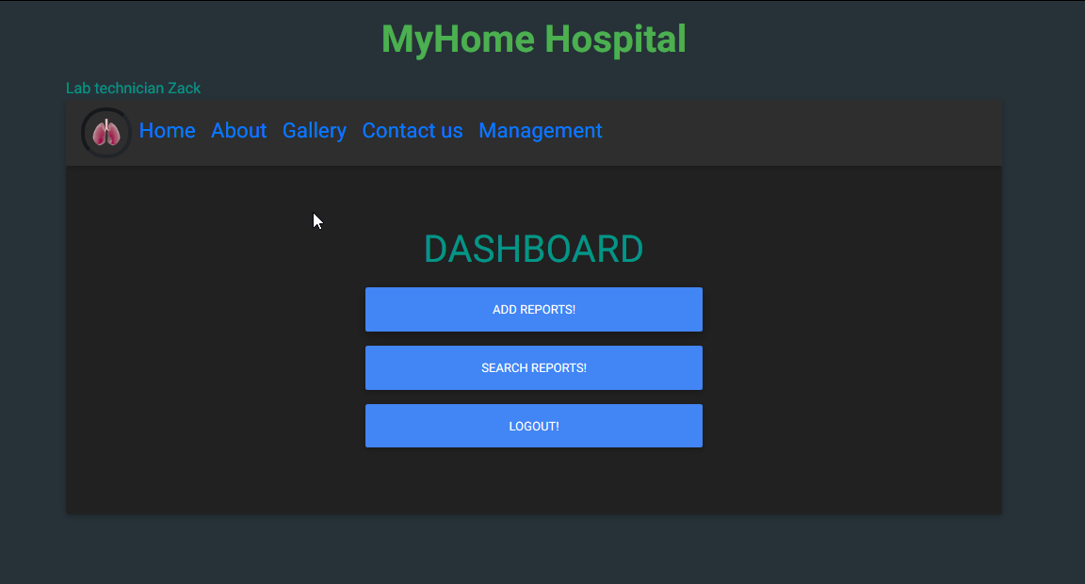

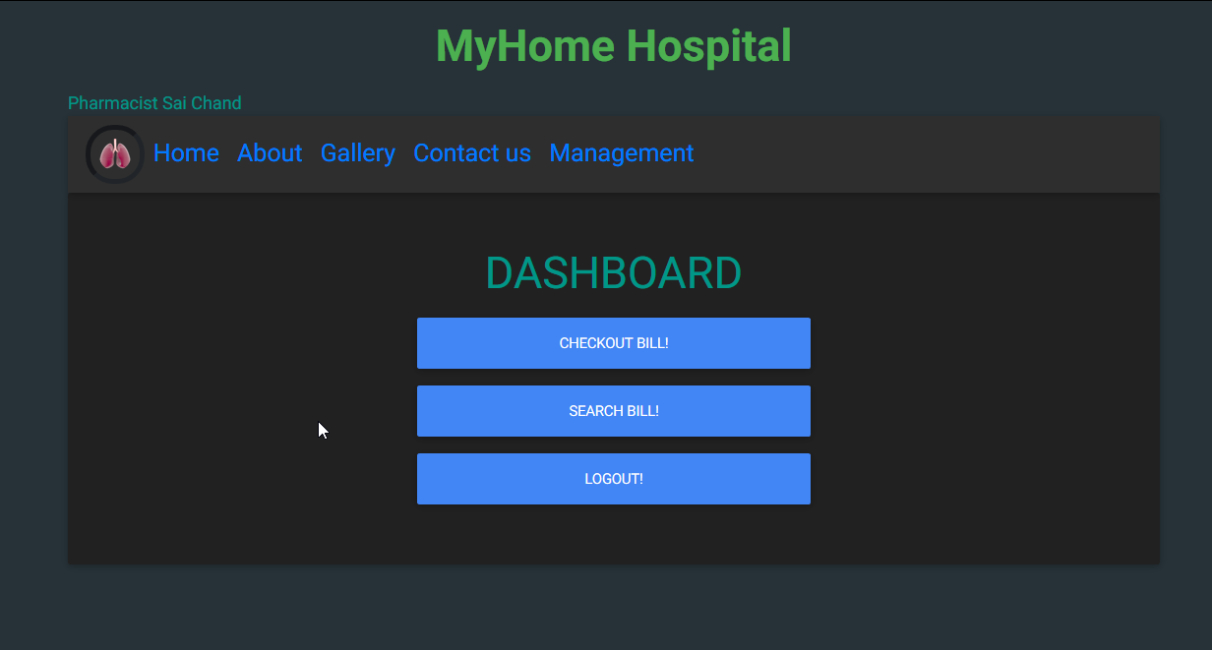

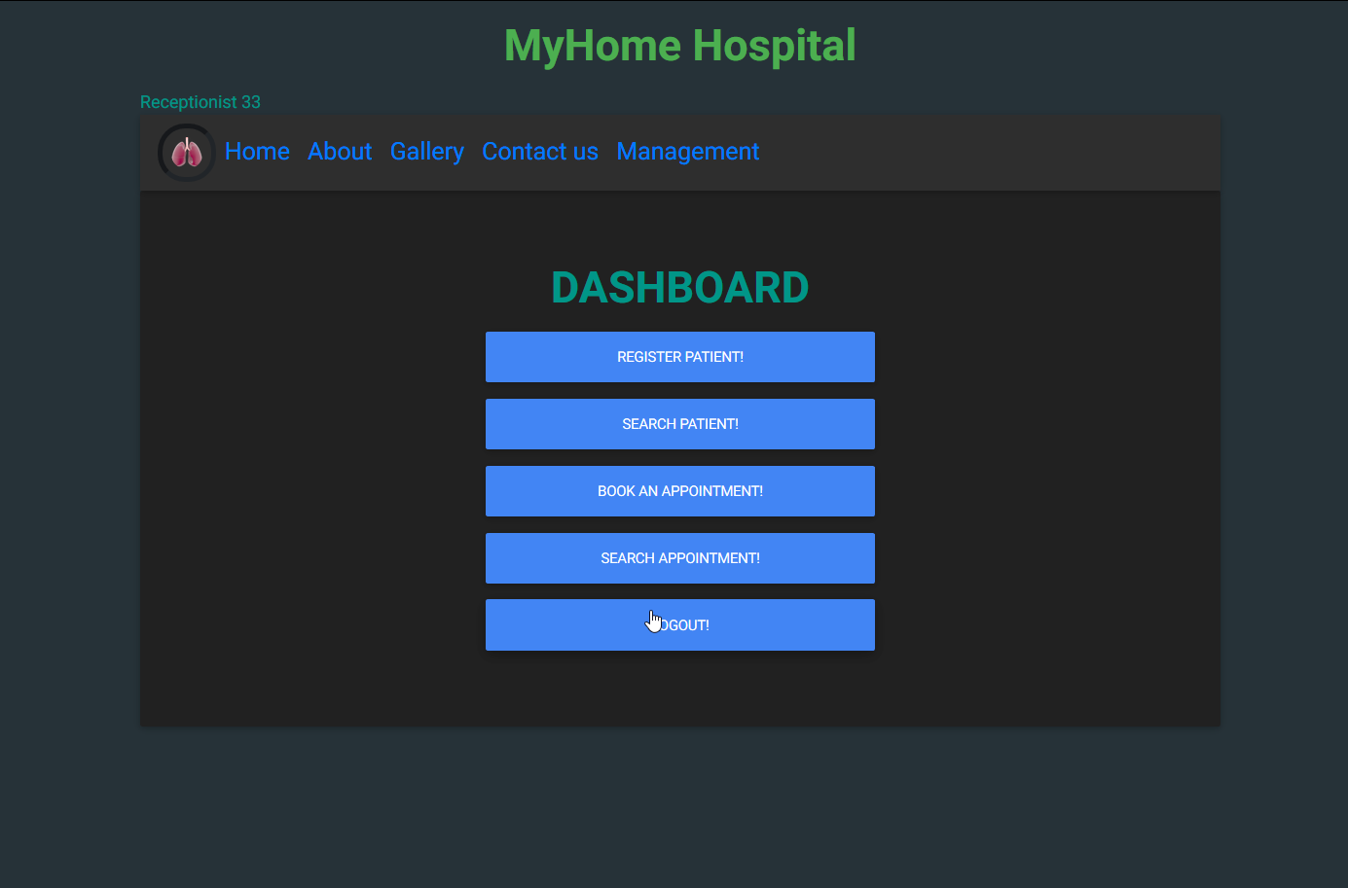

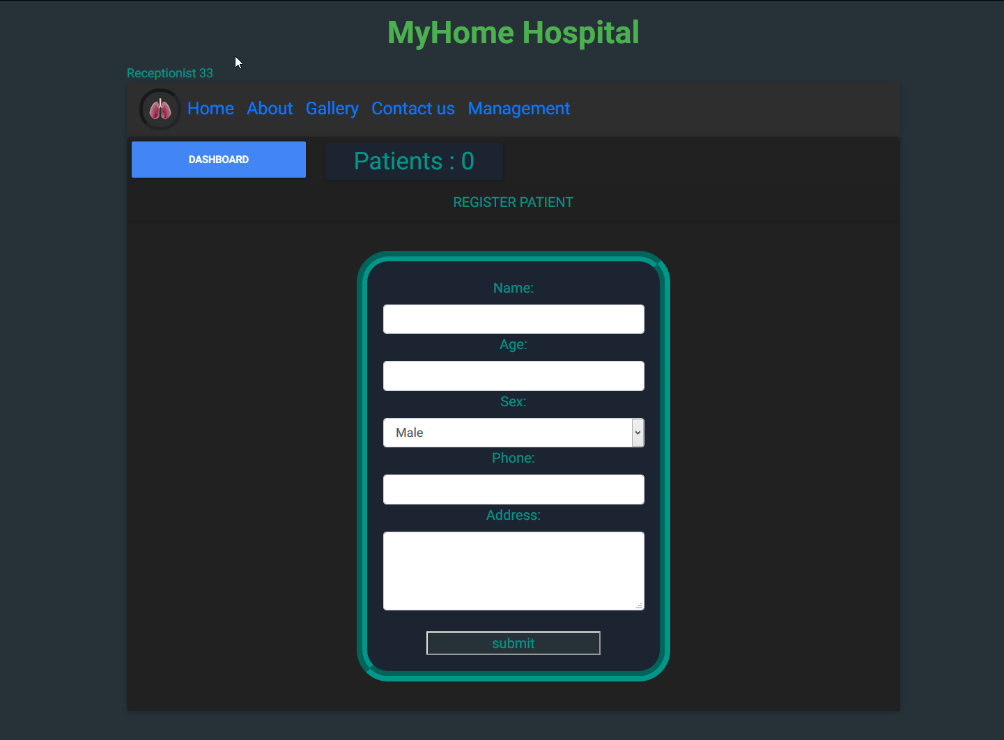

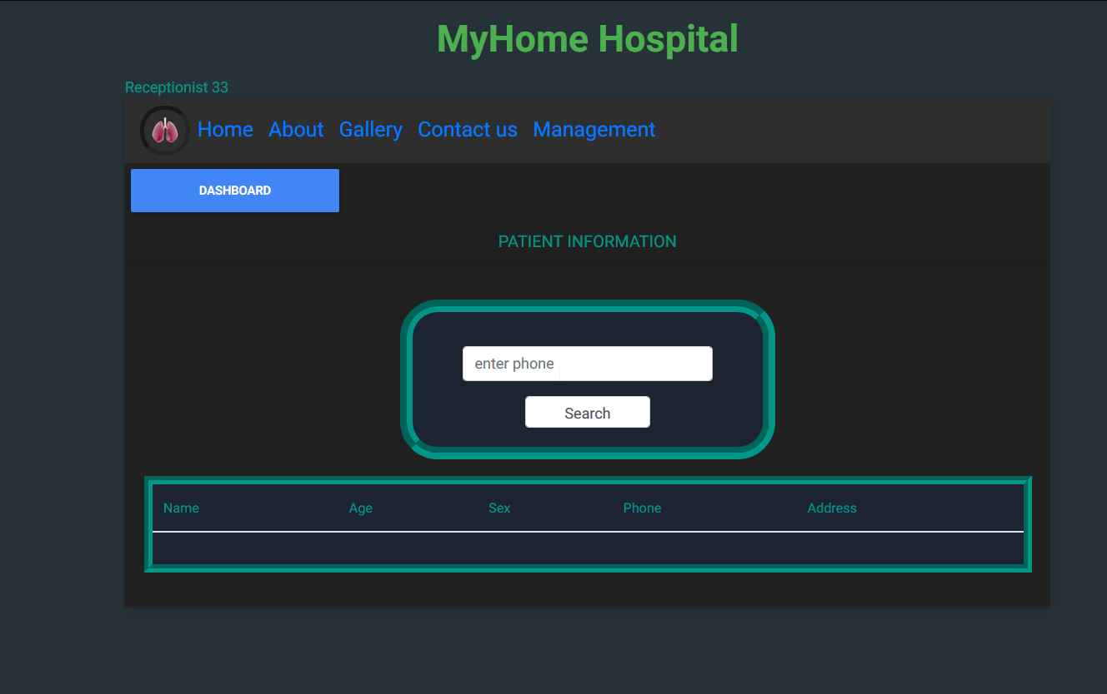

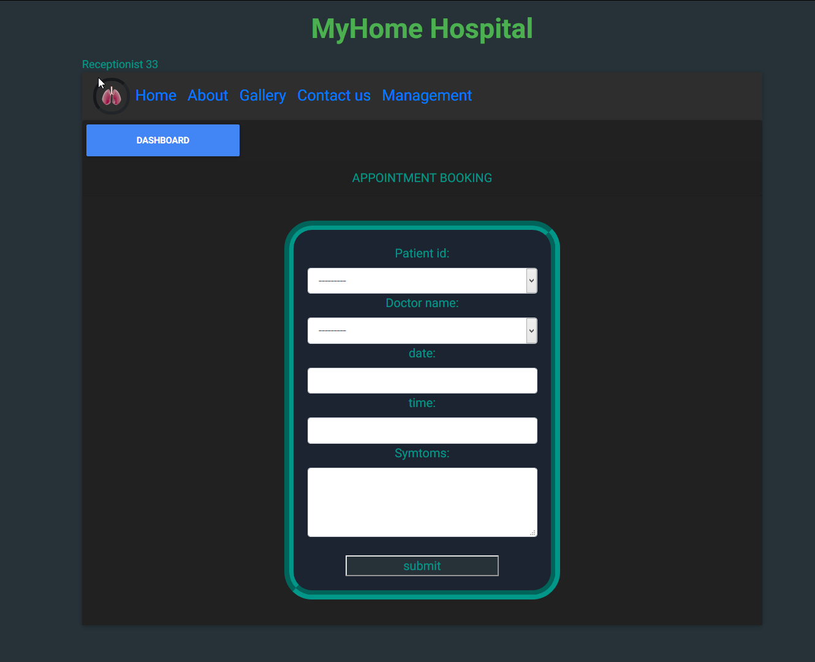

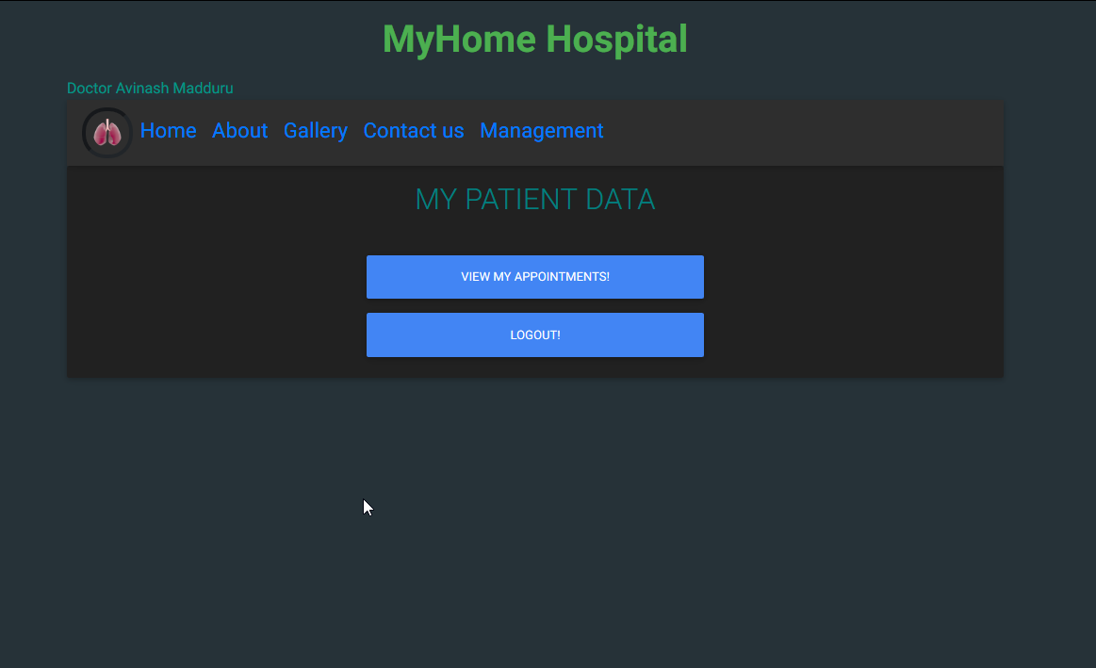

CONCLUSION

Conclusion
The project Hospital Management System (HMS) is for computerizing the working in a hospital. The software takes care of all the requirements of an average hospital and is capable to provide easy and effective storage of information related to patients that come up to the hospital. It generates test reports; provide prescription details including various tests, diet advice, and medicines prescribed to patient and doctor. It also provides injection details and billing facility on the basis of patient’s status whether it is an indoor or outdoor patient. The system also provides the facility of backup as per the

Bibliography

1)The Definitive Guide to Django by Adrian Holovaty

2)Think Python: How to Think Like a Computer Scientist, 2nd edition by Allen B. Downey (O’Reilly, 2015)

