**Lab 2**

**LAB 2**

**SECTION C**

**Akash Patel**

**SUBMISSION DATE: 2/13/19**

**2/13/19**

# Problem

The purpose is to solve problems using simple arithmetic, and work with C integer and floating-point math.

# Analysis

I learned more about integer and floating-point math used in C. I had trouble getting the outputs but in the end I learned that all I had to do was use %d or %lf.

# Design

For 2_2_1 I had to compile and debug a code for getting an area of a rectangle. For 2_2_2 I had to get the volume of an x by z rectangular prism. I modified it by adding one side input and using the volume formula. For 2_3 I had to describe the reason and correct the problem. For 2_4 I had to perform arithmetic operations, so I just wrote each equation on new lines and got the output and printed it. For 2_5 I wrote a program that would use the Pythagorean theorem to compute one side length of a triangle when given two sides.

# Testing

This lab was fairly simple so I just compiled and ran the programs until they worked. I had a few compiling issues due to syntax but that’s about it.

# Comments

This was a simple lab but I shouldn’t have procrastinated on it. I should have got it done much sooner.

# Source Code

/*-----------------------------------------------------------------------------

- SE 185 Lab 02

- Developed for 185-Rursch by T.Tran and K.Wang

- Name: Akash Patel

- Section: SE 185 C

- NetID: apatel1@iastate.edu

- Date: 02/07/2019

-----------------------------------------------------------------------------*/

/*-----------------------------------------------------------------------------

- Includes

-----------------------------------------------------------------------------*/

#include <stdio.h>

#include <math.h>

/*-----------------------------------------------------------------------------

- Defines

-----------------------------------------------------------------------------*/

/*-----------------------------------------------------------------------------

- Prototypes

-----------------------------------------------------------------------------*/

/*-----------------------------------------------------------------------------

- Implementation

-----------------------------------------------------------------------------*/

int main()

{

/* Put your code after this line */

printf("Akash Patel\n");

printf("SE 185 section C\n");

printf("02/07/2019\n");

return 0;

}

/*-----------------------------------------------------------------------------

- SE 185 Lab 02

- Developed for 185-Rursch by T.Tran and K.Wang

- Name: Akash Patel

- Section: SE 185 C

- NetID:145968622

- Date: 02/07/2019

-----------------------------------------------------------------------------*/

/*-----------------------------------------------------------------------------

- Includes

-----------------------------------------------------------------------------*/

#include <stdio.h>

#include <math.h>

/*-----------------------------------------------------------------------------

- Defines

-----------------------------------------------------------------------------*/

/*-----------------------------------------------------------------------------

- Prototypes

-----------------------------------------------------------------------------*/

/*-----------------------------------------------------------------------------

- Implementation

-----------------------------------------------------------------------------*/

int main()

{

/* Put your code after this line */

int x, y;

printf("enter a width: ");

scanf("%d", &x);

printf("Enter a Height: ");

scanf("%d",&y);

printf("A %d by %d rectangle's area is %d\n", x, y, x*y);

return 0;

}

/*-----------------------------------------------------------------------------

- SE 185 Lab 02

- Developed for 185-Rursch by T.Tran and K.Wang

- Name: Akash Patel

- Section: SE 185 C

- NetID:145968622

- Date: 02/07/2019

-----------------------------------------------------------------------------*/

/*-----------------------------------------------------------------------------

- Includes

-----------------------------------------------------------------------------*/

#include <stdio.h>

#include <math.h>

/*-----------------------------------------------------------------------------

- Defines

-----------------------------------------------------------------------------*/

/*-----------------------------------------------------------------------------

- Prototypes

-----------------------------------------------------------------------------*/

/*-----------------------------------------------------------------------------

- Implementation

-----------------------------------------------------------------------------*/

int main()

{

/* Put your code after this line */

int x, y, z;

printf("enter a width: ");

scanf("%d", &x);

printf("Enter a Height: ");

scanf("%d",&y);

printf("Enter a Length: ");

scanf("%d", &z);

printf("A %d by %d by %d rectangular prism's volume is %d\n", x, y, z, x*y*z);

return 0;

}

/*-----------------------------------------------------------------------------

- SE 185 Lab 02

- Developed for 185-Rursch by T.Tran and K.Wang

- Name: Akash Patel

- Section: SE 185 C

- NetID:145968622

- Date: 02/07/2019

-----------------------------------------------------------------------------*/

/*-----------------------------------------------------------------------------

- Includes

-----------------------------------------------------------------------------*/

#include <stdio.h>

/*-----------------------------------------------------------------------------

- Defines

-----------------------------------------------------------------------------*/

/*-----------------------------------------------------------------------------

- Prototypes

-----------------------------------------------------------------------------*/

/*-----------------------------------------------------------------------------

- Implementation

-----------------------------------------------------------------------------*/

int main()

{

int integerResult;

double decimalResult;

integerResult = 77 / 5;

printf("The value of 77/5 is %d, using integer math\n", integerResult);

// I changed %lf to %d to make sure an integer value comes out instead of decimal.

integerResult = 2 + 3;

printf("The value of 2+3 is %d\n", integerResult);

// I inserted integerResult after the printed statement to make sure i get an integer result.

decimalResult = 1.0 / 22.0;

printf("The value 1.0/22.0 is %lf\n", decimalResult);

// i chnaged the %d to %lf to get a decimal answer.

return 0;

}

/*-----------------------------------------------------------------------------

- SE 185 Lab 02

- Developed for 185-Rursch by T.Tran and K.Wang

- Name: Akash Patel

- Section: SE 185 C

- NetID: apatel1@iastate.edu

- Date: 02/07/2019

-----------------------------------------------------------------------------*/

/*-----------------------------------------------------------------------------

- Includes

-----------------------------------------------------------------------------*/

#include <stdio.h>

#include <math.h>

/*-----------------------------------------------------------------------------

- Defines

-----------------------------------------------------------------------------*/

/*-----------------------------------------------------------------------------

- Prototypes

-----------------------------------------------------------------------------*/

/*-----------------------------------------------------------------------------

- Implementation

-----------------------------------------------------------------------------*/

int main()

{

/* Put your code after this line */

int A = 6427 + 1725;

printf("6427 + 1725 = %d\n ", A);

int B = (6971 * 3925) -95;

printf("6971 * 3925 = %d\n", B);

double C = 79 + (12 / 5);

printf("79 + 12 / 5 = %.2lf\n", C);

double D = (3640.0 / 107.9);

printf("3640.0 / 107.9 = %.2lf\n", D);

int E = (22 / 3) * 3;

printf("22 / 3) * 3 = %d\n", E);

int F = 22 / (3 * 3);

printf("22 / (3 * 3) = %d\n", F);

double G = 22 / (3 * 3);

printf("22 / (3 * 3) = %.2lf\n", G);

double H = (22 / 3) * 3;

printf("(22 / 3) * 3 = %.2lf\n", H);

double I = (22.0 / 3) * 3;

printf("(22.0 / 3) * 3 = %.2lf\n", I);

int J = 22.0 / (3 * 3.30);

printf("22.0 / (3 * 3.30) = %d\n", J);

double K = (22.0 / 3.0) * 3.0;

printf("(22.0/3.0) * 3.0 = %.2lf\n", K);

//Creating formulas

double areaOfCircle= 3.14159 * pow(11.7835,2);

printf("The area of the circle is %.2lf\n", areaOfCircle);

//The area of a circle is pi * r^2, so i divided the circumference to get the radius and plugged it into the formula.

double feetToMeters= 14 * .3048;

printf("14 feet converted to meters is %.2f\n", feetToMeters);

// There are 3.28 feet in a meter so I multiplied 14 feet by .3048 meters

double fToC = (76-32)/1.8;

printf("76 degrees Fahrenheit to centrigrade is %.2lf\n", fToC);

// the equation was given so i plugged in 76 for Tf

return 0;

}

/*-----------------------------------------------------------------------------

- SE 185 Lab 02

- Developed for 185-Rursch by T.Tran and K.Wang

- Name: Akash Patel

- Section: SE 185 C

- NetID: aptel1@iastate.edu

- Date: 02/07/2019

-----------------------------------------------------------------------------*/

/*-----------------------------------------------------------------------------

- Includes

-----------------------------------------------------------------------------*/

#include <stdio.h>

#include <math.h>

/*-----------------------------------------------------------------------------

- Defines

-----------------------------------------------------------------------------*/

/*-----------------------------------------------------------------------------

- Prototypes

-----------------------------------------------------------------------------*/

/*-----------------------------------------------------------------------------

- Implementation

-----------------------------------------------------------------------------*/

int main()

{

double a, b, c;

double filler;

/* Put your code after this line */

printf("Enter a value for A:");

scanf("%lf", &a);

printf("Enter a value for B: ");

scanf("%lf", &b);

/* This next line will calculate the square root of whatever value is

inside the parenthesis and assigns it to the variable filler. */

filler = sqrt((pow(a,2) + pow(b,2)));

printf("value of c is: %lf",filler);

return 0;

}

# Screen Shots

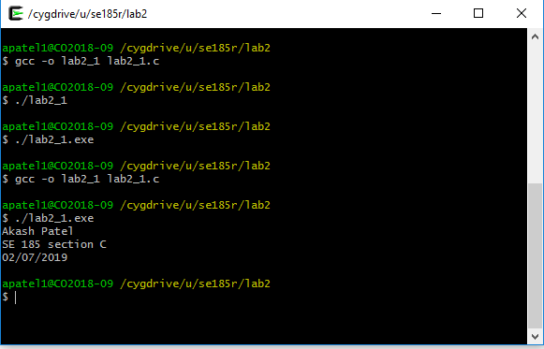 1

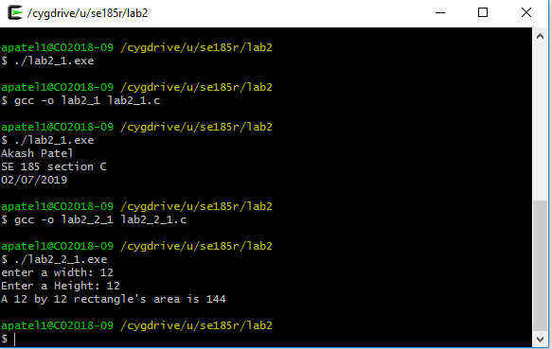2

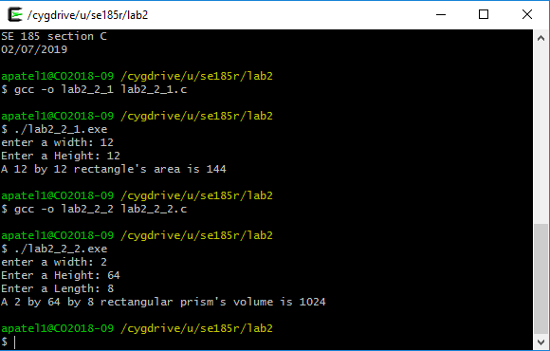3

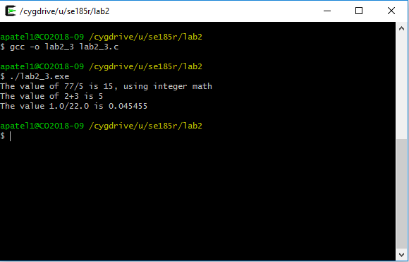4

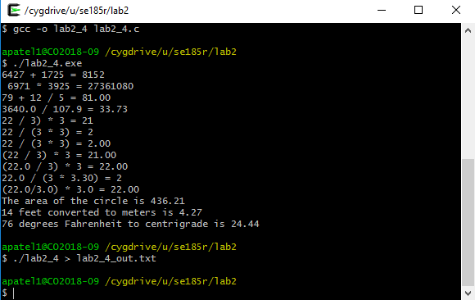5

6