  **COMSOFT TECHNOLOGIES**

Rajaginagar, Bengaluru-560010



AN INTERNSHIP

REPORT

ON

“ENGINNERING SGPA/CGPACALCULATOR”

Bachelor of Engineering

in

Computer Science and Engineering

Logo
Submitted by: SHRINIDHI H T (USN-4SM18CS052)

2020-21

S J M INSTITUTE OF TECHNOLOGY

CHITRADURGA-577502

**ABOUT THE COMPANY**

CST, core strength lies in our super energetic and gigantic team, forming an excellent blend of IT minds along with a creative bent. Taking ownership of not only one’s own task but also creating an enduring & contented customer is what every individual works together with. Our endeavour is to continuously improve and deliver maximum–enriching products & solutions.

Vision

We are committed to going the extra mile to bring success to the clients consistently We are dedicated to delivering the right people, solutions, and services to the clients that they require to meet their technology challenges and business goals.

Mission

Optimizing client satisfaction with quality services Delivering the most efficient and the best solution to our clients to every client leveraging leading technologies & industry best practices.

Development

We develop responsive, functional and super-fast websites. We keep User Experience in mind while creating websites. A website should load quickly and should be accessible even on a small view-port and slow internet connection Creative web solutions blended with latest technologies form the right base for innovative businesses.

Branding and Design

We offer professional Graphic design, Brochure design & Logo design. We are experts in crafting visual content to convey the right message to the customers. We also design custom wraps for your products also known as package designing

Search Engine Optimisation

We help you manage your SEO campaign more efficiently and effectively. We help you gain market share by leveraging our expertise. our holistic approach to identify anything that may be hurting your traffic or rankings and show you just how to outrank the competition.

Research

We equip business leaders with indispensable insights, advice and tools to achieve their goals, our main area of research is in sentimental analysis, having published multiple papers on the same, we are in the process of creating a virtual bot that is intended to use our sentimental analysis data to provide real time replies

**TABLE OF CONTENTS**

Table of contents i

Overview of the Project 1

About Engineering SGPA & CGPA Calculator 2-3

Tools Used 4

Implementation 5-13

Snapshots 14-16

Bibliography 17

**Project Name**: ENGINEERING SGPA/CGPA CALCULATOR

**Team Members**: NAME- Nayan A C

NAME- Akash M

NAME- Shrinidhi H T

This project is based on Web Development And its Applications. The main objective of this project is to learn the implementation of HTML, CSS and JavaScript. The basic webpage of this project is created using HTML and styling of the webpage is done using CSS.

CGPA refers to the cumulative grade point average which literally translates to the sum total of all your credit points. This system helps in assessing the overall academic performance of a student. Although the evaluation criteria may vary from one country to another, the CGPA system is among the most common evaluation way in most professional/technical courses

ABOUT ENGINEERING SGPA/CGPA CALCULATOR PROJECT

The University adopts absolute grading system where in the marks are converted to grades, and every semester results shall be declared with Semester Grade Point Average (SGPA) and Cumulative Grade Point Average (CGPA).The CGPA will be calculated for every semester, except for the first semester.

The grading system with the letter grades and the assigned range of marks under absolute grading system are as given below:

|  |  |  |  |  |  |  |  |
| --- | --- | --- | --- | --- | --- | --- | --- |
| Level | Outstanding | Excellent | Very  Good | Good | Above Average | Average | Fail |
| Letter Grade | S | A | B | C | D | E | F |
| Grade Points | 10 | 9 | 8 | 7 | 6 | 4 | 00 |
| Percentage of Marks Scored in a Course | 5>90 | <90  >80 | <80  >70 | <70  >60 | <60  >45 | <45  >40 | <40 |
| (90-100) | (80-89) | (70-79) | (60-69) | (45-59) | (40-44) | (0-399) |

A student obtaining Grade F in a Course shall be considered fail and is required to reappear in the subsequent SEE. Whatever the letter grade secured by the student during his/her reappearance shall be awarded. The number of attempts taken to clear Course/s shall be indicated in the grade card.

Computation of SGPA and CGPA

The following expression shall be used to compute the semester Grade Point Average (SGPA) and Cumulative Grade Point Average (CGPA) respectively:

SGPA= $∑\left[Course credits*Grade Points \right]for all the Courses in that seemester$

∑ [Course Credits] for all the Courses in that Semester

CGPA=∑ [Course Credits * Grade Points] for all Courses excluding those with F and

transactional grades until that semester

∑[Course Credits] for all Courses excluding those with F grades until that semester

SGPA, which stands for Semester Grade Point Average is an evaluation method that highlights the semester wise performance of the student. It can be calculated by simply adding all the credit points awarded for the subjects and then dividing it by the total credits allotted to that semester.

**TOOLS USED**

**Software Requirements**

• Visual Studio Code 2019.

• Google Chrome or Microsoft Edge of latest version.

• Front End: HTML, CSS, JS (optional)

• Linux 7.1 or Windows XP/7/8/10 OS or Mac OS

**Hardware Requirements**

• Pentium 200-MHz computer with a minimum of 64 MB of RAM (128 MB of RAM recommended).

• Monitor with a refresh rate of at least 40Hz for a smooth GUI experience (optional).

* Minimum Resolution of 1920*1080.

**IMPLEMENTATION**

**Source Code (P2.HTML):**

<!DOCTYPE HTML>

<html lang="en">

<head>

<title>VTU CGPA & SGPA CALCULATOR</title>

<meta name="viewport" content="width=device-width, initial-scale=1">

<meta charset="utf-8">

<meta name="keywords" content="sgpa Calculator, Calculator, cgpa Calculator, VTU, cbcs,non cbcs" />

<script>

addEventListener("load", function () {

setTimeout(hideURLbar, 0);

}, false);

function hideURLbar() {

window.scrollTo(0, 1);

}

</script

<!-- Bootstrap Core CSS -->

<link href="static/css/bootstrap.css" rel='stylesheet' type='text/css' />

<!-- Custom CSS -->

<link href="static/css/style.css" rel='stylesheet' type='text/css' />

<!-- font-awesome icons -->

<link href="static/css/fontawesome-all.min.css" rel="stylesheet">

<!-- pop up box -->

<link href="static/css/popup-box.css" rel="stylesheet" type="text/css" media="all" />

<link rel="stylesheet" href="static/css/owl.carousel.css" type="text/css" media="all">

<link rel="stylesheet" href="static/css/owl.theme.css" type="text/css" media="all">

<link rel="icon" href="logo.png">

<!-- Carousel (for News section) -->

<!-- //Custom Theme files -->

<!-- online fonts -->

<!--<link href="//fonts.googleapis.com/css?family=Poppins:100,100i,200,200i,300,300i,400,400i,500,500i,600,600i,700,700i,800,800i,900,900i"

rel="stylesheet">

<link href="//fonts.googleapis.com/css?family=Gentium+Book+Basic:400,400i,700i" rel="stylesheet"> -->

<!--//online fonts -->

</head>

<video playsinline autoplay muted loop id="bgvid">

<source src="Dark purple.mp4" type="video/mp4">

</video>

<body>

<!-- header -->

<header>

<div class="header-bottom">

<div class="container">

<nav class="navbar navbar-expand-lg navbar-light p-0">

<h1><a class="navbar-brand" href="index.html">

<img src="logo.png" width="40px" > VTU CALCULATOR

</a></h1>

<button class="navbar-toggler ml-lg-auto ml-sm-5" type="button" data-toggle="collapse" data-target="#navbarSupportedContent"

aria-controls="navbarSupportedContent" aria-expanded="false" aria-label="Toggle navigation">

<span class="navbar-toggler-icon"></span>

</button>

<div class="collapse navbar-collapse" id="navbarSupportedContent">

<ul class="navbar-nav text-center ml-auto">

<li class="nav-item mr-lg-3 mt-lg-0 mt-4">

<a class="hover-fill" aria-pressed="false" href="index.html" data-txthover="PERCENTAGE CALCULATOR">PERCENTAGE CALCULATOR</a>

</li>

<li class="nav-item mr-lg-3 mt-lg-0 mt-4">

<a class="hover-fill" aria-pressed="false" href="sgpa.html" data-txthover="SGPA CALCULATOR">SGPA CALCULATOR</a>

</li>

<li class="nav-item">

<a class="hover-fill" aria-pressed="false" href="cgpa.html" data-txthover="CGPA CALCULATOR">CGPA CALCULATOR</a>

</li>

</ul>

</nav>

</div>

</div>

</header>

<!-- //header -->

<!-- banner -->

<div class="screenview_bg bg-theme px-3">

<div class="container">

<section class="wthree-row w3-gallery py-5">

<div class="container py-xl-5">

<div class="w3l_header pb-3">

<h3 class="text-center">VTU PERCENTAGE CALCULATOR</h3>

</div>

</div>

<!-- //gallery container -->

<div class="container">

<div class="login mb-sm-5 px-4 mx-auto mw-100">

<form id="cgpac" action="#" method="post">

<fieldset>

<div class="row justify-content-md-center">

<div class="col-5">

<div class="form-row">

<div class="form-group col-md-6 mb-4">

<label class="col-form-label">CGPA/SGPA</label>

</div>

<div class="col-md-6 mb-4">

<input type="text" class="form-control" id="gpa" name="gpa" placeholder="" required>

</div>

</div>

</div>

</div>

</fieldset>

<br>

<div class='text-center' style="margin-top: 10px">

<button type="submit" class="get-started-btn">Calculate Percentage</button>

</div>

</form>

</div>

</div>

<div class="row">

<div class="col">

<fieldset disabled>

<div class="container" style="margin:0 auto; width: 50%;">

<legend>Result</legend>

<div class="form-row">

<div class="form-group col-md-6 mb-4">

<label class="col-form-label">Percentage</label>

</div>

<div class="col-md-6 mb-4">

<input type="text" id="percentage" class="form-control" placeholder="">

</div>

</div>

</div>

</fieldset>

</div>

</div>

</section>

</div>

</div>

<!-- //banner -->

<!-- //footer -->

<div class="cpy-right">

<p class="text-white">© <script>document.write(new Date().getFullYear())</script> Design by Aspirants

</p>

</div>

**IMPLEMENTATION**

**Source Code (P1.CSS+P1. JS (if used)):**

**CSS**

html,

body {

font-family: 'Gilroy', sans-serif;

font-size: 100%;

overflow-x: hidden;}

video {

object-fit: cover;

width: 100vw;

height: 100vh;

position: fixed;

top: 0;

left: 0;

z-index: -10;

}

body a,

.btn-agile {

transition: 0.5s all;

-webkit-transition: 0.5s all;

-moz-transition: 0.5s all;

-o-transition: 0.5s all;

-ms-transition: 0.5s all;

text-decoration: none;

}

h1,

h2,

h3,

h4,

h5,

h6 {

margin: 0;

font-family: 'Gilroy', sans-serif;

}

p {

line-height: 1.8;

font-size: 15px;

color: #777;

margin: 0;

}

ul {

margin: 0;

padding: 0;

}

li {

list-style-type: none;

font-size: 0.95em;

}

a {

font-size: 0.95em;

}

body a:hover {

text-decoration: none;

}

input[type="submit"] {

cursor: pointer

}

.dropdown-menu a {

display: block;

margin: 10px 0;

color: #000 !important;

}

.dropdown-menu {

padding: 0.5rem 1rem 1rem;

}

**JS**

<!-- js -->

<script src="static/js/jquery-2.2.3.min.js"></script>

<!--pop-up-box -->

<script src="static/js/jquery.magnific-popup.js"></script>

<script type="text/javascript">

document.getElementById('cgpac').onsubmit = function() {

var percentage;

var g = document.getElementById('gpa').value;

percentage = (g-0.75)*10;

document.getElementById('percentage').value = percentage.toFixed(2);

return false; };

</script>

<script>

$(document).ready(function () {

$('.popup-with-zoom-anim').magnificPopup({

type: 'inline',

fixedContentPos: false,

fixedBgPos: true,

overflowY: 'auto',

closeBtnInside: true,

preloader: false,

midClick: true,

removalDelay: 300,

mainClass: 'my-mfp-zoom-in'

});

})

</script>

**IMPLEMENTATION**

**Snapshots:**

**HOME PAGE:**

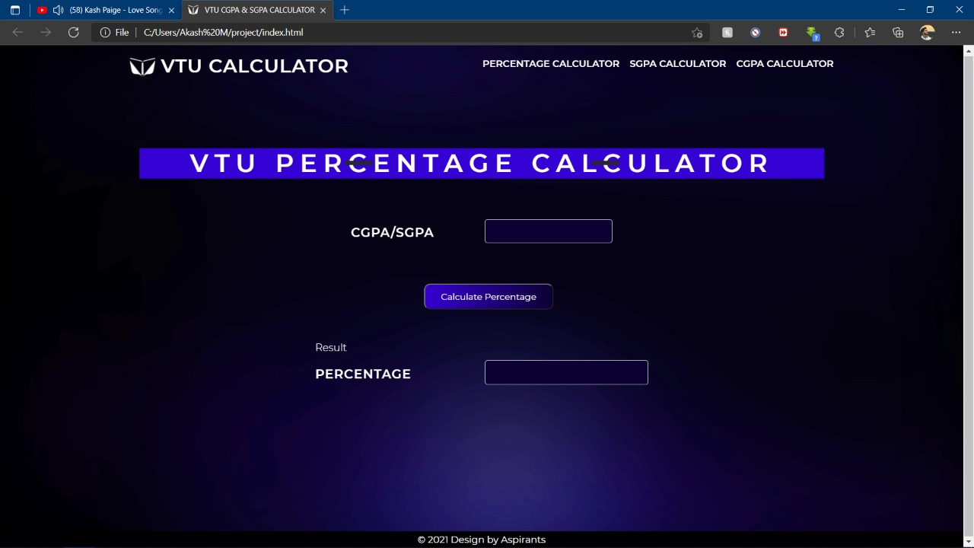

**PERCENTAGE CALCULATOR:**

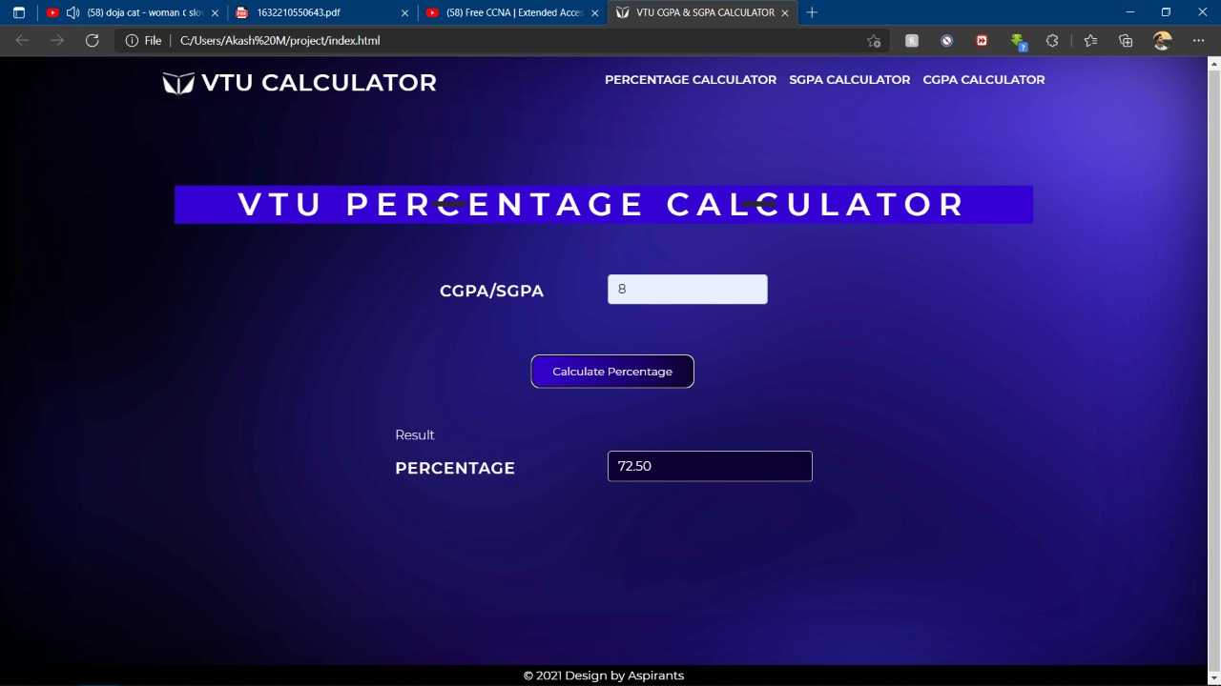

**SGPA CALCULATOR:**

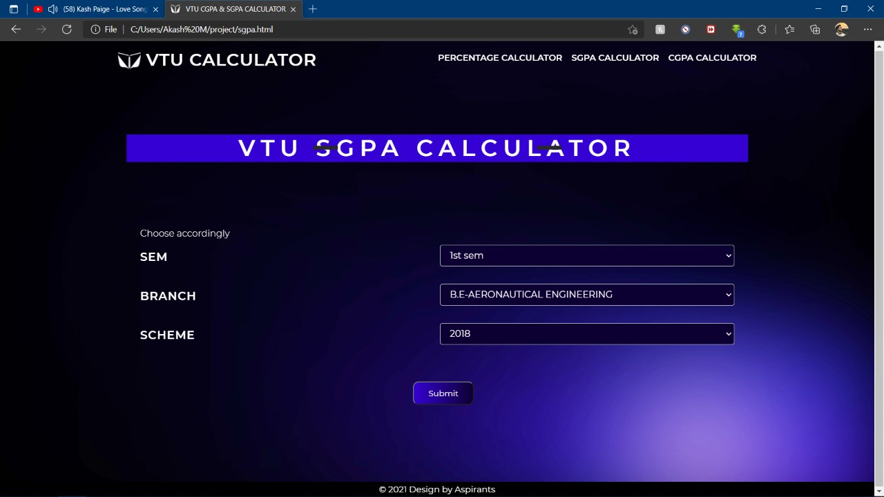

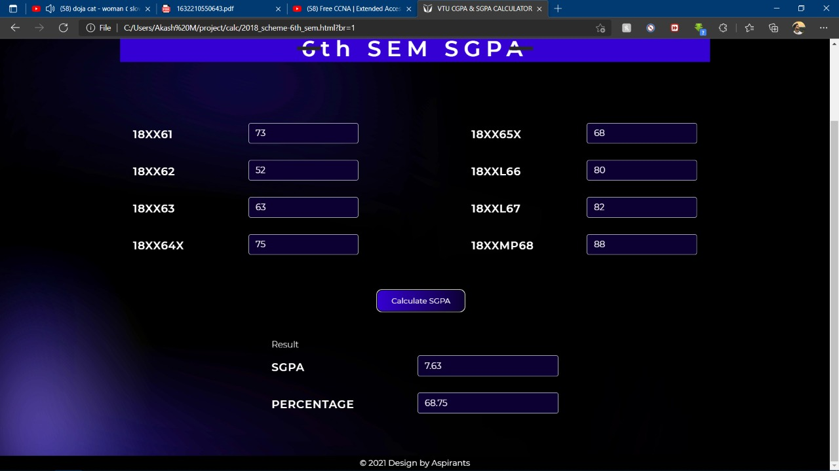

**CGPA CALCULATOR:**

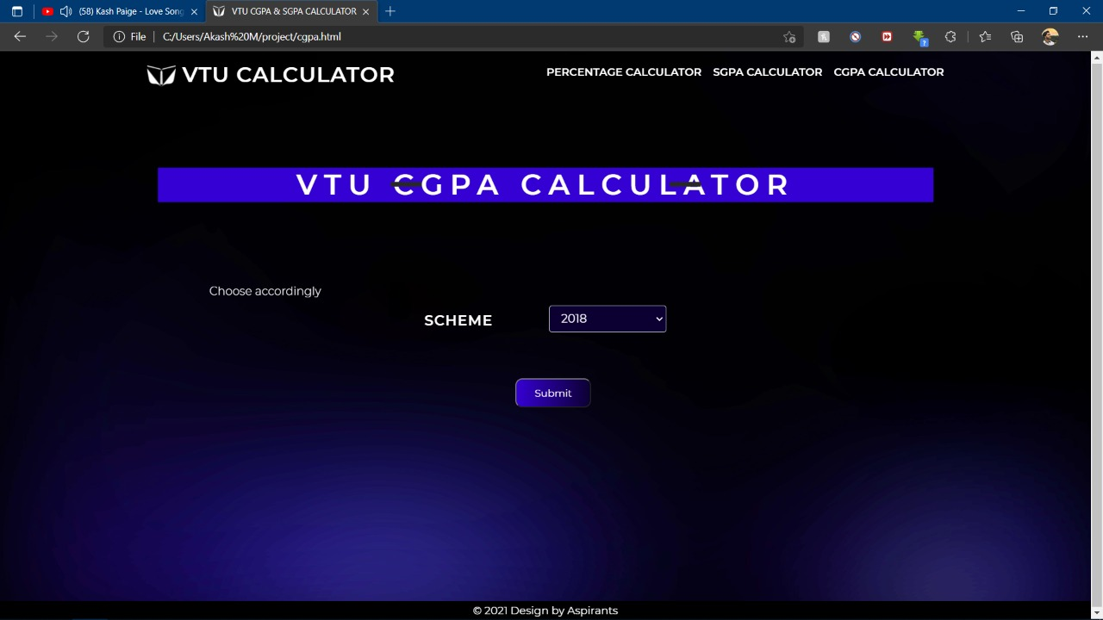

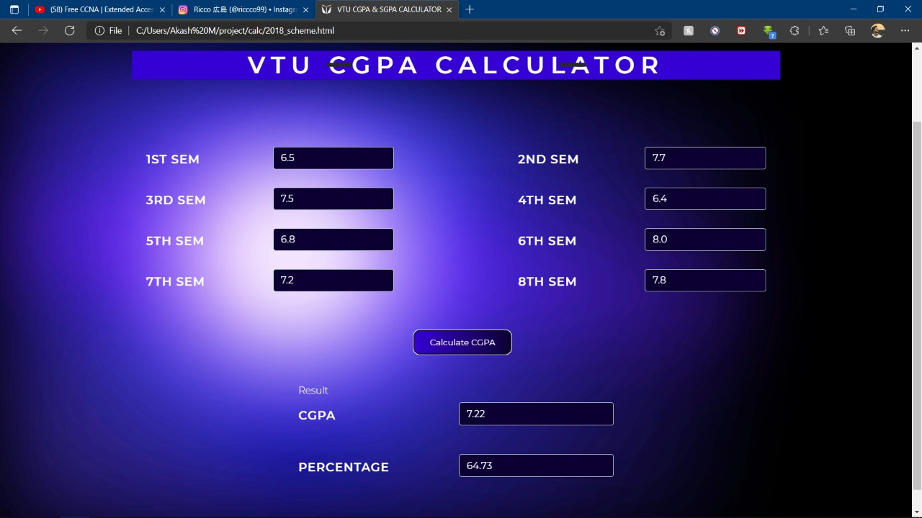

**BIBLIOGRAPHY**

* [**https://www.w3schools.com**](https://www.w3schools.com)
* [**https://www.geeksforgeeks.org**](https://www.geeksforgeeks.org)
* **https://Freepik.com**
* **https://Unsplash.com**
* **https://Flaticon.com**
* **https://traversymedia.com**

**ABOUT MY TEAM**

1. Nayan A C

Leaded the team through the ideas and examples on how to make the pages more dynamic, helped through finding syntaxes and assets like icons, designs reviewing and finalizing has done by him.

2. Shrinidhi H T

Created the base of the project i.e., HTML attributes he has gone through all the syntaxes that we needed, he also researched the content that we needed to our project. Report works were taken care by him.

3. Akash M

Did all the styling and design works like Choosing the right colours, fonts, aesthetics for the project, worked on animating the assets also he used creative applications to make even more zestful. Required assets is collected by him.