HAZOP MASTER PROMPT LIBRARY
Oil & Gas | Offshore Platform | All 14 Deviations | v3.0 HAZOPGURU Style

Industry | Oil & Gas
Location | Offshore Platform
Documents | P&ID Diagrams
Nodes | 11, 15, 28 (extendable to all nodes)
Style | Interactive — HAZOPGURU conversational prompt style
Version | v3.0 — Updated to match HAZOPGURU output quality
Categories | PAF (People at Facility) | PD/LOR (Property Damage / Loss of Revenue) | ECR (Environmental)

HAZOP Technique

The structured HAZOP technique (illustrated in Figure 1) attempts to rigorously and
systematically identify and evaluate how a process may deviate from the design and operational
intent, consequences that may result, and existing or additional safeguards/mitigations
necessary to effectively manage the risk. The HAZOP utilizes a multi-disciplinary team of
experienced personnel typically consisting of (as a minimum) a qualified facilitator, a scribe, an
Operations representative, a Process Engineer, a Process Safety & Risk Engineer, and appropriate
subject matter experts.

The HAZOP technique uses Guidewords (No/Less/ Low, More/High, etc.) in conjunction with key
process Parameters (Flow, Pressure, Temperature, Level, etc.) to form “Deviations” which
prompt the HAZOP Team to explore possible causes and potential consequences of the deviation
from the design and operational intent of the process. For example, the deviation "No Flow"
might prompt the leader to ask the team, "What could cause no flow in this node or line
segment?” Once a cause is identified that could result in the deviation being considered, the
team records the worst case, but credible consequences that could potentially occur assuming
no safeguards or mitigations are in place (this is to ensure proper appreciation of the event to be
avoided).
The HAZOP is conducted respecting the following guidance:
--> Cause must be in the node. An exception is made when evaluating an “interface node,”
in which connecting equipment is not within the HAZOP scope. Example: Separator
performance (within HAZOP scope) can be subjected to slugging from a flowline (outside
HAZOP scope).
--> Consequence may be anywhere (inside or outside the node)
--> Safeguards/mitigations may be anywhere (inside or outside the node)
Where hazardous consequences are identified, available mitigations affecting the likelihood or the severity of the scenario are identified and recorded for each consequence.
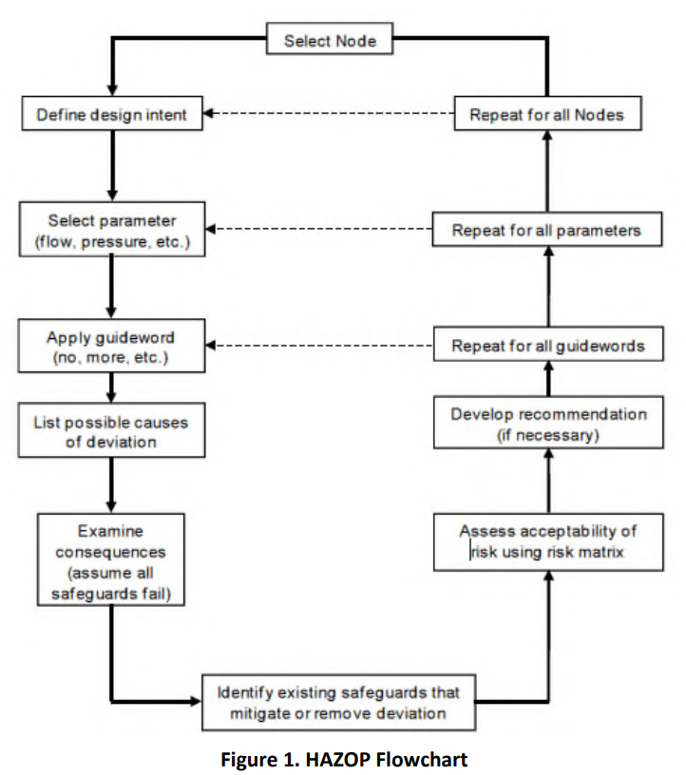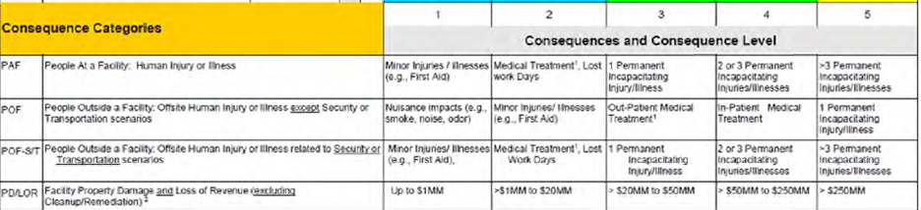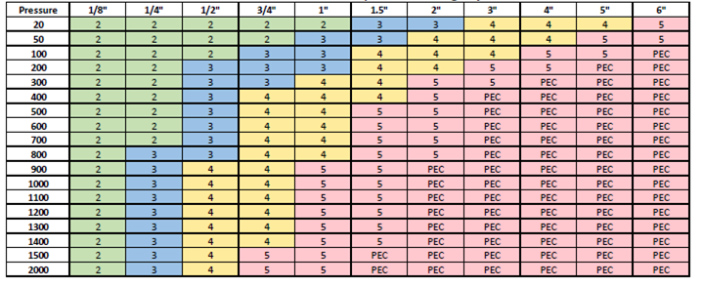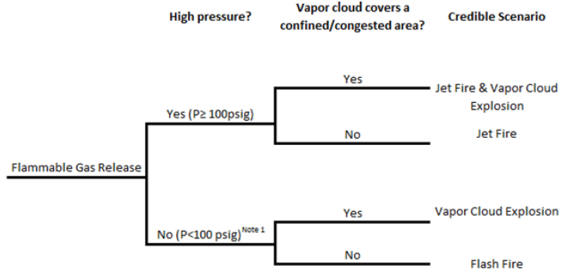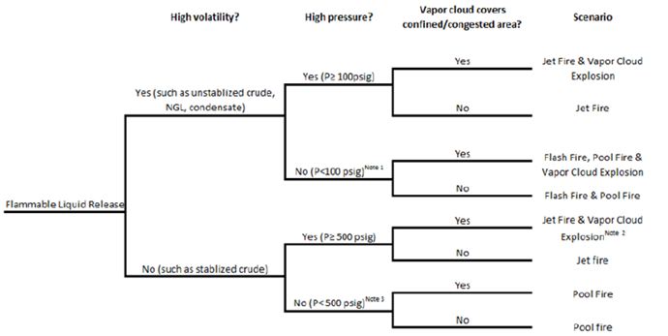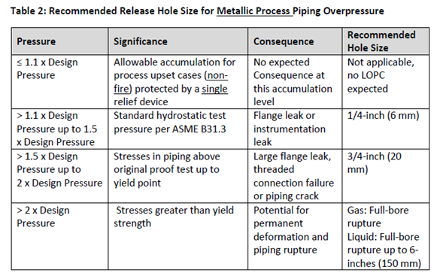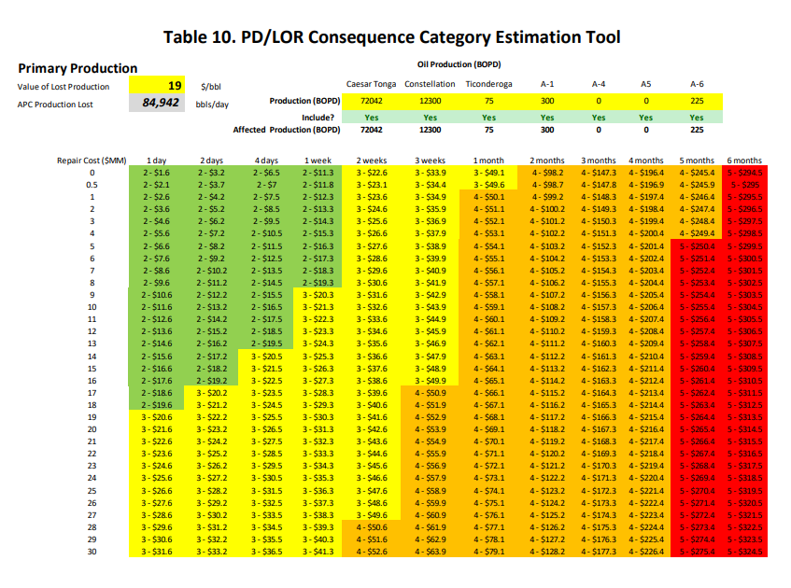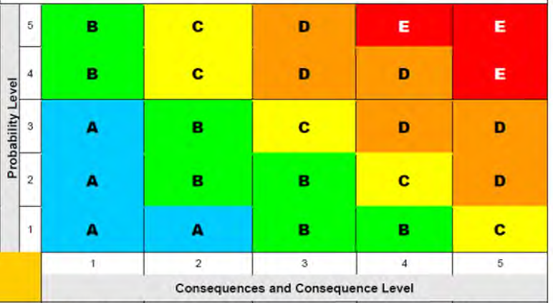
HOW TO USE THIS PROMPT LIBRARY

Each deviation is written as a direct instruction to the AI — in the same style as HAZOPGURU. Paste the prompt text for each deviation in sequence into your AI session. The prompts are designed to be interactive: the AI reads the P&ID, checks with you, then builds the HAZOP table.

WORKFLOW:
- Upload the P&ID diagram to your AI session.
- Paste Deviation 1 (High Pressure) prompt — this includes the P&ID extraction step.
- Confirm or correct the extracted equipment/instrument/safety device lists.
- Provide user inputs when prompted (max pressure PSIG, production rate BOPD).
- After each deviation completes, paste the next deviation prompt.
- For Deviations 2–14: the AI reuses the extraction from Deviation 1 — no need to re-extract.

CAUSE NUMBERING:
Causes are numbered sequentially across ALL deviations. HP Cause 1 = rows 1a/1b/1c. HP Cause 2 = rows 2a/2b/2c. HL Cause 1 continues from last HP cause number (e.g. rows 5a/5b). This maintains a single continuous HAZOP worksheet.

CONSEQUENCE CATEGORIES:
- PAF = People at Facility — use Table 4 (pressure × hole size) for consequence C=1–5 or PEC.
- PD/LOR = Property Damage / Loss of Revenue — financial loss calculation (production + repair).
- ECR = Environmental Cleanup/Remediation — spill volume mapped to cleanup cost.

DEVIATION SUMMARY
# | Deviation | Consequence Categories | ECR? | Rows/Cause | User Input Needed?
1 | High Pressure | PAF, PD/LOR, ECR | Yes | 3 (a/b/c) | Max pressure (PSIG), APC (BOPD)
2 | Low Pressure | PAF+PD/LOR or Operability | No | 2 or 0 | None typically
3 | High Level | PAF, PD/LOR | No | 2 (a/b) | None (uses Design Pressure)
4 | Low Level | PAF, PD/LOR, ECR | Yes | 3 (a/b/c) | Downstream DP confirmation
5 | High Temperature | PD/LOR or Operability | No | 1 or 0 | None typically
6 | Low Temperature | PD/LOR or Operability | No | 1 or 0 | None typically
7 | No / Low Flow | ECR (demulsifier) or Operat. | Cond | 1 or 0 | None
8 | More / High Flow | Operability only | No | 0 | None
9 | Reverse / Misdirected Flow | PAF, PD/LOR | No | 2 (a/b) | Source & destination pressures
10 | Tube Leak | PAF+PD/LOR or No Causes | No | 2 or 0 | None
11 | Composition/Contamination | PAF+PD/LOR+ECR or No Causes | Cond | 3 or 0 | None
12 | Leaks (Corrosion/Erosion) | PAF, PD/LOR, ECR | Yes | 3 (a/b/c) | None
13 | Human Factors | Narrative only | No | Narrative | None
14 | Previous Incidents | Narrative only | No | Narrative | None

KNOWLEDGE BASE — EMBEDDED IN AI MODEL
The tables below are embedded in the full WORKSHEET_GENERATION_PROMPT v2 and do not need to be re-pasted during a session. This section is for human reference.

Table / Reference | Content Summary
Table 2 — Hole Size | ≤1.1x DP → No LOPC | >1.1–1.5x → 1/4" | >1.5–2x → 3/4" | >2x → Full-bore (6")
Table 4 — PAF | Consequence C=1–5 or PEC, mapped from pressure (psi) × hole size. Cap pressure at 2000+ for lookup.
PD/LOR Thresholds | C=1 ≤$1MM | C=2 $1–20MM | C=3 $20–50MM | C=4 $50–250MM | C=5 >$250MM
ECR Thresholds | C=1 <1 bbl | C=2 1–10 bbl | C=3 10–100 bbl | C=4 100–600 bbl | C=5 ≥600 bbl
Risk Matrix 5×5 | A=Negligible | B=Low | C=Medium | D=High | E=Critical. Use A–E only.
Gas Event Tree | P≥100 PSIG + confined → Jet Fire & VCE | P≥100 PSIG + open → Jet Fire | P<100 → Flash Fire
Liquid Event Tree | High-volatility, P≥100 + confined → Jet Fire & VCE | Low-volatility, P<500 → Pool Fire
Probability Rule | P = max(1, C − CME_count). Minimum P is always 1.
Downtime Midpoints | >2x DP → 4 months (120 days) | 1.5–2x → 2 months (60 days) | 1.1–1.5x → 2.5 weeks (17 days)
PEC Definition | Potential Elevated Consequence — Impacts to more than 14 personnel. PEC = C=5. Mark PEC column YES.

DEVIATION 1 — HIGH PRESSURE

NOTE | This is the primary hazard deviation. Follow the full interactive workflow below — P&ID extraction first, user confirmation, then HAZOP table generation. The output of this deviation sets the pattern for all subsequent deviations.

STEP 1 — READ THE P&ID AND EXTRACT
Read the P&ID for HAZOP purposes. Only extract items related to deviations and safety.
Ignore transmitters (PT, TT, LT), indicators, and controllers.

Give the result in 3 lists:

1. Major Equipment — vessels, pumps, compressors, exchangers with equipment number
(e.g. MBD-1020). Sub-items: upstream and downstream equipment list.
For each: show Operating and Design pressure/temperature from P&ID.

2. Instruments (Cause candidates) — control/shutdown valves only:
FSV, LCV, PCV, XCV, MOV, SDV, BDV
For each: state location (upstream/downstream), line service (Gas/Oil/Water).
Note: SDV and BDV are NOT safety devices — they CAN be causes.

3. Safety Devices / Mitigations — PSV, PSHH, PSLL, LSHH, LSLL, VSHH, interlocks.
For each: state location (upstream/downstream), line service (Gas/Oil/Water).
Note: SDV and BDV are NOT safety devices.

Present the 3 lists clearly and ask the user:
"Please review this extraction. Add or remove any equipment/instruments/safety
devices, or type YES to proceed to the HAZOP."

STEP 2 — IDENTIFY CAUSES (after user confirms)
Now start the HAZOP. Deviation 1: HIGH PRESSURE.

What could cause high pressure on this vessel?

RULES for identifying causes:
- Safety devices (PSV, PSHH, LSHH, PSLL, LSLL) CANNOT be causes.
- No generic causes — every cause must reference a specific instrument tag.
- Only automatic process failures. Manual actions are NOT causes.
- Gas outlet valves failing closed are the primary causes.
- SDV and BDV failing closed ARE valid causes.
- Liquid outlet causes (LCV, XCV) do NOT cause high pressure —
they cause high level. Do NOT list them here.

Example: FSV-1010 (Gas outlet) fails closed.

List the causes, then ask the user:
"Before I build the HAZOP table, I need two inputs:
1. What is the maximum pressure (PSIG) this vessel could reach if a cause occurs?
2. What is the daily production rate (BOPD)?"

STEP 3 — BUILD THE HAZOP TABLE (after user provides inputs)
Now build the HAZOP worksheet table with the following columns:
Deviation | Cause | Intermediate Consequence | Consequence Category |
Scenario Comments / Final Impacts | PEC | Mitigations | CME Name |
Current Risk C (Consequence) | Current Risk P (Probability) | Risk Level

Generate rows for EVERY cause × EVERY category (PAF and PD/LOR for each cause).
Do NOT look at safety devices when evaluating consequences.

INTERMEDIATE CONSEQUENCE (same for PAF and PD/LOR rows of the same cause):
"Potential increase in {equipment_tag} operating pressure, potential to exceed the
design pressure of {equipment_tag} or associated header piping, potential loss of
containment ({hole_size} leak), potential {fire_scenario}."

HOLE SIZE — use Table 2 (pressure ratio vs design pressure):
- Ratio ≤ 1.1x DP → EXCLUDE cause (no LOPC, no consequence rows)
- Ratio > 1.1–1.5x → 1/4" flange leak
- Ratio > 1.5–2x → 3/4" large flange leak
- Ratio > 2x → Full-bore rupture (6" for vessels)

STEP 3a — SCENARIO COMMENTS (PAF rows)
NOTE | Scenario comments are in bullet format — 4 bullets per PAF row.

STEP 3b — SCENARIO COMMENTS (PD/LOR rows)
For PD/LOR rows, use the same bullets 1–3 as PAF.
Bullet 4 must show the financial calculation:
- Downtime: >2x DP → 3–5 months (use MIDPOINT = 4 months / 120 days)
1.5–2x → 1–3 months (midpoint = 2 months / 60 days)
1.1–1.5x → 1–4 weeks (midpoint = 2.5 weeks / 17 days)
- Repair cost: Major (>2x DP) ~$20MM | Moderate (1.5–2x) ~$5MM | Minor ~$1MM
- Total Loss = (BOPD × $/bbl × downtime_days) + repair_cost
- Map total to: ≤$1MM→C=1 | $1–20MM→C=2 | $20–50MM→C=3 | $50–250MM→C=4 | >$250MM→C=5
- PD/LOR C=5 is RARE for single instrument failures — use C=4 when in doubt.

STEP 4 — CME NAME & MITIGATIONS COLUMNS
In the CME Name column: list safety devices that mitigate HIGH PRESSURE.
Count them: (e.g. 'PSHH-1000, PSV-1000, Gas Detection, Deluge/TSE (4 CMEs)')

CMEs for High Pressure:
1. PSV — relieves vessel pressure at set point.
2. PSHH — initiates ESD, closes BSDV on high-high pressure signal.
If LOPC (ratio > 1.1x DP) — ADD these 2 additional CMEs:
3. Gas Detection — 2 at 20% LEL or 1 at 45% LEL closes BSDV and shuts in wells.
4. Deluge / TSE — activated by thermal safety element on confirmed fire/heat.

NOT CMEs: BDV, alarms (PAH/PAHH), manual interventions.
ECR CMEs ONLY: PSHH, Gas Detection, BSDV. PSV and Deluge NOT counted for ECR.

In the Mitigations column: explain each CME in a bullet, max 15 words each.

STEP 5 — PROBABILITY AND RISK LEVEL
Current Risk P (Probability) = max(1, C − CME_count)

Where C = Current Risk C (Consequence from PAF table or PD/LOR financial mapping).
CME_count = number of applicable CMEs listed in CME Name column.
Minimum probability is always 1.

Risk Level — use the 5×5 Risk Matrix:
C=1 C=2 C=3 C=4 C=5
P=1 | A | A | B | B | C |
P=2 | A | B | B | C | D |
P=3 | A | B | C | D | D |
P=4 | B | C | D | D | E |
P=5 | B | C | D | E | E |
A=Negligible | B=Low | C=Medium | D=High | E=Critical
Use A–E only. Do NOT write Low/Medium/High.

SCENARIO COMMENT TEMPLATES
# | Comment | Details / Instruction to AI
1 | Maximum pressure to reach {max_pressure} PSIG; design pressure is {design_pressure} PSIG. | {max_pressure} is user input. {design_pressure} comes from the P&ID.
2 | > {ratio}x Design Pressure: potential full-bore rupture up to 6", permanent deformation and piping rupture. | Calculate ratio = max_pressure / design_pressure. Map to Table 2 hole size. Write consequence based on ratio band.
3 | Pressure ≥ 100 PSIG, confined/congested area: Potential Jet Fire and Vapor Cloud Explosion. | Use Gas Event Tree. P ≥ 100 PSIG + confined → Jet Fire & VCE. P ≥ 100 PSIG + open → Jet Fire only. P < 100 PSIG → Flash Fire.
4 (PAF) | If PEC: 'PEC-1 — Impacts to more than 14 personnel possible based on daytime manning level and impact hazard zone.' If not PEC: write consequence comment from Table 5. | PAF only: look up Table 4 using max_pressure (cap at 2000+) and hole size from Table 2. Map to C=1–5. PEC = C=5. Mark PEC column YES if PEC.
4 (PD/LOR) | Estimated downtime: {X} days. Production loss: ${Y}MM + Repair: ${Z}MM = Total: ${T}MM. Consequence level {C}. | Show full calculation. Use midpoint downtime. Map total financial loss to C=1–5 thresholds.

NOTE | ROW FORMAT: For each cause generate PAF row then PD/LOR row then ECR row (3 rows per cause). Number as 1a (PAF), 1b (PD/LOR), 1c (ECR) for cause 1; 2a/2b/2c for cause 2, etc.

DEVIATION 2 — LOW PRESSURE

NOTE | Most Low Pressure causes in separators are operability issues only. Follow the same 2-step pattern — extract, confirm, then identify causes. Always state explicitly if a cause has no hazardous consequence.

STEP 1 — USE EXISTING EXTRACTION
Use the equipment/instrument/safety device list already extracted in Deviation 1.
If this is a new session, re-read the P&ID using the extraction prompt from Deviation 1 first.

STEP 2 — IDENTIFY CAUSES
Deviation 2: LOW PRESSURE.
What could cause low pressure on this vessel?

Consider: PCV or BDV on gas outlet failing open or bypass open;
BDV fails open (inadvertent flaring); upstream feed lost; SDV on inlet fails closed.

RULES:
- Safety devices CANNOT be causes.
- BDV failing open IS a valid Low Pressure cause.
- Each cause evaluated independently.
- For MOST separator nodes: the majority of LP causes are operability issues only.
State this clearly — do NOT force hazardous consequences where none exist.

CONSEQUENCE EVALUATION:
- BDV fails open → inadvertent flaring, potential inability to dump liquids. Operability.
- PCV fails open → separator pressure drops to downstream system pressure. Operability.
- JT cooling / hydrate risk: only if operating at high pressure and rapid depressurisation.
State if JT cooling is NOT a concern at current operating pressure.

If operability only: record cause in table, note consequence, leave PAF/PD/LOR blank.
If hazardous consequence: generate PAF + PD/LOR rows using same format as Deviation 1.

CMEs for Low Pressure (if hazardous): PSLL closes BSDV on low-low pressure.
Manual interventions are NOT CMEs.

NOTE | ROW FORMAT: Number causes continuing from Deviation 1. If operability only — no Na/Nb/Nc rows.

DEVIATION 3 — HIGH LEVEL

NOTE | High Level has a special rule: hole size is FIXED at 1/2" regardless of pressure ratio, and you use the DESIGN PRESSURE (not max pressure) for PAF Table 4 lookup. Evaluate separately for each downstream equipment alignment.

STEP 1 — IDENTIFY CAUSES
Deviation 3: HIGH LEVEL.
What could cause high liquid level on this vessel?

Consider: LCV, XCV, FSV on liquid outlets failing closed; strainer or meter plugging;
check valve on liquid outlet fails closed; manual valve inadvertently closed.

RULES:
- Safety devices (LSHH, PSV) CANNOT be causes.
- Include mechanical failures (strainer plugged, check valve fails closed).
- LCV and XCV on DIFFERENT outlets are typically on independent controllers —
note this explicitly in scenario comments.
- Evaluate SEPARATELY for each downstream alignment:
FGC 1st Stage / FGC 2nd Stage / FGC 3rd Stage / Booster Compressor / Dehydration

STEP 2 — BUILD HAZOP TABLE
SPECIAL HIGH LEVEL RULE — do NOT use Table 2:
- Hole size: FIXED at 1/2" (liquid carryover at gas outlet flange).
- Pressure for Table 4: use DESIGN PRESSURE of the vessel (no pressure increase occurs).
- No ECR row for High Level deviation.

CONSEQUENCE BY DOWNSTREAM ALIGNMENT:
- Positive displacement compressor (FGC): suction valve / piston / running gear damage.
Release size 1/2" at cylinder discharge pressure. LOPC is credible → PAF + PD/LOR rows.
- Centrifugal compressor (BGC): equipment damage only, no LOPC. PD/LOR row only.
- Gas Dehydration: glycol contamination, off-spec gas. Operability only — no rows.

CMEs for High Level:
1. LSHH on separator: shuts in wells/inlet.
2. LSHH on downstream compressor scrubber (LSHH-25xx/26xx): shuts down FGC.
3. VSHH on downstream compressor: shuts down on high vibration.
4. Gas Detection System: closes BSDV/SSV/SDV.
5. Deluge / TSE: activates on confirmed fire/heat.
NOT CMEs: PSV (does not address level).

SCENARIO COMMENT TEMPLATES
# | Comment | Details / Instruction to AI
1 | Impact to {X} person(s) based on daytime manning levels and estimated hazard zone. | Use personnel count from hazard zone assessment. 1 person for low-pressure FGC stage; 2–3 for mid; PEC for highest-pressure stage (e.g. 3rd Stage at 1700–1800 PSIG).
2 | LCV-xxxx and LCV-yyyy are not normally controlled off the same level controller. | State the two valve tags. This confirms the cause is independent and both failing simultaneously is not assumed.
3 | Liquid carryover to a positive displacement compressor — potential suction valve, piston, and running gear damage. Release 1/2" at cylinder discharge pressure (~{discharge_pressure} PSIG). | State the discharge pressure of the downstream compressor stage from P&ID or facility data.
4 (PAF) | Use Table 4 with design pressure + 1/2" hole. If PEC: 'PEC-1 — Impacts to more than 14 personnel possible.' If not PEC: write consequence from Table 5. | Map design_pressure (capped at 2000+) × 1/2" hole → Table 4 consequence C=1–5.
4 (PD/LOR) | Downtime: {X} weeks all production + curtailment of ~{Y}% for {Z} months. Production loss: ${A}MM + Repair: ${B}MM = Total: ${T}MM. | Typical HL downtime: 1–2 weeks full shutdown + ~20% curtailment for 2.5 months for FGC repair.

NOTE | ROW FORMAT: Two rows per cause (Na=PAF, Nb=PD/LOR). No ECR row. Continue sequential numbering.

DEVIATION 4 — LOW LEVEL

NOTE | Low Level causes gas blowby into downstream liquid equipment. Evaluate SEPARATELY for each downstream destination. The key calculation is source operating pressure vs downstream design pressure — this determines the hole size and consequence severity.

STEP 1 — IDENTIFY CAUSES
Deviation 4: LOW LEVEL.
What could cause low liquid level on this vessel?

Consider: LCV fails open or bypass inadvertently open.
Evaluate SEPARATELY for each downstream destination:
LP Oil Separator No.1 / LP Oil Separator No.2 / IP Oil Separator /
HP Oil Separator / Wet Oil Storage Vessel / Oil Flotation Cell

For each destination, identify:
- Design pressure of the destination equipment (weakest link in the system).
- Source operating pressure of this vessel.
- Ratio = source operating pressure / destination design pressure.

STEP 2 — BUILD HAZOP TABLE
Use Table 2 with the ratio to determine hole size for each destination.
Ratio ≤ 1.1x → EXCLUDE (operability note only, no rows).

SPECIAL CASES:
- If PSHH setpoint EXCEEDS downstream DP: do NOT credit PSHH as CME.
- Infrequent alignment (<10% of time): credit 'Low Time at Risk' as IF-8 factor.
- LTI (Long Term Isolation) connections: credit physical lock/LTI tag as PR-10 CME.
- If PSV on downstream is known to be undersized: note explicitly in scenario comments.

CMEs for Low Level:
1. LSLL on source vessel: shuts in wells/inlet — primary CME.
2. PSV on downstream equipment (at appropriate setpoint): COUNT.
3. PSHH on downstream equipment (only if setpoint ≤ downstream DP): COUNT.
4. Gas Detection System: closes BSDV — COUNT.
5. Deluge / TSE: COUNT.
6. Physical lock / LTI tag: COUNT as PR-10.
7. Low Time at Risk (<10%): COUNT as IF-8.

ECR CMEs: PSHH (downstream, if ≤DP), Gas Detection, BSDV.
PSV and Deluge NOT counted for ECR.

SCENARIO COMMENT TEMPLATES
# | Comment | Details / Instruction to AI
1 | PEC-1 if >14 personnel. Otherwise: 'Impact to {X} person(s) based on daytime manning levels and impact hazard zone.' | Check hazard zone size for the downstream equipment location.
2 | LCV-xxxx and LCV-yyyy are not normally controlled off the same level controller. Design Pressures: {downstream equipment list with DPs}. {Weakest link} is the weak link. | List all downstream equipment design pressures. Identify the lowest.
3 | Potential for pressure in downstream {equipment} to exceed {ratio}x design pressure. | State the calculated ratio clearly.
4 | For pressure vessels, an overpressure >2x design pressure is assumed to result in vessel rupture (6" leak). | Only use this bullet if ratio > 2x. Adjust for other ratio bands accordingly.

NOTE | ROW FORMAT: Three rows per cause (Na=PAF, Nb=PD/LOR, Nc=ECR). If operability only — no rows. Continue sequential numbering.

DEVIATION 5 — HIGH TEMPERATURE

NOTE | For most separator nodes (e.g. Nodes 11, 15), this is 'No causes identified.' Confirm from P&ID. Only proceed to HAZOP rows if a cooling system or heat source exists in the node boundary.

STEP 1 — CHECK AND IDENTIFY
Deviation 5: HIGH TEMPERATURE.

Check the P&ID: is there a cooling system (TCV, cooler, heat exchanger) in this node?
If NO cooling system → record: 'No causes identified.' Stop here.

If YES — consider:
- TCV fails closed or cooling medium strainer plugged → inadequate cooling.
- High recycle rate increasing compressor suction temperature.

CONSEQUENCE:
- Compressor: valve/piston ring damage from high inlet temperature → PD/LOR row.
- If design temperature exceeded → potential seal/material failure → PAF + PD/LOR.
- Note if TCV is currently non-functional — reference any design modification in progress.

CMEs: TSHH shuts down equipment on high temperature — COUNT if present.
TAH (alarm only) and TI (operator response) are NOT CMEs.

NOTE | ROW FORMAT: Record 'No causes identified' for separator nodes. Continue sequential numbering.

DEVIATION 6 — LOW TEMPERATURE

NOTE | For most separator nodes, this is 'No causes identified.' For compressor nodes, JT cooling across recycle valves and hydrate formation are the key concerns.

STEP 1 — CHECK AND IDENTIFY
Deviation 6: LOW TEMPERATURE.

Check the P&ID: is there a recycle valve (PCV), cooling system (TCV), or BDV?
If NONE relevant → record: 'No causes identified.' Stop here.

If YES — consider:
- TCV fails open → over-cooling of discharge gas.
- High recycle rate → JT cooling across recycle PCV → hydrate / ice formation.
- BDV fails open → rapid depressurisation → JT cooling.

CONSEQUENCE:
- Hydrate formation → plugging of lines/valves/instrumentation. Operability issue.
- If hydrates cause valve sticking leading to pressure build → cross-ref Deviation 1.
- Compressor damage from cold liquid carryover → PD/LOR row.

State: hydrate is expected in E-spec piping (not D-spec) if applicable.
If recent operating experience shows hydrate events: reference this explicitly.
Note any design modifications in progress — no recommendation needed.

CMEs: TSLL shuts down equipment — COUNT if present.
PSLL shuts down compressor on low suction pressure — COUNT.

NOTE | ROW FORMAT: Record 'No causes identified' for separator nodes. Continue sequential numbering.

DEVIATION 7 — NO / LOW FLOW

NOTE | This deviation focuses on chemical injection losses — not process flow (covered by HP/LP/HL/LL). Each chemical injection point is a separate cause. Most are operability issues. Demulsifier loss has an environmental (ECR) consequence.

STEP 1 — IDENTIFY CAUSES
Deviation 7: NO / LOW FLOW.

For this node, identify chemical injection points from the P&ID:
- Demulsifier injection
- Scale inhibitor injection
- Defoamer injection
- Corrosion inhibitor (captured under Deviation 12 — do NOT repeat here).

Note if any chemical is currently NOT injected at this node.

CONSEQUENCE BY CHEMICAL:
- Demulsifier loss → emulsion in downstream vessels, high BS&W, water quality /
regulatory exceedance. ECR row only.
- Scale inhibitor loss → incremental scaling. Detected within 1–2 shifts. Operability.
- Defoamer loss → foam carryover to compressor suction scrubbers, level control issues.
Glycol contamination if aligned to dehydration. Operability only.

If cause is operability only: record cause, note consequence, no rows generated.
If demulsifier: generate ECR row only.

Note: Human intervention (shift sampling, flow alarms) are NOT CMEs.

NOTE | ROW FORMAT: ECR row only for demulsifier. Operability note for all others. Continue sequential numbering.

DEVIATION 8 — MORE / HIGH FLOW

NOTE | Mirror of the No/Low Flow analysis. Excessive chemical injection typically causes similar consequences to inadequate injection, or results in wasted chemical only. Almost always operability issues.

STEP 1 — IDENTIFY CAUSES
Deviation 8: MORE / HIGH FLOW.

For each chemical injection point identified in Deviation 7:
- Excessive demulsifier → similar to inadequate demulsifier.
Write: 'Similar to Cause [X]' referencing the corresponding No/Low Flow cause.
- Excessive scale inhibitor → wasted chemical. Operability issue only.
- Excessive defoamer → wasted chemical. Operability issue only.

All More/High Flow causes are operability issues — no PAF/PD/LOR/ECR rows.
Record cause and note consequence in table. Leave consequence columns blank.

NOTE | ROW FORMAT: No consequence rows for More/High Flow. Continue sequential numbering.

DEVIATION 9 — REVERSE / MISDIRECTED FLOW

NOTE | The primary concern is outlet misalignment — the separator aligned to two different pressure destinations simultaneously. Evaluate gas outlet misalignment and liquid outlet misalignment as separate causes.

STEP 1 — IDENTIFY CAUSES
Deviation 9: REVERSE / MISDIRECTED FLOW.

Consider:
1. Gas outlet misalignment: separator aligned to 2 gas destinations simultaneously
(e.g. HP Dehy at 1700–1800 PSIG and FGC 1st Stage rated at 270 PSIG).
2. Liquid outlet misalignment: separator liquid outlet aligned to 2 destinations.
3. FSV/check valve fails to close when compressor shuts down (backflow).
4. Compressor settle-out after shutdown.

Note any LTI or blinded/air-gapped connections that reduce misalignment risk.
Note if operating procedures are SILENT on realignment steps for this separator.

STEP 2 — BUILD HAZOP TABLE
For misalignment causes:
- Source = highest operating pressure of any aligned destination.
- Target = lowest design pressure of any component in the concurrent alignment.
- Under worst case: downstream equipment can experience >2x design pressure.
- PSVs on lower-pressure systems are typically NOT sized for misalignment.
- PSLL (HP side) and PSHH (LP side) shut down compression but are UNLIKELY to
prevent overpressure in rapid crossflow — do NOT credit as CMEs.

For settle-out: if settle-out pressure < 1.1x design pressure → operability note only.

CMEs for Reverse/Misdirected Flow:
1. Gas Detection System: closes BSDV — COUNT.
2. Deluge / TSE: COUNT.
3. Check valve (if on P&ID): prevents back-flow — COUNT.
4. Strategic BDVs: note presence; typically too slow to prevent overpressure — KME only.
No ECR row for Reverse/Misdirected Flow.

SCENARIO COMMENT TEMPLATES
# | Comment | Details / Instruction to AI
1 | PEC-1 — Impacts to more than 14 personnel possible. (Gas outlet) OR: Impacts to {X} personnel. (Liquid outlet) | Gas outlet misalignment in a high-pressure system on an offshore production deck typically warrants PEC. Liquid outlet misalignment: check hazard zone.
2 | Operating procedures provide no specific instructions for realigning {equipment_tag} gas/liquid outlets. | State this explicitly if confirmed. It is a key human factors observation supporting the misalignment scenario.
3 | Highest pressure destination operates at {HP_pressure} PSIG. Lowest-pressure destination has design pressure of {LP_DP} PSIG. Under worst-case assumptions, overpressure is >{ratio}x design pressure. | Fill in actual pressures from P&ID and facility data.
4 | For pressure vessels, an overpressure >2x design pressure is assumed to result in permanent deformation and vessel rupture (6" leak). | Only if ratio > 2x. Adjust wording for other ratio bands.

NOTE | ROW FORMAT: Two rows per cause (Na=PAF, Nb=PD/LOR). No ECR row. Continue sequential numbering.

DEVIATION 10 — TUBE LEAK

NOTE | Only applicable if a heat exchanger is present in the node boundary. For separator nodes without exchangers: 'No causes identified.'

STEP 1 — CHECK AND IDENTIFY
Deviation 10: TUBE LEAK.

Check the P&ID: is there a heat exchanger (shell-and-tube or PCHE) in this node?
If NO → record: 'No causes identified.' Stop here.

If YES — consider: crack or leak in heat exchanger tube.

CONSEQUENCE:
- PCHE (Printed Circuit Heat Exchanger): channels are extremely small.
Consequence: very minor gas leak into cooling medium. No hazardous consequence.
- Shell-and-tube with non-flammable cooling medium (water): contamination. No hazard.
- Shell-and-tube with hydrocarbon on both sides: assess cross-contamination and
potential overpressure of lower-pressure side. PAF + PD/LOR if LOPC credible.

NOTE | ROW FORMAT: Record 'No causes identified' for nodes without heat exchangers. Continue sequential numbering.

DEVIATION 11 — COMPOSITION / CONTAMINATION

NOTE | For most offshore separator nodes with no H2S and no cross-contamination pathways: 'No causes identified.' Always state H2S status explicitly.

STEP 1 — CHECK AND IDENTIFY
Deviation 11: COMPOSITION / CONTAMINATION.

State H2S status of well fluids explicitly:
e.g. 'No H2S in well fluids. CO2 is present at relatively low concentrations.'

Consider: H2S breakthrough; sand/scale erosion; glycol carryover; wrong chemical.

If no H2S and no cross-contamination pathways → 'No causes identified.' Stop.

If H2S present: PAF + PD/LOR + ECR rows using same format as Deviation 1.
If sand/scale: covered under Deviation 12. Do NOT repeat here.
Glycol / chemical contamination: operability/commercial issue only. Note and move on.

NOTE | ROW FORMAT: Record 'No causes identified' if applicable. Continue sequential numbering.

DEVIATION 12 — LEAKS — CORROSION / EROSION

NOTE | Internal corrosion or erosion is a single cause covering the full node. List ALL P&ID drawing references. External corrosion is outside HAZOP scope — note and move on. This deviation always generates PAF + PD/LOR + ECR rows.

STEP 1 — IDENTIFY CAUSES
Deviation 12: LEAKS (CORROSION / EROSION).

Cause 1: Internal corrosion or erosion of the piping or equipment.
List ALL P&ID drawing references for this node in the Drawings column.

Cause 2: External corrosion.
Record as: 'External corrosion is primarily a function of the quality of the painting
and coatings program. Evaluation is outside the scope of the HAZOP.'
No consequence rows for Cause 2.

STEP 2 — BUILD HAZOP TABLE (Cause 1 only)
Assume 1/2" leak (facility standard for corrosion scenarios).
Use OPERATING PRESSURE (not max pressure) for Table 4 PAF lookup.

State in scenario comments:
- H2S status and CO2 concentration.
- Most recent inspection: date, method (AUT / internal per API 510), findings.
- Corrosion coupon pull frequency and CMT monthly review.

CMEs for Leaks:
1. Corrosion Inhibition System (PR-21): chemical management, CMT monthly reviews,
twice-daily injection rate verification, coupon programme — COUNT.
2. PSLL on equipment: shuts in upstream on low pressure (leak indicator) — COUNT.
3. Gas Detection System: closes BSDV — COUNT.
4. Deluge / TSE: COUNT.
ECR CMEs: Corrosion Inhibition System, PSLL, Gas Detection.
PSV NOT counted for ECR.

SCENARIO COMMENT TEMPLATES
# | Comment | Details / Instruction to AI
1 (PAF) | Impact to {X} person(s) based on daytime manning levels and estimated hazard zone. | Use hazard zone data. Typically 2–3 persons for separator nodes.
2 | No H2S in well fluids. CO2 is present but at relatively low concentrations. | Adjust if H2S is present. Always state this explicitly.
3 | Last inspection ({method}) performed {date}, no major findings. | State inspection method and findings. AUT = Automated Ultrasonic Testing.
4 | Upstream corrosion coupons pulled {X} times per year and reviewed per CMT. | State actual coupon frequency from facility data.
4 (PD/LOR) | Downtime: ~1–3 months. Production loss: ${A}MM + Repair: ${B}MM = Total: ${T}MM. Consequence level {C}. | Use actual calculated values. 1–3 months typical for corrosion leak repair.
4 (ECR) | Could result in limited environmental release. Estimated spill: ~{X} bbl. Cleanup cost: ${Y}MM. Consequence level {C}. | Map spill volume to ECR threshold table.

NOTE | ROW FORMAT: Three rows (Na=PAF, Nb=PD/LOR, Nc=ECR) for Cause 1. No rows for Cause 2. List all P&ID drawings. Continue sequential numbering.

DEVIATION 13 — HUMAN FACTORS

NOTE | Identify node-specific human factors concerns — not generic ones. Cross-reference existing deviations rather than generating new consequence rows. Default is 'No specific human factors related concerns were identified.'

STEP 1 — ASSESS
Deviation 13: HUMAN FACTORS.

Check for node-specific concerns:
- Are operating procedures silent on any critical alignment operation for this node?
- Are there valves or instruments with labeling or proximity issues?
- Are there routine tasks with high consequence if done incorrectly?

If no specific concerns → record: 'No specific human factors related concerns
were identified.' Stop here.

If a concern is identified:
- Note it in the Cause column.
- Cross-reference the applicable deviation number.
- Do NOT generate new PAF/PD/LOR/ECR rows unless it reveals a gap not covered
by any existing deviation. If a gap exists, add it to the relevant deviation.

NOTE | ROW FORMAT: Narrative format only. No consequence rows. Continue sequential numbering.

DEVIATION 14 — PREVIOUS INCIDENTS / LEARNINGS

NOTE | Review facility incident history for applicability. State clearly whether each incident maps to an existing HAZOP cause or reveals a new gap. Default is 'No specific process safety related events were identified.'

STEP 1 — REVIEW AND RECORD
Deviation 14: PREVIOUS INCIDENTS / LEARNINGS.

Review facility safety databases, PSM records, and audit findings for this node.

If no incidents identified → record: 'No specific process safety related events
were identified.' Stop here.

For each incident identified:
1. Describe the incident briefly.
2. State root cause and contributing factors.
3. State corrective actions and any design modifications implemented.
4. State: 'This event was reviewed for process safety impacts. [Direct applicability
to specific HAZOP scenarios identified / No direct applicability identified.]'

If the incident reveals a gap in existing deviation coverage:
→ Add a new cause to the relevant deviation. Do NOT create rows in this deviation.

NOTE | ROW FORMAT: Narrative format only. No consequence rows. Continue sequential numbering.

END OF HAZOP MASTER PROMPT LIBRARY
Use these prompts to run consistent, audit-ready HAZOP studies across all nodes.

