CRUD OPERATION

I have build crud Operation without using any database as per company assignment

1.Retrieve a list of all tasks
export const allTask = (req,res) => {
try {
if(!tasksArray){
res.status(404).json({success: false,message: 'Tasks not found'})
}
res.status(200).json({
success: true,
message: 'Retrieve All Task Succesfully',
tasksArray
})
} catch (error) {
res.status(400).json({success: false,message:error.message})
}
};
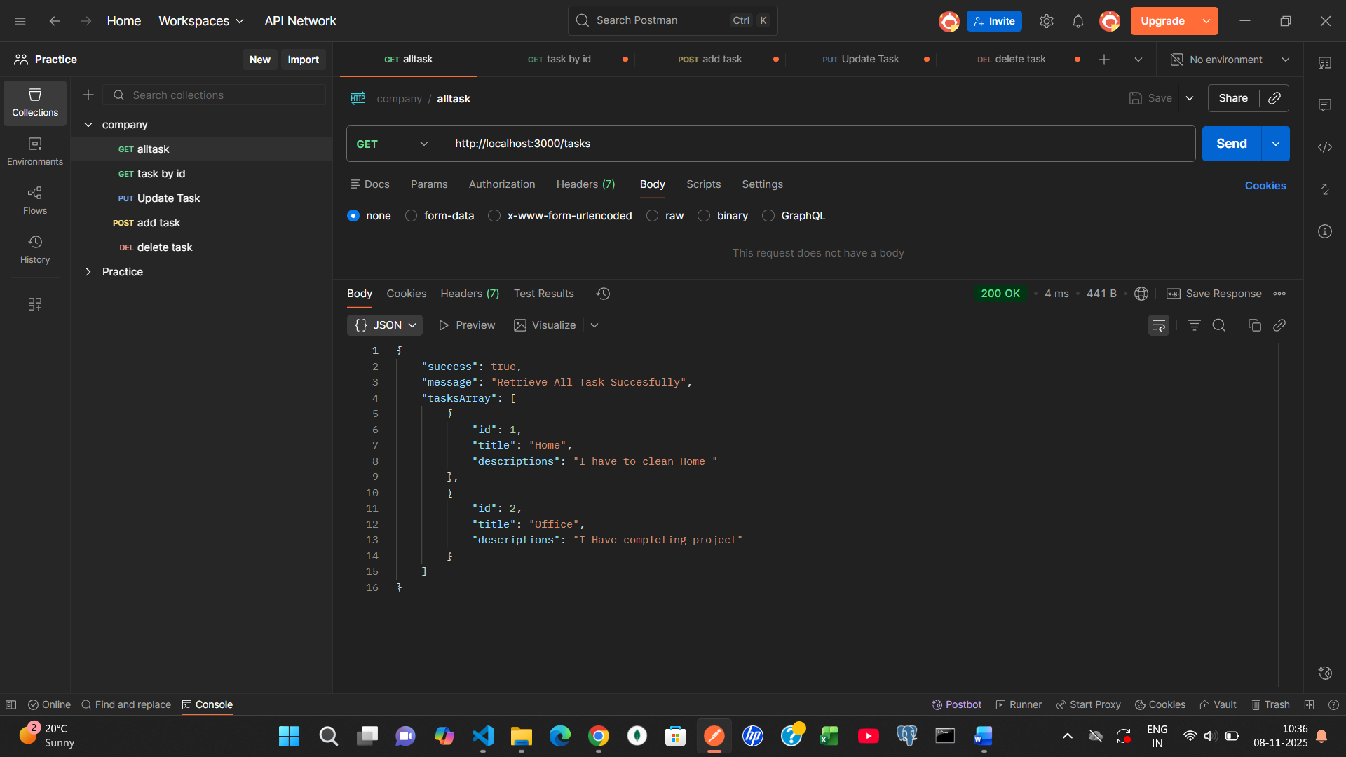

2.Retrieve a specific task by ID
export const getTask = (req,res) => {
try {
const id = req.params.id;
if(!id){
return res.status(404).json({success: false,message: 'Required task Id'})
}
const task = tasksArray.find(task => task.id == id);
if(!task){
return res.status(404).json({success: false,message: 'This Task not found'})
}
res.status(200).json({
success: true,
message: 'Retrieve Task Succesfully',
task
})
} catch (error) {
res.status(400).json({success: false,message:error.message})
}
;

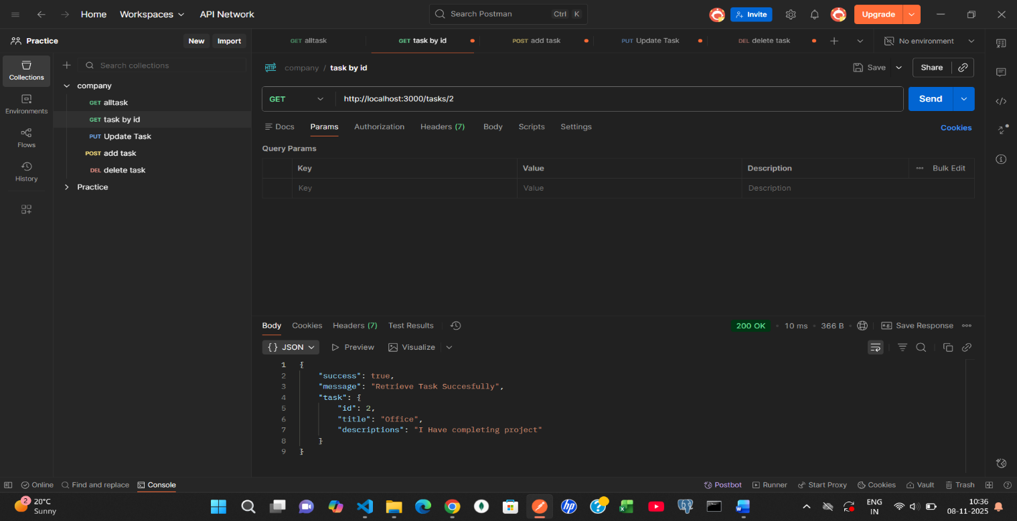

3.Create a new task
export const addTask = (req,res) => {
try {
const data = req.body;
if(!data){
res.status(404).json({success: false,message: 'Task are Required'})
}
tasksArray.push({ id: tasksArray.length + 1, title:data.title, descriptions:data.descriptions });
res.status(200).json({
success: true,
message: 'Task Add SuccesFully',
tasksArray
})
} catch (error) {
res.status(400).json({
success: false,
message: error.message
})
}
}

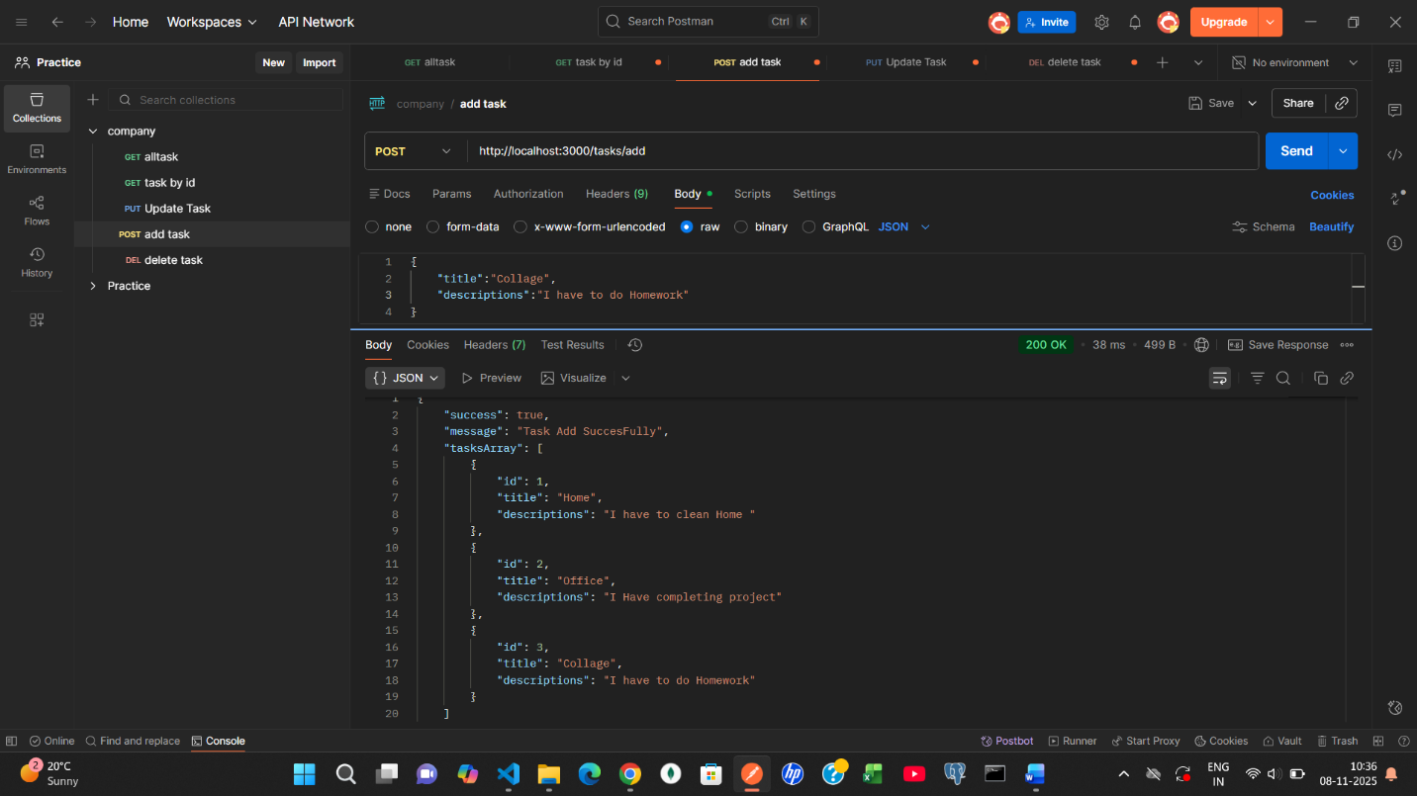

4.Update an existing task by ID
export const updateTask = (req,res) => {
try {
const task = tasksArray.find(task => task.id == req.params.id);
if (!task) return res.status(404).json({ message: "task not found" });
task.title = req.body.title;
task.descriptions = req.body.descriptions;
res.status(200).json({
success: true,
message: 'Task Update SuccesFully',
tasksArray
})
} catch (error) {
res.status(400).json({
success: false,
message: error.message
})
}
}

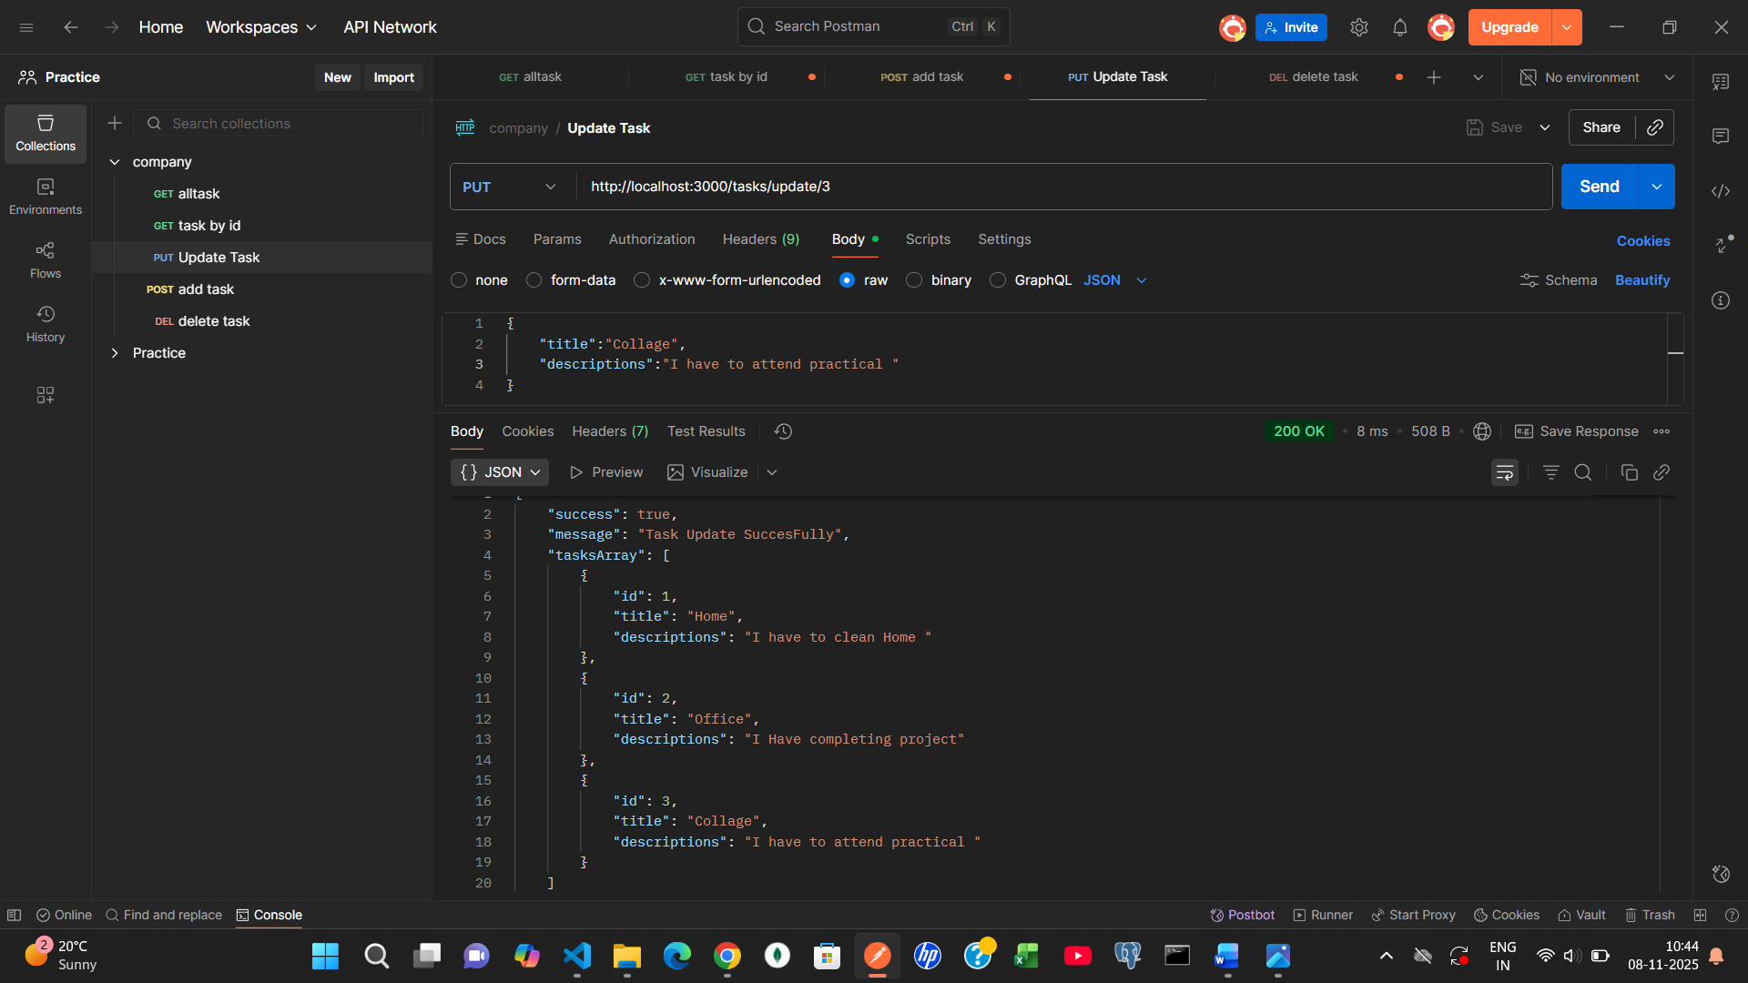

5.Delete a task by ID
export const deleteTask = (req, res) => {
try {
const id = parseInt(req.params.id);
if (!id) {
return res.status(404).json({
success: false,
message: "Task ID is required",
});
}
tasksArray = tasksArray.filter(task => task.id !== id);
res.status(200).json({
success: true,
message: "Task deleted successfully",
tasksArray,
});
} catch (error) {
res.status(400).json({
success: false,
message: error.message,
});
}
};

