Retail Sales & Inventory Performance Analysis
Prepared for: Business Analytics & Information Management coursework / portfolio project
Analyst: Akash Mahalingam | Period covered: Jan 2023 – Dec 2024

1. Project Overview
This project analyzes two years of retail transaction data to identify what drives sales and profitability, and to recommend where the business should focus. The workflow mirrors a real analyst task: pull raw data, clean it, analyze trends, visualize findings, and translate results into a recommendation.

Business Questions
- Which product categories and regions generate the most revenue and profit?
- Is there seasonality in sales that should inform inventory planning?
- Are discounts helping or hurting profitability?
- Where should the business focus resources going forward?

2. Data & Cleaning
The raw dataset contained 3,000 orders across three categories (Furniture, Office Supplies, Technology), four regions, and three customer segments. Before analysis, the following data quality issues were found and fixed:
- Missing discount values (15 rows) — filled with 0, assuming no discount was applied.
- Inconsistent region capitalization (e.g. 'east' vs 'East') — standardized to title case.
- Sales values stored as text with trailing whitespace — stripped and converted to numeric.
- Order dates parsed into proper datetime format and grouped into months for trend analysis.
This step matters because uncleaned data (mismatched capitalization, wrong types) silently breaks groupings and totals — a common real-world gotcha.

3. Key Findings

3.1 Overall Performance
Metric | Value
Total Sales | $2,480,186
Total Profit | $736,751
Overall Profit Margin | 29.7%

3.2 Sales by Category
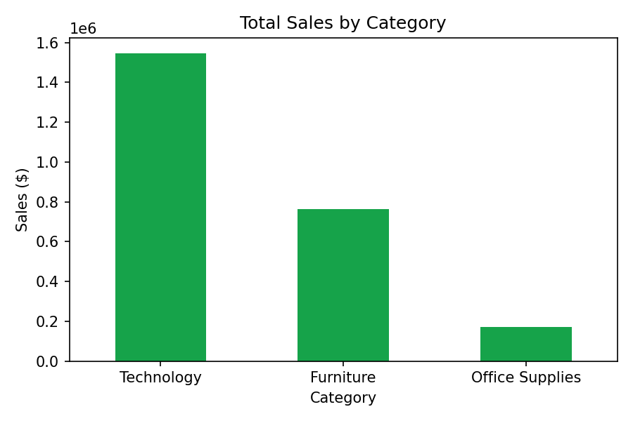
Technology drives the largest share of revenue ($1.55M), more than double Furniture ($763K) and nearly 9x Office Supplies ($171K). Technology is also the most profitable category ($461K profit), so it's the clear priority for marketing and inventory investment.

3.3 Sales by Region
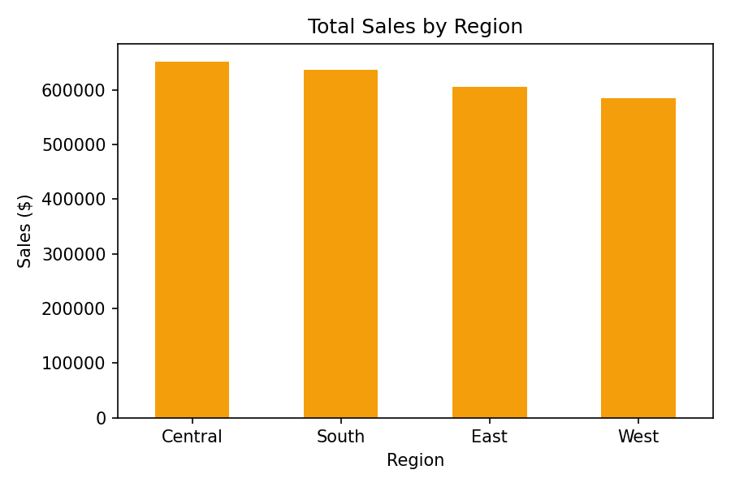
Regional performance is fairly balanced, with Central ($652K) and South ($638K) slightly ahead of East ($606K) and West ($585K). No single region is underperforming dramatically, suggesting demand is broadly national rather than concentrated.

3.4 Monthly Sales Trend
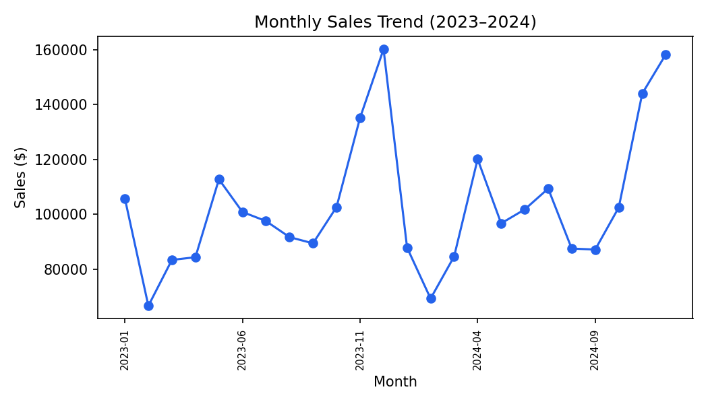
Sales spike sharply every November–December, consistent with holiday shopping season. Inventory and staffing should be scaled up ahead of Q4 each year to avoid stockouts during peak demand.

3.5 Top Sub-Categories
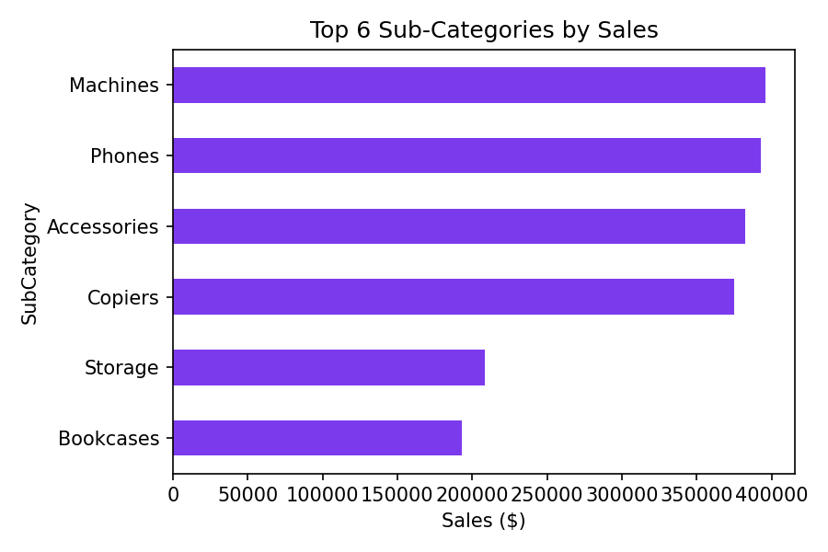
Machines, Phones, Accessories, and Copiers (all Technology) are the top four sub-categories by sales, reinforcing that Technology is the category to protect and grow.

3.6 Discount Impact
Average profit per order drops as discount size increases: $307 for orders with no discount, $223 for discounts up to 15%, and just $167 for discounts above 15%. Heavy discounting is eroding margin faster than it's driving volume — a signal to cap discounts at 15% except for planned clearance events.

4. Recommendations
- Prioritize Technology inventory and marketing spend — it drives the most revenue and the highest profit.
- Build up inventory ahead of Q4 to meet the recurring November–December demand spike.
- Cap standard discounts at 15%; reserve deeper discounts for deliberate clearance of slow-moving stock (e.g. Office Supplies).
- Investigate why Office Supplies underperforms — consider bundling with Technology purchases to lift its sales.
- Maintain current regional distribution strategy since performance is balanced — no urgent reallocation needed.

5. Methodology Note
Data was synthetically generated to mirror realistic retail patterns (seasonality, category mix, discount behavior) for this exercise. The same workflow — clean, analyze, visualize, recommend — applies directly to real datasets such as a company's POS export or a public dataset like the Superstore sales dataset.
Tools used: Python (pandas for cleaning/analysis, matplotlib for charts). Equally doable in Excel with PivotTables and PivotCharts, or Tableau/Power BI for the dashboard layer.

