Superstore Sales & Profitability Analysis
Dataset: Sample Superstore (public dataset, 9,994 orders, 2017–2020)
Analyst: Akash Mahalingam

1. Project Overview
This project analyzes the Sample Superstore dataset — a widely-used, real-world-style retail dataset covering ~10,000 orders across the US from 2017 to 2020. The goal was to find where the business makes and loses money, and turn that into a concrete recommendation.

Business Questions
- Which categories and regions drive the most sales and profit?
- Are any products or categories actually losing money?
- How does discounting affect profitability?
- What should the business change?

2. Data Cleaning
The raw file (Excel, 21 columns) had real data-quality problems typical of exported business data:
- Sales stored as text with a dollar sign (e.g. "$378.0") — stripped and converted to numeric.
- Profit stored in accounting format, where losses are wrapped in parentheses (e.g. "($88)" means -$88) — parsed into signed numeric values.
- 13 missing Postal Codes, and a handful of missing Order Dates, Segments, Regions, and Categories — rows missing a date, category, sales, or profit value (5 rows) were dropped since they can't be analyzed; missing Segment/Region were labeled "Unknown" instead of dropped, since the row still carries usable sales data.
- Order Date parsed into a proper datetime and grouped into months for trend analysis.
This step is the difference between a report that looks right and one that is right — the $ and parentheses formatting alone would silently break any sum() if not handled first.

3. Key Findings

3.1 Overall Performance
Metric | Value
Total Sales | $2,297,066
Total Profit | $286,341
Overall Profit Margin | 12.5%

A 12.5% margin is thin for retail — worth investigating where it's being eaten away (see 3.2 and 3.4).

3.2 Profit by Category — Furniture Is a Problem
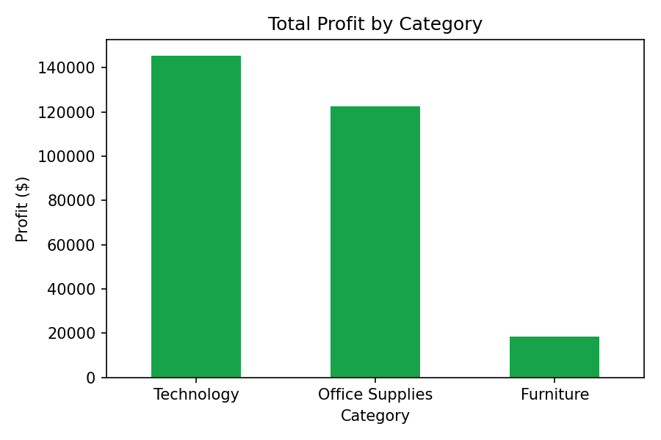
Furniture generates almost as much in sales as Technology ($742K vs $836K) but produces only $18K in profit — a razor-thin 2.5% margin — while Technology converts sales to profit far more efficiently ($145K profit, 17% margin). Office Supplies, despite the lowest sales, actually out-profits Furniture.

3.3 The Sub-Category Losing Money
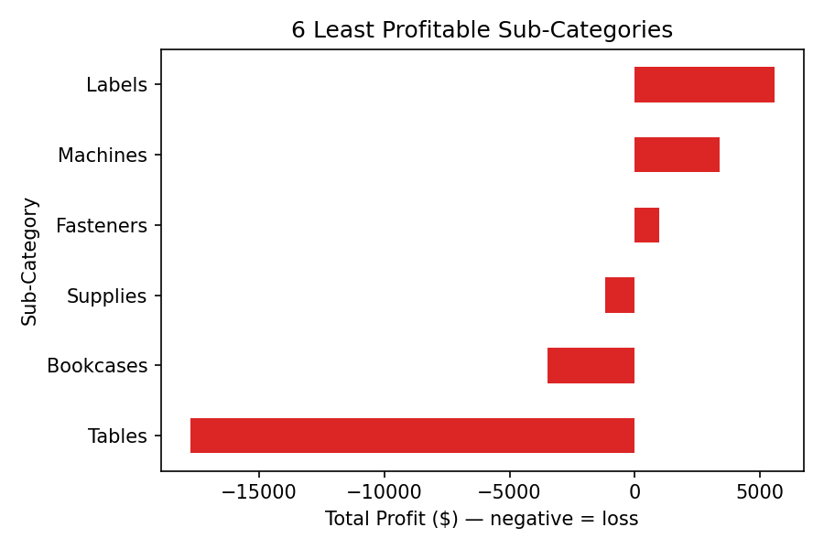
Tables lose money overall (-$17,733 in total profit) despite $207K in sales — every table sold is, on average, a net loss once cost and discounting are factored in. Bookcases are also a small net loss. These two sub-categories are dragging down Furniture's entire category performance.

3.4 Discounting Is Actively Destroying Profit
Average profit per order by discount level:
Discount Level | Avg. Profit / Order
No discount | $66.91
Low (≤20%) | $26.52
High (>20%) | -$97.25

This is the clearest finding in the dataset: orders with discounts above 20% lose money on average. Whatever volume they generate is not covering the margin given up.

3.5 Sales by Region
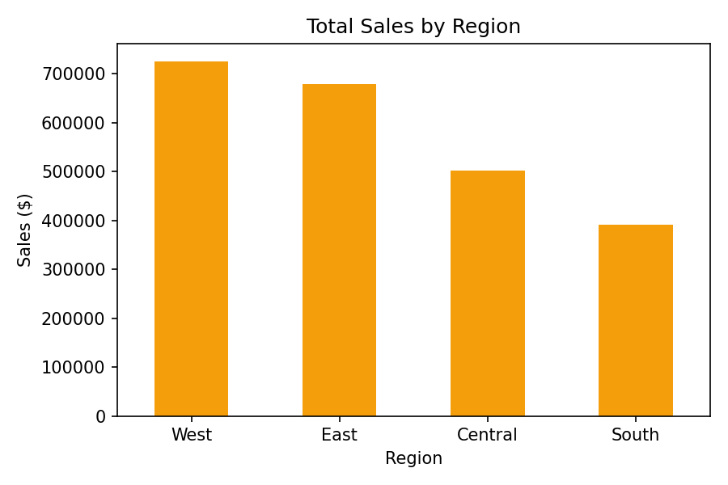
The West ($725K) and East ($679K) lead in sales; the South trails at $392K — worth a closer look at whether that's a demand gap or a distribution/marketing gap.

3.6 Monthly Trend
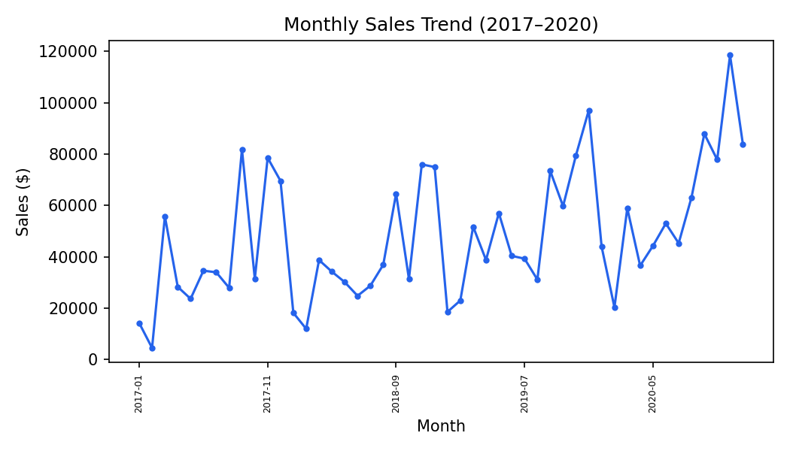
Sales climb steadily through each year with a pronounced November–December peak, consistent with holiday retail seasonality — inventory and staffing should scale up ahead of Q4.

4. Recommendations
- Cap discounts at 20% as standard policy — anything higher is losing money on average and should be reserved for deliberate clearance.
- Re-price or re-negotiate supplier costs on Tables and Bookcases — they are structurally unprofitable at current pricing.
- Shift marketing/inventory investment toward Technology, which converts sales to profit most efficiently.
- Investigate the South region's lower sales — could be under-marketed rather than genuinely lower demand.
- Build Q4 inventory ahead of the recurring November–December demand spike.

5. Methodology Note
Dataset: Sample Superstore, a public dataset (originally distributed with Tableau) commonly used for BI/analytics practice and interviews. Tools used: Python (pandas for cleaning and aggregation, matplotlib for charts). The same analysis is doable in Excel with PivotTables, or Power BI/Tableau for an interactive dashboard version.

