Project Planning Phase
Project Planning Template (Product Backlog, Sprint Planning, Stories, Story Points)

Date | 23 October 2026
Team ID | SWTID-2026-8980
Project Name | Auto Ticket Classification Using Flow Designer
Maximum Marks | 5 Marks
Institution / Dept | Jaya Engineering College (JEC) / Dept of CSE (Anna University Reg. 2021)

Product Backlog, Sprint Schedule, and Estimation (4 Marks)
Backlog items below reflect the actual ServiceNow build: the Update Set, the custom Incident WorkFlow table, the Flow Designer trigger, the If/Else-If classification branches, and the Send Email notification.
Sprint | Functional Requirement (Epic) | User Story Number | User Story / Task | Story Points | Priority | Team Members
Sprint-1 | Requirement Analysis & Planning | USN-1 | As an IT administrator, I can create and activate a local Update Set (Project Update Set, Global scope) so that all configuration is captured. | 2 | High | Akash Prabhu. P (110824104004)
Sprint-1 | Requirement Analysis & Planning | USN-2 | As a project team, we can document the business use case and requirements for auto classification, email notification and structured storage. | 3 | High | Gowtham. R (110824104020)
Sprint-1 | Ticket Data Model | USN-3 | As an IT administrator, I can create the custom table Incident WorkFlow (u_incident_workflow) with an INC auto-number. | 5 | High | Karthik. K (110824104032)
Sprint-1 | Ticket Data Model | USN-4 | As an IT administrator, I can create the nine ticket fields with correct data types and reference tables (sys_user, sys_user_group). | 5 | High | Gokul Raj K (110824104019)
Sprint-1 | Ticket Data Model | USN-5 | As an IT administrator, I can add choice lists for Category, Subcategory and State through the Form Design. | 5 | High | Douglas Christopher (110824104017)
Sprint-2 | Dependent Choice Logic | USN-6 | As a student, I see only the Subcategory options that belong to the selected Category (dependent choice). | 5 | High | Akash Prabhu. P (110824104004)
Sprint-2 | Auto Classification (Flow Designer) | USN-7 | As an IT administrator, I can create the flow Auto Classify School IT Tickets, triggered on record creation when Category is empty. | 3 | High | Gowtham. R (110824104020)
Sprint-2 | Auto Classification (Flow Designer) | USN-8 | As a student, a ticket mentioning Wi-Fi or Network is classified automatically as Network / Wi-Fi. | 4 | High | Karthik. K (110824104032)
Sprint-2 | Auto Classification (Flow Designer) | USN-9 | As a student, a ticket mentioning Projector is classified automatically as Hardware / Projector. | 4 | High | Gokul Raj K (110824104019)
Sprint-2 | Auto Classification (Flow Designer) | USN-10 | As a student, a ticket mentioning Forgot password is classified automatically as Access / Forgot Password. | 4 | High | Douglas Christopher (110824104017)
Sprint-3 | Auto Classification (Flow Designer) | USN-11 | As a student, a ticket mentioning Slow Computer is classified automatically as Performance / Slow Computer. | 4 | High | Akash Prabhu. P (110824104004)
Sprint-3 | Auto Classification (Flow Designer) | USN-12 | As an IT administrator, I can activate the flow so that every new ticket is classified without manual intervention. | 2 | High | Gowtham. R (110824104020)
Sprint-3 | Email Notification | USN-13 | As a caller, I receive a confirmation email (Your Request for the issue has been submitted.) when my ticket is created. | 5 | High | Karthik. K (110824104032)
Sprint-3 | Testing & Validation | USN-14 | As a tester, I can verify Test Scenario 1 (WiFi issue): Category, Subcategory and email are populated correctly. | 5 | High | Gokul Raj K (110824104019)
Sprint-3 | Testing & Validation | USN-15 | As a tester, I can verify Test Scenario 2 (Projector issue): Hardware / Projector assigned and email sent. | 4 | Medium | Douglas Christopher (110824104017)
Sprint-4 | Testing & Validation | USN-16 | As a tester, I can run data validation checks: mandatory fields, unique auto-number, stored values and reference fields. | 5 | Medium | Akash Prabhu. P (110824104004)
Sprint-4 | Testing & Validation | USN-17 | As an administrator, I can verify that only authorized users can access or modify ticket data (access controls). | 3 | Medium | Gowtham. R (110824104020)
Sprint-4 | Deployment & Documentation | USN-18 | As an administrator, I can mark the Update Set Complete and export it to XML for deployment to other instances. | 5 | High | Karthik. K (110824104032)
Sprint-4 | Deployment & Documentation | USN-19 | As a project team, we can finalize the project documentation and conclusion for review and submission. | 5 | Medium | Gokul Raj K (110824104019)
Sprint-4 | Deployment & Documentation | USN-20 | As a project team, we can record future enhancements (assignment automation, SLA tracking, predictive intelligence). | 2 | Low | Douglas Christopher (110824104017)

Project Tracker, Velocity & Burndown Chart (4 Marks)
Sprint | Total Story Points | Duration | Sprint Start Date | Sprint End Date (Planned) | Story Points Completed | Sprint Release Date (Actual)
Sprint-1 | 20 | 6 Days | 26 Oct 2026 | 31 Oct 2026 | 20 | 31 Oct 2026
Sprint-2 | 20 | 6 Days | 02 Nov 2026 | 07 Nov 2026 | 20 | 07 Nov 2026
Sprint-3 | 20 | 6 Days | 09 Nov 2026 | 14 Nov 2026 | 20 | 14 Nov 2026
Sprint-4 | 20 | 6 Days | 16 Nov 2026 | 21 Nov 2026 | 20 | 21 Nov 2026

Velocity:
Average Velocity (AV) = Total Story Points Completed ÷ Number of Sprints
Total Story Points Completed = 20 (Sprint-1) + 20 (Sprint-2) + 20 (Sprint-3) + 20 (Sprint-4) = 80
Number of Sprints = 4 (6-day sprint duration)
Velocity = 80 ÷ 4 = 20 Story Points per Sprint
Burndown Chart:
A burndown chart shows work remaining versus time. The chart below tracks story points remaining across both sprints against the ideal pace needed to finish on schedule.
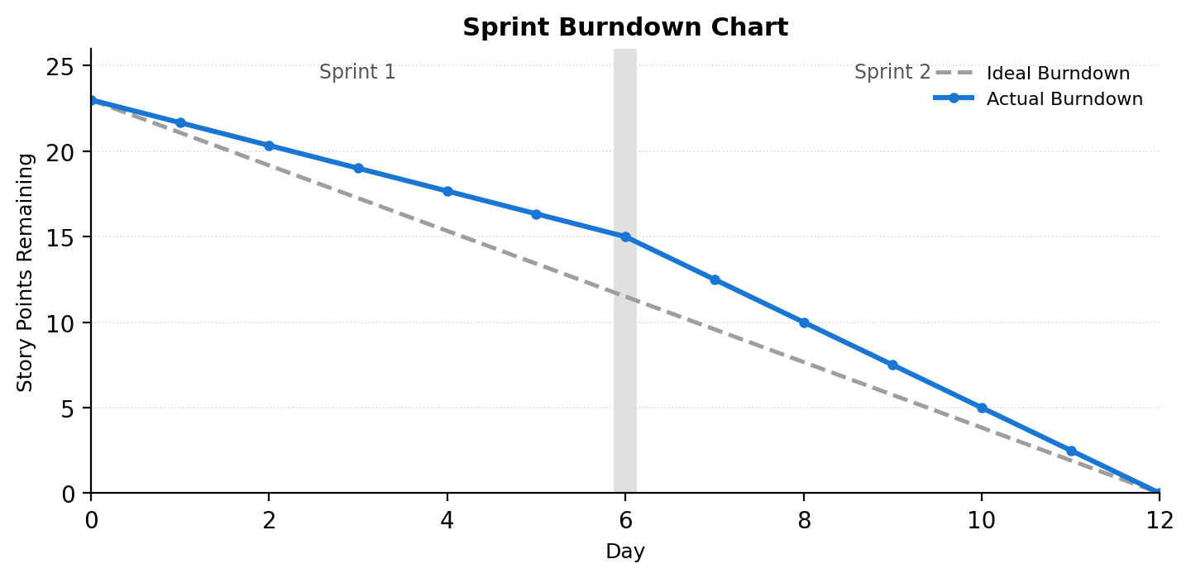
References:
https://www.visual-paradigm.com/scrum/scrum-burndown-chart/
https://www.atlassian.com/agile/tutorials/burndown-charts

