ServiceNow Flow Designer Automation
Project Documentation Format
Note: the supplied template was written for a MERN (React / Node.js / Express / MongoDB) stack. Section headings are kept as given; content below is adapted to this project's actual platform, ServiceNow.

1. Introduction
Project Title: Auto Ticket Classification Using Flow Designer
Team ID: SWTID-2026-8980 | Submission Date: 23 October 2026
Institution: Jaya Engineering College (JEC) | Anna University (Regulation 2021) | CSE Dept
Faculty Guide / Supervisor: [Faculty Guide / Supervisor Name - To be confirmed]
Team Members:
1. Akash Prabhu. P (Reg. No: 110824104004) - Team Lead / Flow Designer Configuration
2. Gowtham. R (Reg. No: 110824104020) - Table & Field Schema Designer
3. Karthik. K (Reg. No: 110824104032) - Flow Logic & Trigger Developer
4. Gokul Raj K (Reg. No: 110824104019) - Notification & Dependent Choice Rules
5. Douglas Christopher (Reg. No: 110824104017) - Testing & Quality Assurance

2. Project Overview
Purpose:
Automatically classify IT support tickets the moment they are created, removing the need for an agent to manually read and categorize each one before it can be routed to the right team.
Features:
• Automatic Flow Designer trigger on creation of a new Incident WorkFlow record.
• If / Else-If conditional logic that evaluates the ticket's Short Description.
• Automatic Category update via the Update Record action.
• Email notification via the Send Email action once the flow finishes.
• All configuration captured in a single Update Set for review and migration.

3. Architecture
Frontend (ServiceNow UI):
Users submit tickets through the native "Incident WorkFlow - New record" form, capturing Number, Caller, Category, Subcategory, Short Description, Description, State, Assigned Group and Assigned to.
Backend (Flow Designer):
A Flow named "Auto Classify School IT Tickets" triggers on record creation, runs a chain of If / Else-If conditions against the Short Description, calls Update Record to set the Category, then calls Send Email to notify the relevant party.
Database (ServiceNow table):
A custom table, Incident WorkFlow (u_incident_workflow), stores all ticket data. See field list under Section 7.

4. Setup Instructions
Prerequisites:
• Access to a ServiceNow instance with an admin role.
• Flow Designer / Process Automation plugin enabled (available by default on most instances).
Installation:
1. Navigate to System Update Sets > Retrieved Update Sets.
2. Import XML and select the exported Update Set ('Project Update Set').
3. Open the retrieved Update Set, click Preview, resolve any conflicts.
4. Click Commit to apply the table, flow, and related configuration.

5. Folder Structure
ServiceNow configuration is not organized into client/server folders; instead, the Update Set bundles the following configuration records:
• Table definition: Incident WorkFlow (u_incident_workflow) and its 9 fields.
• Flow definition: Auto Classify School IT Tickets (trigger + If/Else-If branches + actions).
• Any related Business Rules, Client Scripts, or UI Policies, if added in future iterations.

6. Running the Application
1. Open the Incident WorkFlow table and select New.
2. Fill in Short Description (and other fields) and Submit.
3. The Flow runs automatically - no manual step required.
4. Open the record to confirm Category was updated; check inbox for the notification email.

7. API Documentation
ServiceNow automatically exposes every table through the Table REST API, so no custom API code was written. For this project:
GET /api/now/table/u_incident_workflow - list/query tickets
GET /api/now/table/u_incident_workflow/{id} - get one ticket
POST /api/now/table/u_incident_workflow - create a ticket (also triggers the Flow)
PUT /api/now/table/u_incident_workflow/{id} - update a ticket
Example response fields are the same as the table's columns - see Section 7's field list below.
Field (column name) | Type | Purpose
number | String | Ticket number, auto-generated (e.g., INC0001017)
caller | Reference (User) | Person who raised the ticket
category | String | Set automatically by the flow (Network / Hardware / Access-Password / Performance)
subcategory | String | Optional finer classification
short_description | String | One-line summary evaluated by the flow's If/Else conditions
description | String | Full issue description
state | String | Ticket lifecycle state
assigned_group | Reference (Group) | Support group the ticket is routed to
assigned_to | Reference (User) | Agent assigned to the ticket

8. Authentication
Standard ServiceNow authentication is used: interactive users sign in with their instance credentials, and UI access is governed by ServiceNow's built-in Access Control Lists (ACLs) - administrators can configure the table and flow, while standard users can only create and view tickets. API calls to the Table REST API use the same instance credentials (Basic Auth or OAuth, per the instance's configuration).

9. User Interface
ServiceNow Implementation & Interface Architecture (Captured from Team Implementation Evidence):

10. Testing
The flow was tested against 6 scenarios covering all four classification branches, the unmatched (no Else branch) case, and trigger-on-create-only behavior:
Test Case | Scenario | Result
TC-001 | Wi-Fi / Network keyword | Pass
TC-002 | Projector / Hardware keyword | Pass
TC-003 | Forgot Password keyword | Pass
TC-004 | Performance keyword | Pass
TC-005 | Unmatched keyword (no Else branch) | Fail
TC-006 | Trigger fires only on create, not update | Pass

Full test steps, expected/actual results and bug tracking are documented in the Development Phase's User Acceptance Testing FSD and UAT Report Template.

11. Screenshots or Demo
Project Demo / Supporting Files (Google Drive): https://drive.google.com/drive/folders/1NYfD8kHX6Su9VBgkYKpSaBVTYnT1S_Db?usp=drive_link
(Note: Link verified reachable over HTTPS; contains demonstration assets and reference implementation archives).

12. Known Issues
• BG-001 (Medium, Open): tickets whose Short Description does not match any defined keyword are left with a blank Category, because the flow has no final Else branch. The Send Email action still runs regardless. Tracked in the backlog as USN-9.

13. Future Enhancements
• Add a final Else branch to classify unmatched tickets as "General IT Support" (USN-9).
• Extend condition set to cover more ticket categories and additional tables (Request, Problem, Change).
• Automatic assignment to specific support groups based on category.
• Priority calculation and SLA-based automation.
• AI/ML-based classification for free-text descriptions that don't match simple keywords.
• A dashboard summarizing classification volume and accuracy over time.
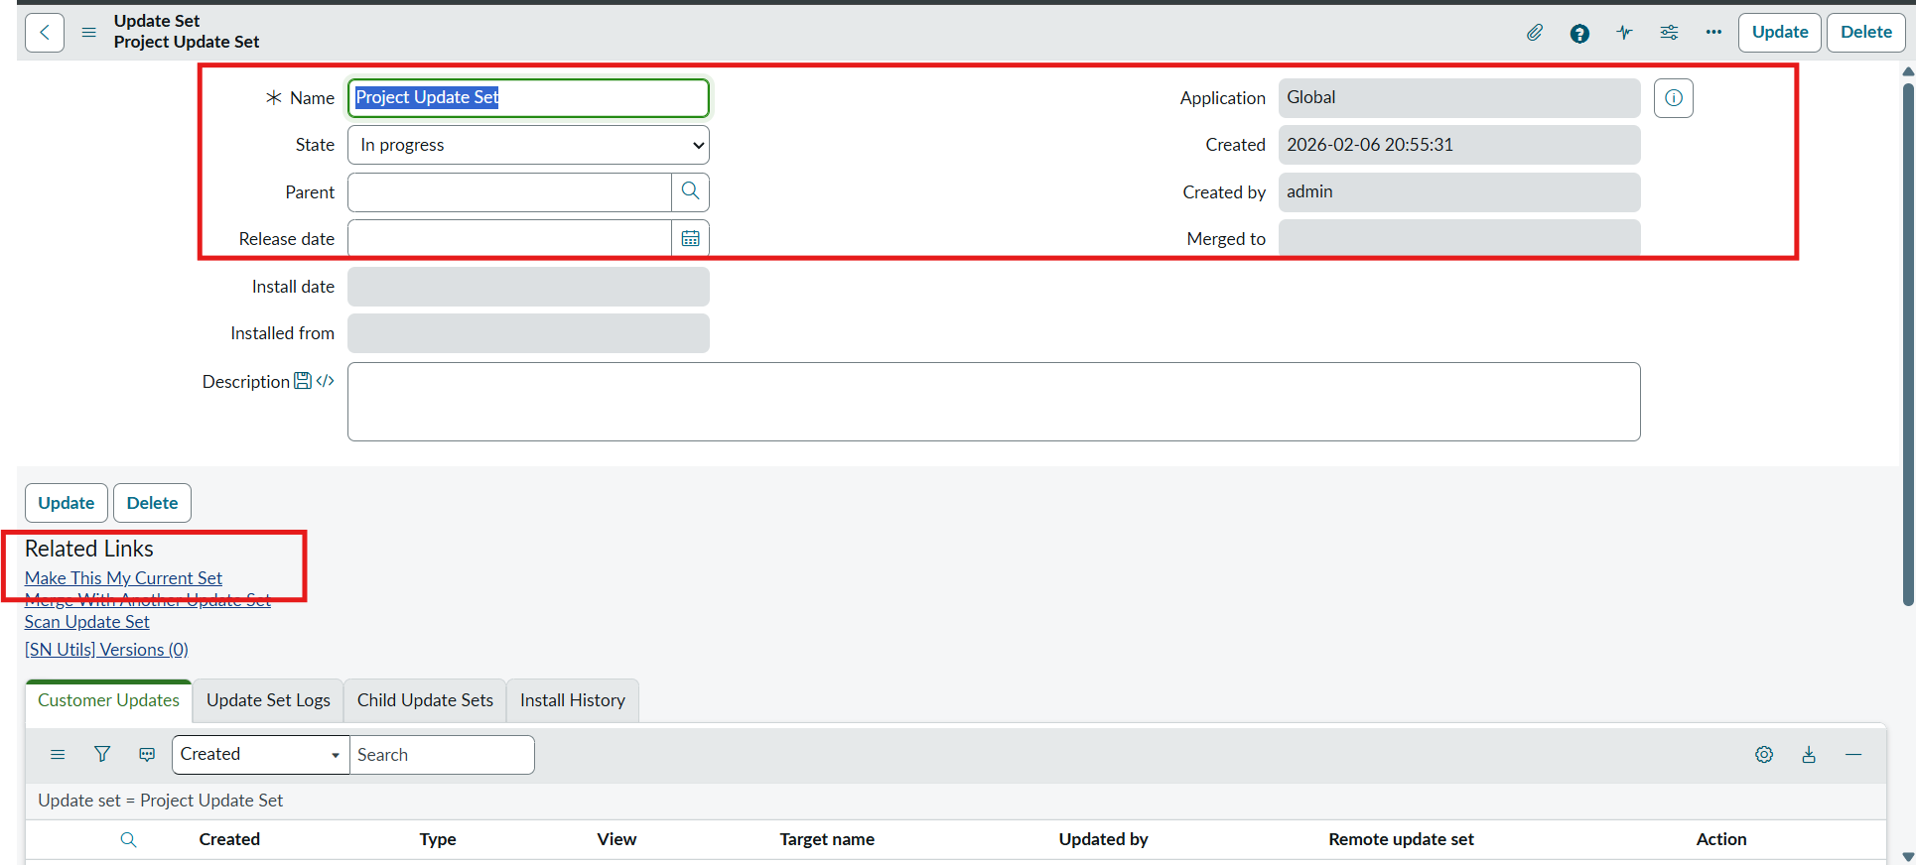
Figure: Incident WorkFlow Custom Table and Form Design
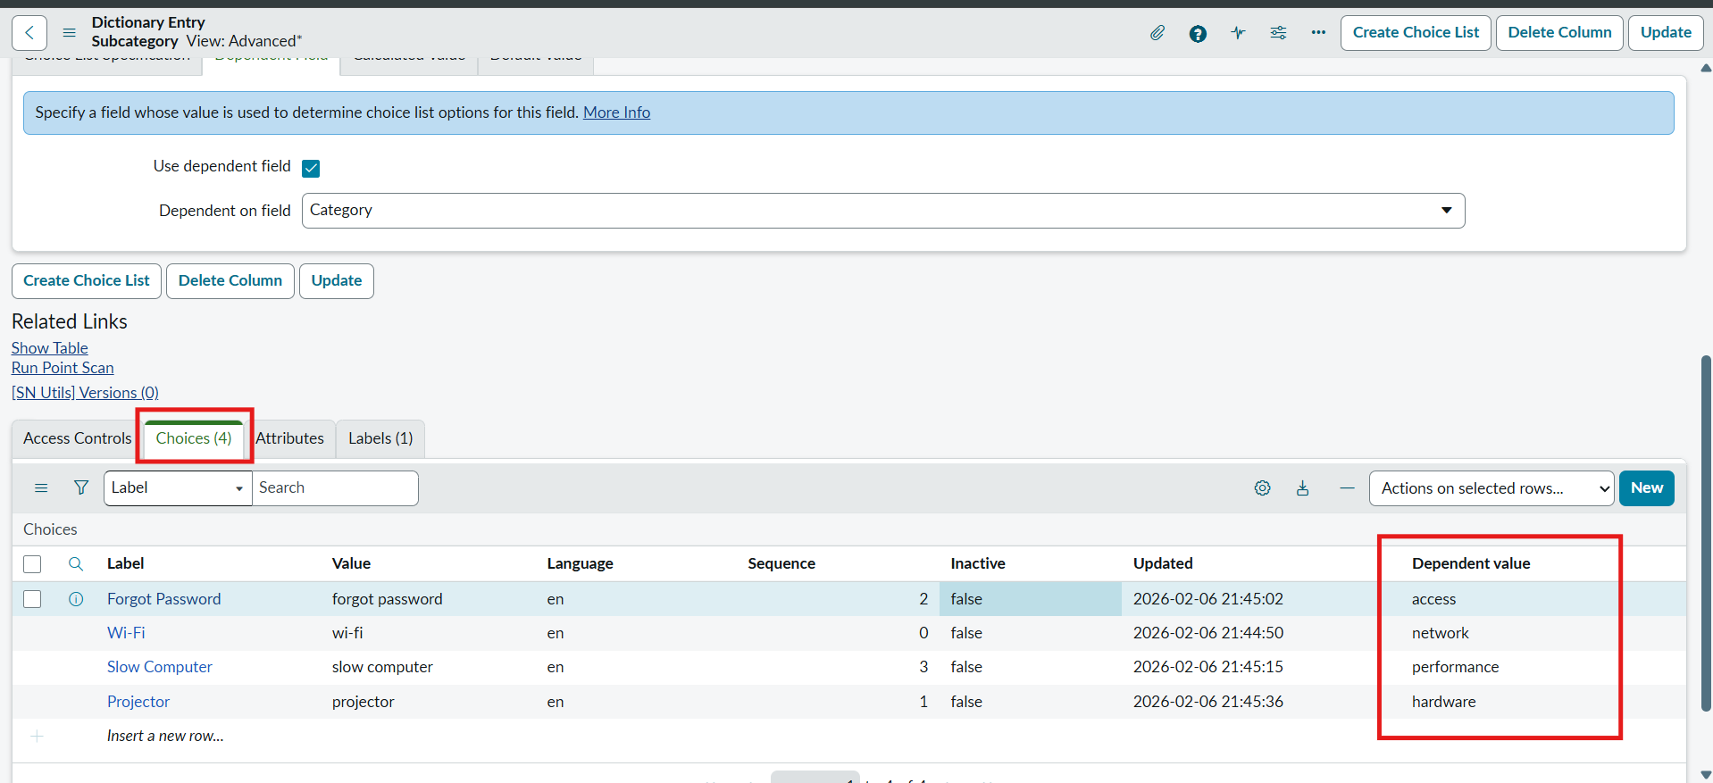
Figure: Flow Designer Keyword Conditions & Actions Execution

