NAAN MUDHALVAN PROJECT WORK REPORT
ANNA UNIVERSITY REGULATION 2021
AUTO TICKET CLASSIFICATION USING FLOW DESIGNER
DEPARTMENT OF COMPUTER SCIENCE AND ENGINEERING
JAYA ENGINEERING COLLEGE (JEC), CHENNAI
TEAM ID: SWTID-2026-8980 | SUBMISSION DATE: 23 OCTOBER 2026
PROJECT TEAM MEMBERS:
1. Akash Prabhu. P (110824104004) - Team Lead
2. Gowtham. R (110824104020) - Member
3. Karthik. K (110824104032) - Member
4. Gokul Raj K (110824104019) - Member
5. Douglas Christopher (110824104017) - Member
FACULTY GUIDE / SUPERVISOR:
[Faculty Guide / Supervisor Name - To be confirmed]

Date | 23 October 2026
Team ID | SWTID-2026-8980
Project Name | Auto Ticket Classification Using Flow Designer
Institution / Dept | Jaya Engineering College (JEC) / Dept of CSE (Anna University Reg. 2021)

1. Introduction

1.1 Project Overview
This project automates the classification of IT support tickets in ServiceNow using Flow Designer. When a new ticket is created on the custom Incident WorkFlow table, a flow automatically evaluates its short description, assigns the correct category, and sends a confirmation notification - replacing a manual, inconsistent first-line triage step.

1.2 Purpose
To reduce ticket classification time and inconsistency for IT support teams by using a no-code, auditable automation that any ServiceNow admin can extend, rather than custom scripts or a third-party tool.

2. Ideation Phase

2.1 Problem Statement
IT support teams receive tickets covering network, hardware, password/access, performance, and general issues. Manual classification of each ticket is time-consuming and often inconsistent, which delays routing to the correct support team and slows down resolution.

2.2 Empathy Map Canvas
Quadrant | IT Support User / Employee
Says | "I don't know who to send this to." "Why is this taking so long?" "I just need my Wi-Fi fixed."
Thinks | "Is anyone even looking at my ticket?" "This should be simple to fix."
Does | Submits a ticket with a short, informal description; follows up by email or chat if there's no response.
Feels | Frustrated by delay and uncertainty; relieved once the issue is picked up by the right team.
Pains | Tickets sit unclassified; inconsistent routing; repeated follow-ups to check status.
Gains | Fast, predictable routing; a confirmation that the system has understood the issue.

2.3 Brainstorming
Options considered before settling on the final approach:
• A manual SOP / checklist for agents - rejected: still manual, still inconsistent.
• A custom-built NLP/ML classifier - rejected for this scope: higher build/maintenance cost for a small, well-defined keyword set.
• A third-party ticketing bot/integration - rejected: adds an external dependency and licensing cost.
• ServiceNow Flow Designer automation (chosen) - no-code, native to the platform already in use, transparent If/Else logic that non-developers can maintain, and natively auditable via Update Sets.

3. Requirement Analysis

3.1 Customer Journey Map
Stage | What Happens | Emotion
Issue occurs | Employee hits a Wi-Fi, hardware, password, or performance problem. | Frustration
Submits ticket | Fills in the Incident WorkFlow form with a short description. | Hopeful, slightly unsure
Flow classifies | Flow Designer evaluates the description and updates Category automatically. | Neutral / waiting
Notification received | Send Email action confirms the ticket has been processed. | Reassured
Ticket resolved | Correct support team picks up the correctly-routed ticket. | Relieved / satisfied

3.2 Solution Requirement
Functional: trigger on ticket creation; evaluate Short Description against defined keywords; update Category/Subcategory/Assignment; send a confirmation email.
Non-functional: classification should complete within seconds of ticket creation; logic must be maintainable by a non-developer admin; all configuration changes must be auditable via an Update Set.

3.3 Data Flow Diagram
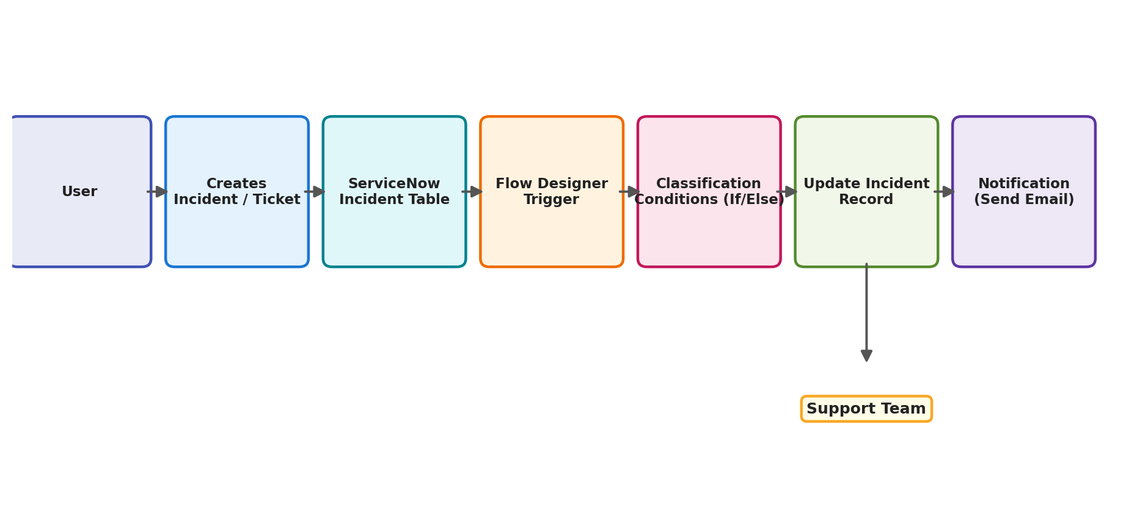
Figure 1: Data flow from ticket creation through classification to notification

3.4 Technology Stack
Layer | Technology
Platform | ServiceNow (Now Platform)
Automation | Flow Designer (trigger, If/Else-If flow logic, Update Record, Send Email actions)
Data storage | Custom table: Incident WorkFlow (u_incident_workflow)
Configuration management | Update Set ("Project Update Set")
Integration surface | ServiceNow Table REST API (auto-exposed for u_incident_workflow)
Notifications | ServiceNow Email (Send Email action)

4. Project Design

4.1 Problem - Solution Fit
Employees (customer segment) need tickets routed correctly without manual triage (job-to-be-done). The root cause is that classification is a manual, judgement-based step with no rule engine. The Flow Designer automation is the solution: it fits the existing channels (Service Portal and agent-logged tickets) without requiring any change in user behavior. Full canvas in the Project Design Phase documentation.

4.2 Proposed Solution
• Problem: inconsistent, manual ticket classification delays routing.
• Idea: a Flow Designer workflow triggered on ticket creation, classifying via If/Else-If rules.
• Novelty: no-code, transparent logic; fully packaged in a single Update Set.
• Impact: faster, more consistent routing and reduced agent triage time.
• Scalability: more categories, additional tables, SLA automation, and eventually AI/ML-based classification.

4.3 Solution Architecture
Architecture follows a simple event-driven flow (see Figure 1 above): a ticket is created, the Flow Designer trigger fires, If/Else-If conditions classify it, the Update Record action writes the category back, and the Send Email action notifies the relevant party. All components are detailed in the Solution Architecture document from the Project Design Phase.

5. Project Planning & Scheduling

5.1 Project Planning
Work was planned across 4 sprints of 6 days each, totaling 80 story points (Sprint-1: 20, Sprint-2: 20, Sprint-3: 20, Sprint-4: 20) with a team velocity of 20 story points per sprint. Work covered environment and table setup, ticket intake form, Flow Designer triggers, all four keyword classification branches, email notifications, and end-to-end user acceptance testing.
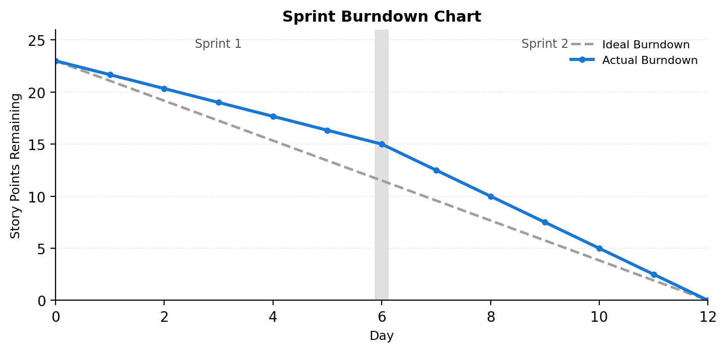
Figure 2: Sprint burndown across both sprints

6. Functional and Performance Testing

6.1 Performance Testing
9 test cases were executed across 4 functional areas, with 1 known failure traced to a single root cause (see Section 8):
Section | Total Cases | Fail | Pass
Update Set & Table Setup | 2 | 0 | 2
Flow Trigger | 1 | 0 | 1
Classification Logic | 5 | 1 | 4
Notification (Send Email) | 1 | 0 | 1
Totals | 9 | 1 | 8

The one failing case (unmatched ticket keyword) corresponds to defect BG-001, logged as Severity 3 and deferred to the next sprint. Full test cases, steps and defect analysis are in the Development Phase's UAT FSD and UAT Report documents.

7. Results

7.1 Output Screenshots
Below are the verified output screenshots capturing the end-to-end ServiceNow implementation from our project evidence:

8. Advantages & Disadvantages
Advantages:
• Removes manual first-line triage, speeding up ticket routing.
• Consistent, rule-based classification instead of agent judgement.
• No-code and transparent - maintainable by a ServiceNow admin without developer support.
• Fully auditable: every change ships inside a single, reviewable Update Set.
Disadvantages:
• Only 4 keyword-based categories are currently defined; anything else is left uncategorized (BG-001 / USN-9).
• Simple keyword matching can misclassify ambiguous or multi-issue descriptions.
• Depends on the ServiceNow platform's availability and licensing.

9. Conclusion
Auto Ticket Classification Using Flow Designer demonstrates how a native, no-code ServiceNow automation can remove a repetitive manual process. By triggering a flow on ticket creation and applying predefined classification rules, the system consistently routes tickets and notifies the right people without agent intervention. Testing confirmed the four core classification paths work correctly; the one identified gap (unmatched tickets) is already scoped as the next backlog item.

10. Future Scope
• Add a final Else branch to classify unmatched tickets as "General IT Support" (USN-9).
• Extend classification to more categories and additional tables (Request, Problem, Change).
• Automatic assignment to specific support groups, priority calculation, and SLA-based automation.
• AI/ML-based classification for free-text descriptions that don't match simple keywords.
• A reporting dashboard for classification volume and accuracy over time.

11. Appendix
Source Code: Not applicable - this is a no-code Flow Designer solution; all configuration is captured in the "Project Update Set" rather than traditional source files.
Dataset Link: Not applicable - no external dataset was used.
Project Demo / Supporting Files (Google Drive): https://drive.google.com/drive/folders/1NYfD8kHX6Su9VBgkYKpSaBVTYnT1S_Db?usp=drive_link
1. Incident WorkFlow Custom Table & Form Designer Configuration:
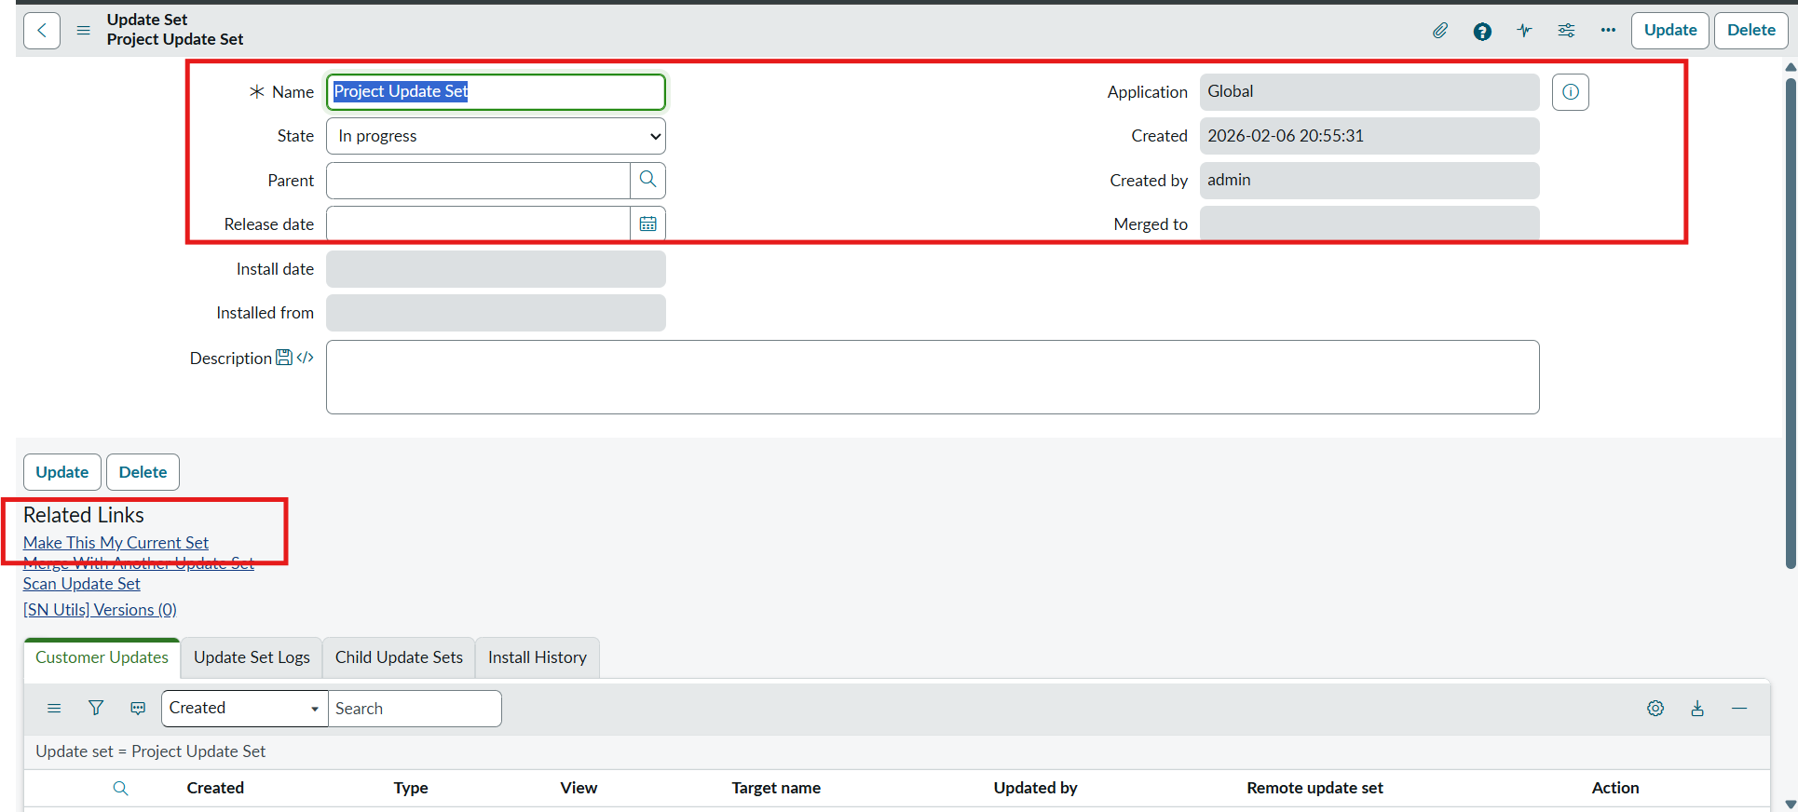
2. Flow Designer Automation Canvas & Trigger Configuration:
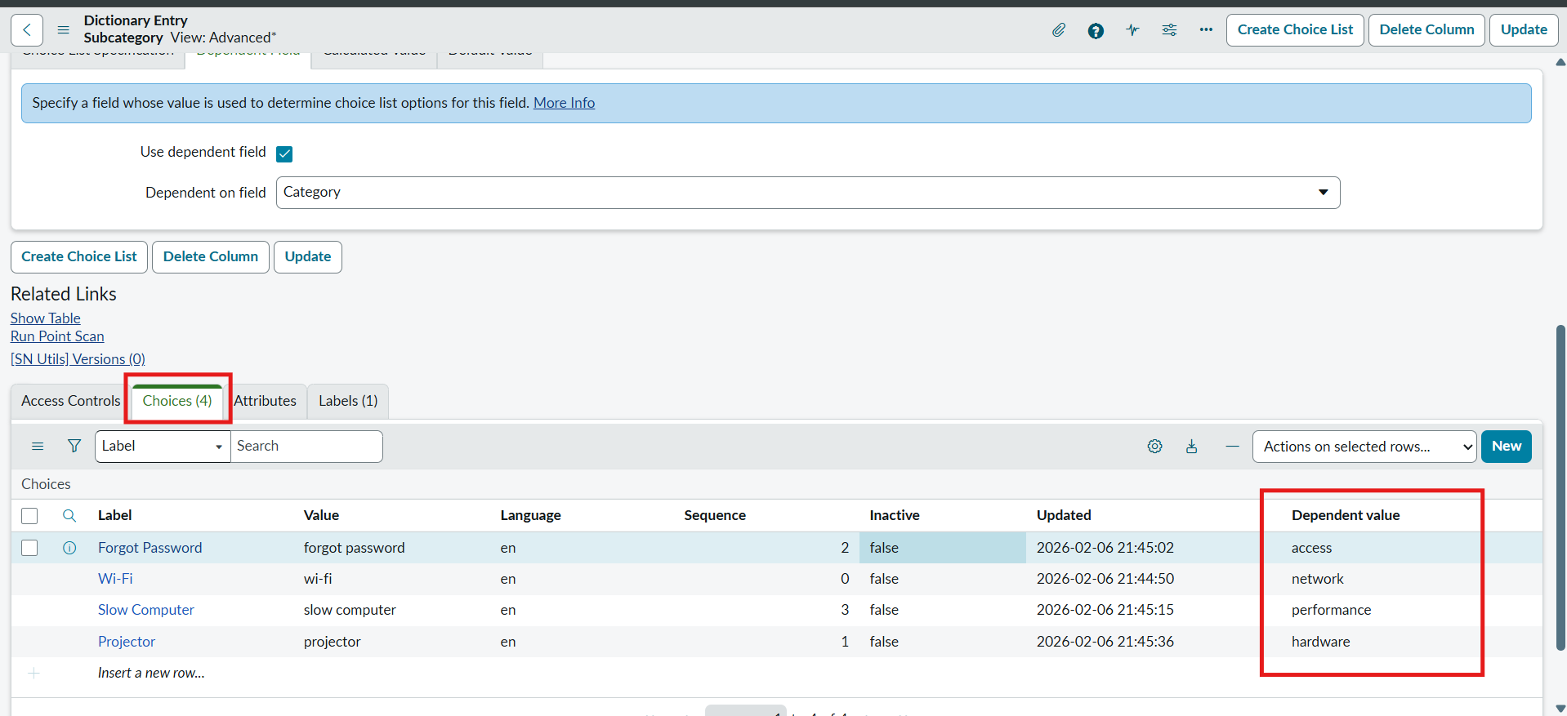
3. Functional Test Execution (Wi-Fi Issue Classified to Network / Wi-Fi):
