## FC Testing UPH Performance Analysis and Opportunities for NA (2024)

## 

# FC-Testing Performance Analysis (Sanitized Demo)

## 1. Business Problem

Amazon’s NA fulfillment-center (FC) testing throughput—measured in **Units-Per-Hour (UPH)**—trailed EU sites.  
The gap throttled inventory availability and created labor-cost inefficiencies.  
Ops leadership requested a deep-dive analysis to:

1. **Pinpoint drivers** of the performance deficit.
2. **Model scenarios** to close the gap.
3. **Recommend actions** that could be operationalized within the fiscal year.

## 2. Techniques Used

* **Root-Cause Analysis** – Visualizations and calculated fields to isolate “ghosted” labor hours and site-type outliers.
* **Capacity Modeling** – Simulated labor-code fixes and backlog restoration to forecast UPH uplift under multiple scenarios.
* **Benchmarking** – Normalized NA vs EU workloads by site type (ARS, NONSORT, TSSL) to ensure apples-to-apples comparisons.

## 3. Recommended Actions & Status

1. **Create dedicated labor codes** for FC testing tasks.
2. **Re-enable buffer storage** in NONSORT/TSSL to smooth work inflow.
3. **Standardize pick & stow** SOPs using EU best practices.

**Status:** White paper approved by senior ops leadership → Region-wide rollout of labor-hour audits and best-practice workshops in progress (Q3 2025).

## 4. Observations

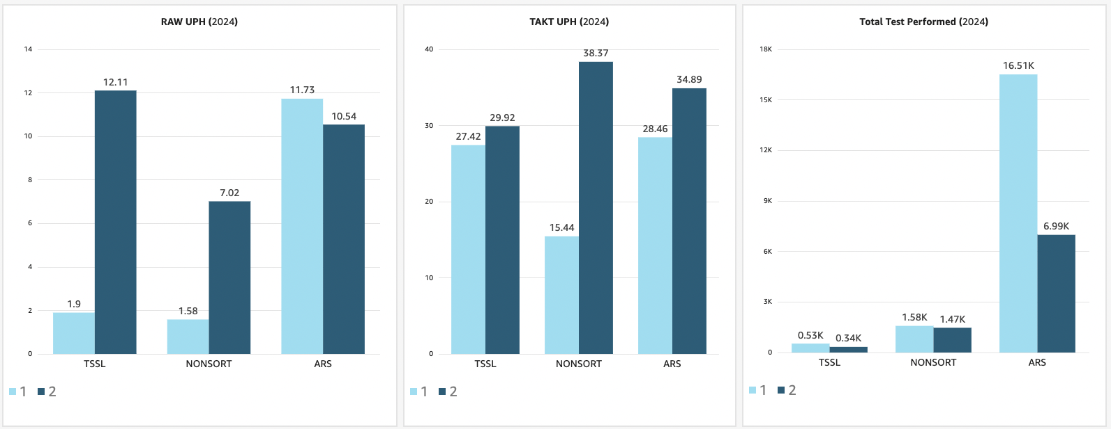

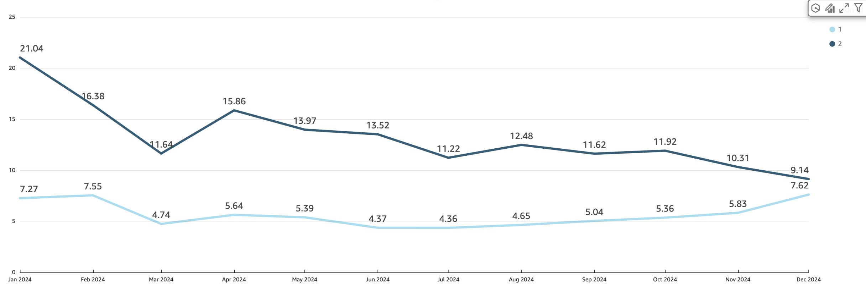**2024 Yearly trend for FC testing UPH across NA vs EU**

**2024 Monthly UPH Trend across FC_types NA vs EU**

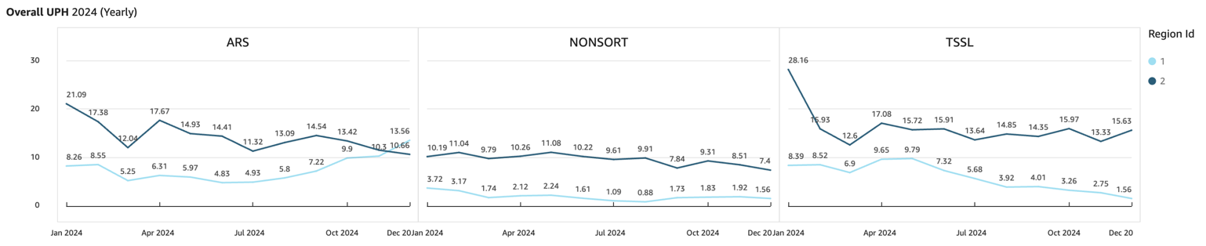

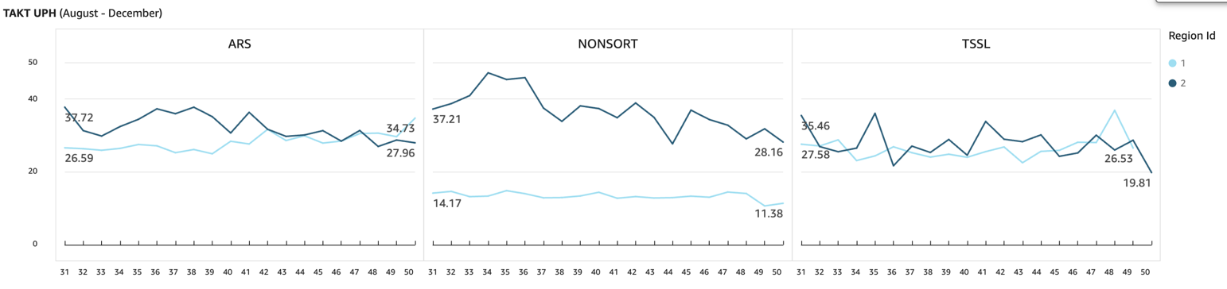

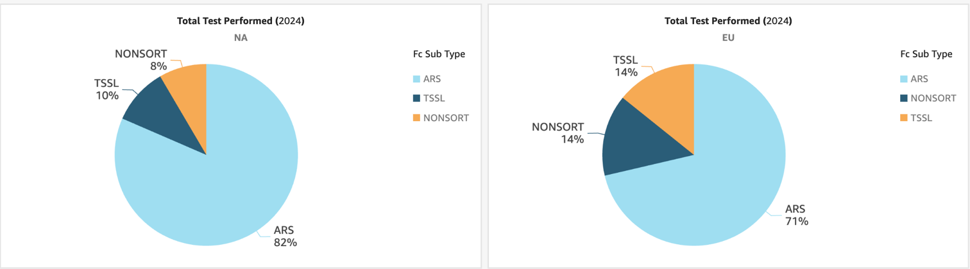**2024 Monthly Total Tests Performed FC_types NA vs EU**

