Customisation Level

Men’s
Pant’s / Short’s
These need not be broken down into separate parts. The only option available will be to change the entire garment for color or print. As in the case of other customisation. There should be a color picker/ palette for solids and a print library for all over print. Again to clarify a pant and shorts cannot be customised in different pants only full garments will change to a different colour or print.

Additionally there should be a check box. Please add the image of that particular part where is says image.
Check Box Yes No Image
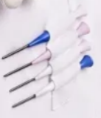
Tee Holder
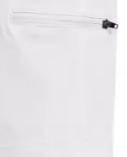
Side pocket w/zippier

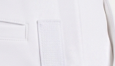
Velcro
StyleNo:- KS1008F
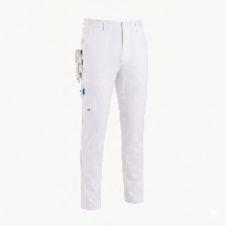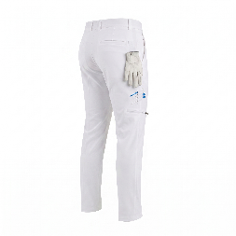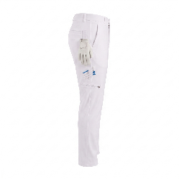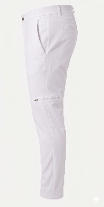
StyleNo:- KS1009F
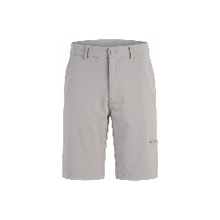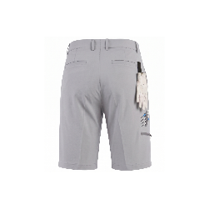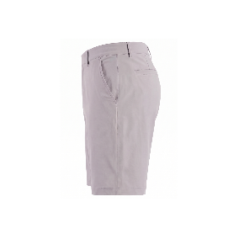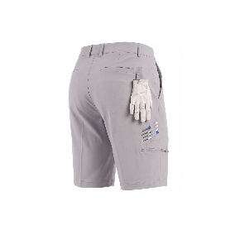
Style No, KS1010F (Side Elastic Pants)

Women’s
(same customisation as on men’s collection)
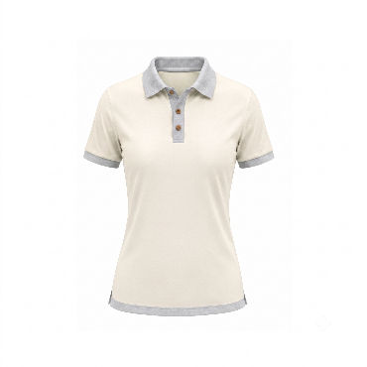
Style NO KL1001 Style NO KL1002 Style NO KL1003
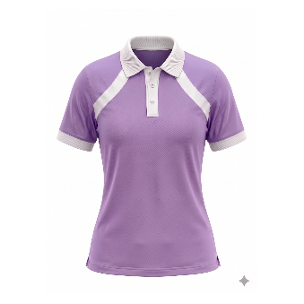
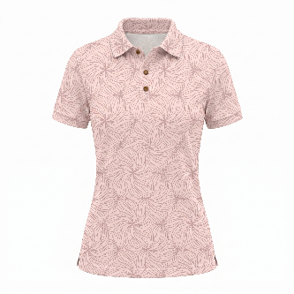

Style NO KL1004
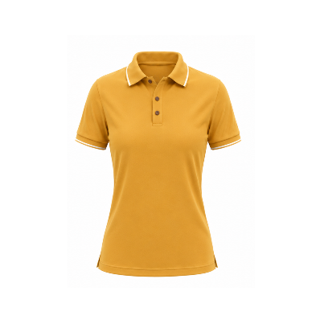
SHORTS same customisation as on men’s collection 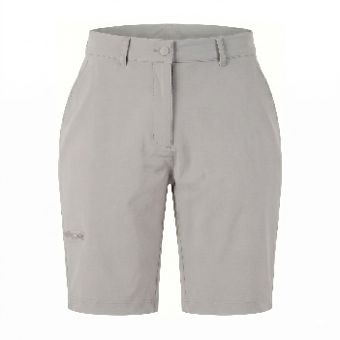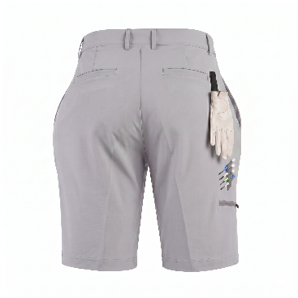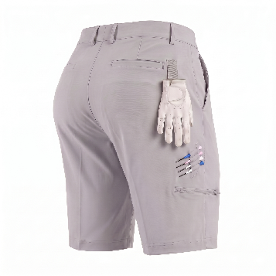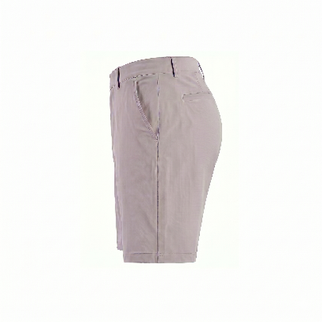

PANTS same customisation as on men’s collection
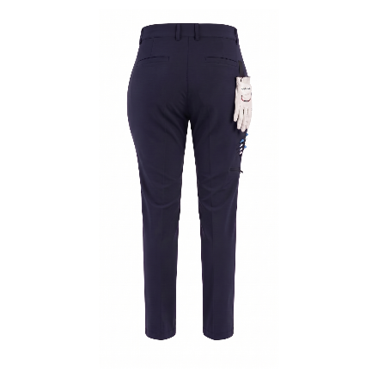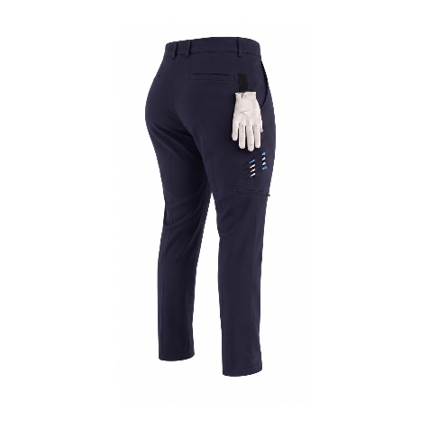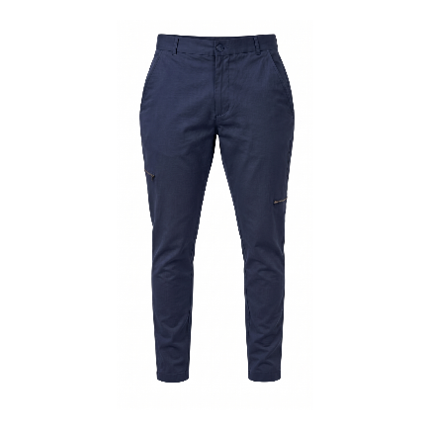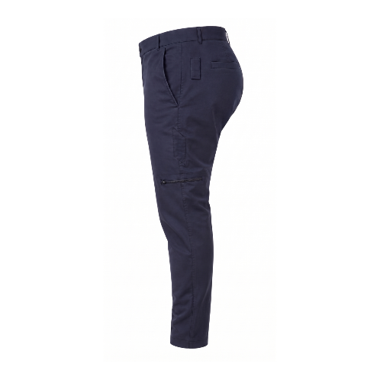
Dress style No KL1014D
Only the collar needs to be customized in the dress and The shorts will be the same colour as the dress collar.

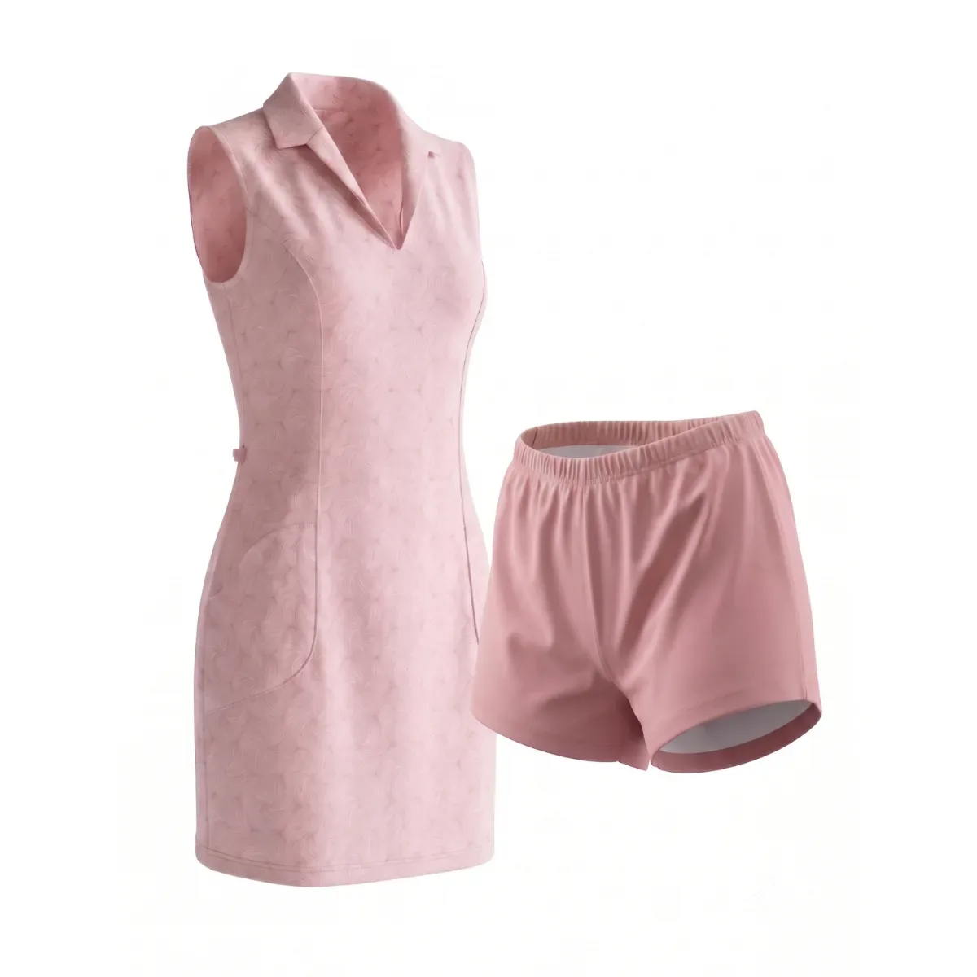

Skorts style No. KL1015G
This needs to be changed in two parts: the top solid belt colour and the printed part.
