- the clients raisd these issues fix it accordingly

1/ Why do we need Solid polo and printed polo on top when you are in any case providing the patterns below ? - Do you have any logic there that im missing ?
2/ Also when there are more than 5 patterns 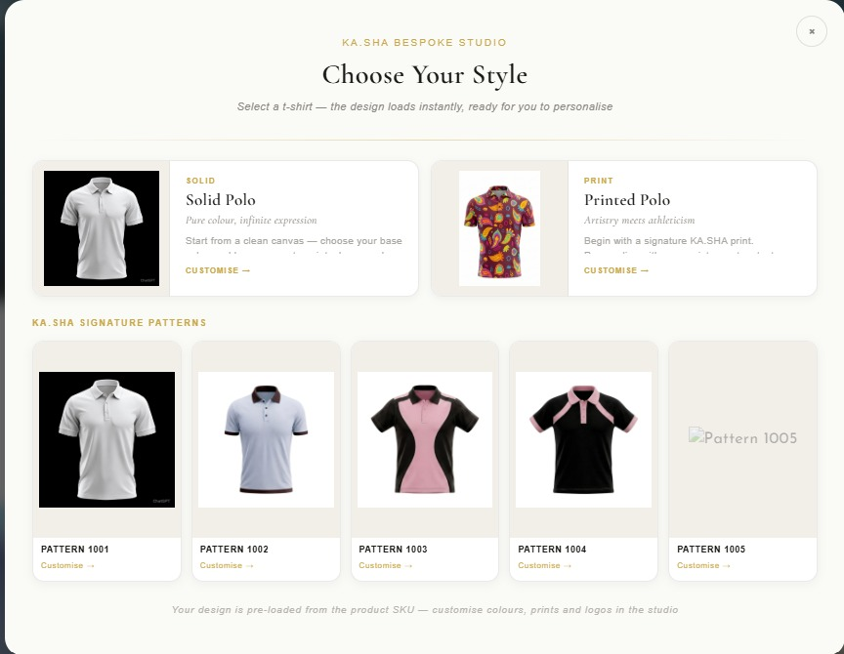to choose from the the customer should be able to scroll to the other patterns too - completed

- When i click on change pattern this appears i cannot see the other pattern options. Please check - still patterns are not loading
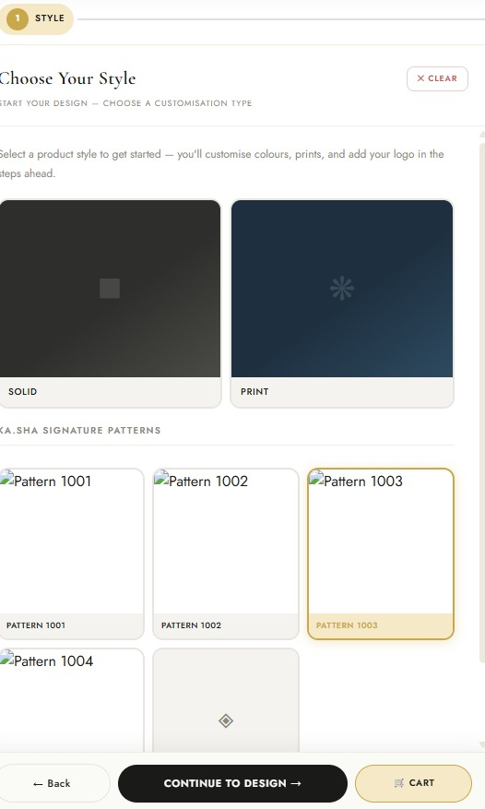

3. As mentioned - if we are showing solid and print, then pattern 001 should not be solid again - completed but not for print

4. 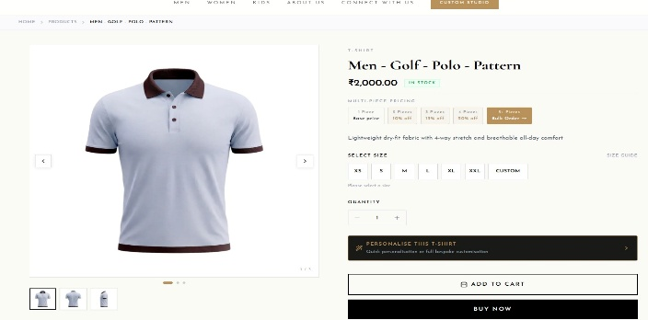When i click on back it does not go back to where i started but goes to this. - completed (wrong back button clicked- there are 2 back buttons one is for overall back another one is flow back )

5.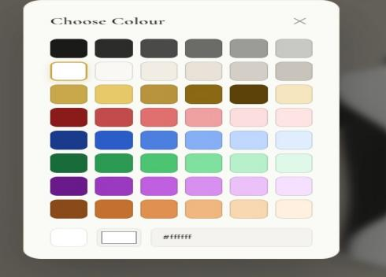 When i click on color only these option show up can we give the customers
1/ option to upload their color - completed
2/ use a color picker like color-zilla or something like that ? - completed

6. 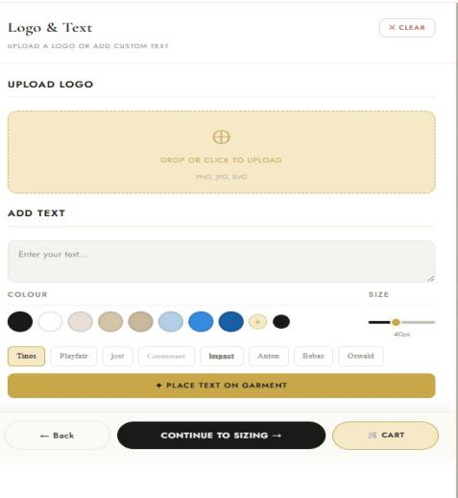1/ Here too can we give the customer more options in the color. Like in my previous comment - completed
2/ When i type the name by clicking the Tinos, Playfair(which i assume are fonts) the font is not changing - completed
3/ Can the logo size be defined in inches rather than % so that the customer can get an idea of size of the logo or the text/Name
7.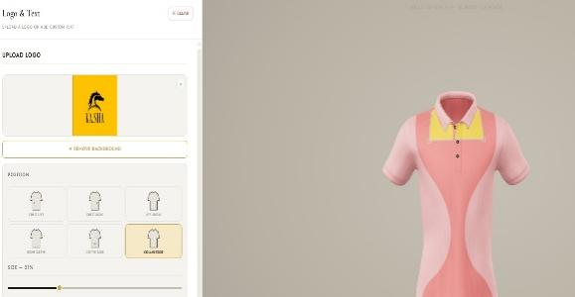 Collar Edge placement is wrong/ also left collar or right collar option please - completed
8. 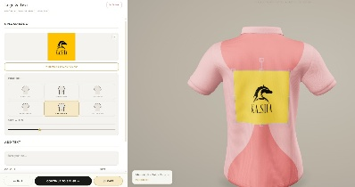Also center back position i think the customer should be able to move the print higher or lower
9. the price needs to change @ Rs. 1 per Sq Inch for the logo or text print
10. 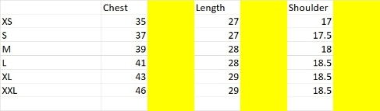The customer
should be able to enter his number in inches/cms in the yellow column but if the figure he inputs clashes with the next size he should be given an alter.
i.e. if he in L puts in chest as 43 then he need to be told that the chest for XL is already 43 therefore he should pick that size
11.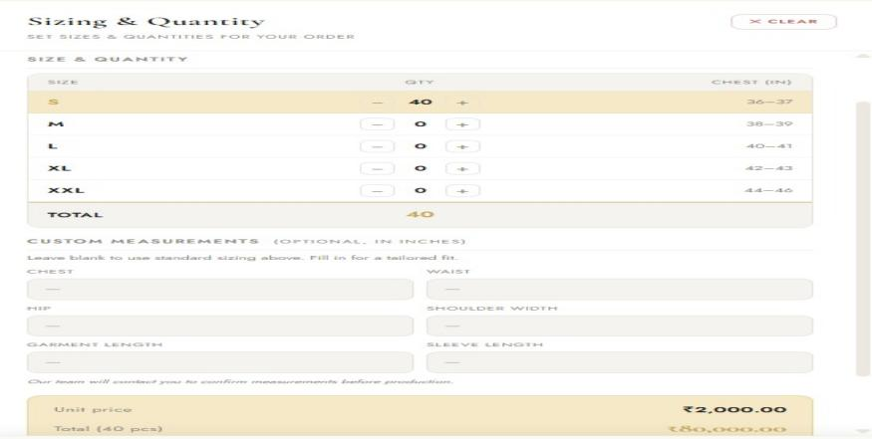 Total figure (under size) not required nor is the Rs 2000 figure. The lower section of custom measurements is fine.
But in block letter we need to mention that our sizes are body measurements and not garment measurement and therefore the customer also needs to be careful to specify garment measurement or body measurement
12. first page pattern 1 is same as solid
Customise your design -
as mentioned earlier and shown in sketch - need Apply button on pop-up window for colour and print - and instruction above - Select colour and click Apply. or Select print and click Apply. - completed
Is it not possible to highlight on 3d image the areas that will change colour.
There is some broken link at bottom of the page.
Cart should be Add to Cart
Clear should be Reset - completed

13. 3D is still revolving - for logo and text it should not revolve.
clicking different placement opitons on the left should show that side in the 3 d model.
we should go back to earlier ui - placement options on right, and upload and alignment on left - this way they can upload backa nd front. now only view changes,
[More than 4 items should go to Bulk enwuiry form

14. [15:35, 26/05/2026] +91 99729 32865: In the Print shirt option - the colalr does not change its not working
[15:35, 26/05/2026] +91 99729 32865: Remarks box should be added before Place Order

