- change font family after t-shirts names

- content is good, but the wording can be made smoother and more professional.
Ka.Sha was born from one man’s passion for golf. After 30 years on the course, our founder, Pranay Somaia, knew exactly what golf wear needed to be — comfortable to move in, designed to help players focus on their game, and, of course, stylish.
Combined with a family legacy in textiles across India and Africa, the result is apparel crafted for players who care just as much about how they play as how they look doing it.
- In lookbook product order is missing and products not placed correctlty.
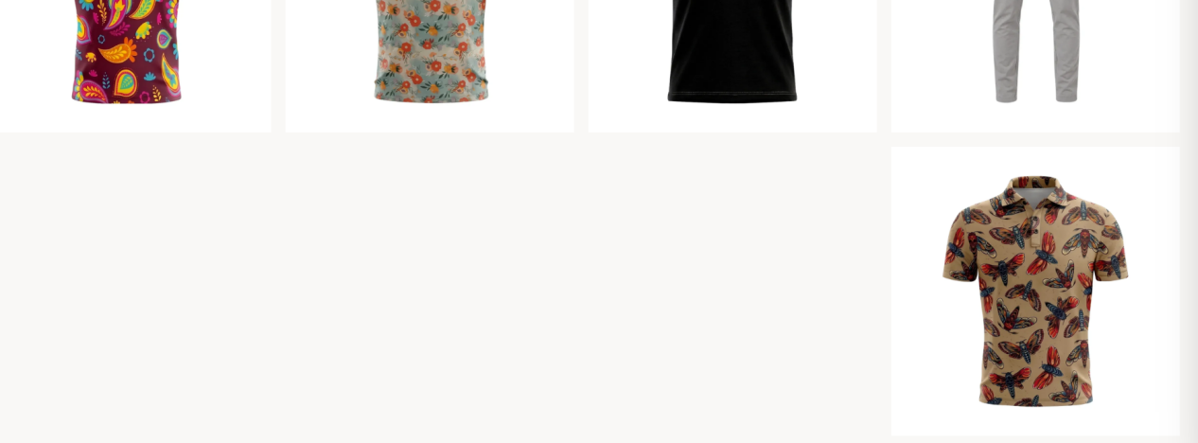

- change .object-fit : cover to .object-fit : center
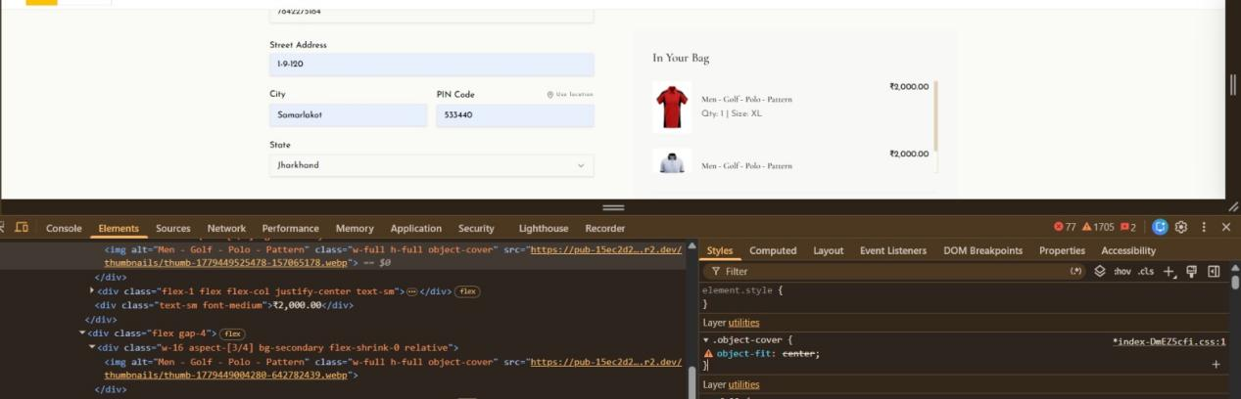

- In address field state column not taking based on the pincode
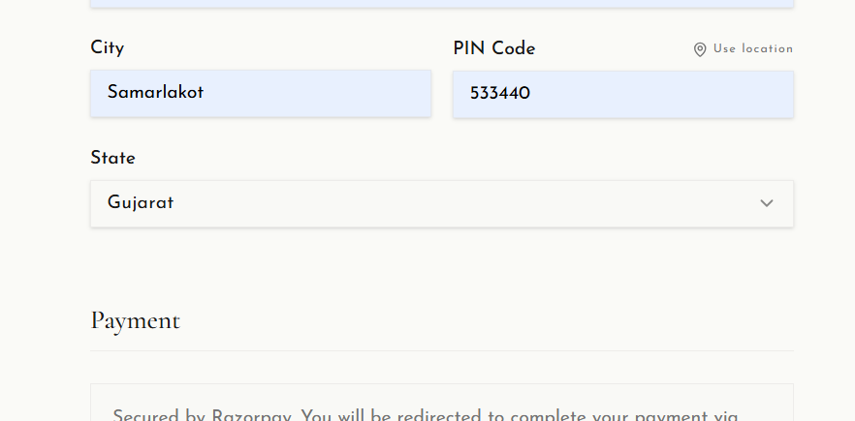

- Everywhere mention proper India number prefix to the mobile number
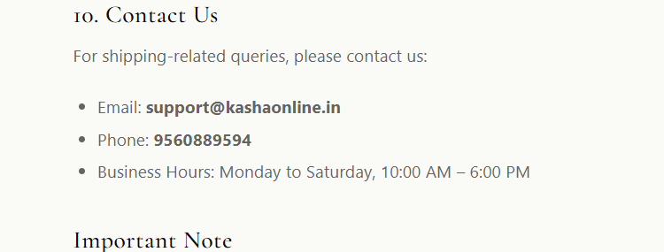

- When I click on the mail link still its opening mails options instead direct email sending in chrome
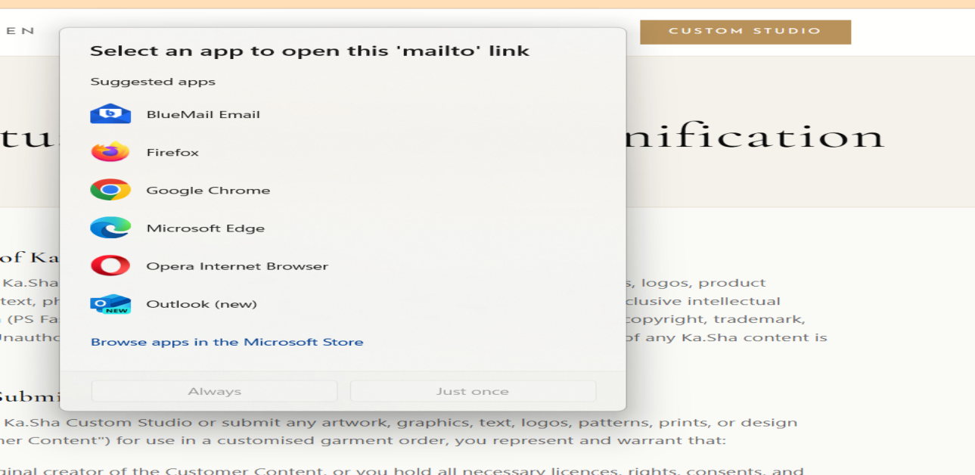

Customisation
- Customization option window -- images are not loading

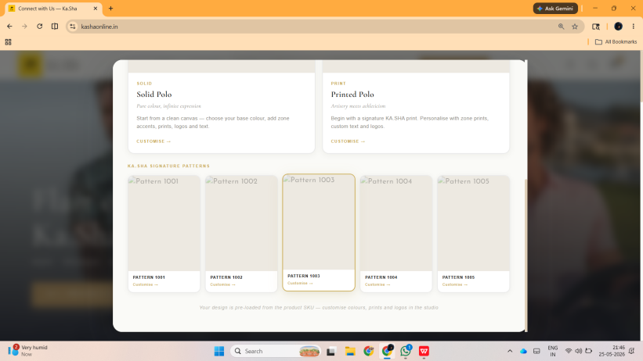

- Cutomisation window taking too much time for loading at starting 
- When I click on cart button getting some error message 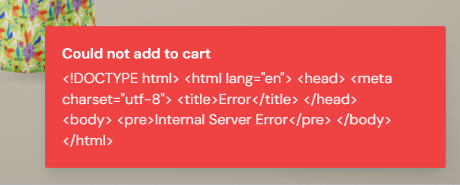
- When I click on the save button getting error message
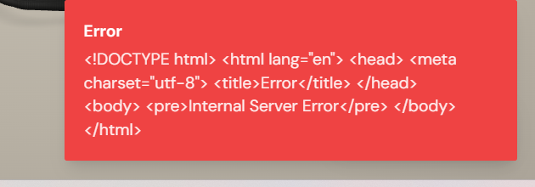
- Sleeves logo and text not placing correctly ---- L.sleave not getting correctly
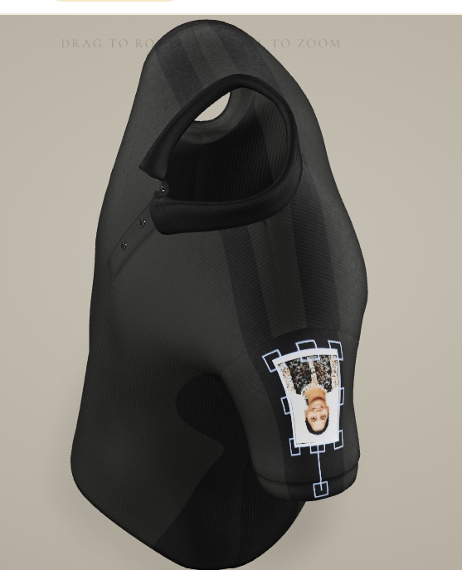
- Text color and font family not reflecting to the 3D model and color picker also not reflecting
- I added card 3d model to cards list but card bag not storing anything
- Active designs are not loading
