Mobile Optimisation
Customisation Page

- 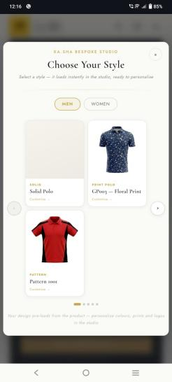increase size of the font for customize -> word and products are not aligned properly getting 3products in each session need to fix this with one by one product with sliding option and increase every product sizes along with names and sentences
- 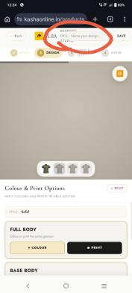Bespoke design studio and name your design button getting overlapping.

- 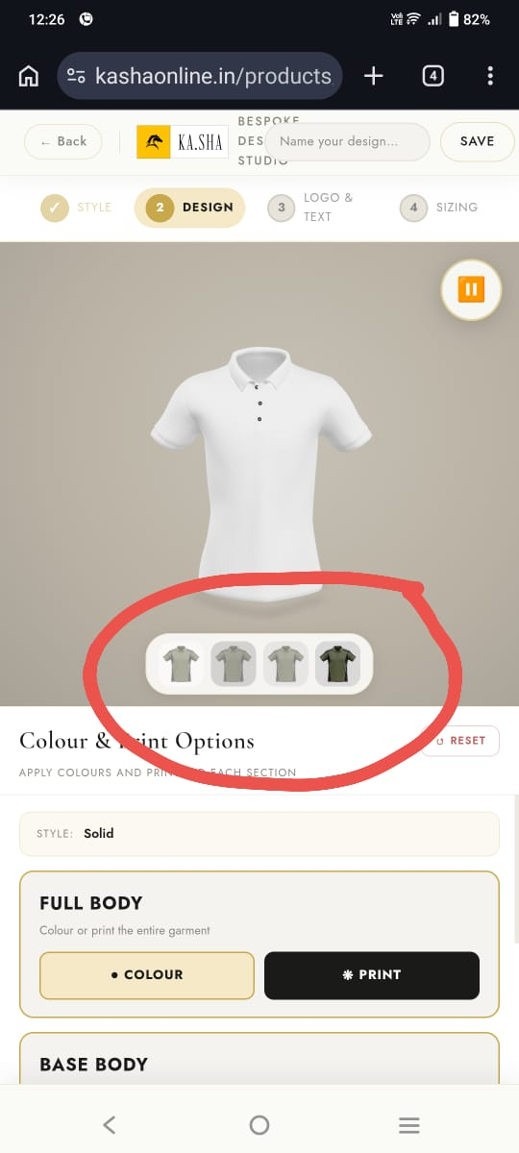everywhere parts images are same we need to show every parts with separate 2D images.

- 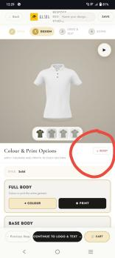increase size of the RESET button

- 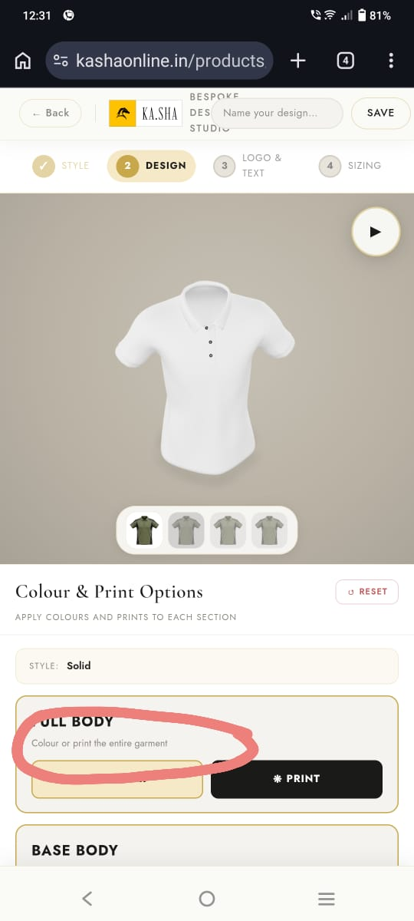increase font size in every session

- 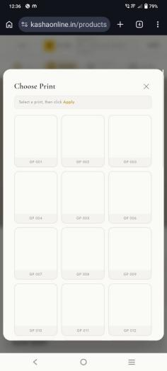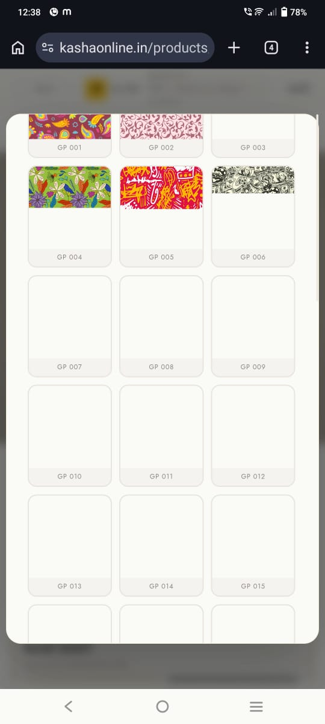 prints are loading very slowly

- 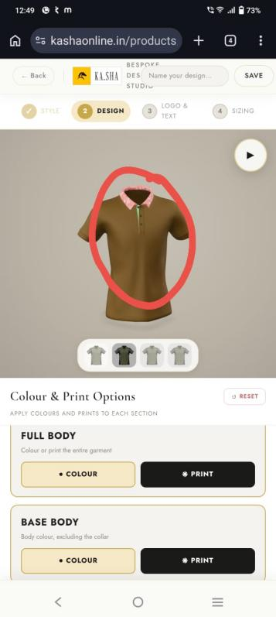in coller see there are 2colurs are getting one is printed and another is green I added green to the color first after I chnaged to print but still green showing

- 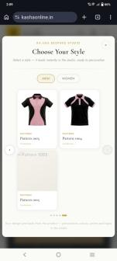Pattern 5 still not getting

- 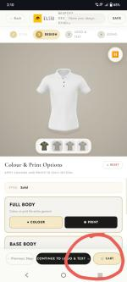When I add the cart it's redirected to the cart page I think it's not necessary to redirect just add to the card and give a successful message that's it because if I want to change again means I need to from the beginning of the customization

- 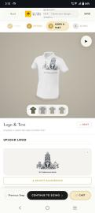 After adding logos there is no option for placing the logo where the options for that and same for logo as well

- 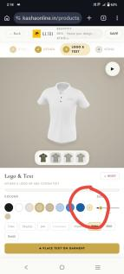increase size of the customisation color option circle

- 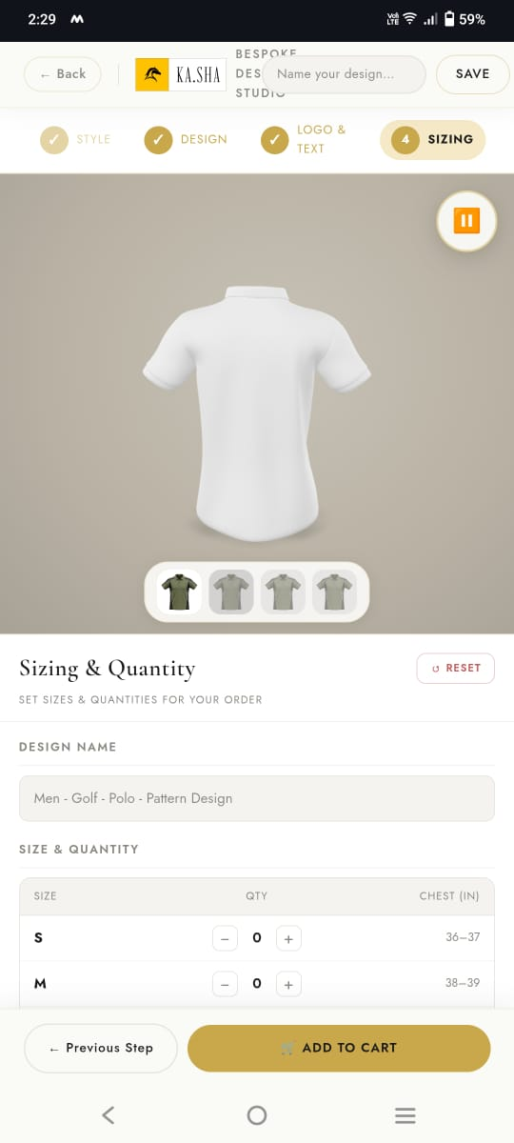in sizing page everywhere increase font sizes

- 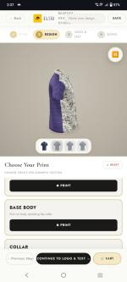while customization website getting very lag and too slow

- 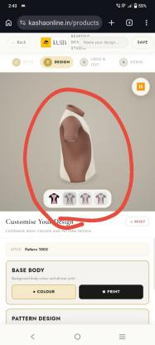I selected a pattern with pink and Black I am getting a different color one

- 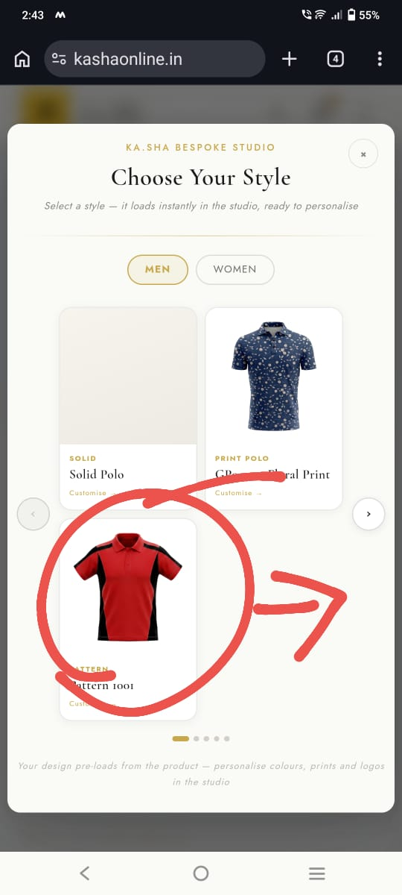I selected a pattern with red and black but getting a different one and different parts with green and black

- 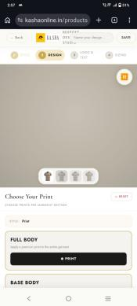 print 3D model loading time too long

- Custom studio pop-up Slider is not working properly
- 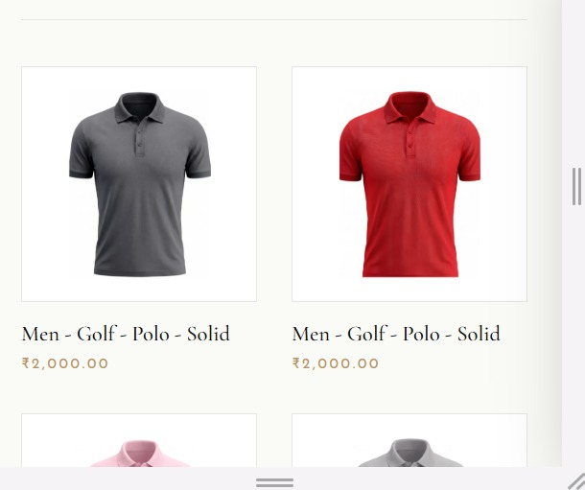In All Products page the arrows are not showing for the product

- 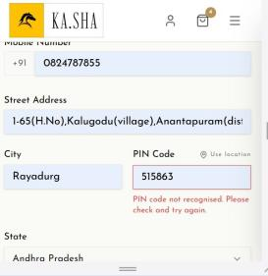While filling the address i am getting this error

- 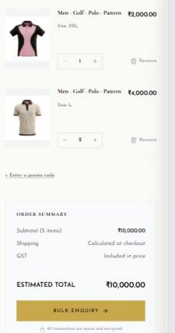I have added different products here and in cart i am getting bulk enquiry option whether it is correct ?

