 | EDGE-BASED INTELLIGENT PATIENT  HEALTH MONITORING SYSTEM | 

KNOWLEDGE DEMONSTRATION REPORT

Submitted by

RENUGADEVI M (730923205121)

in partial fulfillment of the requirement for the award of the degree
of



BACHELOR OF TECHNOLOGY
in

INFORMATION TECHNOLOGY

EXCEL ENGINEERING COLLEGE
(An Autonomous Institution, affiliated to Anna University Chennai and Approved by AICTE, New Delhi)

KOMARAPALAYAM – 637303

NOVEMBER 2026

Mapping of Project with Sustainable development Goals

The Sustainable Development Goals (SDGs), also known as the Global Goals, were adopted by the United Nations in 2015 as a universal call to action to end poverty, protect the planet, and ensure that by 2030 all people enjoy peace and prosperity.
The 17 SDGs are integrated—they recognize that action in one area will affect outcomes in others, and that development must balance social, economic and environmental sustainability

EDGE-BASED INTELLIGENT PATIENT HEALTH MONITORING SYSTEM


Project Outcomes related to SDGs:

SDGs | Related Project Outcomes
SDG 3 – Good Health and Well-being | Supports health technology learning by demonstrating how simulated vital-sign readings can be cleaned, scored and displayed to help staff notice possible patient deterioration. It is an educational prototype and not a clinically validated system.
SDG 9 – Industry, Innovation and Infrastructure | Promotes innovation in digital health infrastructure by demonstrating edge-side processing, compact event-driven data transfer, offline buffering and a lightweight web dashboard built with open-source tools.

Supervisor HOD

EXCEL ENGINEERING COLLEGE (AUTONOMOUS) KOMARAPALAYAM – 637303
BONAFIDE CERTIFICATE

Certified that this Knowledge Demonstration Prototype report titled

“EDGE-BASED INTELLIGENT PATIENT HEALTH MONITORING SYSTEM” is the
bonafide work of RENUGADEVI M (730923205121) who carried out this work under my supervision.

SIGNATURE  Dr.M.VADIVEL M.E.,Ph.D.,  HEAD OF THE DEPARTMENT,  Associate professor,  Department of Information technology, Excel Engineering College,  Komarapalayam – 637303. | SIGNATURE Mrs.S.KIRUTHIKA M.E., SUPERVISOR  Assistant professor,  Department of Information Technology, Excel Engineering College,  Komarapalayam – 637303.

Submitted for the viva-voce examination held on ………………

Internal Examiner External Examiner

ABSTRACT

Patient monitoring systems collect vital-sign readings such as heart rate, oxygen saturation, temperature, respiratory rate and blood pressure so that changes in a patient's condition can be noticed early. In a conventional centralized design, every raw reading is sent to a server, which increases network traffic and makes the system dependent on a continuous connection. This project presents an Edge-Based Intelligent Patient Health Monitoring System, an educational prototype in which an edge node processes readings close to the source. The edge node currently uses a built-in simulator with stable, fever, hypoxia and shock scenarios. It rejects implausible values, applies a median-of-three filter, maintains a slowly adapting personal baseline for each vital sign using an exponentially weighted moving average, and calculates a NEWS2-based early warning score from five parameters. Sustained deviations and short-term trends contribute to a deterioration risk value, and alert levels (Normal, Watch, Warning and Critical) are assigned with hysteresis to avoid rapid flipping between levels. Instead of streaming every reading, the edge node sends a compact summary for each window of samples and sends immediately when the alert level changes. If the server is unavailable, the summaries are held in a bounded buffer and forwarded in order when the connection returns. A Flask server validates an edge key, stores patient, vital, alert and edge-statistics records in SQLite, and publishes live updates through Server-Sent Events. The web dashboard shows the patient list, vital-sign trend charts, alerts with acknowledgement and edge data-transfer counters. The system is intended for academic demonstration. It uses simulated data, does not include physical sensor drivers or clinical validation, and the dashboard figures in this report are illustrative mock-ups. It can be extended in future work with real sensors, complete clinical scoring and secure deployment.

TABLE OF CONTENTS

CHAPTER NO | TITLE | PAGE NO
 | ABSTRACT | iv
 | LIST OF FIGURES | vi
 | LIST OF ABBREVIATIONS | vii
1 | INTRODUCTION | 1
 | 1.1 Problem Statement
 | 1.2 Objectives
2 | PROBLEM FORMULATION | 2
 | 2.1 Existing System
 | 2.2 Feasibility Study
3 | PROPOSED METHODOLOGY | 3
 | 3.1 Proposed System
 | 3.2 System Architecture Diagram
 | 3.3 Design Patterns
 | 3.4 Tools and Technologies used
4 | RESULT AND DISCUSSION | 6
 | 4.1 Result
 | 4.2 Discussion
5 | CONCLUSION | 7
 | REFERENCES | 8
 | PLAGIARISM REPORT | 9

 | LIST OF FIGURES
FIGURE NO | TITLE | PAGE NO
3.2 | System Architecture Diagram | 4
3.3 | Design Patterns | 5
4.1 | Dashboard Mock-up: Critical Scenario | 6
4.2 | Dashboard Mock-up: Stable Scenario | 7

LIST OF ABBREVIATIONS

ABBREVIATION | EXPANSION
API | APPLICATION PROGRAMMING INTERFACE
AVPU | ALERT, VOICE, PAIN, UNRESPONSIVE
CSS | CASCADING STYLE SHEETS
EWMA | EXPONENTIALLY WEIGHTED MOVING AVERAGE
HR | HEART RATE
HTML | HYPERTEXT MARKUP LANGUAGE
HTTP | HYPERTEXT TRANSFER PROTOCOL
IoT | INTERNET OF THINGS
JS | JAVASCRIPT
JSON | JAVASCRIPT OBJECT NOTATION
NEWS2 | NATIONAL EARLY WARNING SCORE 2
RR | RESPIRATORY RATE
REST | REPRESENTATIONAL STATE TRANSFER
SBP | SYSTOLIC BLOOD PRESSURE
SpO2 | PERIPHERAL OXYGEN SATURATION
SQL | STRUCTURED QUERY LANGUAGE
SSE | SERVER-SENT EVENTS
UI | USER INTERFACE
URL | UNIFORM RESOURCE LOCATOR

CHAPTER 1 INTRODUCTION
Patient monitoring systems help healthcare staff observe vital signs such as heart rate, oxygen saturation, temperature, respiratory rate and blood pressure. Traditional centralized systems send every raw reading to a server, which increases network traffic and depends on a continuous connection. This project proposes an Edge-Based Intelligent Patient Health Monitoring System. An edge node cleans the readings, learns a personal baseline for each patient, calculates a NEWS2-based score and risk level, and sends only compact summaries to a Flask server. A live web dashboard shows vital trends, alerts and data-transfer counters. The prototype uses simulated data and is for educational demonstration only.

PROBLEM STATEMENT
Centralized monitoring systems that stream every raw reading use more network bandwidth and may stop working properly when the connection to the server is lost. Sensor readings also contain noise and artefacts that can cause false alarms, and fixed thresholds do not consider the normal values of each patient. An edge-based approach is required to reduce data transfer and keep monitoring logic available when the network is down.

OBJECTIVES
    - To simulate vital-sign streams (heart rate, SpO2, temperature, respiratory rate and systolic blood pressure) for stable, fever, hypoxia and shock scenarios.
    - To clean the readings on the edge node using range checks and a median-of-three filter.
    - To calculate a NEWS2-based score, personal-baseline deviation and risk level with alert hysteresis on the device.
    - To send compact event-driven summaries and buffer them during a server outage using store-and-forward.
    - To store records in SQLite and provide a live dashboard with trends, alerts and acknowledgement.

CHAPTER 2 PROBLEM FORMULATION

EXISTING METHOD
Existing patient monitoring systems mainly stream every raw reading to a central server, where scoring and alerting are performed. Each sample is transmitted even when nothing has changed, which increases network usage, and a loss of connection can interrupt monitoring. Fixed alert thresholds do not consider each patient's own normal range, and noisy readings or sensor glitches can produce false or missed alerts. Alerts may also be repeated when a reading moves back and forth across a threshold. These limitations create a need for a system that processes data near the source, uses patient-specific baselines, sends data only when needed and continues to work during temporary network failures.

FEASIBILITY STUDY.

    - Technical Feasibility: The system uses Python, Flask, SQLite, HTML, CSS and JavaScript, which are sufficient for edge processing, a REST API, data storage and a live dashboard on a single computer.
    - Economic Feasibility: The project is cost-effective because it uses open-source tools and runs on an ordinary computer. The simulator needs no sensor hardware.
    - Operational Feasibility: The dashboard gives staff a simple view of patient status, vital trends and alerts, with one-click alert acknowledgement.
    - Data Feasibility: The system uses simulated vital-sign data, summary records, alert records and edge statistics. No real patient data is required for the demonstration.
    - Schedule Feasibility: The project can be developed in stages: simulator, edge pipeline, server and database, dashboard and testing.
    - Scalability Feasibility: More patients can be added by starting more edge nodes, and the simulator can later be replaced by real sensor drivers such as a pulse oximeter and a temperature sensor on a Raspberry Pi.

CHAPTER 3 PROPOSED METHODOLOGY

PROPOSED SYSTEM
The proposed system, Edge-Based Intelligent Patient Health Monitoring System, processes patient vital signs on an edge node and sends only compact summaries to a ward server. It is developed using Python and Flask for the edge node and backend, SQLite for storage, and HTML, CSS and JavaScript for the dashboard. The system includes modules for signal cleaning, personal baseline learning, NEWS2-based scoring, risk estimation, alert level selection, store-and-forward uplink, alert management and live display. A summary is sent for every window of samples and immediately when the alert level changes. The dashboard shows the patient list with scores, vital trend charts with normal bands, alerts with acknowledgement and the amount of data saved by edge processing. By combining local decision making, adaptive baselines and event-driven communication, the proposed system aims to reduce unnecessary data transfer and keep monitoring working during short network failures.

SYSTEM ARCHITECTURE DIAGRAM
The system architecture diagram shows the structure and data flow of the prototype. A vitals simulator generates heart rate, SpO2, temperature, respiratory rate and systolic blood pressure readings. The edge node cleans the readings, updates the personal baseline, calculates the NEWS2-based score and risk, and selects the alert level. Window summaries are posted as JSON to the Flask server, which checks the edge key, stores the data in SQLite, creates alerts when the level rises and publishes live updates using Server-Sent Events. The web dashboard receives these updates and displays patient status, trends, alerts and edge data-transfer counters. All these components work together to provide an adaptive and resource-efficient monitoring prototype.

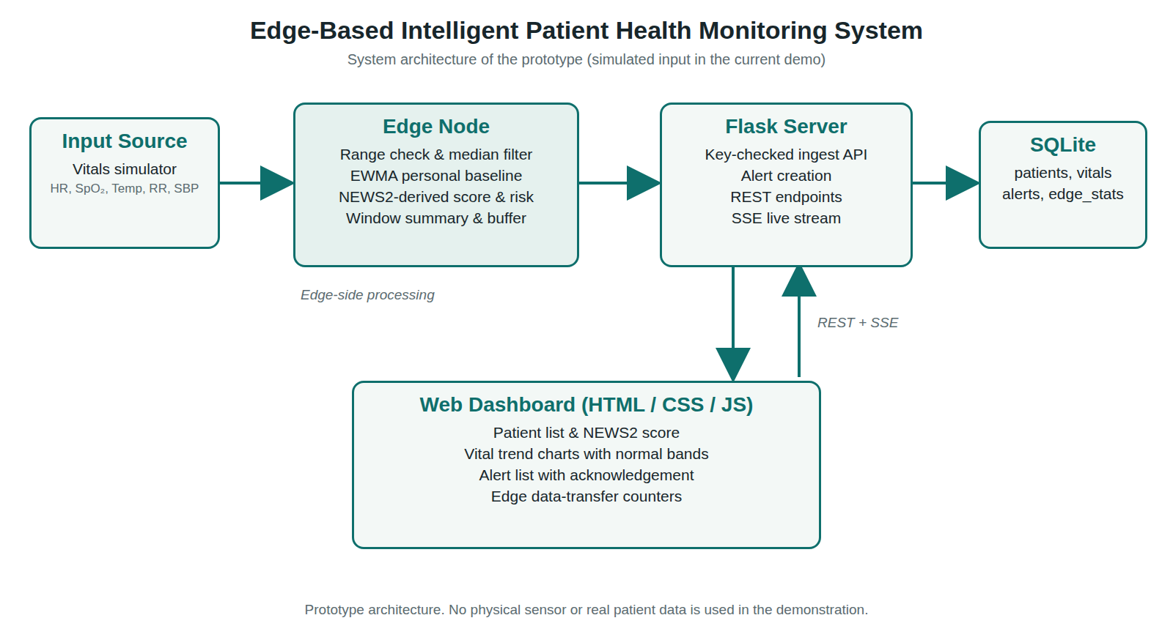
Fig 3.2 SYSTEM ARCHITECTURE DIAGRAM

DESIGN PATTERNS
The Edge-Based Intelligent Patient Health Monitoring System uses software design patterns to keep the code modular and easy to maintain. These patterns separate signal processing, communication, storage and display, and make the edge logic easy to test and extend. The main patterns used in the prototype are listed below.
    - Pipeline: Passes each reading through ordered stages: cleaning, baseline update, scoring, risk estimation and alert level selection.
    - Publish–Subscribe: The Flask server publishes new readings and alerts to subscriber queues, which deliver them to dashboards through SSE.
    - Store-and-Forward: The uplink keeps summaries in a bounded queue and retries after a delay when the server is unreachable.
    - Hysteresis (State): Alert levels rise immediately but fall one level at a time after 15 consecutive samples with a lower target level.
    - Replaceable Source: Simulator.read() acts as a swappable data source, so real sensor drivers can replace it in future work.

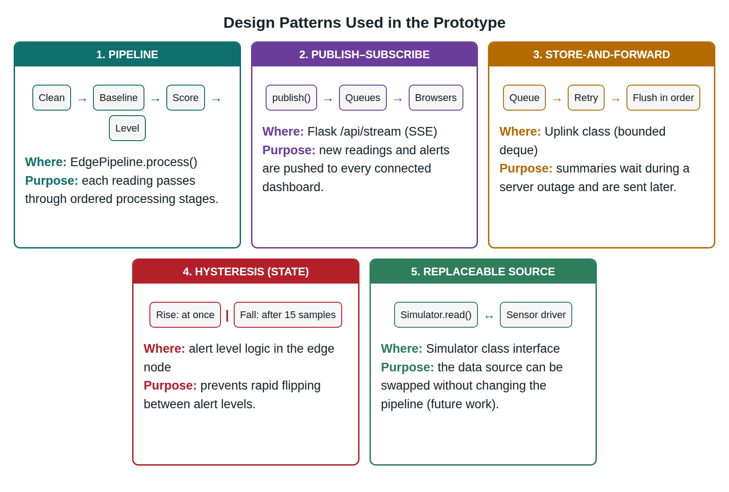
Fig 3.3 DESIGN PATTERNS

TOOLS AND TECHNOLOGIES USED
This section describes the tools and technologies used to develop the Edge-Based Intelligent Patient Health Monitoring System. It includes the programming language, framework, database, frontend technologies and supporting tools used for edge processing, data storage, live updates and dashboard development.
- Programming – Python 3
- Frontend – HTML5, CSS3, JavaScript
- Backend – Flask
- Database – SQLite
- Live Updates – Server-Sent Events (SSE)
- Edge Communication – HTTP and JSON (urllib)
- Signal Processing – Median Filter and EWMA Baseline
- Clinical Scoring – NEWS2-derived (five parameters)
- Simulation – Python random-based scenarios
- Dependency Management – pip (requirements.txt)

CHAPTER 4 RESULT AND DISCUSSION

RESULT
The proposed Edge-Based Intelligent Patient Health Monitoring System provides a prototype platform for observing simulated patient vital signs, scoring them on an edge node and presenting the results on a live dashboard. A one-command demo launcher starts the Flask server and four edge nodes configured for stable, fever, hypoxia and shock scenarios. The dashboard lists the patients with their NEWS2-based scores and alert levels, shows the latest values and trend charts with normal bands for heart rate, SpO2, respiratory rate, temperature and systolic blood pressure, and lists alerts that staff can acknowledge. The Edge processing panel shows counters for raw data size, uplinked data size and the number of summaries waiting in the offline buffer. Fig 4.1 and Fig 4.2 are illustrative mock-ups prepared from the dashboard design using synthetic example values. They are not screenshots of a measured run and do not represent clinical or performance results. Overall, the system integrates signal cleaning, personal baselines, scoring, alerting, storage and live display in one application.
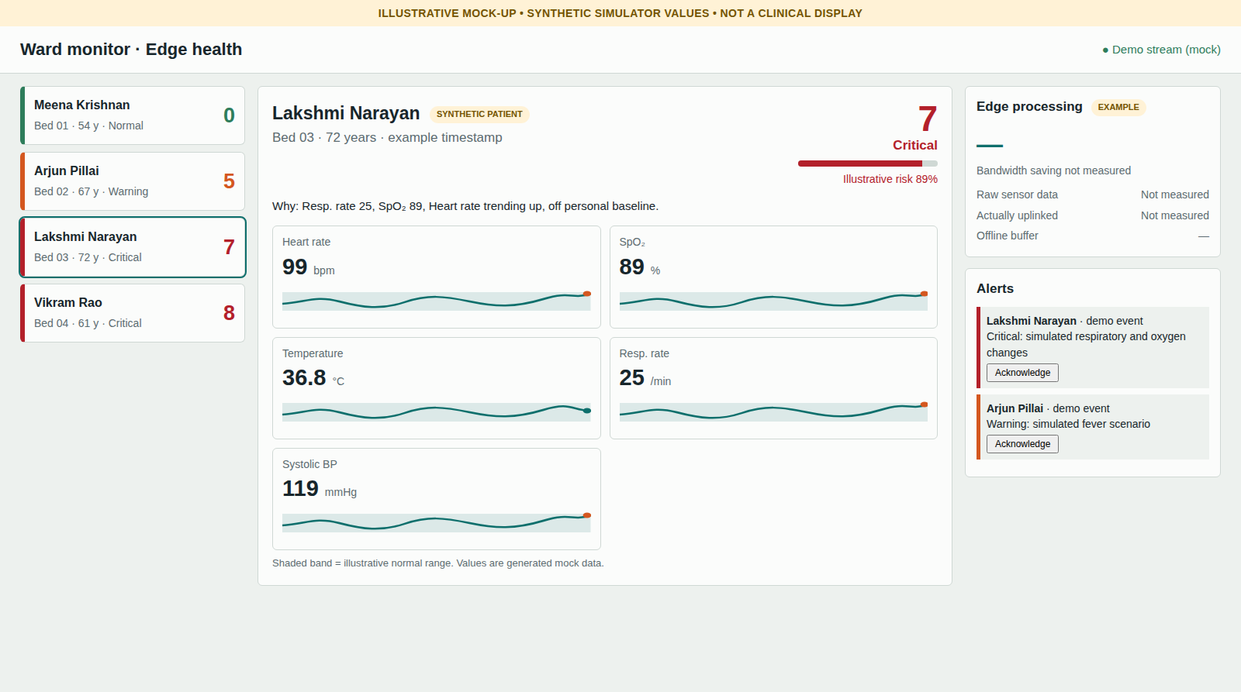
Fig 4.1 DASHBOARD MOCK-UP: CRITICAL SCENARIO (ILLUSTRATIVE)
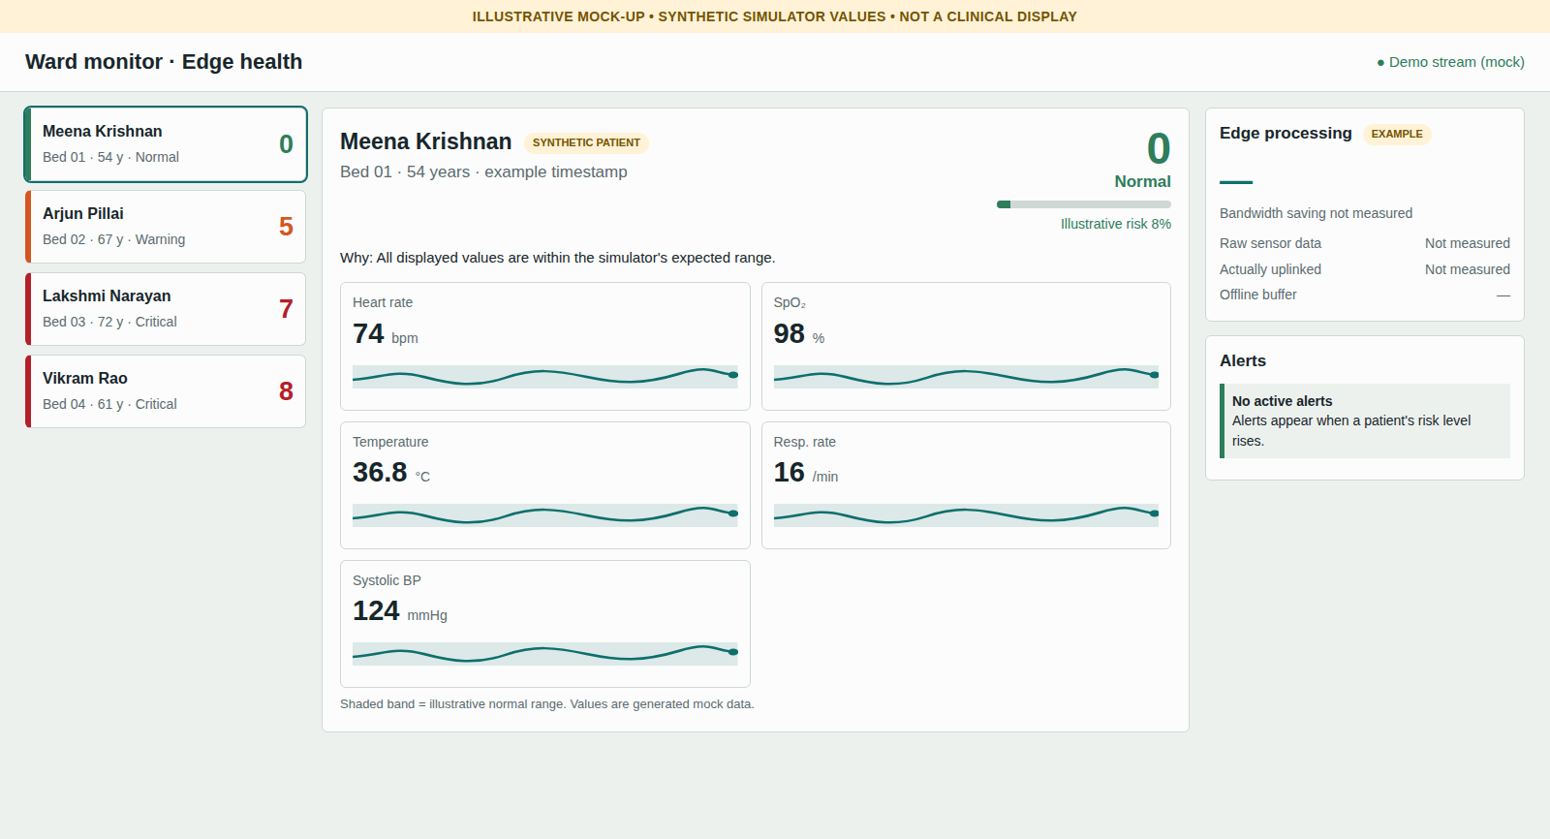
Fig 4.2 DASHBOARD MOCK-UP: STABLE SCENARIO (ILLUSTRATIVE)

DISCUSSION
The Edge-Based Intelligent Patient Health Monitoring System demonstrates how processing near the data source can reduce unnecessary transmission and keep alert logic available during short network failures. The modular design separates the edge node, server and dashboard, which supports easy maintenance and future enhancement. Limitations include the use of simulated data, a NEWS2-based score that covers only five parameters and omits consciousness level and supplemental oxygen, an in-memory buffer that is lost if the edge process stops, and a demonstration edge key that must be replaced before any real use. No formal performance measurements are included, so no numerical improvement is claimed. The prototype is for academic demonstration only and is not a certified medical device.

CHAPTER 5 CONCLUSION
The Edge-Based Intelligent Patient Health Monitoring System demonstrates an edge-oriented design for monitoring patient vital signs using simulated data. The system combines signal cleaning, a personal adaptive baseline, NEWS2-based scoring, risk estimation, alert hysteresis, store-and-forward uplink, a Flask server with SQLite storage and a live web dashboard in one application. Processing the readings on the edge node means that only compact summaries are sent and that alert levels can still be calculated when the server is not reachable. Server-Sent Events provide live dashboard updates, and alert de-duplication and acknowledgement help staff focus on meaningful events. In conclusion, the prototype shows a flexible and understandable approach to edge-based patient monitoring. It is an educational demonstration and not a certified medical device. It can be improved by integrating real sensors such as pulse oximeters and temperature sensors, completing the full NEWS2 requirements, adding durable and secure communication, and evaluating performance and accuracy with measured experiments.

REFERENCES

- Royal College of Physicians, National Early Warning Score (NEWS) 2: Standardising the Assessment of Acute-Illness Severity in the NHS. Updated report of a working party. London: RCP, 2017. This report defines the NEWS2 scoring tables for vital signs, which the project uses as the basis for its five-parameter score.

- W. Shi, J. Cao, Q. Zhang, Y. Li, and L. Xu, “Edge Computing: Vision and Challenges,” IEEE Internet of Things Journal, vol. 3, no. 5, pp. 637–646, 2016. This paper explains the idea of processing data near its source, which motivates running the filtering and scoring logic on the edge node.

- S. W. Roberts, “Control Chart Tests Based on Geometric Moving Averages,” Technometrics, vol. 1, no. 3, pp. 239–250, 1959. This paper introduced the exponentially weighted moving average, the idea behind the adaptive personal baseline used in the edge pipeline.

- M. Grinberg, Flask Web Development: Developing Web Applications with Python, 2nd ed. Sebastopol, CA, USA: O’Reilly Media, 2018. This book explains how to build web applications and REST APIs with Flask, the framework used for the backend server.

- WHATWG, “Server-sent events,” HTML Living Standard, https://html.spec.whatwg.org/multipage/server-sent-events.html. This specification defines the Server-Sent Events mechanism used to push live updates to the dashboard.


EXCEL ENGINEERING COLLEGE
(Autonomous) KOMARAPALAYAM - 637303

Research and Development

PLAGIARISM REPORT

EDGE-BASED INTELLIGENT PATIENT HEALTH MONITORING SYSTEM
Degree/Branch : B.Tech INFORMATION TECHNOLOGY Name of the Student : RENUGADEVI M
Register No.of Student : 730923205121

Name of the Supervisor : Mrs. S. KIRUTHIKA M.E.,

Levels | Similarities | Remarks
0-10%
11-40%
41-60%
61% and
Above
- Level -0: Similarities up to 10%-minor similarities.
- Level -1, 2 &3: Similarities above 10% , Such students shall be asked to submit a revised report within stipulated time period.

Student Signature :

Supervisor Project Coordinator HOD Encl: Proof of all the pages



