Screenshots

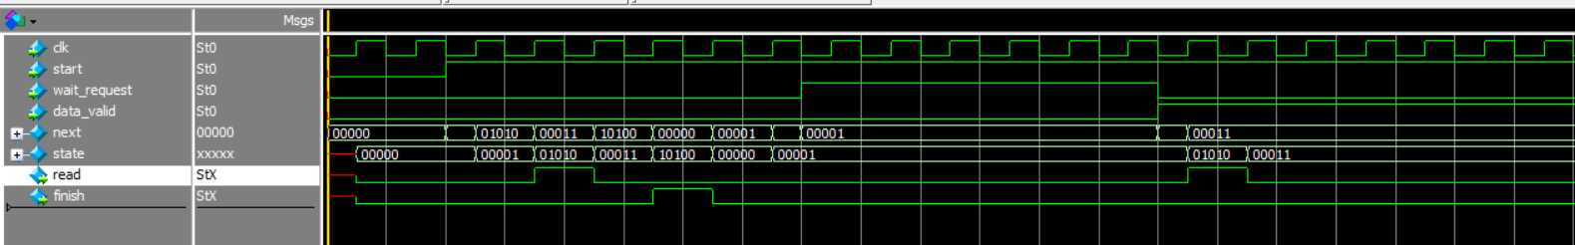read flash

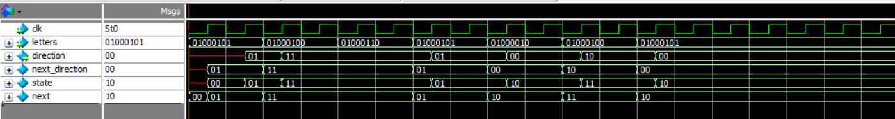

Keyboard



Address