My Portfolio Site

1. Introduction
The goal of this project is show off an individuals portfolio credentials, work experience, education and projects. By creating a portfolio website the user should receive more offers on freelancing. As it demonstrates their experience, the tools they work with, libraries and projects they have built for others.

2. Expected List of Features
- It will be fully responsive.
- It will have Carousel on the landing page.
  - Responsive images and compressed depending on resolution
- Summary of my skills on the landing page.
- The portfolio page will organise completed projects into groups of CSS libraries. Which will be bootstrap3, bootstrap4 and material CSS. By using fancybox
- Display five most recent github repositories
- It will display social contact information from various sites (e.g facebook, twitter and GMAIL) by using fontawesome icons
- Displays their education,
- Displays their achievements,
- Displays their contact information
- Displays their skills.
- Displays their web building tool-set (E.G Meanstack, LAMP stack)
- Displays their programming languages of choice.
- The page will be animated to fade in containers by using animate css and WOW.js

The site will be fully responsive and run on multiple devices. As a result of this it will be more accessible and reach a wider audience. Possibly resulting in users staying longer on the page.
The landing page will contain a carousel displaying the most recent work projects. The reason behind this design choice is to catch potential clients eye, as soon as they land on the page. The images for the carousel will be based on screen resolution, by using a source tags with a media attribute. Thus, only the necessary images will be fetched from reducing download speed. Also the images will be minified by using a node library imagemin which will also reduce download. The landing page will also include a summary of the skills, as well as linking to about and portfolio page. By using minimal HTML and CSS on the landing page as well as reducing image sizes the page will be able download and render quickly. Which should keep potential clients on the site for a longer time resulting in the website being explored. The bottom of every page has a sticky footer that displays contact information via social networking. By doing this is should increase the chance of being contacted by clients.
The portfolio page will use a jquery fancy-box plugin to organise the portfolio cards into groups. In this instance bootstrap3, bootstrap 4 and material CSS. This will allow potential clients to look at CSS frameworks they want or have for their projects. It will also display recent Github projects.
The about page contains a lot of information such as web building tool-set (E.G Meanstack, LAMP stack) programming languages used, education, achievements, contact information and work skills. To ease navigation of the website they will be placed into small sections that all look distinct from one another. To stop information overload the cards in the sections are animated with a library to fade in and fade out.

3. Market Survey
The first noticeable design choice from the website https://jonny.me/ is that it has similar landing page design. They have designed it to be minimal and displays important information like my design. However, there is a vivid difference between their design and mine, mine is more vibrant. I choose this design to make the landing page stand out.

After consideration theirs seems like a better design choice as it would be more friendly to people with accessibility disabilities. The text on the page seems more clearer.
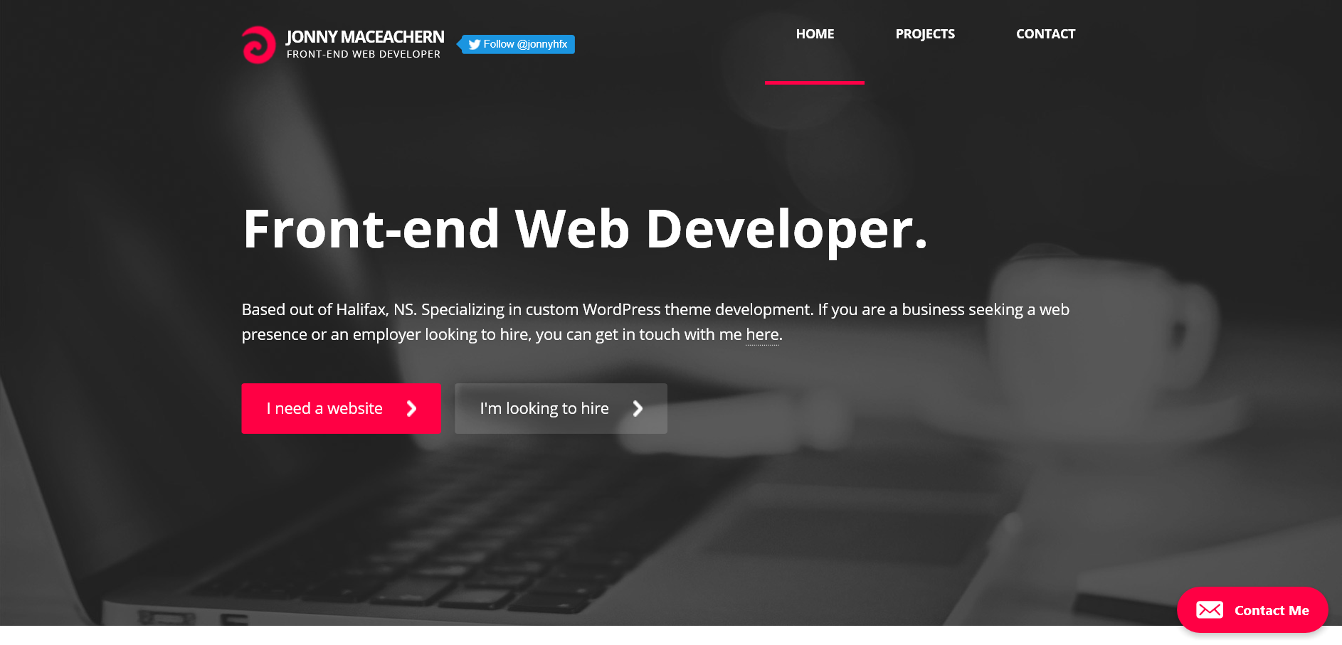

Figure 1: https://jonny.me/ landing page
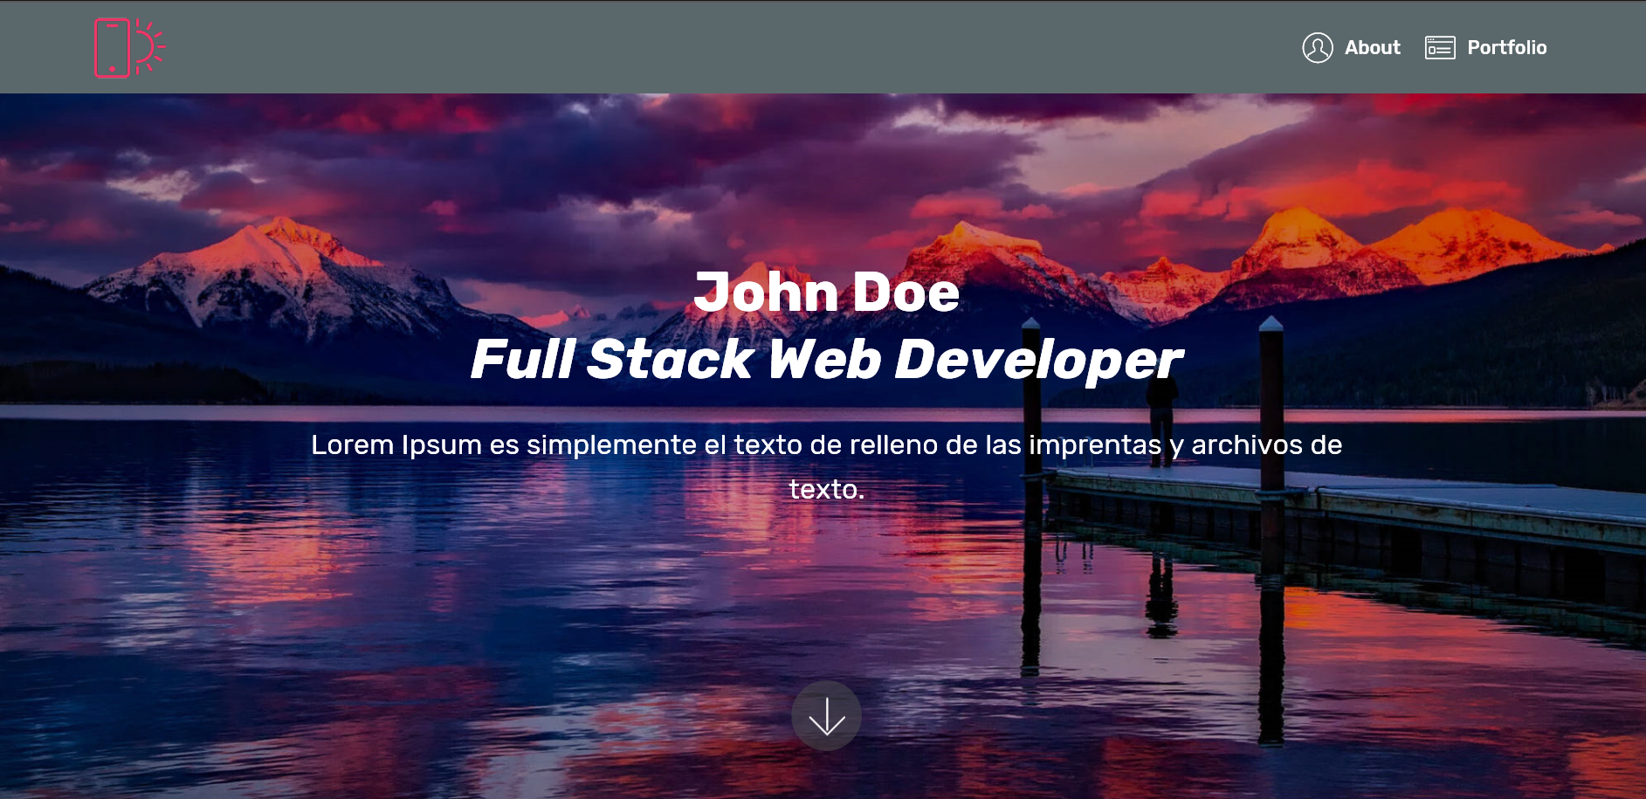

Figure 2: My landing page design

The website suffers some issues as buttons on each section are very small and too close together. It looks like it would be hard to tap them on a mobile device.

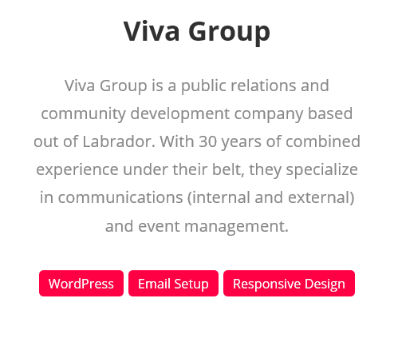

Figure 3: https://jonny.me/ Card button

And finally their form lacks a title or caption it is confusing as to know what the nature of the message is for my design suffers the same flaw. Having the button say enquiry would have helped.
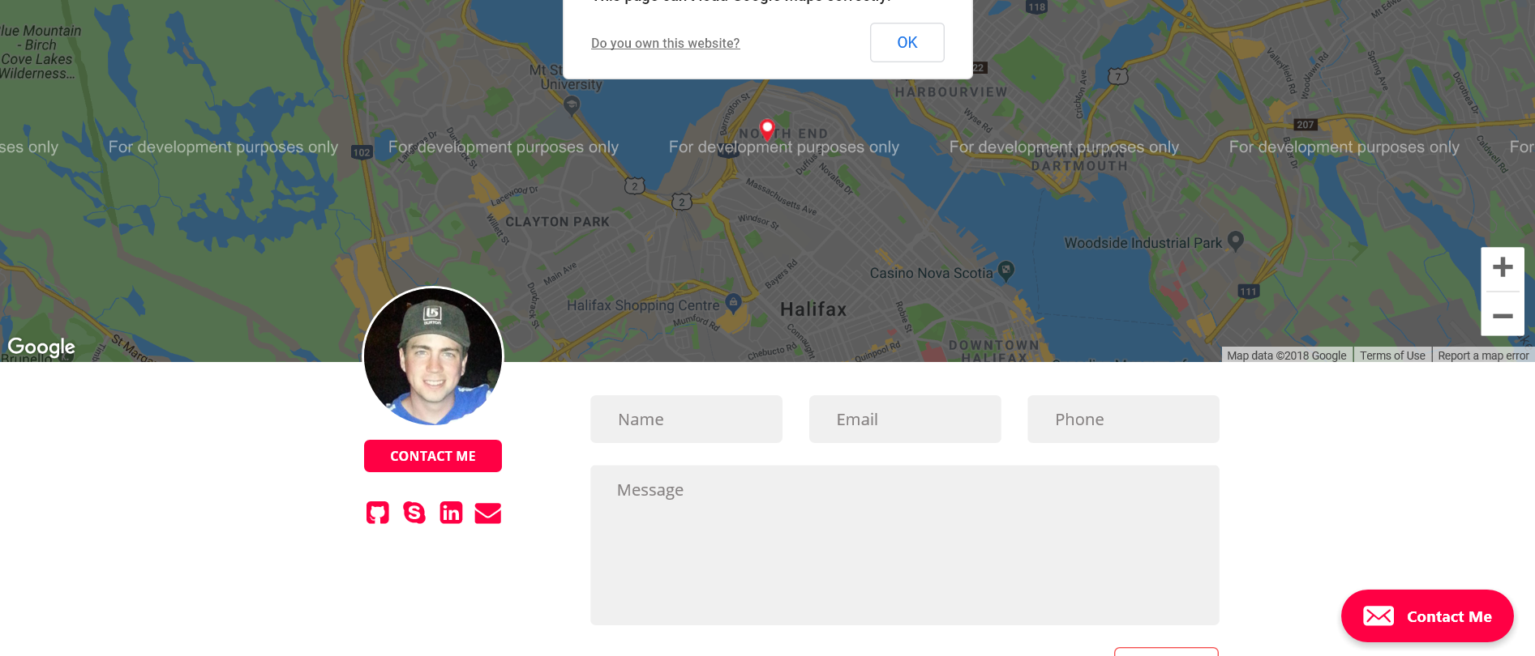

Figure 4: https://jonny.me/ Contact form
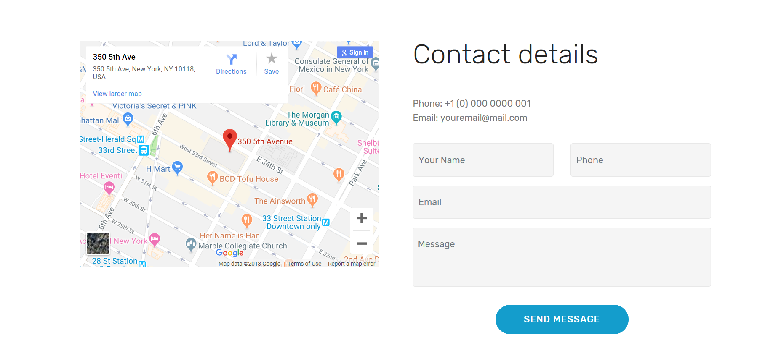

Figure 5: My Contact form design

The website https://jacekjeznach.com/ had some worrying issues such as it relied heavily on JavaScript and seemed unresponsive at times. There was a lot of animation effects which appeared to cause jank and slow it down. The audio autoplaying was a little annoying and finally it had some issues in regard to being responsive. It would display a picture to rotate the device.

The feature I liked the most was the sidebar that resembles a taskbar. There's is docked to the left which I think is a weakness. Users tend to glance right more often. Mine is placed at the bottom docker and takes inspiration from macs docker.
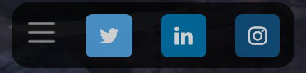

Figure 6: my sticky footer 7: https://jacekjeznach.com/ sticky side nav

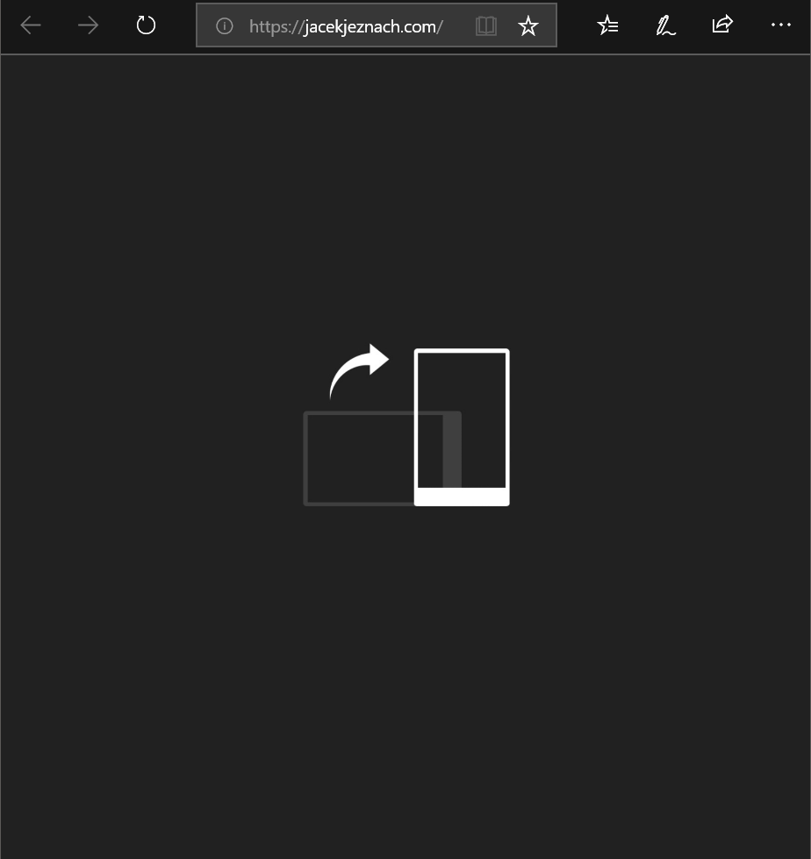

Figure 8: https://jacekjeznach.com/ unresponsive screen size
The layout of http://mattfarley.ca/ is very impressive. It is similar to my design apart from a few a subtle differences such as background white and the sections accentuated with colour. It is a very crisp design. This website has a few things I would like to emulate such as cards hoovering between sections and the choice of colours.
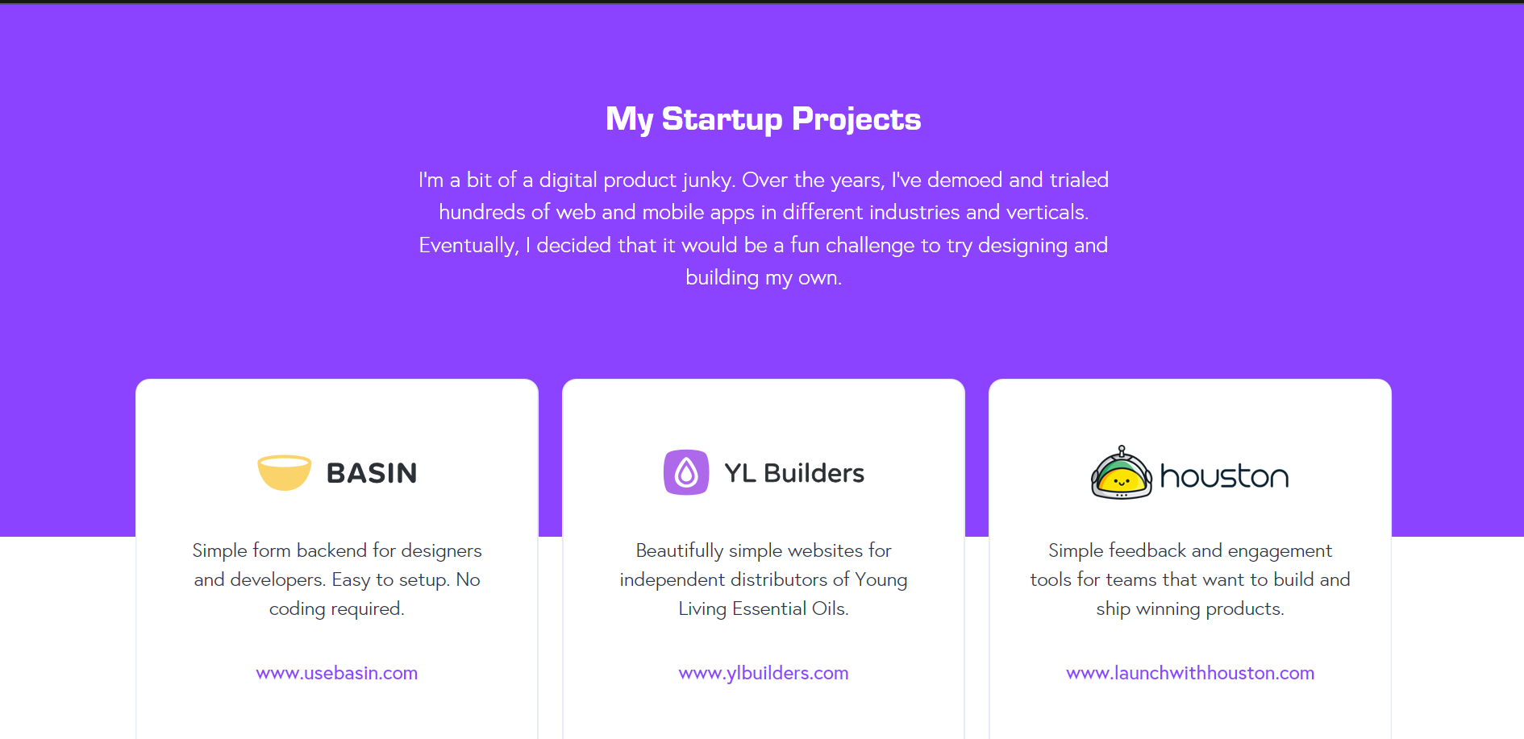

Figure 9: http://mattfarley.ca/ cards
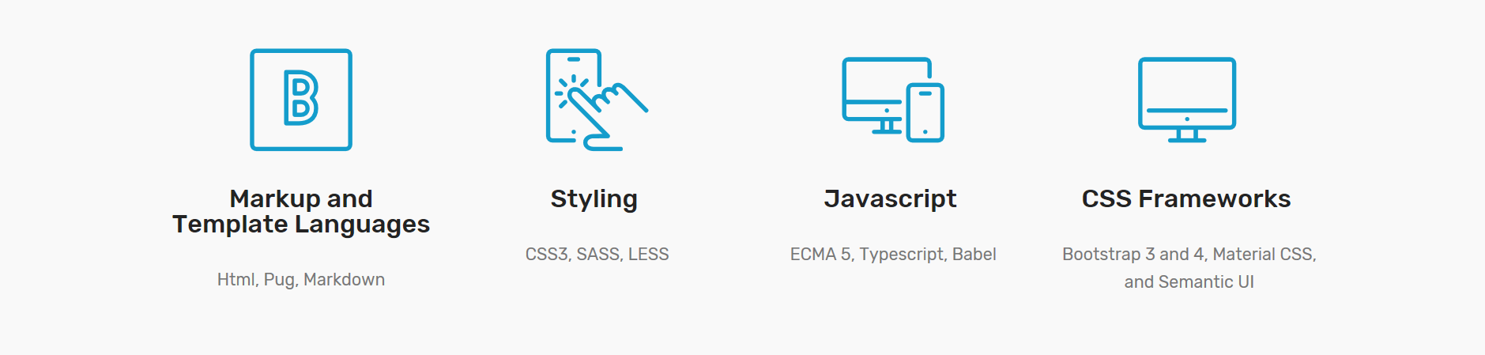
Figure 10: my cards

The website http://dejan.works/ is a full-screen website like mine its font family is very easy on the eye. It is easy on the eye it is great for those who have accessibility needs. However, I do find it lacking in style and seems to simple.

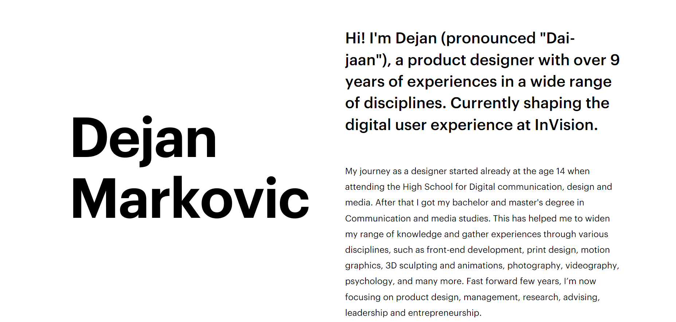
Figure 11: http://dejan.works/ Landing page

The website https://caferati.me/ is very interactive whilst being minimal. The layout of the landing page is very similar it is the same with the way its organises portfolio via tags. However, it offers more options and search functionality. There were some issues the console in edge (CONSOLE1810304: console.memory is not implemented and will return 0 for all attributes. Please use the memory profiler to monitor memory utilization.). And even in Firefox despite working there appeared to be signs of jank.
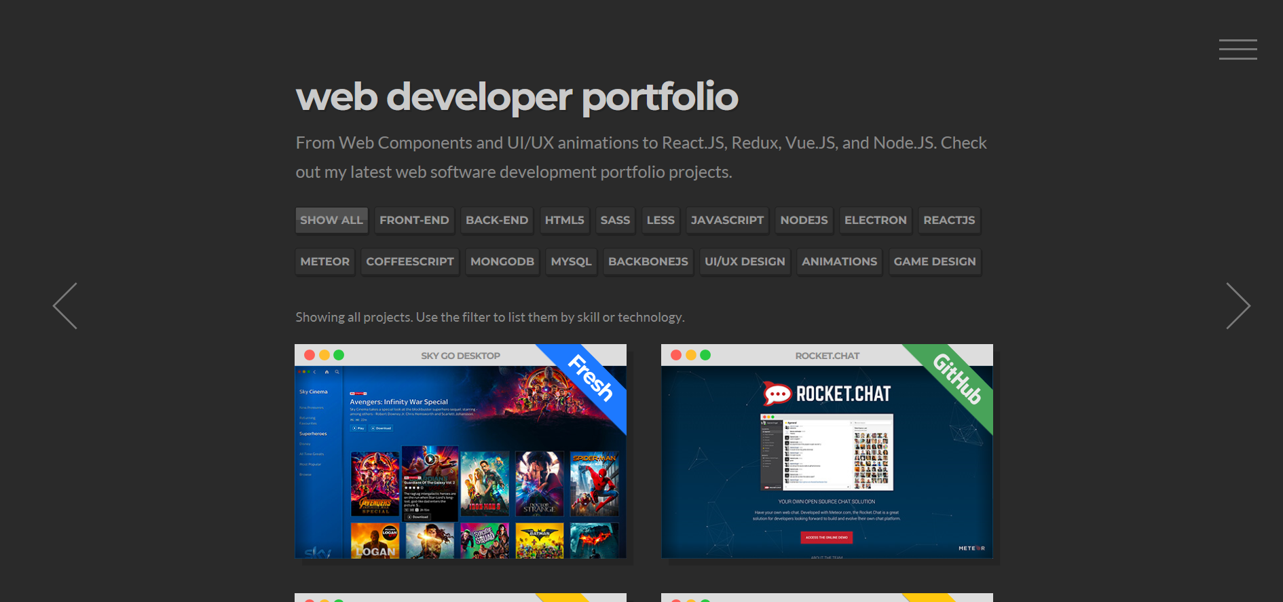
Figure 12: https://caferati.me/ Portfolio

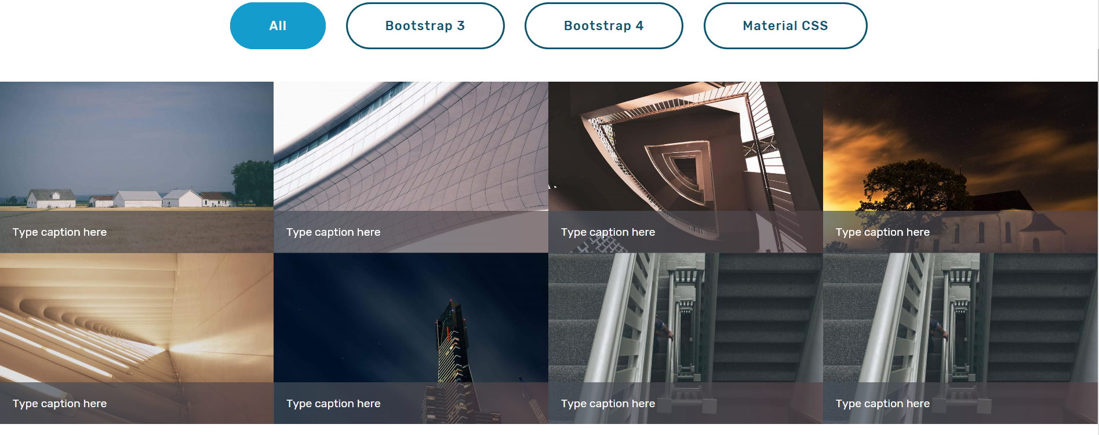
Figure 12: My portfolio

This website shares a lot of similarities with my design the way the portfolio gallery is organised and the cards displaying skills.
The feature I like the most is the contact form it makes it obvious as to what its purpose is in this instance enquiring. However, there are things missing I consider vital such as what tools and languages they use for projects.
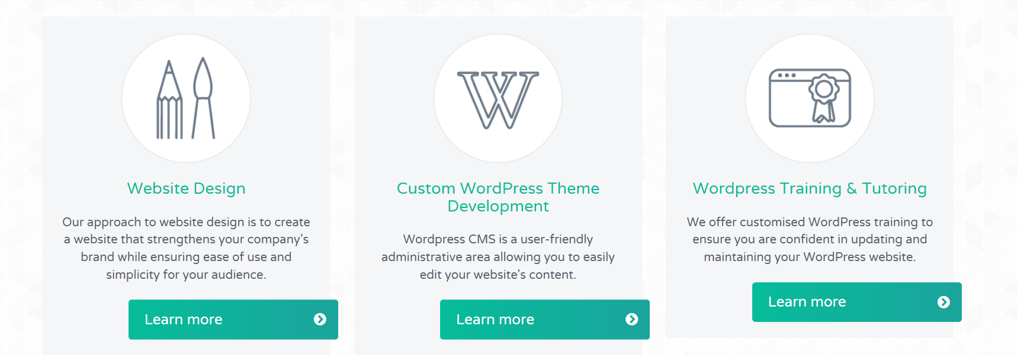

Figure 13: http://www.emilyridge.ie/ cards

The website https://ianlunn.co.uk/ doesn't have many similarities to my design. The only noticeable
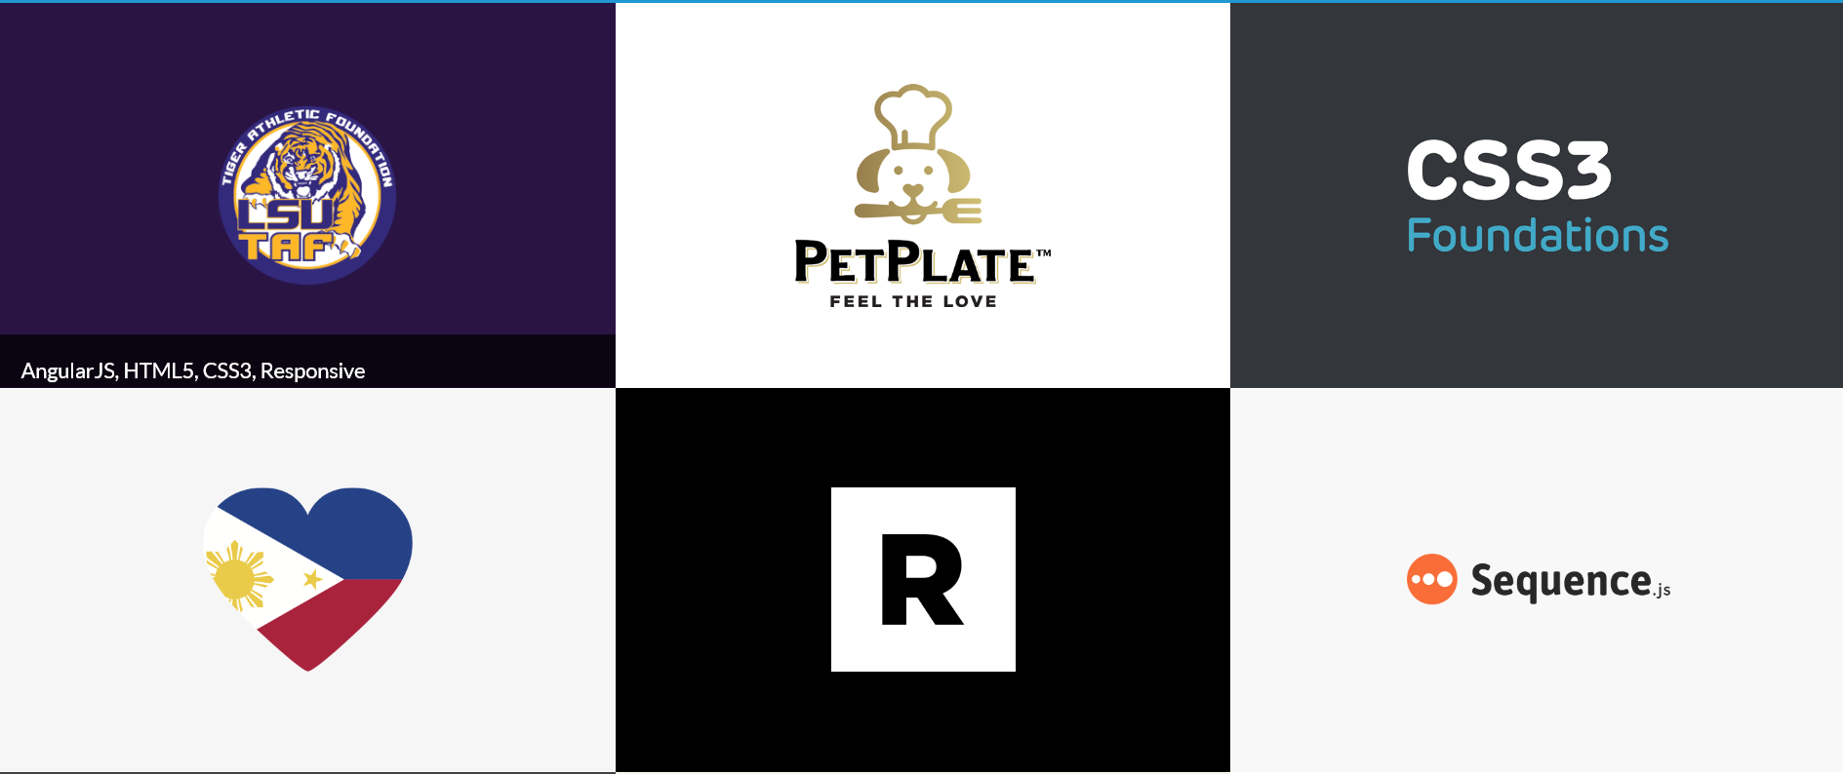
similarities are the portfolio cards as they are similarly grouped

Figure 14: https://ianlunn.co.uk/ portfolio

4. References
Ideas
- http://mattfarley.ca/
- http://dejan.works/
- https://caferati.me/
- http://www.emilyridge.ie/
- https://ianlunn.co.uk/
Dependencies
jquery
- https://jquery.com/
bootstrap4
- https://getbootstrap.com/
fontawesome
- https://fontawesome.com/
fancybox
- http://fancyapps.com/fancybox/3/
animate css
- https://daneden.github.io/animate.css/
wow.js
- https://wowjs.uk/

