QR Code Scan Performance
January 21 – May 28, 2026 | 172 customer scans | Prepacks (codeid=4)
Overview
Prepacks have carried QR codes on their packaging since the start of 2026. Customers scan the code with a phone camera and land directly on the part's McMaster.com product page — no search, no navigation. This report covers the first four months of that traffic and shows who is scanning, what they look at, and which products are pulling repeat scans.
Two findings stand out. First, volume is climbing — weekly scans grew roughly 5× between February and May, with the largest single week (27 scans) occurring May 18. Second, the customers we can identify skew toward small fabrication shops and credit-card buyers. We can also cleanly attribute about half of all scans to a known customer account through IP and visitor-ID triangulation.
Background
Each QR code on a Prepack encodes a McMaster.com URL with two parameters: a part number in the path and a query string identifying the code type. Prepack codes use codeid=4 (e.g. mcmaster.com/91251A242/?mode=qr&codeid=4). When scanned, the customer is taken straight to that part's product page. There is no intermediate landing screen and no login required.
Codeid=4 is reserved for Prepack packaging. Other codeid values exist for separate programs (codeid=2 covers the assortment kits, for example), and those are not included here.
Methodology
We pulled every recorded visit where the landing URL contained mode=qr and codeid=4 between January 21 and May 28, 2026, using the DigitalAnalytics data warehouse (search_source and visit_source tables) and the Neo4j interactions graph for event-level detail.
Two filtering passes were applied before analysis:
- Internal McMaster-Carr traffic was removed by stripping known internal IP ranges and test devices, leaving only legitimate customer scans.
- Duplicate visits and visits with no recorded events were de-duplicated against the visit_id key.
After cleaning, 172 unique customer scans remained.
Volume Trend
Scan volume grew steadily through the spring. Single-digit weeks in January and February gave way to double-digit weeks starting late March, with the strongest period in May.
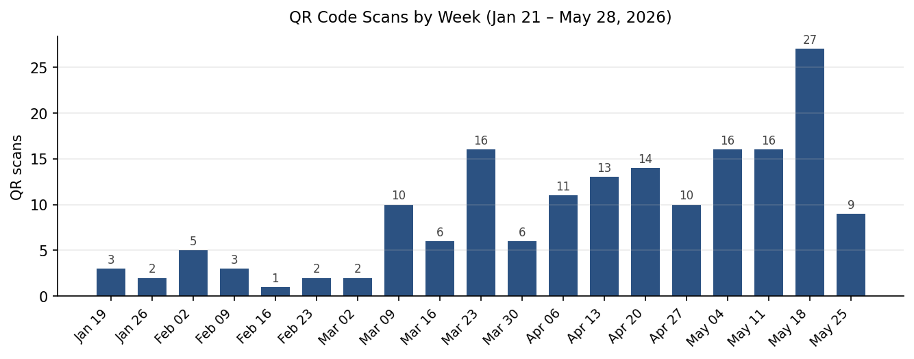
Customer Identification
QR scans land on a public URL, so we don't get a logged-in customer ID by default. To identify who is scanning, we triangulate across three signals available at the moment of the scan:
- Visitor ID — McMaster's persistent web cookie, present on most modern browser sessions.
- Browse ID — a session-level identifier that can be matched against prior contact activity.
- Client IP address — when the IP matches a known CMF (e.g., a shop with a static business IP), we can attribute the scan to that account.
Across the 172 scans, 90 (52%) triangulated to at least one known customer. The other 82 were either first-time mobile visitors with no prior account activity, or arrived from residential carrier IPs that could not be tied to an account.
What the Visits Look Like
Most scans are short. About 69% of customers landed on the product page and left without further interaction — typical behavior for QR codes in physical environments, where curious or accidental scans are common. The remaining 31% explored the site further.
Engagement | Visits | % of total
1 action — landing only | 119 | 69.2%
2 to 5 actions | 41 | 23.8%
6 to 20 actions | 12 | 7.0%
Total | 172 | 100.0%

Of the engaged customers, three placed items in their order pad and one downloaded a CAD model. Engaged sessions consistently showed spec filtering, image expansion, and revisits to the scanned part — behavior consistent with active purchase consideration rather than browsing.
Devices
Mobile phones dominated, as expected. 92% of scans came from a phone (iOS 58%, Android 36%). The remaining 8% came from desktop browsers — typically a person scanning into a phone, then completing the visit on their workstation.
Parts and Repeat Scans
Customers scanned 127 distinct part numbers. Most parts (98 of 127, or 77%) were scanned only once — the long tail you would expect from a broad Prepack catalog. The 29 parts scanned more than once are the most likely candidates for repeat shop-floor use.
Part Number | Scans
91251A242 | 5
95105A159 | 5
7073K332 | 4
1095K11 | 3
91247A628 | 3
92865A546 | 3
97467A117 | 3
92865A543 | 3
97802A316 | 3
91400A196 | 3
91000A469 | 3

Parts with three or more scans suggest the QR code is sitting somewhere it gets used regularly — a shelf label, a maintenance bin, or a tool crib. These are the cleanest signals that the Prepack QR program is being used as intended.
Key Findings
- Volume is growing. Weekly scans climbed roughly 5× between February and May. The trend is consistent enough that we should expect continued growth into Q3 as more Prepacks ship.
- Most scans don't lead to immediate action, but that's normal. The 69% landing-only rate matches benchmarks for physical QR codes. The 31% engagement rate among the rest is healthy and includes real purchase signals.
- We can identify the customer behind about half of all scans. The remaining half are mobile visitors with no prior account history — a growing audience for future engagement.
- Repeat-scan parts point at where the codes are working. The 29 parts scanned more than once indicate physical placement that's getting reused — shop floors, maintenance areas, or known reorder points.
- Mobile-first design is essential. 92% of scans came from a phone. Any follow-up actions we want customers to take from a QR landing page need to work cleanly on a small screen.
Appendix: Definitions
Visit
A continuous browser session ending after 4 hours of inactivity, scoped to a single visit_id.
Engagement (user_action_engagement_count)
The number of deliberate user actions taken during a visit. Excludes passive events like page scrolls or banner impressions.
Triangulation
Inferring the customer behind an anonymous scan by combining browser cookie (visitor_id), session identifier (browse_id), and client IP against known CMF records.
Prepack
A pre-packaged kit of one or more parts shipped as a single unit, carrying a QR code on its packaging to make reordering easy.

