**WELCOME**DEPARTMENT OF ECE

COMPUTER AIDED DIGITAL DESIGN

UE21EC252A

PROF.Y J PAVITHRA

PROJECT: TIC-TAC-TOE GAME

NAME : AKASH RAVI BHAT

SRN : PES1UG21EC025

SEC : A

TIC-TAC-TOE GAME USING FSM

AIM: Simulation and FPGA Implementation of FSM of TIC-TAC-TOE GAME using Xilinx Vivado tool.

PROCEDURE:

Step1: Create a Vivado Project using IDE sourcing verilog HDL model and targeting a specific FPGA device located on the Basys3 (Xilinx Artix-7 FPGA: XC7A35T-1CPG236C)

Step2 : Simulate the design using Vivado Simulator (Test Bench Module).

Step3 : Synthesize the design and observe the Schematic.

Step4 : Implement the design.

Step5 : Write Design Constraint (XDC) file to constrain the pin locations.

Step6 : Generate the bitstream.

Step7 : Configure the FPGA using the generated bitstream and verify the functionality in hardware.

FSM State diagram

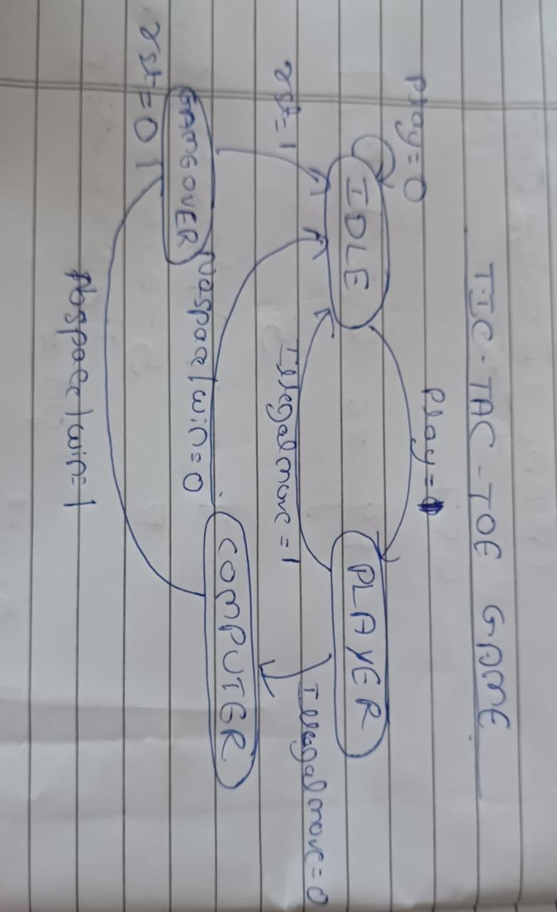

DESIGN SOURCE

module rk(clk,rst,play,illegal_move,no_space,win,qout,seq,clk_div);

input logic clk,rst;

input logic play;

input logic illegal_move;

input logic no_space;

input logic win;

output logic seq;

output logic clk_div;

output logic [2:0]qout;

parameter idle=3'b000,

player = 3'b001,

computer = 3'b010,

game_over = 3'b011;

reg[2:0]present,next;

logic [26:0] count=0;

always@(posedge clk)

begin

count<=count+1;

/*if(count[26]==1)

begin

clk_div<=count[26];

count<=0;

end */

end

assign clk_div=count[26];

always@(posedge count[26])

begin

if(rst)

present<=idle;

else

present<=next;

end

always@(present , play,illegal_move,no_space,win)

begin

next = idle;

case(present)

idle:begin if(play) next =player; end

player: begin if(illegal_move) next = idle;

else next = computer;end

computer: begin if(no_space | win ) next = game_over ;

else next = idle ; end

game_over: begin if(rst) next = idle ;

else next = game_over ; end

endcase

end

assign qout= (present === idle )? 3'b000 : (present === player )? 3'b001: (present === computer )? 3'b010 : (present === game_over )? 3'b011: 3'b111;

assign seq= (present === game_over )? 1 :0;

endmodule

SIMULATION SOURCE

module rk_tb();

reg clk,rst;

reg play,illegal_move,no_space,win;

wire[2:0] qout;

wire seq;

wire clk_div;

rk dut(.clk(clk),.rst(rst),.play(play),.illegal_move(illegal_move),.no_space(no_space),.win(win),.qout(qout),.seq(seq),.clk_div(clk_div));

always #5 clk=~clk;

initial begin

play=1;

illegal_move=0;

no_space=0;

win=0;

rst=1;

clk=0;

play=0;

#4rst=0;

#6play=1;

#10illegal_move=0;

#10no_space=0;

#10rst=1;

#10$finish;

end

endmodule

OUTPUT WAVEFORM:

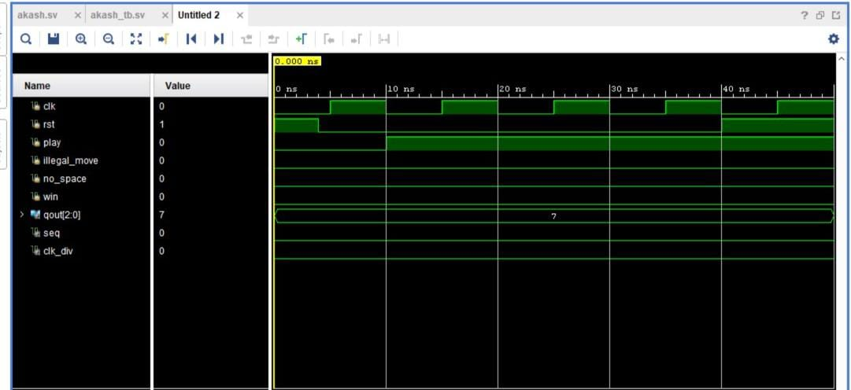

IMPLEMENTED DESIGN

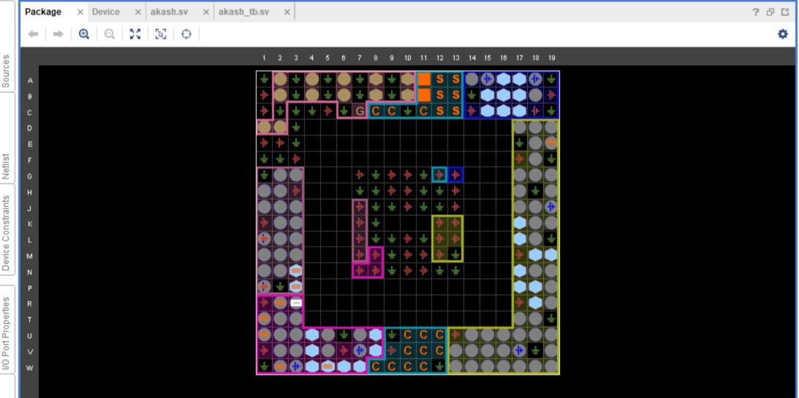

ELABORATED DESIGN

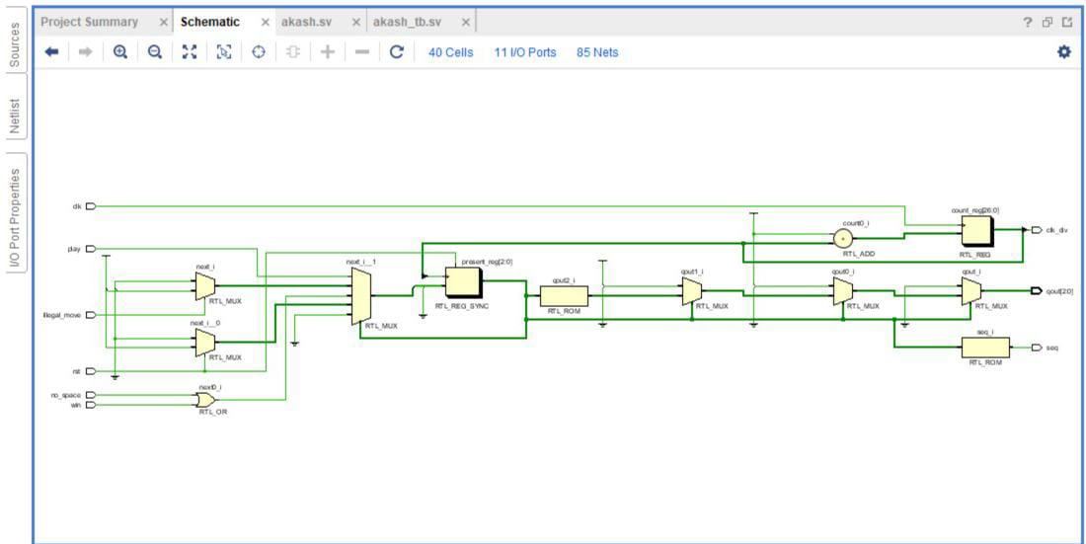

SYNTHESISED DESIGN

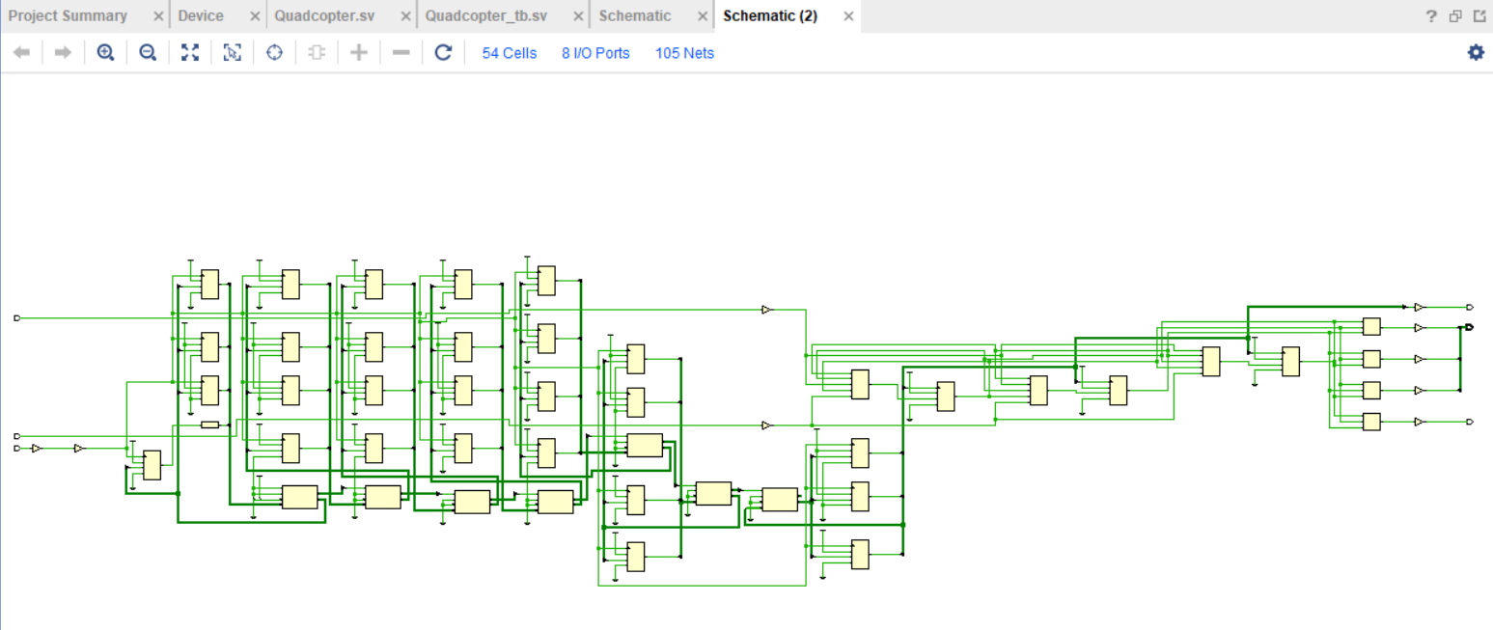

RESULT

TIC-TAC-TOE GAME FSM was successfully simulated and implemented