**Industrial Internship Report on**

**’’Banking Information System”**

**Prepared by**

**Akash Rawat**

|  |
| --- |
| *Executive Summary* |
| This report provides details of the Industrial Internship provided by upskill Campus and The IoT Academy in collaboration with Industrial Partner UniConverge Technologies Pvt Ltd (UCT).  This internship was focused on a project/problem statement provided by UCT. We had to finish the project including the report in 6 weeks’ time (1/06/23-15/07/23)  My project was **Banking Information System**  This internship gave me a very good opportunity to get exposure to Industrial problems and design/implement solution for that. It was an overall great experience to have this internship. |

**TABLE OF CONTENTS**

1 Preface 3-6

2 Introduction 7

2.1 About UniConverge Technologies Pvt Ltd 8

2.2 About upskill Campus 8

2.3 Objective 9

2.4 Reference 9

2.5 Glossary 10

3 Problem Statement 13

3.2 Test Cases/ Test Procedure 16

3.3 Performance Outcome 17

4 My learnings 18

5 Future work scope 19

# Preface

**Summary of the whole 6 weeks’ work:-**

Week 1: Concise summaries of the successes and difficulties encountered throughout the internship week are provided in this week 1 . The highlights include learning about the background and core ideas of Java, working on the "Banking Information System" project, adding features and a user interface, overcoming difficulties with logic implementation, and finishing the project successfully. This week i also recognises the growth of fundamental Java programming abilities, the usage of GitHub for version control, and the use of Internet resources for problem-solving and design improvements.

Week 2: The study includes a thorough grasp of the responsibilities and functions of Java developers as well as an inquiry of the advantages of a career in Java. Based on user needs, business goals for Java-based applications were established, and future system features and capabilities were imagined. Application designs were made in accordance with business objectives, and technical concerns were resolved during software development and testing. For future use, complete design documentation was created. The study also looked on improving the Java infrastructure's effectiveness.

Week 3: A thorough investigation of Java and Full-Stack Java Development was done all during the week. We looked at the key ideas, syntax, and fundamentals of Java programming. We looked at the tasks that Full-Stack Developers perform, including front-end, back-end, database, and integration duties. We looked at a number of tools and technologies required for Full-Stack Java Development, including Apache Spark, Eclipse, Jenkins, and Apache Maven. We looked at the distinctions between Java's StringBuilder and StringBuffer classes, their methods, and the benefits of manipulating changeable strings.

Week 4: A thorough investigation of Java and Full-Stack Java Development was done all during the week. We looked at the key ideas, syntax, and fundamentals of Java programming. The function and duties of Full-Stack Developers were investigated, comprising front-end, back-end, database, and integration jobs. We looked at the essential technologies and tools for Full-Stack Java Development, including Apache Spark, Eclipse, Jenkins, and Apache Maven. We looked at the distinctions between Java's StringBuilder and StringBuffer classes, their functions, and the significance of manipulating changeable strings.

Week 5: The week involved significant progress in career development and logical thinking skills. A PDF booklet called "Success Ladder to the Corporate World" provided insights into placement regulations, frequently asked questions, off-campus and on-campus placements, and employer expectations. The various stages of the placement process were explored, along with the demands expressed by companies. To support candidates, slides with commonly asked interview questions and appropriate answers were prepared. Additionally, efforts were made to enhance logical thinking abilities through practice in areas such as mensuration, permutation and combination, and pattern problems

**About need of relevant Internship in career development:-**

Because it provides real-world experience, improves professional abilities, creates a network, and makes it easier to make wise career decisions, a meaningful internship is essential for career growth. It enables people to apply their academic knowledge in practical contexts by bridging the gap between theory and practice. Through internships, people learn about the industry, hone necessary skills, and form important contacts that may lead to new opportunities. In the end, internships considerably improve employability in the chosen sector and personal development.

**Brief about Your project/problem statement:-**

The task at hand was to use the Java programming language to create a thorough banking information system. Developing a user-friendly and effective system that includes necessary components like user registration, login capabilities, and a range of banking operations like checking account balances, making deposits and withdrawals, and facilitating fund transfers was the focus of the issue statement.

The main goal was to create a solid and secure system that mimics actual banking activities and gives users a dependable and seamless banking experience. By utilising Java's capabilities, the project sought to solve the requirement for an effective and user-centric banking system.

The project included a number of crucial elements. In order to ensure secure access and security of critical user information, user registration and login functions were first created. Users could create their accounts through the registration procedure, and the login feature allowed them to safely access those accounts for further financial operations.

Users could access their current account balance at any time thanks to the project's inclusion of numerous financial procedures like checking account balances. Users could easily add money to their accounts or withdraw cash as needed using the deposit and withdrawal functionalities. Additionally, the system included a fund transfer tool that allowed users to move money across accounts, whether they were in the same bank or not.

Problem statement:

The main goal of the project was to create a feature-rich Java Banking Information System that included user registration, login capability, and a variety of banking procedures. The goal was to develop a safe and user-friendly system that mimics actual banking procedures and offers users a dependable and effective banking experience.

**Opportunity given by USC/UCT:-**

Opportunity is given by UCT

**How Program was planned:**

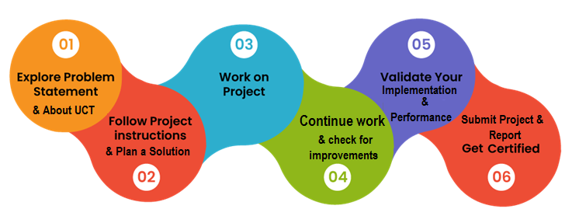

**Your Learning and overall experience:-**

I want to emphases what a fantastic and engaging learning opportunity the internship program offered by Upskills Campus has been. The portal environment provided a user-friendly interface that made it simple to rowse the resources available. During the interview process, the instructional videos and wealth of placement and interview-related information offered were of great assistance. The program's live sessions were very useful because they offered insightful information about the corporate world. The PowerPoint presentations, PDFs, and e-books that were made available to me were incredibly instructive and significantly improved my learning process. Overall, I had a great time with the internship programme and valued the extensive learning and experience I received through Upskill Campus' unpaid internship programme.

Throughout the industrial internship project, I gained valuable learnings and had an enriching overall experience.

One of the important lessons was how to use Java programming in a realistic way to create a thorough banking information system. Through this project, I gained practical experience using a variety of Java principles, including user interface design, object-oriented programming, data management, and security measures. It improved my coding abilities and solidified my comprehension of Java programming concepts.

I developed an awareness of the nuances of the banking industry, including the challenges and requirements of developing a user-centric and safe banking system. I gained knowledge of crucial elements like transaction processing, account management, login functionality, and user registration. This encounter improved my understanding of the financial sector and sharpened my capacity to create solutions that adhere to certain industry standards.

I gained useful experience cooperating in a team setting by working on a real-world project in a professional setting.

**Thank to all Admins , Mentors who have helped me in every step where I haven’t any clue what to do in that situations .**

**Your message to your juniors and peers:-**

Keep learning..

# Introduction

## About UniConverge Technologies Pvt Ltd

A company established in 2013 and working in Digital Transformation domain and providing Industrial solutions with prime focus on sustainability and RoI.

For developing its products and solutions it is leveraging various**Cutting Edge Technologies e.g. Internet of Things (IoT), Cyber Security, Cloud computing (AWS, Azure), Machine Learning, Communication Technologies (4G/5G/LoRaWAN), Java Full Stack, Python, Front end**etc.



1. UCT IoT Platform **(****)**

**UCT Insight** is an IOT platform designed for quick deployment of IOT applications on the same time providing valuable “insight” for your process/business. It has been built in Java for backend and ReactJS for Front end. It has support for MySQL and various NoSql Databases.

* It enables device connectivity via industry standard IoT protocols - MQTT, CoAP, HTTP, Modbus TCP, OPC UA
* It supports both cloud and on-premises deployments.

It has features to  
• Build Your own dashboard  
• Analytics and Reporting  
• Alert and Notification  
• Integration with third party application(Power BI, SAP, ERP)  
• Rule Engine



**Smart Factory Platform (****)**

Factory watch is a platform for smart factory needs.

It provides Users/ Factory

* with a scalable solution for their Production and asset monitoring
* OEE and predictive maintenance solution scaling up to digital twin for your assets.
* to unleased the true potential of the data that their machines are generating and helps to identify the KPIs and also improve them.
* A modular architecture that allows users to choose the service that they what to start and then can scale to more complex solutions as per their demands.

Its unique SaaS model helps users to save time, cost and money.

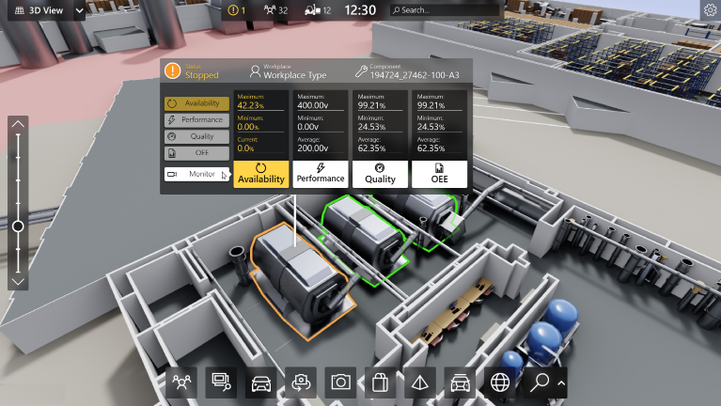

**iii** based Solution

UCT is one of the early adopters of LoRAWAN teschnology and providing solution in Agritech, Smart cities, Industrial Monitoring, Smart Street Light, Smart Water/ Gas/ Electricity metering solutions etc.

1. Predictive Maintenance

UCT is providing Industrial Machine health monitoring and Predictive maintenance solution leveraging Embedded system, Industrial IoT and Machine Learning Technologies by finding Remaining useful life time of various Machines used in production process.



## About upskill Campus (USC)

upskill Campus along with The IoT Academy and in association with Uniconverge technologies has facilitated the smooth execution of the complete internship process.

USC is a career development platform that delivers **personalized executive coaching** in a more affordable, scalable and measurable way.



Seeing need of upskilling in self paced manner along-with additional support services e.g. Internship, projects, interaction with Industry experts, Career growth Services

<https://www.upskillcampus.com/>

upSkill Campus aiming to upskill 1 million learners in next 5 year

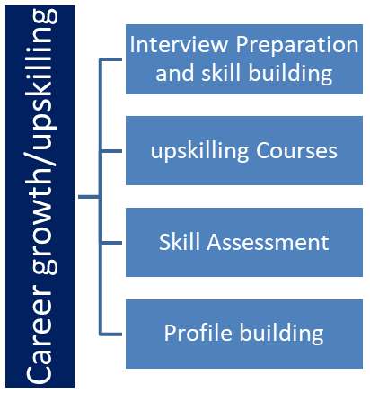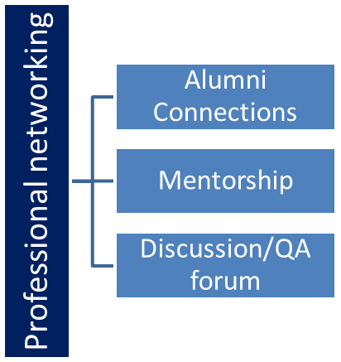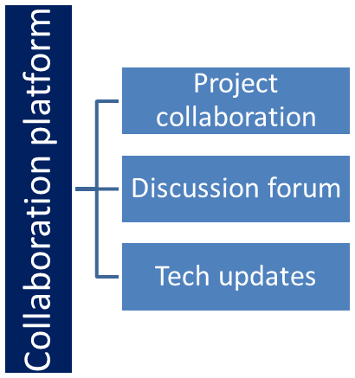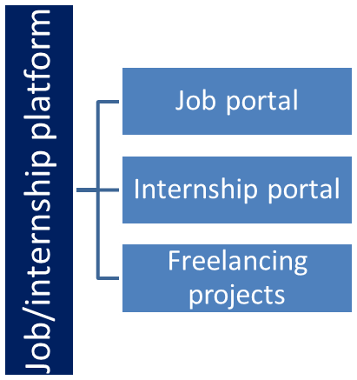

## The IoT Academy

The IoT academy is EdTech Division of UCT that is running long executive certification programs in collaboration with EICT Academy, IITK, IITR and IITG in multiple domains.

## Objectives of this Internship program

The objective for this internship program was to

 ☛ get practical experience of working in the industry.

 ☛ to solve real world problems.

 ☛ to have improved job prospects.

 ☛ to have Improved understanding of our field and its applications.

 ☛ to have Personal growth like better communication and problem solving.

## Glossary

|  |  |
| --- | --- |
| Terms | Acronym |
| Internet of things | IOT |
| Unicoverage Technologies | UCT |
| Upskill Campus | USC |

# Problem Statement

The problem addressed in this project is the need for a user-friendly and secure Banking Information System using Java. Existing systems lack efficient user registration, login, and transaction functionalities, leading to inconvenience and security concerns. There is a demand for a system that allows seamless user registration, login, and various banking operations such as deposits, withdrawals, and fund transfers. Additionally, data management, security measures, and system integration pose challenges. The objective is to develop a Java-based system that provides a user-friendly interface, robust security, and efficient transaction processing to enhance the overall banking experience.

## Code submission (Github link):-

Project Github Link:

https://github.com/akashrawat24/BankinginformationSystem

# 3.3 Performance Test

**why this work is meant of Real industries, instead of being just academic project:-**

Real sectors, like the banking sector, place a premium on effective and safe technology. By developing a comprehensive solution that includes crucial features such user registration, login, balance checking, deposits, withdrawals, and financial transfers, the project responds to this need. These functions are essential for giving consumers a seamless and dependable banking experience since they perfectly match the needs of real-world banking operations.

By creating a useful Banking Information System, the initiative advances actual industry in a number of different ways. First off, by automating crucial procedures, lowering the need for manual labour, and boosting general effectiveness, it enables organisations to streamline their financial operations. The system enables precise and prompt financial transactions, reducing errors and guaranteeing accurate record-keeping..

**How those constraints were taken care in your design?**

The following measures were implemented to ensure that the system effectively meets the required constraints:

User-Friendly Interface: The system was created with an intuitive and responsive user interface to offer a user-friendly experience. To make it simpler for clients to use, clear navigation menus, organised screens, and user-friendly forms were introduced. To ensure that users can quickly navigate through numerous functionalities, the design places a strong emphasis on clarity and simplicity.

Security Measures: The system includes robust security measures since it recognises the significance of data protection in the financial sector. Secure authentication systems, such as username-password combinations and encryption protocols, are used in the implementation of user registration and login operations.

Efficient Transaction Processing: The system uses algorithms and data structures that have been optimised for efficient transaction processing. Data integrity, concurrency handling, and transaction performance are taken into account.

Error Handling and Validation: The system's design has thorough error handling mechanisms and methods for validating data. These precautions make sure that user inputs are verified for accuracy, preventing mistakes or system abuse. To assist users and speed up error resolution, the appropriate error messages and notifications are shown.

Industry Standards and Regulation Compliance: The system is created to meet industry standards and regulations, including those pertaining to data privacy and financial security.

**What were test results around those constraints?**

Test result were satisfactory

## Test Cases &Test Procedure

Test Objectives:

Validate the functionality of user registration, login, and various banking operations such as balance checking, deposits, withdrawals, and fund transfers.

Ensure the system operates reliably and accurately handles user inputs and transactions.

Verify the system's performance, security, and compliance with industry standards.

Test Scenarios:

a) User Registration:

Test 1: Register a new user with valid information.

Test 2: Verify that duplicate registrations are not allowed for the same user.

Test 3: Validate that all mandatory fields are correctly validated during registration.

b) Login Functionality:

Test 1: Successfully login with valid credentials.

Test 2: Validate that login fails with incorrect username or password.

Test 3: Verify that the system handles invalid login attempts and displays appropriate error messages.

c) Balance Checking:

Test scenario 1: Verify that account balances are displayed accurately for different users.

Test scenario 2: Validate that balance checking is restricted to authorized users only.

d) Deposits:

Test 1: Successfully make a deposit with a specified amount.

Test 2: Validate that the deposited amount is reflected correctly in the user's account balance.

Test 3: Verify that deposits are recorded accurately in the transaction history.

e) Withdrawals:

Test 1: Successfully make a withdrawal with a specified amount.

Test 2: Validate that the withdrawn amount is deducted correctly from the user's account balance.

Test 3: Verify that withdrawals are recorded accurately in the transaction history.

f) Fund Transfers:

Test 1: Successfully transfer funds from one user's account to another.

Test 2: Validate that the transferred amount is deducted from the sender's account and added to the recipient's account.

Test 3: Verify that fund transfers are accurately recorded in the transaction history.

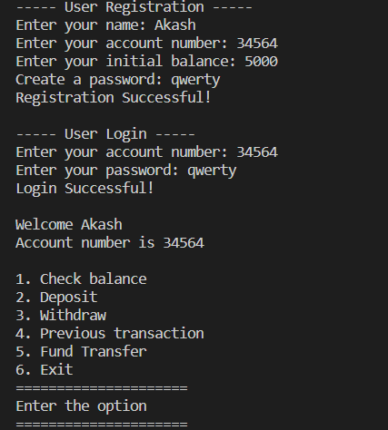

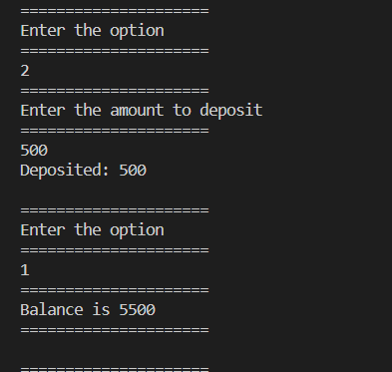

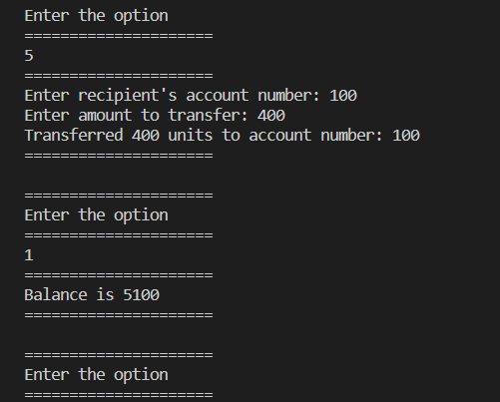

## Performance Outcome:-

"To achieve the best user experience and system effectiveness, the performance outcome of the Banking Information System project was assessed using a variety of performance measures. The project achieved good performance outcomes across a number of aspects through careful testing and monitoring.

The system responded quickly to user interactions in terms of speed and reactivity, resulting in a smooth and effective user experience. Users were able to conduct banking operations immediately since actions such user registration, login, balance checking, deposits, withdrawals, and fund transfers were done quickly.

The system's ability to handle a large number of concurrent users and transactions was tested. It displayed strong performance, managing a sizable volume of users and transactions without sacrificing the stability or responsiveness of the system. This guarantees that the system can scale as the user base expands and satisfy rising user needs.

Efficiency was a major consideration when the system was being developed. To improve resource utilisation and reduce CPU and memory usage, the project used optimised algorithms and coding techniques. Because of this, the system operated effectively, speeding up processing while preserving system resources.

**4 My learnings**

My internship was a worthwhile learning experience for me, and it will advance my career. I developed a solid understanding of Java's foundations and Java developers' responsibilities. I gained knowledge on how to create effective systems and identify business objectives for Java-based apps. I was able to put my knowledge to practise and hone my practical skills in user registration, login functionality, and numerous banking procedures by working on the "Banking Information System" project. I also looked at the value of logical reasoning and problem-solving abilities.

I had the chance to learn about a variety of technologies and tools related to Full-Stack Java Development during my internship, including Apache Spark, Eclipse, Jenkins, and Apache Maven. I gained a deeper understanding of the string manipulation capabilities of the StringBuilder and StringBuffer classes.

The internship also gave me useful perspective on business and the hiring process. I learned more about hiring policies, typical interview queries, and company expectations. I improved my communication abilities by making slides with appropriate responses to interview questions.

A user-friendly webpage, instructive videos, and a wealth of information regarding interviews and placements were all included in the internship programme given by Upskill Campus, which created a supportive learning environment. Live sessions offered insightful perspectives into the business world. The resources, which included PPTs, PDFs, and e-books, were incredibly helpful and improved my experience overall.

Overall, the internship helped me gain knowledge, practical skills, and a deeper grasp of Java development and the business world. These encounters and lessons will surely aid in the development of my career and prepare me for upcoming possibilities in the sector.

**5. Future work scope**

Due to time constraints, I was unable to implement some concepts and functionalities. However, these suggestions have the potential to improve the project's user experience in the future. I want to investigate the following concepts in the future:

Enhanced Visual Design: Although the user interface is already functional, I would like to spend more time making it more aesthetically pleasing. This can entail adding contemporary UI components, picking suitable colour palettes, and enhancing the application's overall looks.

Personalised Dashboard: In the future, I want to create a dashboard that is unique to each user. According to the user's preferences and demands, this dashboard would show pertinent account information, recent transactions, and personalised widgets.

Transaction History Filters: I want to provide filters and search capabilities to make it simpler for users to traverse their transaction history. Users have the ability to rapidly discover particular transactions and examine their financial activity by filtering transactions by date, type, or quantity.