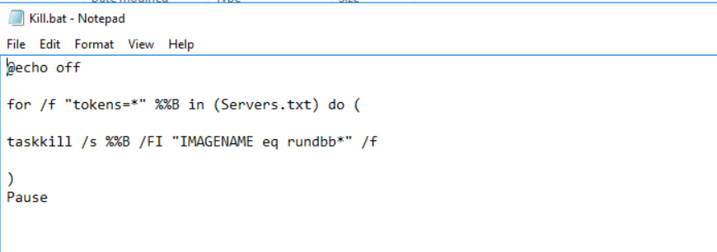

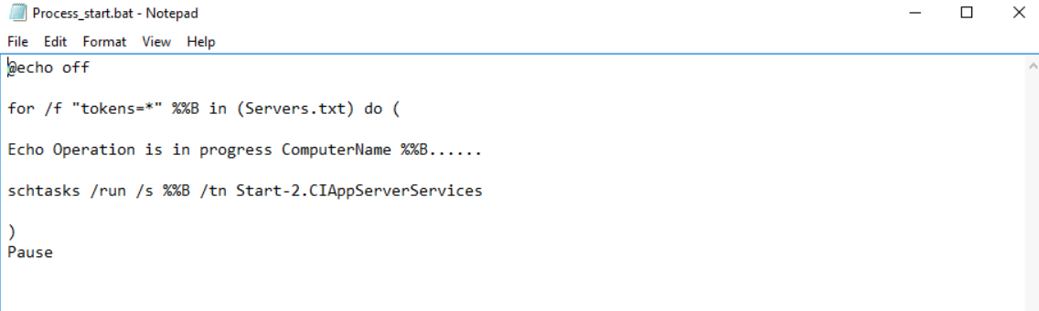
Download Package -

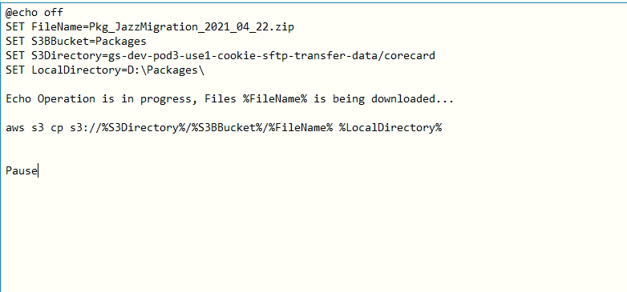

Upload Package -
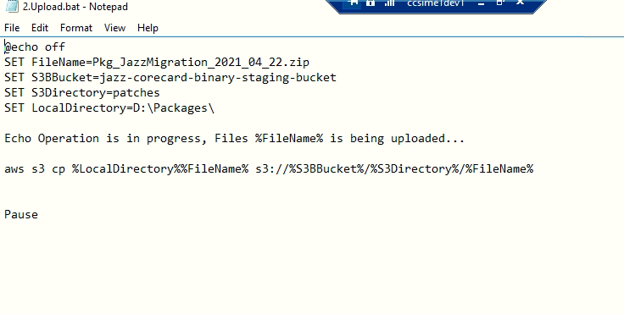

schtasks /run /s <machine name> /tn <task name>

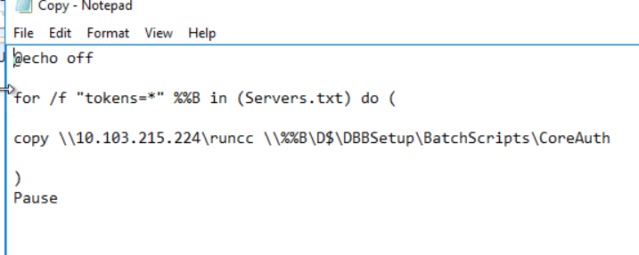

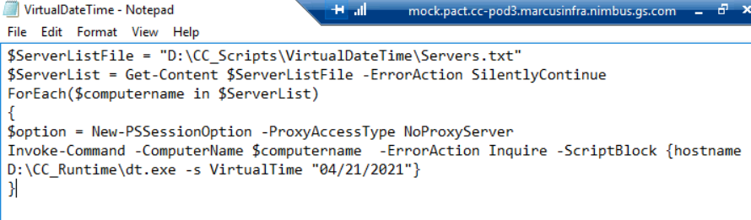

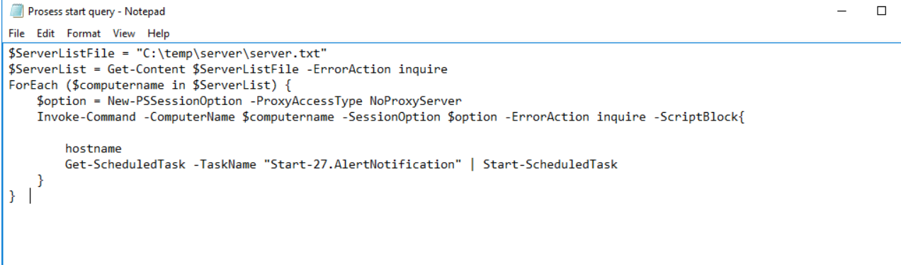
aws ec2 describe-instances --filters "Name=tag:Name,Values=*mock*" "Name=instance-state-name,Values=running" --query "Reservations[*].Instances[*].{Instance:InstanceId,IpAddress:PrivateIpAddress,Name:Tags[?Key=='Name']|[0].Value} --region us-east-1 --output table

