Tracking, Analysis and Visualization of Football Player Potentials in Video Games
Akash Hegde¹
¹M.Tech. Student, Computer Network Engineering, R. V. College of Engineering, Karnataka, India

---------------------------------------------------------------------***---------------------------------------------------------------------

Abstract – Video games have become a huge part of the entertainment industry over the past two decades. There have been an increased number of gamers in the competitive gaming arena, otherwise known as e-Sports. This trend has led to the collection and analysis of previous data in order to be better prepared for the upcoming versions of a particular game. The case of competitive football has been considered and the potentials of the players have been tracked, analyzed and visualized for a period of 14 years, from 2007 to 2020. Bar graphs and pie charts have been used for the visualization to determine the frequency and percentage distribution of player potentials which have the highest possible potentials over the course of a football season. Predictions are also made for the upcoming 2020-21 season in terms of player potentials based on real-life performance and previous data.

Key Words: data visualization, computer graphics, data science, predictive analysis, competitive gaming.

1. INTRODUCTION

There has been a continuous rise in the adoption of video games as a source of entertainment for children and grown-ups alike. These games consist of single-player and multi-player options. Single-player games allow the player to control one or more characters in a game world which consists of a number of non-playable characters (NPCs), ranging from a few dozen to thousands. These NPCs are scripted to perform certain functions and follow looped sequences continuously. This is usually known as in-game artificial intelligence or game AI.
However, multi-player video games allow various players from all over the world to connect to each other in a shared game world over the Internet. These are known as gaming lobbies and are set up in one or more servers assigned by the company that is hosting the particular video game. These lobbies can sometimes host up to 200 players at a particular time, allowing them to communicate with each other over text chat and voice.
The multiplayer component of certain video games has also led to competitive gaming in virtual arenas around the world. These are collectively known as eSports and are basically a form of sport, but conducted in a virtual environment. One such eSport title is the popular football franchise FIFA, which is discussed in detail in the following section.
1.1 The EA Sports FIFA Franchise

The Canadian video game company Electronic Arts (EA) publishes a series of football simulation video game annually under the banner of EA Sports FIFA. These video games simulate the real-world playing styles and techniques used in football, and provide players with a sense of pride and accomplishment in terms of managing a team of virtual football players.
The series began using the official FIFA license in 1993 and has since produced yearly installments, the latest being EA Sports FIFA 20. Each annual release occurs around the end of August or September, with a playable demo released two-three weeks earlier. The numbering scheme followed by the franchise relates to the shortening of the upcoming football season of that particular year; for example, the FIFA 20 game includes the players and clubs participating in the 2019-20 football season in real life.
The series primarily offers players the ability to engage in single-player matches against the scripted game AI, over various levels of difficulty, ranging from beginner to legendary. It also offers players to pit their teams against players around the world over online sessions, either using the existing teams or creating their own. This game mode has gained a lot of players recently and continues to rise in demand due to its competitive nature.
In order to remain competitive, the players go through previous year’s data and track the performance of individual football players in real life, study their techniques and try to incorporate them in the game. This is usually determined by two ratings given to the players – player overall and player potential. Player overall gives the rating of the player in the current scenario in real life, whereas player potential tries to determine the potential to which the player can reach over time. The tracking, analysis and visualization of player potentials have been carried out for a period of 14 years, ranging from FIFA 07 (2006-07) to FIFA 20 (2019-20).
1.2 Organization of the Paper

Section 1 gives the introduction to gaming, competitive gaming and the FIFA franchise. Section 2 describes the related work and the data sources. Section 3 gives the analysis and visualization and finally, Section4 gives the conclusion.
2. RELATED WORK AND DATA SOURCES

Several researchers have collected and explored the datasets of particular FIFA games over the years. Open-source datasets are available on websites such as Kaggle and GitHub, which allows users to easily download and perform analysis on them.
Karan Gadiya has created the open-source FIFA 19 player dataset [1] and further explored the differences observed between players of different clubs and countries, ages and market values [2].
Aishwarya Sharma has performed exploratory data analysis on the open-source FIFA 19 player dataset and built a linear regression model to determine the transfer market value of a particular player [3].
Furthermore, data scientist Jason Zivkovic has also explored the FIFA 19 player dataset, but the analysis involves k-means clustering approach [4] [5] which helps virtual club managers to effectively manage their teams and players.
Similar analysis has been performed by Roshan Sharma, who has considered the issues of finding out the most economical football club, effect of player age and skill set on potential [6].
FIFA 18 also had open-source datasets made by Aman Shrivastava [7] and Kamil Sijko [8], which contained the detailed data present in the game, including all players, clubs and countries. Anuj Agarwal had performed analysis on this dataset, by correlating player age with overall and potential ratings [9].
Most researchers build these datasets from the popular website SOFIFA [10], which provides the complete database of each and every game, ranging from FIFA 07 to FIFA 20. This website has been considered in this analysis and data has been scraped and made available to be used by the general public on GitHub [11].
3. ANALYSIS AND VISUALIZATION
The previous section described the details of the FIFA 20 dataset sourced from SOFIFA for this particular analysis. Only players with high potentials are considered as these players would be viable to make a higher impact on the team’s performance and results.
The data is considered over a period of 14 years, from FIFA 07 to FIFA 20. The features taken into consideration are player names, age, overall rating, potential rating, team and playing position. However, the main feature that has been analyzed is the player potential, and the visualizations have been done using the matplotlib Python library. Table 1 gives the count of players having exceptional potentials, from FIFA 07 to FIFA 20. These players all have their potentials 90 or above.

Table 1: Count of high potential players

Game | Release Date | Player Count
FIFA 07 | August 30, 2006 | 141
FIFA 08 | August 30, 2007 | 76
FIFA 09 | August 30, 2008 | 76
FIFA 10 | August 30, 2009 | 76
FIFA 11 | August 30, 2010 | 49
FIFA 12 | August 30, 2011 | 20
FIFA 13 | August 31, 2012 | 22
FIFA 14 | August 31, 2013 | 16
FIFA 15 | August 29, 2014 | 12
FIFA 16 | August 28, 2015 | 14
FIFA 17 | August 25, 2016 | 31
FIFA 18 | August 28, 2017 | 42
FIFA 19 | August 21, 2018 | 47
FIFA 20 | August 20, 2019 | 39

It can be observed from Table 1 that the player count was initially very high. The expectations of the players to have a higher potential and perform exceptionally both in game and in real life has been observed to be reducing over time.
3.1 FIFA 07
FIFA 07 was one of the first games to be sourced in the SOFIFA dataset. This was also one of the most coveted games, in terms of gameplay and mechanics. Fig. 1 and Fig. 2 depict the potentials of players in FIFA 07, in terms of frequency and the percentage distribution.
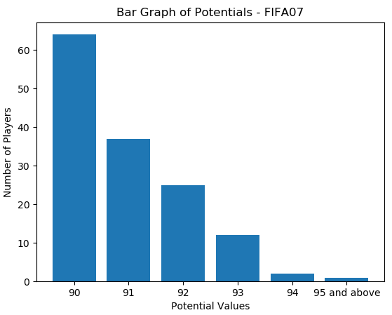
Fig. 1: Bar graph of potentials – FIFA 07
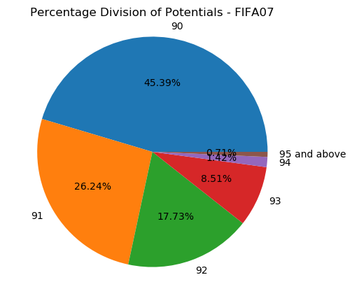
Fig. 2: Percentage of potentials – FIFA 07

It can be observed from Fig. 1 and Fig. 2 that the expected number of players with potentials of 90 was higher than any other potential, making up 45.39% of the high potential players. 0.7% of the high potential players were considered to reach potentials of 95 and above.
3.2 FIFA 08
FIFA 08 introduced a new game mode called “Be a Pro”, in which the player could control only one player on the field. Fig. 3 and Fig. 4 depict the potentials of players in FIFA 08, in terms of frequency and the percentage distribution.
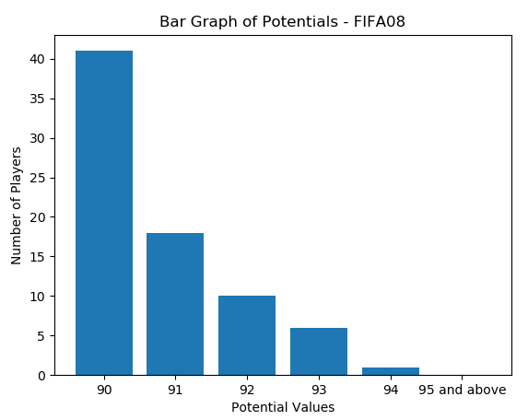
Fig. 3: Bar graph of potentials – FIFA 08

Similar to FIFA 07, it can be observed from Fig. 3 and Fig. 4 that the expected number of players with potentials of 90 was higher than any other potential, making up 53.95% of the high potential players. Surprisingly, none of the high potential players were considered to reach potentials of 95 and above.
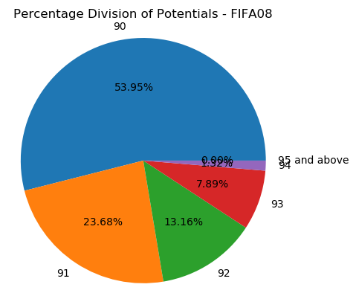
Fig. 4: Percentage of potentials – FIFA 08

3.3 FIFA 09
FIFA 09 allowed users to update player ratings based on their performance in real life, acting as a live season feature. Fig. 5 and Fig. 6 depict the potentials of players in FIFA 09, in terms of frequency and the percentage distribution.
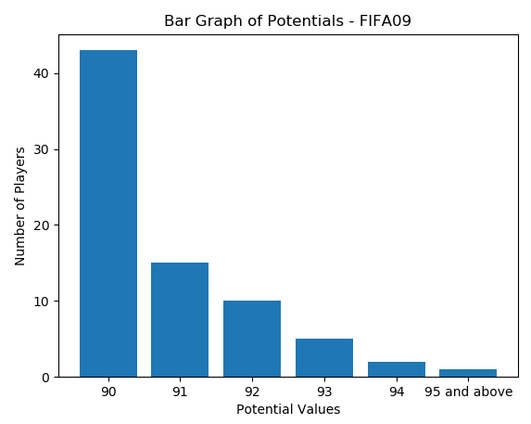
Fig. 5: Bar graph of potentials – FIFA 09
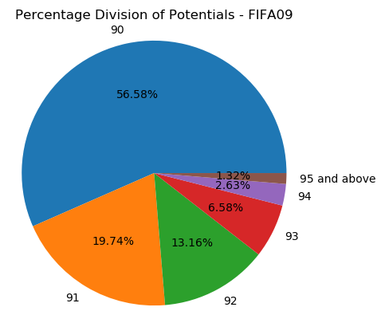
Fig. 6: Percentage of potentials – FIFA 09

It can be observed from Fig. 5 and Fig. 6 that the expected number of players with potentials of 90 was higher than any other potential, making up 56.58% of the high potential players, much higher than FIFA 08. 1.32% of the high potential players were considered to reach potentials of 95 and above.
3.4 FIFA 10
FIFA 10 incorporated better player growth and an assistant manager system. Fig. 7 and Fig. 8 depict the potentials of players in FIFA 10, in terms of frequency and the percentage distribution.
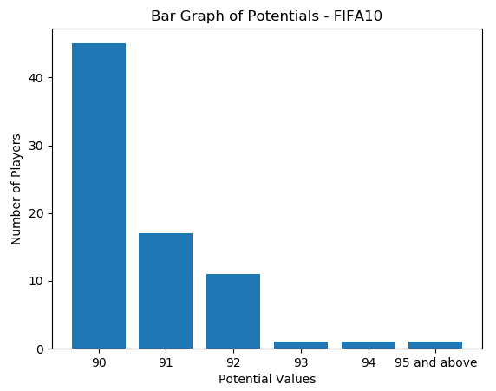
Fig. 7: Bar graph of potentials – FIFA 10
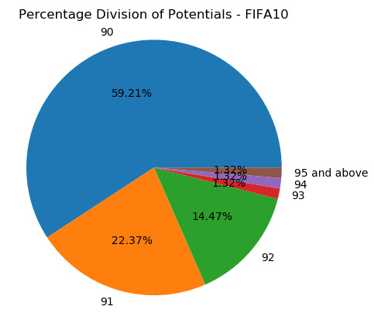
Fig. 8: Percentage of potentials – FIFA 10

It can be observed from Fig. 7 and Fig. 8 that the expected number of players with potentials of 90 was higher than any other potential, making up 59.21% of the high potential players, much higher than FIFA 09. Equal percentage distributions of players were considered to reach potentials of 93, 94 and 95, namely 1.32%.

3.5 FIFA 11
FIFA 11 allowed players to play either as a manager or a player. Fig. 9 and Fig. 10 depict the potentials of players in FIFA 11, in terms of frequency and the percentage distribution.
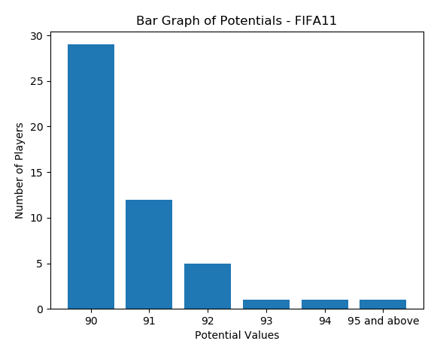
Fig. 9: Bar graph of potentials – FIFA 11
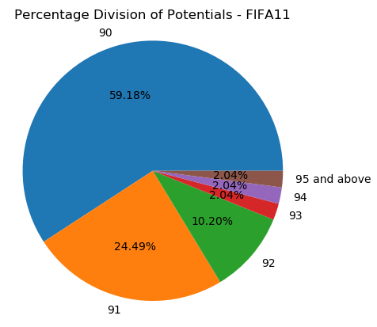
Fig. 10: Percentage of potentials – FIFA 11

It can be observed from Fig. 9 and Fig. 10 that the expected number of players with potentials of 90 was almost equal to that of FIFA 10, making up 59.18% of the high potential players. Similar to FIFA 10, equal percentage distributions of players were considered to reach potentials of 93, 94 and 95, namely 2.04%.
3.6 FIFA 12
FIFA 12 introduced new player movement mechanics and updated their player impact model. Fig. 11 and Fig. 12 depict the potentials of players in FIFA 12, in terms of frequency and the percentage distribution.
It can be observed from Fig. 11 and Fig. 12 that the expected number of players with potentials of 90 and 91 were equal, making up 35% each. Similar to FIFA 10 and FIFA 11, equal percentage distributions of players were considered to reach potentials of 93, 94 and 95, namely 5%.
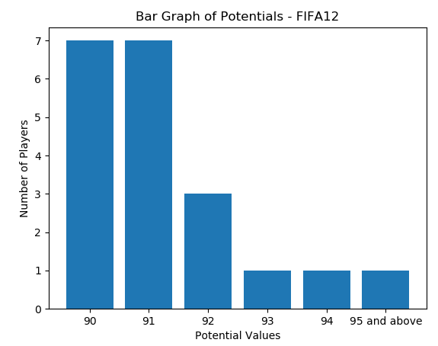
Fig. 11: Bar graph of potentials – FIFA 12
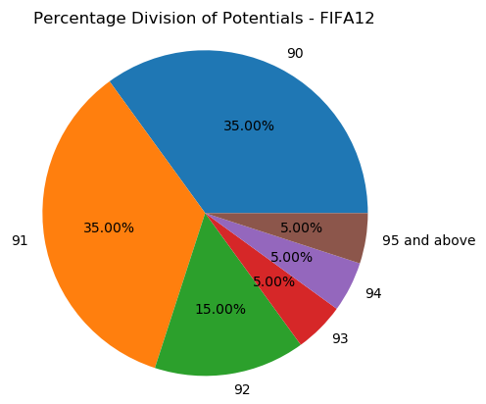
Fig. 12: Percentage of potentials – FIFA 12

3.7 FIFA 13
FIFA 13 drastically improved dribbling mechanics and also introduced first touch control system. Fig. 13 and Fig. 14 depict the potentials of players in FIFA 13, in terms of frequency and the percentage distribution.
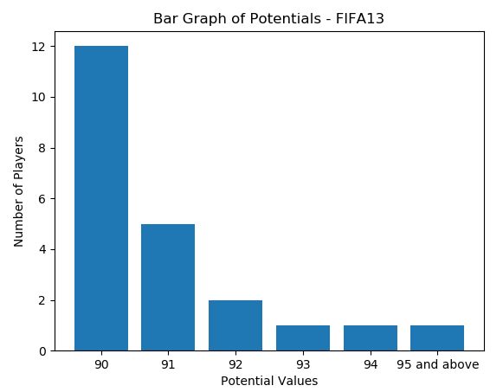
Fig. 13: Bar graph of potentials – FIFA 13
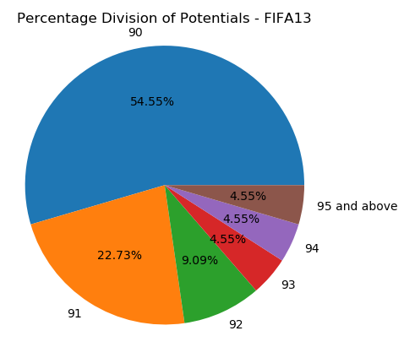
Fig. 14: Percentage of potentials – FIFA 13

It can be observed from Fig. 13 and Fig. 14 that the expected number of players with potentials of 90 was higher than any other potential, making up 54.55% of the high potential players. Similar to FIFA 10, FIFA 11 and FIFA 12, equal percentage distributions of players were considered to reach potentials of 93, 94 and 95, namely 4.55%.
3.8 FIFA 14
FIFA 14 improved graphics, gameplay and player movement by introducing a completely new game engine known as “Ignite”. Fig. 15 and Fig. 16 depict the potentials of players in FIFA 14, in terms of frequency and the percentage distribution.
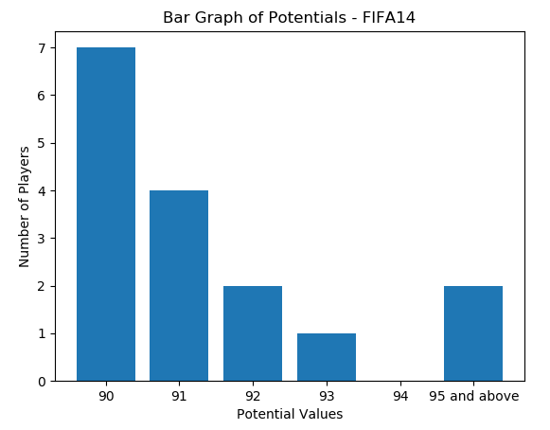
Fig. 15: Bar graph of potentials – FIFA 14

It can be observed from Fig. 15 and Fig. 16 that the expected number of players with potentials of 90 was higher than any other potential, making up 43.75% of the high potential players. Surprisingly, none of the high potential players were considered to reach a potential rating of 94.
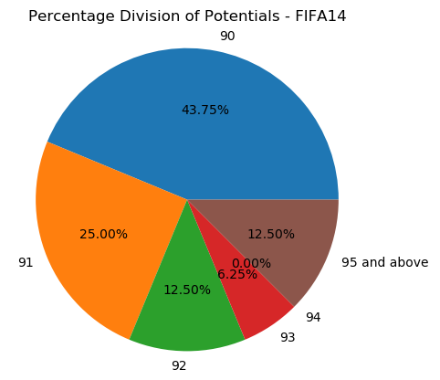
Fig. 16: Percentage of potentials – FIFA 14

3.9 FIFA 15
FIFA 15 incorporated the complete licensing and authentic presentation packages for the English Premier League. Fig. 17 and Fig. 18 depict the potentials of players in FIFA 15, in terms of frequency and the percentage distribution.
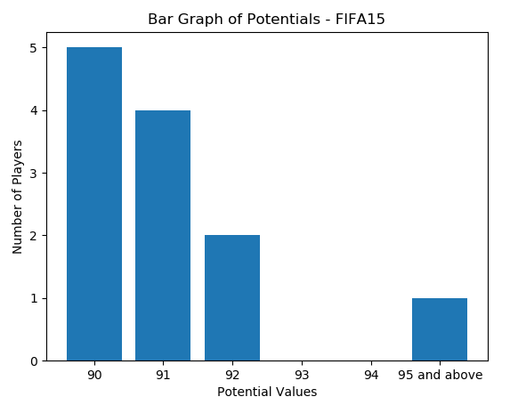
Fig. 17: Bar graph of potentials – FIFA 15
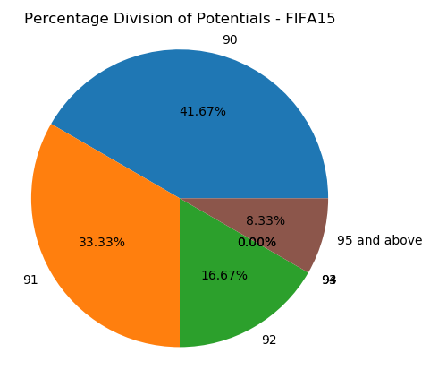
Fig. 18: Percentage of potentials – FIFA 15
It can be observed from Fig. 17 and Fig. 18 that the expected number of players with potentials of 90 was higher than any other potential, making up 41.67% of the high potential players, but the total number of high potential players was the lowest ever, at only 12 players. Only one player was considered to reach potential of 95 and above.
3.10 FIFA 16
FIFA 16 was one of the first games to be sourced in the SOFIFA dataset. This was also one of the most coveted games, in terms of gameplay and mechanics. Fig. 19 and Fig. 20 depict the potentials of players in FIFA 16, in terms of frequency and the percentage distribution.
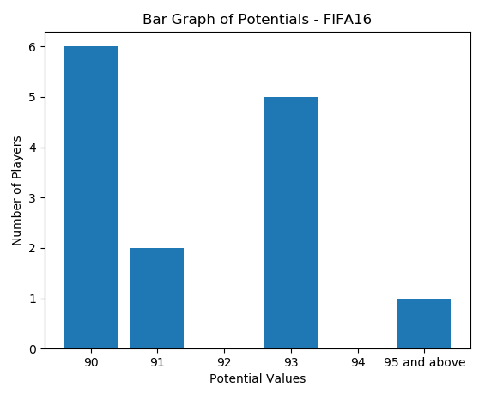
Fig. 19: Bar graph of potentials – FIFA 16
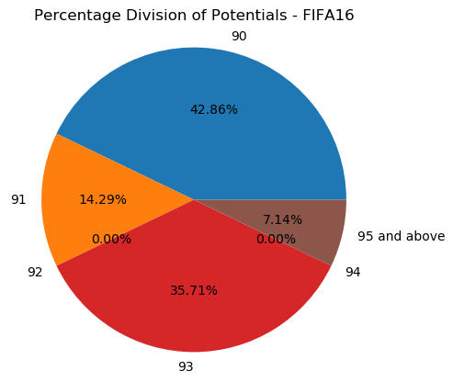
Fig. 20: Percentage of potentials – FIFA 16

It can be observed from Fig. 19 and Fig. 20 that the expected number of players with potentials of 90 was higher than any other potential, making up 42.86% of the high potential players. However, a large proportion of players (35.71%) were also expected to reach a potential rating of 93.
3.11 FIFA 17
FIFA 17 introduced the new generation of game engine known as “Frostbite”, which added improved gameplay and graphics to the game. A story mode known as “The Journey” was also added, where players could take on the role of a fictional English striker called Alex Hunter. Fig. 21 and Fig. 22 depict the potentials of players in FIFA 17, in terms of frequency and the percentage distribution.
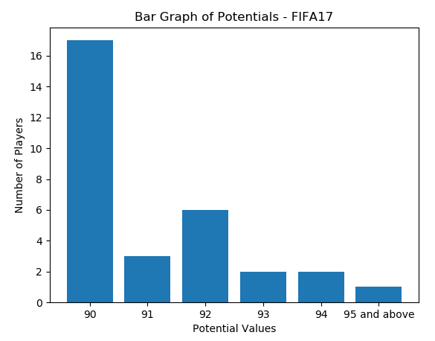
Fig. 21: Bar graph of potentials – FIFA 17
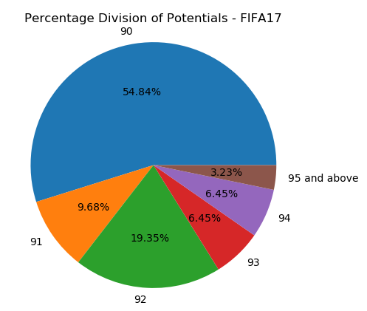
Fig. 22: Percentage of potentials – FIFA 17

It can be observed from Fig. 21 and Fig. 22 that the expected number of players with potentials of 90 was higher than any other potential, making up 54.84% of the high potential players. Equal percentage distributions of players were considered to reach potentials of 93 and 94, namely 6.45%.
3.12 FIFA 18
FIFA 18 continued the story of Alex Hunter from FIFA 17 and also introduced legendary players in the multiplayer game mode FIFA Ultimate Team. Fig. 23 and Fig. 24 depict the potentials of players in FIFA 18, in terms of frequency and the percentage distribution.
It can be observed from Fig. 23 and Fig. 24 that the expected number of players with potentials of 90 was higher than any other potential, making up 42.86% of the high potential players. Surprisingly, none of the high potential players were considered to reach a potential rating of 95 and above.
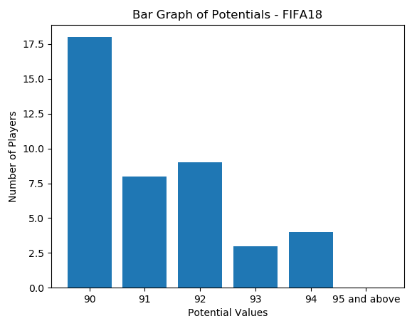
Fig. 23: Bar graph of potentials – FIFA 18
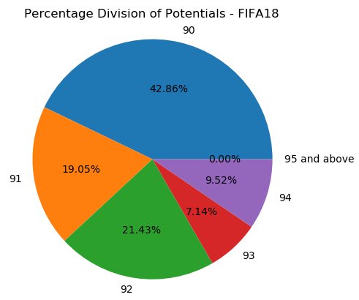
Fig. 24: Percentage of potentials – FIFA 18
3.13 FIFA 19
FIFA 19 obtained the official licensing for the UEFA Champions League and Europa League. It also concluded the story of Alex Hunter. Fig. 25 and Fig. 26 depict the potentials of players in FIFA 19, in terms of frequency and the percentage distribution.
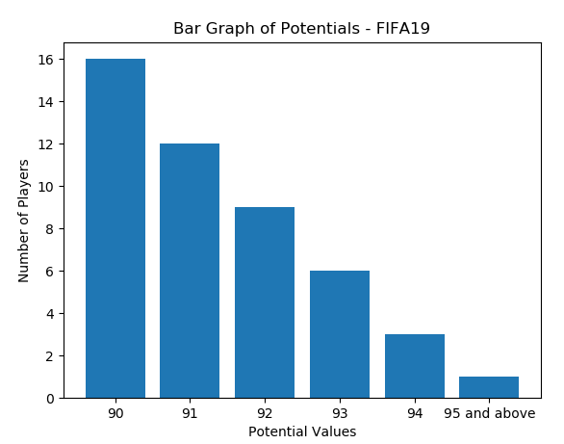
Fig. 25: Bar graph of potentials – FIFA 19
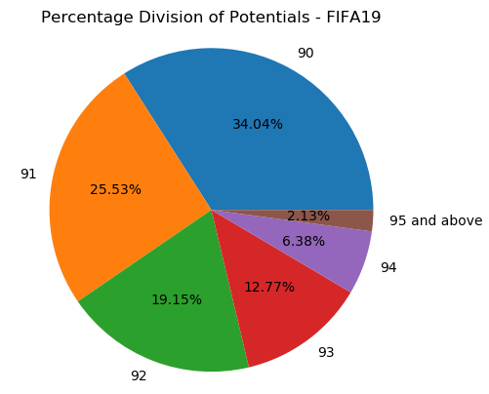
Fig. 26: Percentage of potentials – FIFA 19
It can be observed from Fig. 25 and Fig. 26 that the expected number of players with potentials of 90 was higher than any other potential, making up 34.04% of the high potential players. 2.13% of the high potential players were considered to reach potentials of 95 and above.
3.14 FIFA 20
FIFA 20 introduced a game mode which involved street football in various locations around the world, known as “Volta.” Fig. 27 and Fig. 28 depict the potentials of players in FIFA 20, in terms of frequency and the percentage distribution.
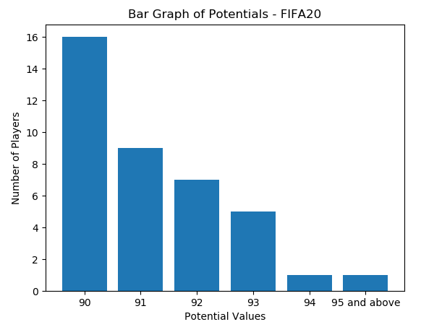
Fig. 27: Bar graph of potentials – FIFA 20

It can be observed from Fig. 27 and Fig. 28 that the expected number of players with potentials of 90 was higher than any other potential, making up 41.03% of the high potential players. Equal percentage distributions of players were considered to reach potentials of 94 and 95 and above, namely 2.56%.
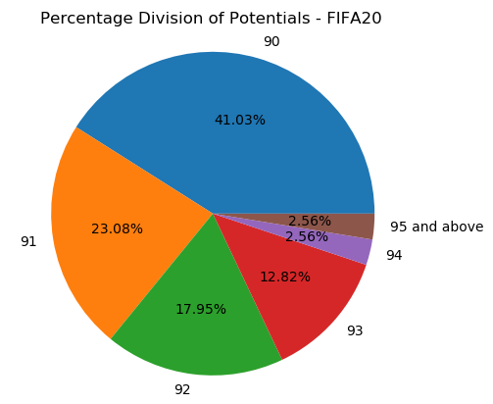
Fig. 28: Percentage of potentials – FIFA 20

4. CONCLUSION

The advent of the hugely popular culture of video games also brought in a lot of competitive players to the gaming world. This culture, known as eSports, involves virtual sporting tournaments that take place all over the world. Football is one such eSport which considers the annual releases of EA Sports FIFA titles to be used as the official games for the eSport, among other games.
The increasing demand for learning how the football players perform on the pitch and to emulate the same in the virtual world lead to the analysis of data from previous installments of the FIFA game franchise. This paper has tracked, analyzed and visualized the exceptional potential ratings of players over the period of 14 years, ranging from FIFA 07 all the way to FIFA 20.
It can be concluded after thorough analysis and visualization that most well-performing players are expected to reach overall ratings of 90 over the course of their career. This takes into account their age and depends on their playing time on the field as well. Injuries can always hamper a sportsperson’s career in real life, and it can adversely affect his or her ratings in the virtual world, thereby showcasing a small limitation of this particular analysis.
With reference to the performance of the players prior to the global lockdown due to COVID-19, it can be safe to assume that at least 35-40 players will be considered as the frontrunners among the world, with highest player potential ratings. Amongst these, the highest ones could be expected as Erling Haaland, Jadon Sancho and Kylian Mbappe, as they have been in wonderful form throughout the 2019-20 season. Their potentials could well be expected to reach at least 92-94 in the upcoming installment of the FIFA franchise, namely FIFA 21. Lionel Messi could once again reach the list of top potentials as he demonstrated good form and has featured in every single list of highest potentials so far in the considered list of annual FIFA titles.
REFERENCES

- K. Gadiya, “FIFA 19 complete player dataset”, 2019.
Online:https://www.kaggle.com/karangadiya/fifa19
- K. Gadiya, “Exploratory data analysis on FIFA 2019 data”, 2019.
Online:https://www.kaggle.com/karangadiya/exploratory-data-analysis-on-fifa-2019-data
- A. Sharma, “FIFA Data Analysis & Player Value Prediction”, 2019.
Online:https://www.kaggle.com/aishwarya1992/fifa-data-analysis-player-value-prediction
- J. Zivkovic, “An In Depth Analysis of FIFA 19”, 2019.
Online:https://www.dontblamethedata.com/blog/an-in-depth-analysis-of-fifa19/
- J. Zivkovic, “Clustering to Help Club Managers”, 2019.
Online:https://www.kaggle.com/jaseziv83/clustering-to-help-club-managers
- R. Sharma, “FIFA 2019 Analysis”, 2019.
Online:https://github.com/sharmaroshan/FIFA-2019-Analysis
- A. Shrivastava, “FIFA 18 dataset”, 2018.
Online:https://github.com/amanthedorkknight/fifa18-all-player-statistics
- K. Sijko, “Fifa 18 data exploration”, 2018.
Online:https://www.kaggle.com/kamils/fifa-18-data-exploration/data
- A. Agarwal, “Fifa Players Analysis: Correlating players Age with Overall rating and Potential”, 2017.
Online:https://rstudio-pubs-static.s3.amazonaws.com/345191_75eb78c296af41dc80b64989b84787b8.html
- SOFIFA Database, 2020.
Online:https://sofifa.com/
- A. Hegde, “FIFA Players Database”, 2020.
Online:https://github.com/akashshegde11/FIFA-Players-Database

BIOGRAPHY
 | Akash Hegde is a final year Master of Technology student in the specialization of Computer Network Engineering, Department of Computer Science and Engineering, R. V. College of Engineering, Bengaluru, Karnataka, India.

