|  | INTERNATIONAL TELECOMMUNICATION UNION  **TELECOMMUNICATION** **STANDARDIZATION SECTOR**  STUDY PERIOD 2022-2024 | | **Focus Group on AI Native Networks** | |
| --- | --- | --- | --- | --- |
| **AINN-I-xx** | |
| **Original: English** | |
| **Question(s):** | | N/A | Virtual, TBD 2024 | |
| **INPUT DOCUMENT** | | | | |
| **Source:** | | *CDAC* | | |
| **Title:** | | *NatureLover Team - Report on* *ITU WTSA Hackathon 2024 – AI boosted Interpretable Renewable Energy Forecasting* | | |
| **Contact:** | | Akash Shinde | | E-mail: akashshinde1418@gmail.com |

| **Abstract:** | This document contains the submission of a report for *NatureLovers team* towards ITU WTSA Hackathon 2024 for use case AI boosted Interpretable Renewable Energy Forecasting. |
| --- | --- |

## Use case introduction:

## **“**AI boosted Interpretable Renewable Solar Energy Forecasting**”**

### Problem Statement

1. **Intermittent Solar Energy Production**: Solar energy production is highly variable due to factors such as weather conditions, cloud cover, and seasonal changes. This variability poses a challenge for private and government electricity producers in managing supply and demand.
2. **Electricity Trading and Grid Management**: Efficient electricity trading and grid stability require accurate forecasts to balance production with consumption, prevent overloading, and plan maintenance activities effectively.
3. **Limitations of Traditional Forecasting**: Traditional models, typically based on simple regression techniques, often suffer from low accuracy and lack interpretability, making it difficult for grid operators to trust and act on the predictions.

### Objective

To develop an AI-based solution that provides accurate and interpretable short-term (nowcasting) and long-term (day ahead) forecasting of solar energy production. This solution will assist in:

* **Optimizing Electricity Trading**: Helping private producers decide when to use or sell electricity.
* **Power Grid Management**: Enabling government companies to manage grid stability and schedule maintenance activities efficiently.

Consider the scene map below:

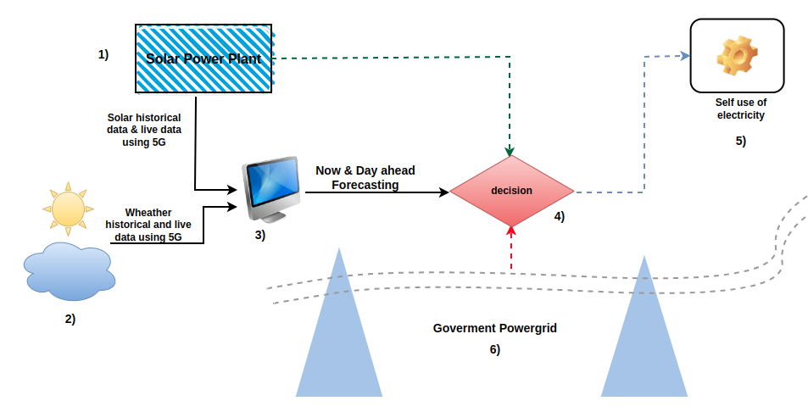

### Proposed Solution

#### 1. Data Collection and Preprocessing

* **Data Sources**:
  + Historical solar power generation data from private and government plants.
  + Weather data (temperature, cloud cover, humidity, etc.).
  + Geospatial data (location, altitude, orientation of panels, etc.).
* **Data Preprocessing**:
  + Cleaning and handling missing data.
  + Feature engineering (e.g., creating derived features like solar irradiance).
  + Data normalization and scaling.

#### 2. Modeling Techniques

* **Conventional tree Based AI Models**: For capturing complex interaction between features **and Interpretation.**
  + Decision Tree
  + Random Forest
  + GRadient Boost
* **Nowcasting Approach**:
  + Real-time or near real-time predictions using recent data and rapid adaptation to changing conditions.
* **Long-term Forecasting**:
  + Predictions for a longer horizon, using a combination of historical data and predictive analytics.

#### 3. Interpretability Techniques

* **Visualization**:
  + Heatmaps, feature importance plots, and time-series visualizations to effectively communicate the model's insights to grid operators.

#### 4. Deployment and Integration

* **API Development**: For integrating with existing systems used by electricity producers and grid managers.
* **Real-time Dashboard**: For visualizing predictions, uncertainties, and explanations.
* **Alerts and Notifications**: For proactive decision-making and grid management.

### Potential Benefits

* **Improved Accuracy**: AI models can learn complex patterns and interactions, significantly enhancing the accuracy of solar energy forecasts.
* **Enhanced Interpretability**: Model interpretability tools make AI predictions more transparent, increasing trust and usability among grid operators.
* **Operational Efficiency**: Accurate forecasting enables optimized trading and efficient grid management, reducing costs and improving reliability.

### Future Directions

* **Incorporating External Data**: Using satellite imagery, real-time weather data, and IoT devices for enhanced prediction accuracy.
* **Collaboration with Energy Stakeholders**: Working closely with energy producers, grid operators, and policymakers to fine-tune models and integrate them into operational workflows.

**Use case requirements**

1. It’s required to use numerical weather prediction data for day-ahead forecasting.
2. It’s required to use measured power data from renewable power plants, which is always private, for model training.
3. It’s required to use real-time observed weather data for error analysis.

**Relation to Standards**

1. SDG 7: Affordable and Clean Energy
2. SDG 9: Industry, Innovation, and Infrastructure
3. SDG 11: Sustainable Cities and Communities

_________________