ForgeERP
Organization ERP User Guide
Organization software ko basics se complete workflow tak kaise use karein
Hinglish step-by-step manual • Screenshots + workflow diagrams
Version 1.0 | 06 November 2026
Screenshots isolated demo data se liye gaye hain: Shree Forge Industries, FY 2627.
Real company names, amounts, GSTIN, passwords aur counts aapke deployment me alag honge.

Is guide me kya hai
1. Shuruat: ERP kya hai, login, screen aur navigation
2. Pehla setup: company se opening stock tak
3. Masters: Parties, Items, Warehouses, Processes, Party Rates, Company
4. Dashboard
5. Sales: invoice banana, GST, print, duplicate, cancel
6. Purchase: supplier bill aur input GST
7. Accounting: Receipt/Payment, allocation, Party Ledger
8. Inventory: Stock Summary, Stock Ledger, Opening Stock
9. Jobwork: Inward → Job Card → Certificate → Invoice
10. Reports: GSTR-1, Trial Balance, Outstanding, P&L
11. Tally Export, connector aur e-Invoice JSON
12. Audit Trail aur in-app Docs
13. Mobile use aur keyboard shortcuts
14. Daily / weekly / month-end SOP
15. Troubleshooting aur glossary
Note: Word me Navigation Pane kholkar headings se jump kar sakte hain. Screenshots high-resolution hain; chhota text padhne ke liye Word zoom badha lein.

1. Shuruat: ERP kya hai, login, screen aur navigation

1.1 Ye software kis kaam aata hai?
ForgeERP organization ka daily business record rakhta hai: customer/supplier masters, stock, sales invoice, purchase bill, jobwork, payments, GST reports, Tally export aur audit trail. Simple bhasha me: pehle basic data setup karo, phir transaction post karo, phir payment/report se result dekho.
- Sales = customer ko maal/service bechna aur GST invoice banana.
- Purchase = supplier se maal/service kharidna aur input GST record karna.
- Jobwork = customer ka material receive karke process karna, certificate dena aur service invoice banana.
- Inventory = kitna stock aaya, gaya, bacha aur uski value.
- Accounting = paisa aaya/gaya, invoice ke against allocation, party ledger.
- Reports = GSTR-1 summary, Trial Balance, Outstanding, P&L.
- Tally Export / e-Invoice = Tally ya GST portal ke liye files prepare karna.
- Audit Trail = kisne kya create/update/cancel/export kiya, uska log.
Important limitation: Is checkout ka ERP workspace first non-platform organization ki books serve karta hai. Platform Admin me banayi gayi doosri organizations ke logins abhi read-only organization portal kholte hain; unki alag books is runtime me available nahi hain.

1.2 Login kaise karein
1. Browser me organization ka ForgeERP URL kholiye.
2. Email aur Password daliye. Demo screenshot me owner@shreeforge.example.com / forge123 hint dikhta hai; production me apna assigned credential use karein.
3. Sign in dabaiye. Success par Dashboard khulta hai.
4. Galat password par error aaye to credential check karein ya admin se reset karwayein. Bar-bar guess na karein.
5. Kaam ke baad top-right avatar/account menu se Sign out karein, especially shared computer par.
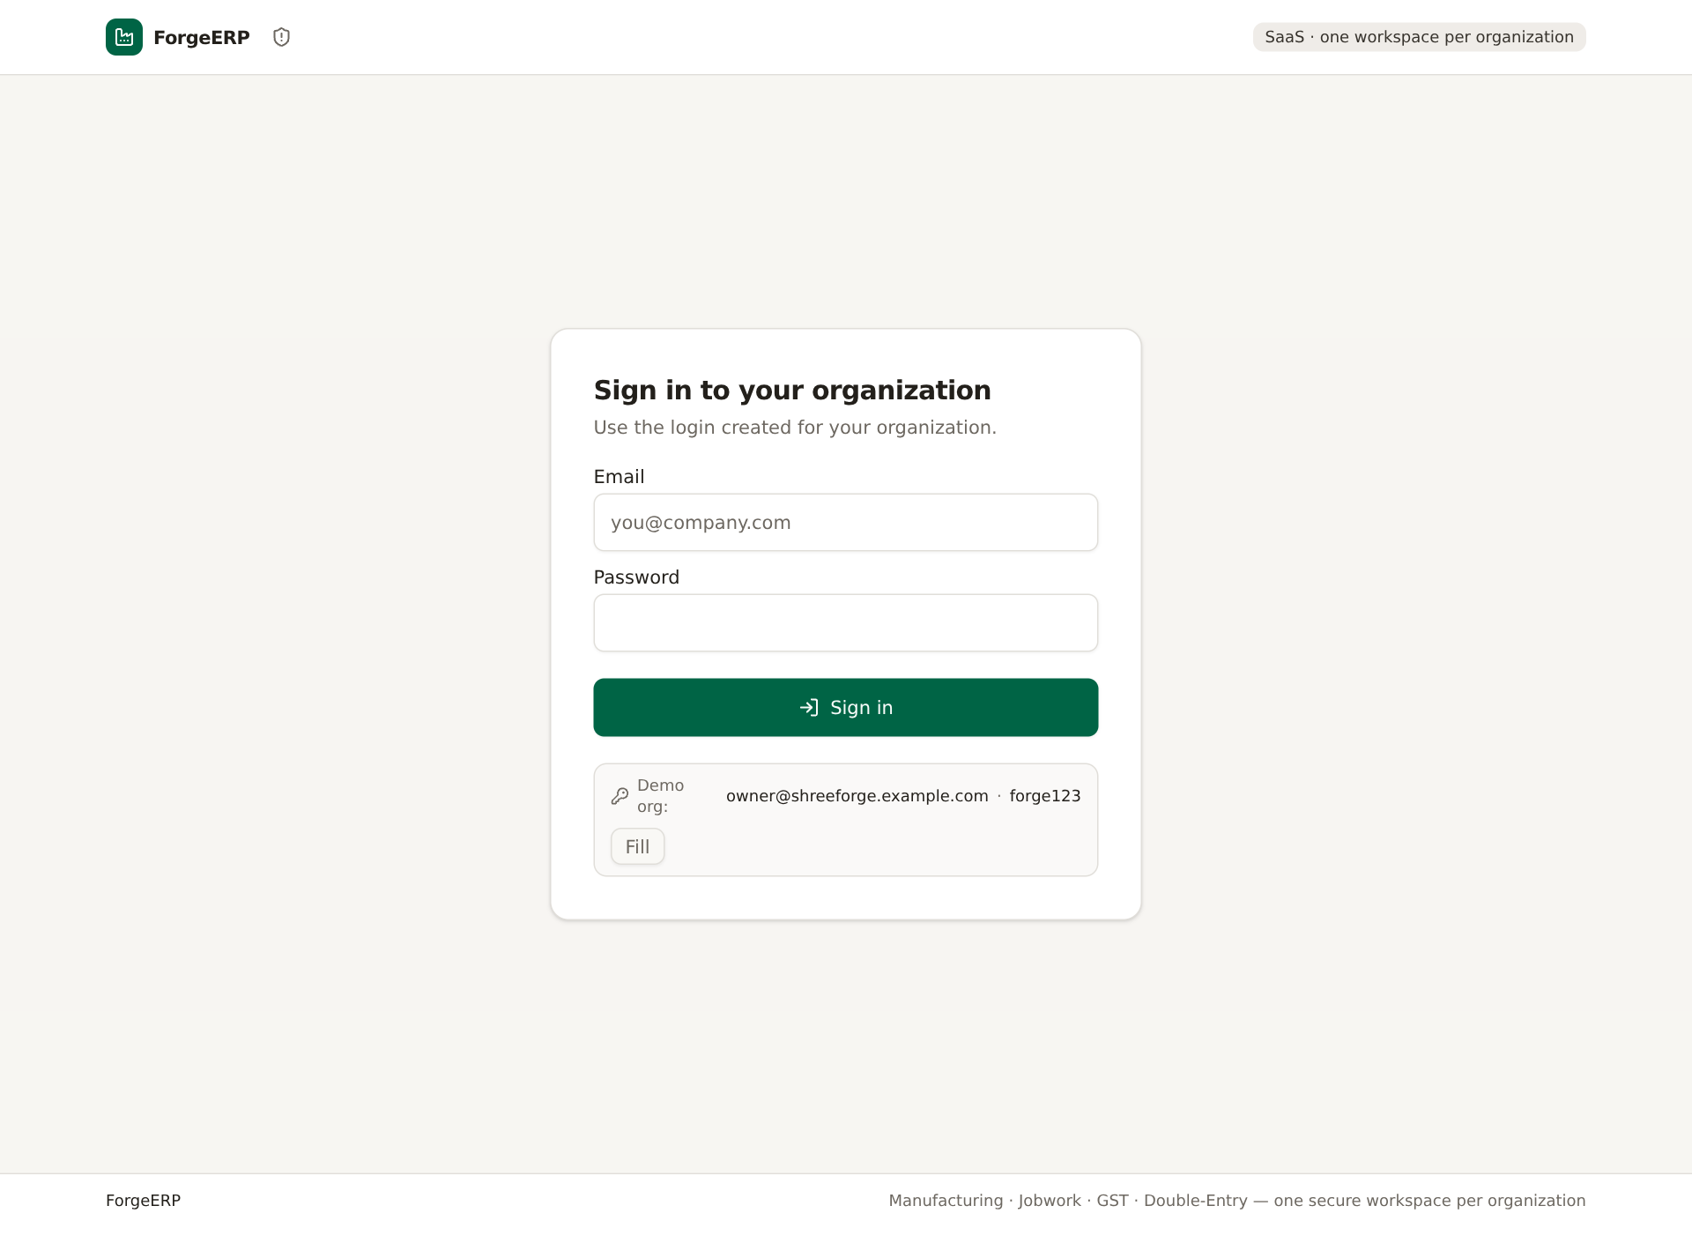
Screenshot: Organization login screen. Demo hint sirf demo lab ke liye hai.

1.3 Roles ka farq
Role | Kya kar sakta hai | Kya nahi kar sakta
OWNER | Business data create/update/cancel, exports, reports, settings | Platform Admin console manage nahi kar sakta
ACCOUNTANT | Daily posting, payments, reports, exports | Owner-level platform controls nahi
VIEWER | Read-only dekhna | Create/update/cancel/export jaise mutations nahi
SUPER_ADMIN | Platform Admin console | Normal org ERP ka daily user nahi; alag console

1.4 Screen ke main hisse
- Top bar: search/jump, GSTIN, FY, date, company name, account menu.
- Left sidebar: Dashboard, Sales, Purchase, Jobwork, Inventory, Accounting, Reports, Masters, Tally Export, Audit Trail.
- Main area: selected module ki list, tabs, forms aur reports.
- Footer: Docs link aur product context.
- Mobile: bottom navigation Home/Sales/Purchase/Jobwork/Stock aur hamburger menu se full navigation.
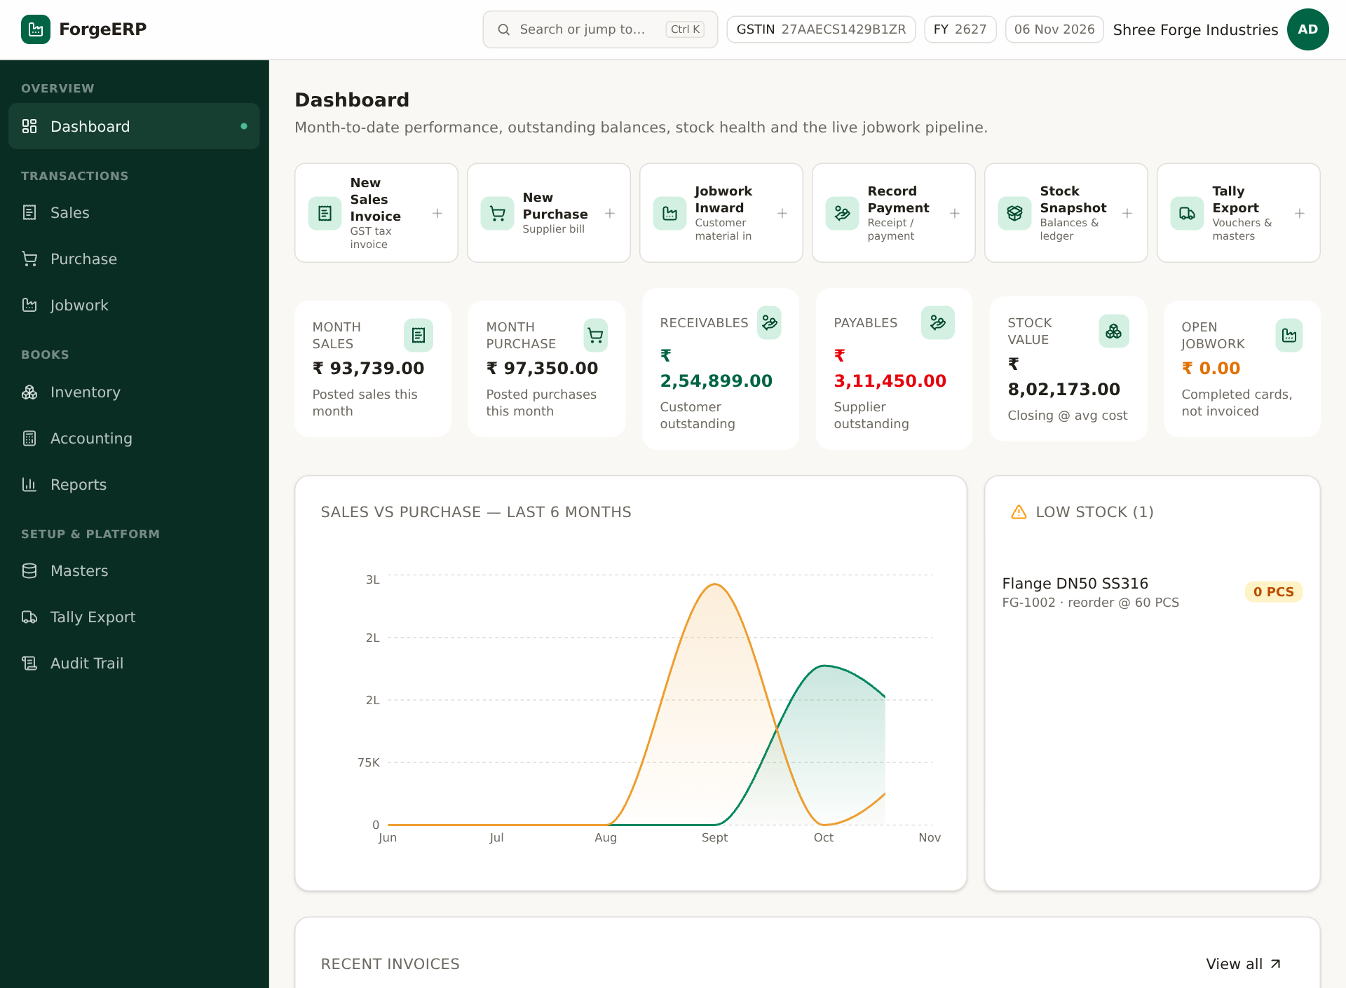
Screenshot: Dashboard aur left navigation. Yahi se daily review start hota hai.

1.5 Navigation aur shortcuts
Shortcut | Kaam
Ctrl / Cmd + K | Command palette kholna; module/search/jump
/ | Command palette kholna
? | Shortcut help
Alt + S | New sales invoice
Alt + P | New purchase invoice
g phir d/s/p/j/i/a/r/m/t/u/o | Dashboard/Sales/Purchase/Jobwork/Inventory/Accounting/Reports/Masters/Tally/Audit/Docs
Esc | Palette/dialog band karna

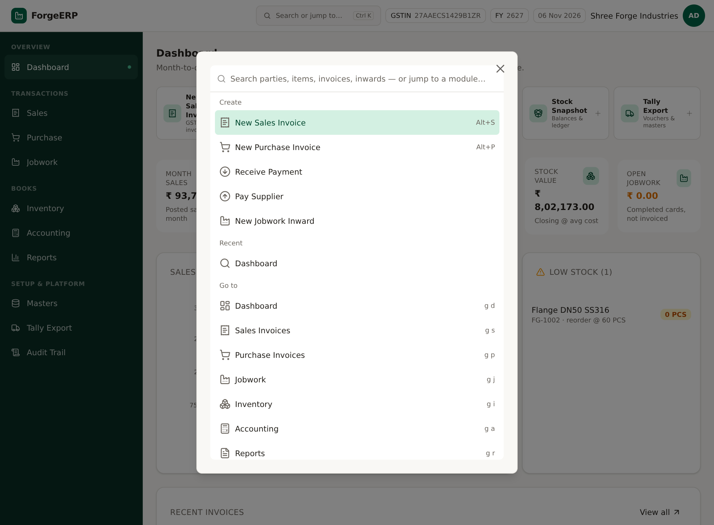
Screenshot: Command palette: type karke module ya action choose karein.
Note: Shortcuts tab kaam karte hain jab aap input/textarea me type nahi kar rahe. g ke baad agla key 1.5 second ke andar dabana hota hai.

2. Pehla setup: company se opening stock tak
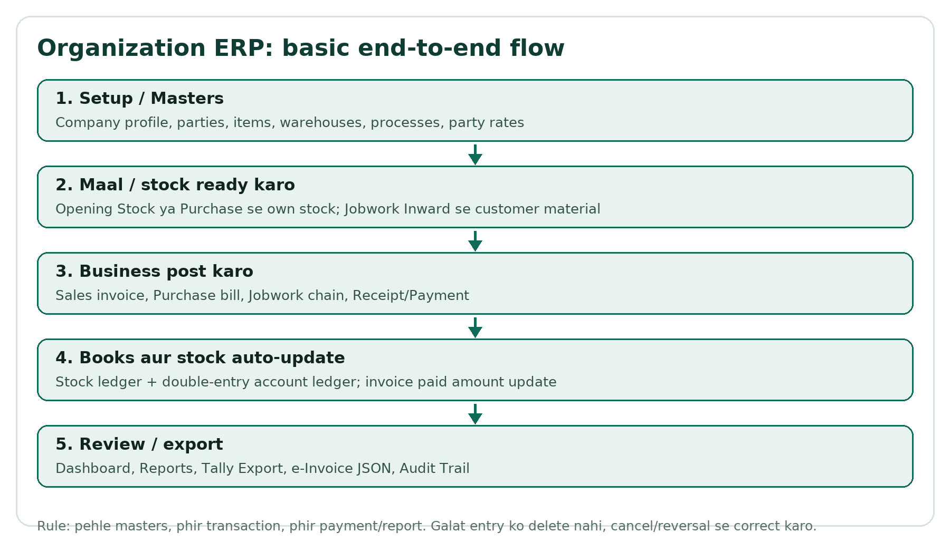
Flow: Organization ERP ka basic end-to-end flow.

2.1 Setup ka sahi order
1. Masters > Company: trade name, legal name, GSTIN, state, address, pincode, bank details save karein.
2. Masters > Parties: customers, suppliers, jobworkers banayein; GSTIN/state/pincode sahi rakhein.
3. Masters > Items: stock/service items, HSN/SAC, UOM, GST rate, sale/cost rate, reorder level.
4. Masters > Warehouses: MAIN / Jobwork Store jaise locations.
5. Masters > Processes: jobwork operations, basis, rate, lot charge.
6. Masters > Party Rates: specific customer ke liye process rate overrides.
7. Inventory > Opening Stock: go-live date ka physical stock qty aur rate.
8. Phir Sales/Purchase/Jobwork/Accounting start karein.
Note: Masters galat honge to invoice, GST, stock aur reports galat ho sakte hain. Pehle 10–20 real records se dry-run karein, phir bulk kaam shuru karein.

2.2 Go-live checklist
Check | Kyun zaroori
Company GSTIN/state/pincode | Invoice header aur e-Invoice seller details
Party GSTIN/state/pincode | B2B/B2C, CGST/SGST/IGST, e-Invoice buyer details
Item HSN/SAC + GST rate | Tax calculation aur reports
Warehouse | Stock availability aur ledger
Opening stock | Go-live se pehle ka physical stock
Process + party rates | Jobwork billing
User role | Viewer ko galti se posting access na mile

3. Masters: basic data ko detail me samjhein
Masters wo reference data hai jiske against har transaction validate hota hai. Tabs: Parties, Items, Warehouses, Processes, Party Rates, Company.

3.1 Parties
Party customer, supplier ya jobworker ho sakti hai. Ek party multiple types rakh sakti hai. Code unique hota hai; GSTIN live checksum-validate hota hai.
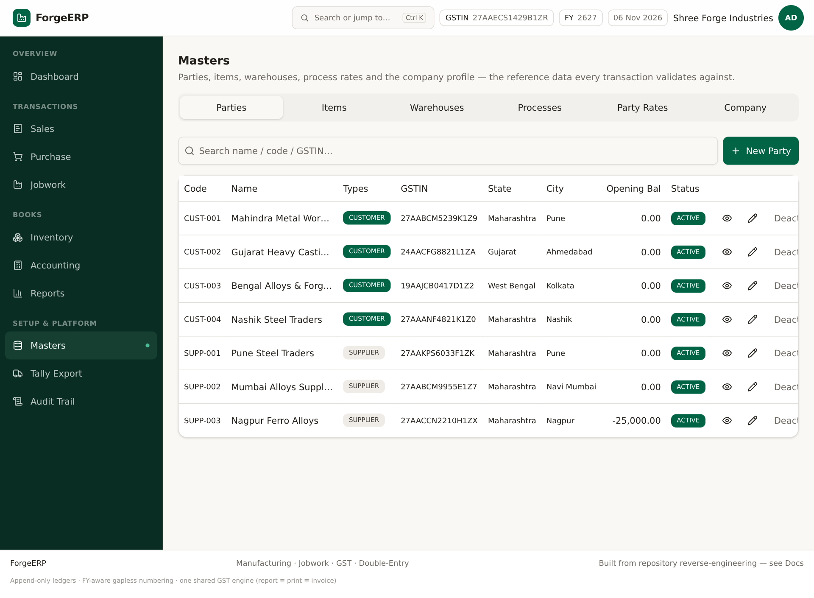
Screenshot: Parties list: code, name, types, GSTIN, state, city, opening balance, status.
1. Masters > Parties > New Party.
2. Code aur Name bharein. Code short unique rakhein, jaise CUST-004.
3. Types me CUSTOMER / SUPPLIER / JOBWORKER select karein.
4. GSTIN ho to darj karein; state code GSTIN se derive ho sakta hai. Address, city, pincode, phone, email bharein.
5. Opening Balance: positive = customer receivable, negative = supplier payable. Sirf go-live opening ke liye use karein.
6. Create party dabaiye. List me naya row verify karein.
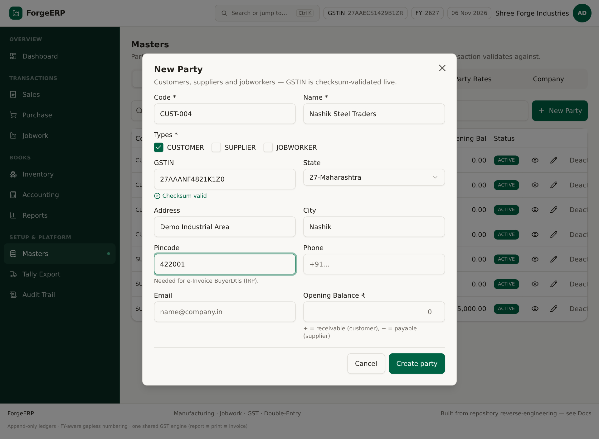
Screenshot: New Party form. GSTIN checksum valid message aur pincode e-Invoice ke liye important hai.
Field | Use / tip
Code * | Unique short ID; invoice/list me dikhta hai
Name * | Legal/party name
Types * | CUSTOMER sales ke liye, SUPPLIER purchase ke liye, JOBWORKER jobwork context
GSTIN | B2B aur e-Invoice ke liye; format/checksum sahi ho
State | Place of supply aur tax split ko affect karta hai
Address/City/Pincode | Invoice print aur e-Invoice BuyerDtls; pincode 6 digit
Opening Balance | Sirf opening receivable/payable; regular invoice ka replacement nahi
Active/Deactivate | Inactive party ko naye transaction me use na karein

3.2 Items
Item finished goods, raw material, service ya non-stock ho sakta hai. Stock item sales par availability check hota hai; service item stock movement skip karta hai.
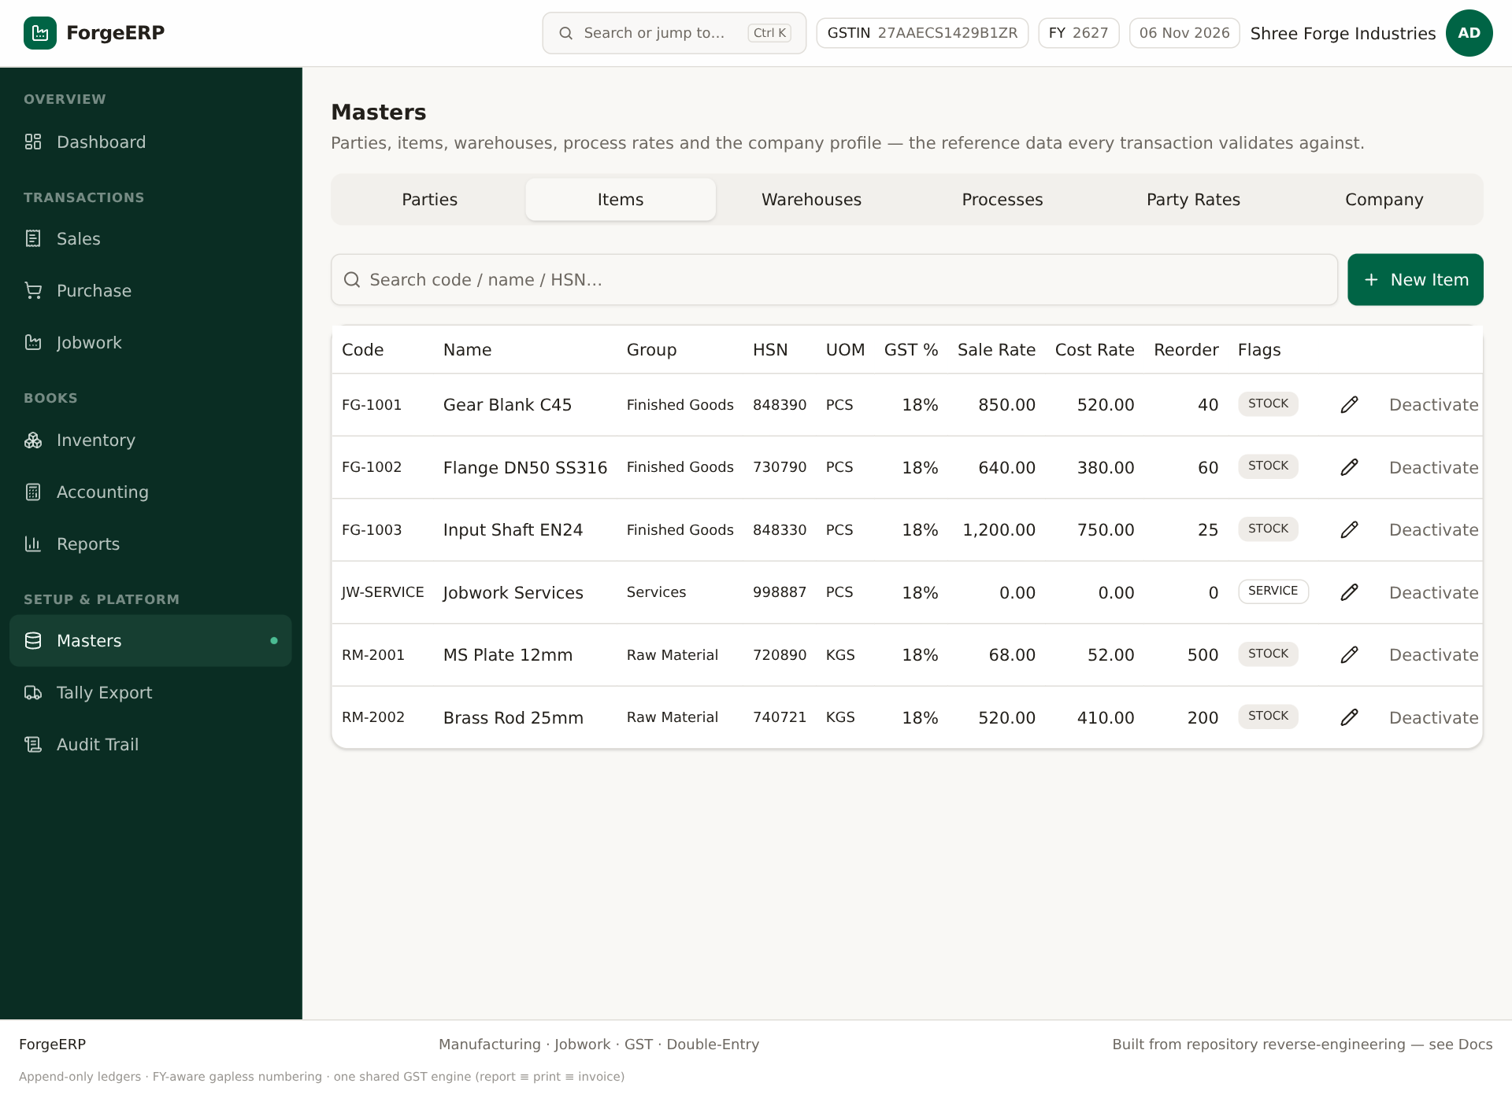
Screenshot: Items list: HSN, UOM, GST %, sale/cost rate, reorder level, flags.
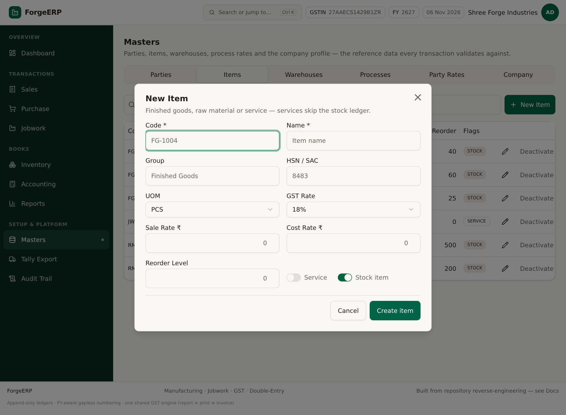
Screenshot: New Item form: code, name, group, HSN/SAC, UOM, GST rate, rates, reorder, service/stock flags.
1. Masters > Items > New Item.
2. Code, Name, Group bharein. HSN/SAC correct daalein; e-Invoice me 6/8 digit important hai.
3. UOM choose karein: PCS, KG, MTR, LTR, BOX etc.
4. GST Rate, Sale Rate, Cost Rate, Reorder Level set karein.
5. Service item hai to Service flag; stock maintain karna hai to Stock item flag.
6. Create item dabaiye aur list me verify karein.
Note: JW-SERVICE naam ka service item jobwork invoice ke liye seed/master data me expected hota hai. Use casually delete/rename na karein jab tak jobwork flow use ho raha ho.

3.3 Warehouses
Warehouse stock location hai. Invoice aur opening stock me warehouse choose karna padta hai. Availability selected warehouse par check hoti hai.
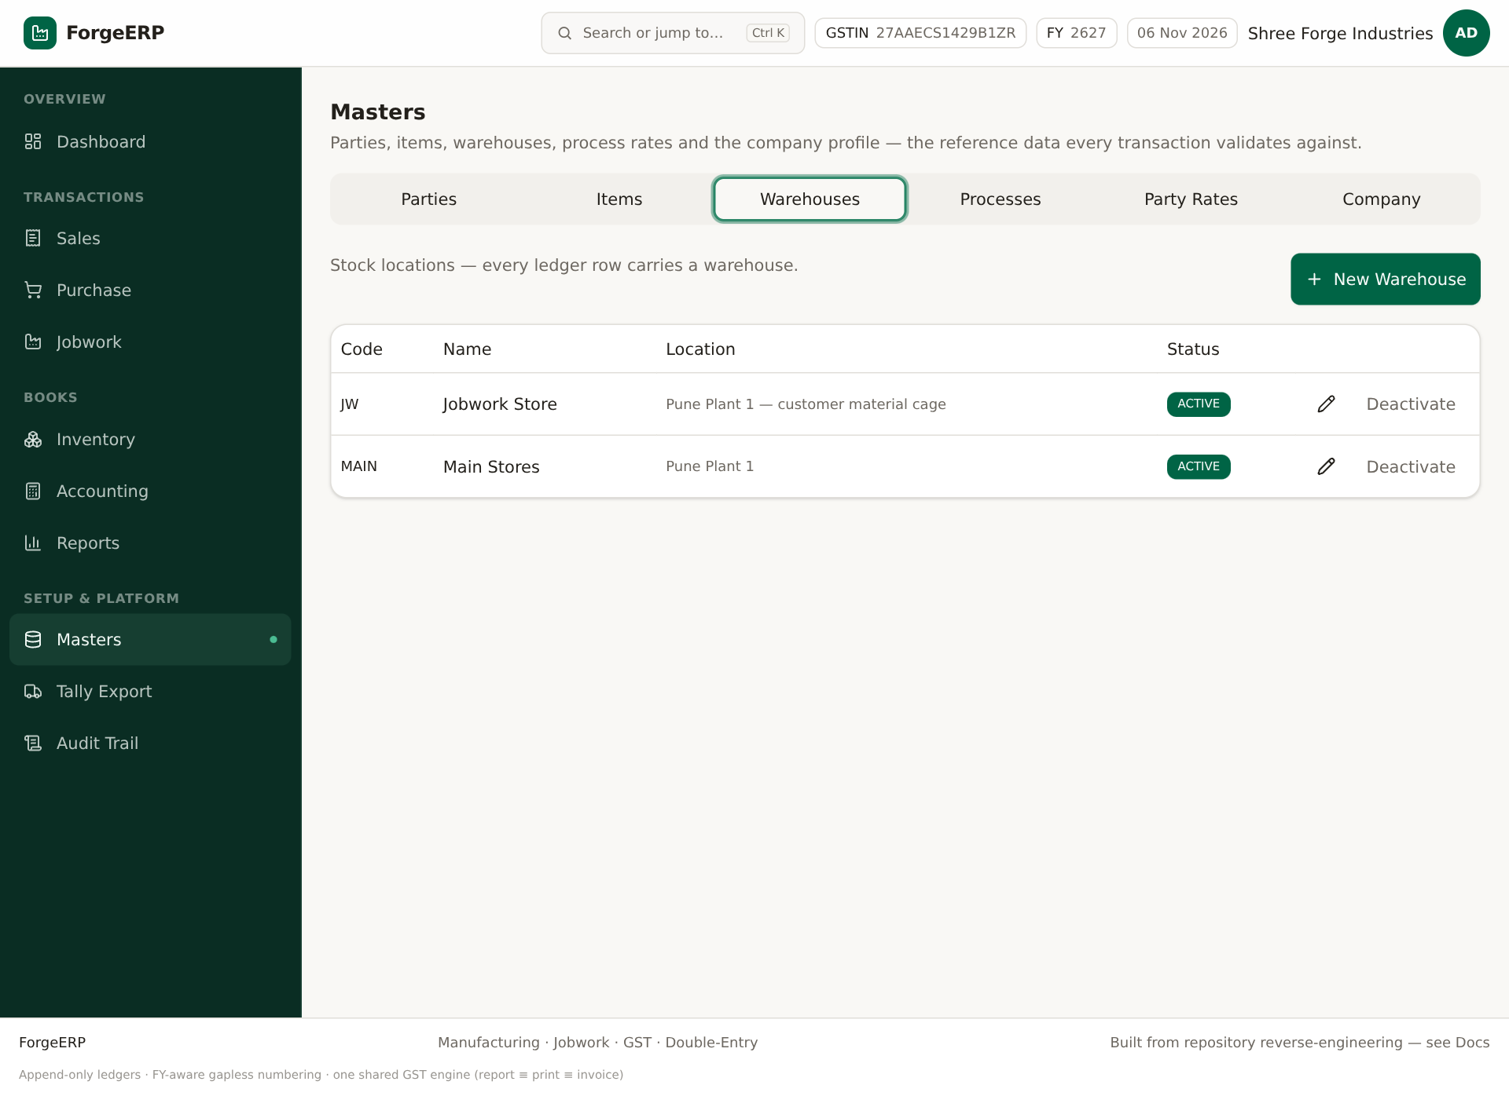
Screenshot: Warehouses: MAIN aur Jobwork Store jaise locations.
1. Masters > Warehouses > New Warehouse.
2. Code, Name, Location bharein; Create karein.
3. Opening stock aur invoices me sahi warehouse select karein.

3.4 Processes
Process jobwork operation hai: shot blasting, heat treatment, galvanizing, machining, QC, packing. Basis WEIGHT = per KG, QTY = per piece. Lot charge process ke liye fixed charge hai.
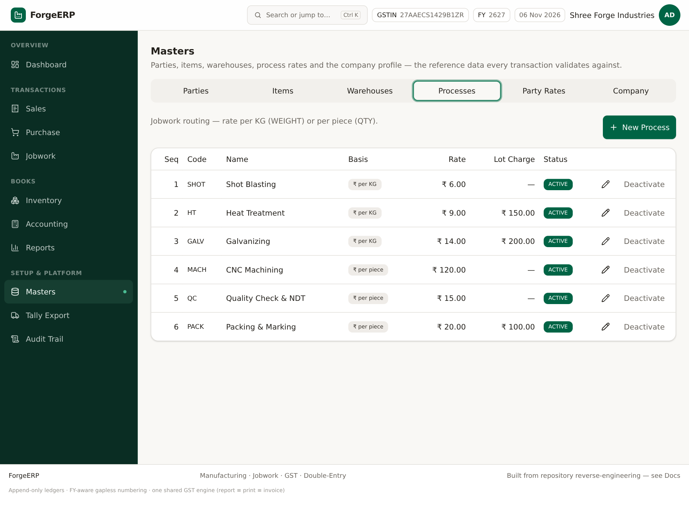
Screenshot: Processes: sequence, basis, rate, lot charge, status.
1. Masters > Processes > New Process.
2. Code, Sequence, Name, Basis, Rate, Lot Charge bharein.
3. Sequence routing order ke liye hai; job card me processes select kar sakte hain.

3.5 Party Rates
Kisi specific customer ke liye default process rate override karna ho to Party Rates use karein. Job card server party-specific rate resolve karta hai; dialog estimate default rates dikha sakta hai.
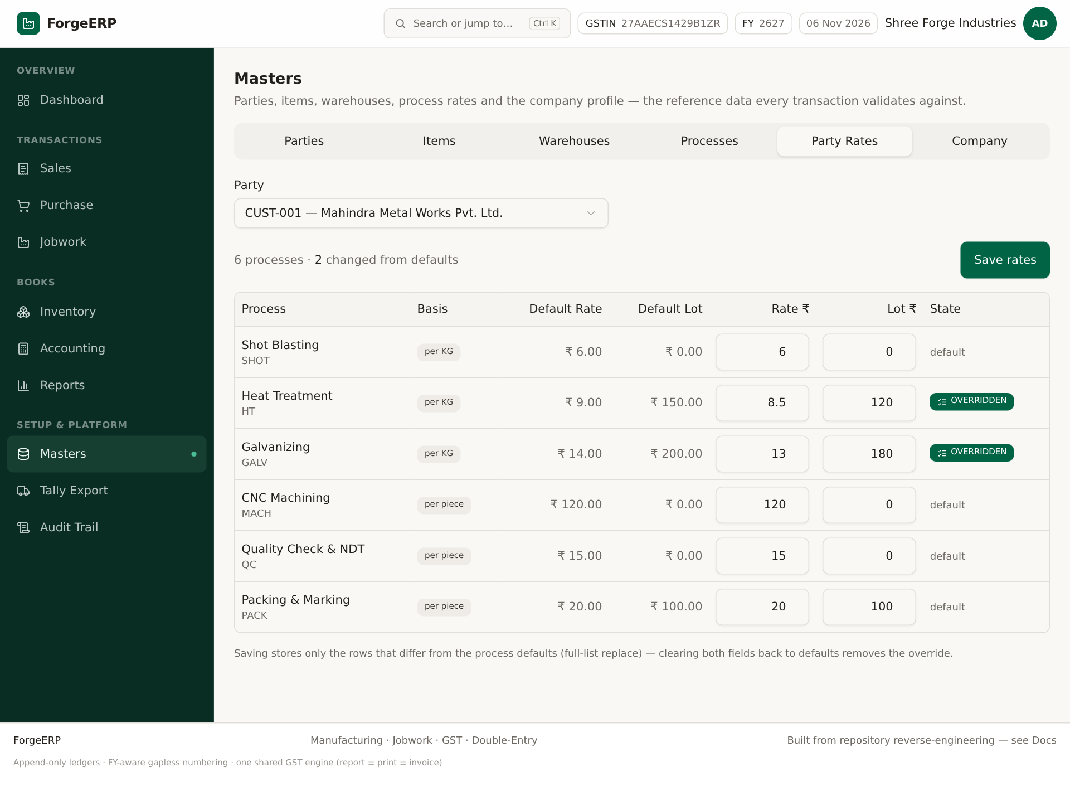
Screenshot: Party Rates: default vs overridden rate/lot charge. Save rates se overrides store hote hain.
1. Masters > Party Rates me Party select karein.
2. Har process ke Rate ₹ aur Lot ₹ fields edit karein.
3. Save rates dabaiye. OVERRIDDEN badge changed rows dikhata hai.
4. Default par wapas laana ho to values default ke barabar karein; override remove ho jata hai.

3.6 Company
Company profile invoice header, GSTIN, bank details aur Tally ledger mapping ka source hai.
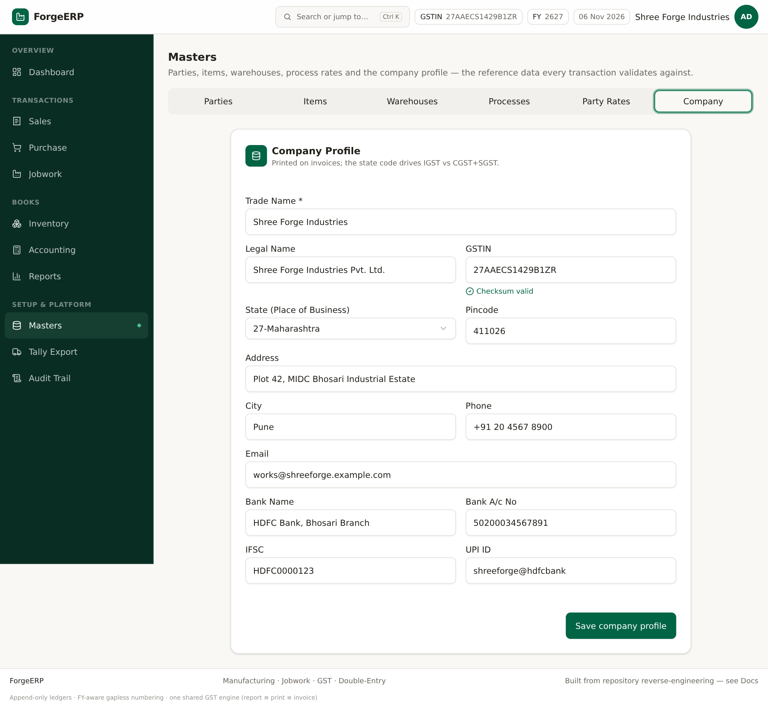
Screenshot: Company profile: trade/legal name, GSTIN, state, address, pincode, contact, bank/UPI.
1. Masters > Company kholiye.
2. Trade Name, Legal Name, GSTIN, State, Address, City, Pincode, Phone, Email verify karein.
3. Bank Name, A/c No, IFSC, UPI ID invoice print ke liye bharein.
4. Save company profile dabaiye.
Note: Company pincode/GSTIN missing ho to e-Invoice pre-validation hard error de sakti hai. Party pincode bhi 6 digit hona chahiye.

4. Dashboard
Dashboard month-to-date sales/purchase, receivables, payables, stock value, open jobwork value, 6-month trend, recent invoices aur low-stock alerts dikhata hai. Quick action buttons se seedha create/module screens khulte hain.
Screenshot: Dashboard KPIs, trend, low stock aur recent invoices.
- Month Sales/Purchase: posted vouchers ka month total.
- Receivables/Payables: party balances ka overview.
- Stock Value: weighted-average valuation ka snapshot.
- Open Jobwork: pending/processed material aur value context.
- Low Stock: reorder level se neeche items.
- Recent invoices par click karke detail khol sakte hain.
Note: Dashboard numbers tabhi sahi honge jab invoices/payments/stock sahi post hue hon. Ise final statutory report na samjhein; Reports section se verify karein.

5. Sales: invoice banana, GST, print, duplicate, cancel
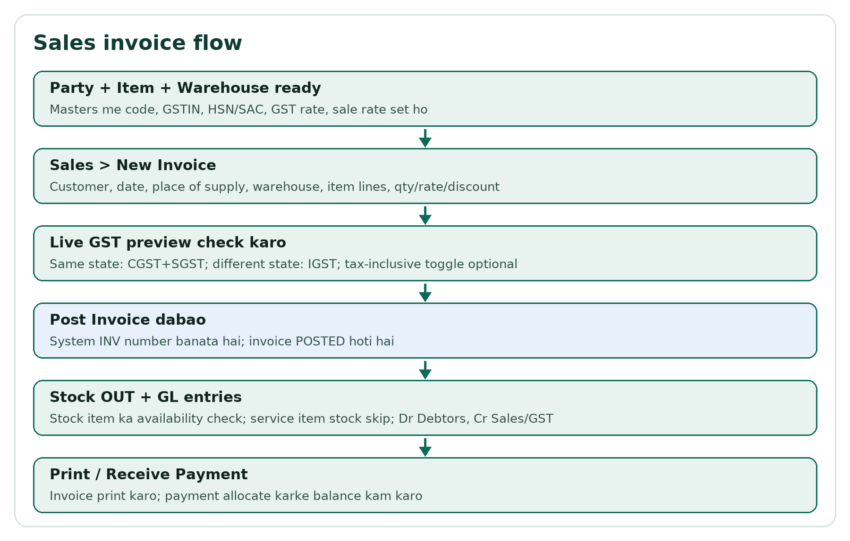
Flow: Sales invoice ka posting flow.

5.1 Sales list
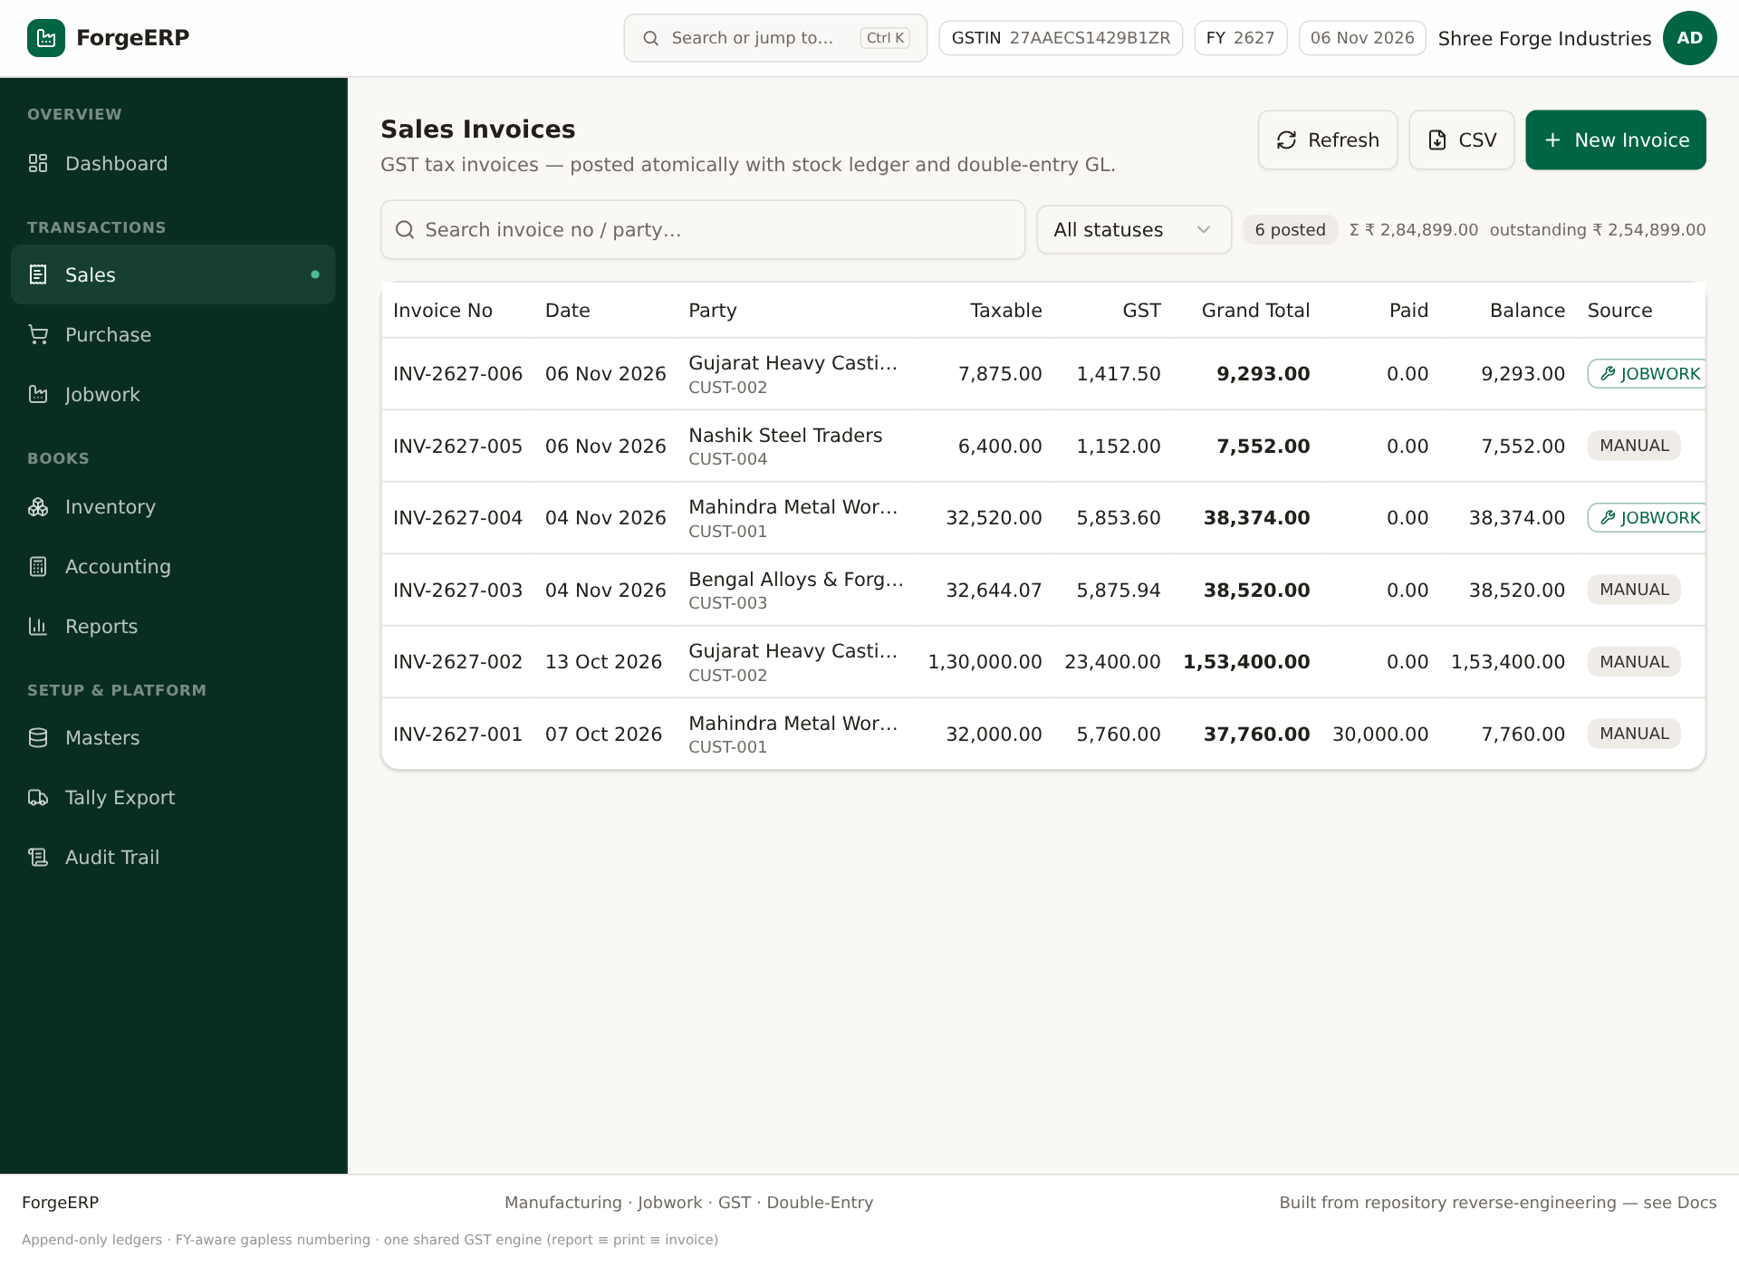
Screenshot: Sales invoices list: invoice no, date, party, taxable, GST, grand total, paid, balance, source, status.
- Search invoice no/party se filter karein.
- Status filter: POSTED / CANCELLED context.
- Row click ya View icon se invoice detail.
- Duplicate icon se same party/items ke saath naya draft.
- Tally menu se XML/JSON/CSV, masters, connector queue, mark sent, e-Invoice JSON.

5.2 Naya sales invoice
1. Sales > New Invoice.
2. Customer select karein. Party ka state/GSTIN load hota hai.
3. Date aur Place of Supply verify karein. PoS default party state se aata hai.
4. Stock from warehouse select karein. Stock items ki availability isi warehouse par check hogi.
5. Line items me Item select karein; UOM/HSN/GST/sale rate auto aa sakte hain.
6. Qty, Rate, Disc % bharein. Add line se multiple items.
7. Tax inclusive toggle tabhi on karein jab rate GST ke saath final ho.
8. Live GST preview me Taxable, CGST/SGST/IGST, Round off, Grand Total check karein.
9. Remarks optional. Post Invoice dabaiye.
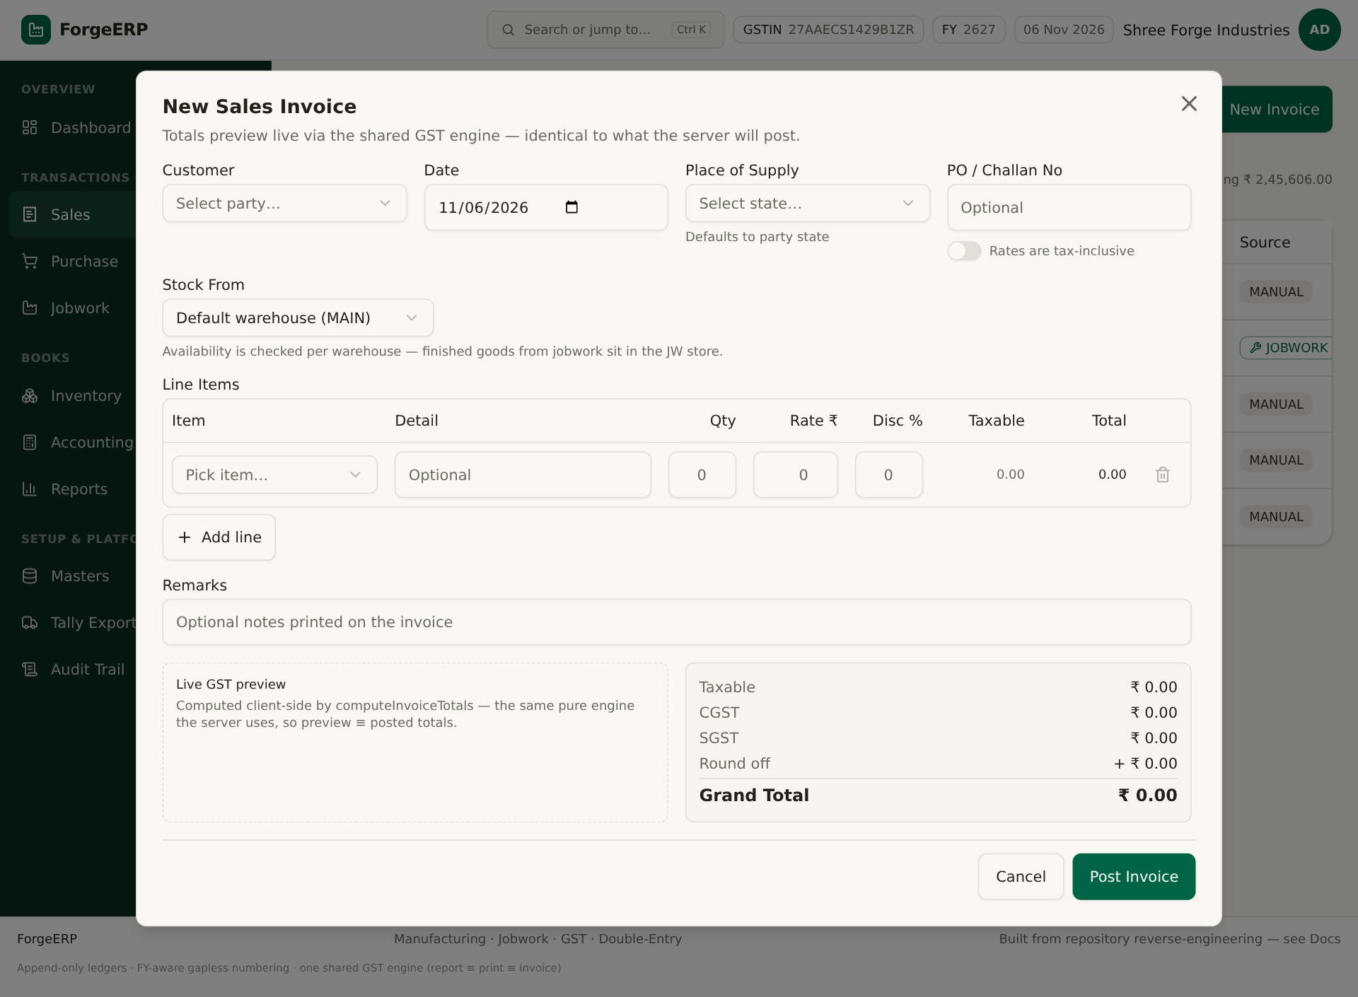
Screenshot: New Sales Invoice blank form.
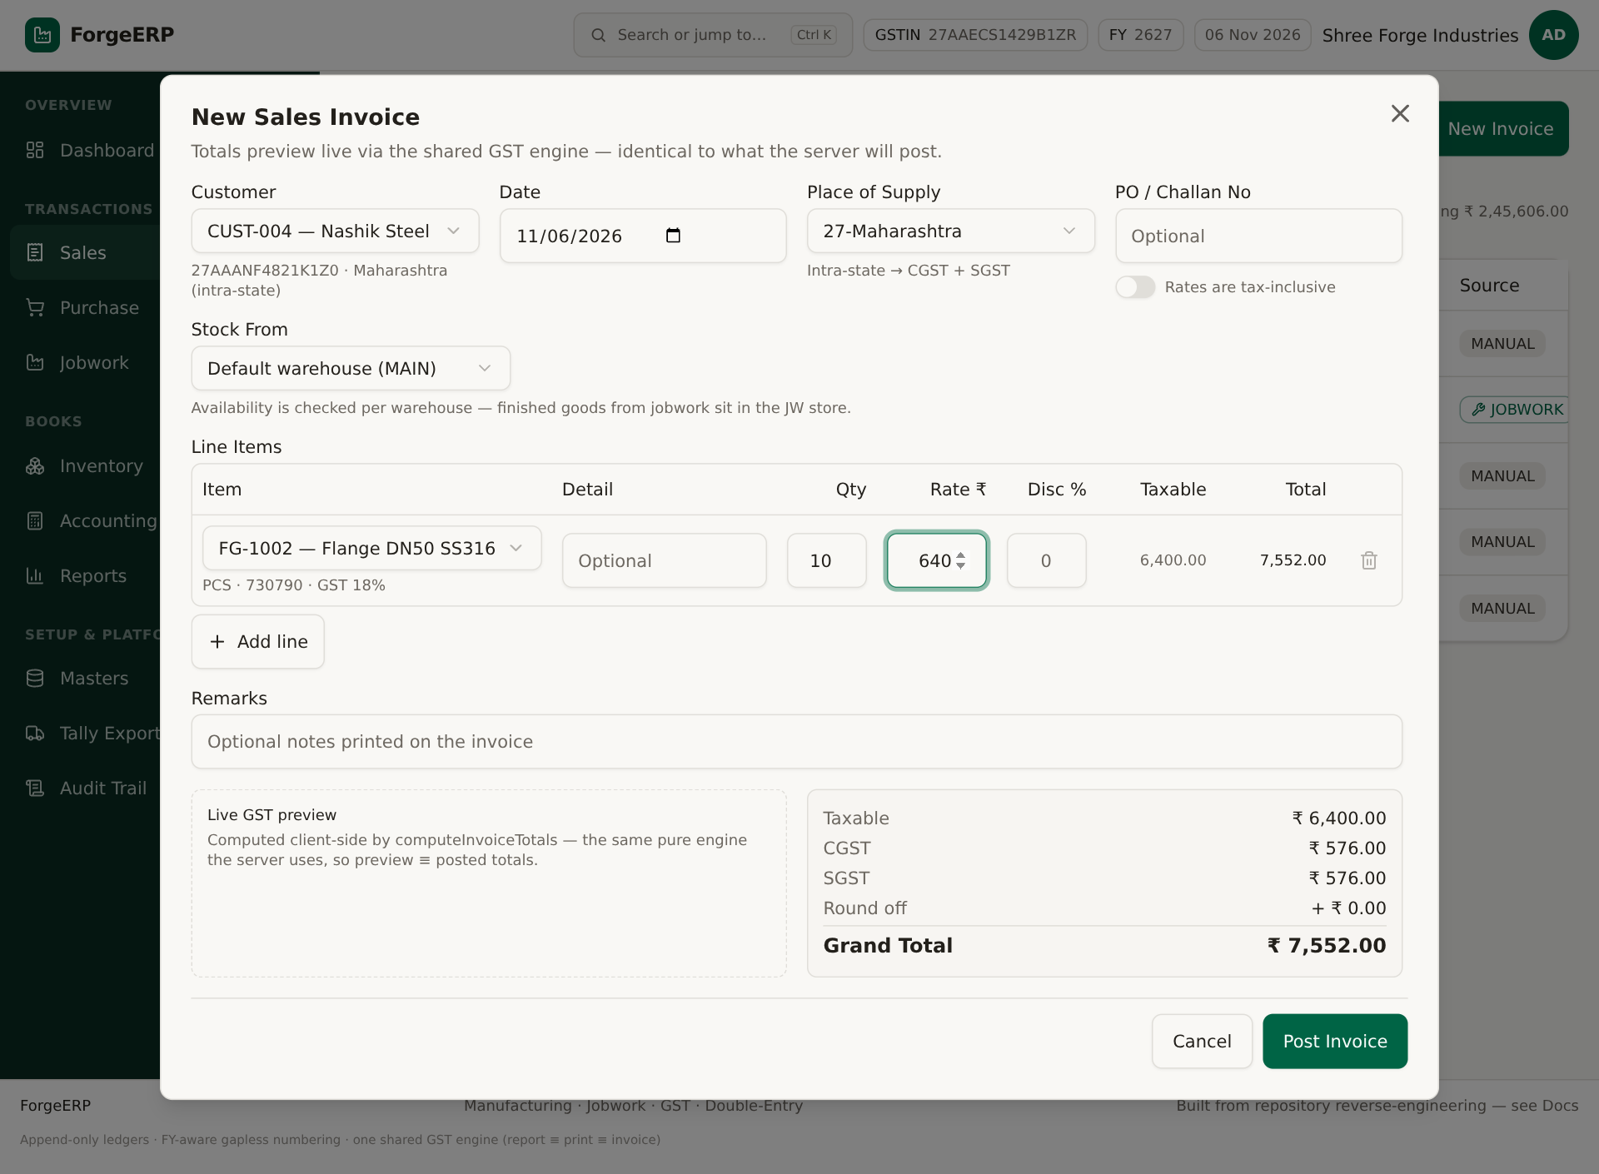
Screenshot: Demo: CUST-004, FG-1002, 10 pcs × ₹640, 18% GST; taxable ₹6,400, GST ₹1,152, total ₹7,552.

5.3 GST calculation kaise sochein
Condition | Tax split
Company state = Place of Supply | CGST + SGST, aadha-aadha
Company state ≠ Place of Supply | IGST
Tax inclusive ON | Gross amount me se taxable nikalta hai: gross / (1 + rate/100)
Round off | Grand total nearest ₹1 par round; RND ledger entry

Note: Party GSTIN hone par GSTR-1 summary me B2B bucket; GSTIN na ho to B2C. e-Invoice sirf eligible B2B sales ke liye hai.

5.4 Post hone ke baad kya hota hai?
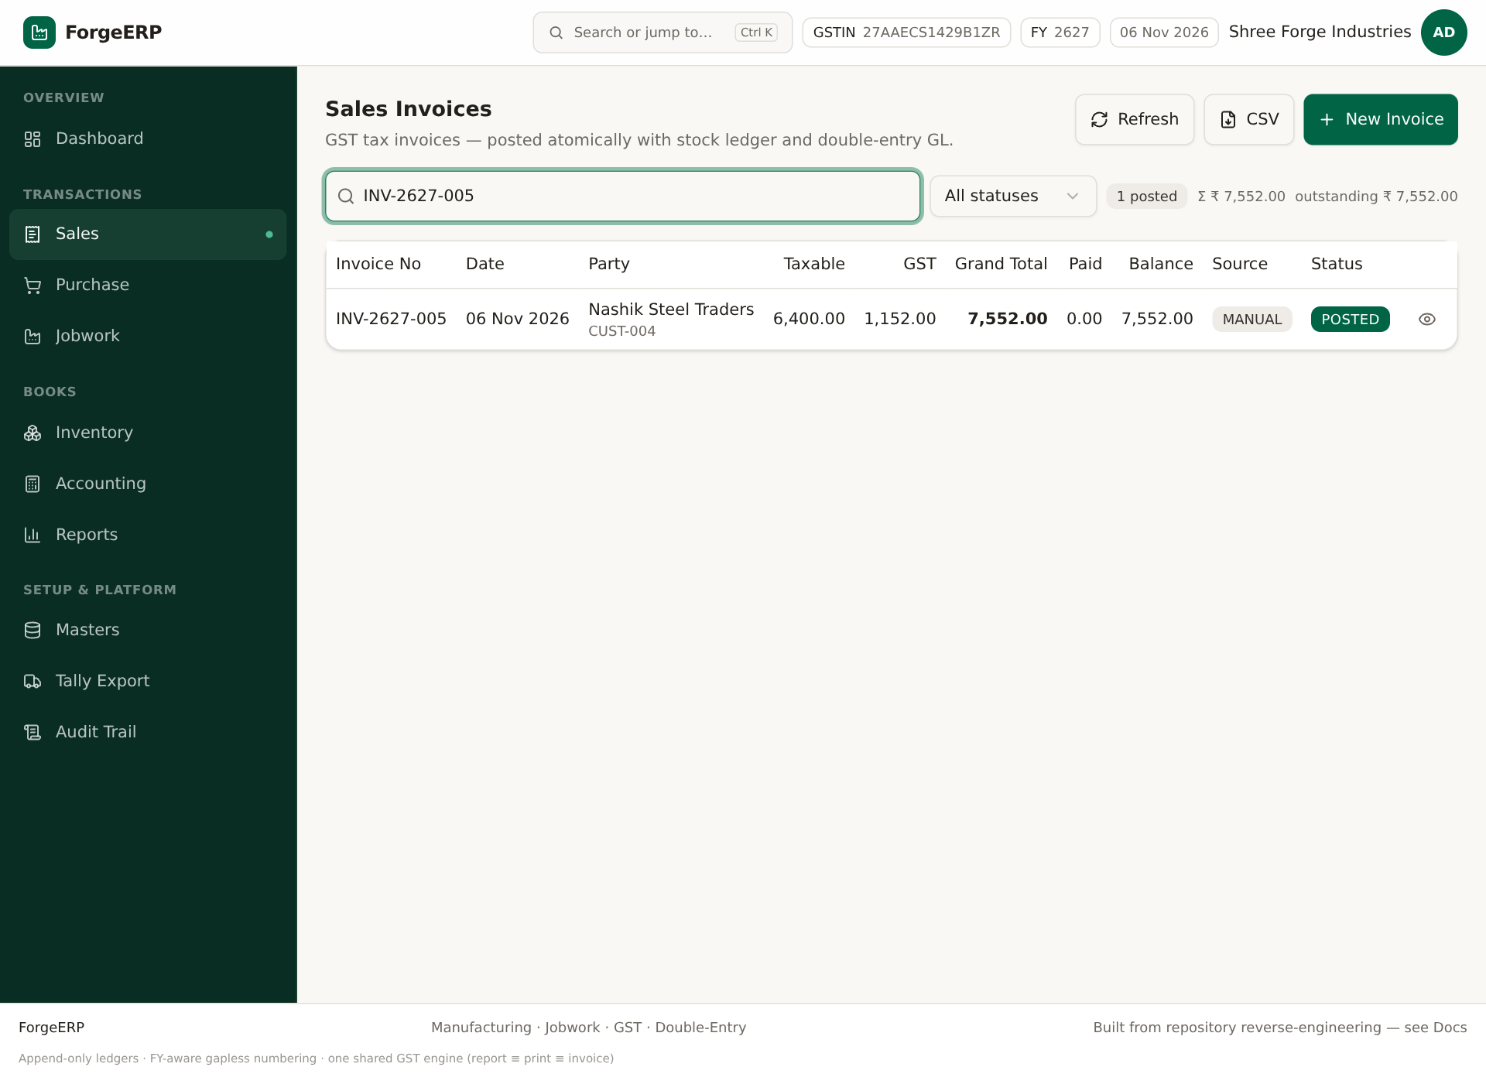
Screenshot: Post ke baad list/search me INV-2627-005 verify karein.
- Invoice number INV-FY- sequence se generate hota hai; number reuse nahi hota.
- Invoice + items save; stock item ke liye StockLedger SALES qtyOut.
- Weighted-average cost par stock value reduce; availability kam ho to error.
- GL: Dr Debtors, Cr Sales, Cr output GST, round-off adjustment.
- List refresh; status POSTED; grand total/paid/balance dikhte hain.

5.5 Invoice detail, print, duplicate
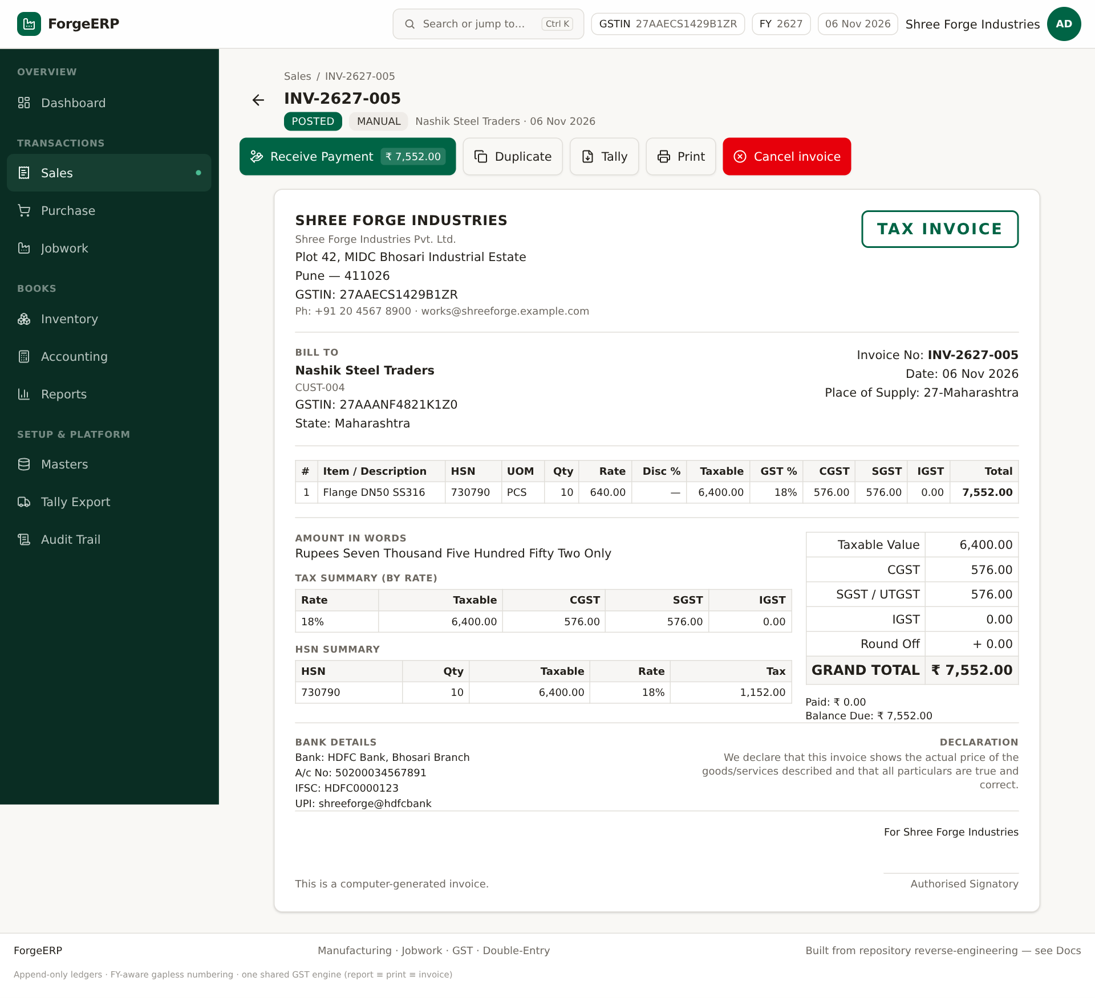
Screenshot: Invoice detail: Receive Payment, Duplicate, Tally, Print, Cancel invoice.
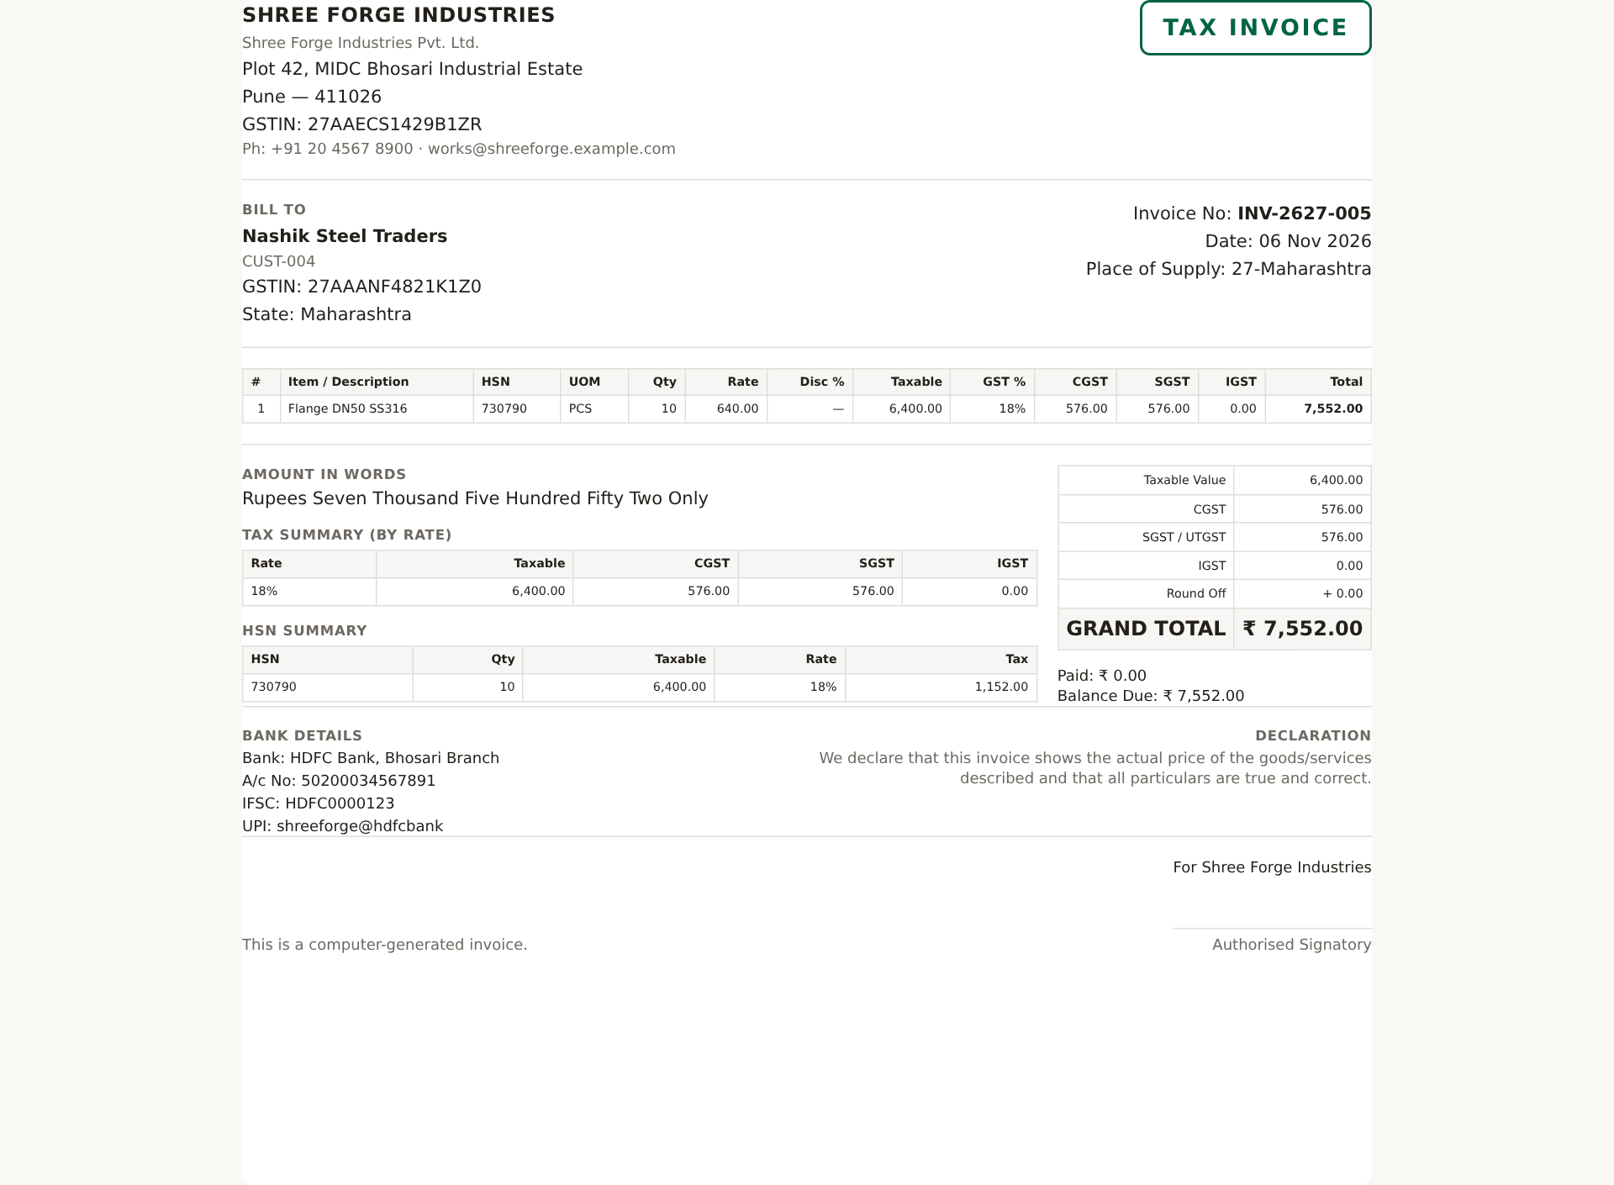
Screenshot: Print layout: GST tax invoice, HSN summary, tax split, amount in words, bank details.
1. Detail me party, lines, HSN, tax split, total, paid/balance verify karein.
2. Print dabaiye aur browser print dialog me printer/PDF choose karein.
3. Receive Payment dabane par Accounting me prefilled receipt dialog khulta hai; allocation check karke Post Payment karein.
4. Duplicate se naya draft banta hai; purani invoice copy nahi hoti, naya number milta hai.

5.6 Cancel invoice
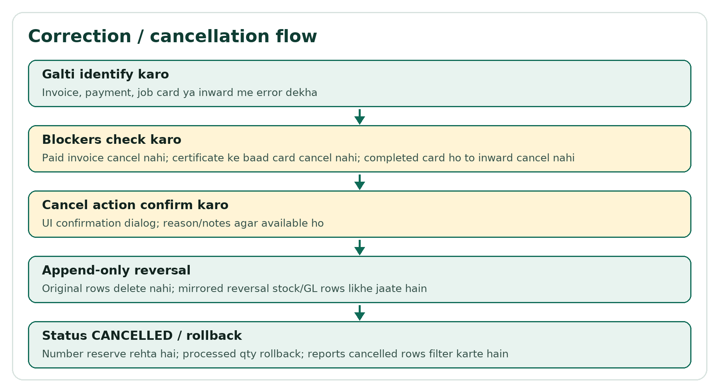
Flow: Cancellation append-only reversal flow.
1. Invoice detail me Cancel invoice dabaiye.
2. Confirmation padhein. Agar payment allocated/paid amount > 0 hai to cancel block ho sakta hai; pehle payment correction karein.
3. Confirm karne par original rows delete nahi hote; mirrored reversal stock/GL rows likhe jaate hain.
4. Status CANCELLED hota hai; number reserved rehta hai; reports cancelled rows filter karte hain.
Note: Cancel ka matlab business reversal hai, record gayab karna nahi. Audit Trail me cancellation log hota hai.

6. Purchase: supplier bill aur input GST
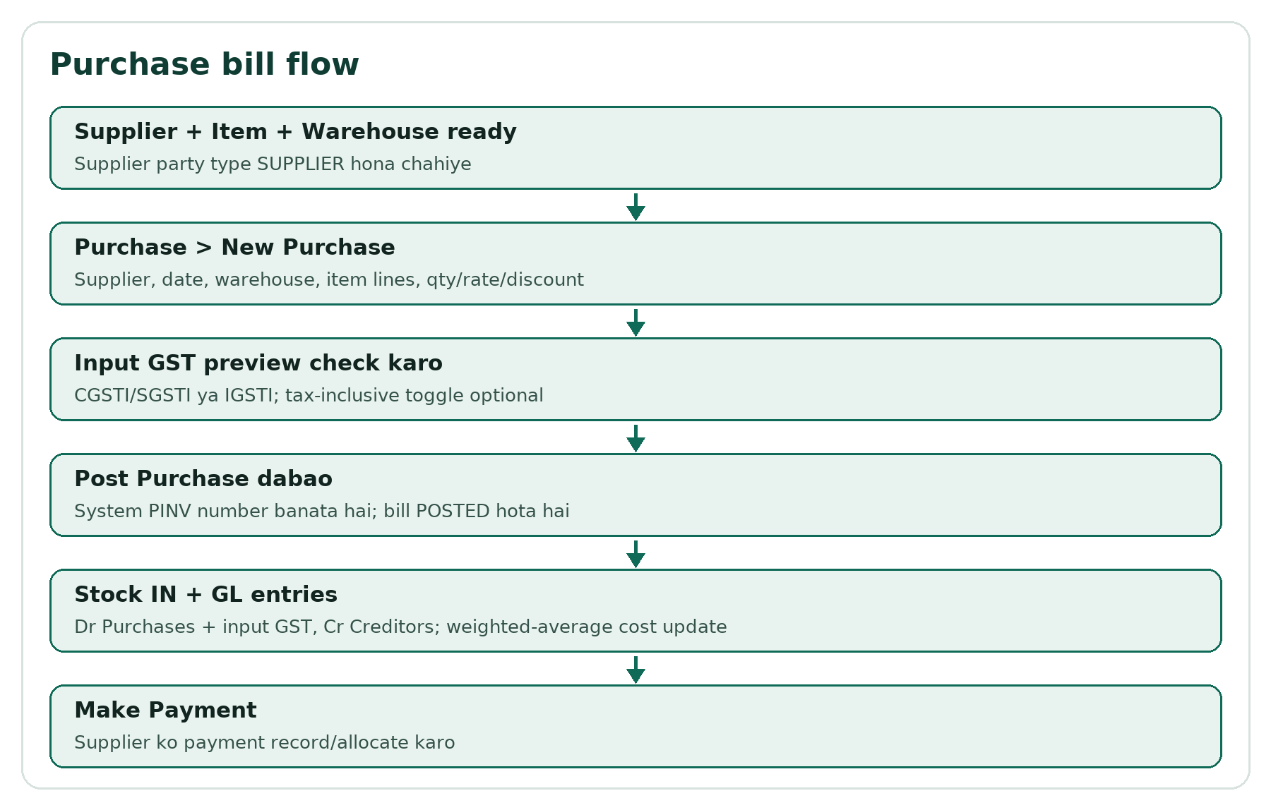
Flow: Purchase posting flow.
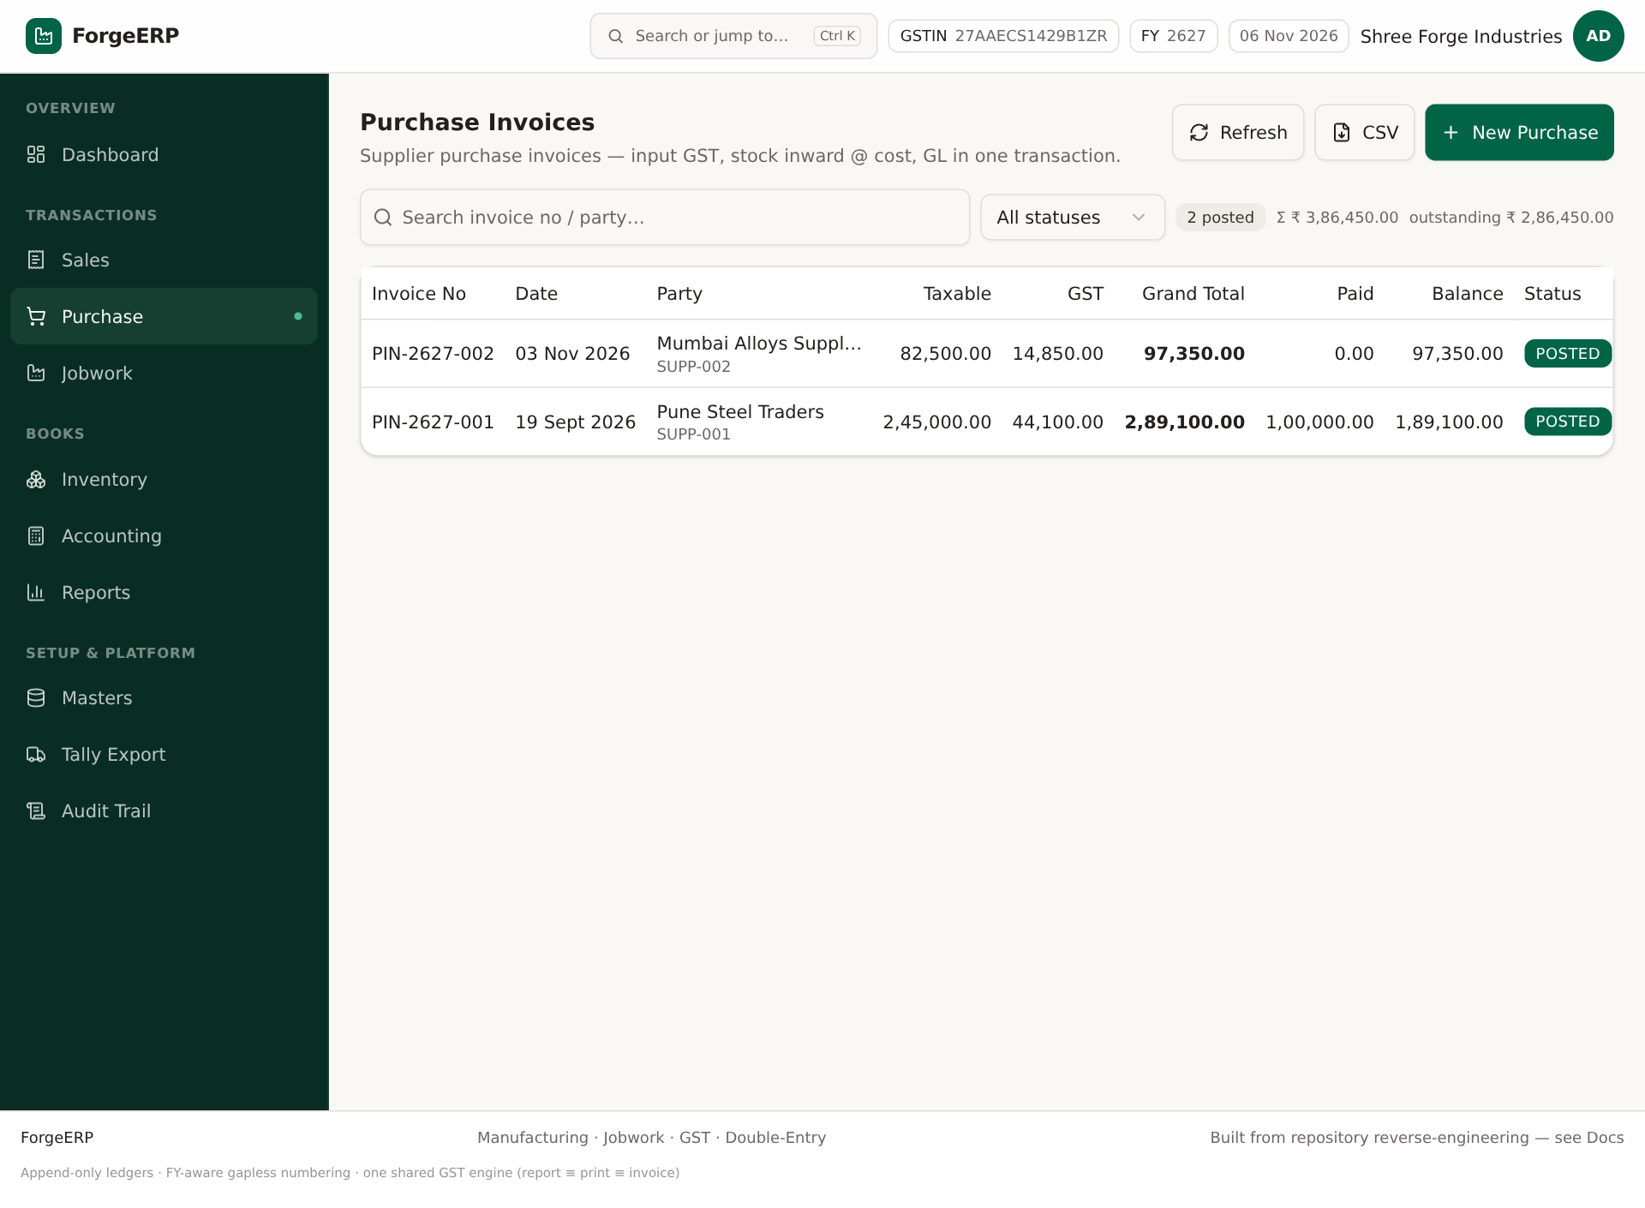
Screenshot: Purchase invoices list.
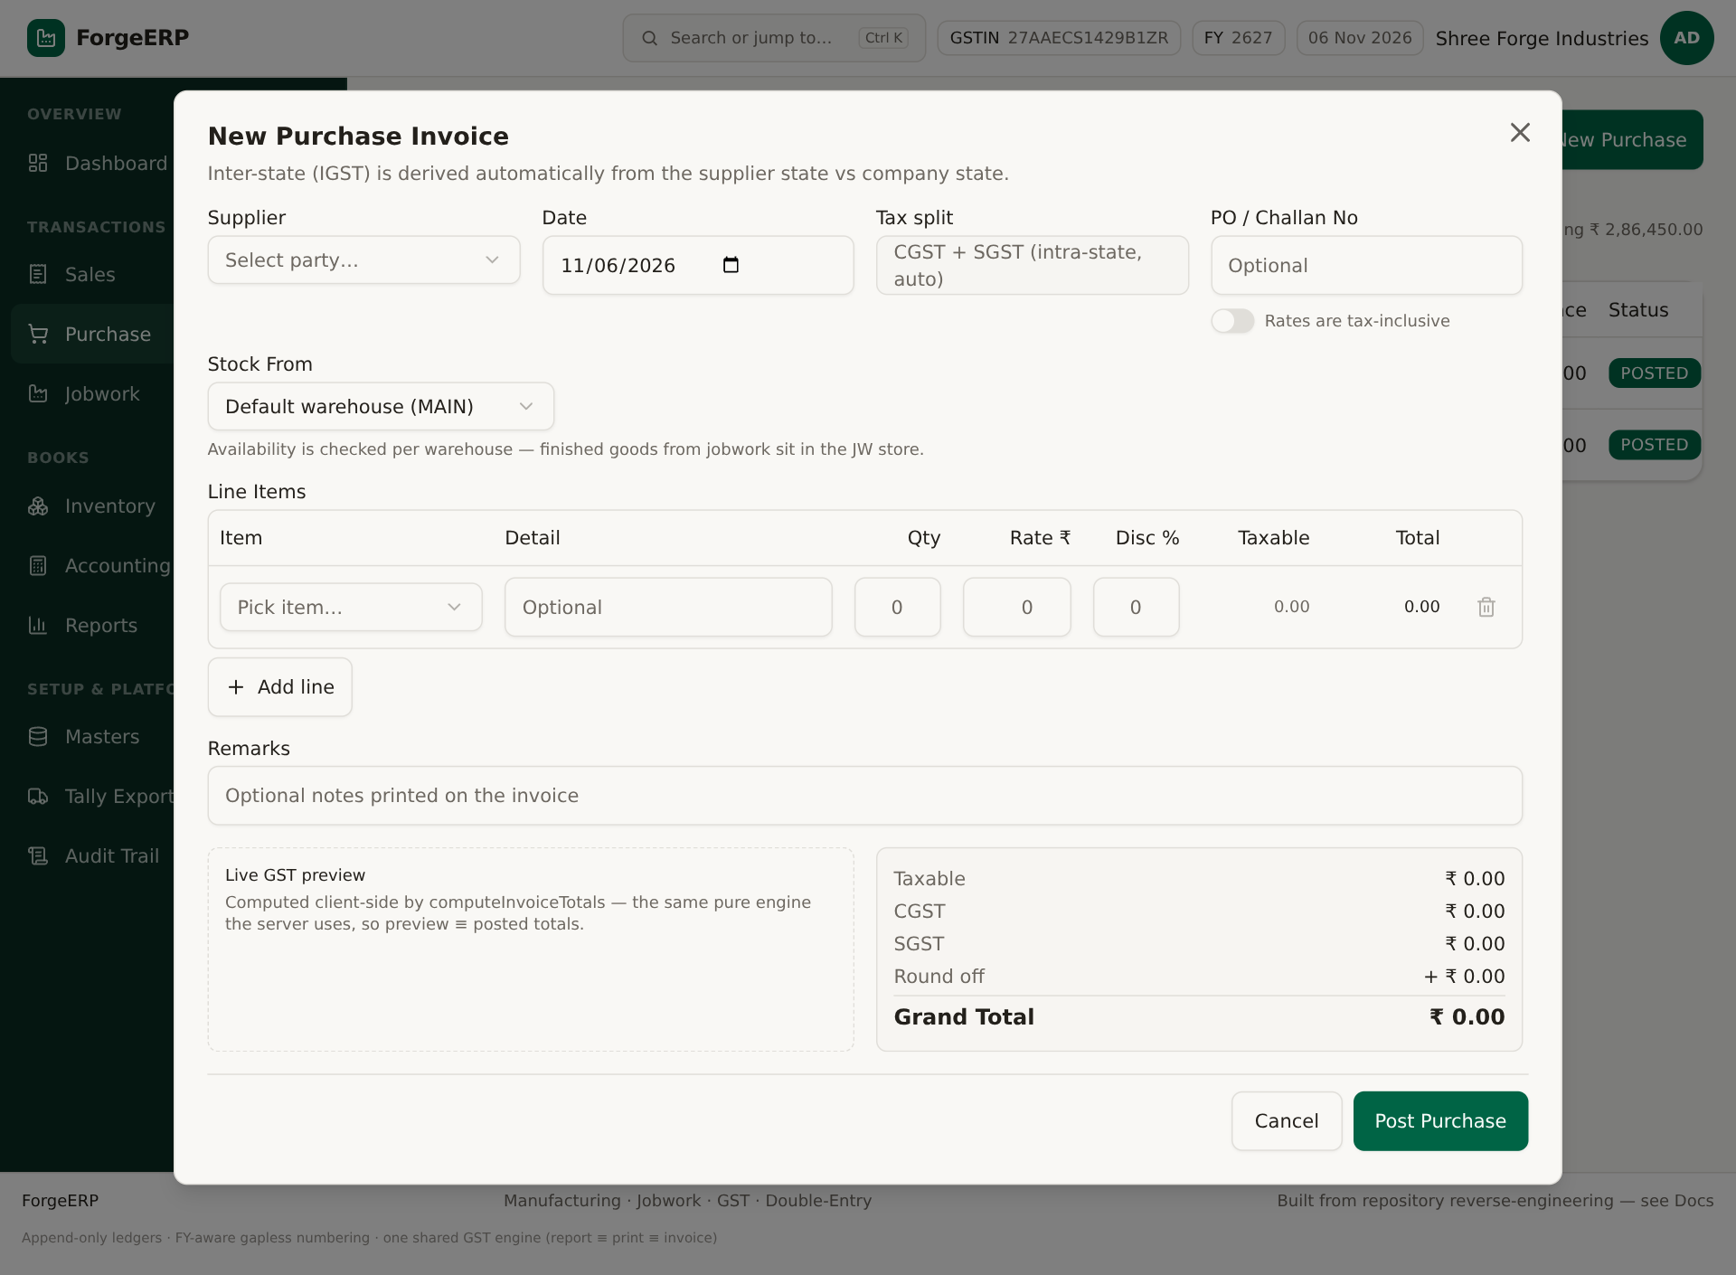
Screenshot: New Purchase form: supplier, date, warehouse, lines, input GST preview.
1. Purchase > New Purchase.
2. Supplier select karein; supplier party type SUPPLIER hona chahiye.
3. Date, warehouse, item lines, qty/rate/discount bharein.
4. Input GST preview check karein: CGSTI/SGSTI ya IGSTI.
5. Post Purchase dabaiye.
6. Stock IN hota hai; weighted-average cost update; GL Dr Purchases + input GST, Cr Creditors.
7. Supplier ko payment Accounting > New Payment > PAYMENT se record/allocate karein.
Note: Purchase cancellation bhi reversal entries se hoti hai; paid/allocated bill par pehle payment allocation correct karni pad sakti hai.

7. Accounting: Receipt/Payment, allocation, Party Ledger
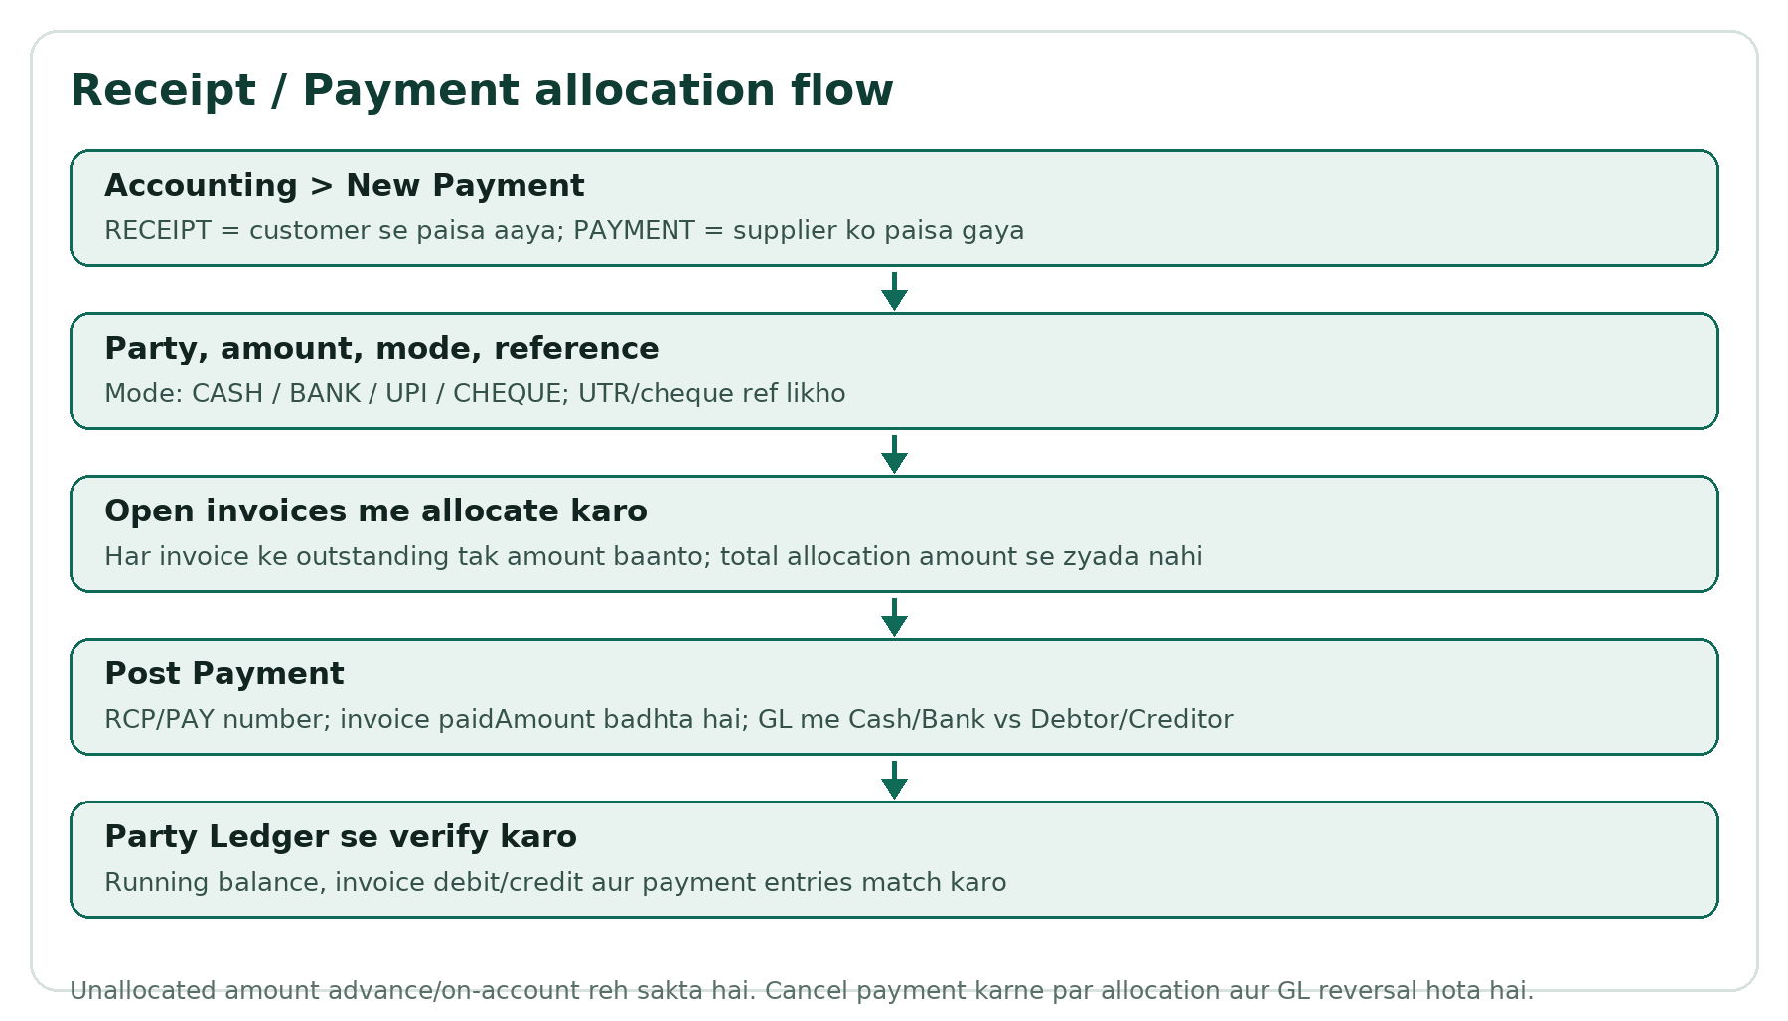
Flow: Payment allocation flow.

7.1 Payments list
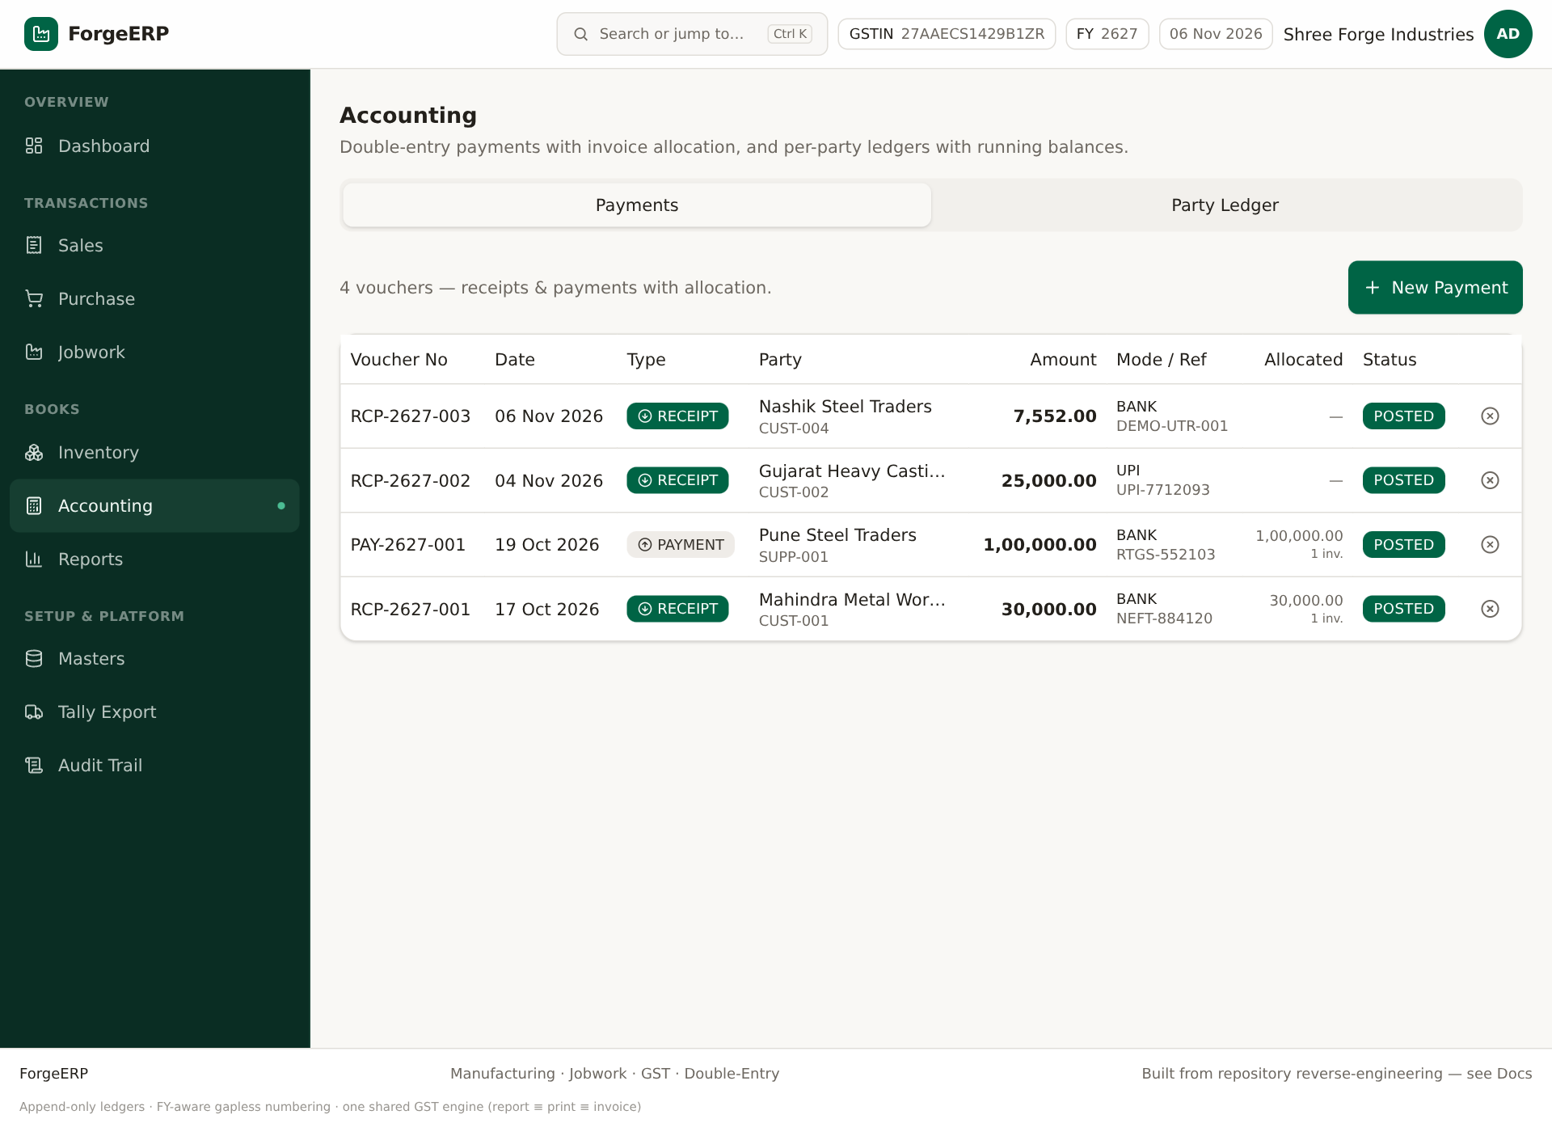
Screenshot: Payments list: voucher no, date, type, party, amount, mode/ref, allocated, status.

7.2 Receipt ya Payment post karna
1. Accounting > New Payment.
2. RECEIPT choose karein agar customer se paisa aaya; PAYMENT agar supplier ko paisa gaya.
3. Party, Date, Amount, Mode aur Reference No bharein. Mode: CASH/BANK/UPI/CHEQUE.
4. Allocate against open invoices me invoice-wise amount bharein.
5. Allocated total, Amount se zyada na ho; har allocation invoice outstanding se zyada na ho.
6. Post Payment dabaiye. RCP/PAY number generate hota hai.
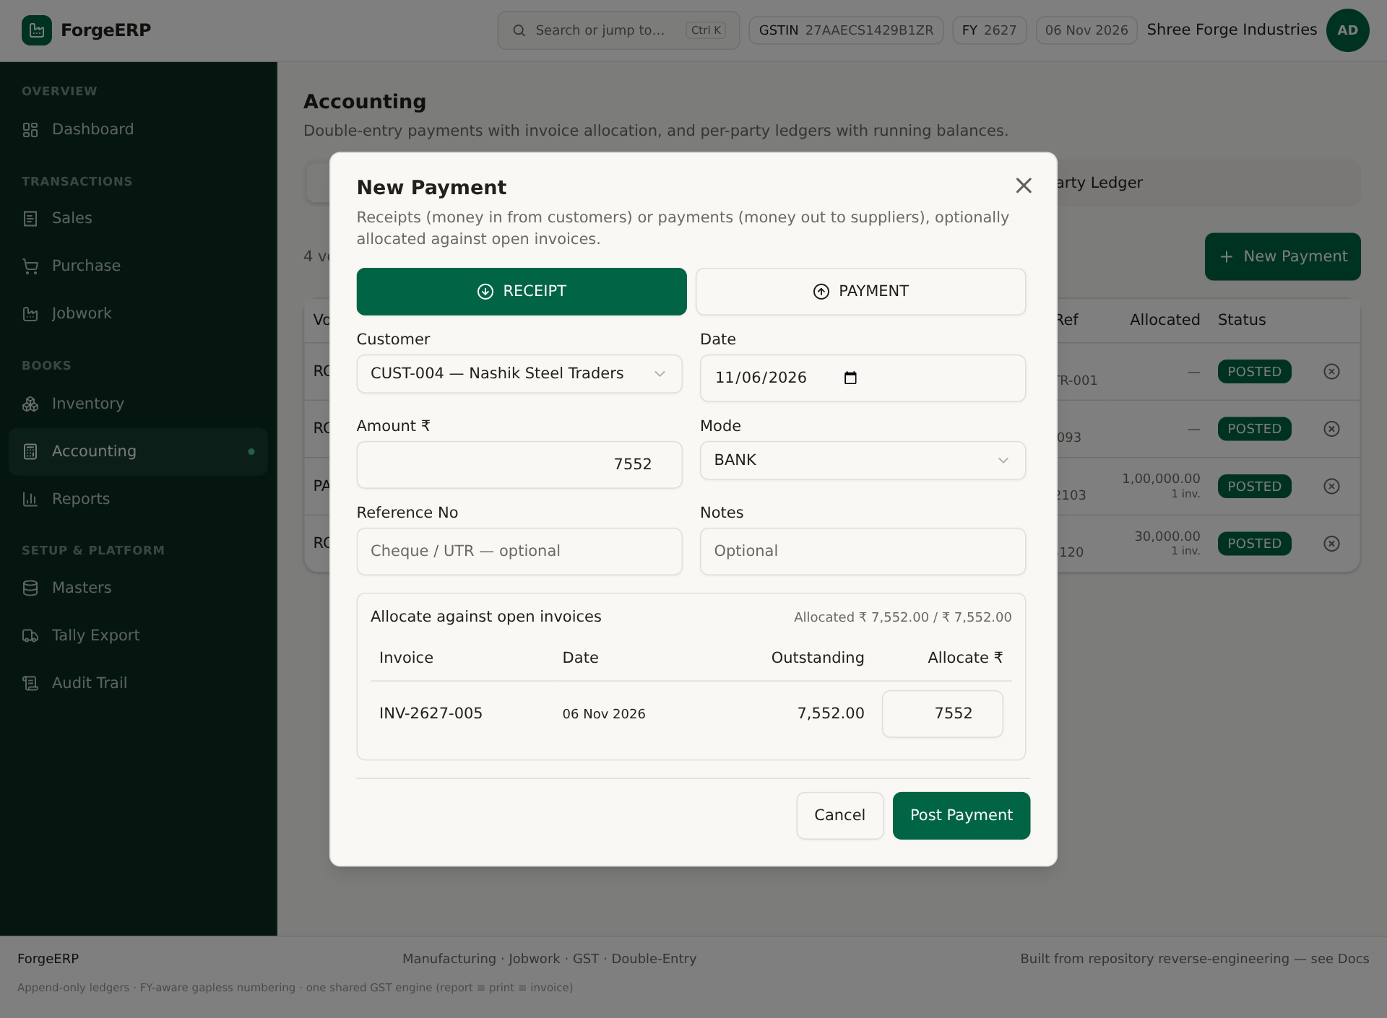
Screenshot: Receive Payment se prefilled allocation dialog. Post karne se pehle Allocate ₹ column verify karein.
Note: Agar allocation nahi bharenge to payment on-account/advance reh sakti hai aur invoice balance kam nahi hoga. Invoice detail ke Receive Payment button se prefilled allocation milta hai.

7.3 Party Ledger
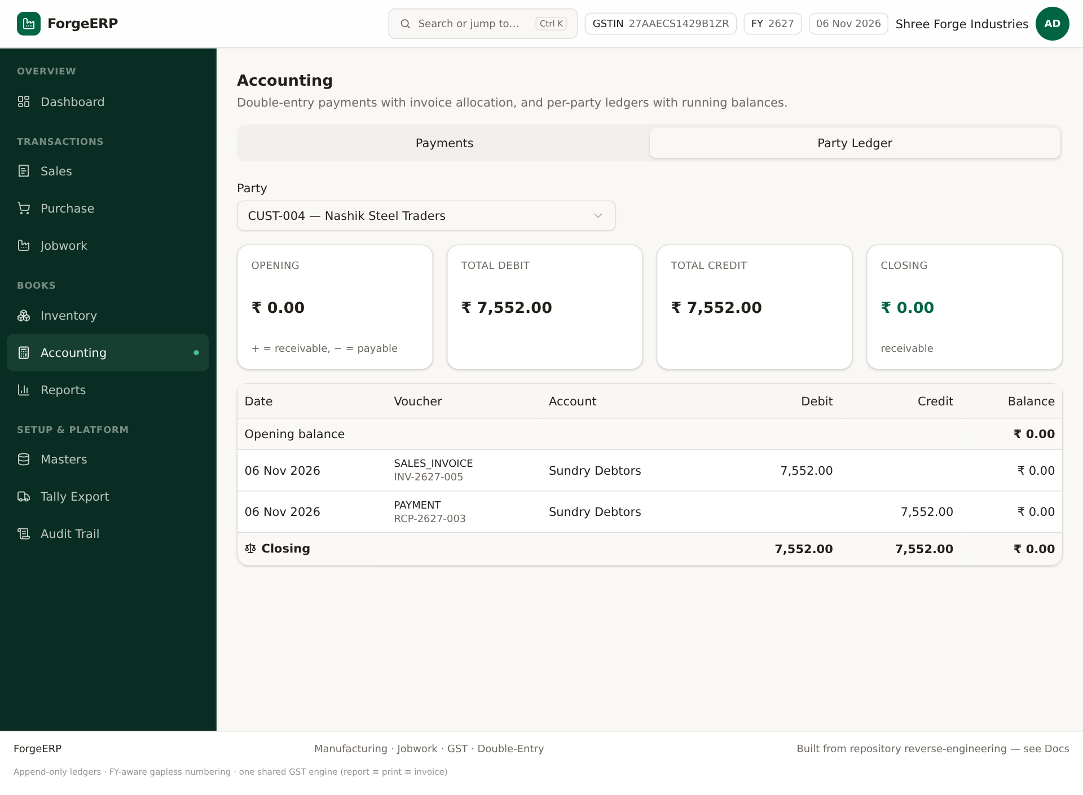
Screenshot: Party Ledger: opening, invoices, payments, running balance.
1. Accounting > Party Ledger tab.
2. Party select karein.
3. Opening balance, invoice debit/credit, payment entries aur closing balance match karein.
4. Customer receivable positive context; supplier payable negative/opening context ko party type ke saath samjhein.

7.4 Payment cancel
Payments list me cancel icon se payment cancel kar sakte hain. Cancel karne par allocations aur GL reversal hote hain; invoice paid amount wapas adjust hota hai. Confirmation ke baad hi karein.

8. Inventory: Stock Summary, Stock Ledger, Opening Stock

8.1 Stock Summary
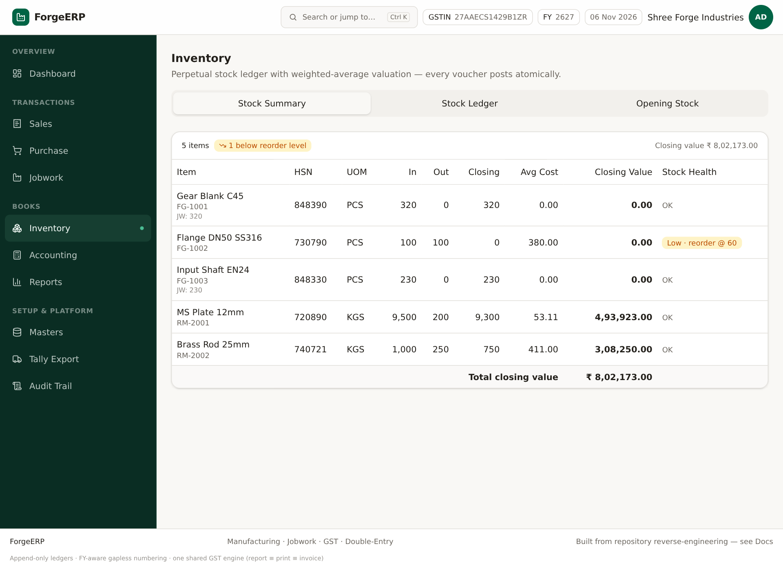
Screenshot: Stock Summary: in, out, closing qty, average cost, closing value, low-stock flag.
- Per item closing qty aur value dekhein.
- Avg cost weighted-average valuation hai.
- Low stock flag closing qty < reorder level par.
- Total closing value dashboard/financial context se match karein.

8.2 Stock Ledger
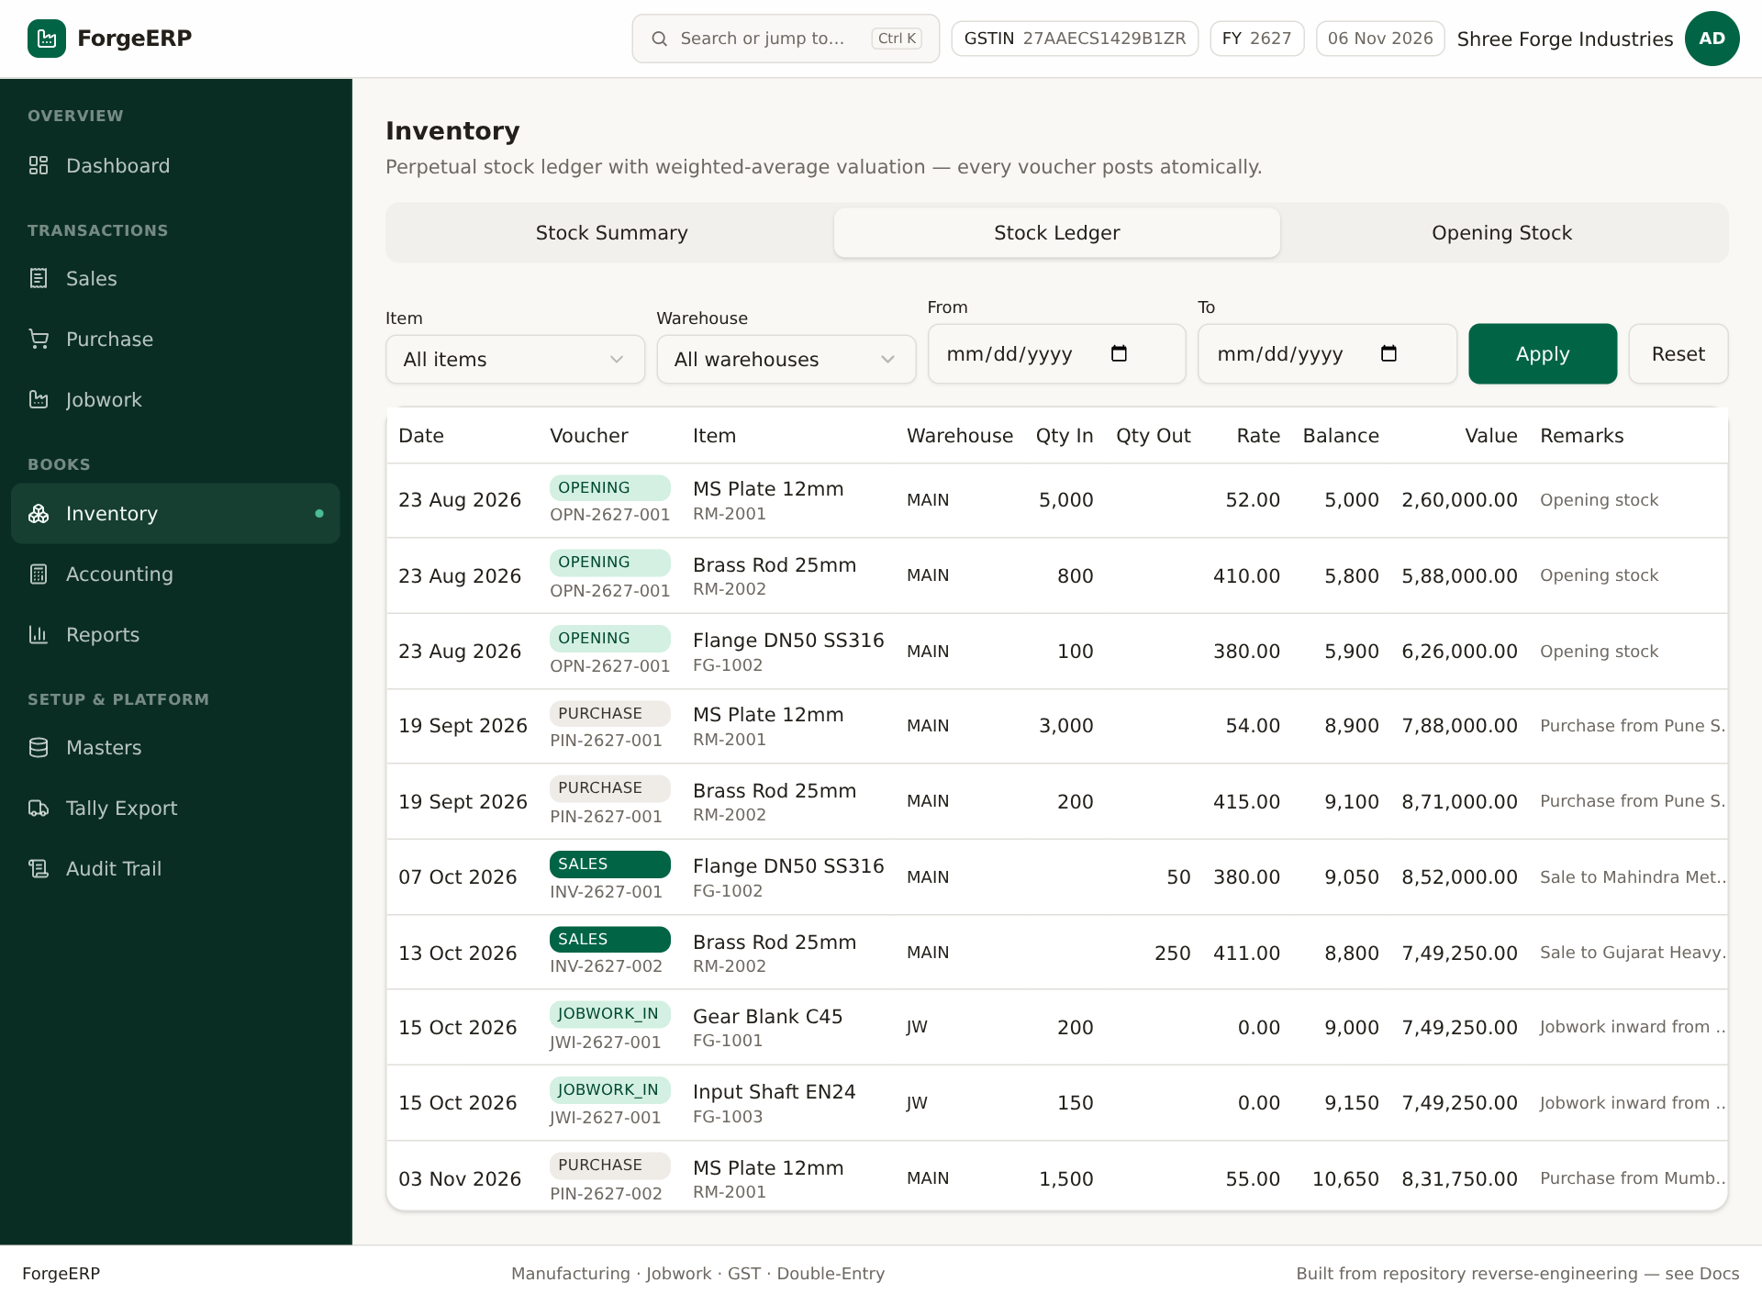
Screenshot: Stock Ledger: date, voucher, warehouse, qty in/out, balance, value, remarks.
1. Inventory > Stock Ledger.
2. Item, Warehouse, From/To filters set karke Apply karein.
3. Har movement ka source dekhein: OPENING, PURCHASE, SALES, JOBWORK_IN, reversals.
4. Running balance aur value ko physical stock se reconcile karein.

8.3 Opening Stock
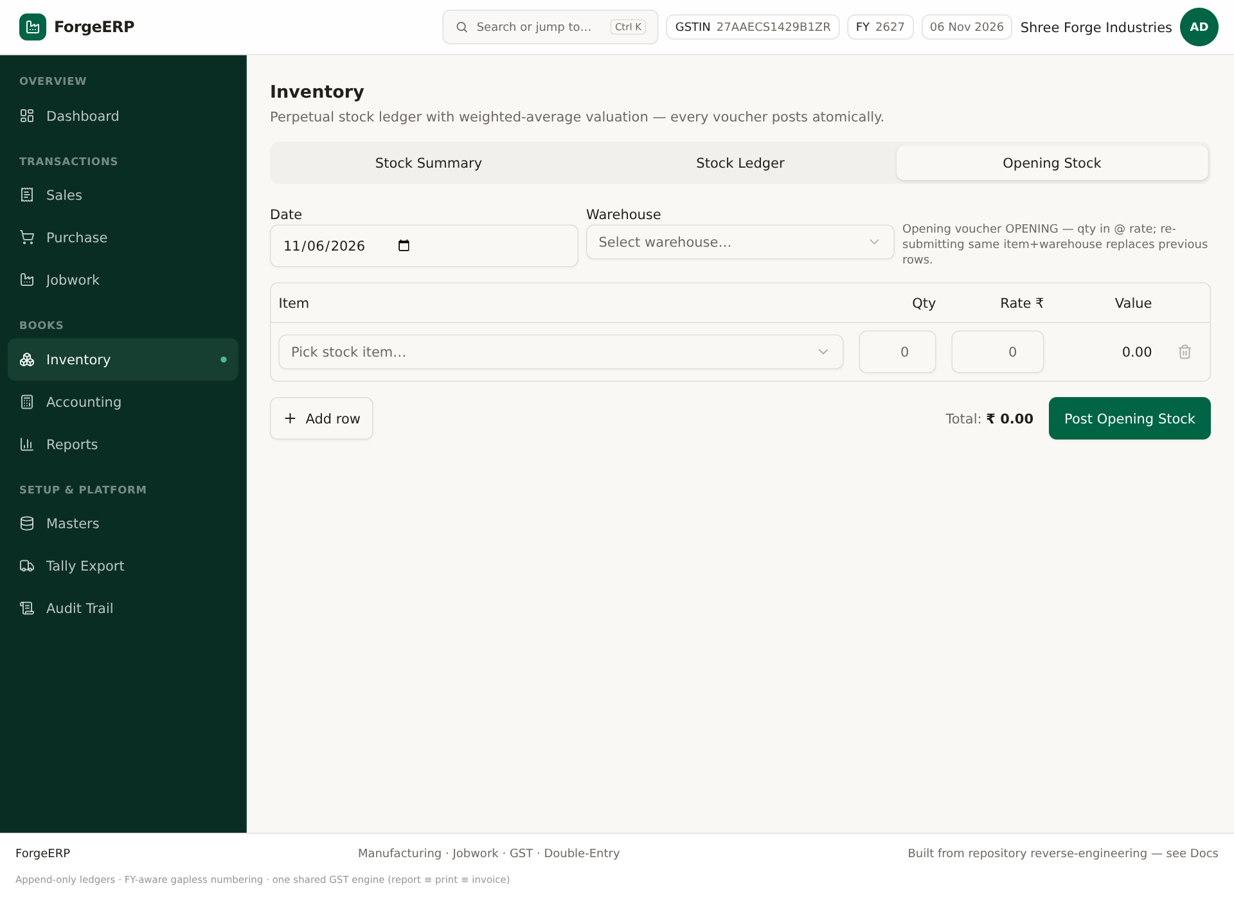
Screenshot: Opening Stock form: date, warehouse, item rows, qty, rate, value.
1. Inventory > Opening Stock.
2. Go-live date aur warehouse select karein.
3. Item, Qty, Rate bharein; Add Row se multiple items.
4. Post Opening Stock dabaiye.
5. Stock Ledger me OPENING entries verify karein.
Note: Same item+warehouse ke opening rows re-submit karne par purani rows cancel/replace hoti hain. Isliye opening stock ko bar-bar bina reconcile kiye post na karein.

9. Jobwork: Inward → Job Card → Certificate → Invoice
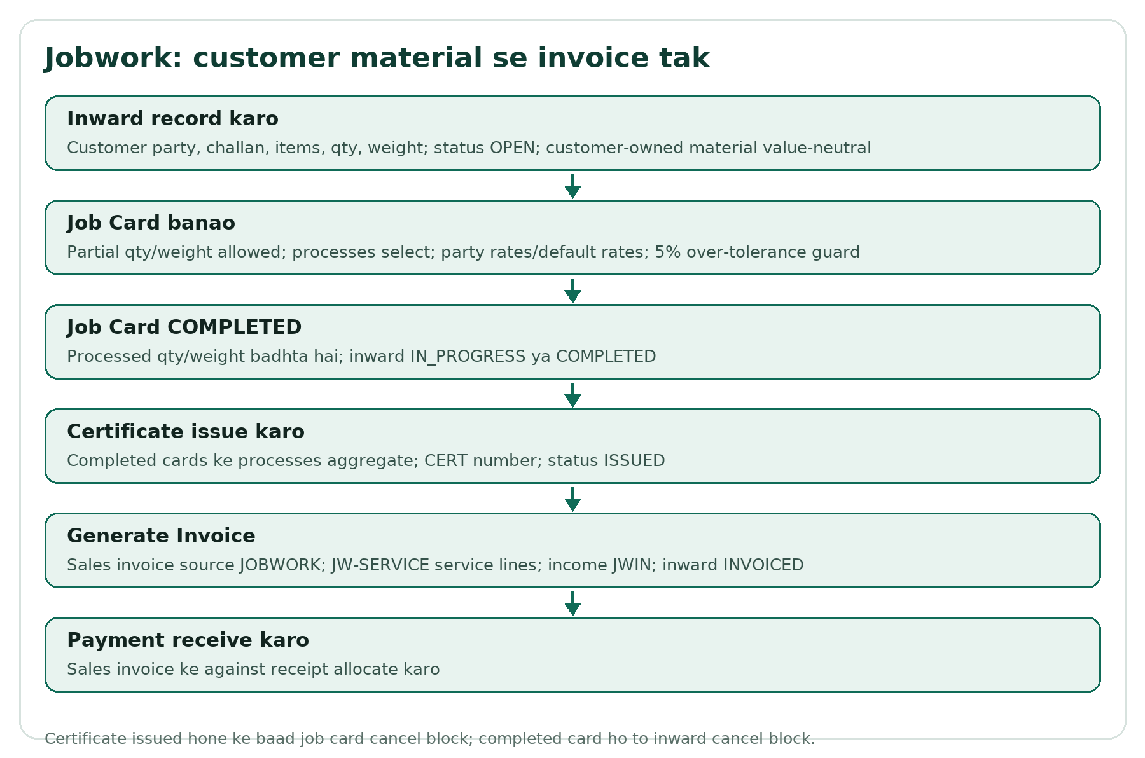
Flow: Jobwork ki core manufacturing chain.

9.1 Jobwork kya hai?
Jobwork me customer apna material bhejta hai; organization us par processes karta hai; material customer-owned rehta hai. Billing process charges ki hoti hai, material ki purchase/sale nahi. Inward stock ledger value-neutral qtyIn hota hai.

9.2 Inward list aur Pending
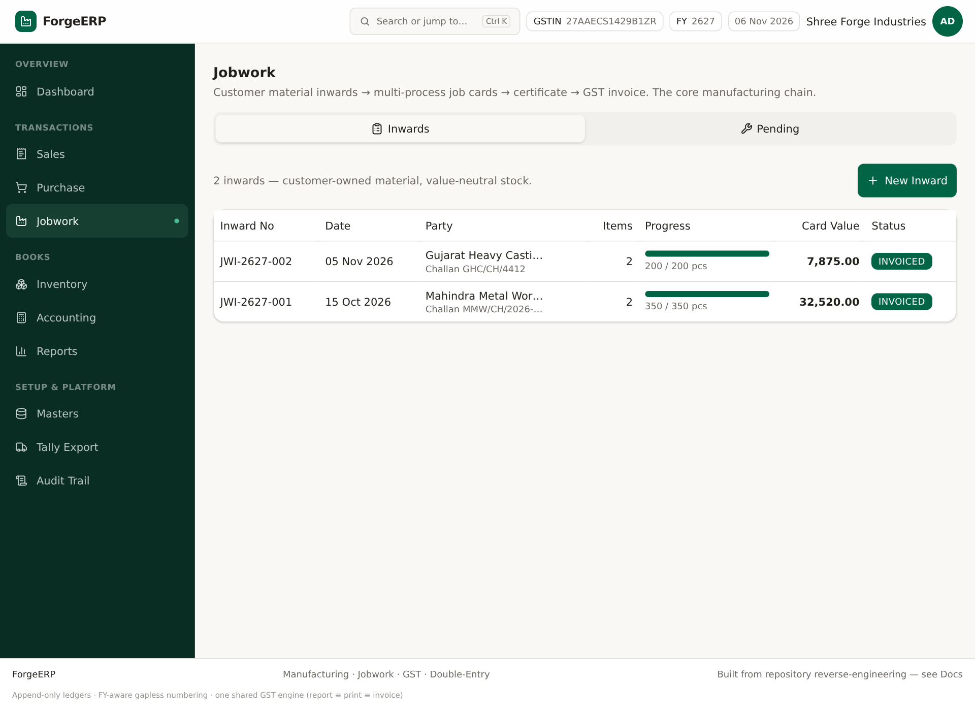
Screenshot: Jobwork Inwards: inward no, party, items, progress, card value, status.
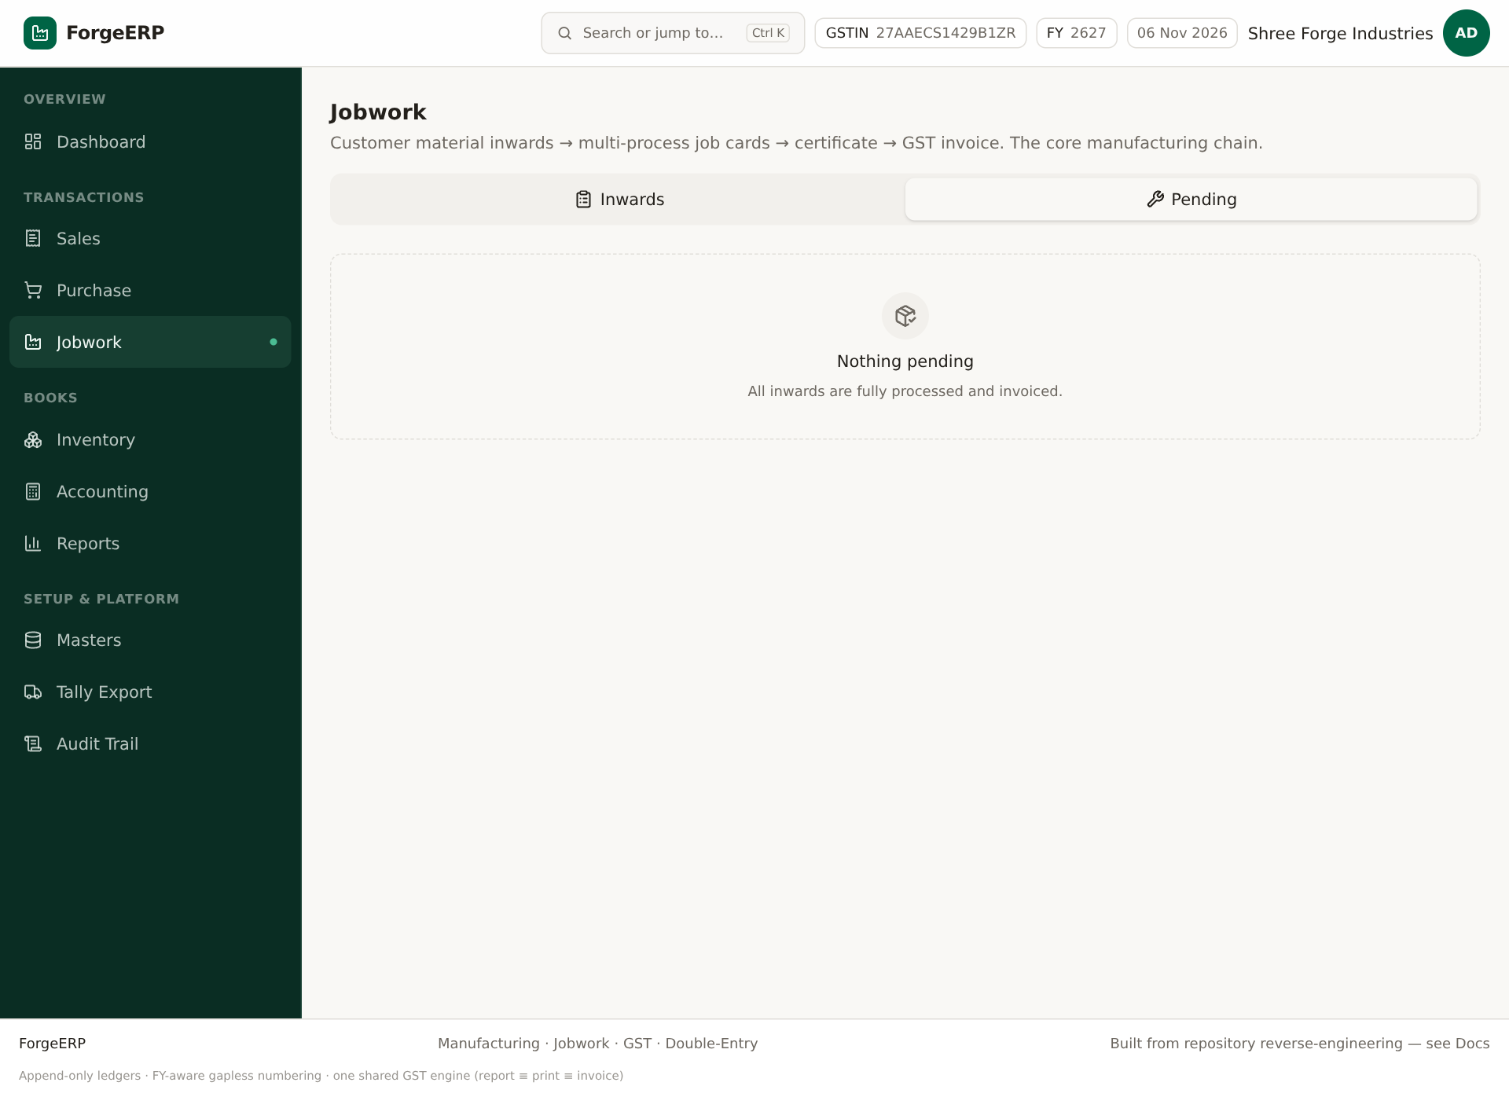
Screenshot: Pending report: received/processed/remaining qty-weight aur pending processes. Demo me chain complete hone ke baad empty aa sakta hai.

9.3 Naya Inward
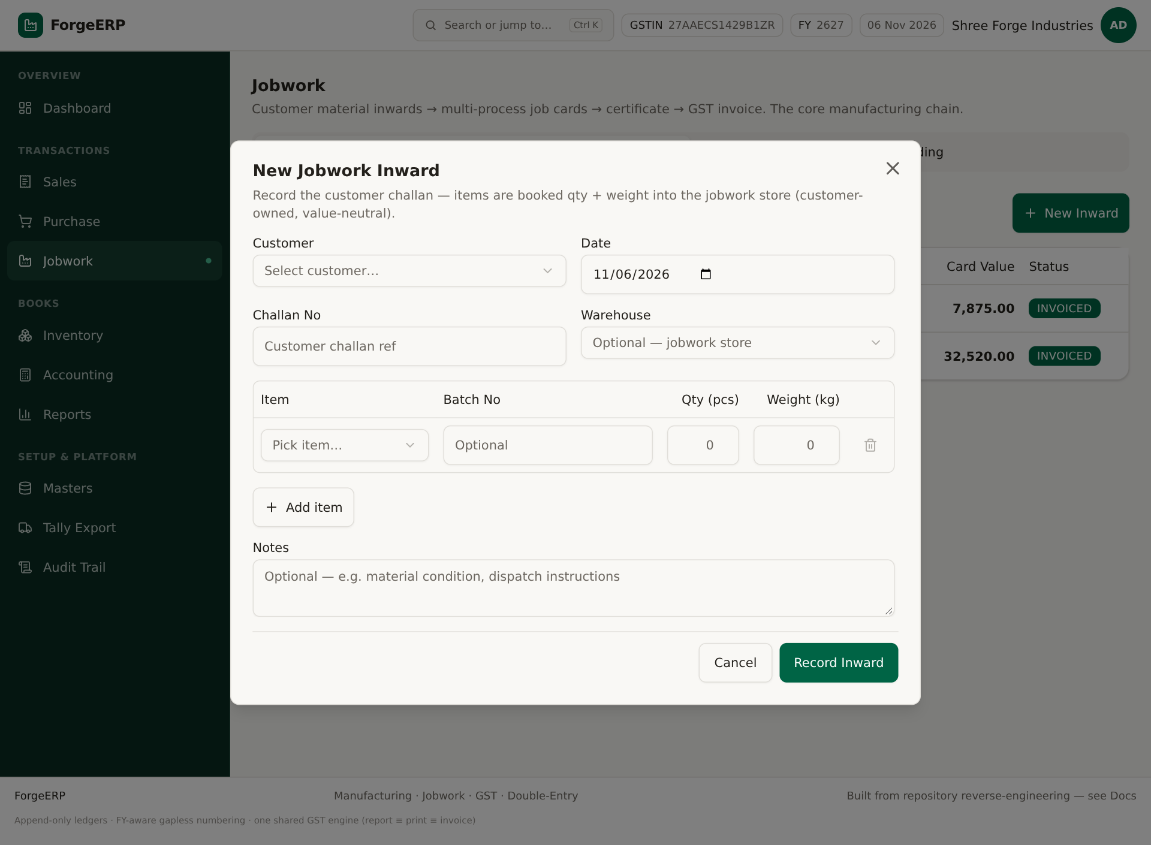
Screenshot: New Jobwork Inward: customer, challan, items, batch, qty, weight, notes.
1. Jobwork > Inwards > New Inward.
2. Customer party, date, challan no bharein.
3. Items add karein: item, batch optional, qty, weight kg.
4. Notes me material condition/dispatch instructions likh sakte hain.
5. Record Inward dabaiye. JWI number generate; status OPEN.

9.4 Inward detail
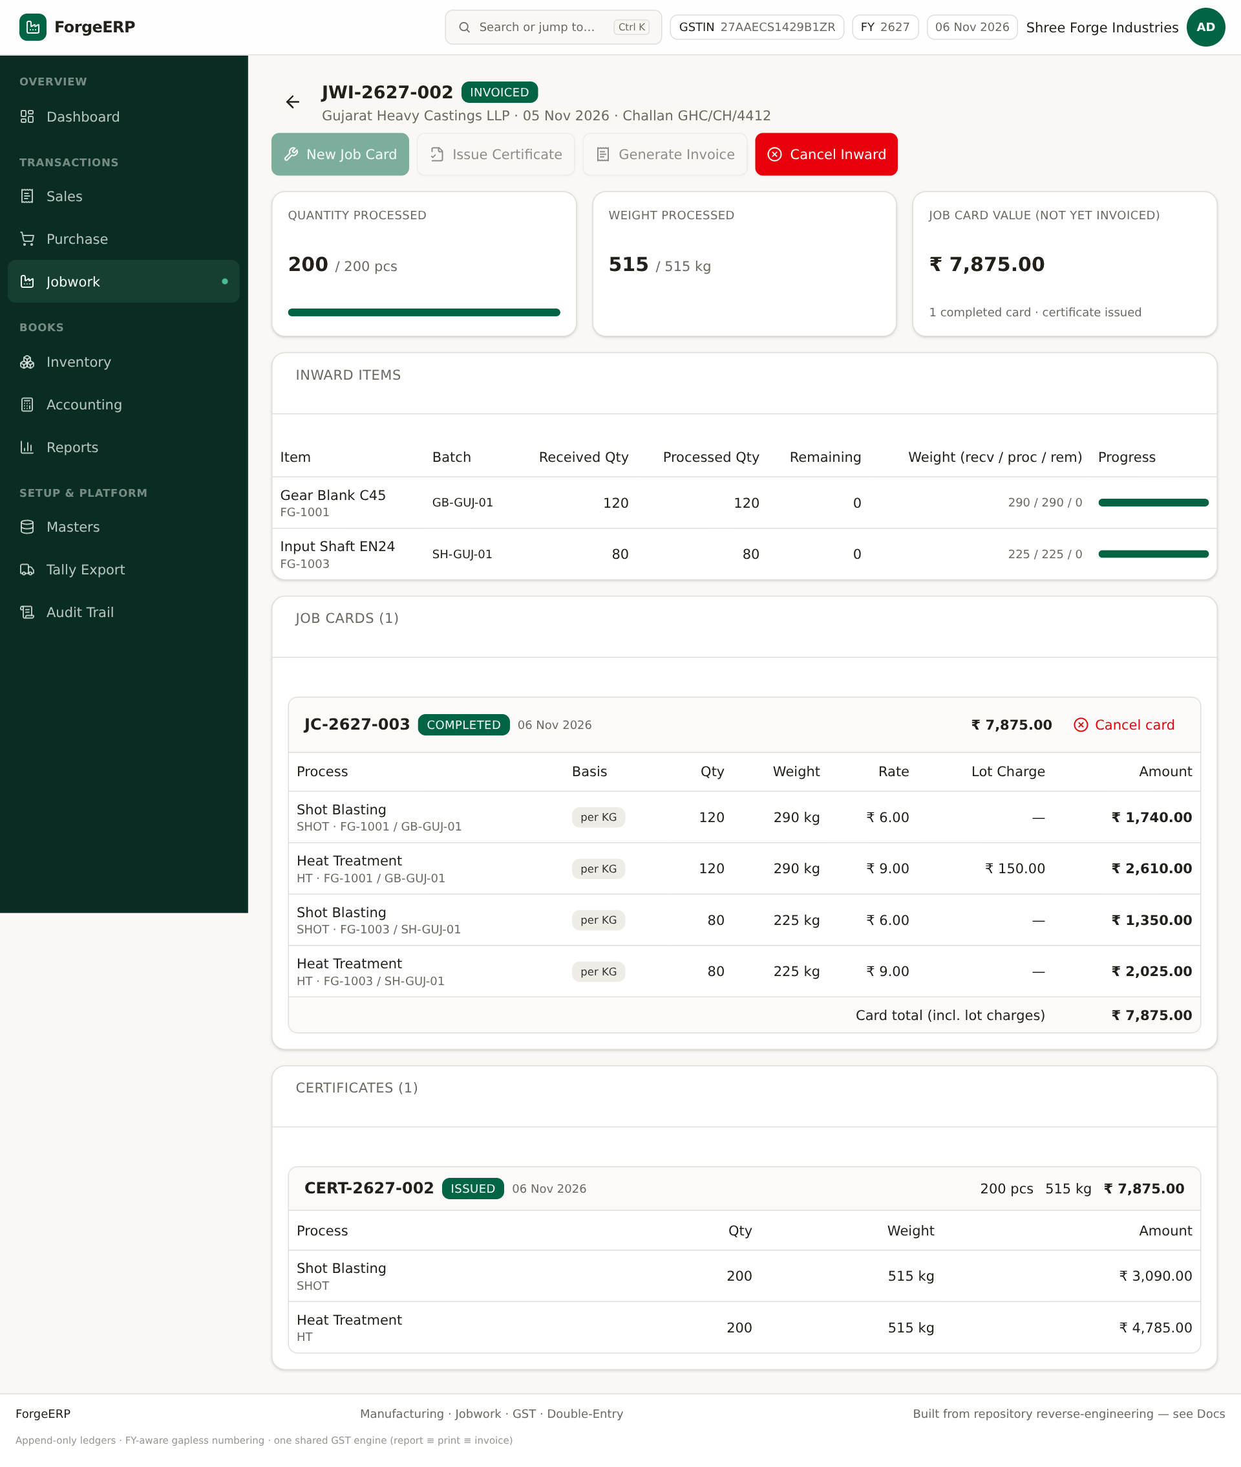
Screenshot: Inward detail: received/processed progress, job cards, certificate, invoice actions.

9.5 Job Card
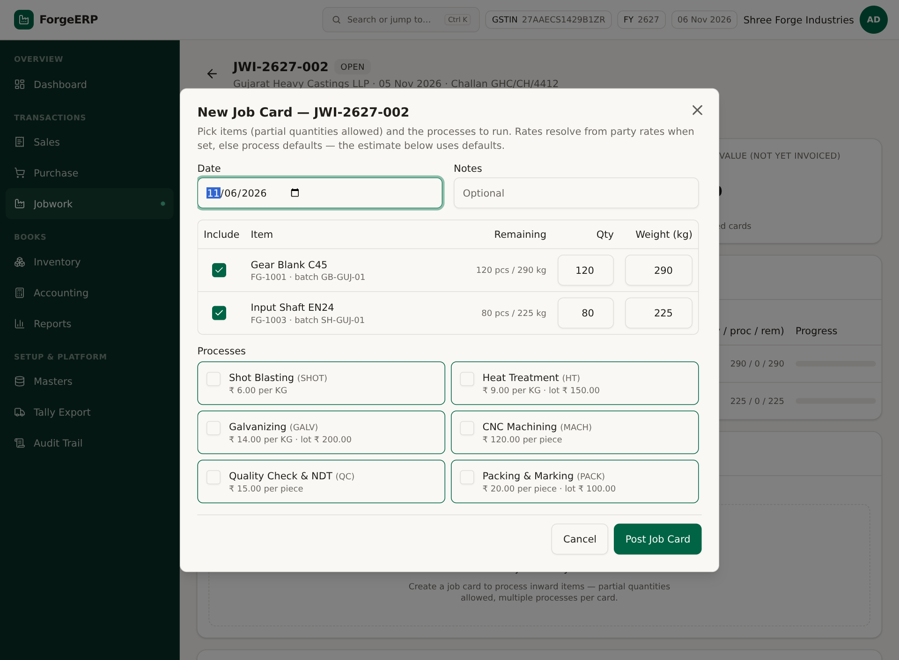
Screenshot: New Job Card: include items, partial qty/weight, processes select.
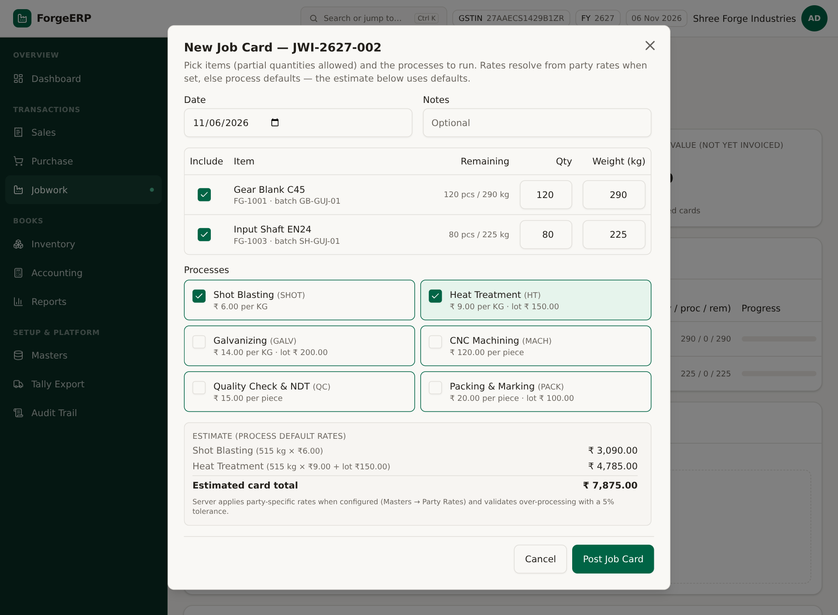
Screenshot: Processes select karne par estimate. Server party rates apply karta hai; 5% over-tolerance guard.
1. Inward detail > New Job Card.
2. Date/notes bharein.
3. Include column me items tick karein; partial Qty aur Weight Wt kg allowed hai.
4. Processes me required operations select karein.
5. Estimate review karein; final server party-specific rates use karta hai.
6. Post Job Card dabaiye. Card COMPLETED; processed qty/weight badhta hai.
Note: Over-processing guard: processed + new qty/weight received qty/weight se 5% tolerance tak allow hai. Zyada hone par server error deta hai.

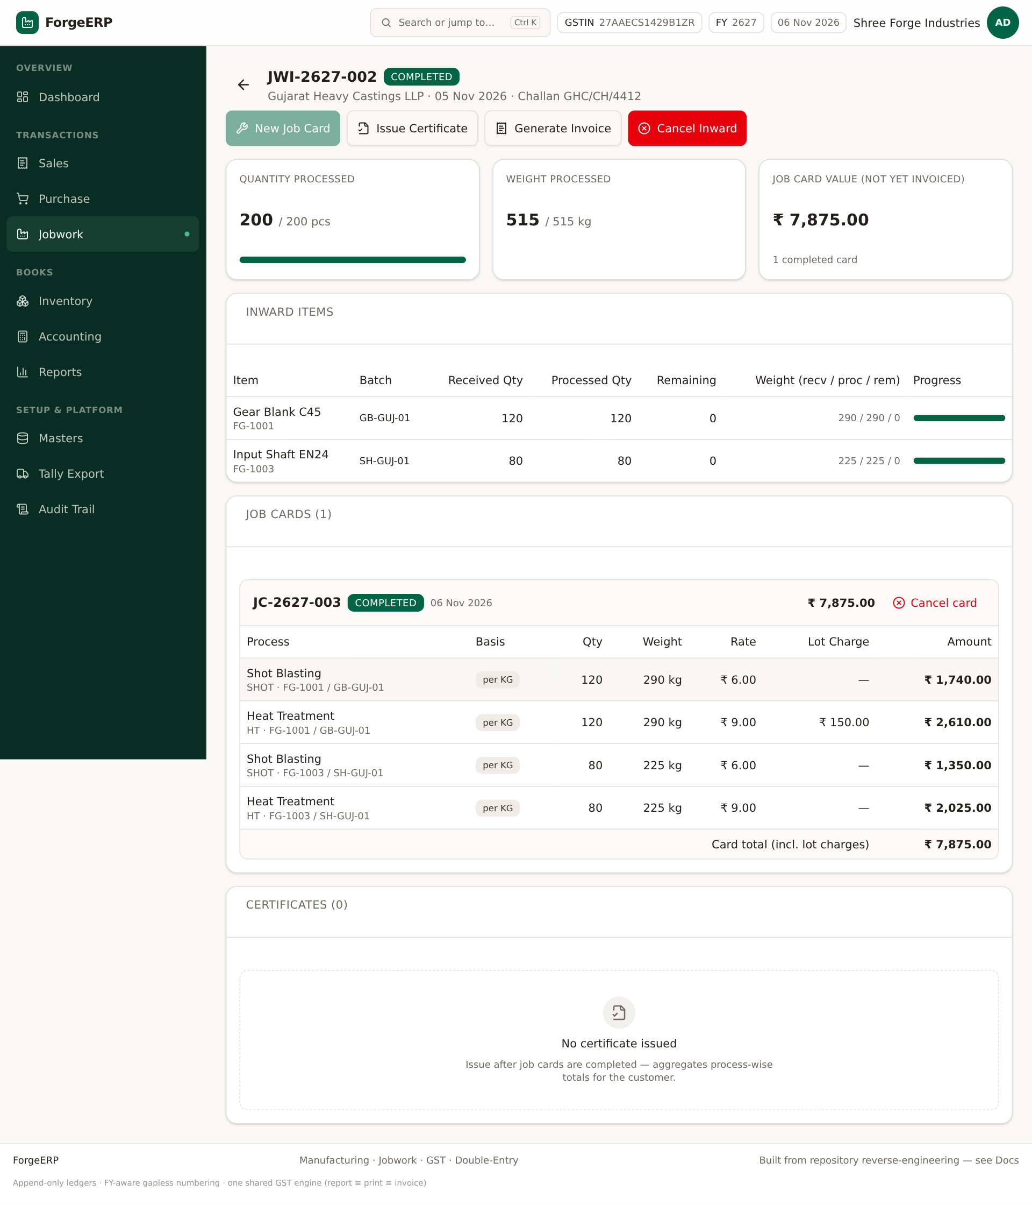
Screenshot: Job card complete hone ke baad inward progress aur card value update.

9.6 Certificate
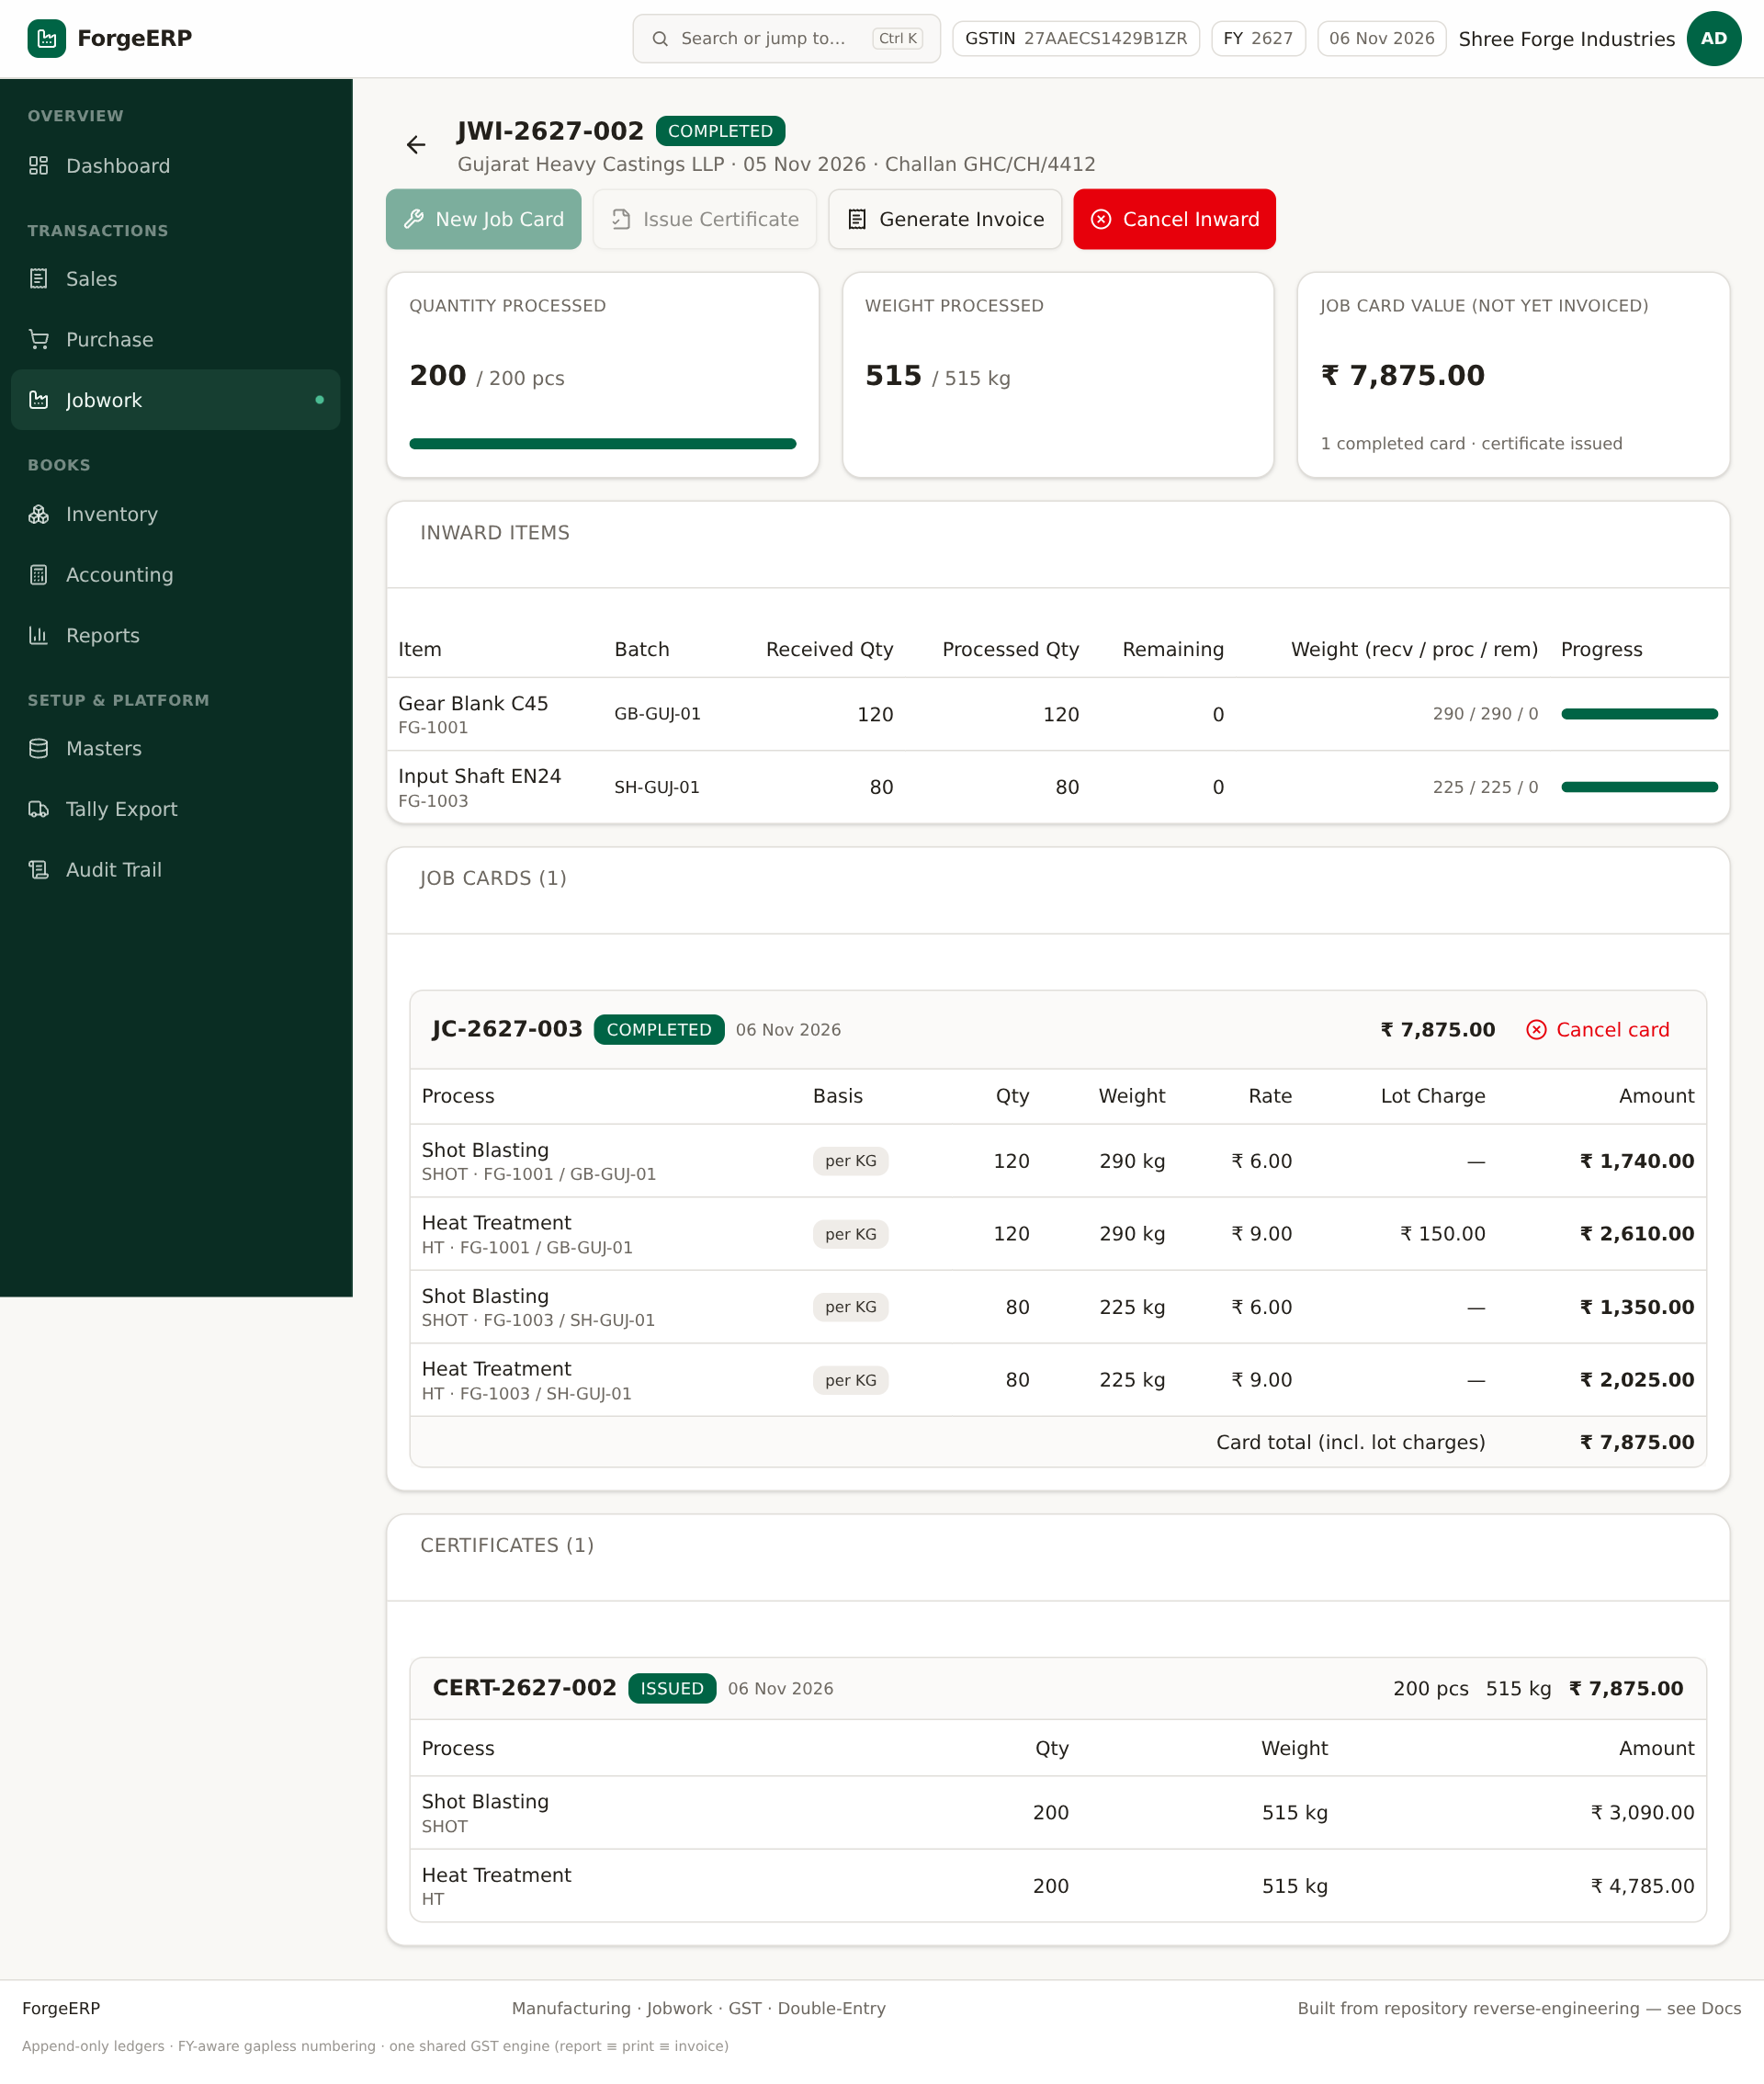
Screenshot: Certificate issued: completed card processes ka aggregate.
1. Inward detail > Issue Certificate.
2. System completed cards ke processes aggregate karke CERT number banata hai.
3. Certificate status ISSUED; customer ko dispatch/service proof ke roop me de sakte hain.

9.7 Generate Invoice
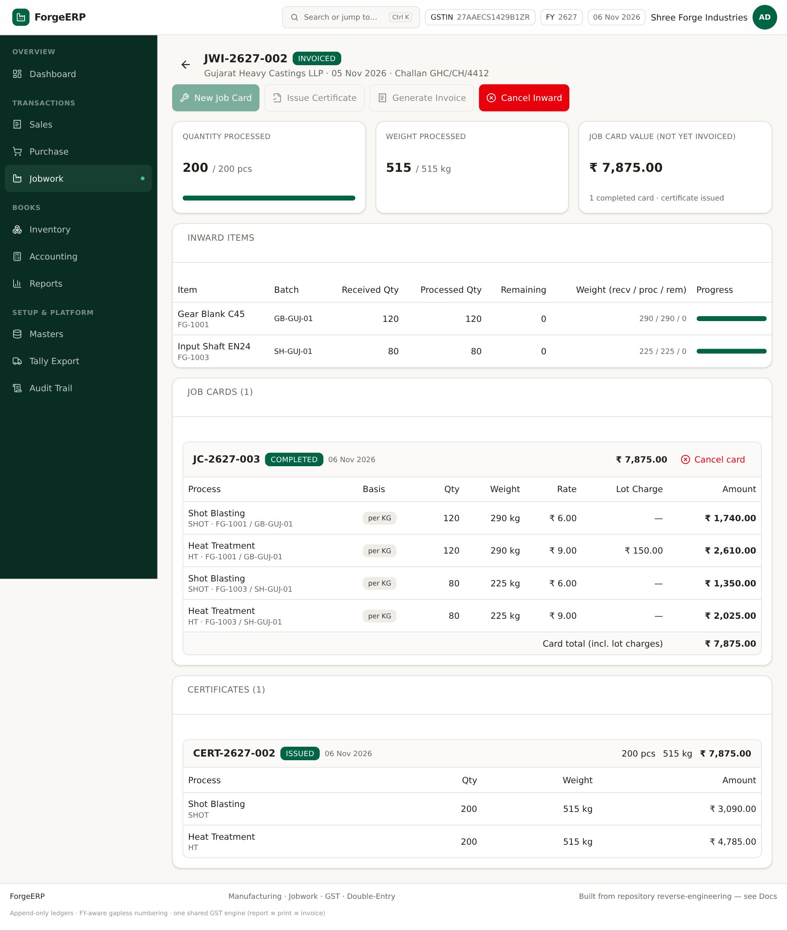
Screenshot: Jobwork se Sales invoice generate; source JOBWORK, income JWIN.
1. Inward detail > Generate Invoice.
2. System JW-SERVICE service item ke through aggregated process amounts ki sales invoice banata hai.
3. Invoice source JOBWORK hoti hai; GST service rate apply; inward INVOICED.
4. Sales/Accounting me invoice aur receipt verify karein.

9.8 Cancel rules
Action | Rule
Cancel Job Card | Certificate issued hone ke baad block; warna processed qty rollback
Cancel Inward | Koi completed job card hai to block; reversal stock entries
Certificate/Invoice ke baad correction | Pehle dependent invoice/payment/card chain samjhein; destructive delete nahi

10. Reports: GSTR-1, Trial Balance, Outstanding, P&L

10.1 GSTR-1 summary
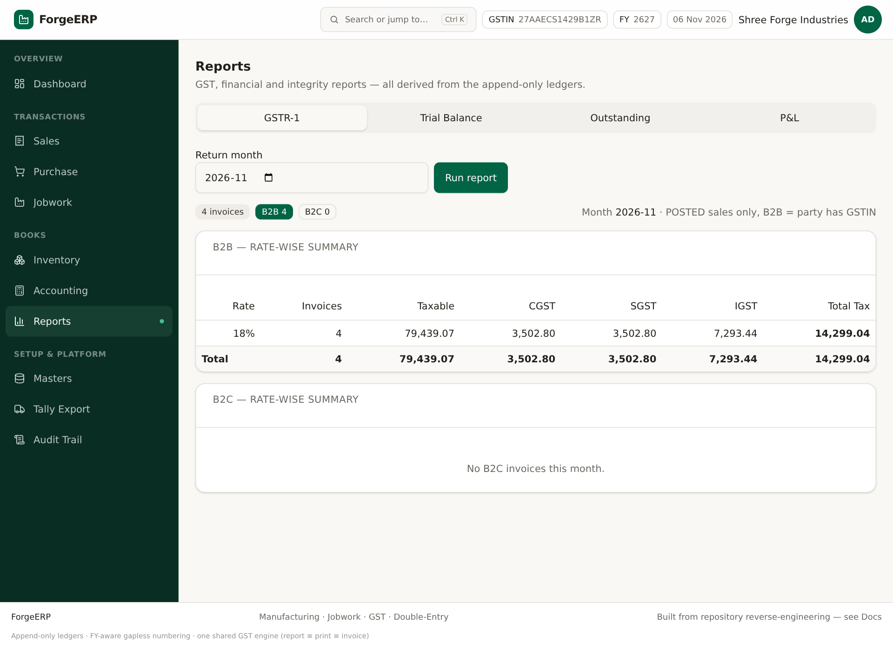
Screenshot: GSTR-1: month select, Run report, B2B/B2C rate-wise summary.
1. Reports > GSTR-1.
2. Return month choose karke Run report.
3. B2B = party ke paas GSTIN; B2C = GSTIN nahi.
4. Rate-wise taxable, CGST, SGST, IGST, total tax dekhein.
Note: Ye summary report hai, full GSTR-1 JSON/return filing utility nahi. Portal par filing se pehle CA/GST practitioner se reconcile karein.

10.2 Trial Balance
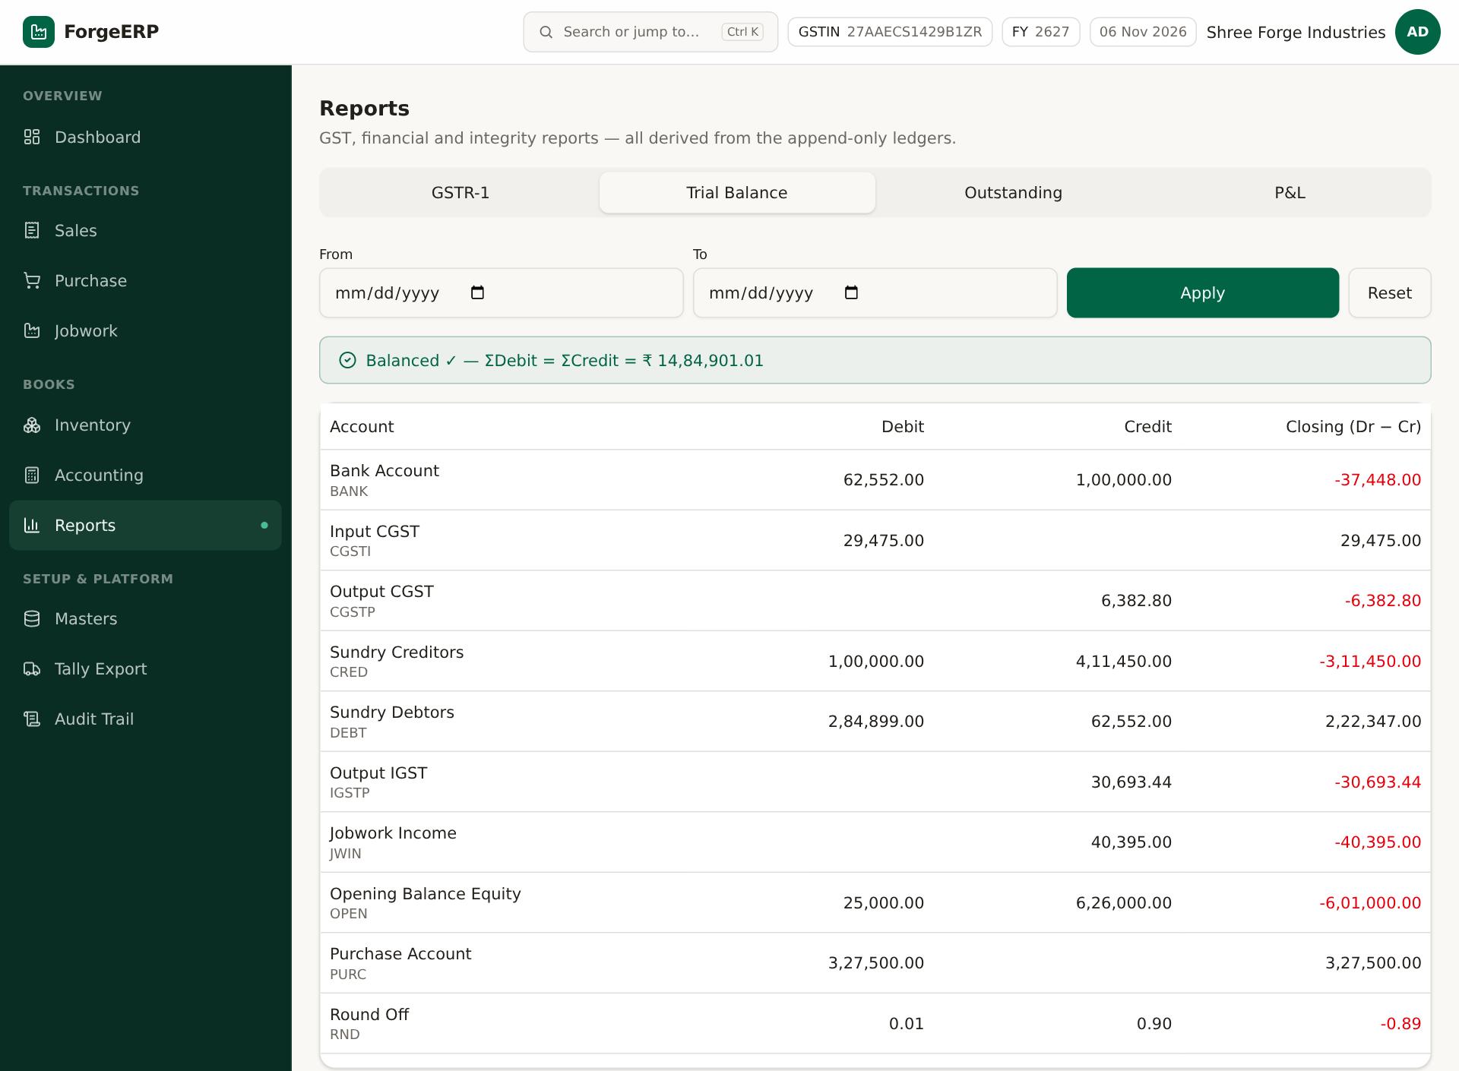
Screenshot: Trial Balance: account-wise debit/credit/closing; balanced banner.
1. Reports > Trial Balance.
2. From/To optional; Apply/Reset.
3. Total Debit = Total Credit integrity banner check karein.
4. Account codes: DEBT, CRED, STKV, SALS, JWIN, PURC, GST input/output, CASH, BANK, RND, OPEN.

10.3 Outstanding
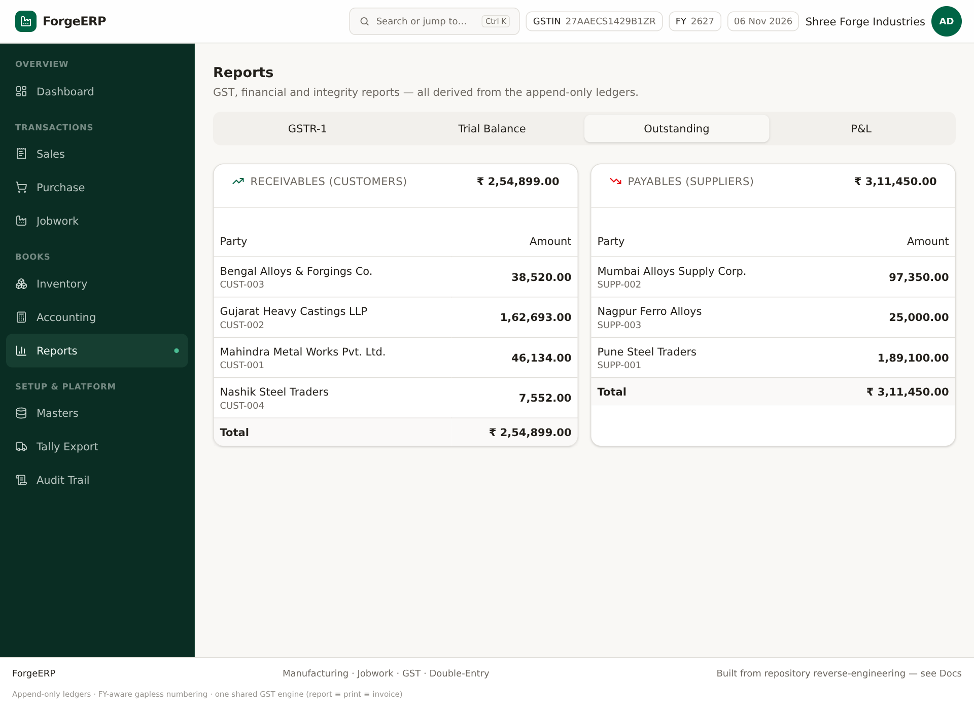
Screenshot: Outstanding: customer receivables aur supplier payables.
Party-wise invoice balances aur opening balance ka summary. Collection/follow-up ke liye use karein. Payment allocation sahi hogi to outstanding accurate hoga.

10.4 P&L
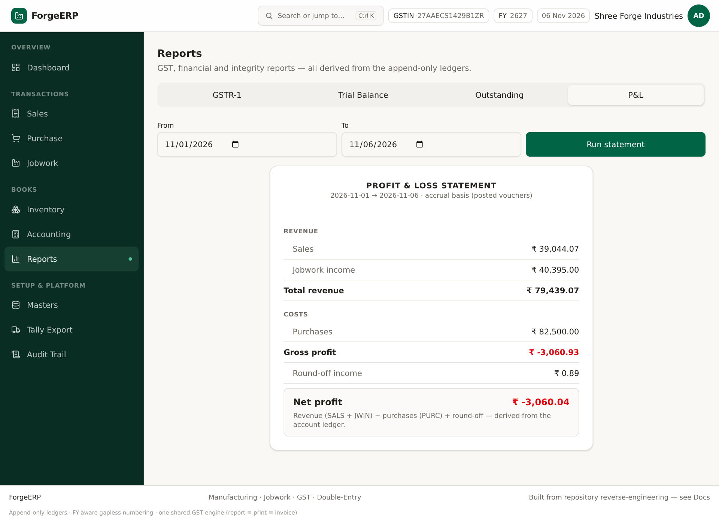
Screenshot: P&L: revenue, purchases, gross profit, round-off, net profit.
Limitation: Is version ka P&L simplified accrual view hai: Revenue (SALS+JWIN) − Purchases (PURC) + round-off. Full expense ledger, COGS matching, depreciation aur statutory adjustments included nahi. Ise management snapshot samjhein, final accounts nahi.

11. Tally Export, connector aur e-Invoice JSON
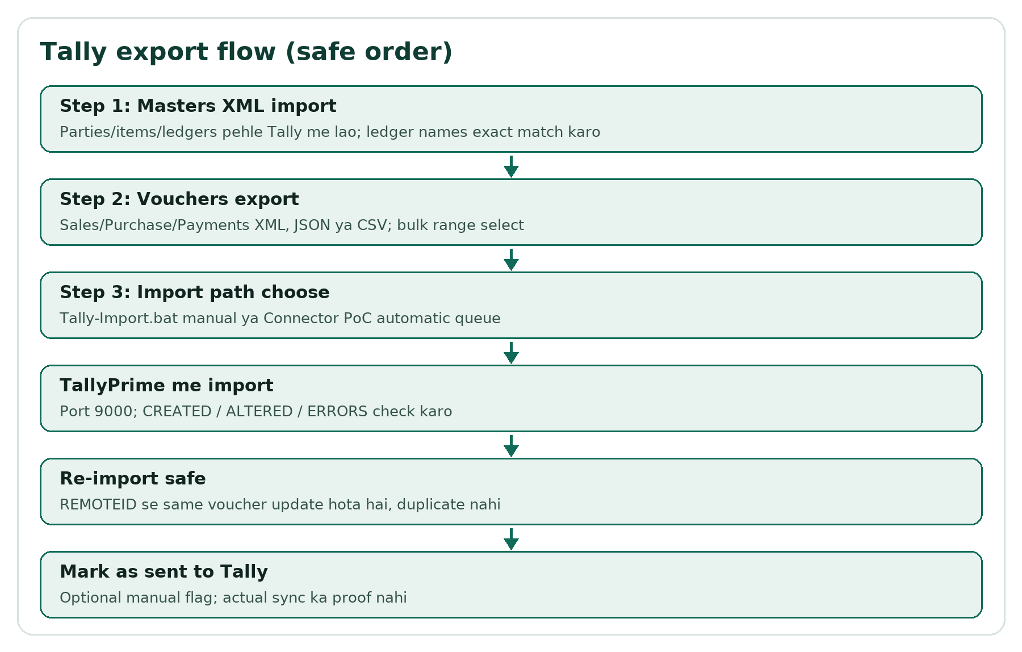
Flow: Tally export ka safe order.

11.1 Tally Export page
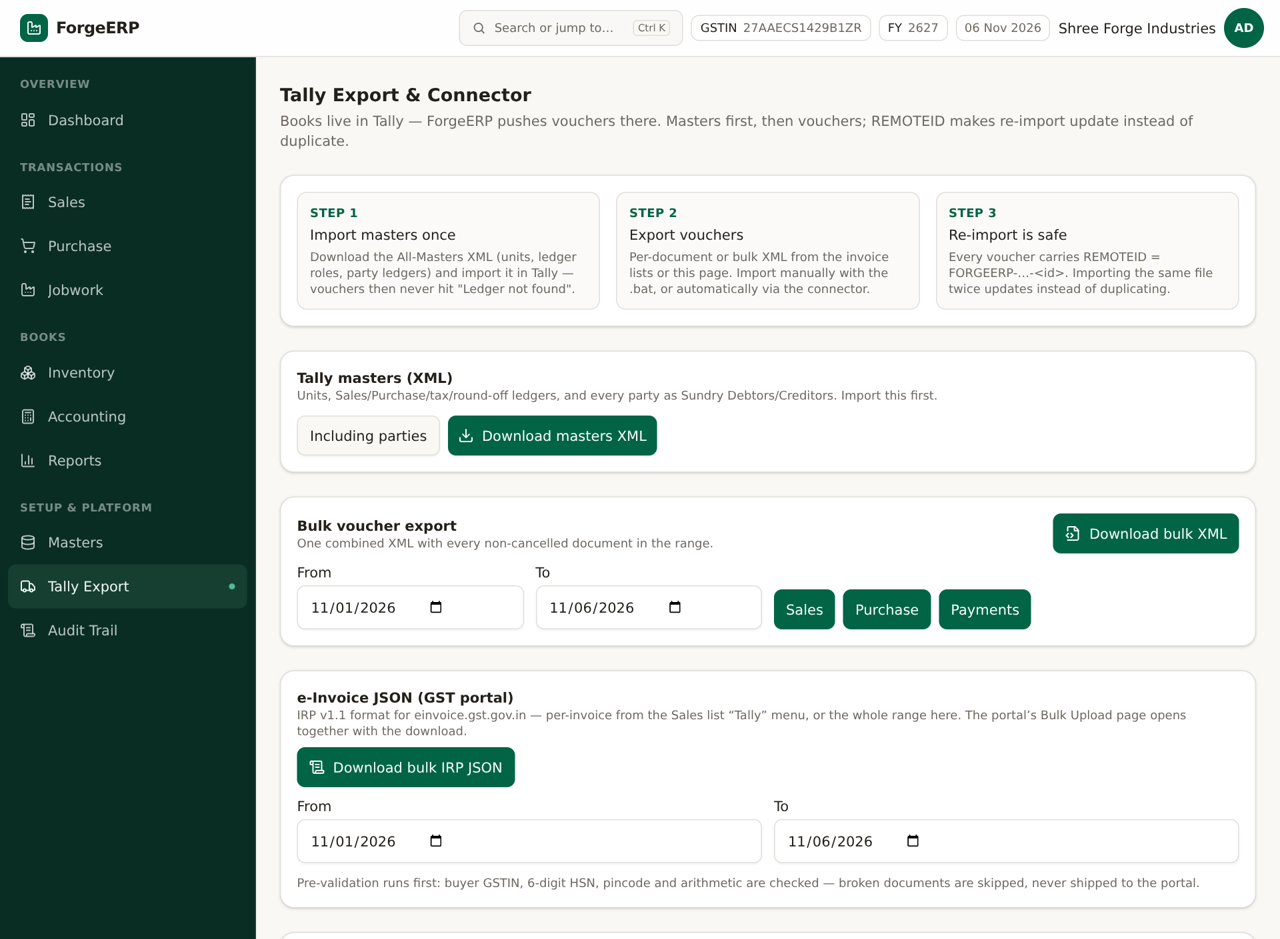
Screenshot: Tally Export: masters-first, bulk voucher export, e-Invoice bulk, connector, .bat, ledger names.
1. Step 1: Tally masters XML download/import karein. Parties/items/ledgers pehle Tally me hone chahiye.
2. Step 2: Bulk voucher export me From/To choose karein; Sales/Purchase/Payments buttons.
3. Formats: XML import file, JSON, CSV. Single invoice ke liye Sales/Purchase list ke Tally menu use karein.
4. Step 3: Tally-Import.bat manual import ya connector PoC queue use karein.
5. Ledger names in Tally me exact ledger mapping save karein; mismatch common import error hai.

11.2 Manual .bat import
- Tally-Import.bat download karein.
- Exported *_tally.xml ko .bat par drop karein ya double-click; newest Downloads file pick ho sakti hai.
- TallyPrime port 9000 par open ho; CREATED/ALTERED/ERRORS output padhein.
- Re-import par REMOTEID voucher update karta hai, duplicate nahi banata.

11.3 Connector PoC
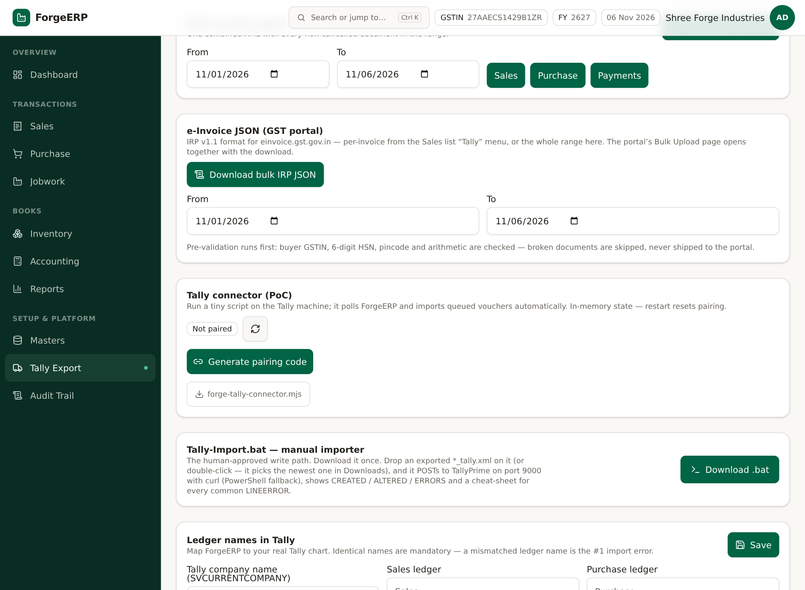
Screenshot: Connector: pairing code, script download, status, queued jobs.
1. Generate pairing code dabaiye; code single-use aur 10 minute valid hai.
2. Tally machine par Node 18+ aur forge-tally-connector.mjs rakhein.
3. Pair command me server URL aur code use karein; phir run command.
4. TallyPrime open rakhein, port 9000, acts as Both.
5. Invoice list ke Tally menu se Queue for Tally connector karein.
6. Status Online/Paired/offline, pending jobs aur recent results dekhein.
Note: Connector in-memory PoC hai: server restart par pairing/state reset ho sakti hai. Online window ~90 seconds; poll ek job deta hai. Production-grade permanent sync assume na karein.

11.4 e-Invoice JSON
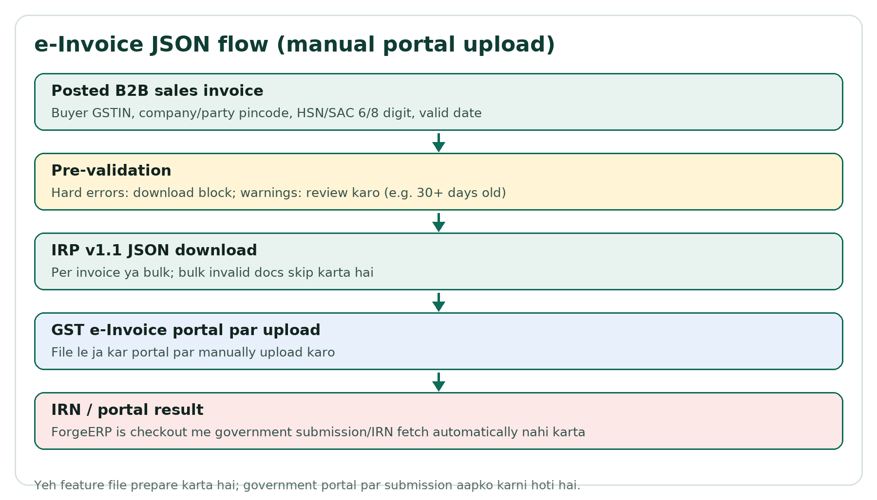
Flow: e-Invoice JSON prepare hota hai; portal upload manual hai.
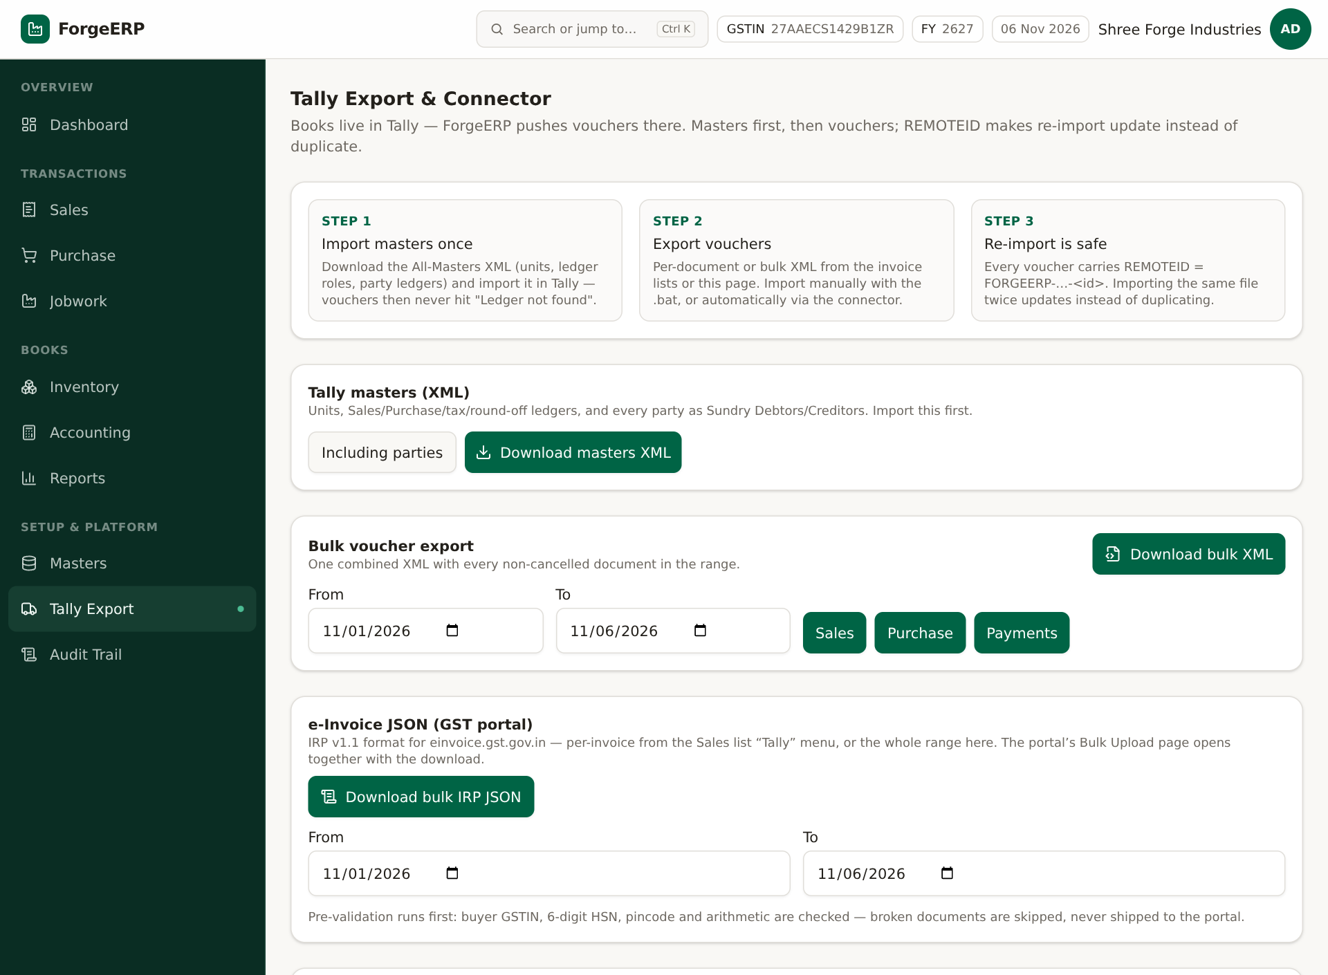
Screenshot: Bulk IRP JSON range aur download button.
1. Per invoice: Sales list > Tally menu > e-Invoice JSON (GST portal).
2. Bulk: Tally Export page me From/To choose karke Download bulk IRP JSON.
3. Pre-validation hard errors par download block; warnings review karein.
4. JSON ko GST e-Invoice portal par manually upload karein.
Pre-validation point | Meaning
B2B only | Buyer GSTIN mandatory; B2C/unregistered eligible nahi
Company/party pincode | 6 digit required
HSN/SAC | 6 ya 8 digits required
Future date | IRP reject karta hai; error
30+ days old | Warning; IRN timing rules practitioner se verify karein
Cancelled invoice | Generation blocked

Note: ForgeERP is checkout me IRN automatically fetch/government submission nahi karta. Bulk export invalid documents skip kar sakta hai; skipped list/errors check karein.

12. Audit Trail aur in-app Docs
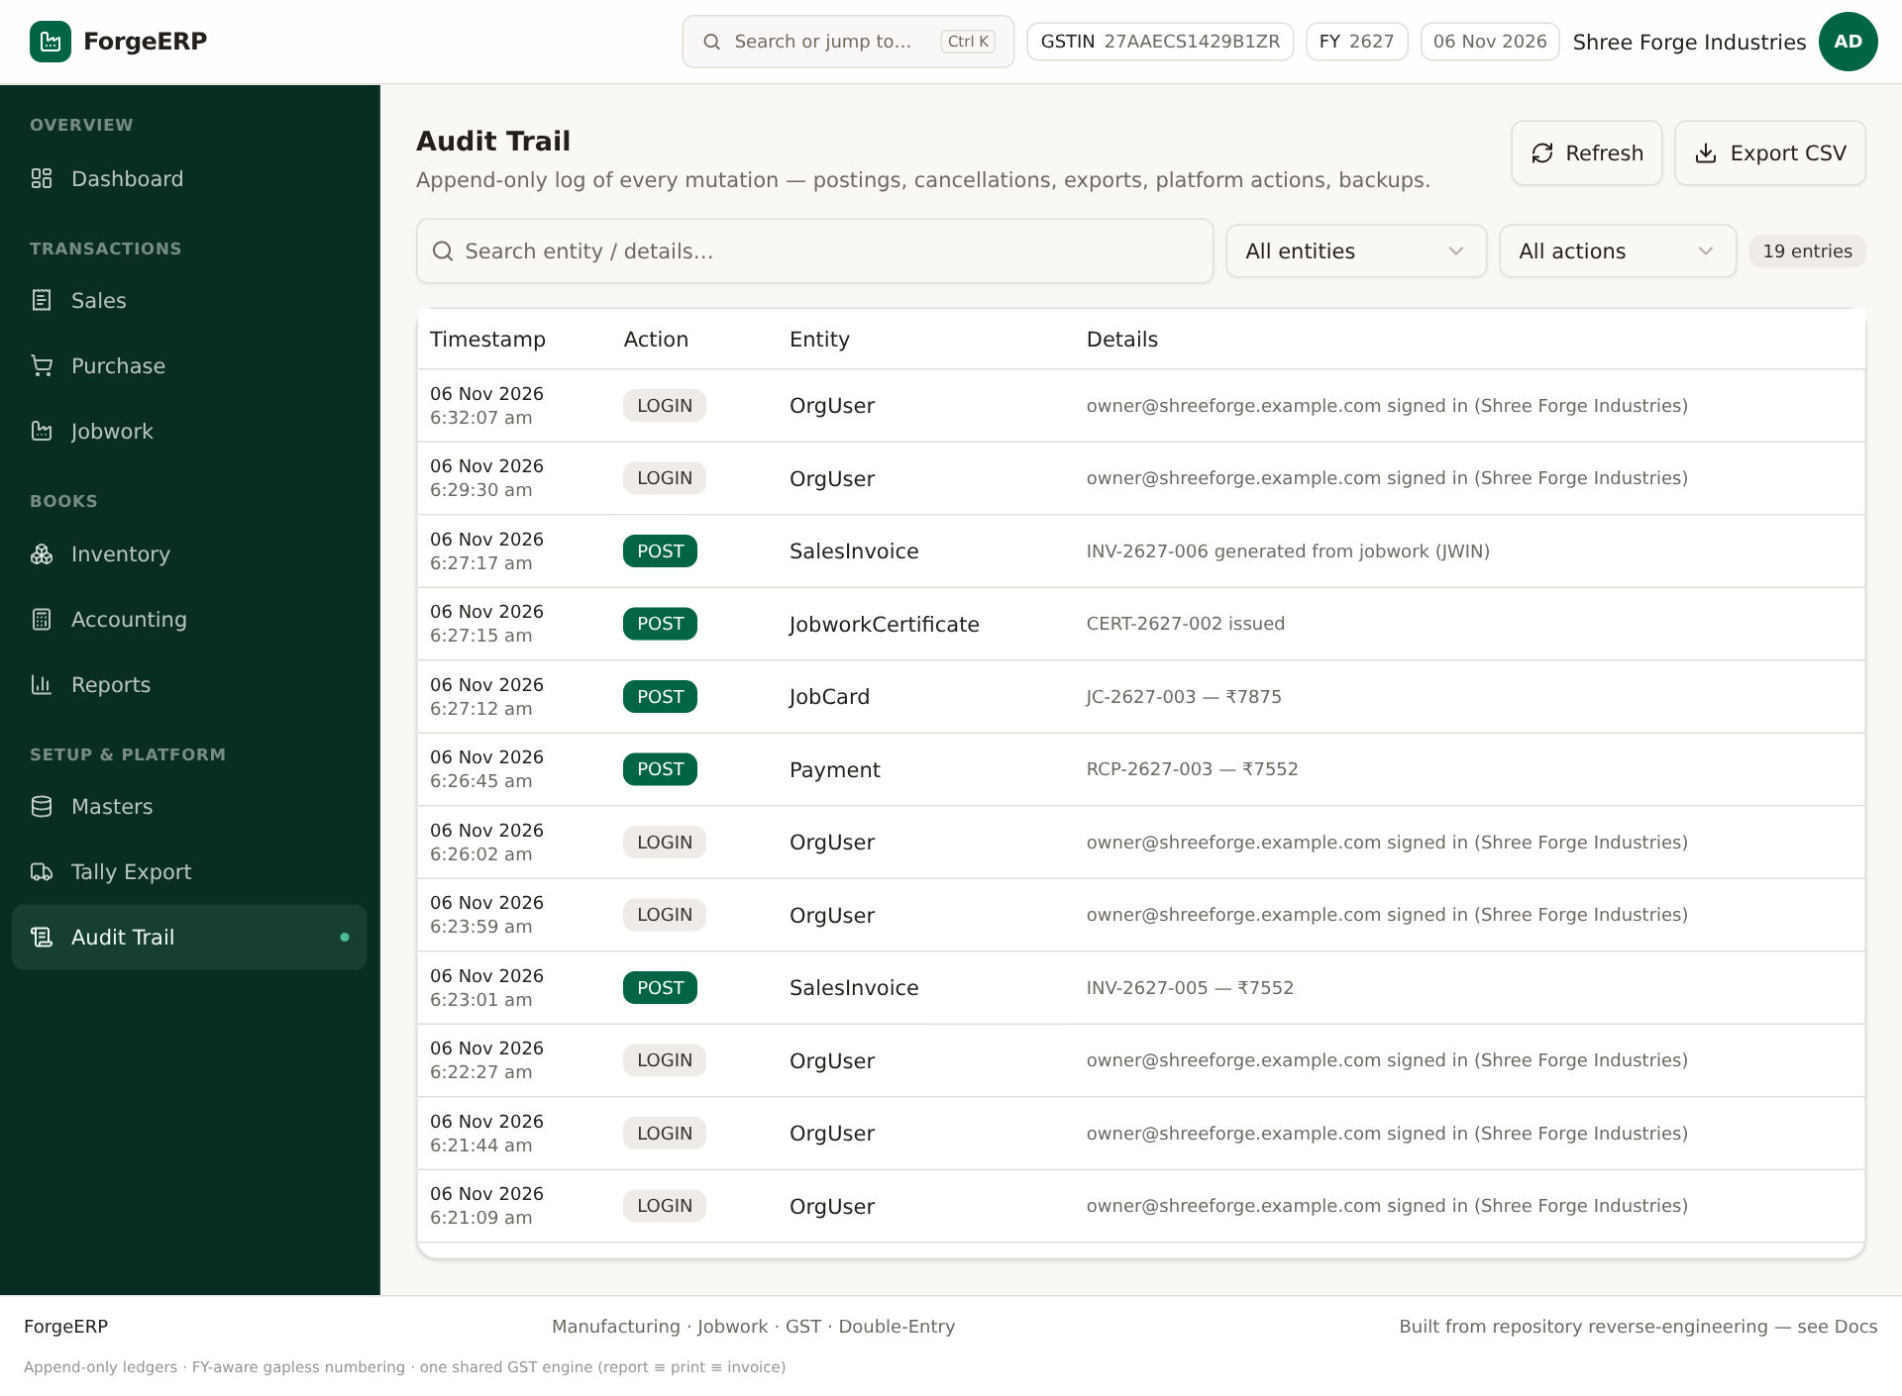
Screenshot: Audit Trail: timestamp, action, entity, details; filters aur CSV export.
1. Audit Trail kholiye.
2. Entity/action filters aur search se entry dhoondhein.
3. Refresh se latest logs; Export CSV se filtered rows download.
4. Posting, cancellation, export, platform action, backup jaise events verify karein.
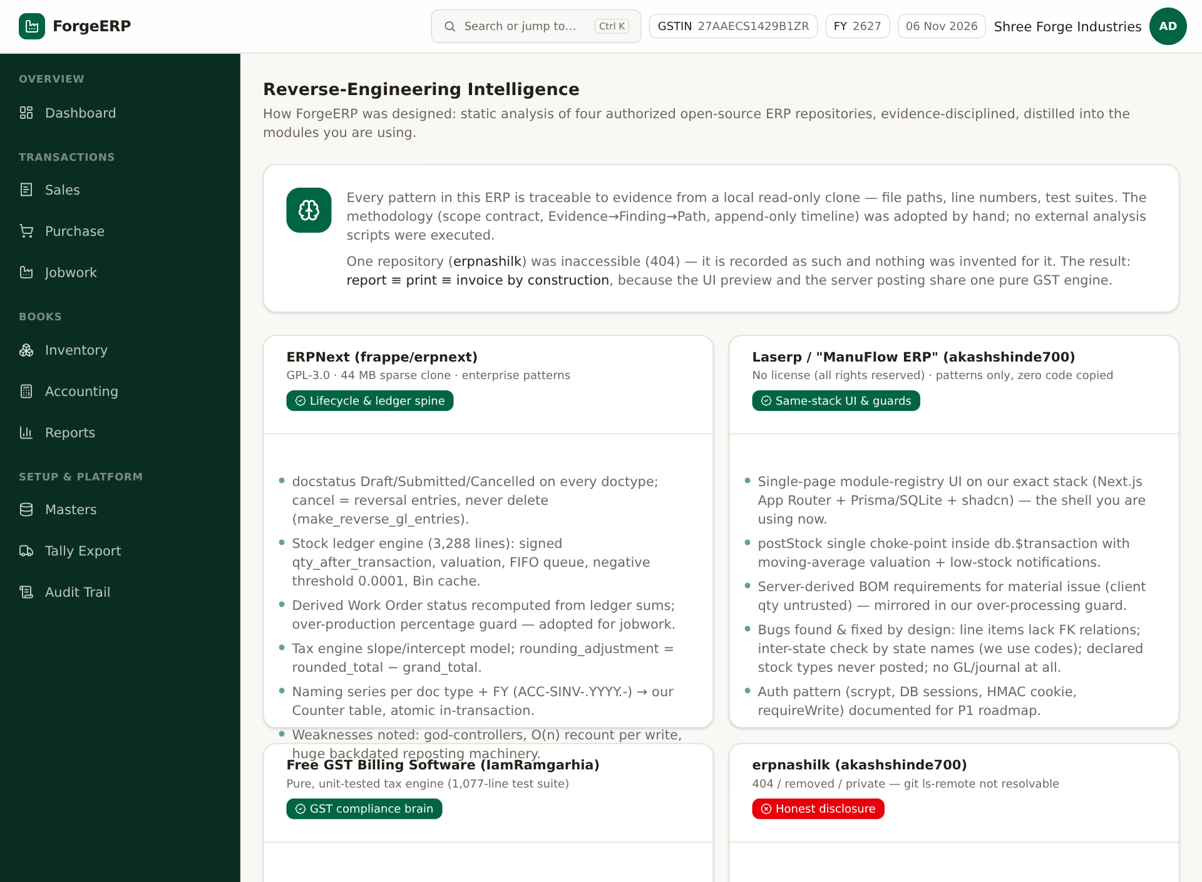
Screenshot: In-app Docs: repository reverse-engineering intelligence/reference links.
Docs page technical reference hai: kahan se patterns liye gaye, implementation notes. Daily user ke liye upar diye gaye modules/workflows primary guide hain.

13. Mobile use aur keyboard shortcuts
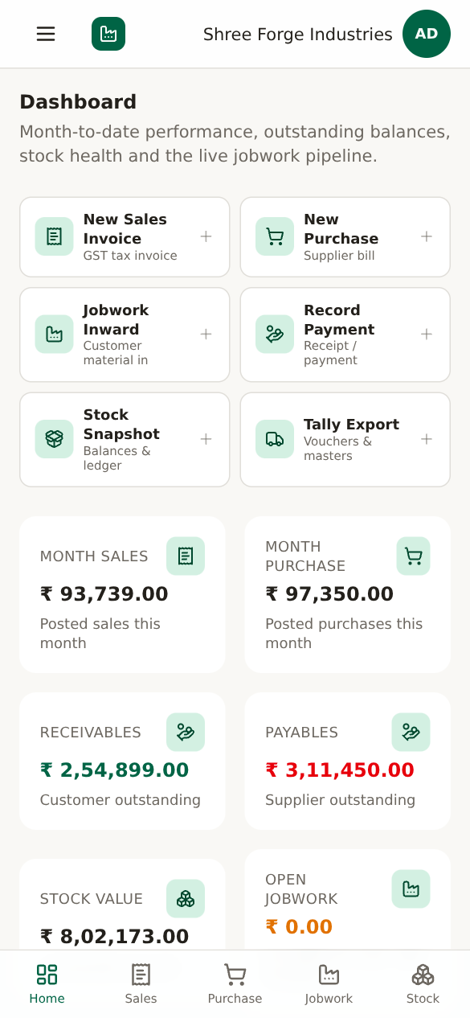
Screenshot: Mobile dashboard: quick actions aur KPI cards.
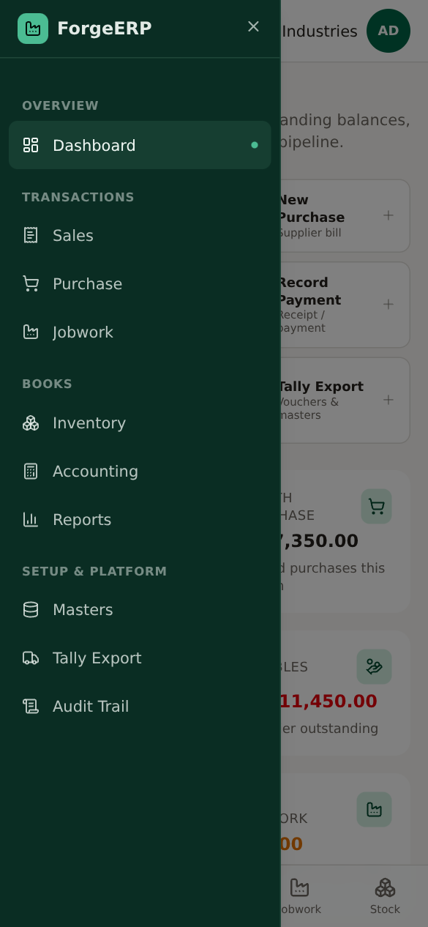
Screenshot: Mobile drawer: full module navigation.
- Bottom nav: Home, Sales, Purchase, Jobwork, Stock.
- Hamburger/Open navigation se Masters, Accounting, Reports, Tally, Audit.
- Forms me scroll karke fields bharein; dropdown native/select controls use karein.
- Shared mobile par Sign out zaroor karein.

14. Daily / weekly / month-end SOP
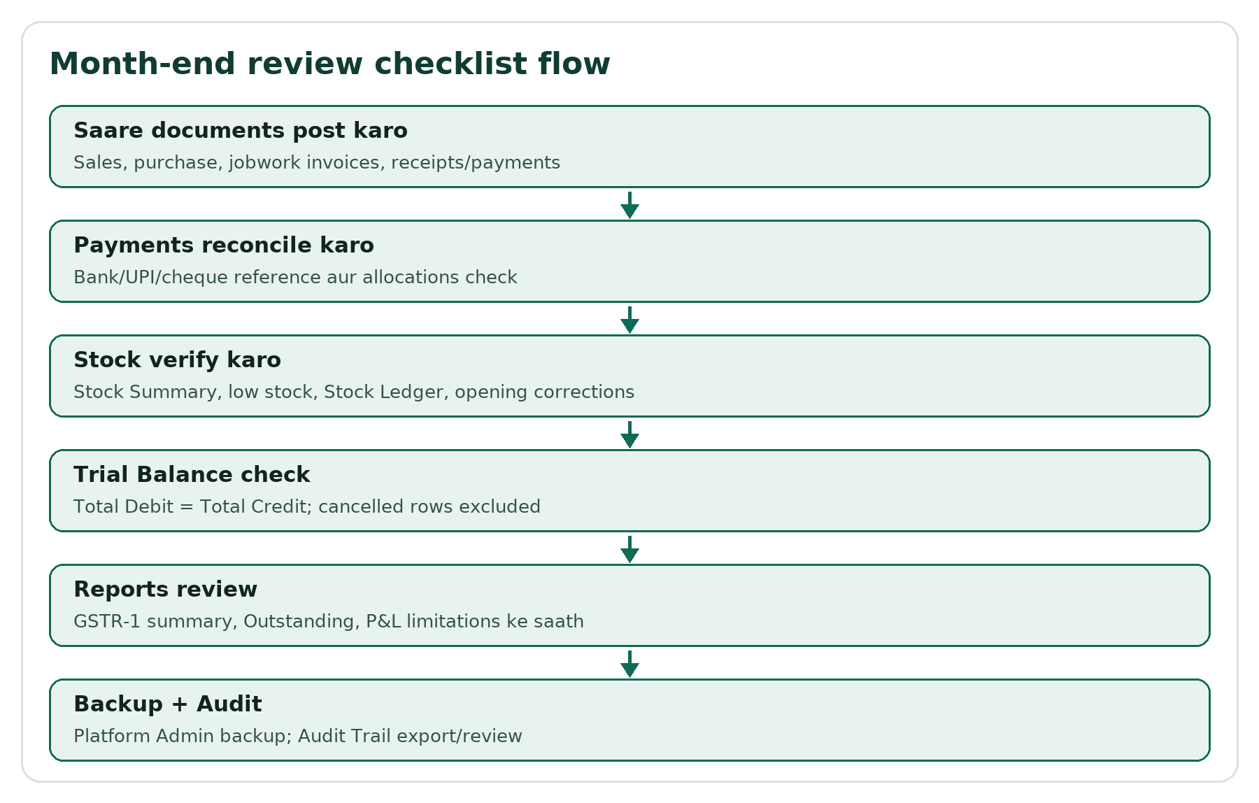
Flow: Month-end review flow.

14.1 Daily
- Dashboard se sales/purchase/stock/receivables snapshot.
- Naye sales/purchase/jobwork documents post karein.
- Receipts/payments record aur allocate karein.
- Low stock aur pending jobwork check karein.

14.2 Weekly
- Outstanding report se collection follow-up.
- Stock Summary vs physical sample count.
- Party Ledger me unallocated payments review.
- Audit Trail me unusual cancellations/exports.

14.3 Month-end
- Saare invoices/payments post; cancellations reviewed.
- Trial Balance Dr=Cr check.
- GSTR-1 summary ko books se reconcile.
- P&L limitations ke saath review; CA ko data export.
- Platform Admin se backup; backup file secure store.

15. Troubleshooting aur glossary

15.1 Common problems
Problem | Kya check karein
Login nahi ho raha | Email/password, caps lock, admin reset, session revoked
Invoice post nahi ho raha | Party/item/warehouse, qty>0, rate>=0, stock availability, plan/suspension
GST galat lag raha | Company state, party state, place of supply, item GST rate, tax-inclusive toggle
Stock negative/available nahi | Opening stock, purchase posting, warehouse selection, cancellations
Payment ke baad bhi balance dikhta hai | Allocation bhari ya nahi; invoice outstanding; payment cancel/repost
Job card post nahi ho raha | Received vs processed qty/weight, 5% tolerance, certificate/invoice blockers
e-Invoice JSON nahi mil raha | B2B GSTIN, pincode, HSN 6/8 digit, future/cancelled invoice, hard errors
Tally import error | Masters pehle, ledger names exact, port 9000, LINEERROR details
Reports access denied | Plan feature advancedReports, suspension/expiry, role
Export access denied | Plan feature exportData, role VIEWER

15.2 Glossary
Term | Matlab
Master | Basic reference data: party/item/warehouse/process/company
Posting | Transaction ko permanent business record banana
GL | General Ledger / account ledger; double-entry debit-credit
Dr / Cr | Debit / Credit
HSN / SAC | Goods / service classification code
CGST/SGST/IGST | Intra-state split / inter-state GST
B2B / B2C | Registered GSTIN party / unregistered consumer
Allocation | Payment ko specific invoice ke against baantna
Outstanding | Invoice ka unpaid balance
Weighted-average cost | Stock value ka average cost method
Jobwork | Customer material par processing service
Inward | Customer material receipt
Job Card | Processing operation record
Certificate | Jobwork completion/dispatch proof
IRP / IRN | Invoice Registration Portal / Invoice Reference Number
REMOTEID | Tally me voucher identity; re-import update ke liye
Append-only | Purana row delete nahi; reversal/cancel rows add

Compliance: Final tax filing, statutory audit aur legal compliance ke liye qualified CA/GST practitioner se verify karein. Ye guide software use karne ke liye hai.

