ForgeERP
Platform Admin Guide
Organizations, plans, subscriptions, inquiries, blog aur backup ko kaise manage karein
Hinglish step-by-step manual • Screenshots + workflow diagrams
Version 1.0 | 06 November 2026
Screenshots isolated demo data se liye gaye hain: Shree Forge Industries, FY 2627.
Real company names, amounts, GSTIN, passwords aur counts aapke deployment me alag honge.

Is guide me kya hai
1. Platform Admin kya hai aur ERP se alag kyun
2. Login, console map aur security basics
3. Organizations: create, plan, limits, login, subscription, delete
4. Plans: pricing, limits, features
5. Inquiries: lead log aur follow-ups
6. Blog: draft/published content
7. Data & backup: download, scope, restore
8. Enforcement rules aur runtime limitations
9. Admin SOP, troubleshooting, glossary
Note: Word me Navigation Pane kholkar headings se jump kar sakte hain. Screenshots high-resolution hain; chhota text padhne ke liye Word zoom badha lein.

1. Platform Admin kya hai aur ERP se alag kyun
Platform Admin deployment ka control plane hai. Ye customer organizations, plans, trial/paid status, limits, owner logins, inquiries, blog content aur backup manage karta hai. Organization ERP daily business books hai; Platform Admin uske upar access/commercial controls hai.
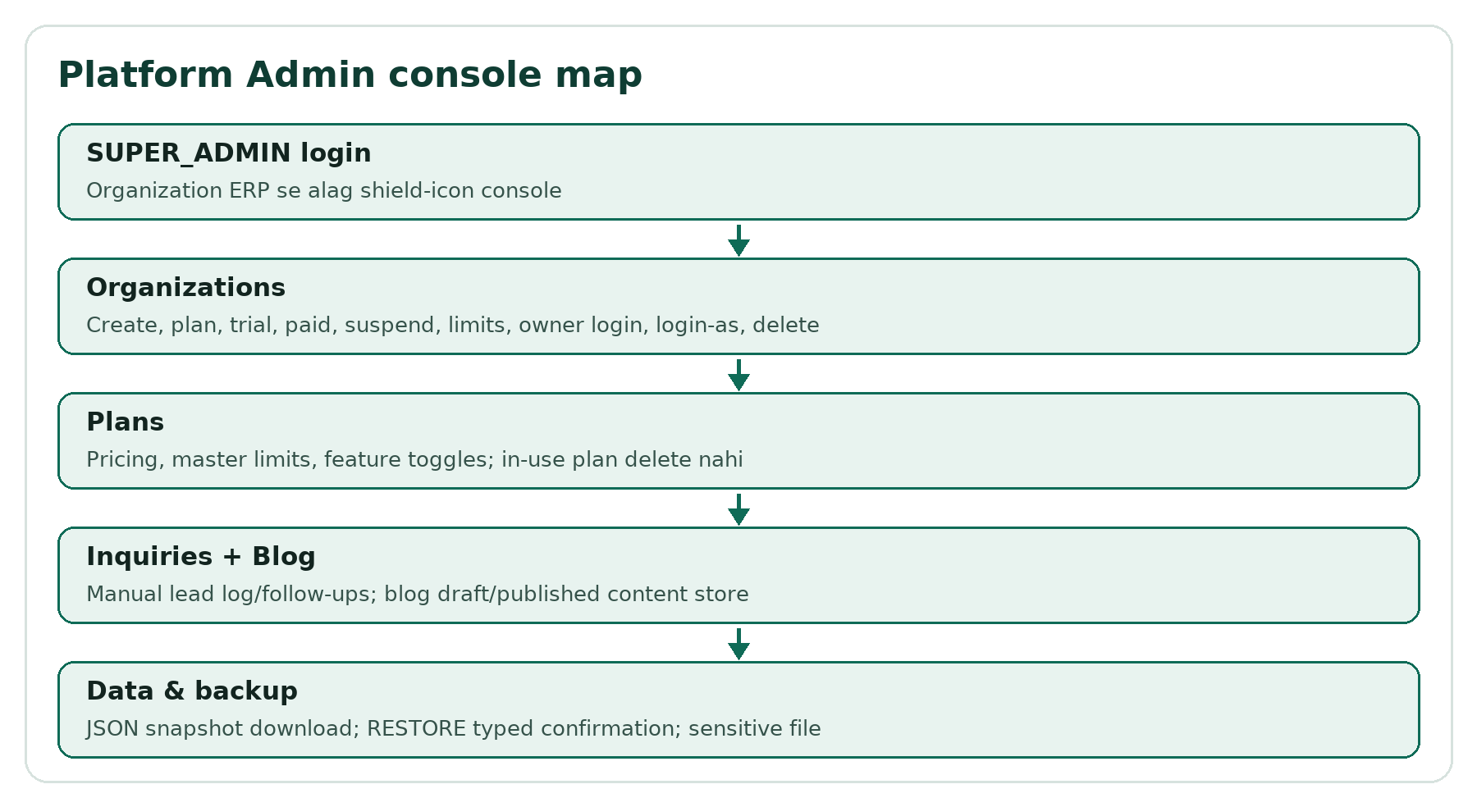
Flow: Platform Admin console map.
Important limitation: Is runtime me ERP workspace first non-platform organization ki books serve karta hai. Nayi organizations ke logins non-operating hone par read-only portal kholte hain; separate per-org books roadmap item hai.

1.1 Admin vs Org user
Console | Kaun | Kaam
Organization ERP | OWNER/ACCOUNTANT/VIEWER | Sales, purchase, stock, jobwork, payments, reports
Platform Admin | SUPER_ADMIN | Orgs, plans, subscriptions, limits, inquiries, blog, backup

2. Login, console map aur security basics

2.1 Login
1. Login screen par shield/Platform admin icon se separate console kholiye.
2. Admin email aur password daliye. Production password deployment owner/admin se milega; screenshots isolated demo se hain.
3. Sign in dabaiye. Header me SUPER_ADMIN identity dikhti hai.
4. Back to login se login screen; Logout se session end.
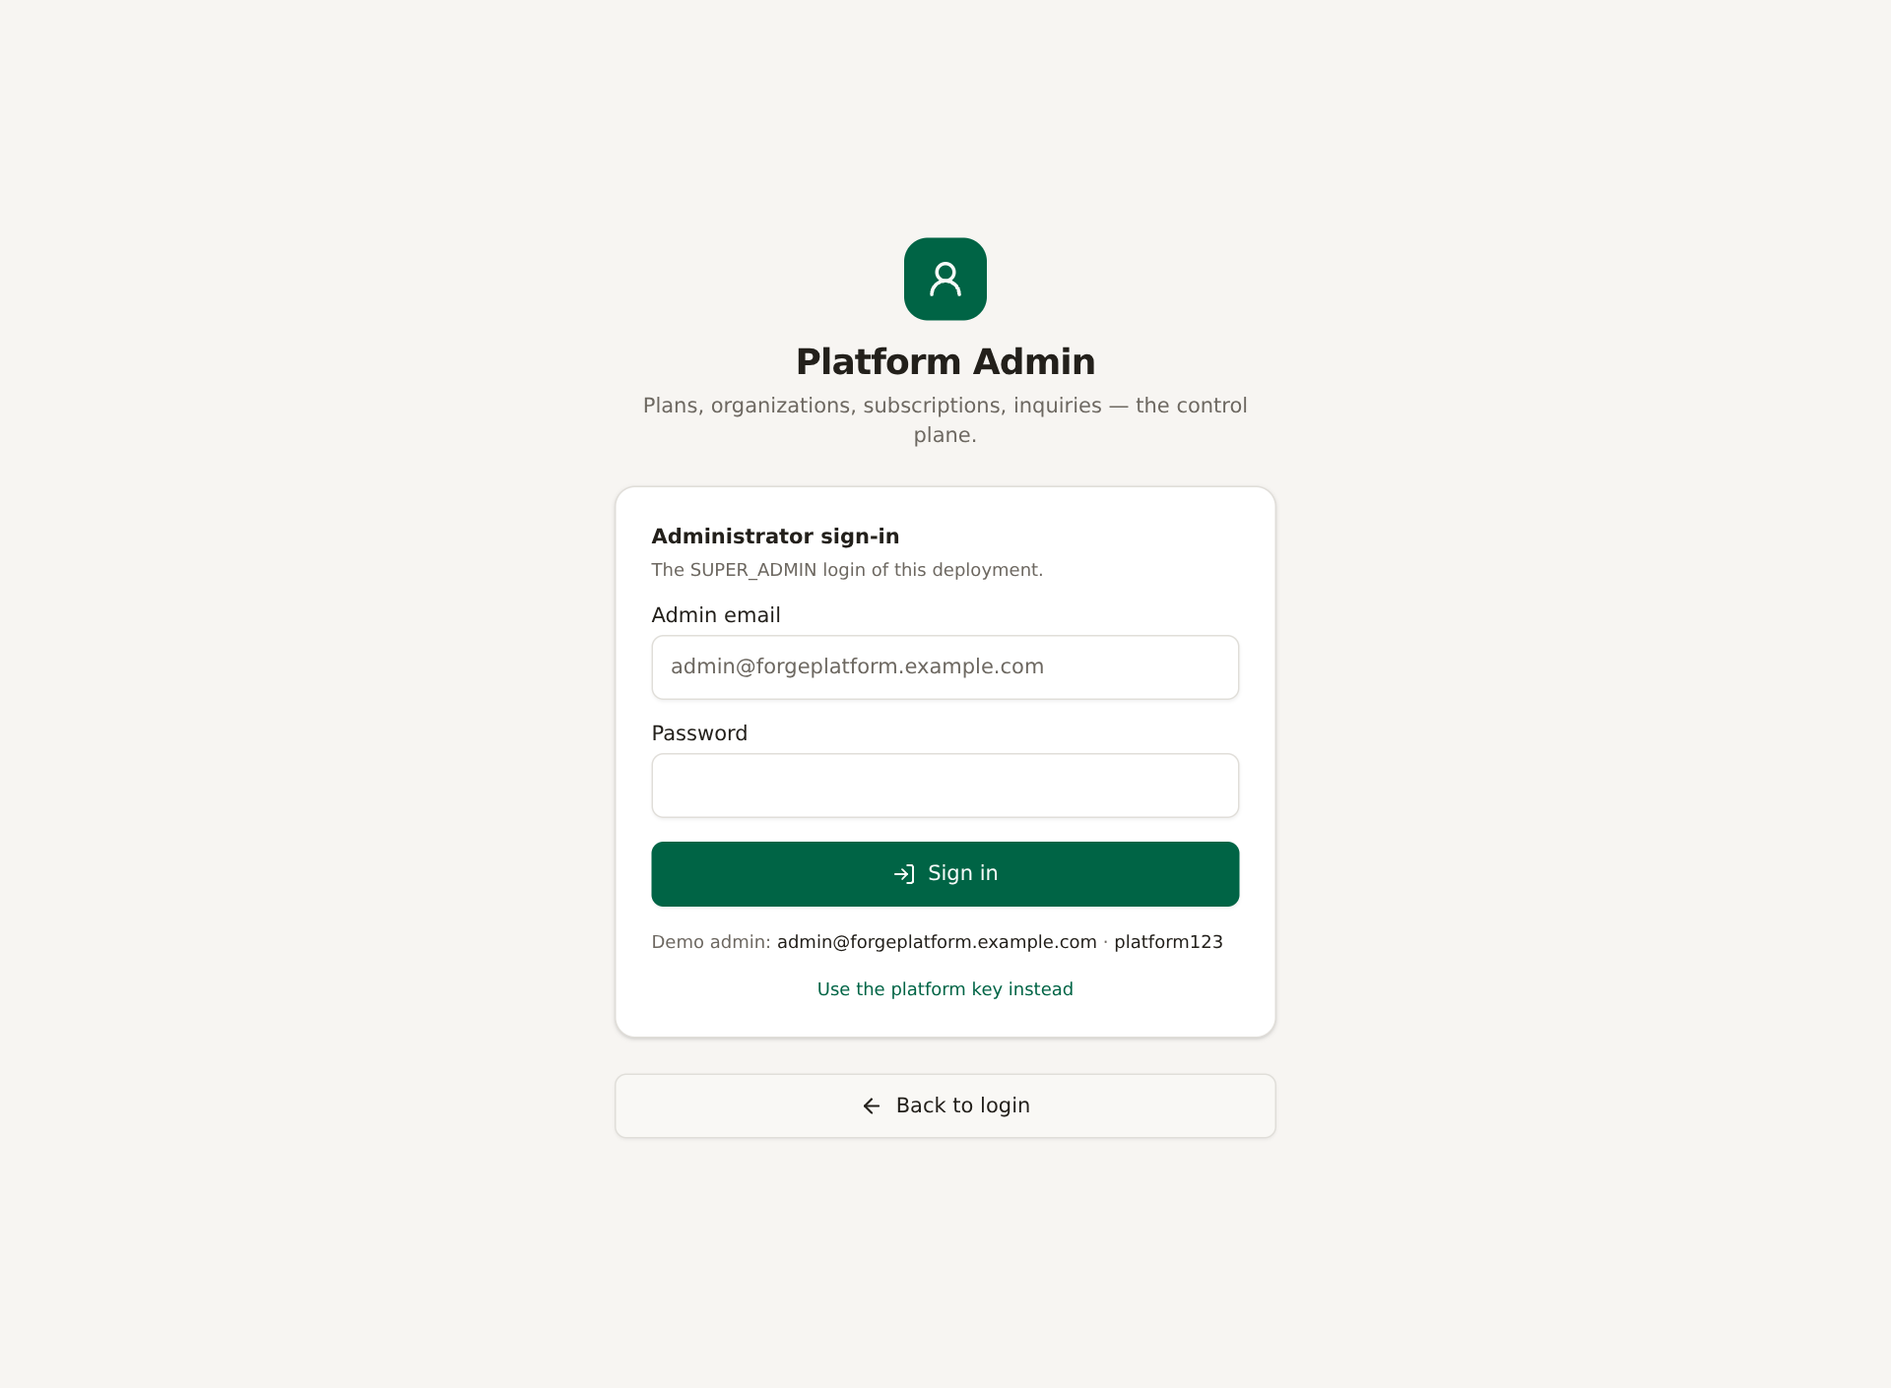
Screenshot: Platform Admin sign-in gate.
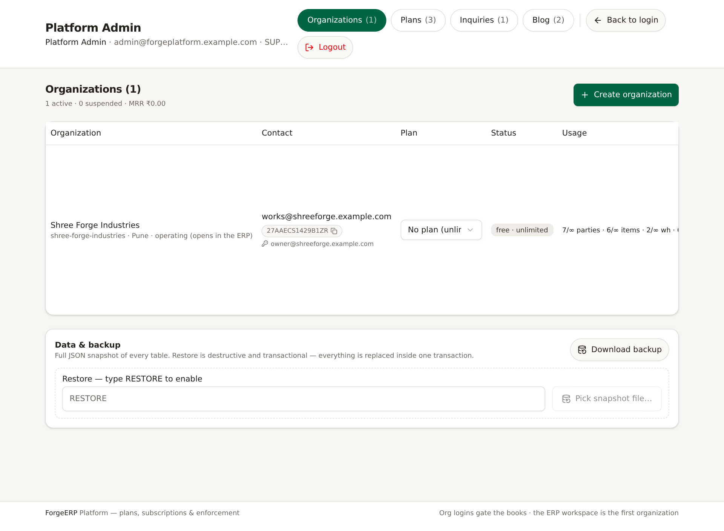
Screenshot: Organizations tab: org list, plan/status/usage, Data & backup card.
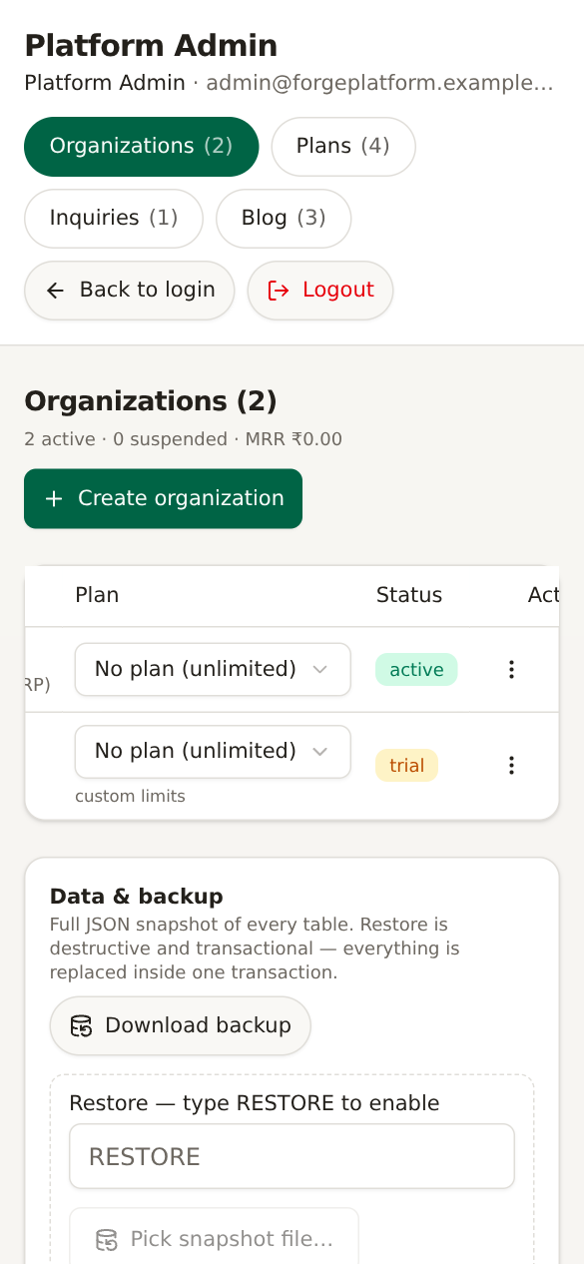
Screenshot: Mobile par Platform Admin: tabs wrap hote hain; org table horizontally scroll karke Actions dekhein.

2.2 Security basics
- Admin credential kisi org user ke saath share na karein.
- Password reset ke baad purane sessions revoke ho sakte hain; dobara sign-in karna padega.
- Login-as current browser session ko org owner session se replace karta hai; wapas admin banne ke liye logout + admin login.
- Backup file sensitive hai: org users ke password hashes included hain.
- Delete/restore destructive hain; typed confirmation aur current backup ke bina na karein.

3. Organizations: create, plan, limits, login, subscription, delete
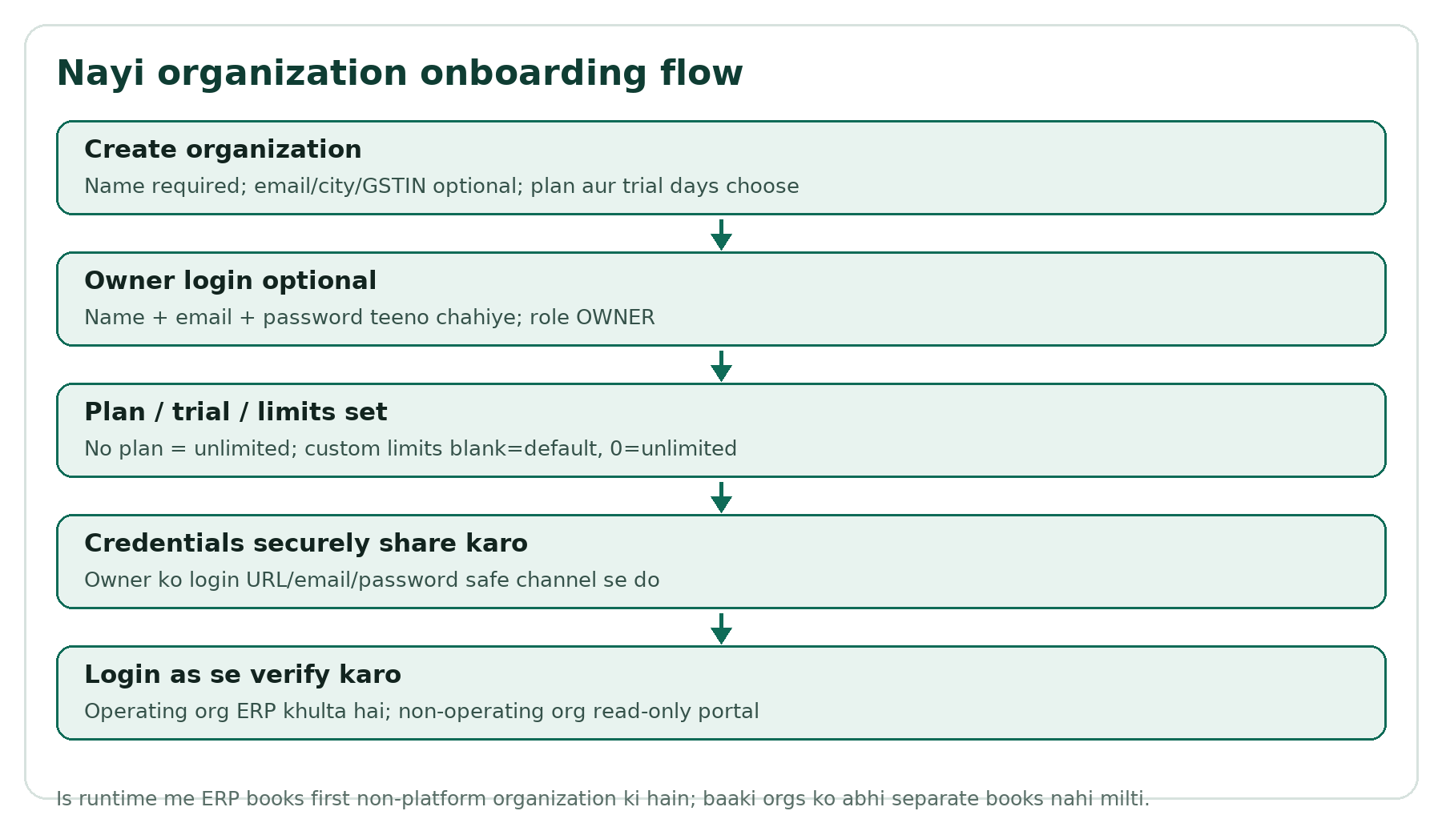
Flow: Nayi organization onboarding flow.

3.1 Organization list kaise padhein
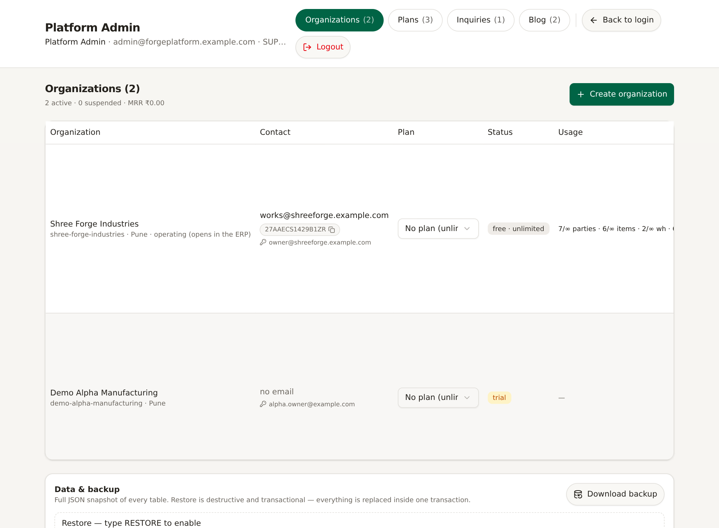
Screenshot: Organizations list me nayi Demo Alpha Manufacturing row. Operating org ERP books serve karti hai.
Column | Meaning
Organization | Name, slug, city; operating marker first org ke liye
Contact | Org email, GSTIN, owner login email
Plan | Assigned plan; No plan = unlimited; custom limits marker
Status | active/trial/suspended/expired context
Usage | Operating org ke global master/invoice counts; non-operating me —
Period/Trial | Paid until / trial until / no expiry
Actions | Mark paid, +7d trial, suspend/activate, customize, reset login, login-as, delete

3.2 Nayi organization create karna
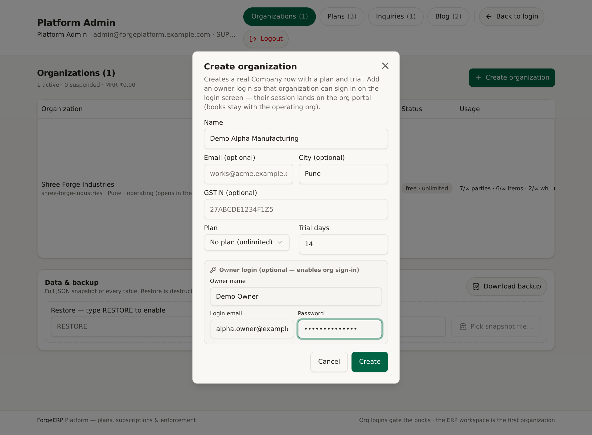
Screenshot: Create organization form: name, contact, GSTIN, plan, trial days, owner login.
1. Organizations > Create organization.
2. Name required hai. Email, city, GSTIN optional.
3. Plan choose karein ya No plan (unlimited). Trial days default 14; 0 = no trial date.
4. Owner login dena ho to Owner name, email, password teeno bharein; role OWNER banta hai.
5. Create dabaiye. List me nayi org verify karein.
Note: Owner login optional hai, lekin agar dena hai to name/email/password teeno chahiye. Email unique hona chahiye. Non-operating org ka login abhi portal kholega, ERP books nahi.

3.3 Plan assign karna
1. Org row ke Plan dropdown se plan select karein.
2. No plan (unlimited) choose karne par plan limits/features enforce nahi hote.
3. Change ke baad status/limits marker verify karein.

3.4 Custom limits
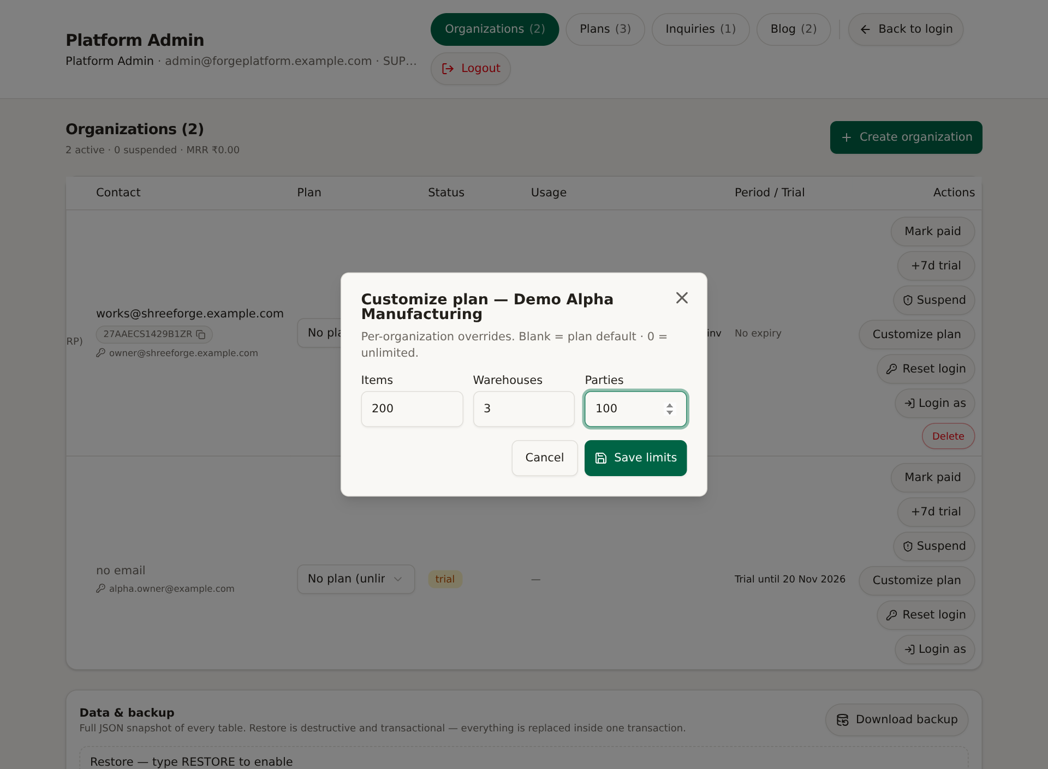
Screenshot: Customize plan: Items, Warehouses, Parties overrides.
1. Org row > Customize plan.
2. Blank = plan default; 0 = unlimited; positive number = custom cap.
3. Save limits dabaiye. Row par custom limits marker aata hai.
4. Reset custom se overrides hatate hain aur plan defaults apply hote hain.
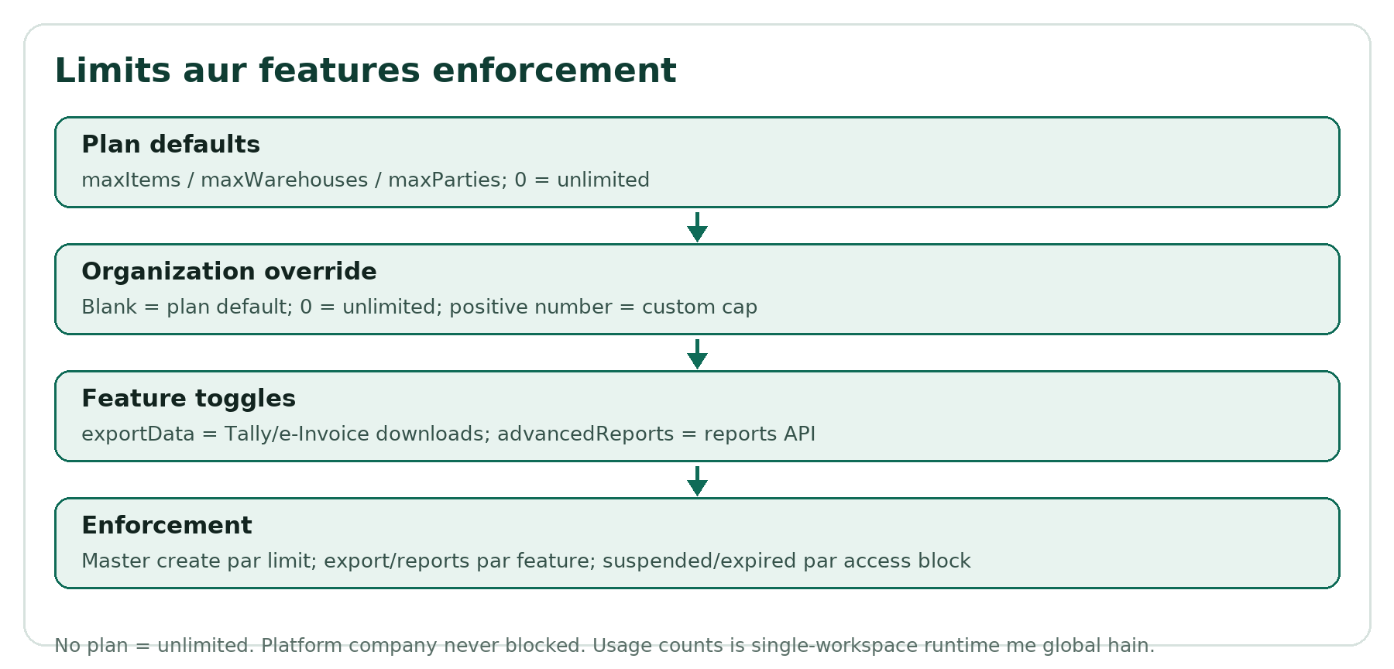
Flow: Limits aur features enforcement.

3.5 Owner login reset/set
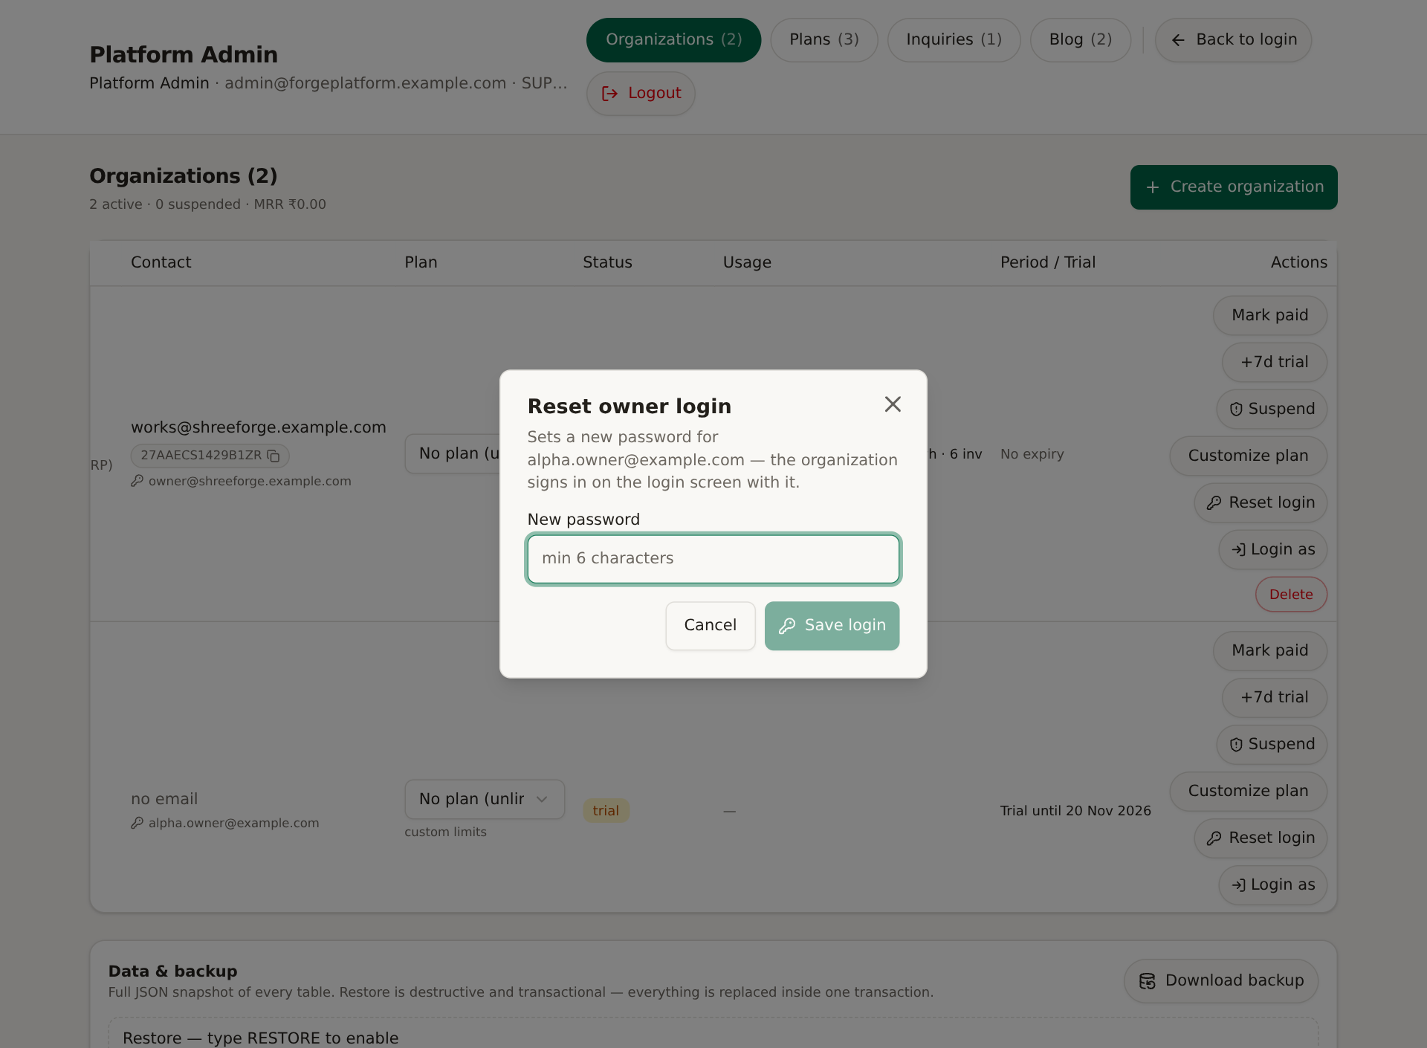
Screenshot: Reset owner login dialog: new password.
1. Org row > Reset login / Set login.
2. New password minimum 6 characters; strong password recommend.
3. Save login dabaiye.
4. Existing user ka password change hota hai aur tokenVersion badhne se live sessions revoke hote hain.
5. Owner ko secure channel se credential share karein.

3.6 Login as
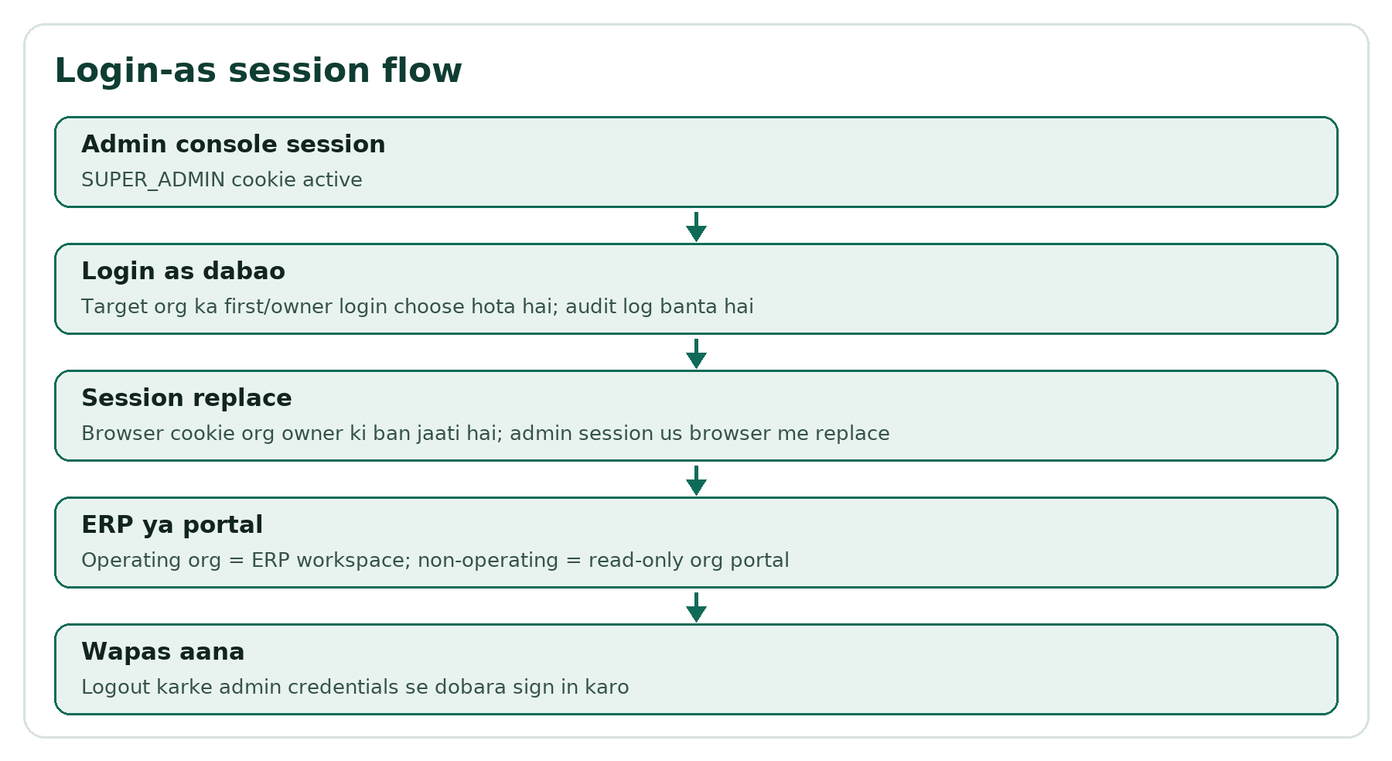
Flow: Login-as session replacement flow.
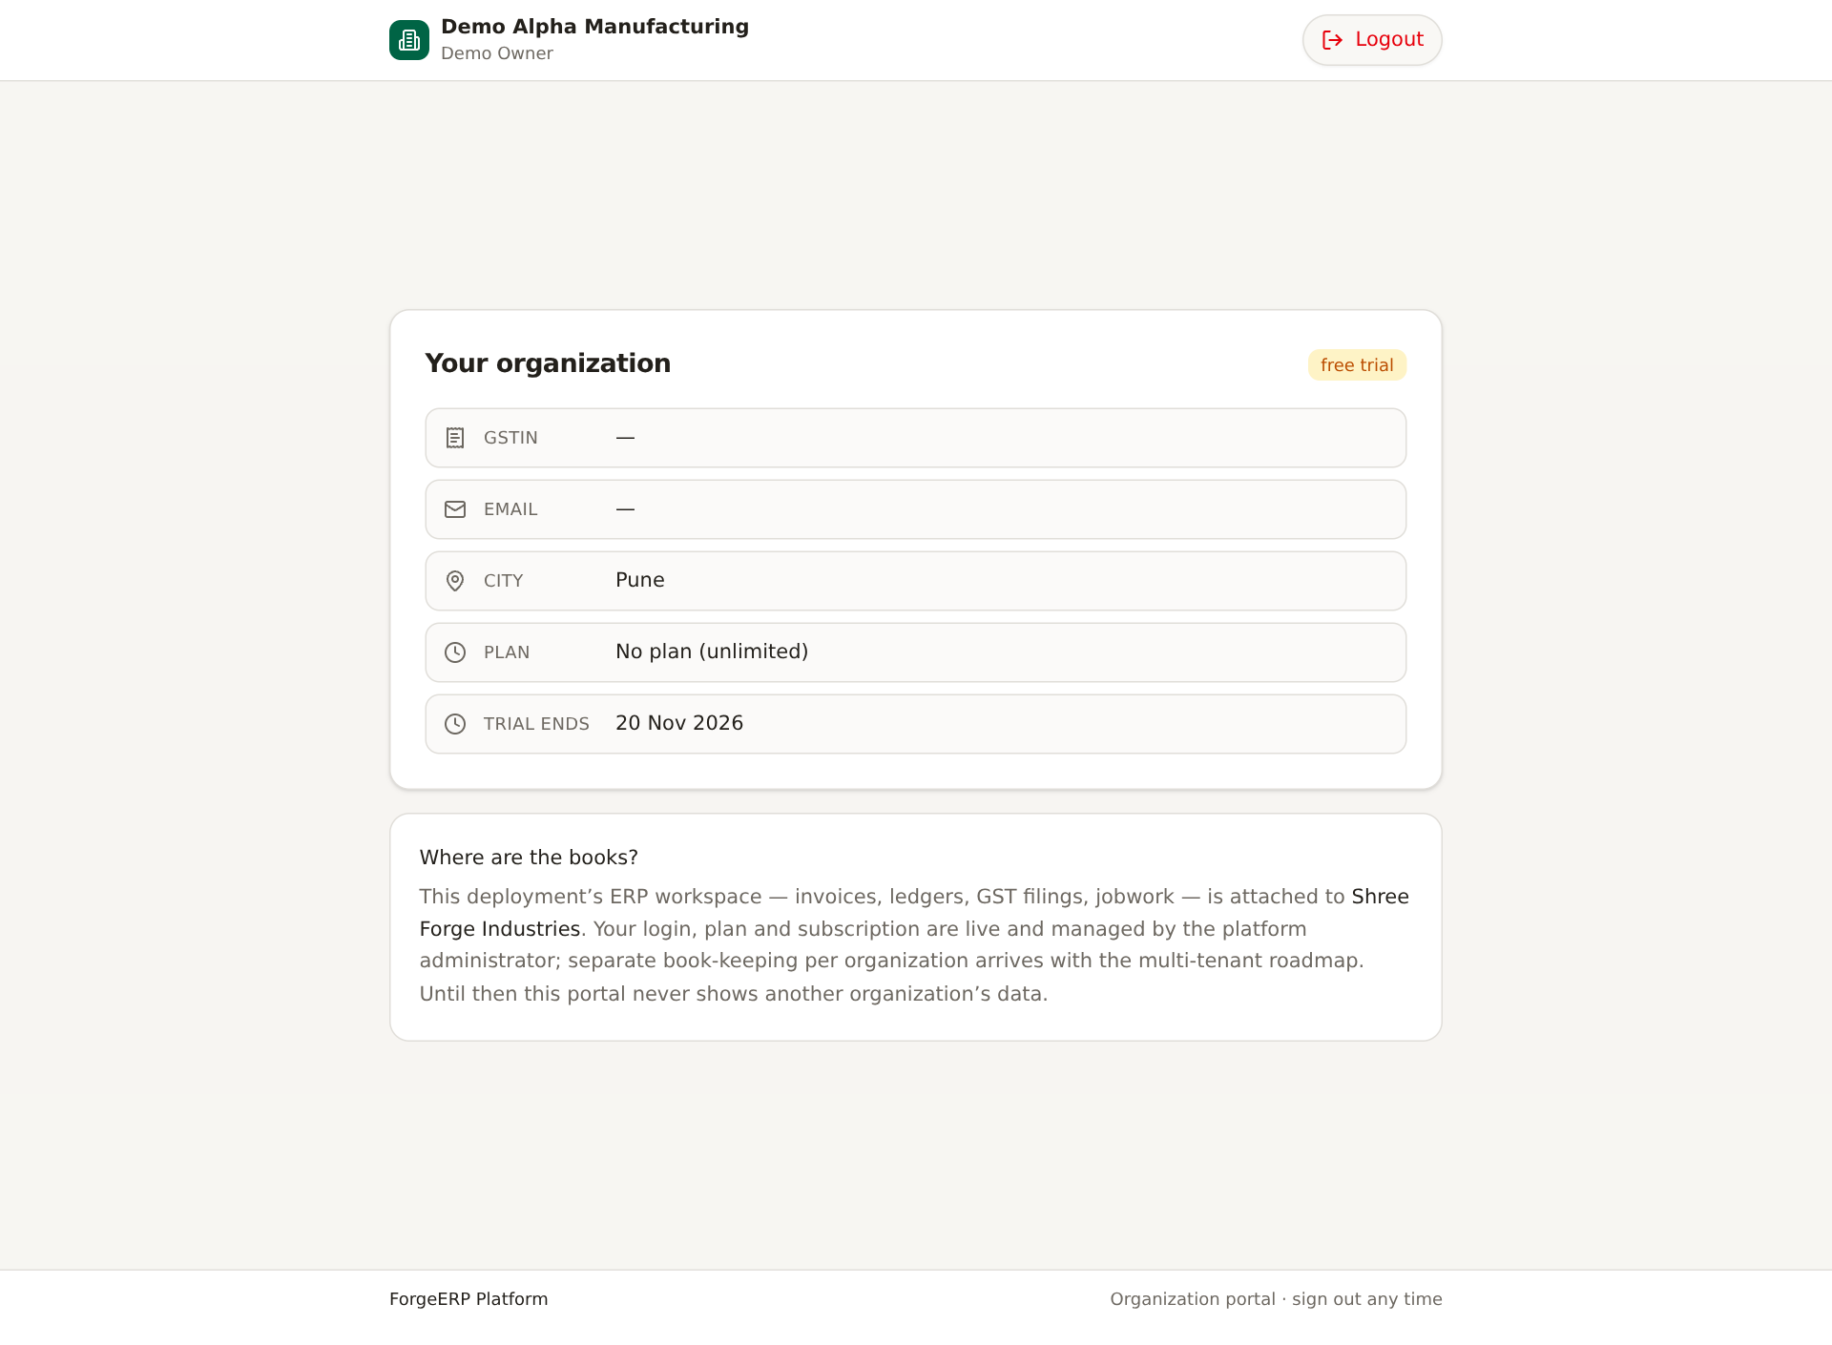
Screenshot: Non-operating org ka read-only portal after Login as.
1. Org row > Login as.
2. Browser session target org ke owner login me replace hota hai.
3. Operating org ho to ERP workspace; non-operating ho to organization portal.
4. Wapas Platform Admin aane ke liye Logout karke admin credentials se sign in karein.
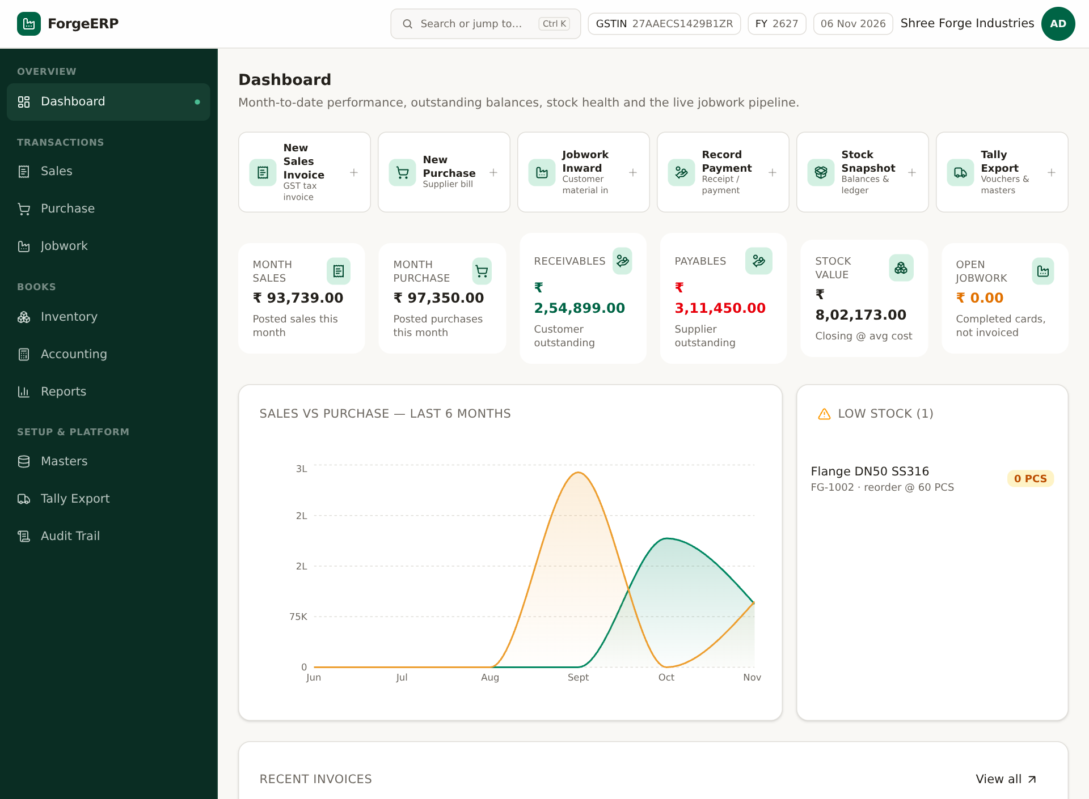
Screenshot: Operating organization context me ERP workspace. Books isi first org ki hain.

3.7 Suspend / Activate
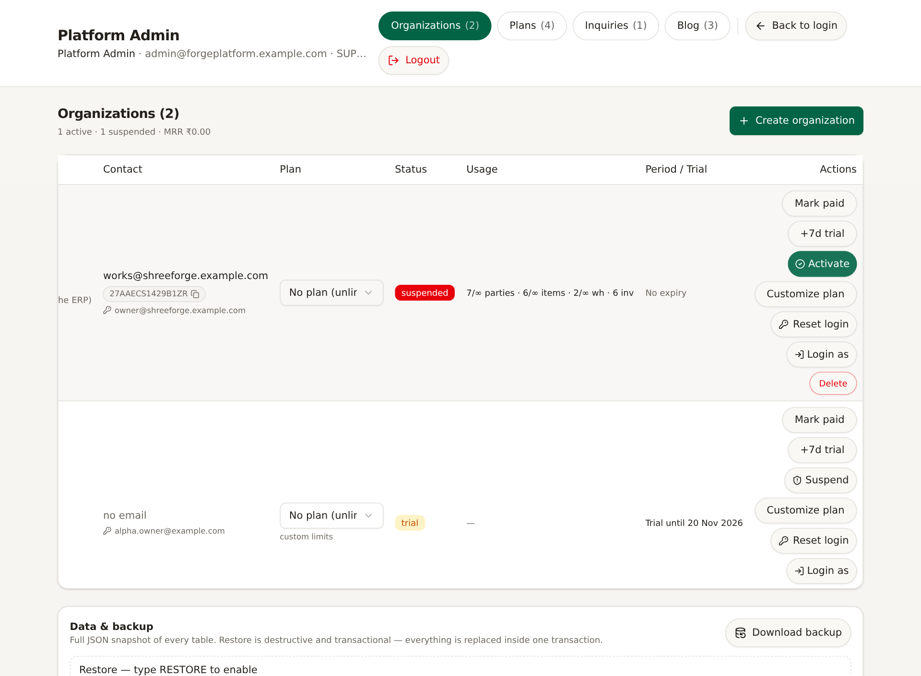
Screenshot: Suspended organization status.
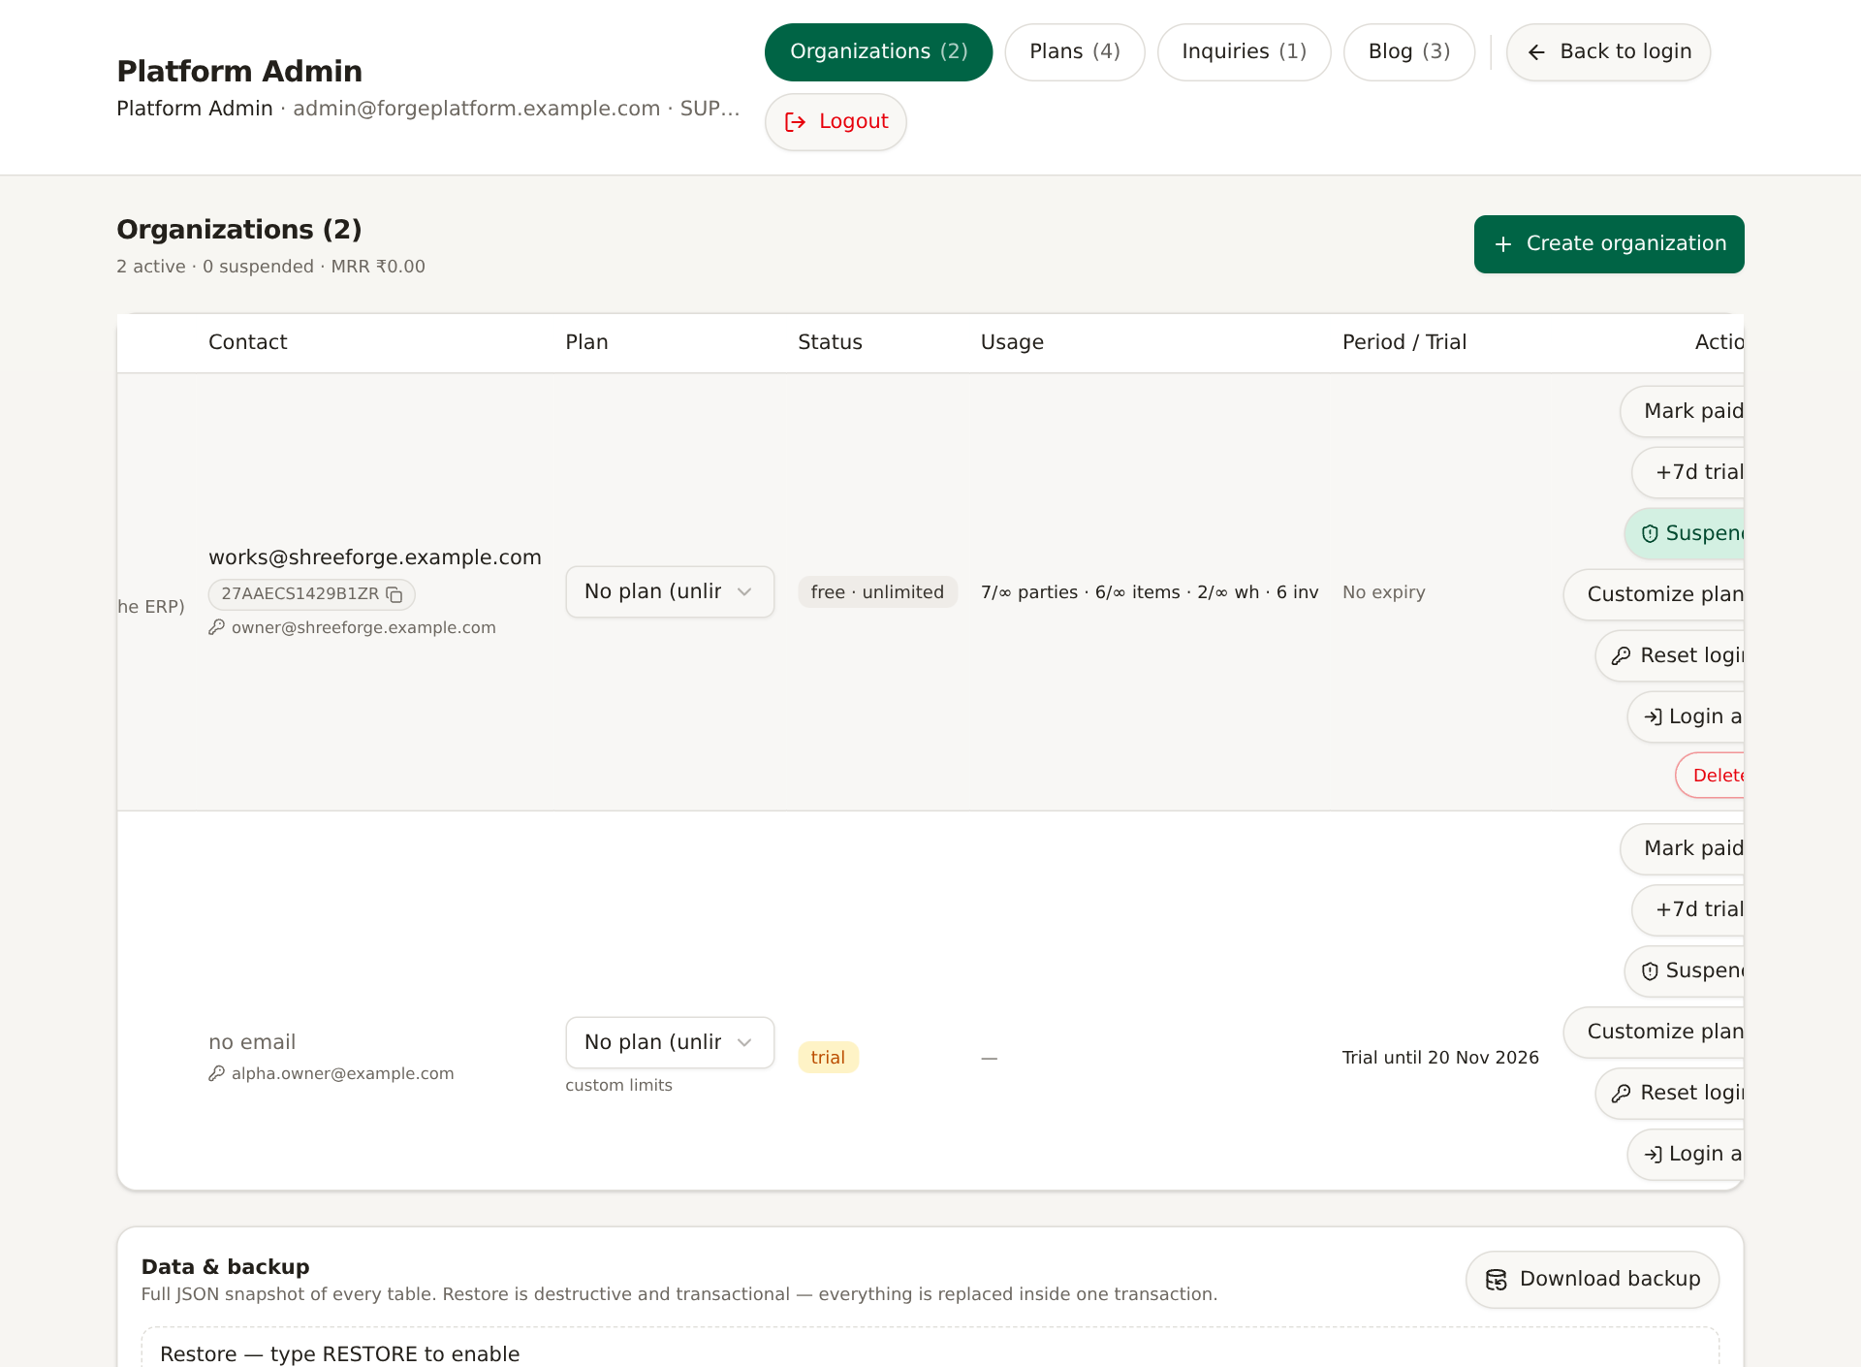
Screenshot: Activate ke baad status active.
1. Suspend dabaiye: org SUSPENDED hoti hai; business access/mutations block.
2. Activate dabaiye: saasStatus ACTIVE hota hai.
3. Suspension manual control hai; trial extend karne se suspension automatically nahi hatati.

3.8 Mark paid aur trial extension
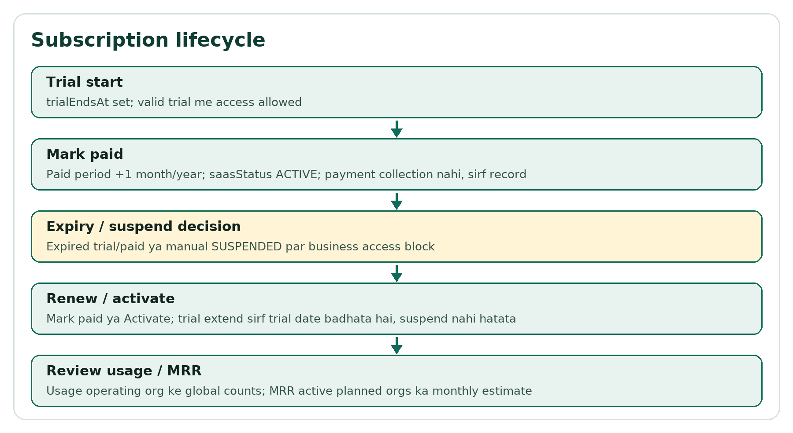
Flow: Subscription lifecycle.
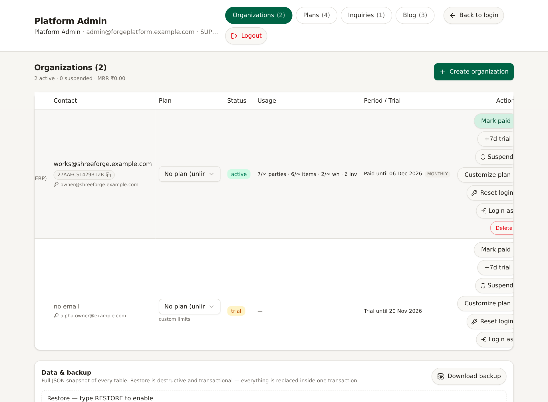
Screenshot: Mark paid ke baad paid period update.
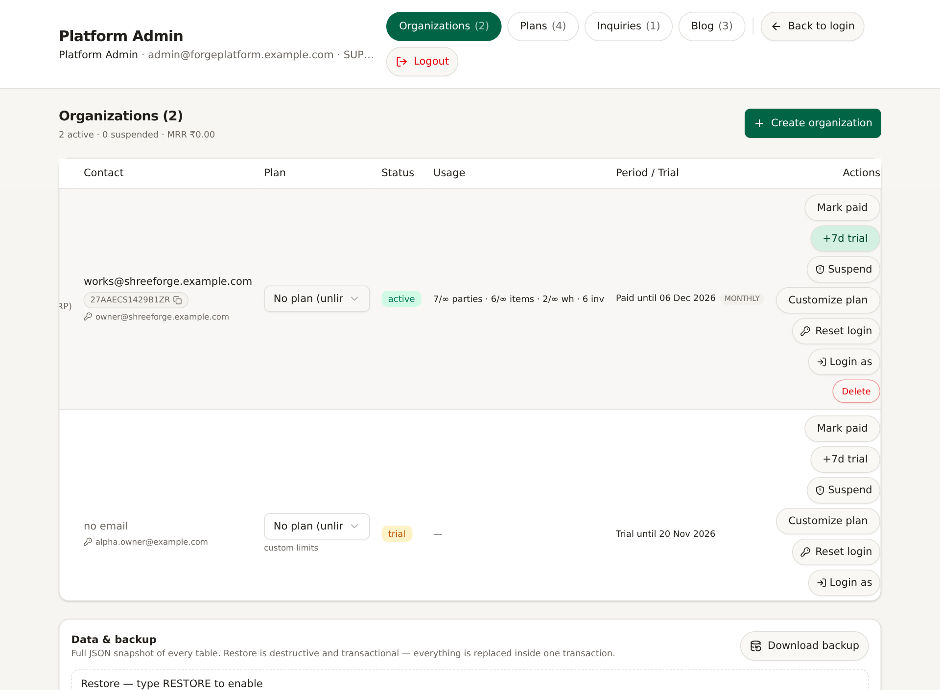
Screenshot: +7d trial ke baad trial date update.
Action | Kya karta hai | Kya nahi karta
Mark paid | paidUntil ko current/base se +1 month/year extend; ACTIVE; billing cycle set | Payment gateway collection nahi; sirf subscription record
+7d trial | trialEndsAt +7 days; valid trial access | SUSPENDED status nahi hatata; paid period nahi badhata
Suspend | Manual block | Data delete nahi
Activate | Suspend hatata hai | Expired dates khud extend nahi karta

3.9 Delete organization
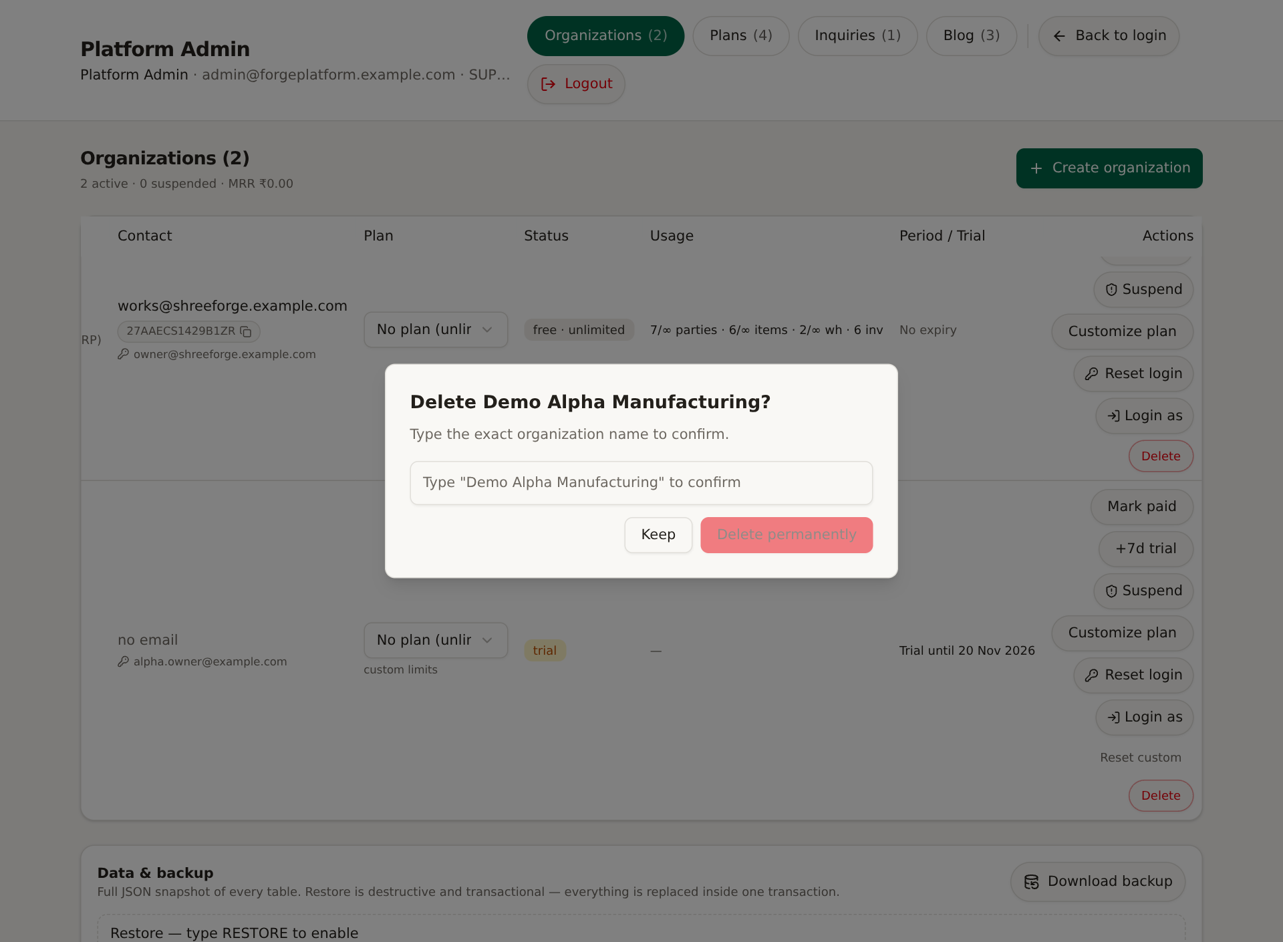
Screenshot: Delete confirmation: exact name type karna padta hai. Screenshot me Keep choose kiya gaya.
1. Org row > Delete.
2. Confirmation me exact organization name type karein.
3. Non-operating org delete karne par Company row aur uske users remove hote hain.
4. Operating org delete karne par ALL business data wipe hota hai: invoices, ledgers, jobwork, masters.
5. Bina approved backup aur business approval ke delete na karein.
Safety: Guide screenshots me destructive delete perform nahi kiya gaya; confirmation kholkar Keep dabaya gaya.

4. Plans: pricing, limits, features
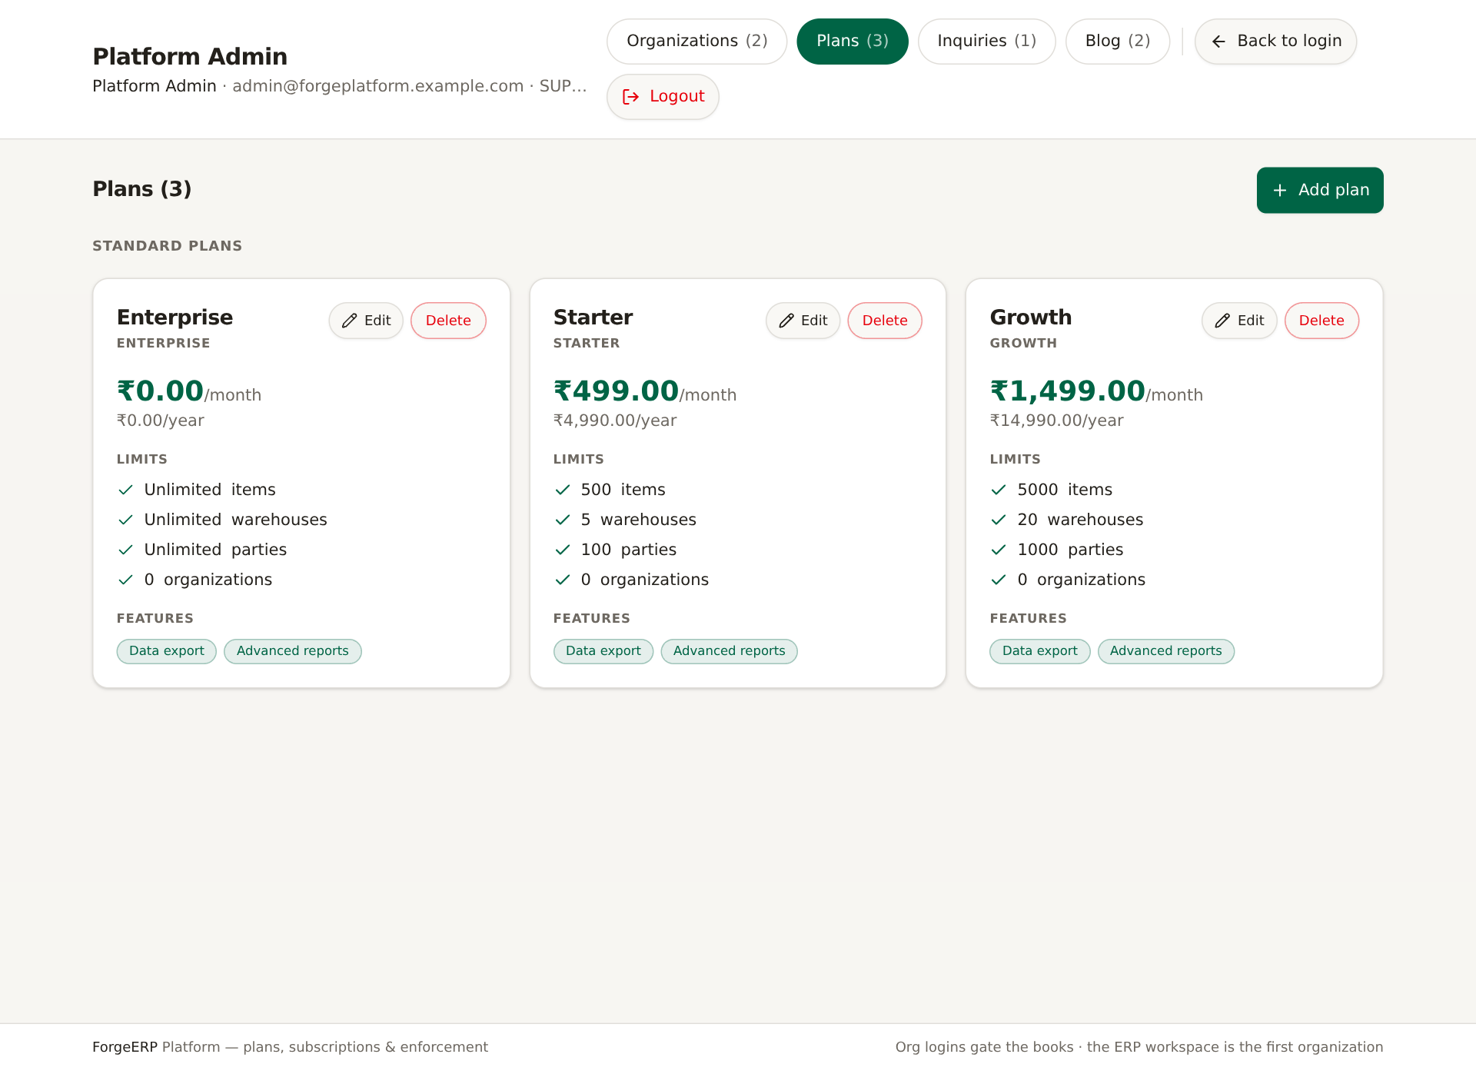
Screenshot: Plans tab: Starter/Growth/Enterprise jaise cards, pricing, limits, features.
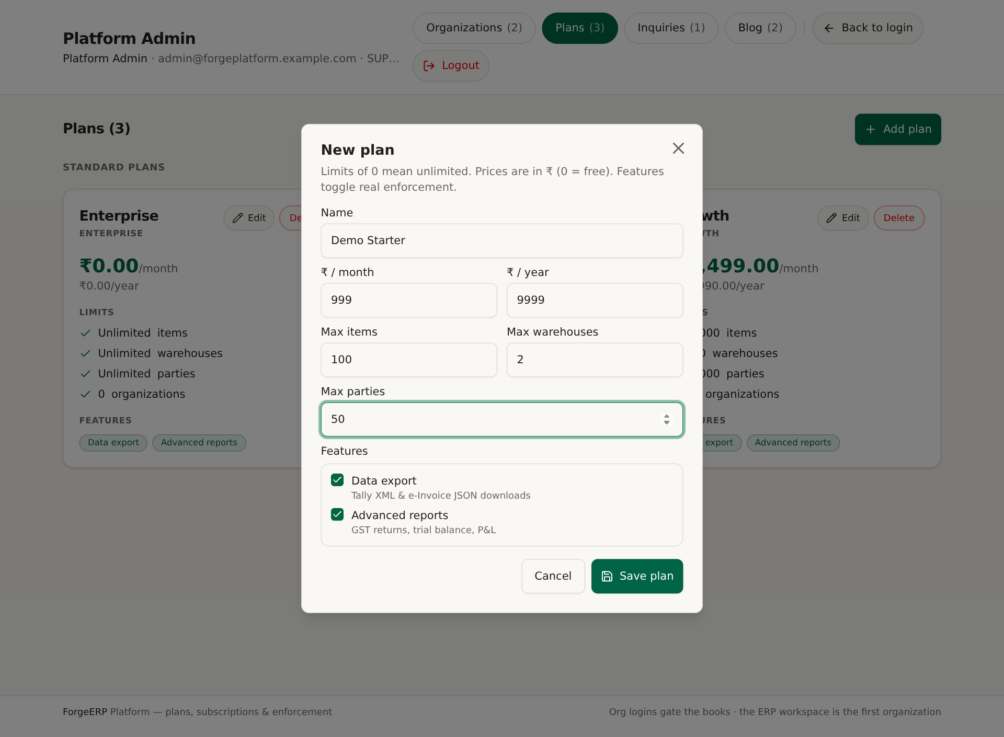
Screenshot: New plan form: name, monthly/yearly price, max items/warehouses/parties, feature toggles.

4.1 Plan fields
Field | Meaning
Name | Unique plan name
₹/month, ₹/year | Pricing display/MRR context; 0 = free
Max items/warehouses/parties | Master create limits; 0 = unlimited
Data export (exportData) | Tally XML/JSON aur e-Invoice JSON downloads
Advanced reports (advancedReports) | GSTR-1, Trial Balance, P&L reports API

4.2 Plan banana/edit/delete
1. Plans > Add plan; fields bharein; Save plan.
2. Edit se pricing/limits/features update karein.
3. Delete sirf tab possible jab koi organization us plan ko use na kar rahi ho.
4. In-use plan delete karne se pehle orgs ko doosre plan par move karein.
Note: Feature toggles real enforcement karte hain. Sirf do feature keys catalogued hain: exportData aur advancedReports. Koi aur hypothetical feature assume na karein.

5. Inquiries: lead log aur follow-ups
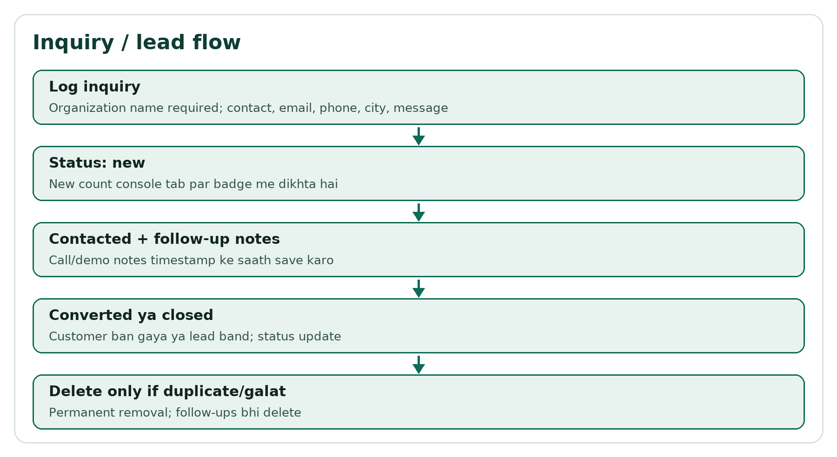
Flow: Inquiry flow.
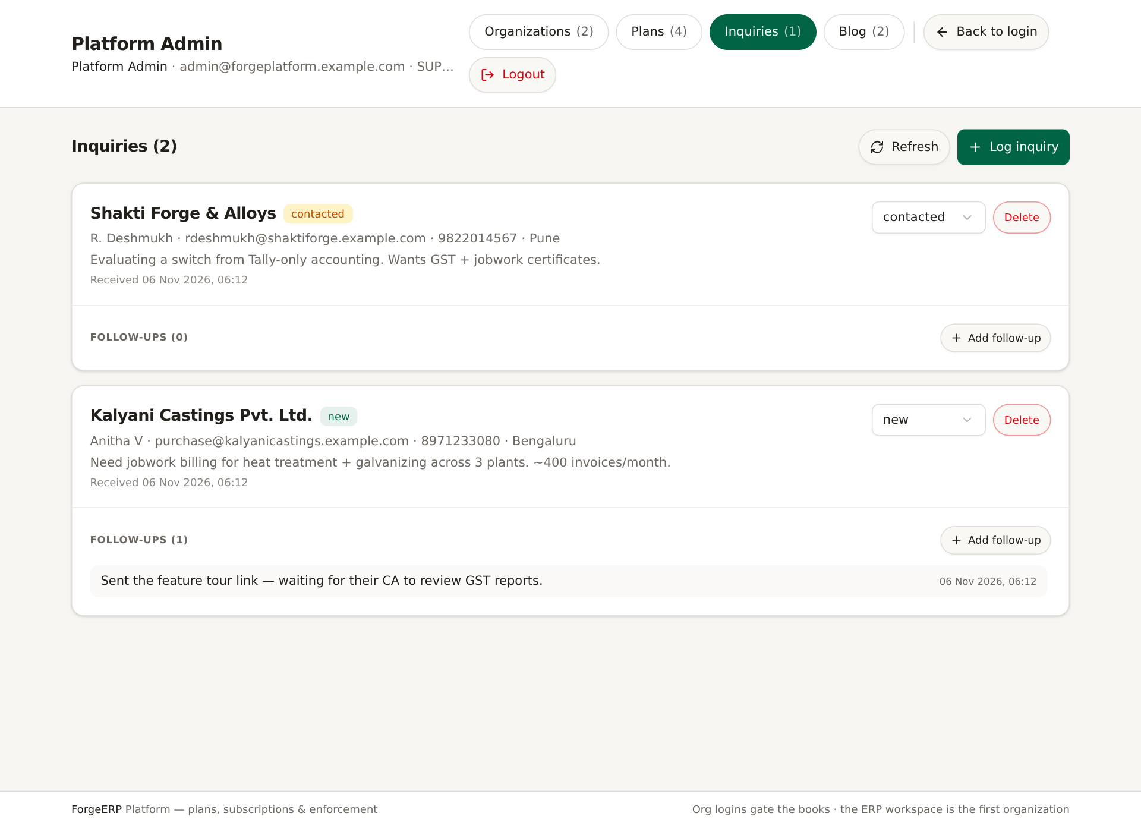
Screenshot: Inquiries list: status, contact details, follow-ups.
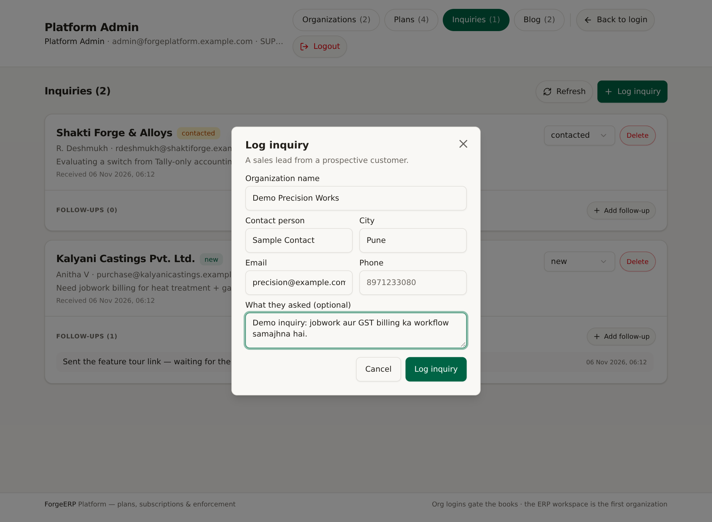
Screenshot: Log inquiry form.

5.1 Inquiry log karna
1. Inquiries > Log inquiry.
2. Organization name required; contact name, city, email, phone, message optional.
3. Log inquiry dabaiye. Status new se start hota hai.

5.2 Status aur follow-up
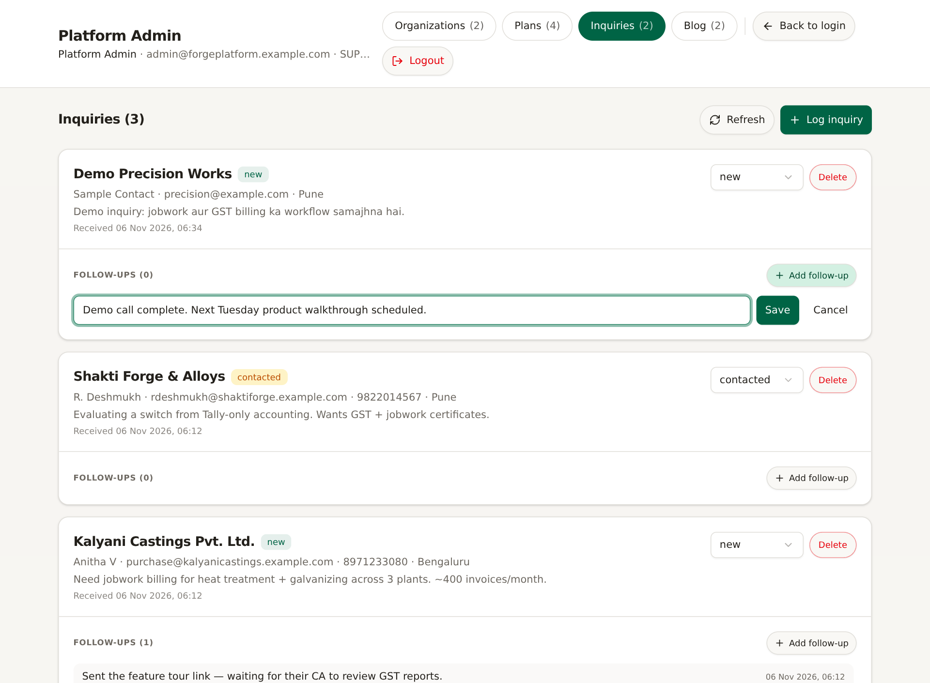
Screenshot: Follow-up note entry.
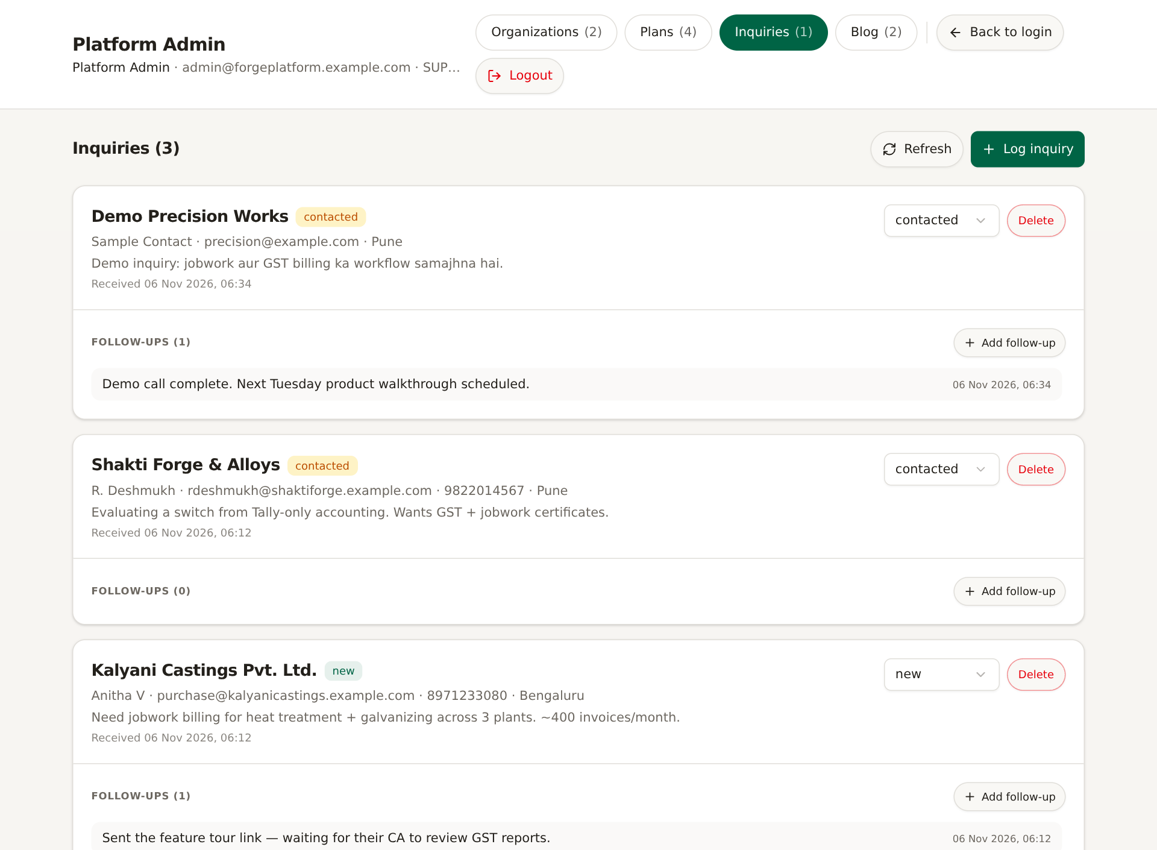
Screenshot: Contacted status aur saved follow-up.
1. Status dropdown: new → contacted → converted/closed.
2. Add follow-up se call/demo note likhein; Save karein.
3. Follow-ups timestamp ke saath list hote hain.
4. Duplicate/galat lead ho to Delete confirmation ke baad remove karein.
Note: Is checkout me public website inquiry form route verify nahi hua; console manual lead log ke roop me use hota hai. New count tab badge me dikhta hai.

6. Blog: draft/published content
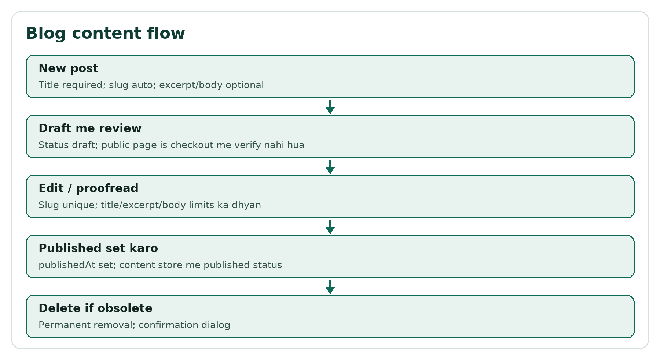
Flow: Blog content flow.
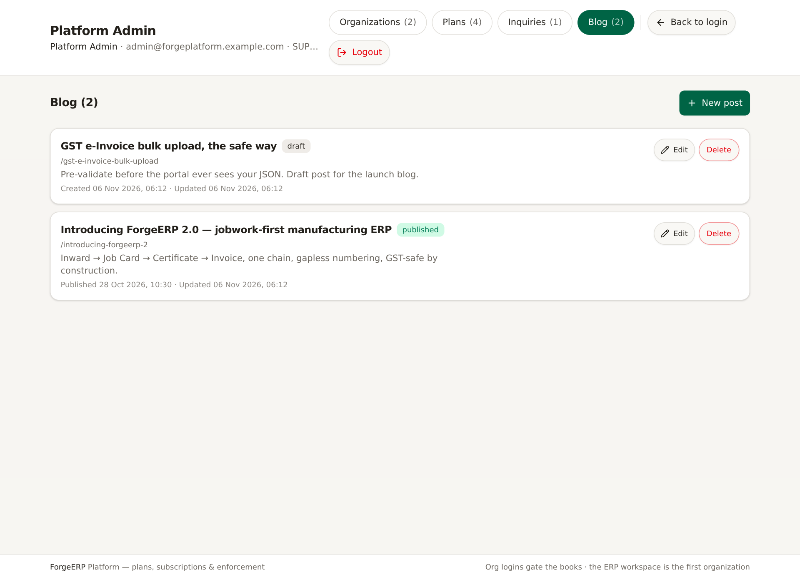
Screenshot: Blog list: title, slug, status, excerpt, dates, edit/delete.
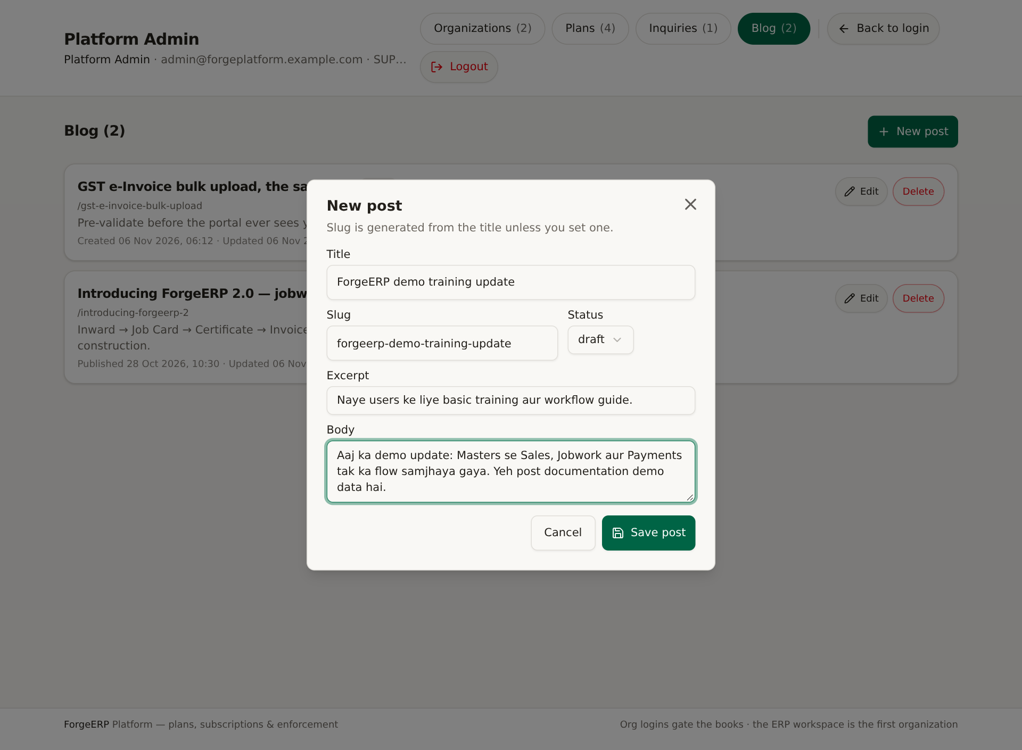
Screenshot: New post editor: title, slug, status, excerpt, body.
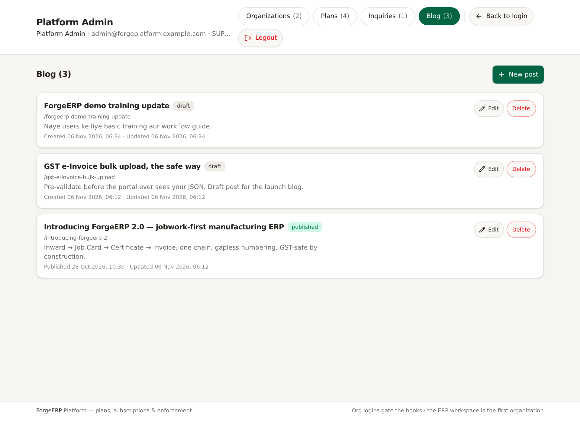
Screenshot: Saved draft post.
1. Blog > New post.
2. Title required; slug title se auto generate hota hai, manually change kar sakte hain.
3. Status draft/published choose karein; excerpt/body optional.
4. Save post. Published par publishedAt set hota hai.
5. Edit se update; slug unique rehna chahiye. Delete permanent removal hai.
Scope: Is checkout me public blog rendering route verify nahi hua. Blog tab content store/manage karta hai; published status ka public effect deployment par depend kar sakta hai.

7. Data & backup: download, scope, restore
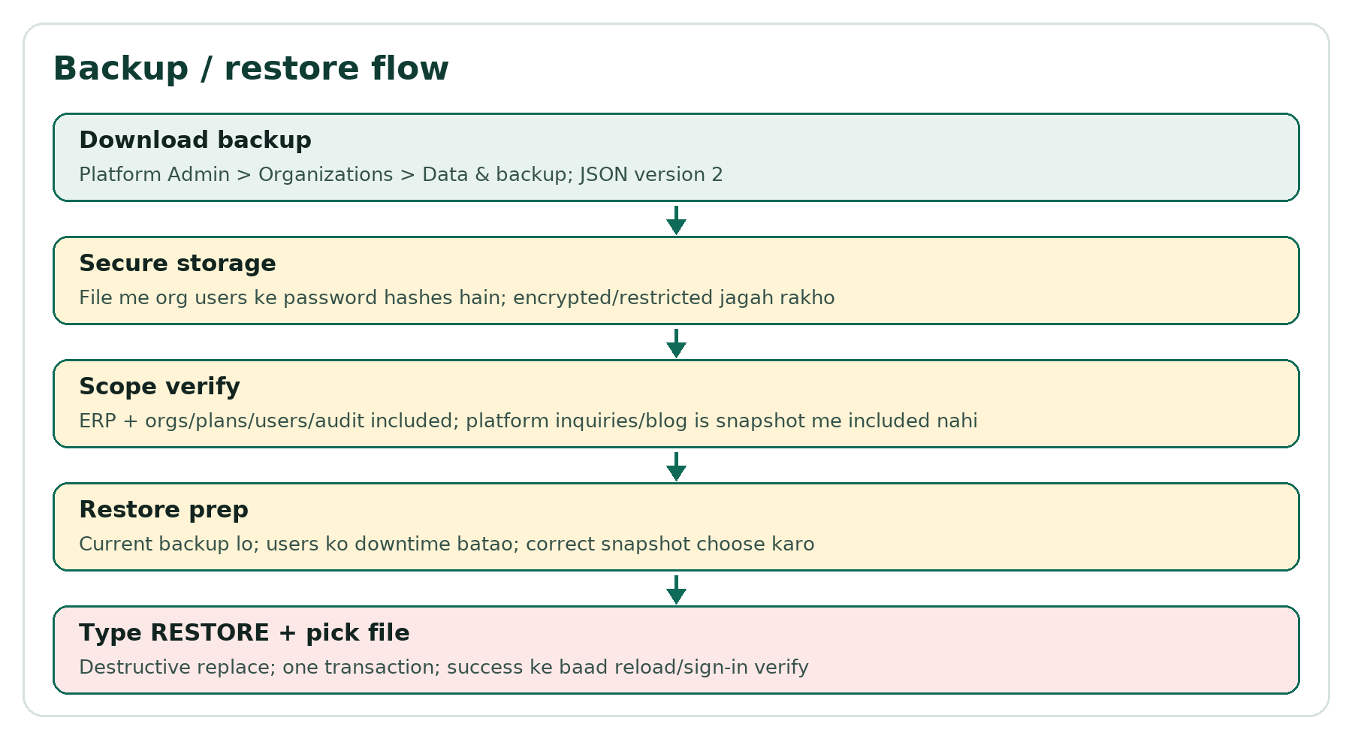
Flow: Backup/restore flow.
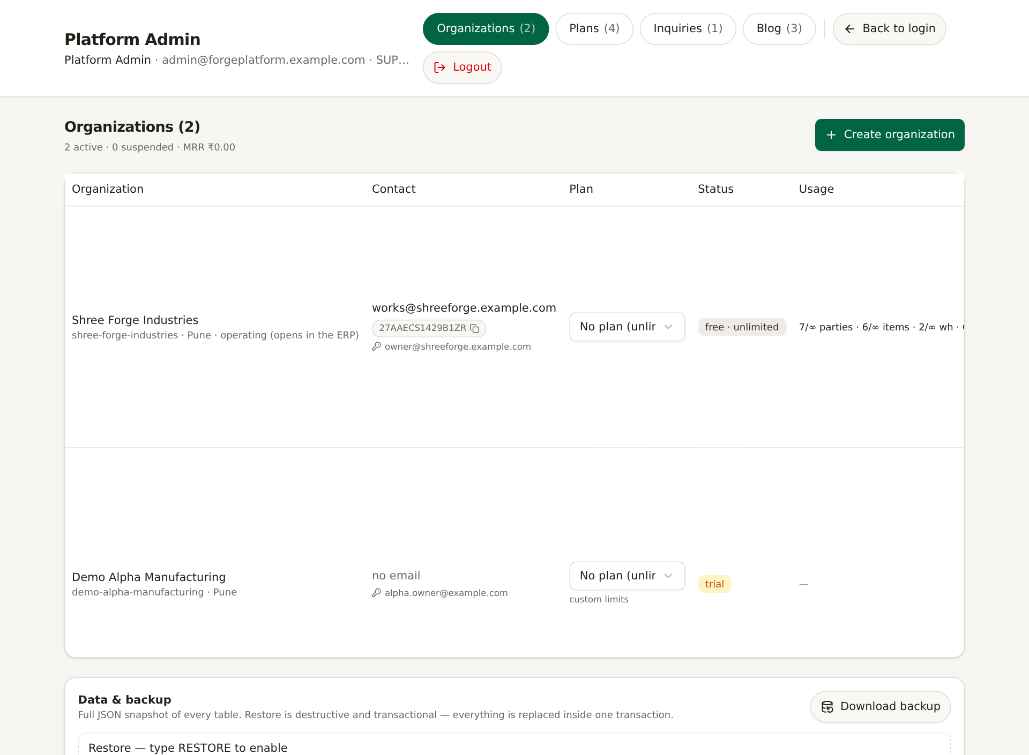
Screenshot: Data & backup card: Download backup, RESTORE typed confirmation, pick snapshot file.

7.1 Backup download
1. Organizations tab ke neeche Data & backup card kholiye.
2. Download backup dabaiye; JSON snapshot download hota hai.
3. File ko encrypted/restricted storage me rakhein; public share na karein.
4. Backup ke baad file size/counts sanity check karein.

7.2 Backup me kya included hai?
Included | Notes
Company / organizations | Plans, subscription fields, custom limits
OrgUser | Email, name, role, companyId, tokenVersion, passwordHash included
Masters | Parties, items, warehouses, processes, partyProcessRates
Transactions | Sales/purchase invoices + items, payments + allocations
Ledgers | StockLedger, AccountLedger
Jobwork | Inwards + items, job cards + processes, certificates
System | Counters, auditLogs

Important scope warning: UI card “every table” likhta hai, lekin source-verified snapshot me PlatformInquiry, PlatformInquiryFollowUp aur PlatformBlogPost included nahi hain. Inka alag record/export process rakhein.

7.3 Restore
1. Restore se pehle current state ka fresh backup lein.
2. Users ko downtime batayein; correct snapshot file choose karein.
3. Restore — type RESTORE to enable field me RESTORE likhein.
4. Pick snapshot file se JSON select karein.
5. Restore destructive replace hai: covered tables wipe/reinsert ek transaction me hoti hain; timeout ~60 seconds.
6. Success ke baad page reload karein; logins/counts verify karein; zaroorat ho to dobara sign-in.
Note: Restore ke baad password hashes/tokenVersion snapshot ke hisaab se wapas aa sakte hain. Agar snapshot purana hai to current passwords/sessions affect ho sakte hain. Restore ko last-resort disaster recovery samjhein.

8. Enforcement rules aur runtime limitations

8.1 Access rules
Rule | Effect
Platform company | Never billed/blocked; console operator
SUSPENDED | Business access/mutations block
Trial/paid expiry | Valid date tak access; expire par block
No plan | Unlimited; features included
Plan limits | Item/warehouse/party create par cap; 0 unlimited
Custom override | Blank = plan default; 0 unlimited; number = cap
exportData off | Tally/e-Invoice downloads blocked
advancedReports off | Reports API blocked
VIEWER role | Read-only; mutations blocked

8.2 Single-workspace limitation
- ERP books first non-platform organization ki hain.
- Usage counts global hain aur operating org ko attribute hote hain.
- Non-operating org logins read-only portal kholte hain.
- Operating org delete karna poora business data wipe kar sakta hai.
- MRR active planned organizations ke monthly price ka estimate hai; actual payment collection proof nahi.

9. Admin SOP, troubleshooting, glossary

9.1 Weekly admin SOP
- Organizations me trial/expired/suspended rows review.
- Inquiries new/contacted follow-ups close karein.
- Plans pricing/limits business policy se match karein.
- Backup download karke secure storage me verify karein.
- Audit Trail me platform actions/delete/backup review.

9.2 Troubleshooting
Problem | Check
Admin login fail | SUPER_ADMIN email/password, deployment bootstrap, session revoke
Org user login fail | Owner login set/reset, email unique, password min 6, org status
Org ko ERP nahi mil raha | Kya org operating/first hai? Non-operating portal expected
Limit error | Plan/custom max, current global usage, 0 unlimited rule
Reports/export blocked | Plan features, suspension/expiry, role
Mark paid ke baad bhi block | Suspended status? expiry? Activate/renew check
Trial extend se access nahi mila | Suspend alag hai; Activate karein; paid expiry check
Backup restore fail | RESTORE typed, valid version/data, transaction timeout, file integrity
Plan delete nahi ho raha | In-use organizations ko pehle move karein

9.3 Glossary
Term | Matlab
SUPER_ADMIN | Platform console administrator
Operating org | First non-platform org jiski ERP books is workspace me hain
Plan | Pricing + limits + features bundle
Custom limits | Org-specific override of plan limits
MRR | Monthly recurring revenue estimate from active planned orgs
Trial | trialEndsAt tak free access window
Mark paid | Subscription paid period record/extend; payment collection nahi
Login-as | Admin session ko org owner session me temporarily replace karna
Snapshot | Backup JSON file
RESTORE | Destructive snapshot replace confirmation

Safety: Destructive actions se pehle approval + backup + rollback plan rakhein. Platform Admin production control plane hai; galat action multiple organizations ko affect kar sakta hai.

