SHREE FORGE INDUSTRIES • FY 2627
ForgeERP
Manufacturing · Jobwork · GST · Double-Entry
Organization ERP
User Guide
Software ko basics se complete workflow tak kaise use karein — Hinglish step-by-step manual, live demo data ke saath.
Document
Title | ForgeERP — Organization ERP User Guide (Hinglish)
Version | Version 2.0 | 08 November 2026
Audience | Owner, accountant aur staff — jo ForgeERP daily use karte hain
Language | Hinglish (Hindi + English), UI labels English me
Demo organization | Shree Forge Industries, Pune (FY 2627) — GSTIN 27AAECS1429B1ZR
Demo login | owner@shreeforge.example.com / forge123
Screenshots | 08 Nov 2026 ko Playwright se is checkout par live liye gaye; data demo seed ka hai

Screenshots ke baare me
Is guide ke saare screenshots ek demo dataset se liye gaye hain. Aapke deployment me company name, GSTIN, party/item names, amounts aur dates alag honge — lekin screens, buttons aur flow wahi honge.
Ye manual software use karne ke liye hai. Tax filing, statutory audit aur legal compliance ke liye apne CA / GST practitioner se verify zaroor karein.

Is guide me kya hai
Ye guide aapko zero se expert banane ke liye likhi gayi hai. Order se padhein — pehle login aur setup, phir ek ek module. Har screen ka screenshot aur uske niche numbered steps di hain.
Section | Kya seekhenge
1. Shuruat | Login, screen layout, navigation aur keyboard shortcuts
2. Pehla setup | Company se opening stock tak — sahi order aur go-live checklist
3. Masters | Parties, Items, Warehouses, Processes, Party Rates, Company
4. Dashboard | Daily review ka cockpit — KPIs, trend, alerts
5. Sales | Quote-to-Cash, GST invoice banana, print, duplicate, cancel
6. Purchase | Supplier bill, input GST, procurement flow
7. Accounting | Receipt / payment, allocation, party ledger, journals
8. Inventory | Stock summary, ledger, lots & serials, opening stock
9. Customer Jobwork | Inward → Job Card → Certificate → Invoice (core flow)
10. Reports | GSTR-1, Trial Balance, Outstanding, P&L, Action Center
11. Own Projects & Mfg | Projects, BOMs, work orders, MRP, tasks
12. CRM & Service | Leads, salespersons, service calls
13. Tally Export | Masters/vouchers XML, connector, e-Invoice JSON
14. Audit Trail & Docs | Har action ka log; in-app technical reference
15. Daily / Weekly / Month-end SOP | Roz ka kaam aur month-end checklist
16. Troubleshooting & Glossary | Common problems aur unke fixes; shabdon ka matlab

Padhne ka tarika
Har screenshot ke niche steps hain — unko waise hi follow karein.
Word me Navigation Pane kholein (View → Navigation Pane) heading se section par jump karein.
Screenshot chhota lage to Word me zoom badha lein (status bar, bottom-right).

1. Shuruat: login, screen aur navigation

1.1 Ye software kis kaam aata hai?
ForgeERP aapki company ka daily business record rakhta hai — ek jagah:
- Sales — customer ko maal/service bechna aur GST tax invoice banana
- Purchase — supplier se kharidari, input GST record
- Customer Jobwork — customer ka material leke process karna, certificate dena aur service invoice banana
- Inventory — kitna stock aaya, gaya, bacha aur uski value (weighted-average)
- Accounting — paisa aaya/gaya, invoice-wise allocation, party ledger, double-entry journals
- Reports — GSTR-1, Trial Balance, Outstanding, P&L — sab ledger se derived
- Tally Export / e-Invoice — Tally aur GST portal ke liye files
- Audit Trail — kisne kya create/update/cancel/export kiya, poora log

1.2 Login kaise karein
- Browser me organization ka ForgeERP URL kholiye (demo me http://localhost:3000).
- Email aur Password daliye. Demo screenshot me owner@shreeforge.example.com / forge123 hint dikhta hai; production me apna assigned credential use karein.
- Sign in dabaiye. Success par Dashboard khulta hai.
- Galat password par error aaye to credential check karein ya admin se reset karwayein. Bar-bar guess na karein.
- Shared computer par kaam ke baad top-right avatar se Sign out zaroor karein.
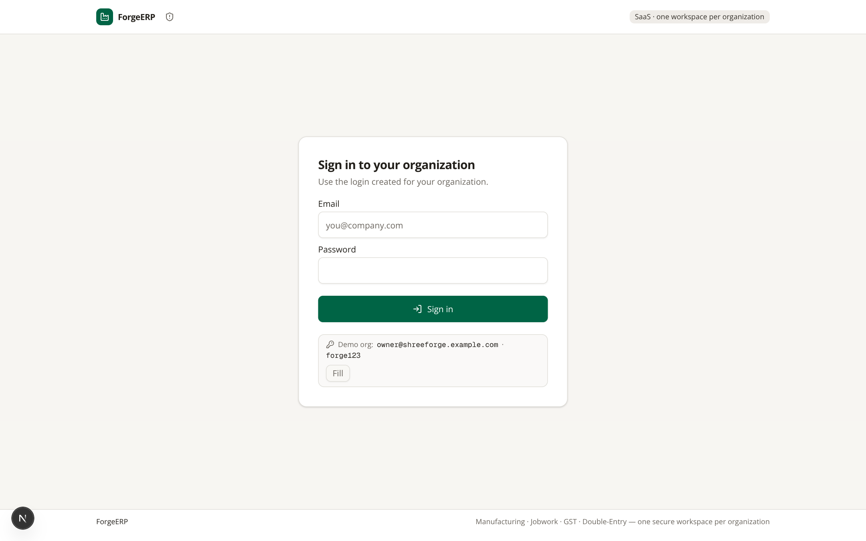
Screenshot 1.1 — Login screen. “Fill” button demo credentials khud bhar deta hai (sirf demo lab me).

1.3 Roles ka farq
Role | Kya kar sakta hai | Kya nahi kar sakta
OWNER | Business data create/update/cancel, exports, reports, settings | Platform Admin console manage nahi kar sakta
ACCOUNTANT | Daily posting, payments, reports, exports | Owner-level platform controls nahi
VIEWER | Read-only dekhna | Create/update/cancel/export jaise mutations nahi

1.4 Screen ke main hisse
- Top bar — global search (“Search or jump to…”, Ctrl+K), GSTIN, FY, aaj ki date, company name aur account menu.
- Left sidebar — modules: Dashboard, CRM & Service, Sales, Purchase, Customer Jobwork, Own Projects & Mfg, Inventory, Accounting, Reports, Masters, Tally Export, Audit Trail.
- Main area — selected module ki list, tabs, forms aur reports.
- Footer — Docs link (technical reference) aur product tagline.
- Mobile — bottom navigation (Home / Sales / Purchase / Jobwork / Stock) aur hamburger menu se full navigation.
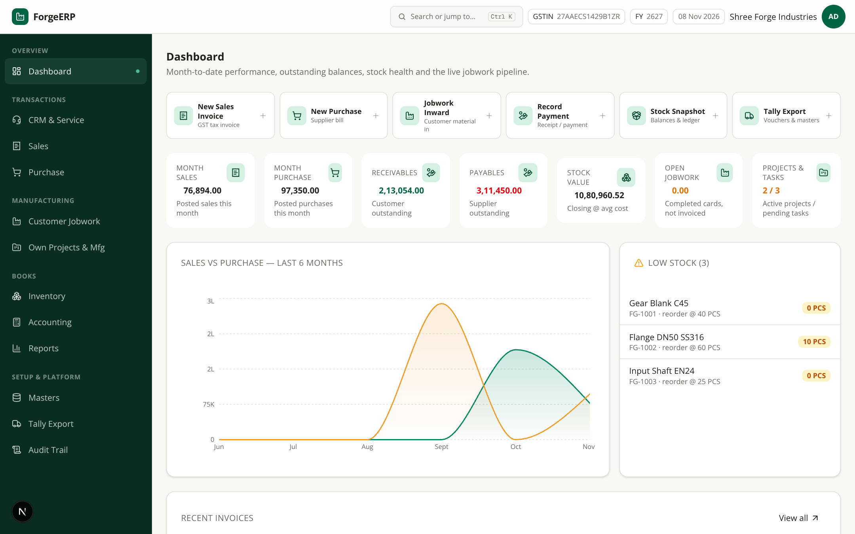
Screenshot 1.2 — Login ke baad Dashboard: quick actions, KPI cards, 6-month sales vs purchase trend, recent invoices, low stock.

1.5 Navigation shortcuts (tez kaam ke liye)
Shortcut | Kaam
Ctrl / Cmd + K (ya /) | Command palette kholna — module jump + global search
? | Shortcut help screen
Alt + S | New sales invoice (kahin se bhi)
Alt + P | New purchase invoice
g phir d / c / s / p / j / b / i / a / r / m / t / u / o | Dashboard / CRM / Sales / Purchase / Jobwork / Manufacturing / Inventory / Accounting / Reports / Masters / Tally / Audit / Docs
Esc | Palette / dialog band karna
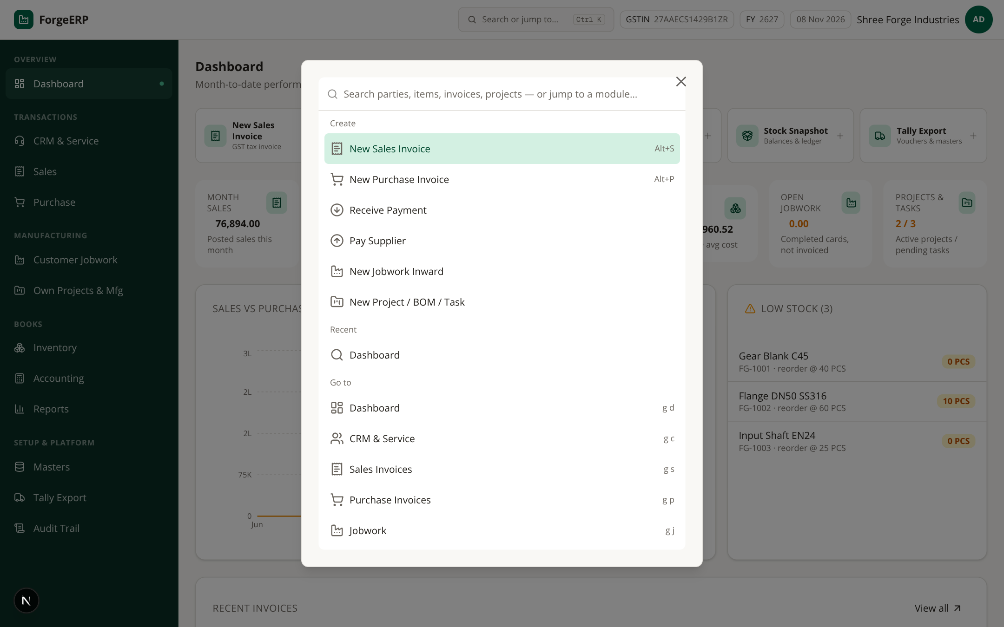
Screenshot 1.3 — Ctrl+K command palette: “New Sales Invoice”, “Receive Payment” jaise actions aur har module direct jump.
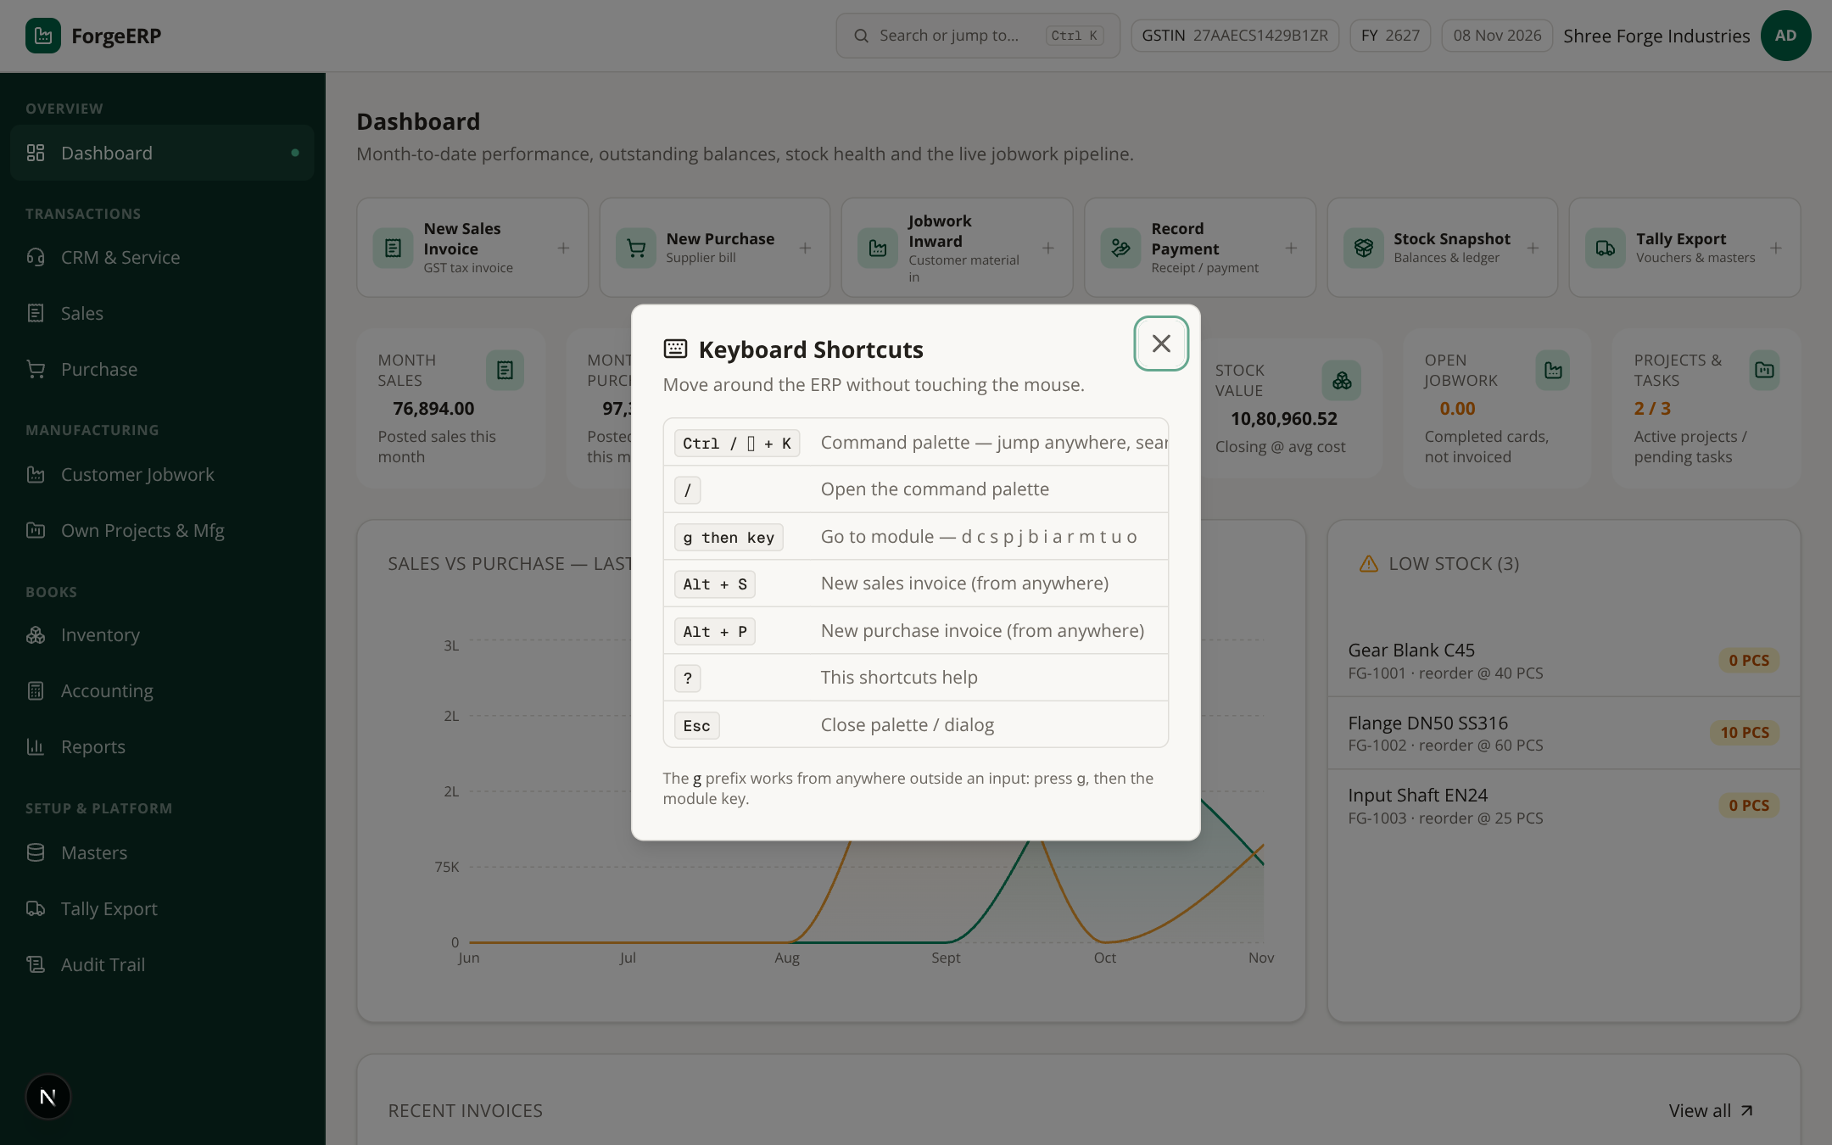
Screenshot 1.4 — “?” dabane par keyboard shortcuts ki poori list.
Yaad rakhiye
Shortcuts tab kaam karte hain jab aap input/textarea me type nahi kar rahe hon.
g ke baad agla key 1.5 second ke andar dabana hota hai.
Command palette me party/invoice/item ka naam type karke bhi direct jump milta hai.

2. Pehla setup: company se opening stock tak

2.1 Setup ka sahi order
Naye organization me ye order follow karein — ek step galat hua to aage ki sab entries galat hongi:
- Masters → Company — trade name, legal name, GSTIN, state, address, pincode, phone, email, bank details save karein. Invoice header aur e-Invoice seller details yahin se aate hain.
- Masters → Parties — customers, suppliers, jobworkers banayein; GSTIN / state / pincode sahi rakhein.
- Masters → Items — stock/service items: HSN/SAC, UOM, GST rate, sale/cost rate, reorder level.
- Masters → Warehouses — MAIN (Main Stores) aur JW (Jobwork Store) jaise locations.
- Masters → Processes — jobwork operations: basis (per KG / per piece), rate, lot charge.
- Masters → Party Rates — kisi specific customer ke liye process rate override karna ho to.
- Inventory → Opening Stock — go-live date ka physical stock, qty aur rate.
- Phir Sales / Purchase / Jobwork / Accounting shuru karein.
Note
Masters galat honge to invoice, GST, stock aur reports sab galat ho sakte hain. Pehle 10–20 real records se dry-run karein, phir bulk kaam shuru karein.

2.2 Go-live checklist
Check | Kyun zaroori hai
Company GSTIN / state / pincode | Invoice header aur e-Invoice seller details
Party GSTIN / state / pincode | B2B vs B2C, CGST+SGST vs IGST split, e-Invoice buyer details
Item HSN/SAC + GST rate | Tax calculation aur GSTR-1 / HSN summary
Warehouse | Stock availability aur ledger ki location
Opening stock (qty + rate) | Go-live se pehle ka physical stock; closing value sahi banegi
Process + party rates | Jobwork billing sahi ho
User role (OWNER / ACCOUNTANT / VIEWER) | Viewer ko galti se posting access na mile

2.3 Pehli baar login karne wala checklist (5 minute)
- Login karke Dashboard dekhein — saare KPI cards ₹0 / empty honge, ye normal hai.
- Masters → Company kholkar apni company profile poori bharein aur Save karein.
- Masters → Parties me apne top 5 customers aur top 5 suppliers add karein.
- Masters → Items me aapke fastest-moving 10 items add karein.
- Inventory → Opening Stock me aaj ki date ka physical stock daalein.
- Ek test sales invoice banakar Post karein, phir Reports → Trial Balance me Dr = Cr check karein.

3. Masters: basic data ko detail me samjhein
Masters wo reference data hai jiske against har transaction validate hota hai. Tabs:
Parties · Items · Warehouses · Processes · Party Rates · Company

3.1 Parties (customers / suppliers / jobworkers)
Party customer, supplier ya jobworker ho sakti hai — ek party multiple types rakh sakti hai. Code unique hota hai; GSTIN live checksum-validate hota hai.
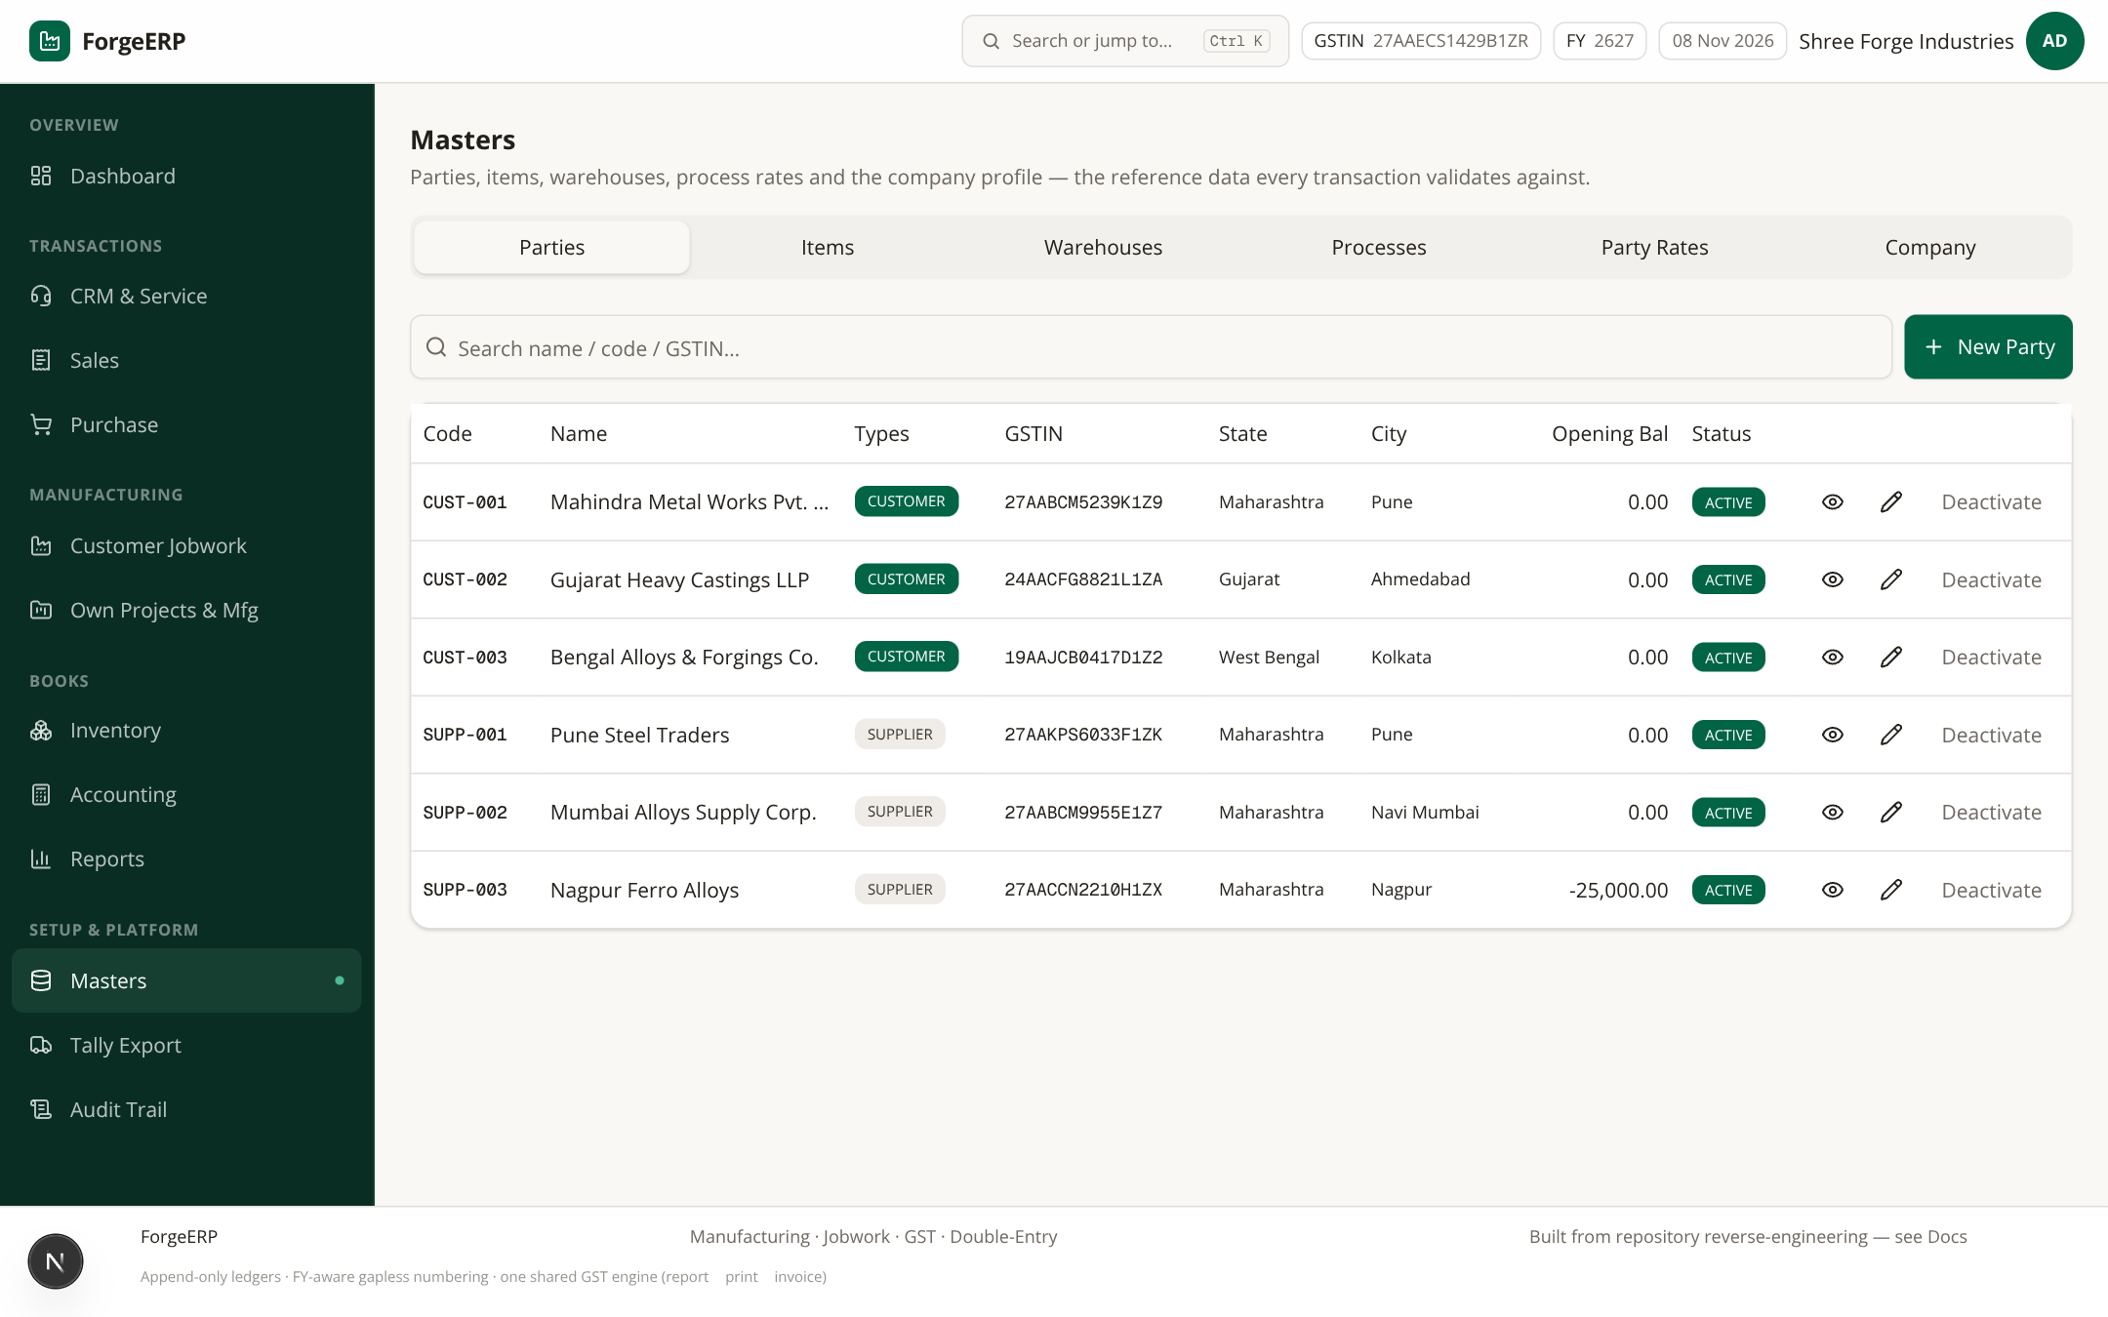
Screenshot 3.1 — Parties list: code, name, types, GSTIN, state, city, opening balance, status. Types: CUSTOMER (sales), SUPPLIER (purchase), JOBWORKER.
- Masters → Parties → New Party.
- Code aur Name bharein. Code short unique rakhein — jaise CUST-004.
- Types me CUSTOMER / SUPPLIER / JOBWORKER select karein (ek se zyada bhi chalega).
- GSTIN ho to darj karein; state code GSTIN se derive ho sakta hai. Address, city, pincode, phone, email bharein.
- Opening Balance: positive = customer receivable, negative = supplier payable. Sirf go-live opening ke liye use karein — regular invoice ka replacement nahi.
- Create Party dabaiye. List me naya row verify karein.
Field | Use / tip
Code * | Unique short ID; invoice/list me dikhta hai
Name * | Legal / party name — invoice print par yahi chhapta hai
Types * | CUSTOMER sales ke liye, SUPPLIER purchase ke liye
GSTIN | B2B aur e-Invoice ke liye; format/checksum sahi hona chahiye
State | Place of supply tax split ko affect karta hai
Address / City / Pincode | Invoice print aur e-Invoice buyer details; pincode 6 digit
Opening Balance | Sirf opening receivable/payable
Active | Inactive party ko naye transaction me use na karein

3.2 Items
Item finished goods, raw material, service ya non-stock ho sakta hai. Stock item sales par availability check hota hai; service item stock movement skip karta hai.
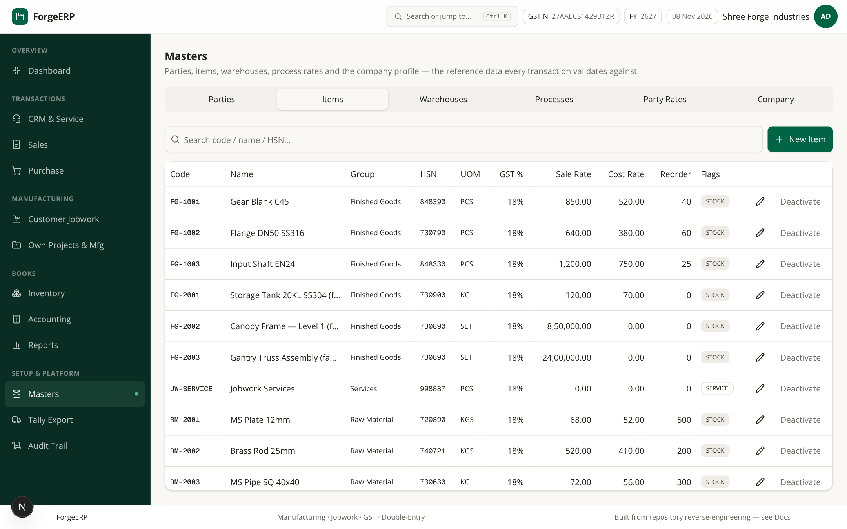
Screenshot 3.2 — Items list: code, name, group, HSN, UOM, GST %, rates, reorder level, flags. Demo me FG-1001 Gear Blank C45, FG-1002 Flange DN50 SS316, FG-1003 Input Shaft EN24 etc.
- Masters → Items → New Item.
- Code, Name, Group bharein. HSN/SAC correct daalein — e-Invoice me 6 ya 8 digit important hai.
- UOM choose karein: PCS, KG, KGS, MTR, LTR, SET, BOX etc.
- GST Rate, Sale Rate, Cost Rate, Reorder Level set karein.
- Service item hai to Service flag on karein; stock maintain karna hai to Stock item flag.
- Create Item dabaiye aur list me verify karein.
Note — JW-SERVICE
JW-SERVICE naam ka service item jobwork invoice ke liye seed data me zaroori hai (SAC 998887, 18%). Isko casually delete ya rename mat karein jab tak jobwork flow use ho raha ho.

3.3 Warehouses
Warehouse stock location hai. Invoice aur opening stock me warehouse choose karte hain; availability selected warehouse par check hoti hai.
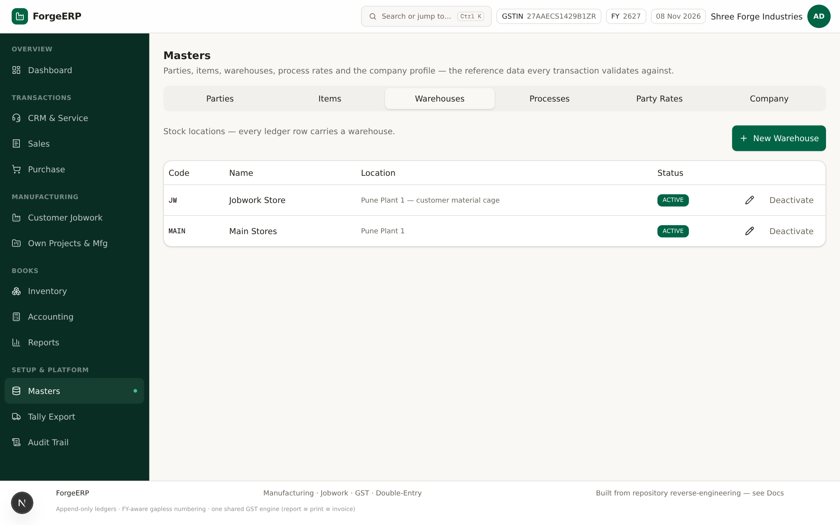
Screenshot 3.3 — Warehouses: demo me MAIN (Main Stores) aur JW (Jobwork Store). Jobwork ka finished goods JW me rehta hai.
- Masters → Warehouses → New Warehouse.
- Code, Name, Location bharein; Create karein.
- Opening stock aur invoices me sahi warehouse select karein — stock reports isi se split hote hain.

3.4 Processes (jobwork operations)
Process jobwork operation hai — shot blasting, heat treatment, galvanizing, CNC machining, QC, packing. Basis WEIGHT = per KG billing; QTY = per piece billing. Lot charge fixed charge hai jo poore lot par lagta hai.
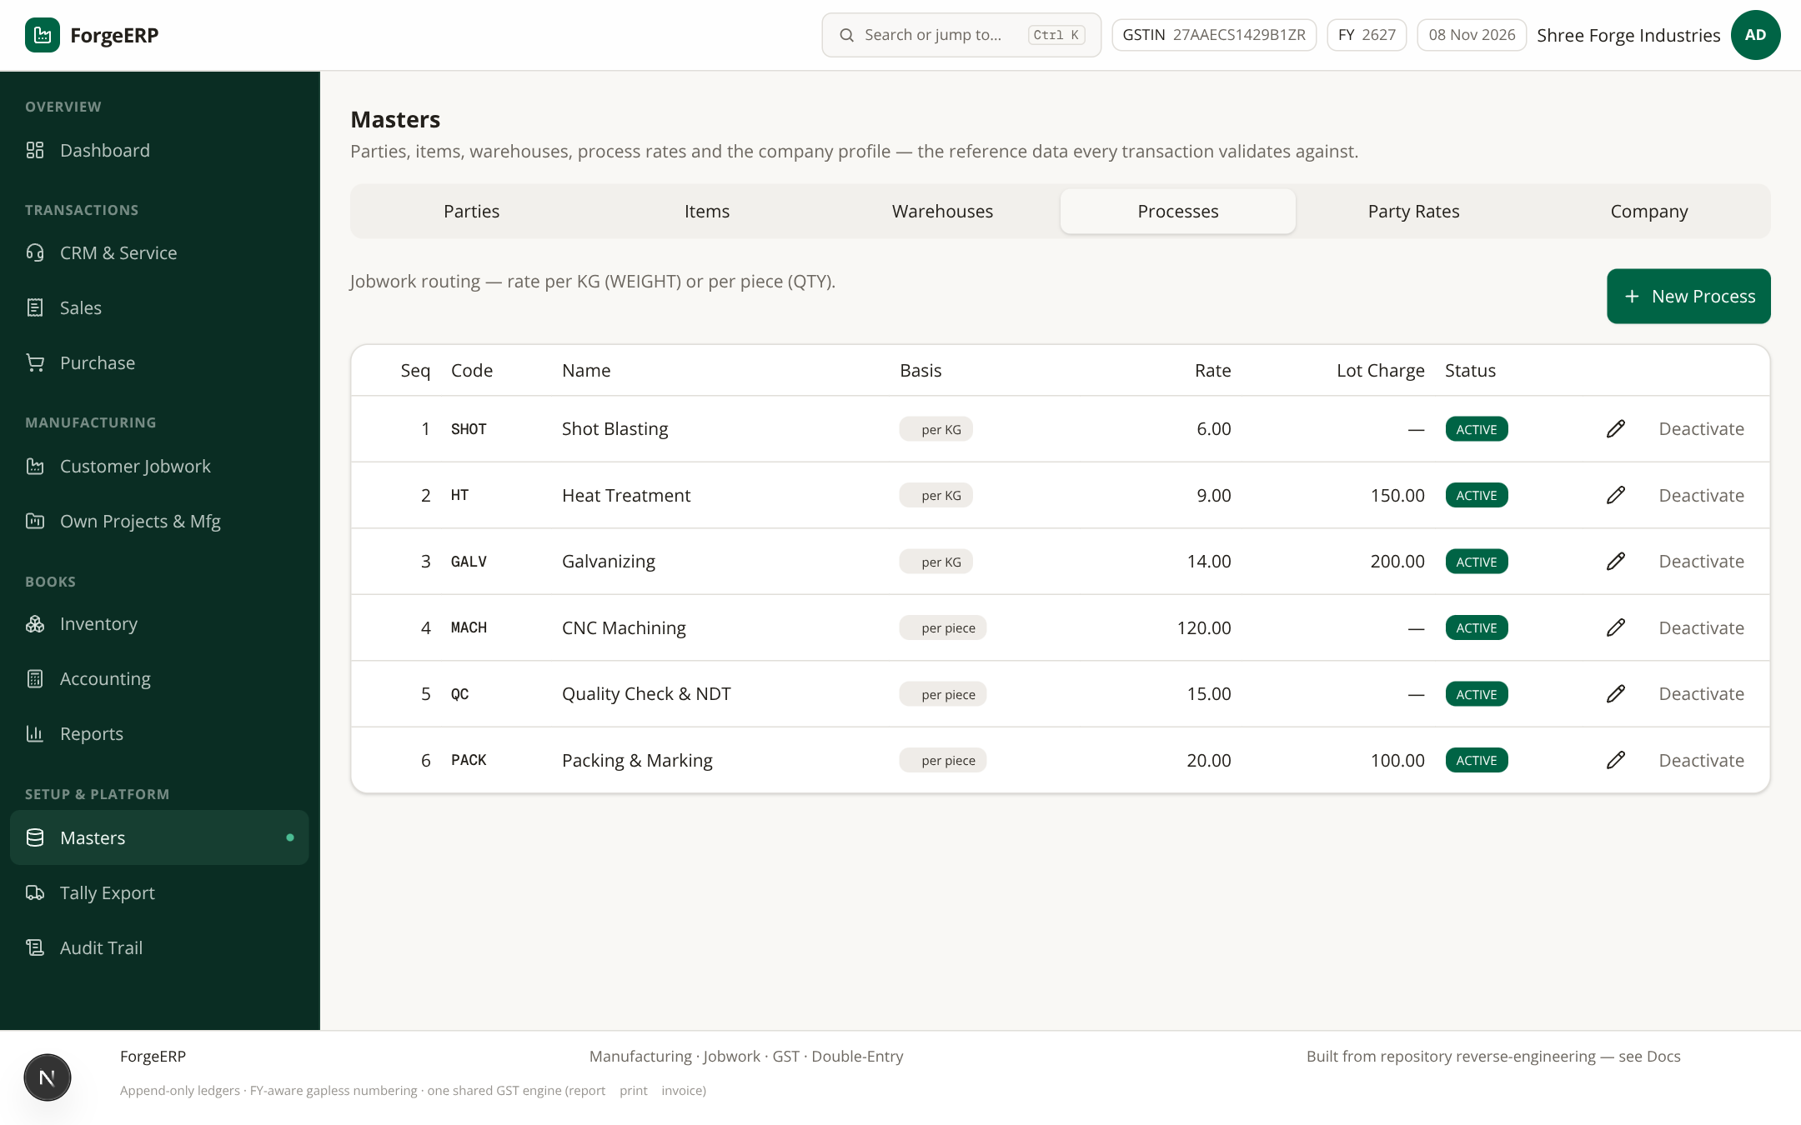
Screenshot 3.4 — Processes: sequence, code, basis, rate, lot charge. Demo: SHOT ₹6/KG, HT ₹9/KG + lot ₹150, GALV ₹14/KG, MACH ₹120/pc, QC ₹15/pc, PACK ₹20/pc + lot ₹100.
- Masters → Processes → New Process.
- Code, Sequence, Name, Basis (WEIGHT/QTY), Rate, Lot Charge bharein.
- Sequence routing order ke liye hai; job card me processes freely select kar sakte hain.

3.5 Party Rates (customer-specific overrides)
Kisi specific customer ke liye default process rate override karna ho to Party Rates use karein. Job card server hamesha party-specific rate resolve karta hai; create dialog ka estimate sirf default rates dikhata hai.
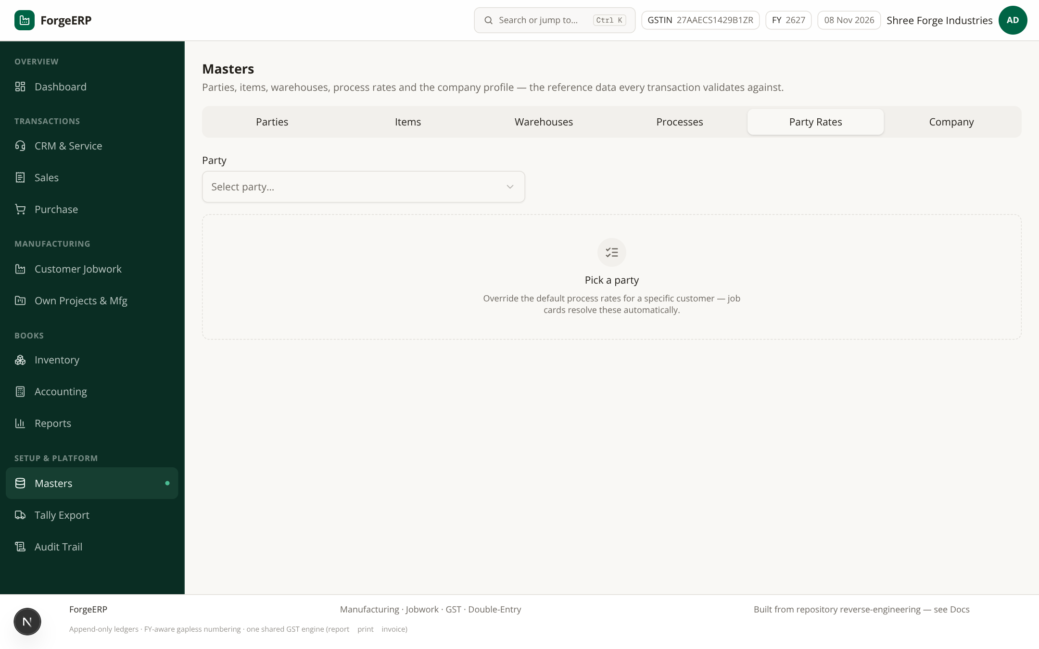
Screenshot 3.5 — Party Rates: party choose karke har process ka Rate ₹ aur Lot ₹ edit karein; OVERRIDDEN badge changed rows dikhata hai.
- Masters → Party Rates me Party select karein.
- Har process ke liye Rate ₹ aur Lot ₹ fields edit karein.
- Save Rates dabaiye. Default par wapas laana ho to values default ke barabar karein — override automatically remove ho jata hai.

3.6 Company profile
Company profile invoice header, GSTIN, bank details aur Tally ledger mapping ka source hai — GST invoice print par yahi chhapta hai.
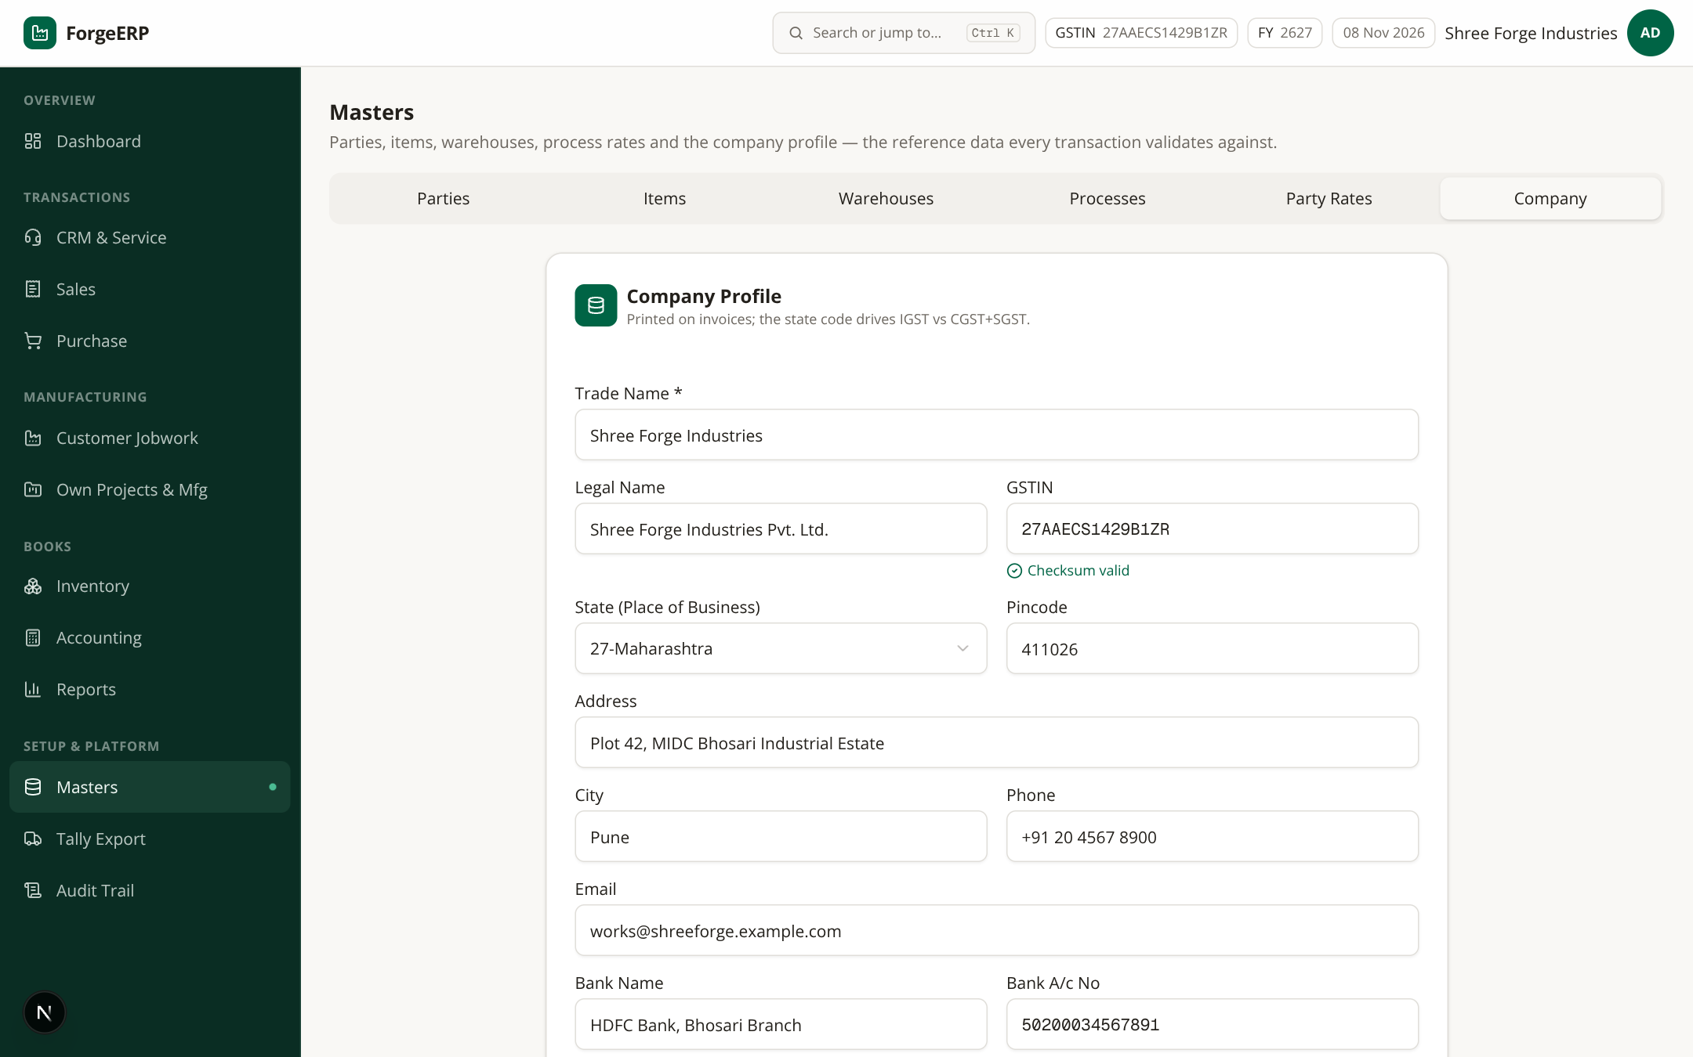
Screenshot 3.6 — Company profile: trade name, legal name, GSTIN 27AAECS1429B1ZR, state (27-Maharashtra), address, pincode, contact, bank/UPI, overhead absorption %.
- Masters → Company kholiye.
- Trade Name, Legal Name, GSTIN, State, Address, City, Pincode, Phone, Email verify karein.
- Bank Name, A/c No, IFSC, UPI ID bharein — invoice ke BANK DETAILS block me print hote hain.
- Save Company Profile dabaiye. Changes next print se effect me aate hain.
e-Invoice tip
Company ya party ka pincode 6 digit nahi hai to e-Invoice pre-validation hard error de sakti hai. GSTIN galat checksum wala hai to party save nahi hogi.

4. Dashboard: daily review ka cockpit
Login ke baad sabse pehle Dashboard dekhein. Month-to-date sales/purchase, receivables, payables, stock value, open jobwork, 6-month trend, recent invoices aur low-stock alerts — ek nazar me.
Screenshot 4.1 — Dashboard: quick actions (New Sales Invoice / New Purchase / Jobwork Inward / Record Payment / Stock Snapshot / Tally Export), KPI cards, sales-vs-purchase chart, low stock list.

4.1 Har card ka matlab
Card | Kya dikhta hai
Month Sales / Purchase | Is mahine post hue invoices / bills ka total
Receivables | Customers se aana baaki paisa (invoice balances)
Payables | Suppliers ko dena baaki
Stock Value | Closing stock ki value @ weighted-average cost
Open Jobwork | Completed cards jo abhi invoice nahi hue
Projects & Tasks | Active projects / pending tasks (manufacturing)
Low Stock | Reorder level se neeche items — reorder ka signal

4.2 Quick actions
Dashboard ke top tiles seedha create screens kholte hain: New Sales Invoice, New Purchase, Jobwork Inward, Record Payment, Stock Snapshot, Tally Export. Keyboard se bhi: Alt+S / Alt+P.

4.3 Recent invoices & low stock
- Recent invoices par click karke direct invoice detail khulta hai.
- Low stock list me item aur reorder point dikhte hain — “View all” se inventory module khulta hai.
Yaad rakhein
Dashboard ke numbers tabhi sahi honge jab invoices/payments/stock sahi post hue hon. Ise final statutory report na samjhein — Reports section se verify karein.

5. Sales: quote se cash tak (Quote-to-Cash)

5.1 Sales invoices list
Sales module ke do tabs hain: Sales Invoices aur Quote to Cash (quotations → sales orders → delivery). List me invoice no, date, party, taxable, GST, grand total, paid, balance, source aur status dikhte hain.
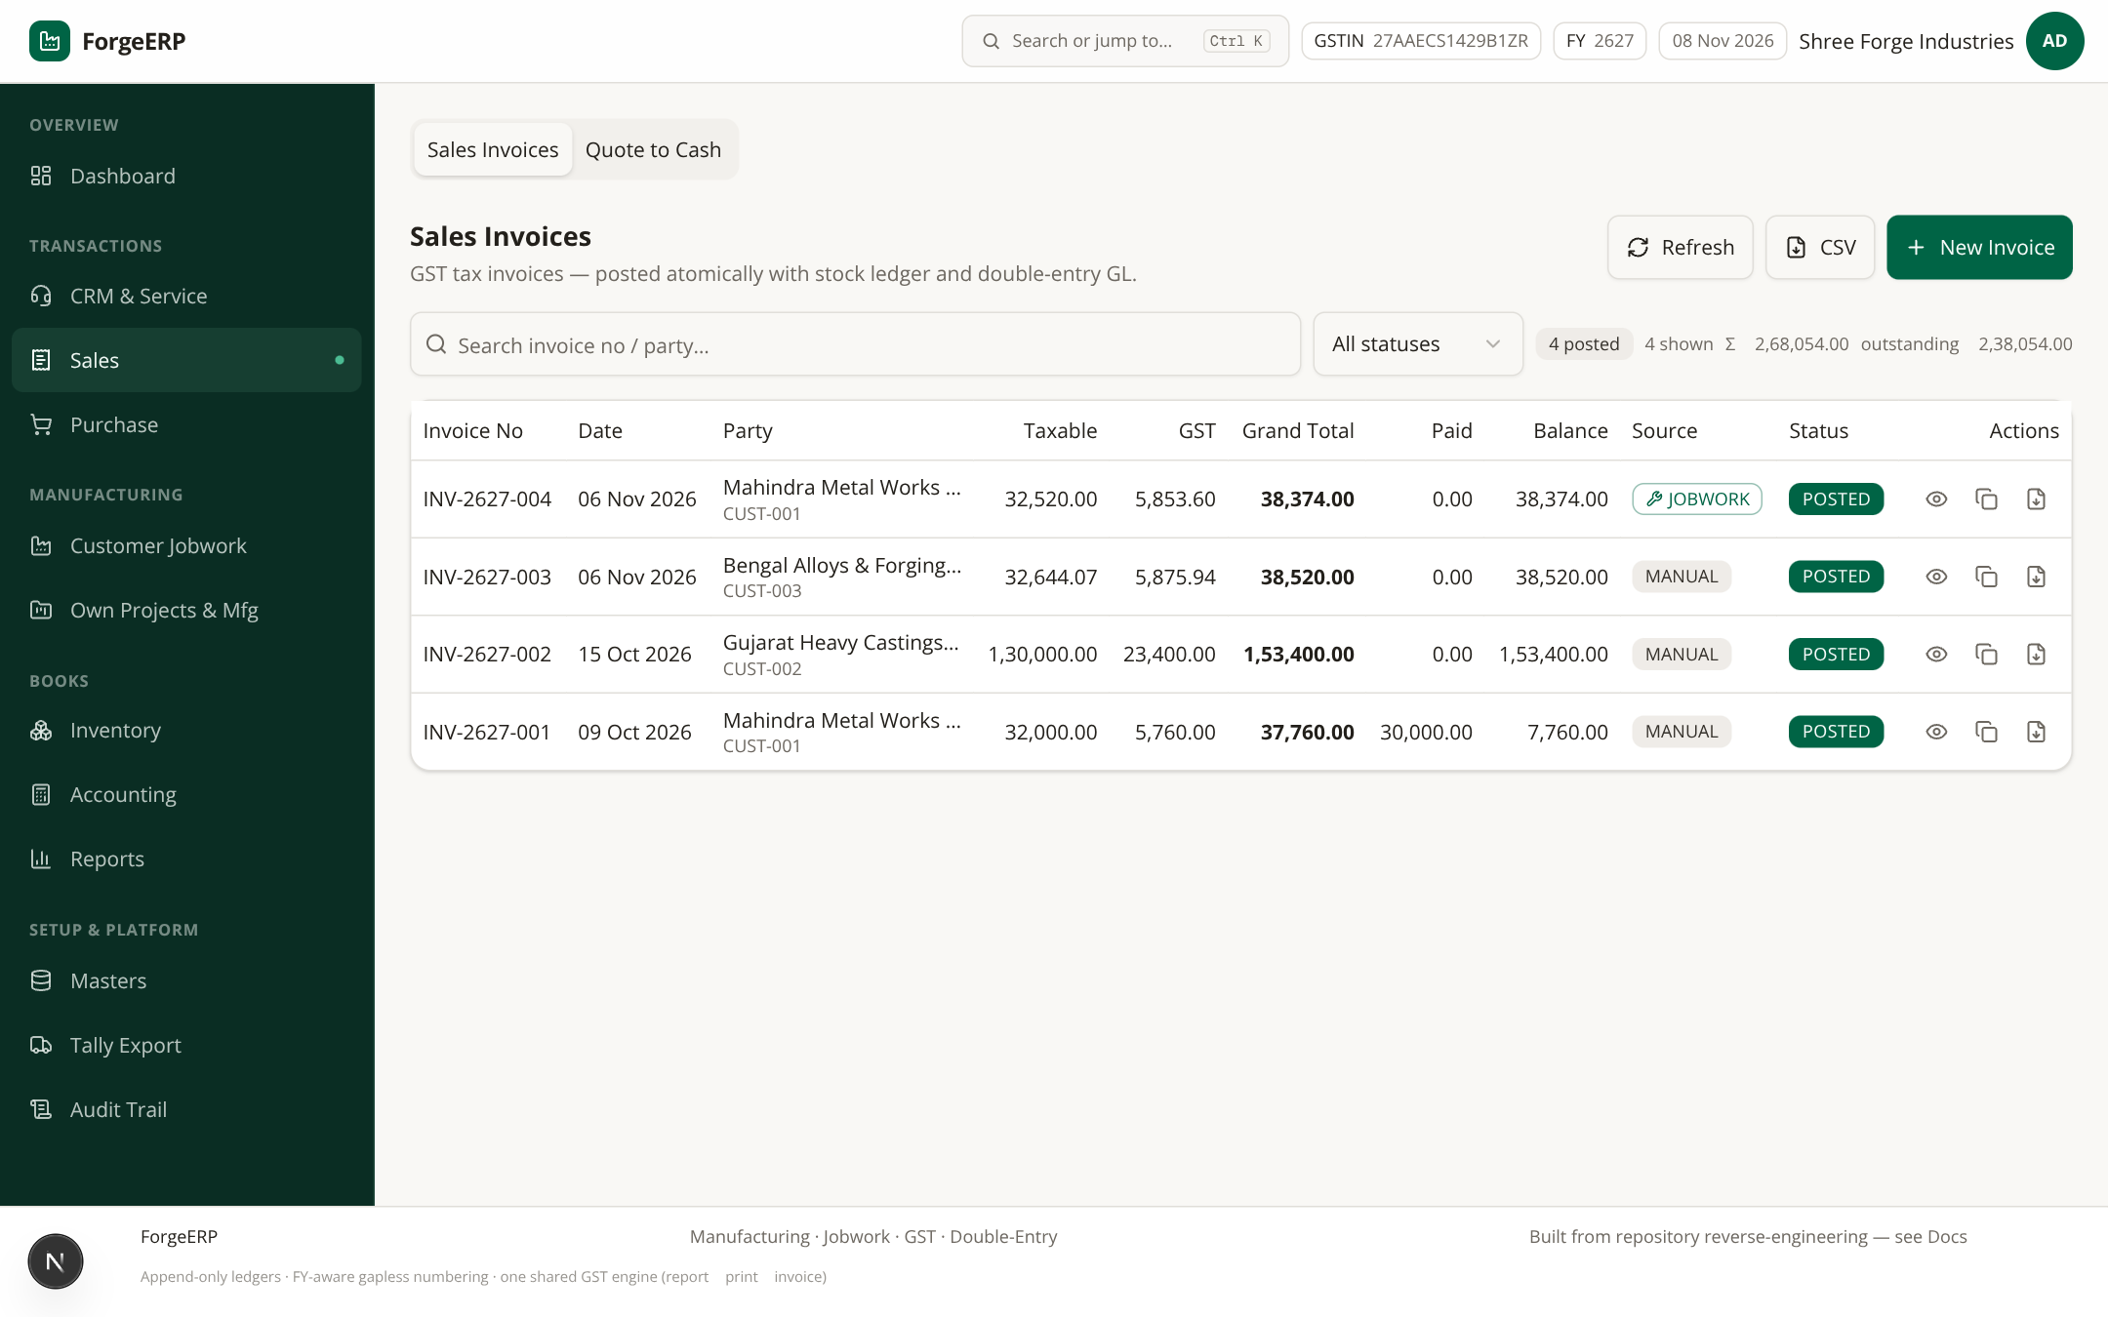
Screenshot 5.1 — Sales invoices: 4 posted invoices (INV-2627-001…004, total ₹2,68,054 out of which ₹2,38,054 outstanding). JWI-2627-001 se bani jobwork invoice source=JOBWORK dikh rahi hai.
- Search box me invoice no ya party ka naam type karein (300ms debounce).
- Status filter: All / POSTED / CANCELLED.
- Eye icon = detail view; duplicate icon = same party/items ke saath naya draft; Tally menu = XML/JSON/CSV export.
- CSV button se current filtered list download hoti hai.

5.2 Naya sales invoice banana (step-by-step)
- Sales → New Invoice (ya Dashboard quick tile, ya Alt+S, ya command palette).
- Customer select karein. Party ka GSTIN/state load hota hai; Place of Supply uske state par default hoti hai (27-Maharashtra).
- Date verify karein. PO / Challan No optional hai.
- Stock From: warehouse select karein — availability isi warehouse me check hogi.
- Line items me Item pick karein; UOM / HSN / GST% / sale rate auto bhar jate hain.
- Qty, Rate, Disc % bharein. “Add line” se naye items add karein.
- Tax inclusive toggle tabhi on karein jab rate GST samet final ho (gross/(1+rate/100) se taxable nikalta hai).
- Live GST preview me Taxable, CGST/SGST/IGST, Round off aur Grand Total check karein — yehi number server post karega.
- Post Invoice dabaiye. INV-2627-### format me number generate hota hai aur invoice POSTED hota hai.
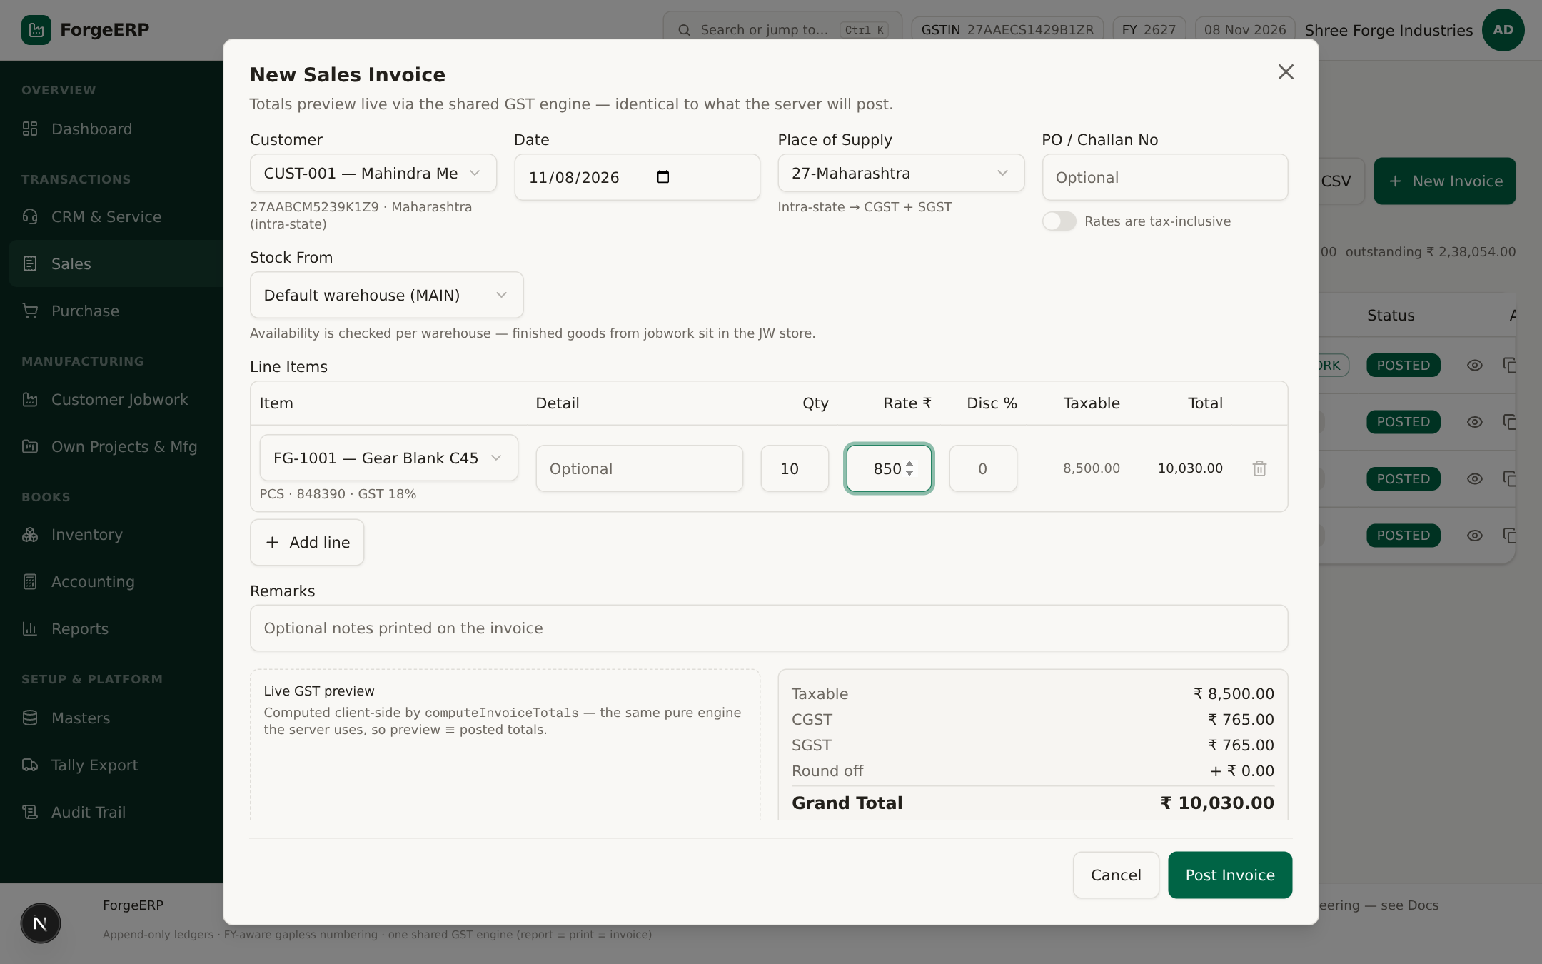
Screenshot 5.2 — New Sales Invoice (live): CUST-001 Mahindra Metal Works, FG-1001 Gear Blank C45 × 10 pcs @ ₹850, intra-state → CGST ₹765 + SGST ₹765, Grand Total ₹10,030.00. Preview wahi engine use karta hai jo server post karta hai.

5.3 GST kaise lagta hai (ek nazar me)
Condition | Tax split
Company state = Place of Supply (jaise dono 27-Maharashtra) | CGST + SGST — aadha aadha
Company state ≠ Place of Supply | IGST (total rate, poora)
Tax inclusive ON | Gross me se taxable nikalta hai: taxable = gross / (1 + rate/100)
Round off | Grand total nearest ₹1 par round; difference RND ledger me
Rate-wise split | Har line ka apna GST rate alag se calculate hota hai; inter-state sirf IGST
Note — B2B / B2C
Party ke saath GSTIN hai to invoice GSTR-1 me B2B bucket me jati hai; GSTIN nahi to B2C.
e-Invoice sirf eligible B2B invoices ke liye hai (Section 13 ke rules dekhein).

5.4 Post hone ke baad kya hota hai?
- Gapless number milta hai: INV-2627-005 (FY 2026-27 ka 5va voucher). Number kabhi reuse nahi hota.
- Invoice + lines save; har stock item ke liye StockLedger SALES (qty out) weighted-average cost par post hota hai.
- Stock availability kam ho to save reject hota hai — pehle stock check karein (Inventory module).
- GL entries: Dr Debtors, Cr Sales, Cr output GST (CGST+SGST ya IGST), round-off adjustment.
- List refresh; status POSTED; Paid / Balance columns dikhte hain.

5.5 Invoice detail, print, payment, duplicate, cancel
List me eye icon dabane par detail khulta hai — yahi printable GST tax invoice bhi hai.
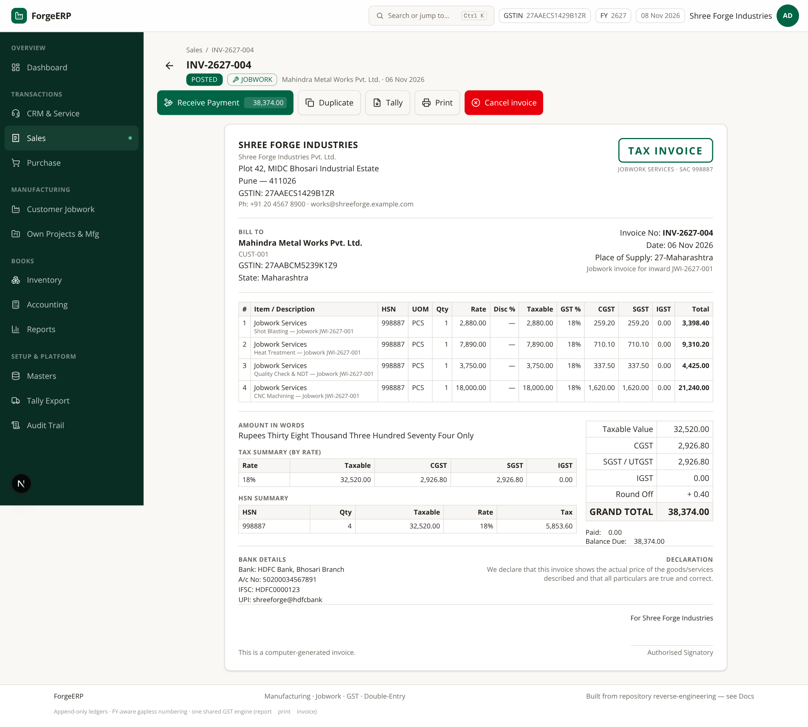
Screenshot 5.3 — Invoice detail (INV-2627-004, source=JOBWORK, ₹38,374.00 outstanding): Receive Payment, Duplicate, Tally, Print, Cancel invoice buttons; neeche poora GST tax invoice — HSN summary, rate-wise tax split, amount in words (Rupees Thirty Eight Thousand…), bank details aur signature block.
- Detail me lines, HSN summary, tax split aur total verify karein.
- Print dabaiye — browser print dialog se PDF ya printer choose karein. Print layout poora GST-compliant hai.
- Receive Payment dabane par Accounting me prefilled receipt dialog khulta hai — allocation check karke Post Payment karein.
- Duplicate se nayi invoice banta hai — purani copy nahi hoti, naya number milta hai.
- Cancel invoice karne par reversal stock/GL rows likhe jaate hain; status CANCELLED hota hai aur number reserved rehta hai.
Cancel ke rules
Agar invoice ke against payment allocated (paidAmount > 0) hai to cancel block hota hai — pehle payment cancel/correct karein.
Cancel = business reversal, record gayab nahi. Audit Trail me poora log rehta hai.
Cancelled invoice GSTR-1 aur sales reports me include nahi hoti.

5.6 Quote to Cash (quotations → sales orders → dispatch)
Sales → Quote to Cash tab me teen stages hain: Quotations, Sales Orders, Delivery & QC.
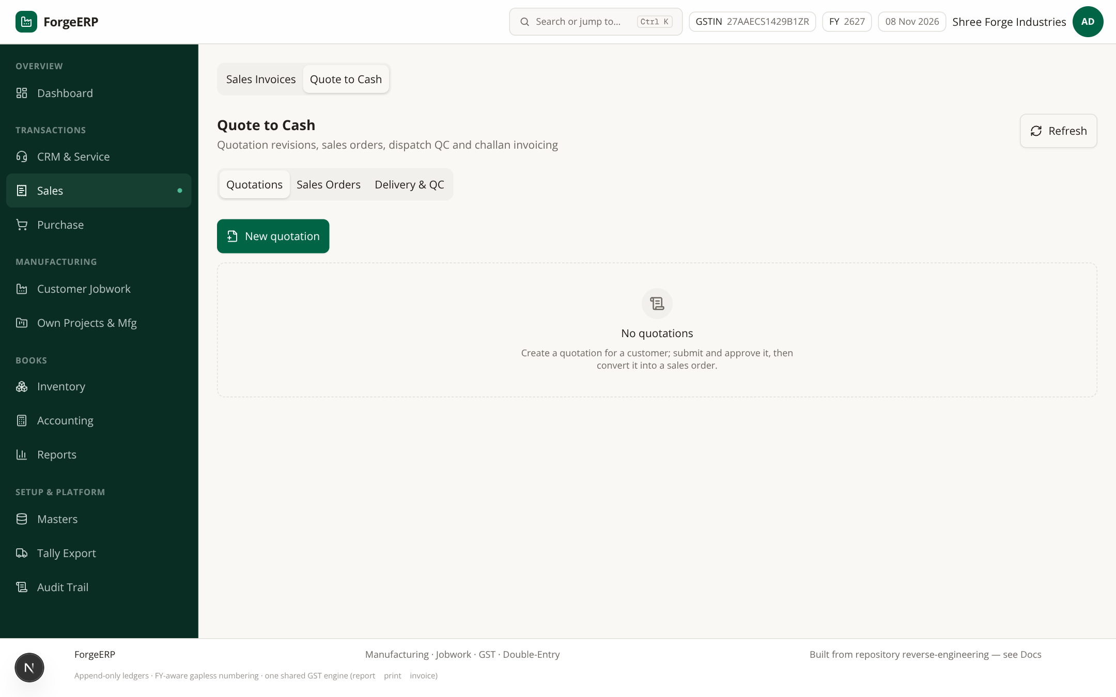
Screenshot 5.4 — Quote to Cash tab (blank demo me): Quotations → Sales Orders → Delivery & QC. Quotation accept hone par order, order se delivery challan, challan se invoice ban sakti hai.
- Quotation banayein → customer accept kare → Sales Order confirm karein (credit limit/days check hote hain).
- Delivery challan + QC se goods dispatch; challan se directly invoice generate ho sakti hai.
- Demo data me quotations/orders empty hain — ye screens production me daily kaam aati hain.

6. Purchase: supplier bill aur input GST
Purchase module me supplier ka bill post hota hai; stock IN hota hai aur input GST (CGSTI/SGSTI ya IGSTI) credit hota hai. Sales ka mirror flow hai.
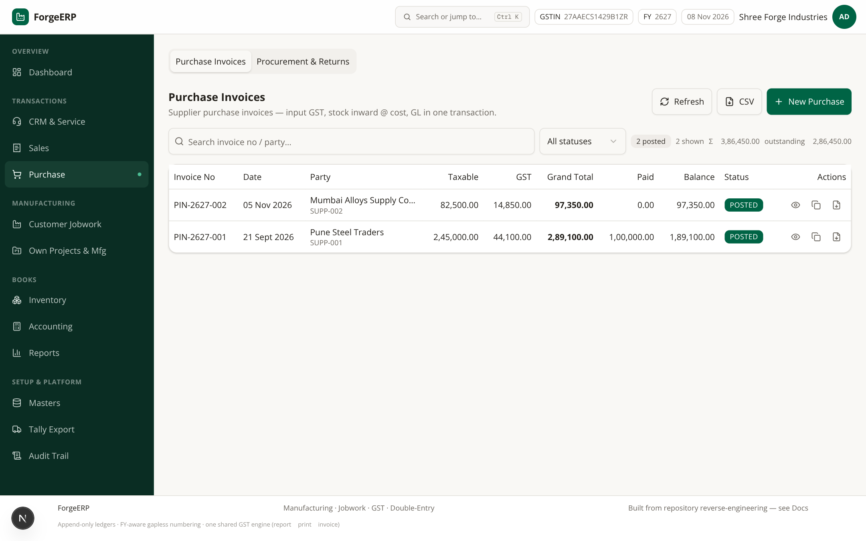
Screenshot 6.1 — Purchase bills: PIN-2627-001 (₹2,89,100, partial paid ₹1,00,000) aur PIN-2627-002 (₹97,350). Invoice no PIN-2627-### format me ate hain.

6.1 Purchase ka flow
- Purchase → New Purchase.
- Supplier select karein — party type SUPPLIER hona chahiye. Supplier ka state/GSTIN load hota hai; inter-state ho to IGST apne aap.
- Date, warehouse, PO number (optional) bharein.
- Line items me Item pick karein; qty / rate / discount bharein.
- Input GST preview check karein: intra-state → CGST+SGST, inter-state → IGST. Tax-inclusive option bhi hai.
- Post Purchase dabaiye. Stock IN hota hai @ cost (weighted-average update); GL: Dr Purchases + Dr input GST, Cr Creditors.
- Supplier ko payment Accounting → New Payment → PAYMENT se record aur allocate karein.

6.2 Procurement & Returns tab
Requisitions → RFQ & Comparison → Purchase Orders → GRN & QC → Three-way Match → Returns & Notes: poora procurement pipeline.
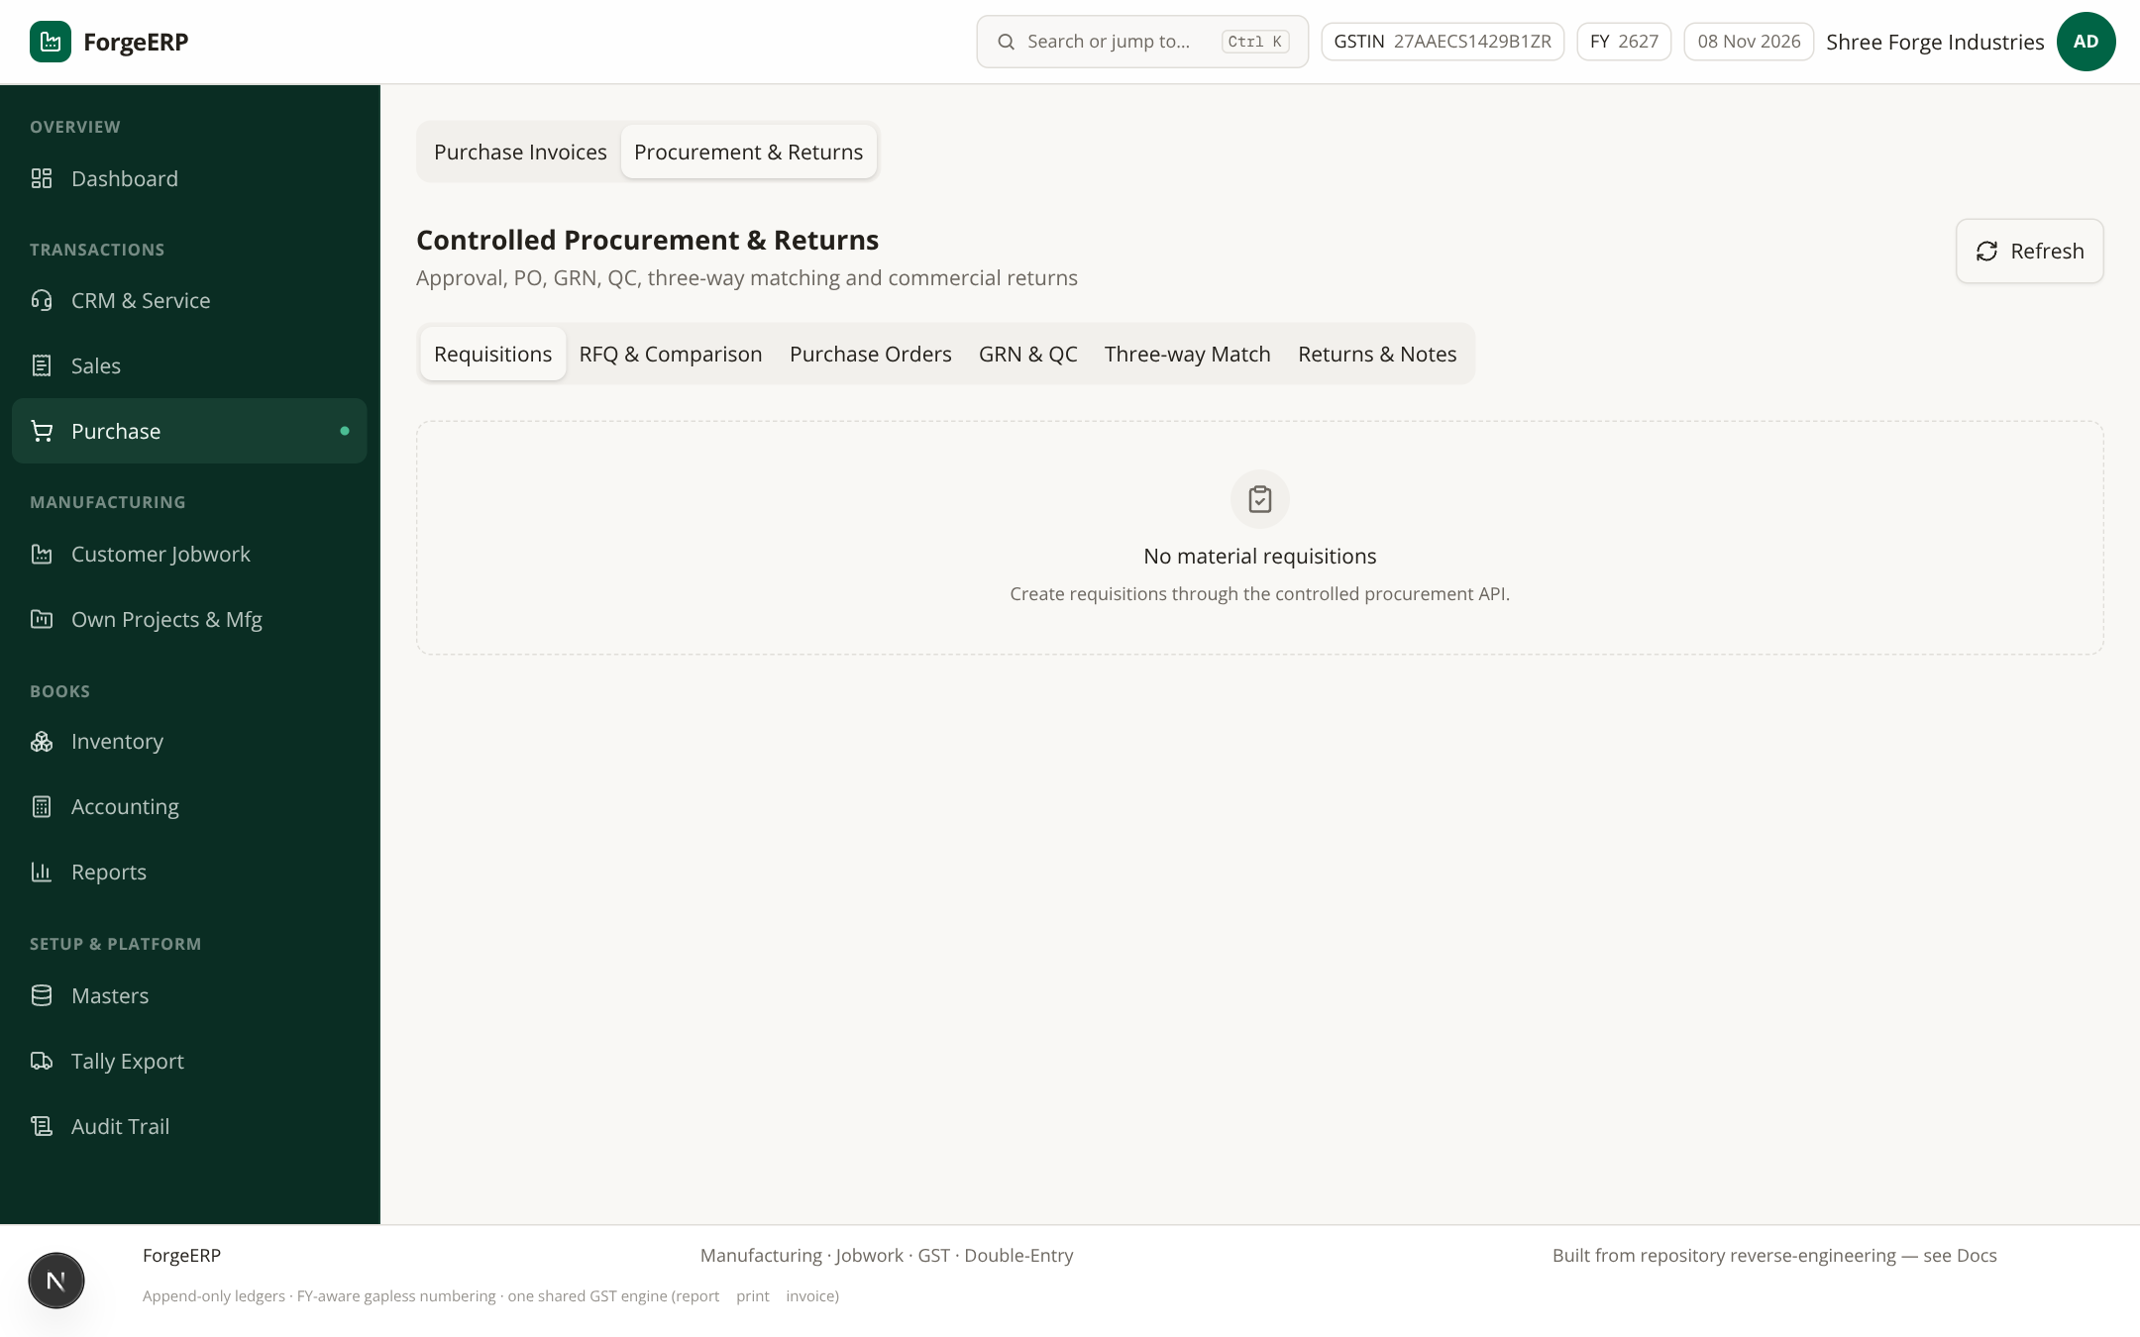
Screenshot 6.2 — Procurement & Returns: six sub-tabs — Requisitions, RFQ & Comparison, Purchase Orders, GRN & QC, Three-way Match, Returns & Notes. GRN ke baad hi stock ledger me receipt dikhega; three-way match PO↔GRN↔bill ko reconcile karta hai.
- Purchase Requisition raise karein (department) → RFQ bhejein suppliers ko → quotes compare → PO create.
- GRN (Goods Receipt Note) par QC hota hai; uske baad hi stock available hota hai.
- Returns & Notes se debit notes / purchase returns post hote hain.
Cancel rules
Purchase bill cancel bhi reversal entries se hoti hai (delete nahi). Paid/allocated bill par pehle payment allocation correct karni pad sakti hai — Accounting se payment review karein.

7. Accounting: receipts, payments aur party ledger

7.1 Payments list
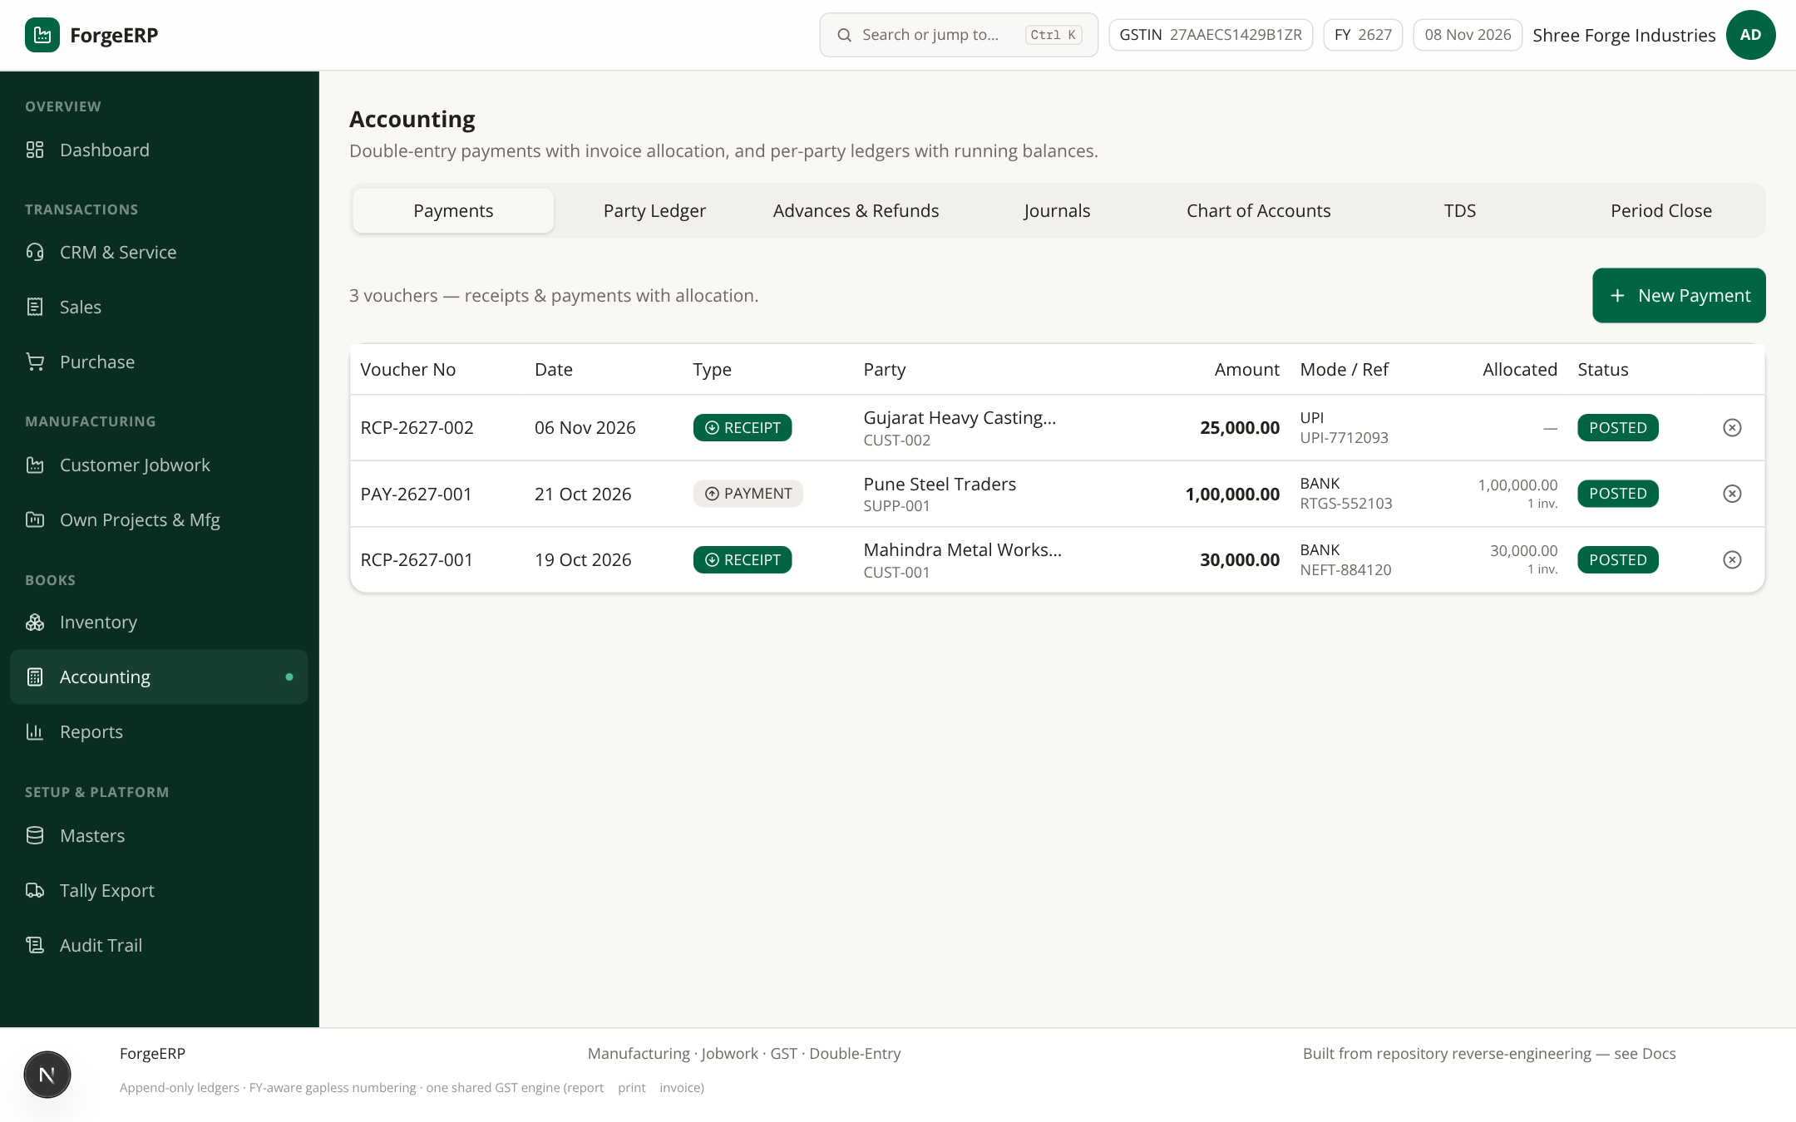
Screenshot 7.1 — Payments: voucher no, date, type (RECEIPT/PAYMENT), party, amount, mode/ref, allocated, status. Demo me 3 payments posted hain.
Naya payment:
- Accounting → New Payment.
- Type choose karein — RECEIPT (customer se aaya) / PAYMENT (supplier ko gaya).
- Party, Date, Amount, Mode (CASH / BANK / UPI / CHEQUE) aur Reference No bharein.
- Allocate against open invoices me invoice-wise amount bharein — har allocation us invoice ke outstanding se zyada nahi ho sakta, aur total allocation amount se zyada nahi ho sakta.
- Post Payment dabaiye. RCP/PAY-2627-### number milta hai; invoice paid amounts update hote hain; GL auto post hota hai.
Sabse easy tarika
Invoice detail se “Receive Payment” dabaiye — allocation khud bhari hoti hai (invoice-wise outstanding se). Sirf verify karke Post Payment karein.
Bina allocation ke payment on-account/advance rehta hai aur invoice balance kam nahi hoga.

7.2 Party Ledger
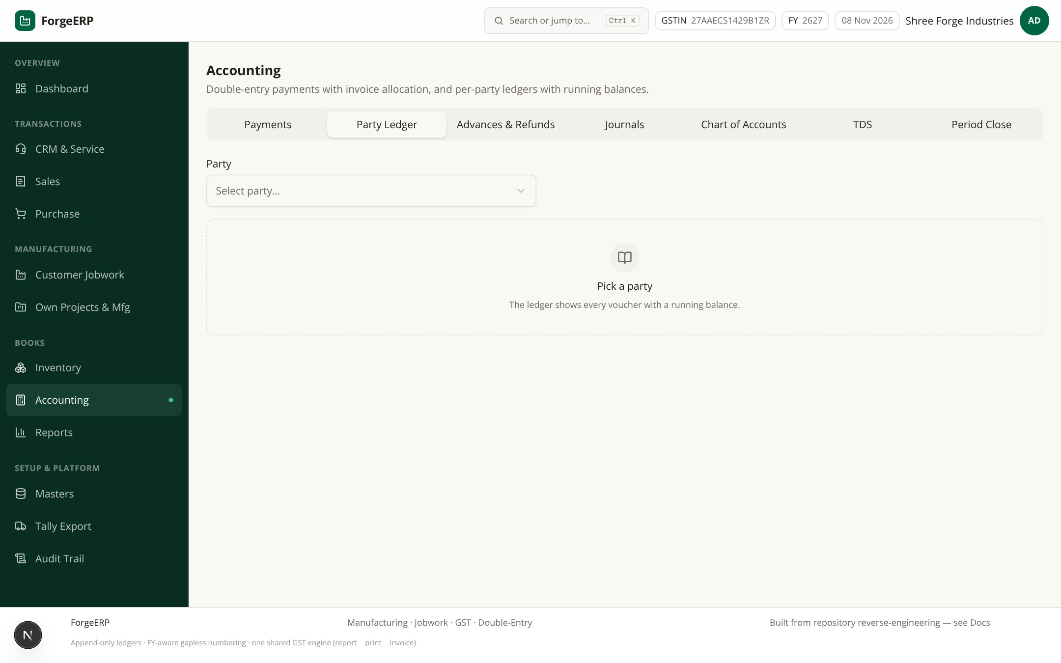
Screenshot 7.2 — Party Ledger: party select karke opening, invoices (Dr), payments (Cr) aur running balance dekhein. Customer receivable / supplier payable context ke saath.
- Accounting → Party Ledger tab.
- Party select karein. Invoice debits aur payment credits chronologically dikhte hain; closing balance final hai.
- Mismatch lage to check karein: opening balance, missing allocation, cancelled invoice/payment.

7.3 Journals (manual double-entry)
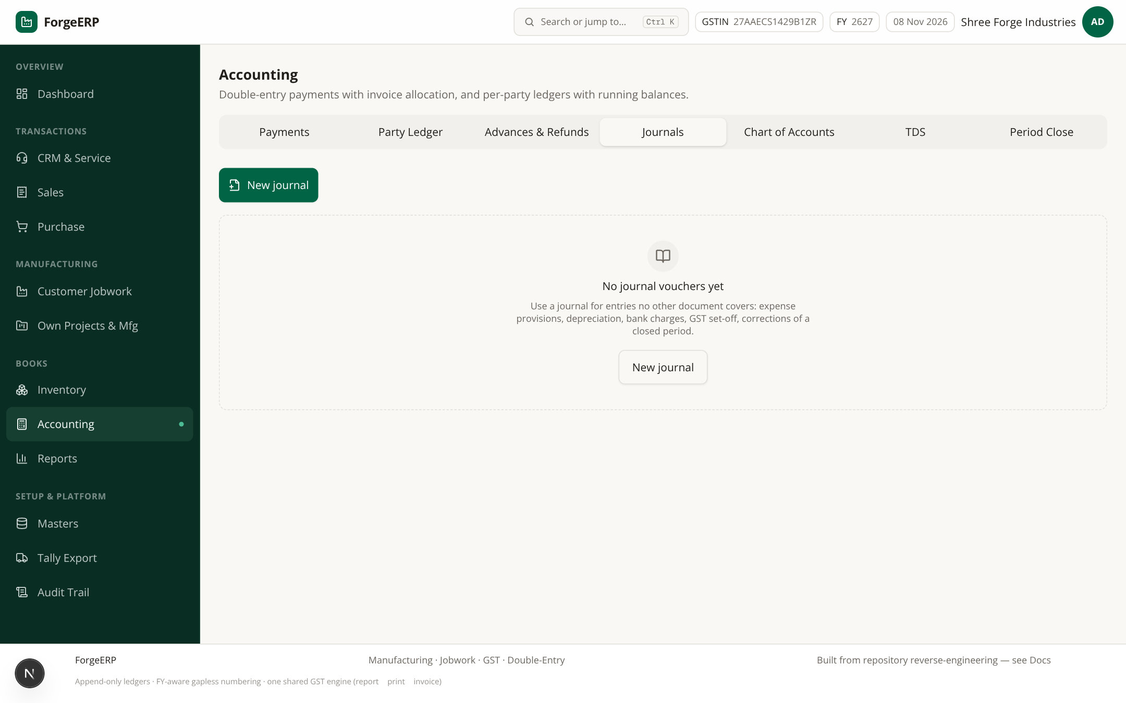
Screenshot 7.3 — Journals: manual double-entry vouchers (Dr = Cr enforced). Cancel = mirrored reversal; purani rows kabhi delete nahi hoti.
- JournalVoucher me free-form entries darj karein; har line Dr ya Cr. Sum Dr must equal sum Cr.
- Chart of Accounts tab me company-defined ledgers (expenses/income/asset/liability heads) manage karein.
- TDS tab me 194C/194J jaise sections — supplier payments par TDS payable auto track.
- Period Close tab books lock date set karta hai — is date ke pehle koi posting/cancel nahi hogi.
Period lock ka matlab
Books locked date ke pehle post/cancel karne ki koshish block hogi. GSTR-1 file karke ye date zaroor set karein.
Lock sirf OWNER hata sakta hai; har hati/use audit me log hoti hai.

8. Inventory: stock summary, ledger, lots

8.1 Stock Summary
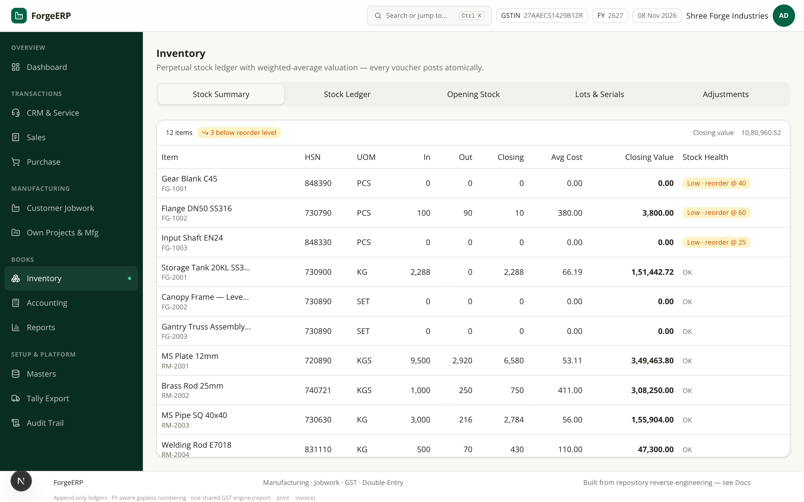
Screenshot 8.1 — Stock Summary: per item received/issued/closing qty, average cost, closing value; low-stock flag reorder level se neeche. Total closing value dashboard card se match hoti hai.
- Avg cost = weighted-average valuation (sab receipts ka running average).
- Low stock = closing qty < item reorder level — seedha reorder ka signal.
- Date range filter se kisi bhi din ka snapshot nikal sakte hain.

8.2 Stock Ledger
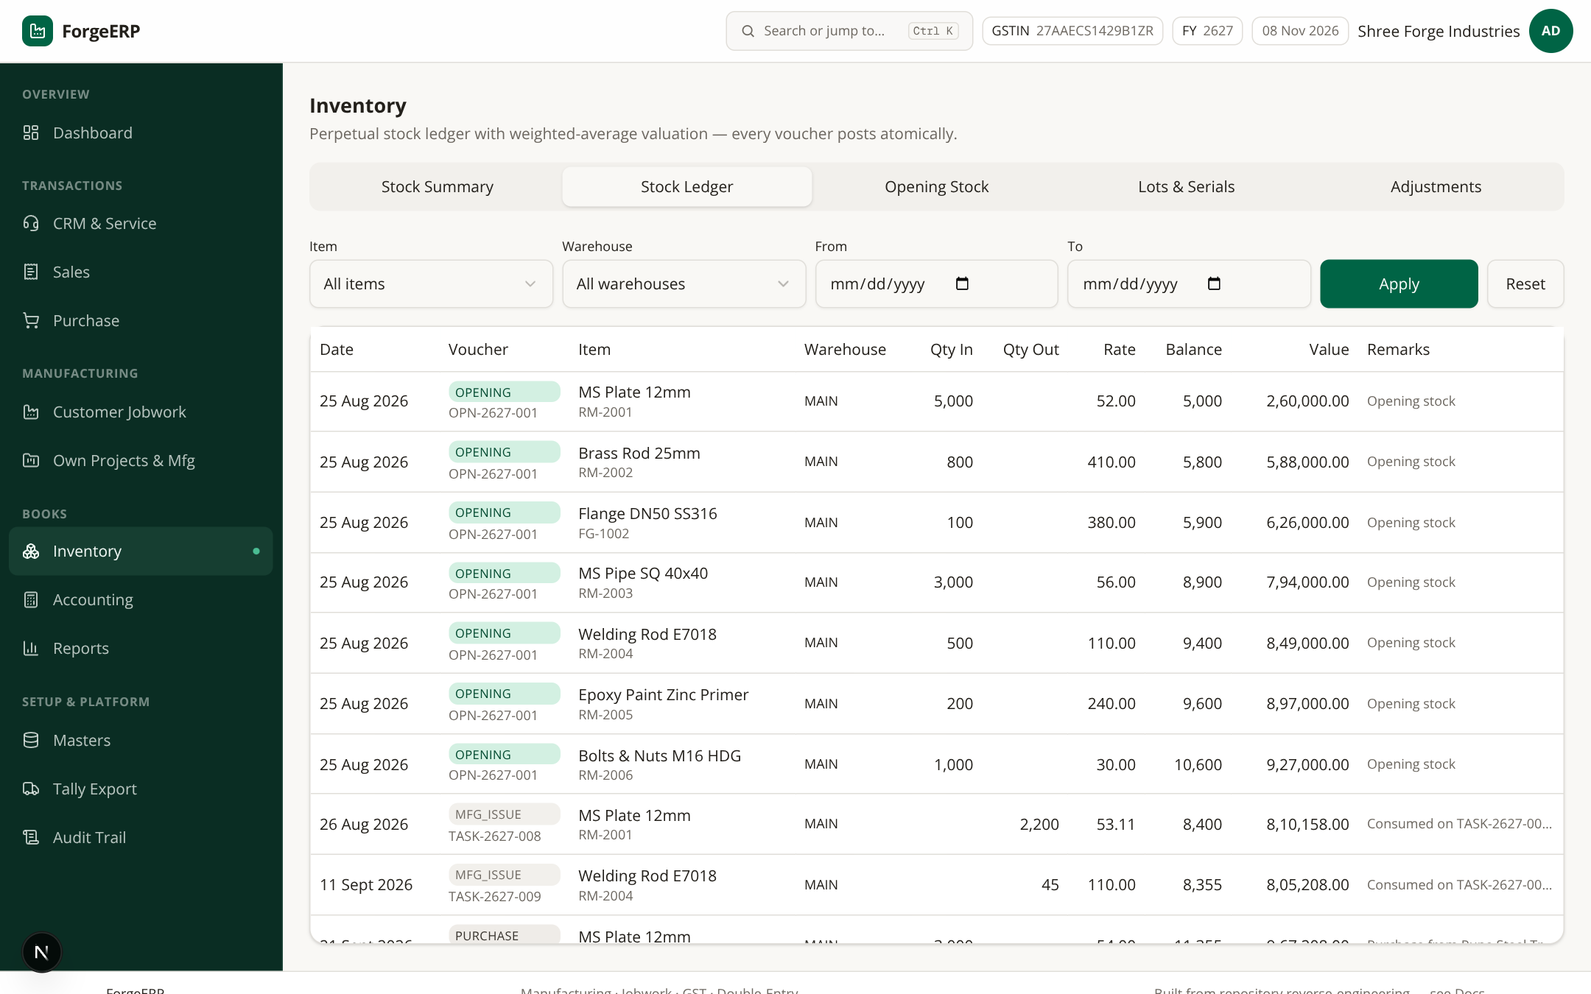
Screenshot 8.2 — Stock Ledger: har movement — OPENING, PURCHASE, SALES, JOBWORK_IN (value-neutral), adjustments aur reversals. Item/warehouse/date filters; running balance + value.
- Inventory → Stock Ledger.
- Item, Warehouse, From/To set karke Apply karein.
- Har line ka source document (invoice no / inward no / adjustment no) column me dikhta hai — audit trail poora hai.

8.3 Lots & Serials (traceability)
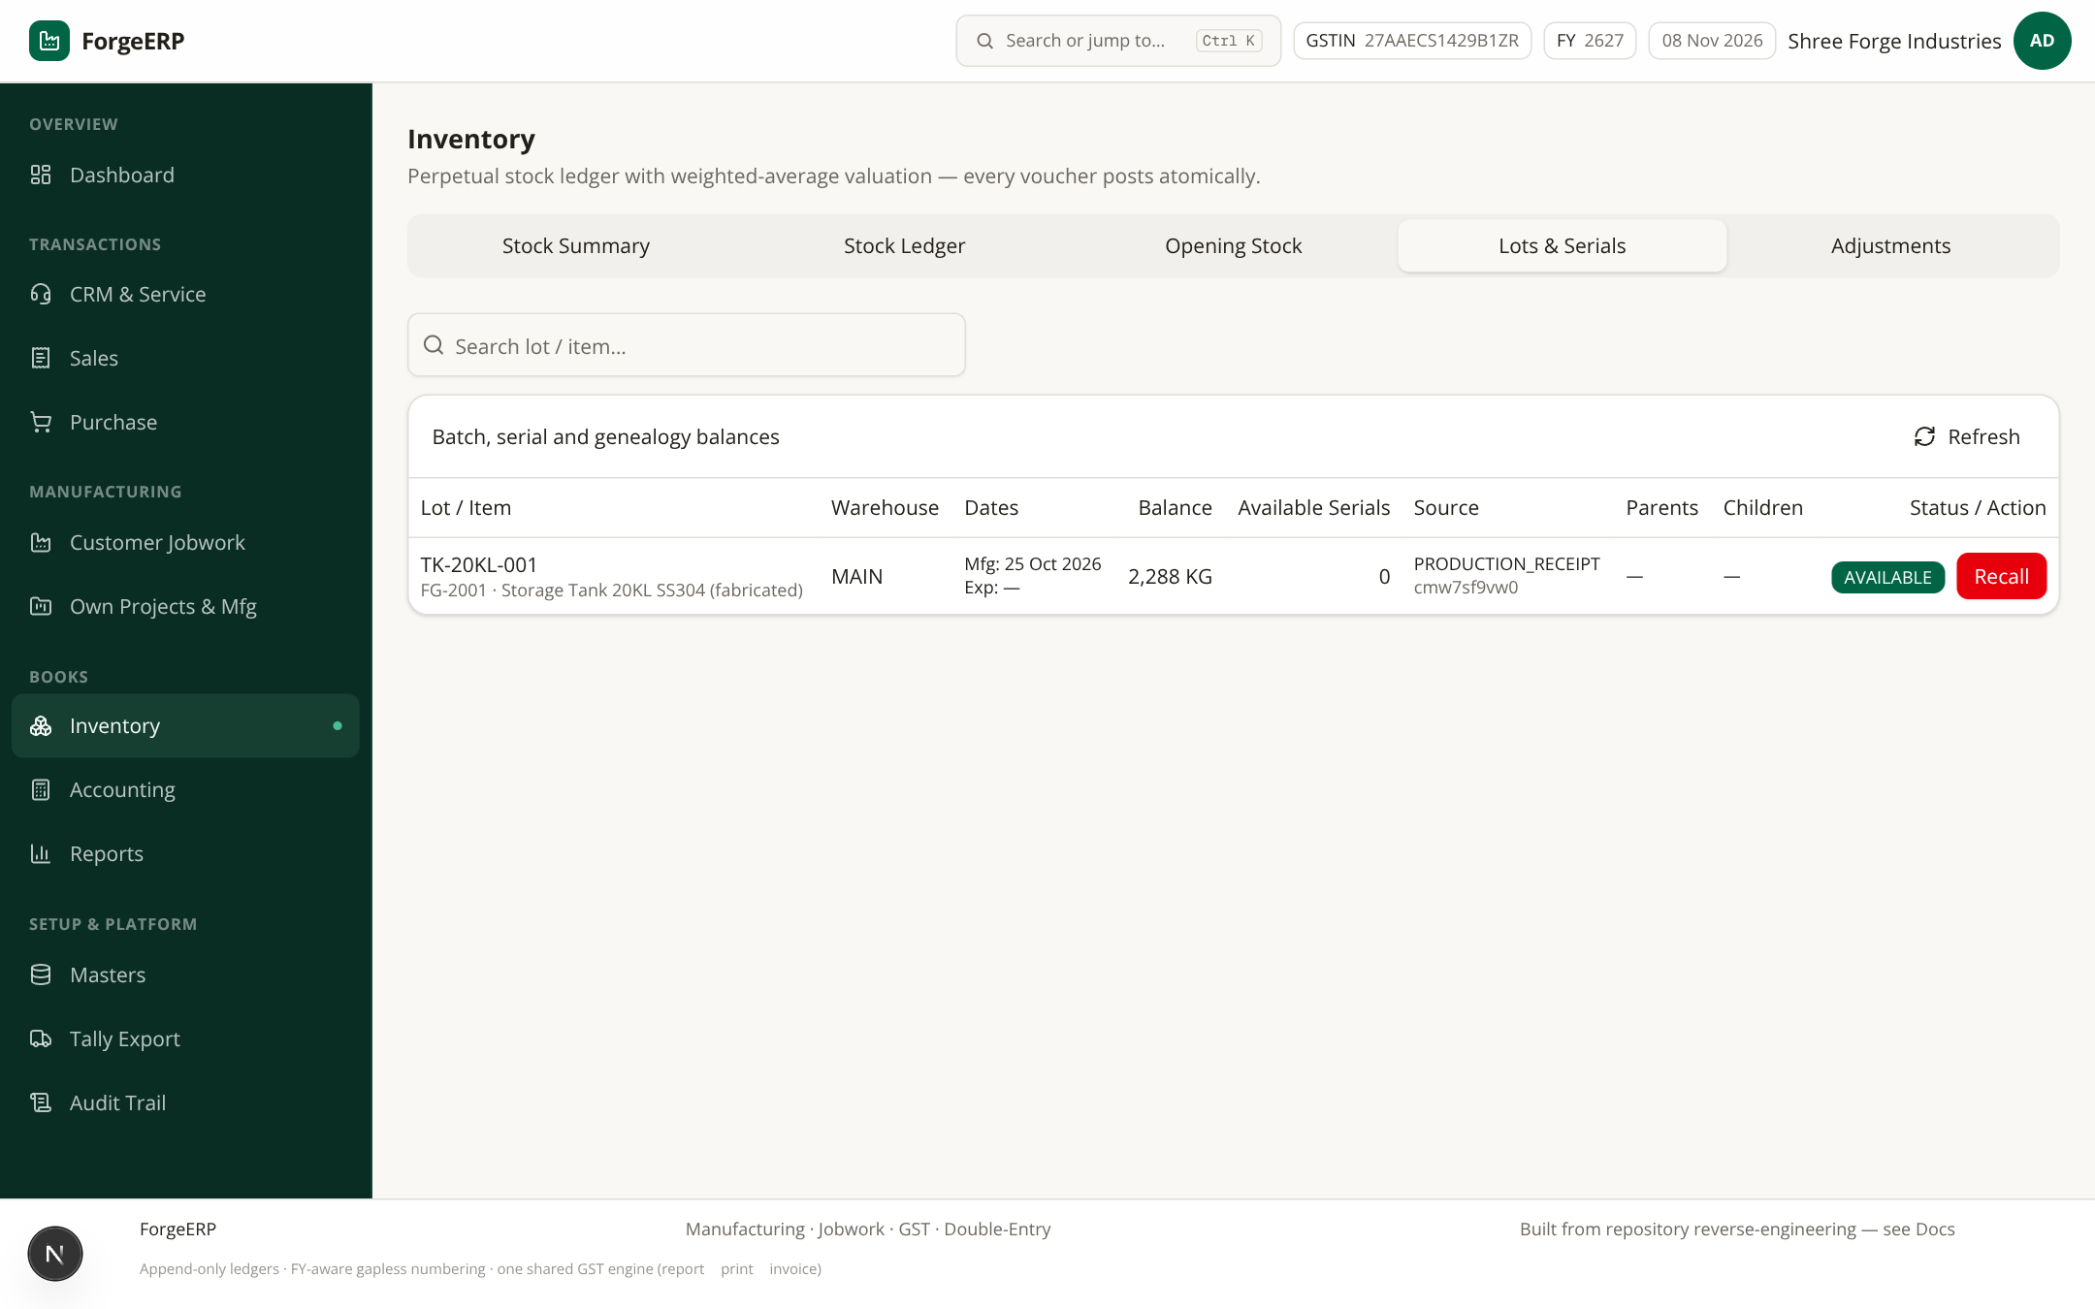
Screenshot 8.3 — Lots & Serials: batch-wise stock aur serial numbers; GRN se lot create hota hai, jobwork/issues me lot track hota hai, certificate me genealogy print hoti hai.

8.4 Opening Stock (go-live)
- Inventory → Opening Stock tab.
- Go-live date aur warehouse select karein.
- Item, Qty, Rate bharein; Add Row se multiple items ek saath.
- Post Opening Stock dabaiye — StockLedger me OPENING entries banti hain.
Re-submit ka behavior
Same item + warehouse + voucher ke opening rows re-submit karne par purani rows cancel/replace hoti hain. Opening stock casually re-post mat karein — pehle ledger reconcile karein.

9. Customer Jobwork: Inward → Job Card → Certificate → Invoice
Ye ForgeERP ka core flow hai. Customer apna material bhejta hai; company uspar processes karti hai; material customer-owned rehta hai — billing sirf process charges ki hoti hai. Inward stock ledger me value-neutral qtyIn hota hai.

9.1 Inward list aur pending report
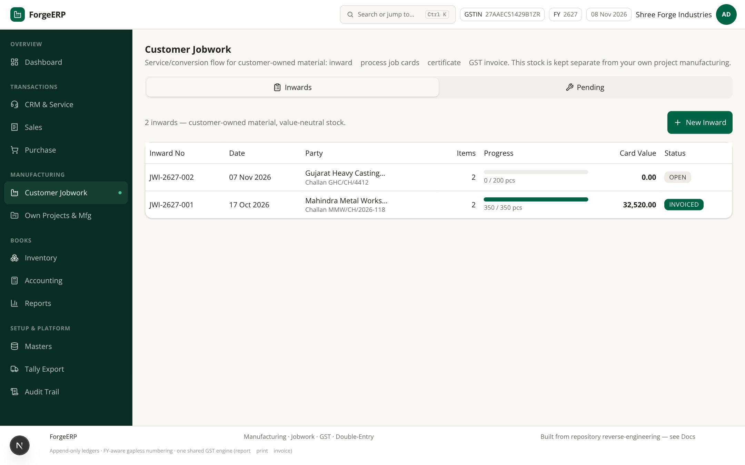
Screenshot 9.1 — Jobwork inwards: JWI-2627-002 (OPEN, 0/200 pcs) aur JWI-2627-001 (INVOICED, 350/350 pcs, card value ₹32,520). Tabs: Inwards / Pending. Pending me har item ka received/processed/remaining qty-weight aur pending processes dikhte hain.

9.2 Naya Inward (customer challan receive karna)
- Customer Jobwork → New Inward.
- Customer party, date aur challan no bharein (jaise Challan MMW/CH/2026-118).
- Items add karein: item, batch (optional), qty, weight (kg). Qty aur weight dono track hote hain.
- Record Inward dabaiye. JWI-2627-### number milta hai; status OPEN; stock ledger me JOBWORK_IN (value-neutral) post hota hai.

9.3 Inward detail
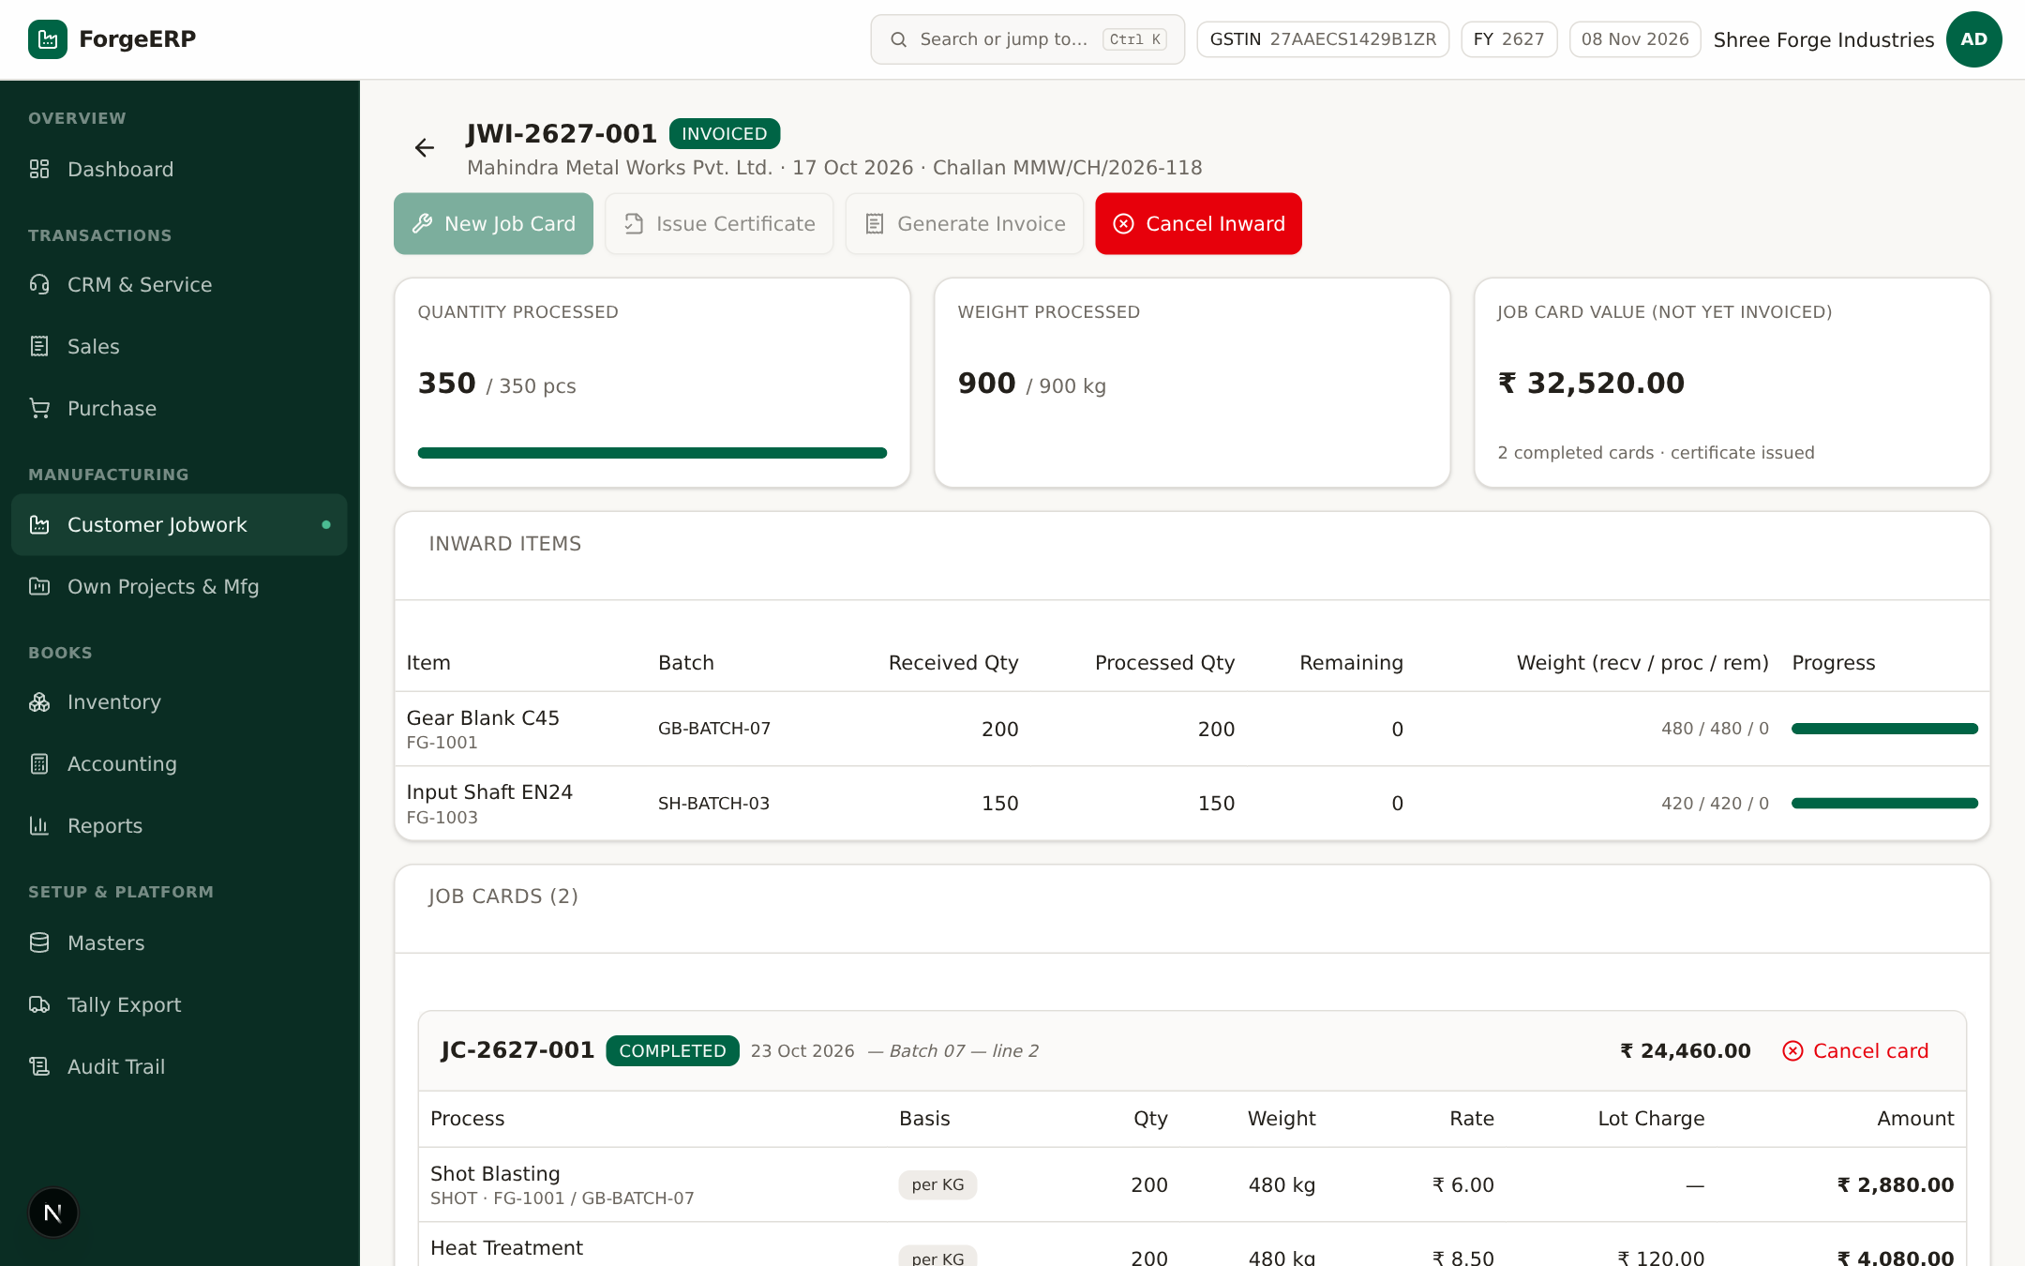
Screenshot 9.2 — JWI-2627-001 detail (INVOICED): quantity/weight processed 350/350 pcs aur 900/900 kg, job card value ₹32,520, 2 inward items (Gear Blank C45 200 pcs, Input Shaft EN24 150 pcs) progress bars ke saath, aur completed job cards ki list.
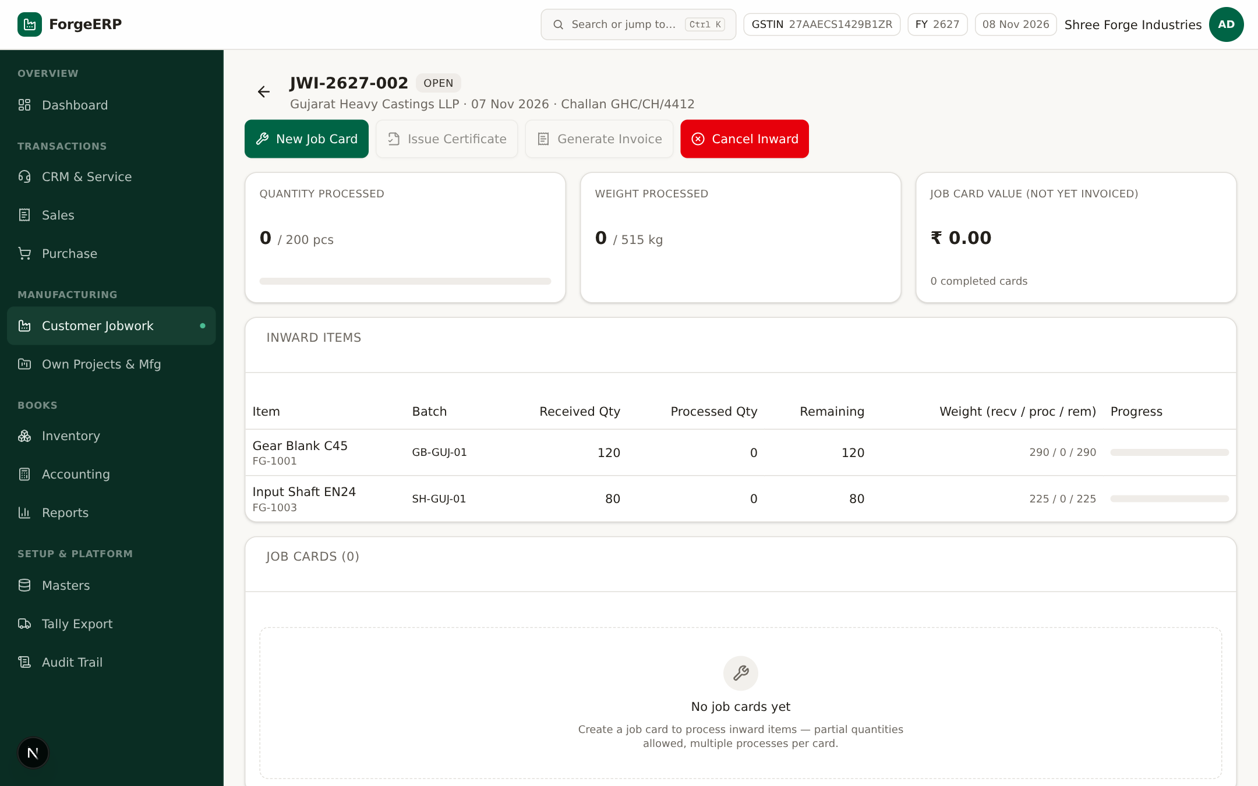
Screenshot 9.3 — JWI-2627-002 detail (OPEN): abhi kuch process nahi hua — New Job Card button enabled hai, Issue Certificate / Generate Invoice abhi disabled.
- New Job Card — process kaam record karne ke liye
- Issue Certificate — completed cards ko aggregate karke certificate banane ke liye
- Generate Invoice — jobwork services ki GST sales invoice banane ke liye
- Cancel Inward — reversal ke saath inward cancel (sirf jab koi completed job card na ho)

9.4 Job Card banana (process kaam record karna)
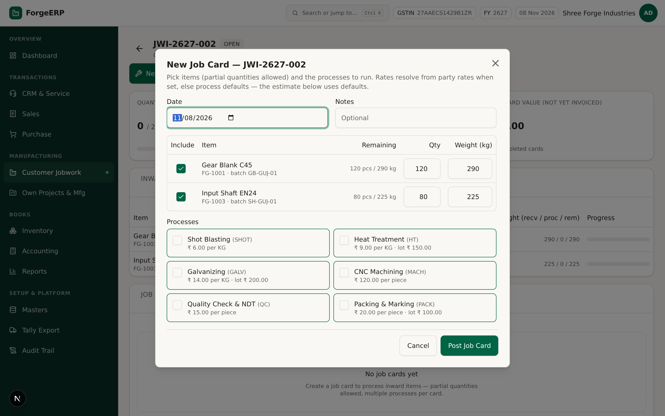
Screenshot 9.4 — New Job Card: items tick karein (partial qty/weight allowed — remaining dikhta hai), processes select karein. Demo rates: Shot Blasting ₹6/KG, Heat Treatment ₹9/KG + lot ₹150, Galvanizing ₹14/KG, CNC ₹120/piece, QC ₹15/piece, Packing ₹20/piece.
- Inward detail → New Job Card.
- Date aur notes (optional).
- Include column me items tick karein; partial Qty aur Weight Wt kg allowed hai (remaining ke saath).
- Processes me required operations select karein — party-specific rate hoga to wahi apply hoga, warna process default.
- Estimate review karein. Final server party rates use karta hai.
- Post Job Card dabaiye. Card COMPLETED banega; processed qty/weight badh jayega; inward progress update hoga.
Over-processing guard
processed + new qty/weight received qty/weight se 5% tolerance tak allow hai. Usse zyada post karne par server reject karta hai — received qty pehle verify karein.

9.5 Certificate
- Inward detail → Issue Certificate.
- System completed job cards ke processes aggregate karta hai (total qty, weight, amount) aur CERT-2627-### banata hai.
- Certificate status ISSUED; customer ko dispatch/service proof ke roop me de sakte hain.

9.6 Generate Invoice
- Inward detail → Generate Invoice.
- System JW-SERVICE (SAC 998887, 18%) service item ke through aggregated process amounts ki sales invoice banata hai — ek line per process type.
- Invoice source JOBWORK dikhti hai; income JWIN ledger me jati hai; inward status INVOICED.
- Sales list aur Party Ledger me verify karein; customer ko bill bhejein.

9.7 Cancel rules (jobwork)
Action | Rule
Cancel Job Card | Certificate issued hone ke baad block; warna processed qty/weight rollback
Cancel Inward | Koi completed job card hai to block; warna reversal stock entries
Cancel Certificate | Certificate cancel karne par uske against generate hui invoice pehle handle karni pad sakti hai
Correction general | Invoice/payment/card chain dependent hote hain — delete kabhi nahi hota, sirf reversal

10. Reports: GST, finance aur outstanding
Reports ke saare figures append-only ledgers se derive hote hain — invoice ≡ print ≡ report by construction. Tabs: Action Center, GSTR-1, GSTR-3B, HSN Summary, Trial Balance, Outstanding, Cash & Bank, Customers, Suppliers, Production Cost, Efficiency, Inventory Planning, P&L, P&L by Ledger, Aging, Back Orders, Sales Analysis, Purchase by Supplier, Project Profitability.

10.1 Action Center
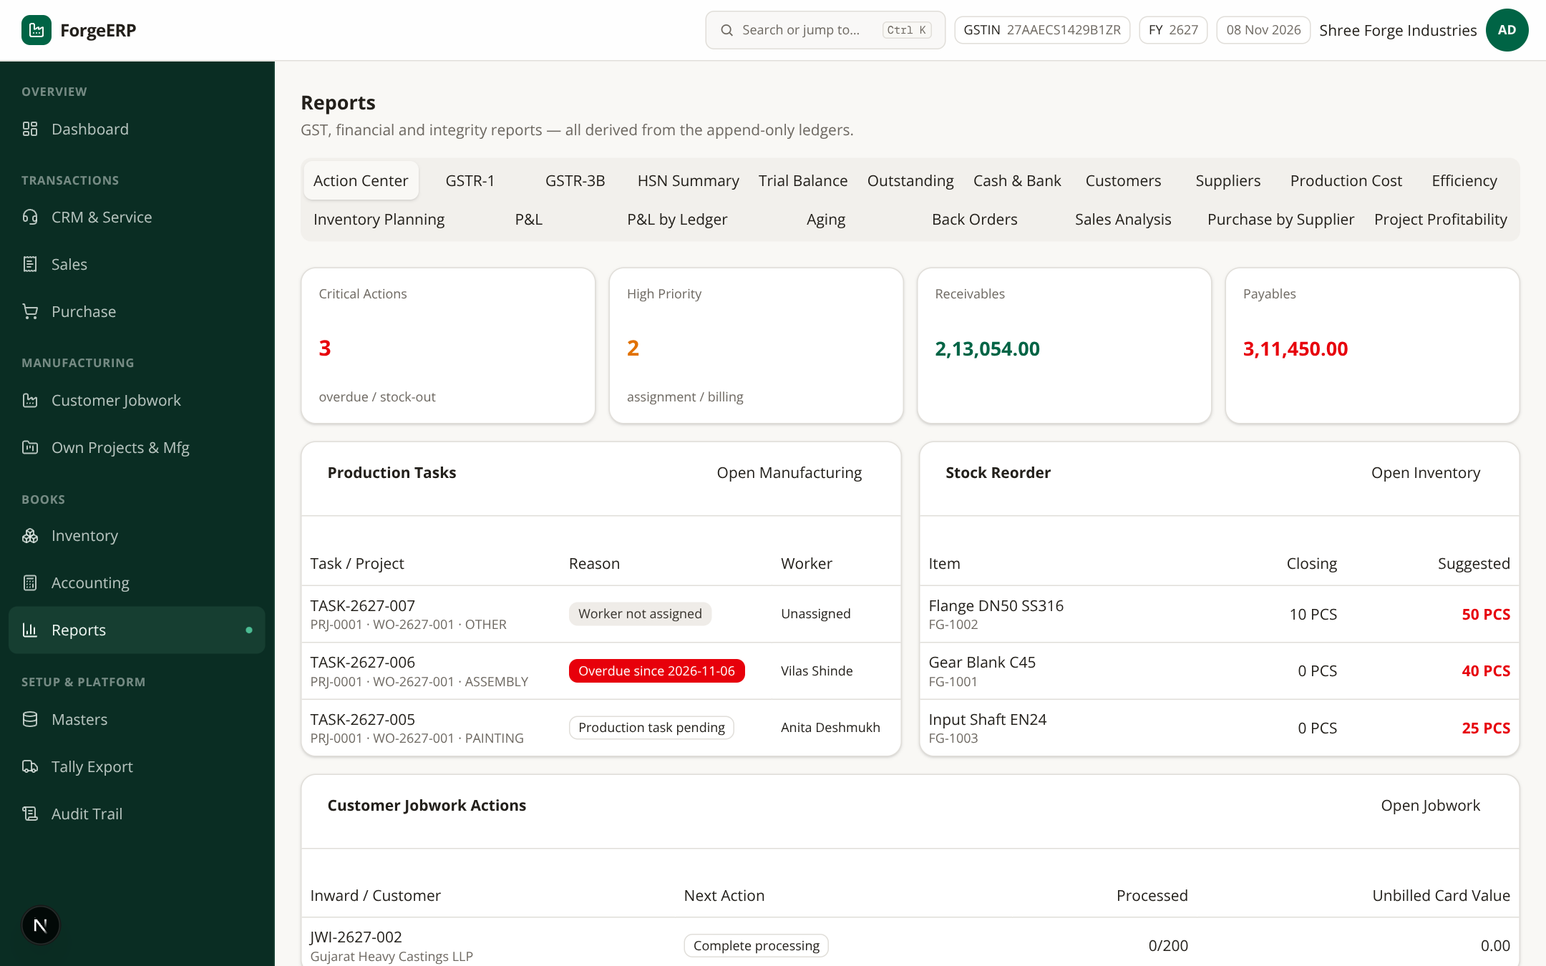
Screenshot 10.1 — Action Center: aaj ke follow-ups — overdue receivables, pending jobwork, low stock aur pending orders ek jagah; har item se seedha related screen khulta hai.

10.2 GSTR-1 summary
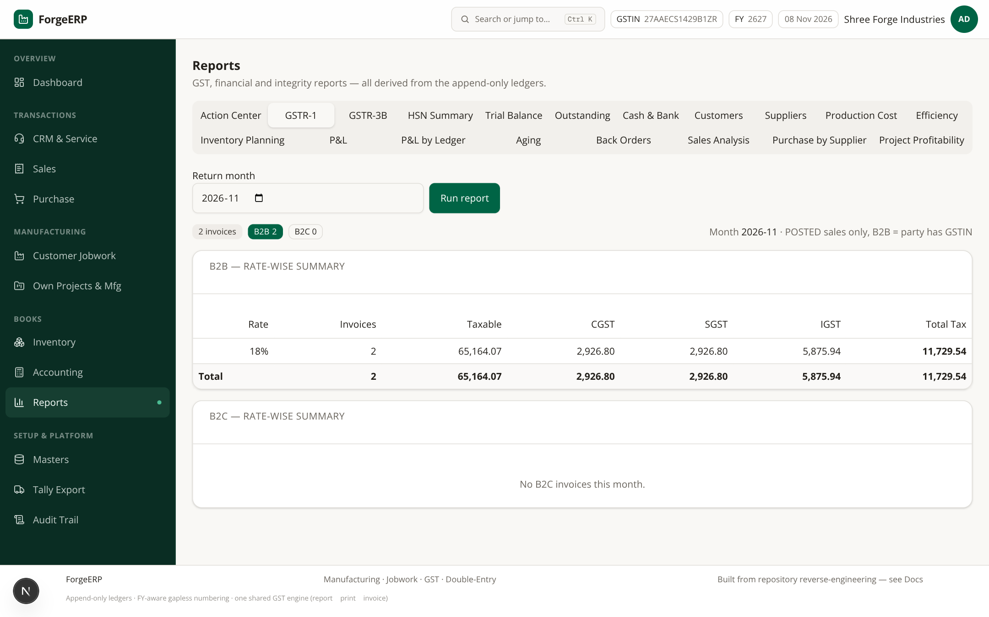
Screenshot 10.2 — GSTR-1: month 2026-11 select karke Run report — B2B (2 invoices, taxable ₹65,164.07, GST ₹11,729.54) aur B2C rate-wise split. POSTED sales only; B2B = party ke paas GSTIN.
- Reports → GSTR-1 tab.
- Return month choose karke Run report.
- B2B aur B2C rate-wise columns check karein: taxable, CGST, SGST, IGST, total tax.
Scope
Ye summary report hai, full GSTR-1 JSON/filing utility nahi. Filing se pehle ledger aur Excel export CA/GST practitioner se reconcile karwayein.

10.3 Trial Balance
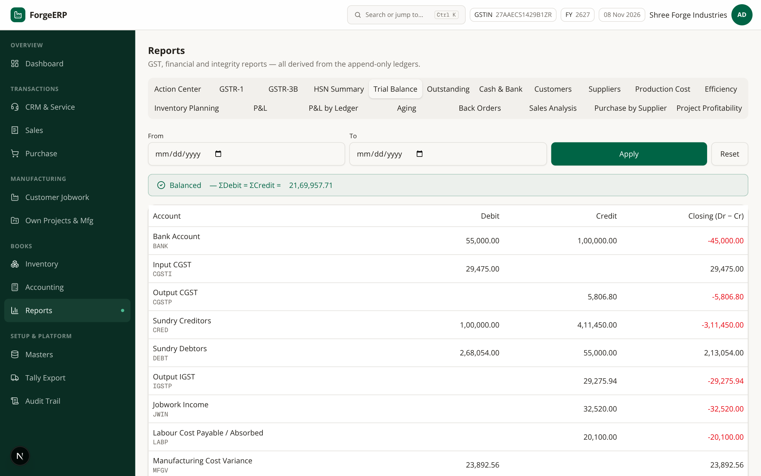
Screenshot 10.3 — Trial Balance: account-wise Dr/Cr/closing. ΣDebit = ΣCredit integrity banner dikhana chahiye — agar diverge kare to koi manual journal galat hai.
- Account codes: DEBT (debtors), CRED (creditors), STKV (stock), SALS (sales), JWIN (jobwork income), PURC (purchases), GST input/output, CASH, BANK, RND (round off), OVHA (overhead absorption).
- From/To optional; Apply/Reset filters.

10.4 Outstanding
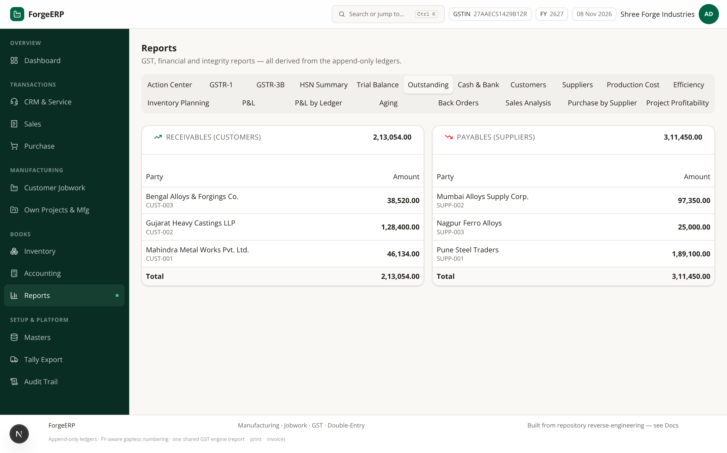
Screenshot 10.4 — Outstanding: customer-wise receivables aur supplier-wise payables, invoice-level breakup + opening balance. Collection follow-up ka seedha tool.
- Customer side: invoice no, party, due date, balance. Supplier side same.
- Payment allocation sahi hogi to outstanding real hai; warna “invoice paid nahi dikh rahi” complaint aati hai.

10.5 P&L (period)
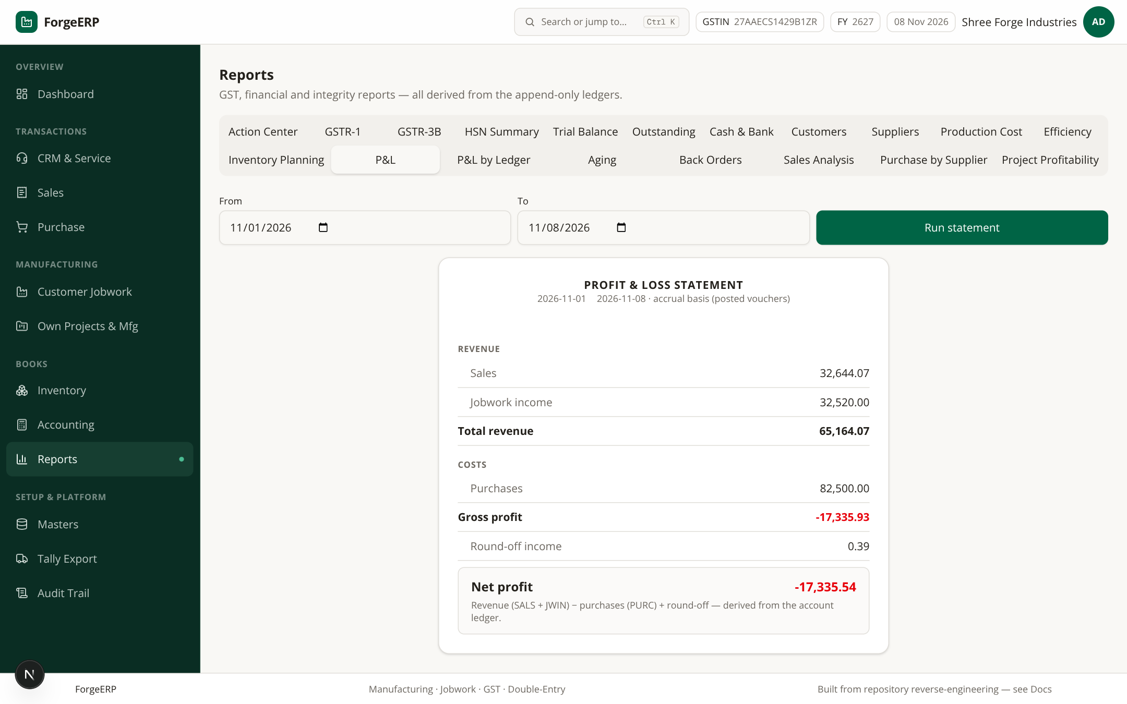
Screenshot 10.5 — P&L (period): Revenue (SALS + JWIN) − Purchases (PURC) ± round-off = net. Simplified accrual view — management snapshot, statutory accounts nahi.
P&L limitation
Is version me full expense ledger, COGS matching, depreciation aur statutory adjustments included nahi hain. Ise decision-making snapshot ki tarah istemal karein; final accounts ke liye CA se baat karein.

10.6 Aur reports
- GSTR-3B / HSN Summary — monthly return totals aur HSN-wise outward supplies.
- Cash & Bank — bank/cash account movements.
- Aging — receivables/payables ageing buckets (0–30, 31–60, 61–90, 90+).
- Sales Analysis / Purchase by Supplier — party-wise trends.
- Production Cost / Efficiency — routing, capacity, OEE context (Own Projects & Mfg ke saath).
- Back Orders / Inventory Planning — shortage aur reorder planning.

11. Own Projects & Mfg (apna fabrication/manufacturing)
Customer-owned material kaam (jobwork) “Customer Jobwork” me hota hai. Apne stock aur apne customer ke liye banaye jane wale kaam — project, BOM, work order — “Own Projects & Mfg” me hote hain.
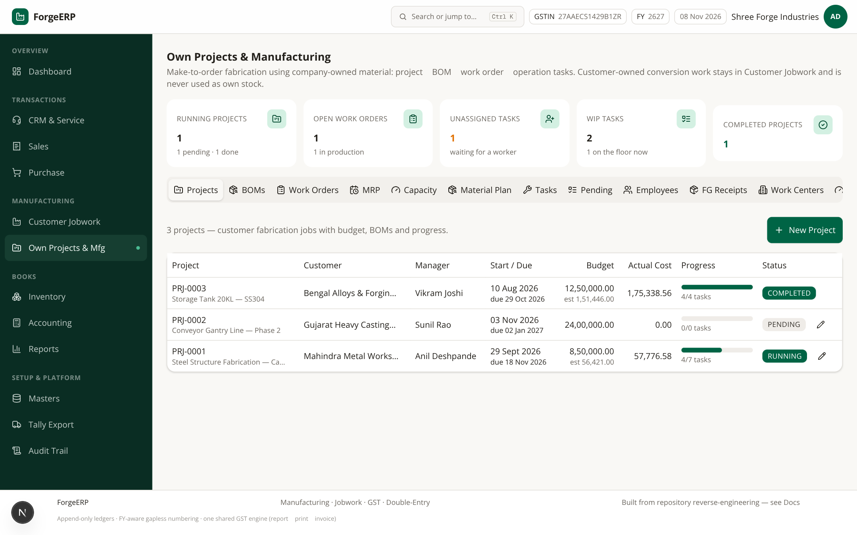
Screenshot 11.1 — Own Projects & Mfg: 1 running project (PRJ-0001 Steel Structure Fabrication, due 18 Nov), 1 pending (PRJ-0002 Conveyor Gantry, due 02 Jan), 1 completed (PRJ-0003 Storage Tank 20KL). KPIs: running/open WO/unassigned/WIP/completed. Tabs: Projects, BOMs, Work Orders, MRP, Capacity, Material Plan, Tasks, Pending, Employees, FG Receipts, Work Centers.

11.1 Flow ek nazar me
- Project create karein (customer, budget, start/due date) → BOM define karein (FG-2002 canopy frame jaise: raw items + scrap).
- Work Order release karein → tasks/production routing auto bante hain → work centers aur shift calendar capacity enforce.
- Production tasks floor par progress hote hain; Pending tab me kya ruka hai dikh jata hai.
- FG Receipts se finished goods stock me aate hain (FG-2001/FG-2002 jaise).
- MRP run demand vs stock vs open POs check karke purchase suggestions deta hai.
Jobwork se farq
Jobwork = customer ka maal, billing process charges ki. Own Projects = aapka maal, aapki sale. Ek dusre me mix mat karein — reports aur stock dono bigad jate hain.

12. CRM & Service: leads aur complaints
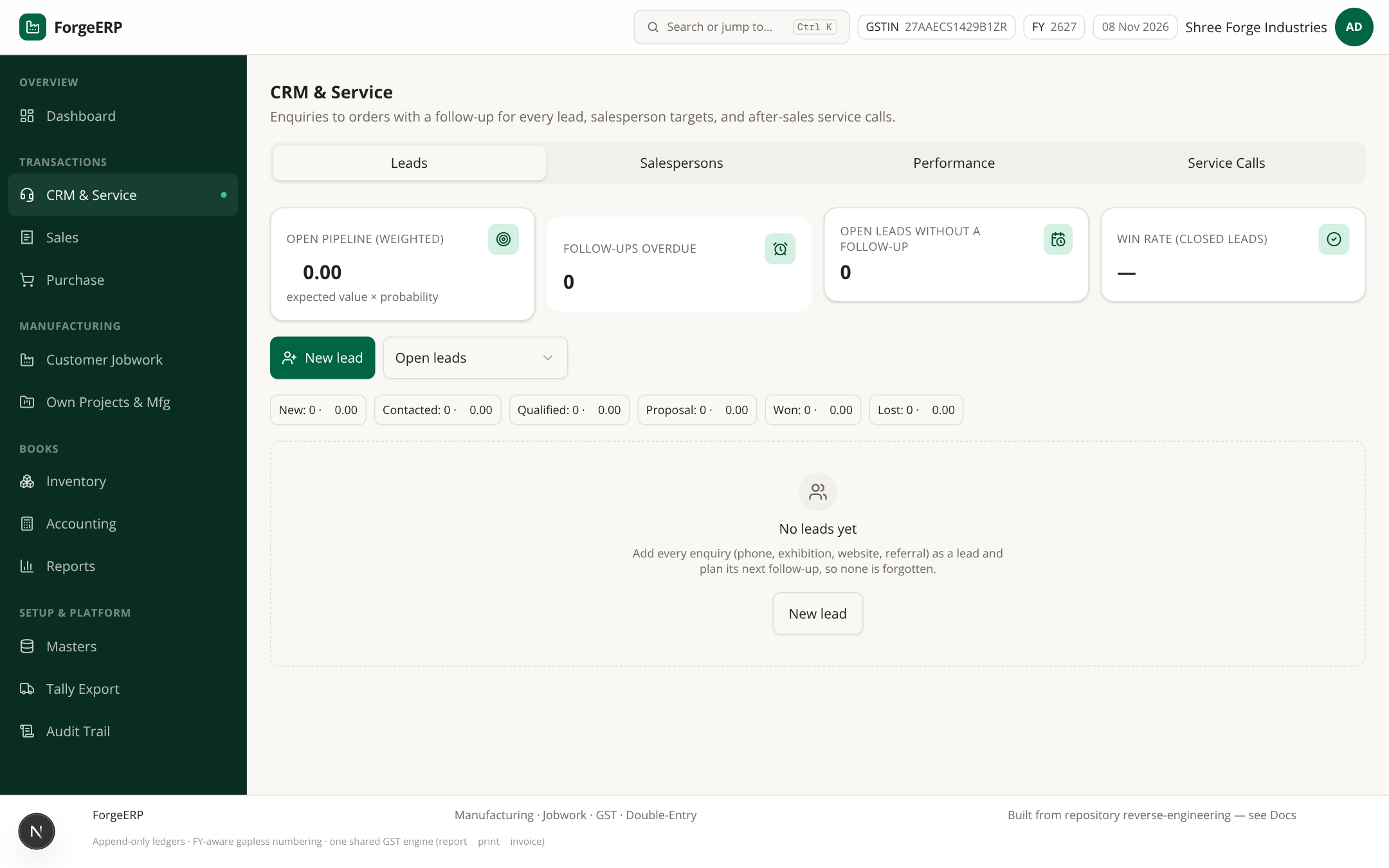
Screenshot 12.1 — CRM & Service (Leads tab): NEW/CONTACTED/QUALIFIED/PROPOSAL/WON/LOST pipeline, source, expected value, probability, follow-up date, salesperson. Demo me 2 sample inquiries seeded hain.

12.1 Tabs
- Leads — form se lead capture; status pipeline move karein; follow-up reminders.
- Salespersons — team, monthly targets, codes.
- Performance — salesperson-wise conversion/stats.
- Service Calls — complaint → assign → resolve → invoice flow (warranty flag ke saath).
Lead WON hone par usko Party me convert karein, phir Sales module se quotation/invoice banayein — yahi poora funnel hai.

13. Tally Export aur e-Invoice
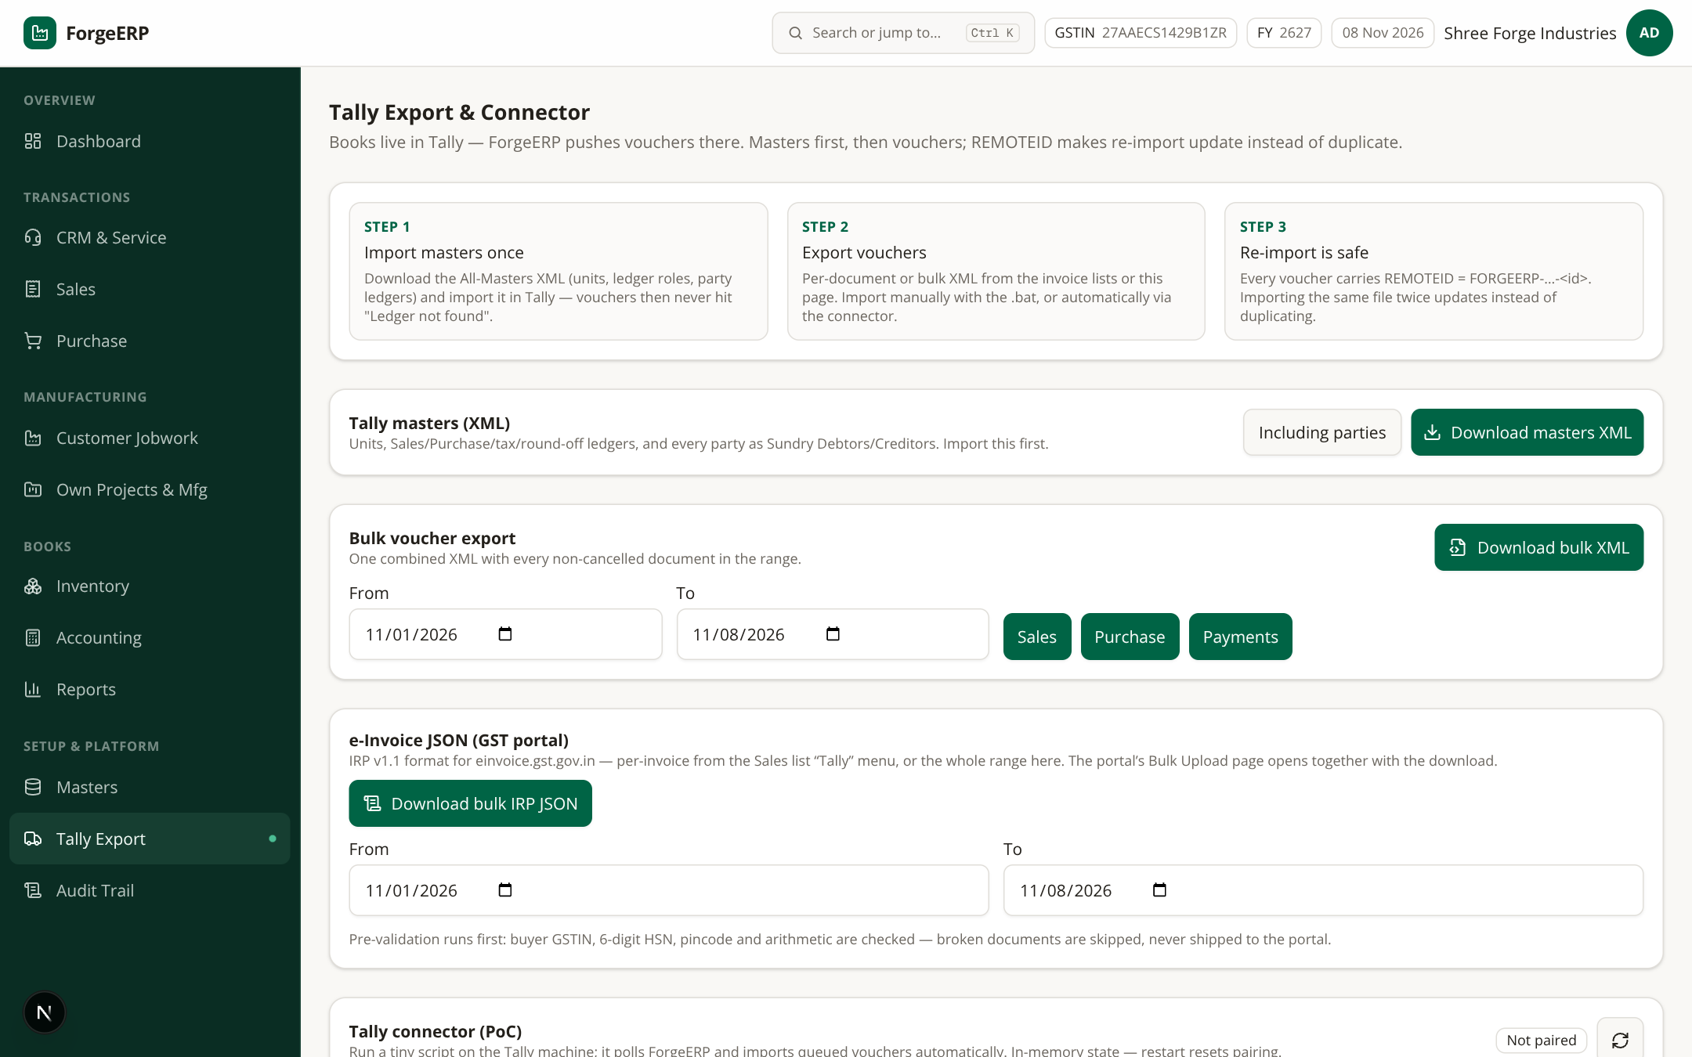
Screenshot 13.1 — Tally Export & Connector: Step 1 masters import → Step 2 voucher export → Step 3 re-import safe (REMOTEID se update, duplicate nahi). Masters XML, bulk voucher XML, e-Invoice bulk IRP JSON, aur Tally connector PoC.

13.1 Sahi order
- Step 1 — Tally Export page se “Download masters XML” (Parties ko Sundry Debtors/Creditors ke roop me map karta hai, Ledger roles, tax ledgers) — pehle Tally me import karein.
- Step 2 — “Bulk voucher export” me From/To choose karke Sales / Purchase / Payments button dabaiye — ek combined XML milta hai.
- TallyPrime port 9000 par open rakhein; XML import karein (ya Tally-Import.bat se bulk).
- Re-import par REMOTEID voucher update karta hai — duplicates nahi bante.

13.2 e-Invoice JSON (GST portal)
- Single invoice: Sales list → Tally menu → “e-Invoice JSON (GST portal)”.
- Bulk: Tally Export page me range choose karke “Download bulk IRP JSON”.
- Pre-validation hard errors par download block hota hai; warnings review worthy hain.
- JSON GST portal par manually upload karein — ForgeERP khud IRN fetch/government submit nahi karta.
Pre-validation point | Meaning
B2B only | Buyer GSTIN mandatory; B2C eligible nahi
Company / party pincode | 6 digit required
HSN/SAC | 6 ya 8 digits
Future date | IRP reject karta hai — error
30+ days old | Warning; IRN timing rules practitioner se verify karein
Cancelled invoice | Generation blocked
Connector PoC
Pairing code single-use aur 10 minute valid hota hai; Tally machine par node forge-tally-connector.mjs run hota hai; TallyPrime “Both” mode me port 9000 par.
Ye in-memory proof-of-concept hai — server restart par pairing reset ho sakti hai. Permanent sync guarantee na samjhein.

14. Audit Trail aur in-app Docs
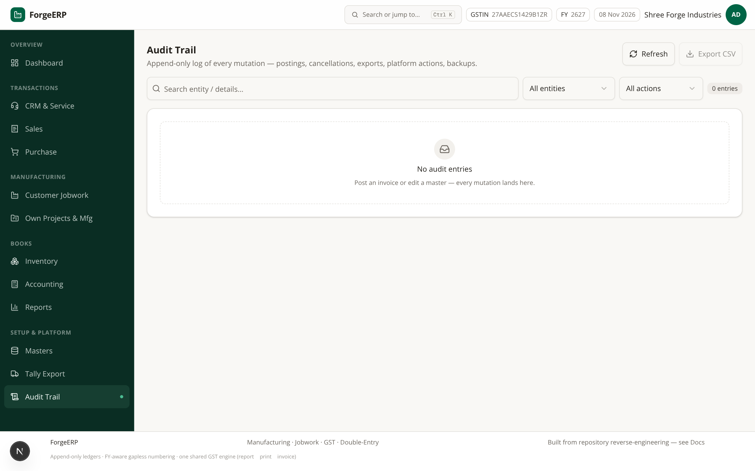
Screenshot 14.1 — Audit Trail: timestamp, action (CREATE/UPDATE/CANCEL/POST/EXPORT/…), entity, entity ID, details, actor (kis user ne). Filters + CSV export — compliance aur dispute resolution ka base.
- Audit Trail kholiye — default latest 100 entries dikhte hain.
- Entity ya action filter aur search se entry dhoondhein.
- Export CSV se filtered rows download karein (auditor/CA ko dene ke liye).
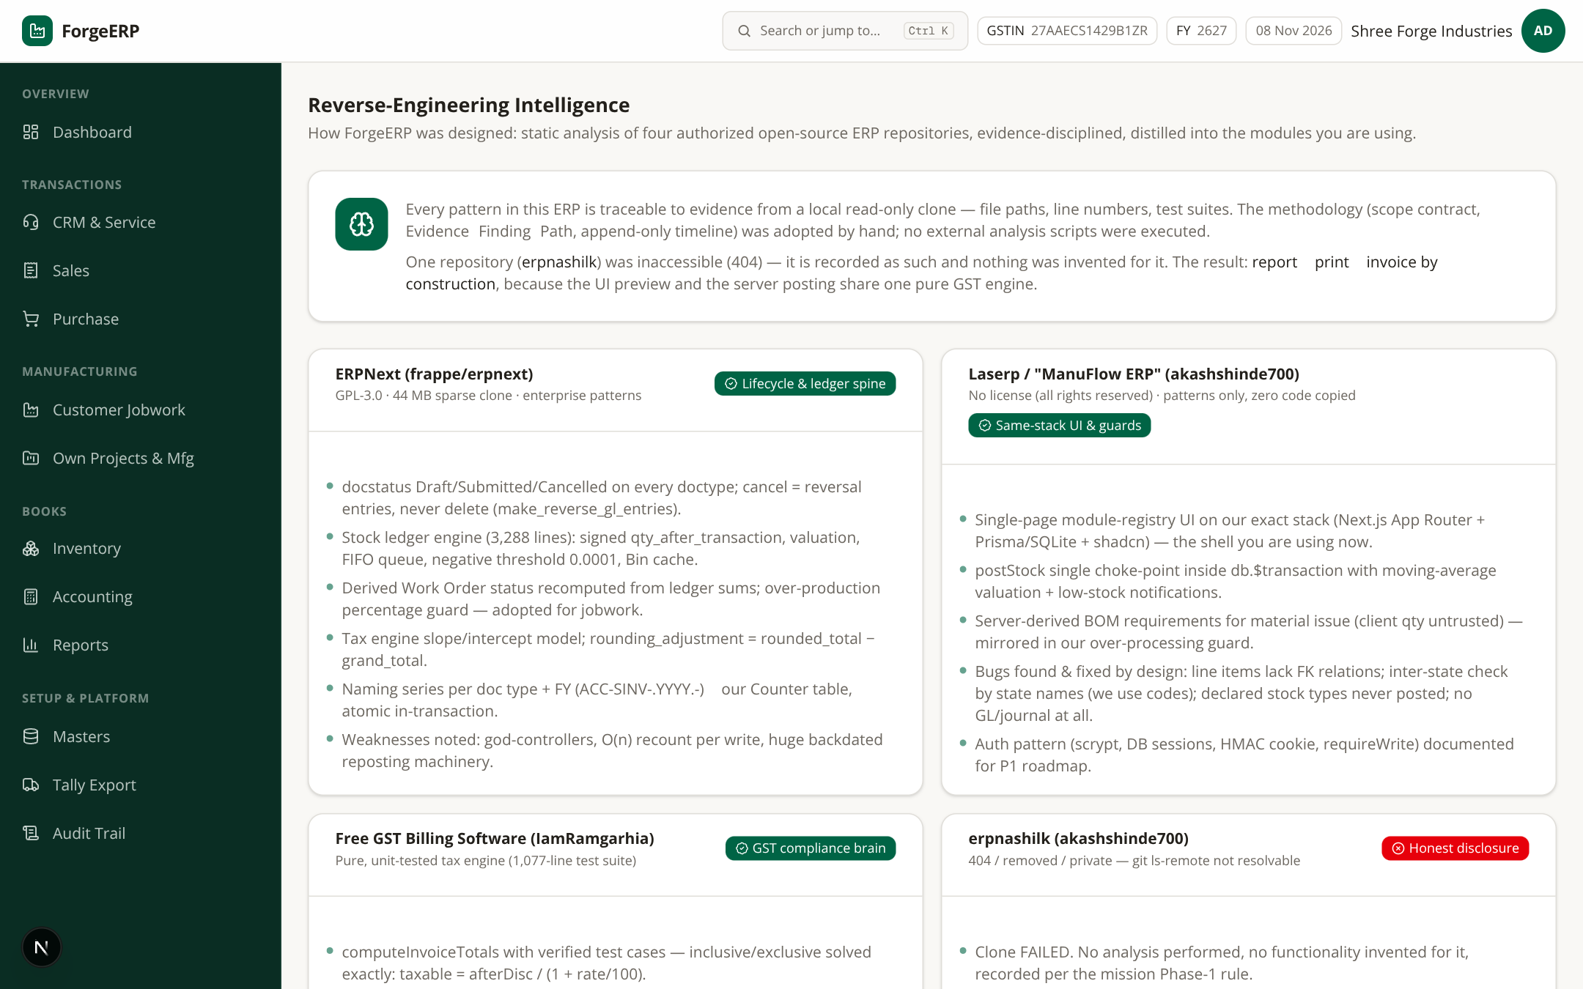
Screenshot 14.2 — In-app Docs page: repository reverse-engineering par based technical reference — kahan se patterns liye gaye, implementation notes. Daily users ke liye zaroori nahi; technical team/auditors ke liye useful.

15. Daily / Weekly / Month-end SOP

15.1 Daily (10 minutes)
- Dashboard kholkar sales/purchase/stock/receivables snapshot dekhein.
- Aaj ke sales / purchase / jobwork documents post karein.
- Receipts aur payments record karke invoices ke against allocate karein.
- Low stock list aur pending jobwork check karein.

15.2 Weekly (30 minutes)
- Outstanding report se collection follow-up karein (phone/email; promised dates note karein).
- Stock Summary vs physical sample count reconcile karein.
- Party Ledger me unallocated payments review karein.
- Audit Trail me unusual cancellations / exports dekhein.

15.3 Month-end (2–3 hours)
- Saare invoices/payments post hain — verify karein (Sales/Purchase lists me “POSTED” filter).
- Trial Balance check karein: ΣDebit = ΣCredit.
- GSTR-1 summary ko books se reconcile karein; mismatch ho to lines re-check karein.
- P&L limitations ke saath review karein; CA ko data export karein.
- Owner/admin backup lein (Platform Admin ya backup script) — file secure jagah store karein.
- Period Close se books lock date set karein — next month se pehle ki entries safe ho jayengi.

16. Troubleshooting: common problems aur fixes
Problem | Kya check karein
Login nahi ho raha | Email/password, caps lock, admin reset, session revoke; shared PC par Sign out tha?
Invoice post nahi ho raha | Party/item/warehouse; qty > 0, rate ≥ 0; stock availability; plan suspension
GST galat lag raha | Company state, party state, place of supply, item GST rate, tax-inclusive toggle
Stock negative / available nahi | Opening stock tha? purchase post hui? sahi warehouse? cancelled entries?
Payment ke baad bhi balance dikhta hai | Allocation bhara tha? invoice ka outstanding? payment cancel/repost?
Job card post nahi ho raha | Received vs processed qty/weight; 5% tolerance; certificate/invoice blockers
e-Invoice JSON nahi mil raha | B2B GSTIN, 6-digit pincode, HSN 6/8 digit, future/cancelled invoice
Tally import error | Masters pehle import hue? Ledger names exact? Port 9000; LINEERROR details padhein
Reports access denied | Plan me advancedReports feature? saasStatus ACTIVE? role VIEWER to read-only only
Export access denied | Plan me exportData feature? role VIEWER ko exports nahi milte
Invoice number gap lag raha | Numbering gapless-forward hai; cancelled invoice ka number reserved rehta hai (reuse nahi hota)
Dashboard numbers match nahi karte | Pending payments allocate kiye? cancelled docs filter? month boundary?

17. Glossary (shabdon ka matlab)
Term | Matlab
Master | Basic reference data — party / item / warehouse / process / company
Posting | Transaction ko permanent business record banana
GL | General Ledger — double-entry debit/credit accounts
Dr / Cr | Debit / Credit
HSN / SAC | Goods / Service classification code (GST)
CGST / SGST / IGST | Intra-state split / Inter-state GST
B2B / B2C | GSTIN-registered party / unregistered consumer
Allocation | Payment ko specific invoice ke against baantna
Outstanding | Invoice ka unpaid balance
Weighted-average cost | Stock valuation ka running-average method
Jobwork | Customer material par processing service
Inward | Customer material receipt (JWI)
Job Card | Processing operation ka record (JC)
Certificate | Jobwork completion / dispatch proof (CERT)
IRP / IRN | Invoice Registration Portal / Invoice Reference Number
REMOTEID | Tally me voucher identity — re-import update ke liye
Append-only | Purana row delete nahi hota; reversal/cancel rows add hote hain
FY | Financial year (2627 = FY 2026-27) — numbering ke saath tied
RND | Round-off ledger (nearest ₹1 difference)
OVHA | Overhead absorption ledger (manufacturing cost roll-up)

18. Compliance aur zimmedari
Important
Ye guide software use karne ke liye hai — legal/tax advice nahi.
GSTR-1/3B filing, e-Invoice IRN, TDS, audit, account finalization — sab ke liye qualified CA / GST practitioner se verify karein.
Demo data (Shree Forge Industries) sirf training ke liye hai. Production me apne real masters banayein.

ForgeERP Organization ERP User Guide — Version 2.0 · 08 November 2026
Screenshots captured via Playwright from this repository checkout (FY 2627 demo seed).

