YANTRIX TECHNOLOGY
Website + Admin Panel — Poori User Guide
(Hinglish mein, har page aur har panel ke screenshots ke saath)

Cheez | Detail
Software | Yantrix Technology — marketing website + password-protected admin panel (Next.js)
Website ka address | http://localhost:3000 (development mein)
Admin panel ka address | http://localhost:3000/admin
Dev login (default) | Email: admin@yantrixtechnology.com Password: Yantrix@2024
Login ka doosra step | 6-digit one-time code (OTP) — development mein ye code server terminal mein print hota hai, production mein email par aata hai
Guide banane ki date | 30 October 2026
Code branch | arena/4665132d-yantrix (repo: akashshinde700/yantrix)

Ye guide un logon ke liye hai jinhe bilkul nahi pata ki ye software kya hai aur kaise chalate hain. Isme har page aur har admin panel ka asli screenshot hai, aur uske neeche simple Hinglish mein likha hai ki wahan kya karna hai. Upar se neeche tak seedha padhte jaiye — last tak aap poora software chalana seekh jayenge.

Is guide mein kya-kya hai (Contents)
- Hissa 0 — Software kya hai, kaise chalaye (install + start) aur login kaise kare
- Hissa 1 — Public website ke saare pages (Home, Courses, Course detail, About, Contact, Privacy, mobile view)
- Hissa 2 — Admin panel mein login karne ka poora tarika (password + OTP)
- Hissa 3 — Admin panel ke saare 13 panels, ek-ek karke screenshots ke saath
- Hissa 4 — Rozmarra ke kaam (nayi course add karna, enquiry update karna, slide badalna…)
- Hissa 5 — Problems aur unke solutions (troubleshooting)

Hissa 0 — Software samjhiye aur chalana shuru kijiye

0.1 Ye software asal mein kya hai?
Yantrix Technology ek IT training institute (Dhanori, Pune) ki marketing website hai. Lekin ye sirf website nahi hai — iske saath ek poora admin panel bhi aata hai jisse website ka har ek text, photo, course, FAQ, SEO setting sab kuch bina code chhue badla ja sakta hai. Yani do hisse hain:
- Public website — jo visitors (students) dekhte hain: Home, Courses, About, Contact, Privacy, Terms.
- Admin panel — jo sirf aap (institute waale) dekhte hain: /admin par password + OTP se login karke.
Admin panel mein jo bhi save karte hain wo turant website par live ho jaata hai — alag se "publish" karne ki zaroorat nahi.

0.2 Computer par kaise chalaye (ek baar ka setup)
Step 1: Computer mein Node.js (version 18 ya naya) install kare — nodejs.org se mil jaata hai.
Step 2: Project folder mein terminal / command prompt kholein.
Step 3: Likhein: npm install (ye saari zaroori cheezein download kar dega, ek baar hi karna hai)
Step 4: Likhein: cp .env.example .env (Windows par: copy .env.example .env) — ye settings file banata hai
Step 5: Likhein: npm run dev — ab server chalu ho jaayega
Step 6: Browser mein kholein: http://localhost:3000 → website dikhegi. http://localhost:3000/admin → admin panel ka login.
💡 Tip: Server band karna ho to terminal mein Ctrl + C dabaayein.
Data kahan save hota hai: content, enquiries aur admin accounts MySQL database mein jaate hain (DATABASE_URL setting). Agar database chalu nahi hai to software apne aap JSON files (./data folder) mein save kar leta hai, isliye naye checkout mein bhi sab kuch chalta hai. Ye behaviour CONTENT_STORE setting se control hota hai (auto / mysql / json).

0.3 Admin login ke accounts aur roles
Pehli baar login karte waqt owner account ban jaata hai. Development mein default account yeh hai: admin@yantrixtechnology.com / Yantrix@2024. Production mein .env mein ADMIN_EMAIL aur ADMIN_PASSWORD dena zaroori hai.
Role | Kya kar sakta hai
owner | Sab kuch — admin accounts banana, content reset karna, sab panels
editor | Website ka content add/edit/delete karna aur enquiries manage karna
viewer | Sirf dekh sakta hai (read-only), koi button kaam nahi karega

⚠️ Dhyan rakhein: Production (live site) par ADMIN_SESSION_SECRET aur SMTP (email) settings ke bina login kaam nahi karega — ye jaan-boojh kar ki gayi security hai.

0.4 Poora naksha — kaunsa panel kya karta hai
Panel | Kaam
Dashboard | Counters, nayi enquiries, SEO/AEO health score
Hero slides | Home page ke bade banner slides, photos, headings, buttons
Courses | Course cards — duration, fees, level, modes, syllabus chips
FAQs | Sawaal-jawaab jo website ke FAQ section aur Google schema mein jaate hain
Trainers | Team / trainers ke cards
Placed students | Placement wall par students ke records
Page sections | Har section ka heading/description + section chhupana
Pages & navigation | Page copy (home/courses/about/contact) + header/footer links
SEO · AEO · GEO | Titles, descriptions, keywords, OpenGraph, verification, analytics, llms.txt
Enquiries | Contact form se aayi enquiries — status, notes, CSV export
Email notifications | Enquiry/OTP emails ke templates aur test email
Admin users | Naye admin banana, roles aur password badalna (sirf owner)
Site settings | Brand, contact, WhatsApp, socials, footer, legal text, password, reset

Hissa 1 — Public website (jo students dekhte hain)
Ye hissa isliye zaroori hai kyunki admin panel mein badla har cheez yahi dikhti hai. Pehle samajh lijiye ki website par kya-kya hai.

1.1 Home page — welcome popup
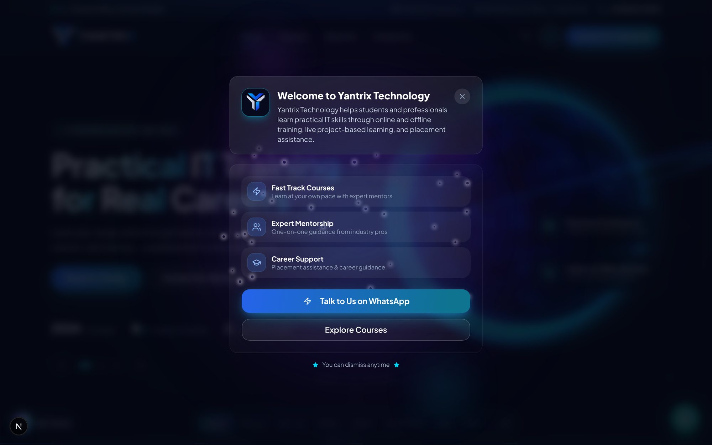
Home page kholte hi aane wala welcome popup
Website pehli baar kholte hi ek welcome popup dikhta hai. Isme institute ka introduction, teen highlight cards (Fast Track Courses, Expert Mentorship, Career Support), WhatsApp button aur "Explore Courses" button hota hai.
- Popup band karne ke liye upar dayiñ taraf X (cross) button dabayein.
- "Talk to Us on WhatsApp" — seedha WhatsApp chat khul jaati hai.
- "Explore Courses" — courses page par le jaata hai.
- Ek baar band karne ke baad us visit mein popup dobara nahi aata.

1.2 Home page — hero (main banner)
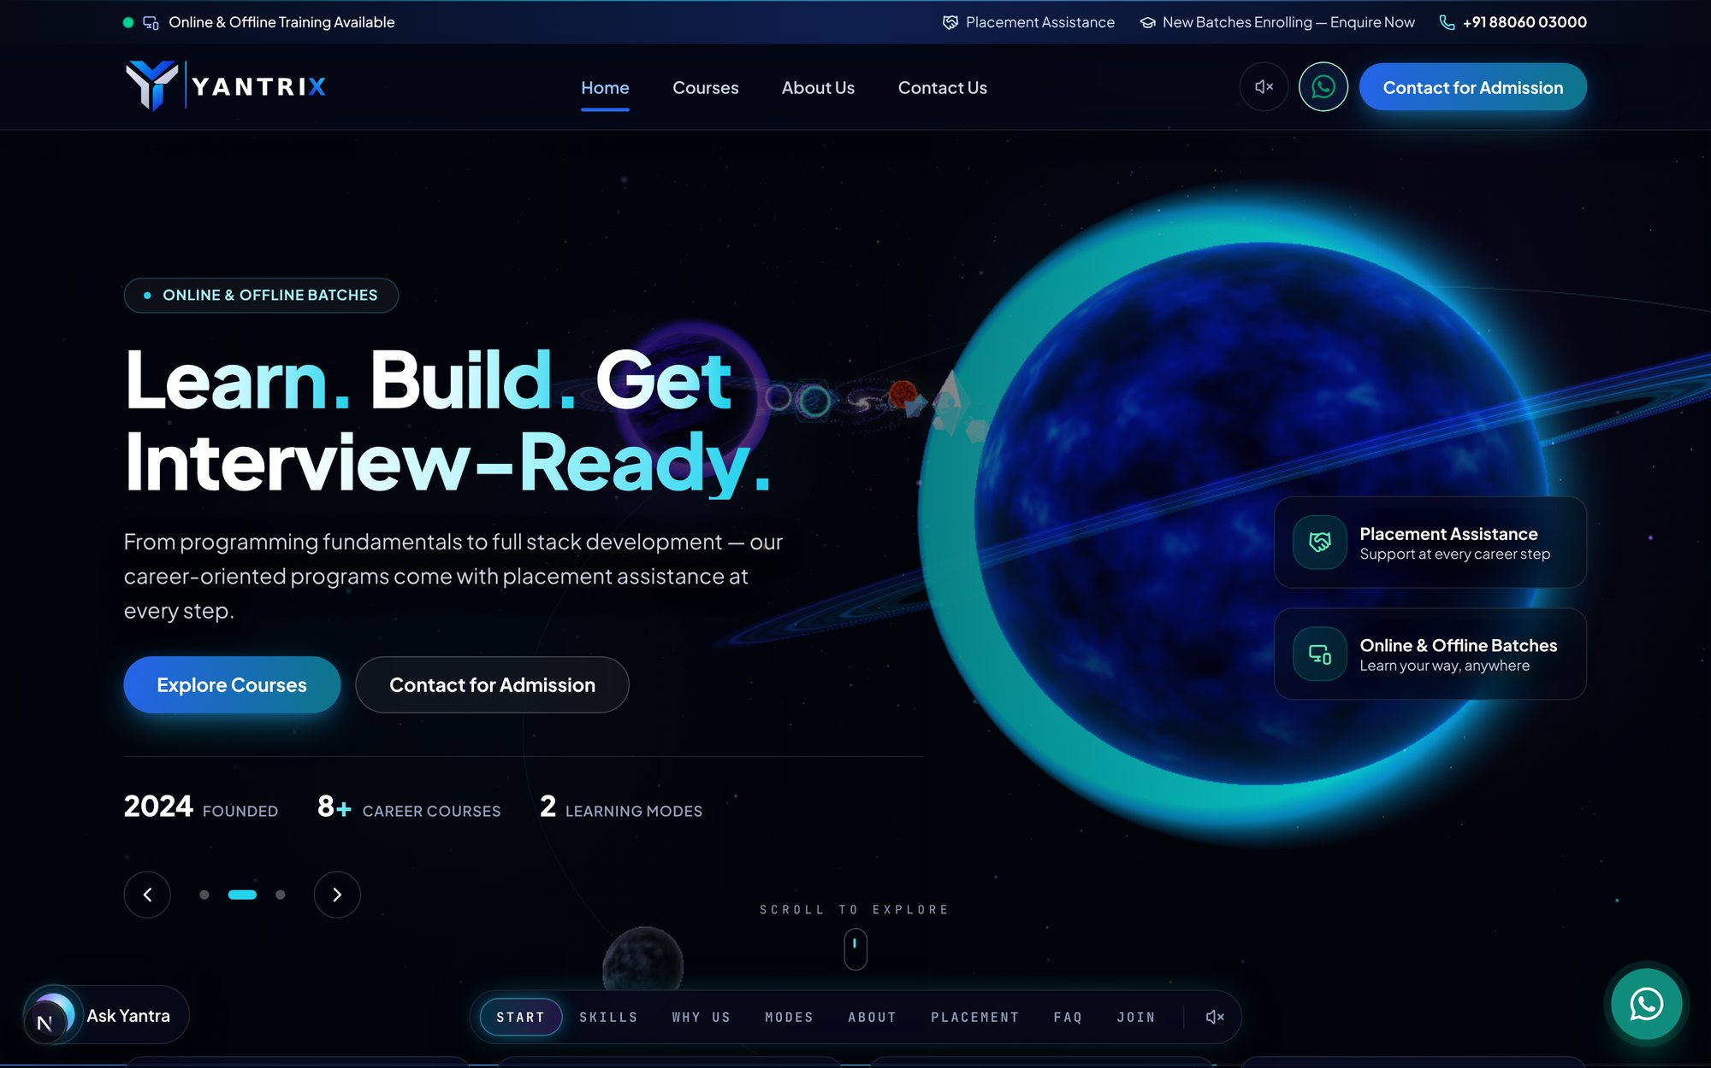
Home page ka hero banner, upar navigation ke saath
Sabse upar ek patli top-bar (batch/phone info), phir header mein logo + menu: Home, Courses, About Us, Contact Us, saath mein sound button, WhatsApp button aur "Contact for Admission" button. Beech mein bada hero slider hai jo admin panel ke Hero slides panel se control hota hai.
- Header ka koi bhi menu item click karke page badlein.
- Hero slider apne aap badalta rehta hai; slides admin → Hero slides se edit hoti hain.
- Neeche dayiñ taraf gol WhatsApp button har page par tairta rehta hai.
- Neeche bayiñ taraf "Ask Yantra" chat guide ka button hai (agla section dekhein).

1.3 Home page ke baaki sections (upar se neeche)
Hero ke neeche home page par ye sections aate hain. In sab ke heading/text admin → Page sections panel se badle ja sakte hain.
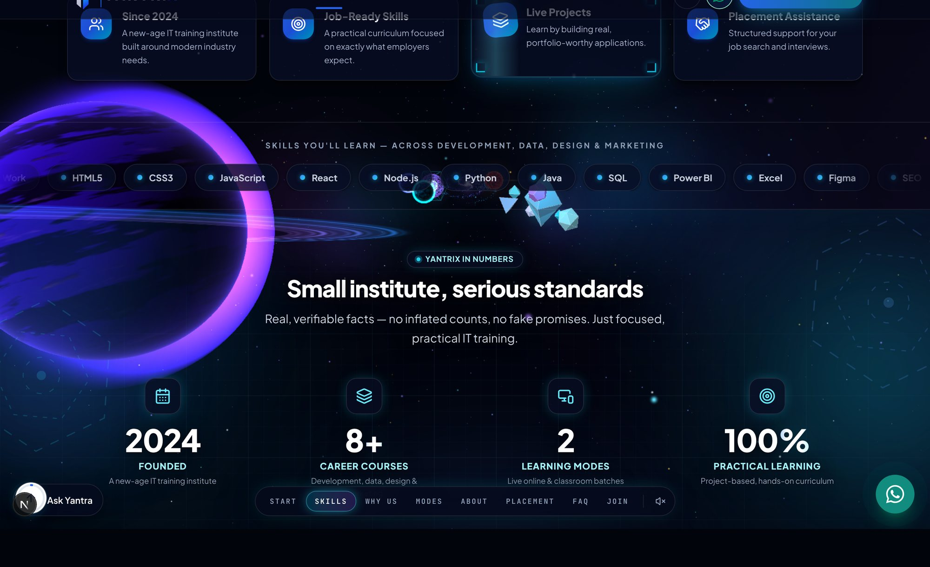
Section: courses ka preview ("Build Skills That Employers Look For")
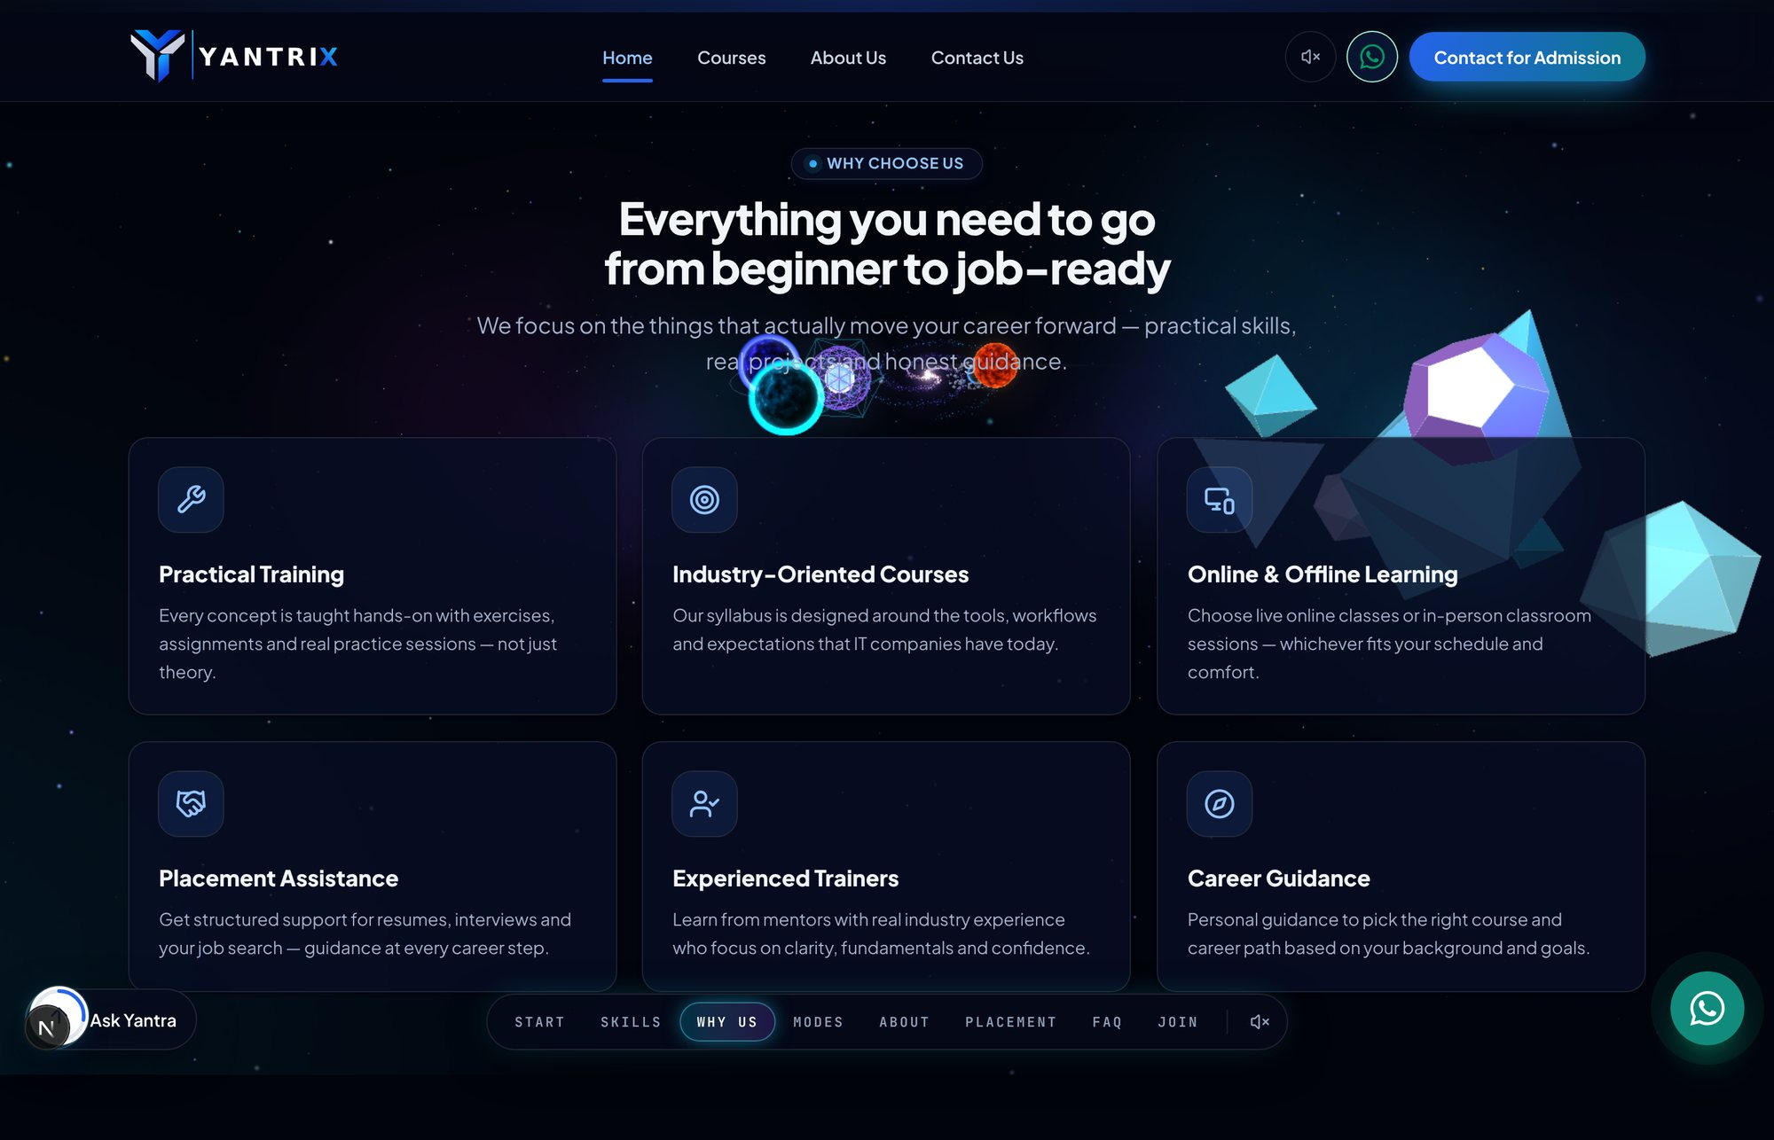
Section: "Small institute, serious standards" — stats ke saath
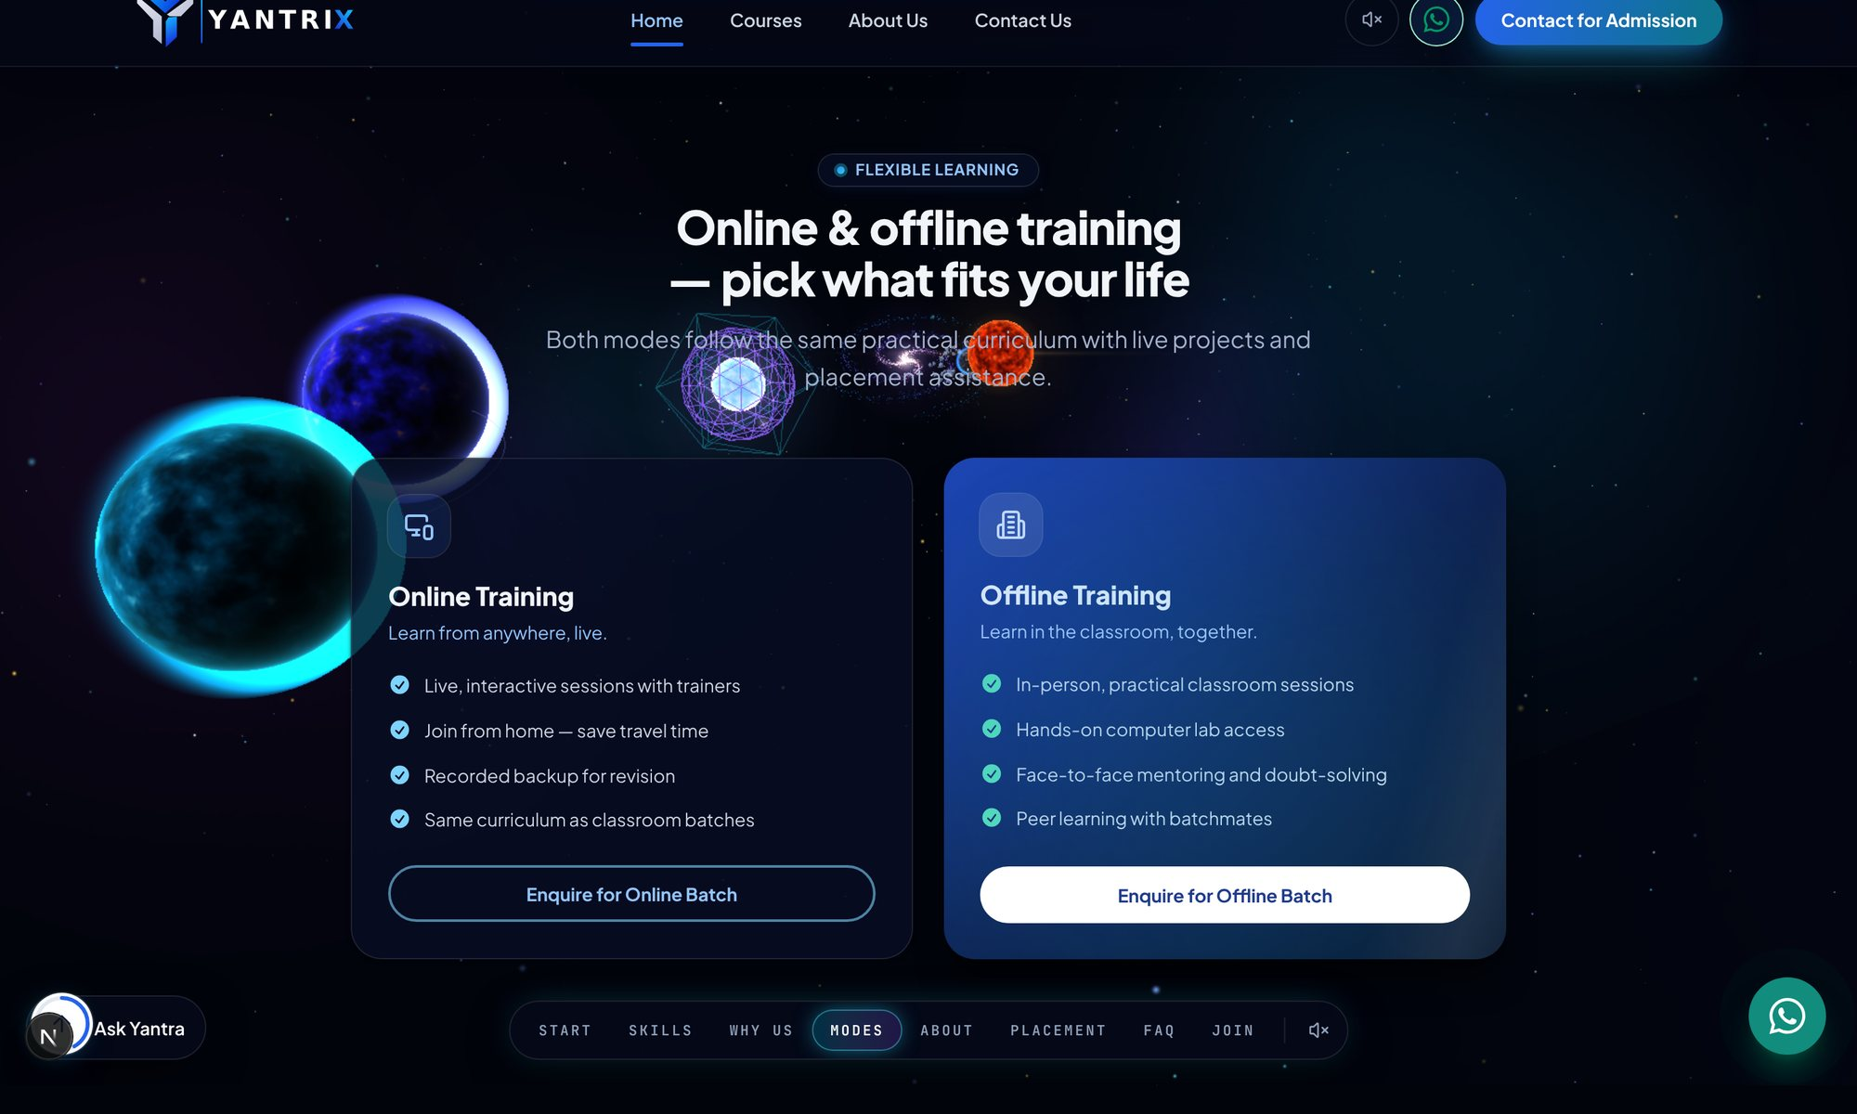
Section: training modes — Online / Offline batches
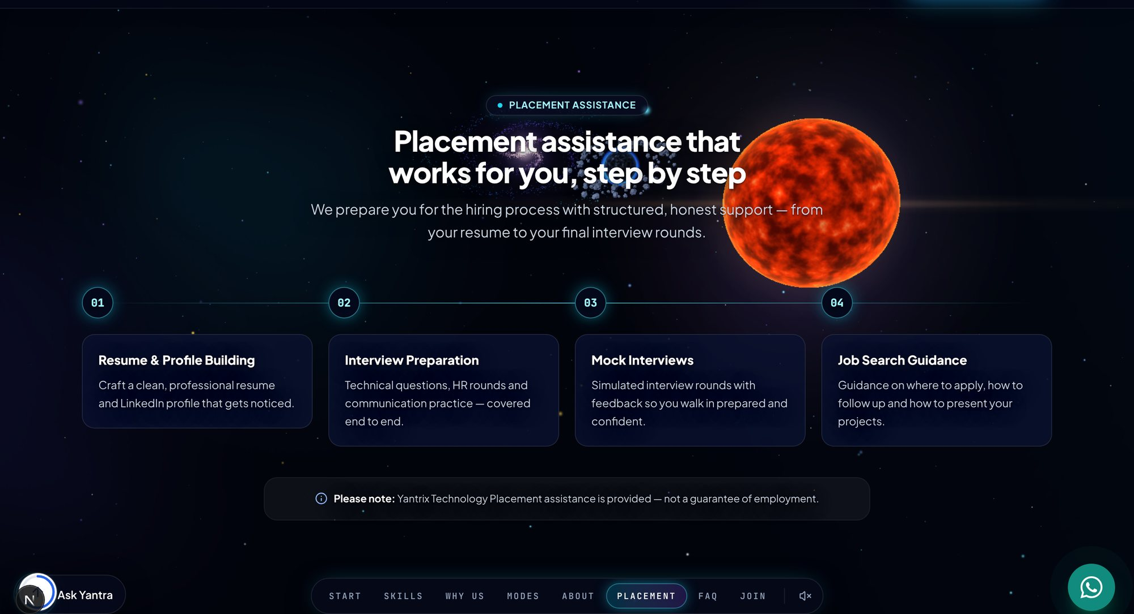
Section: placement assistance ke steps
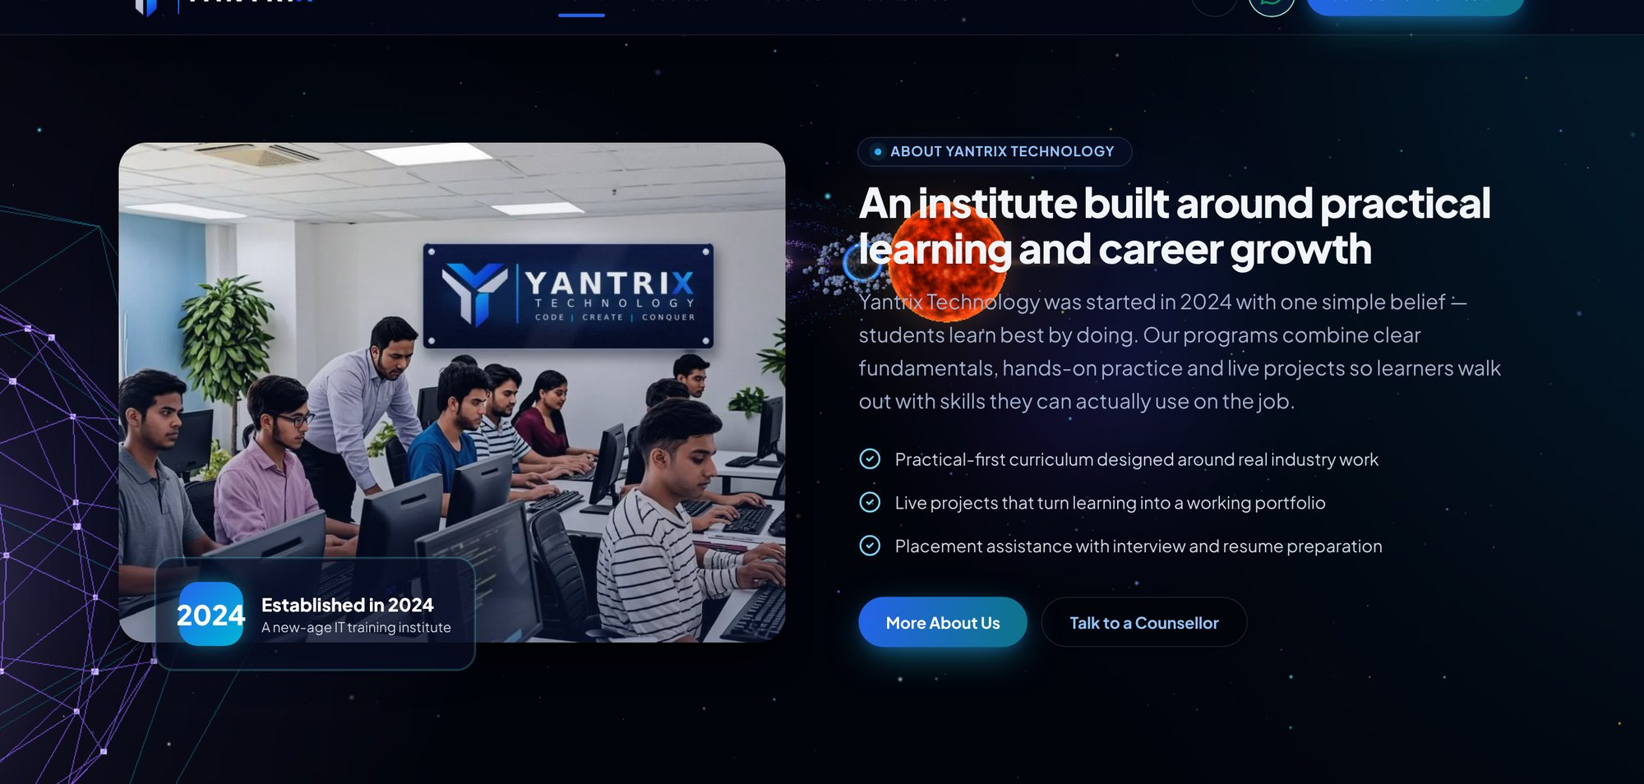
Section: institute ke baare mein (photo ke saath)
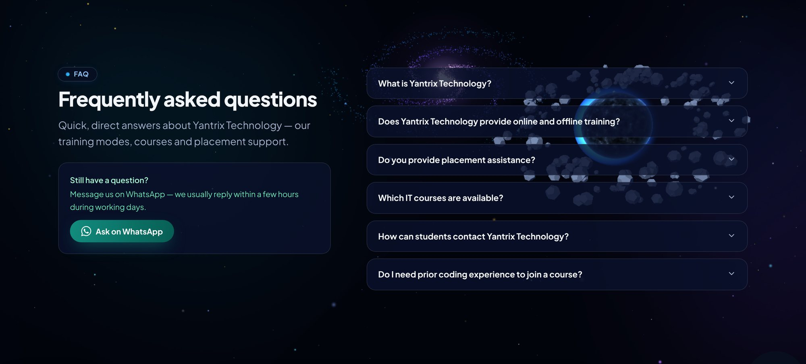
Section: Frequently asked questions (accordion)
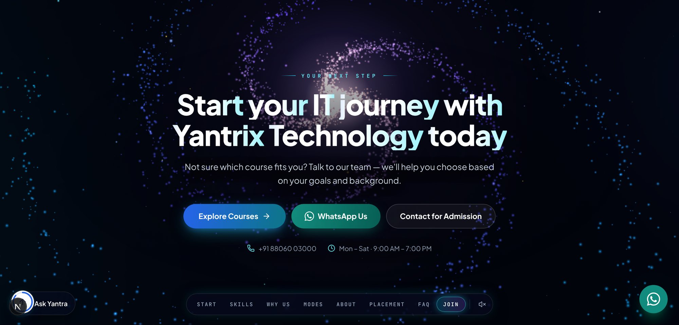
Section: aakhri call-to-action — "Start your IT journey…"
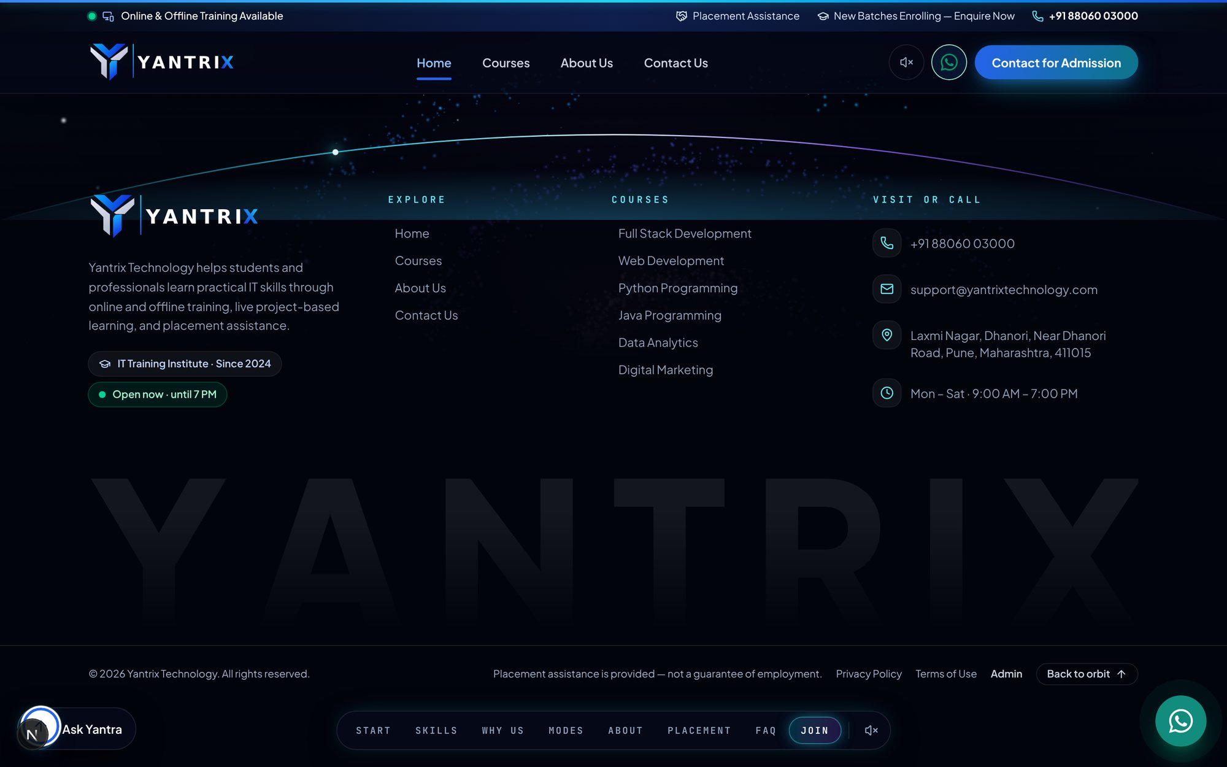
Footer — links, contact details aur legal pages
- FAQ section mein kisi bhi sawaal par click karein — jawaab khul jaata hai (accordion).
- Footer mein Courses, Institute, Support ke links, address, phone aur social icons hote hain.
- Footer ke sabse neeche Privacy Policy aur Terms of Service ke links hain.

1.4 "Ask Yantra" — website ka apna guide chat
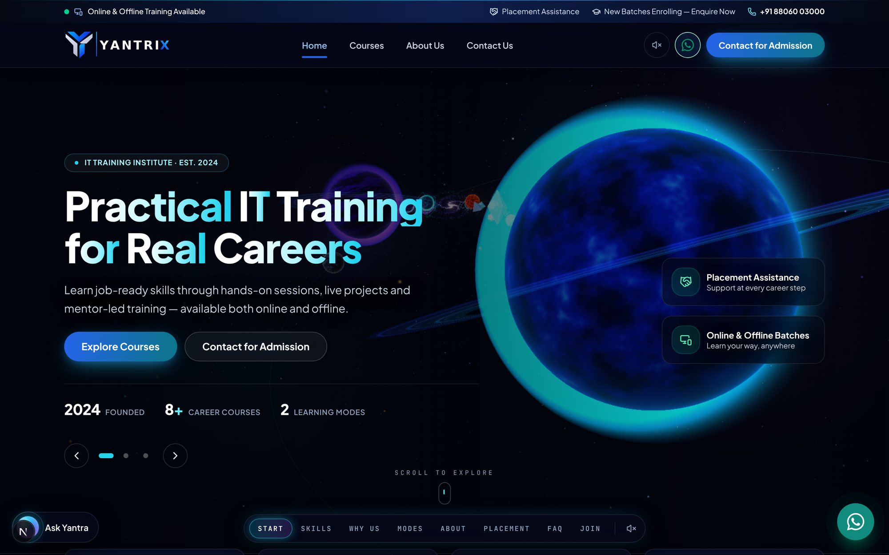
Ask Yantra chat guide — sawaal poochhiye, jawaab website ke content se milta hai
Step 1: Kisi bhi page par bayiñ taraf neeche "Ask Yantra" gol button dabayein.
Step 2: Chat khulti hai — niche input box mein sawaal likhein (jaise "What are the fees for python?").
Step 3: Enter dabayein; jawaab website ke apne courses/FAQs se milta hai (koi AI key nahi lagti).
Step 4: Jo jawaab nahi mil pata wo WhatsApp par bhej diya jaata hai.

1.5 Courses page
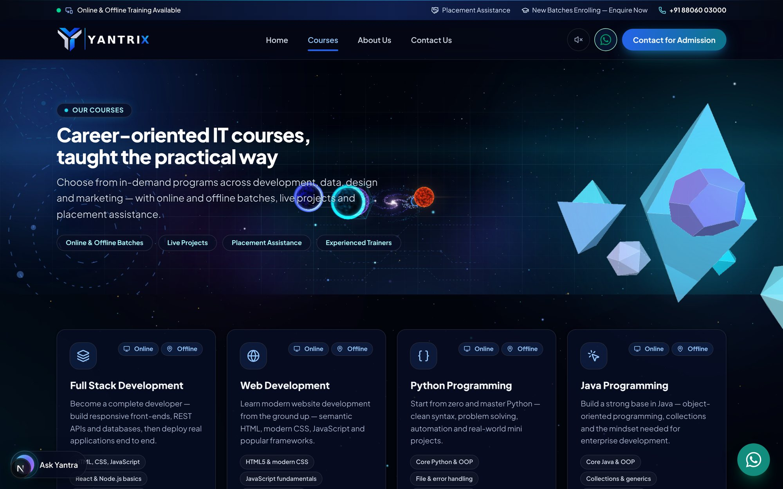
Courses page — hero aur course cards ki shuruaat
Courses page par saari courses cards mein dikhti hain. Har card par: course ka icon, Online/Offline badges, naam, chhota description, syllabus chips aur "Enquire" button hota hai.
- Kisi card ka "Enquire" button dabane par contact/enquiry form tak pahunchte hain.
- Card par click karke us course ka detail page khulta hai.
- Ye poori list admin → Courses panel se control hoti hai (add/edit/hide/delete).

1.6 Course detail page
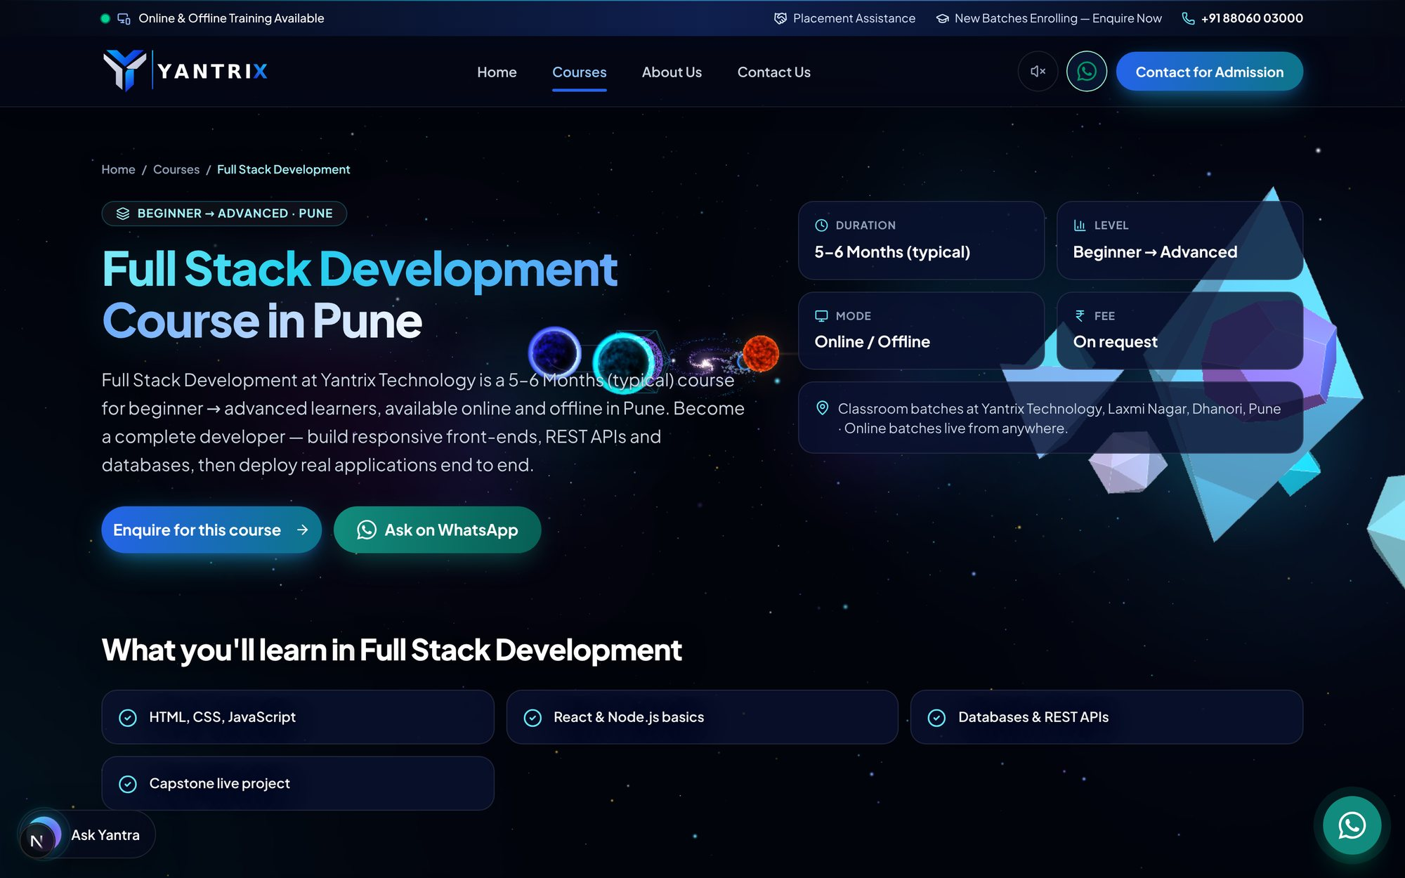
Course detail page — ek course ki poori jaankari
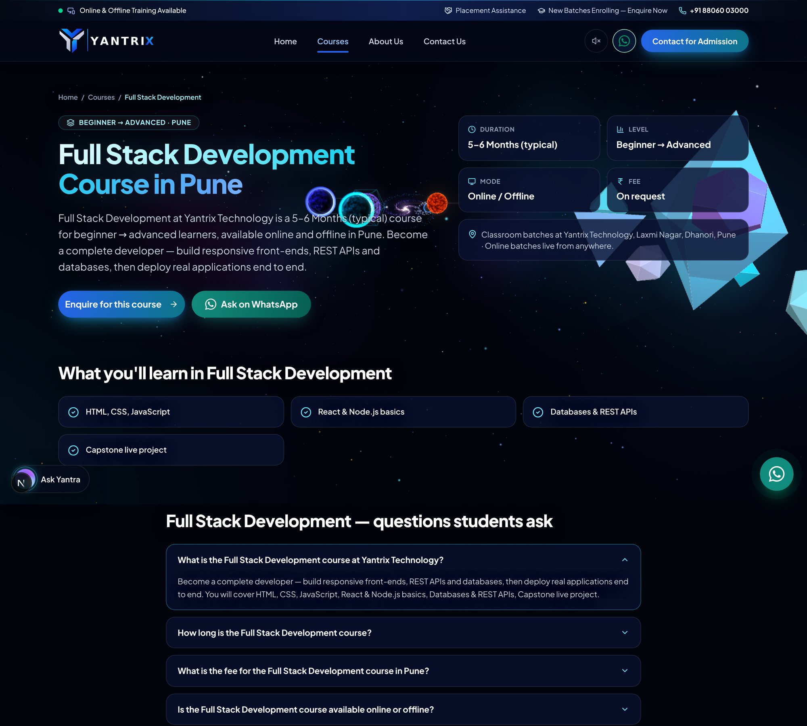
Course detail page poora (neeche scroll karte jaiye) — hissa 1/3
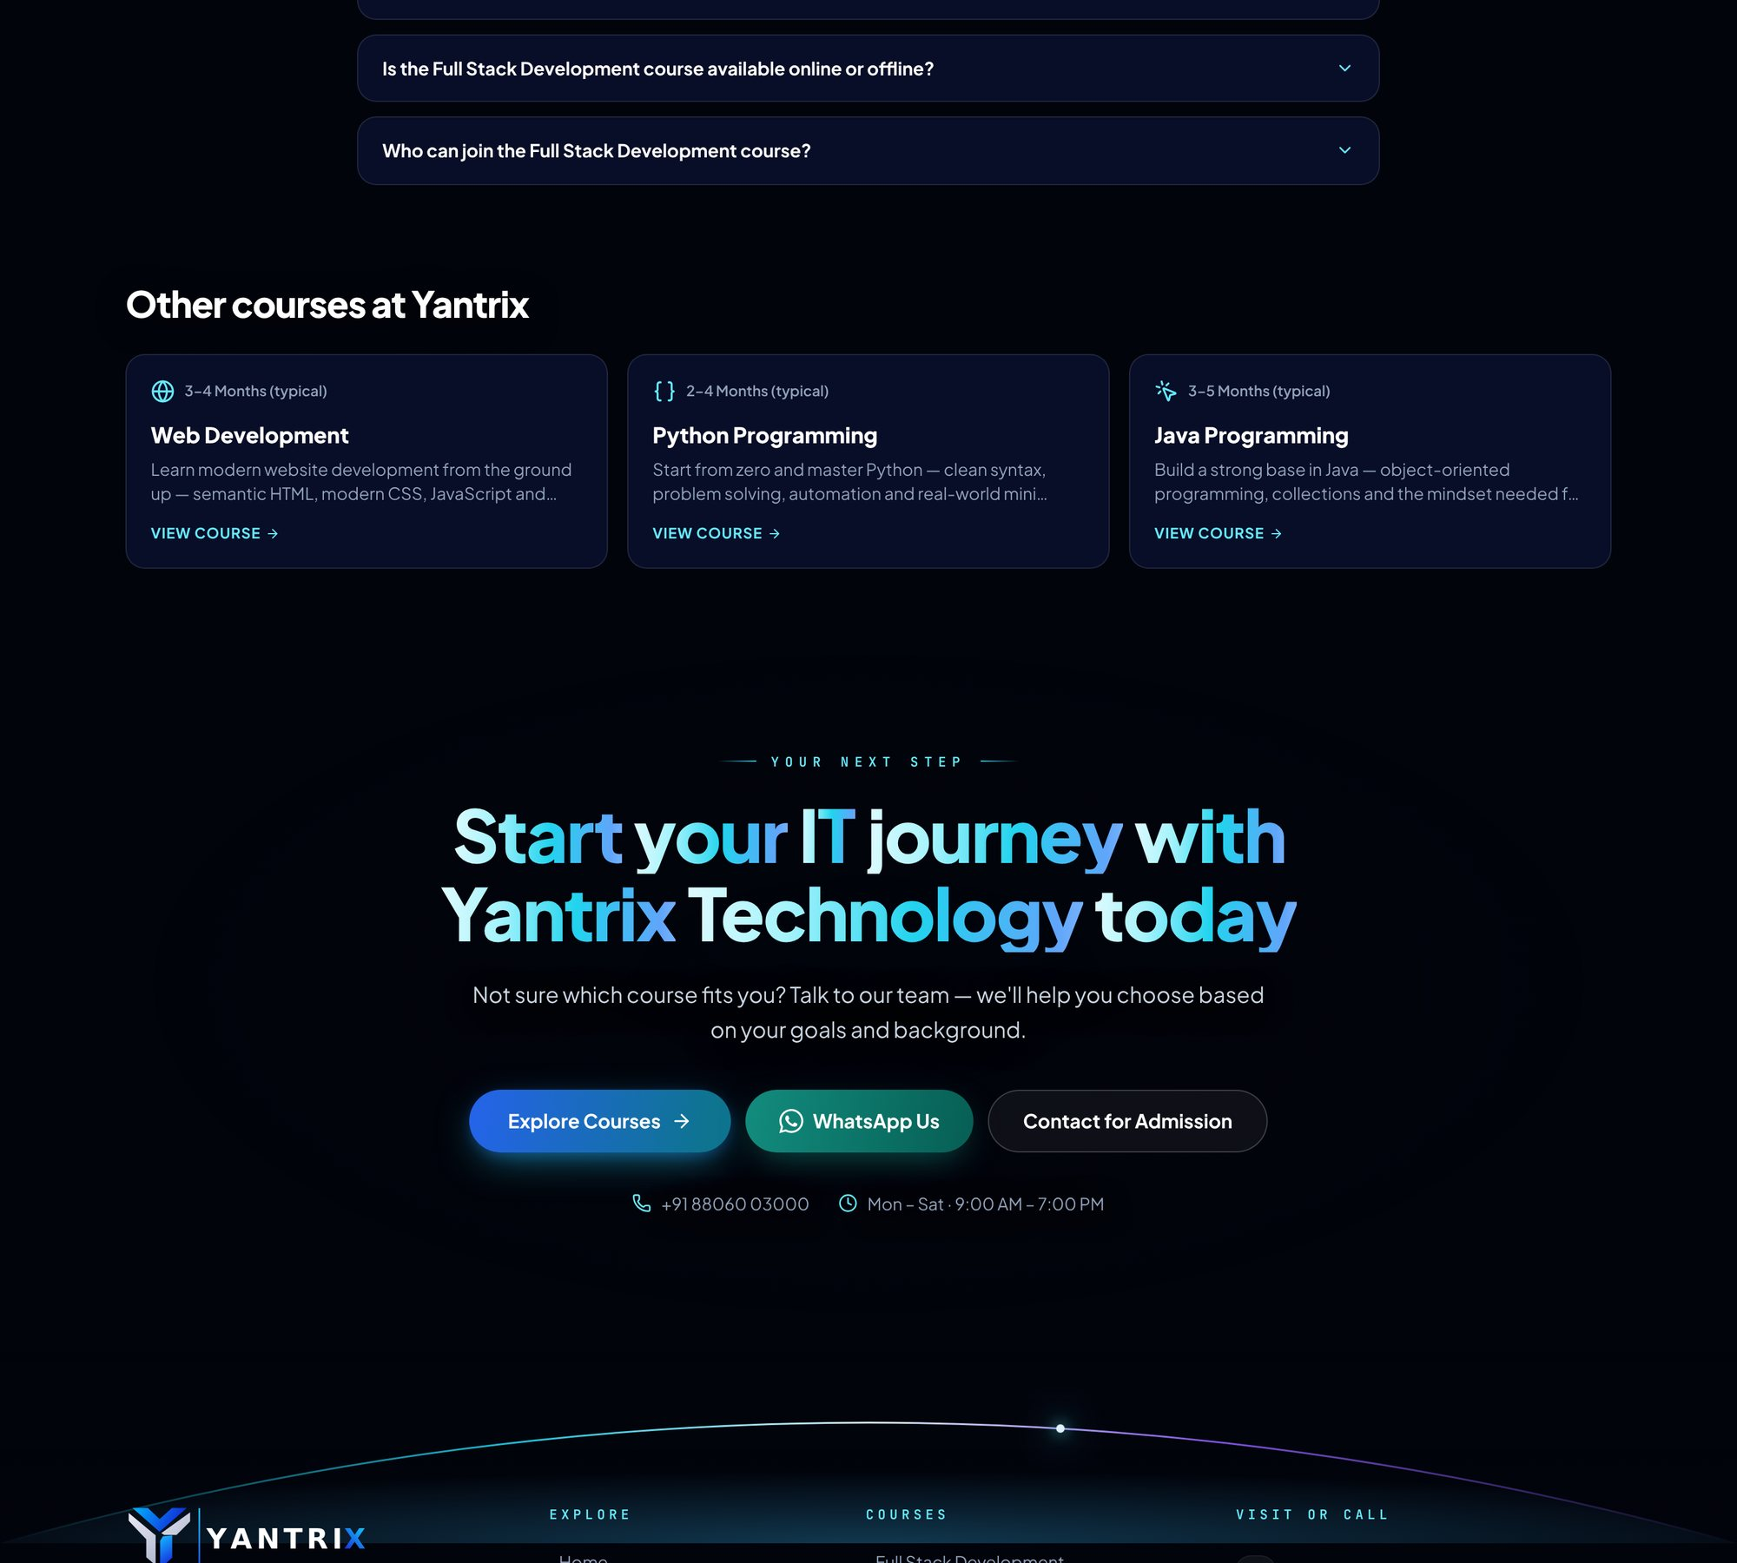
Course detail page poora (neeche scroll karte jaiye) — hissa 2/3
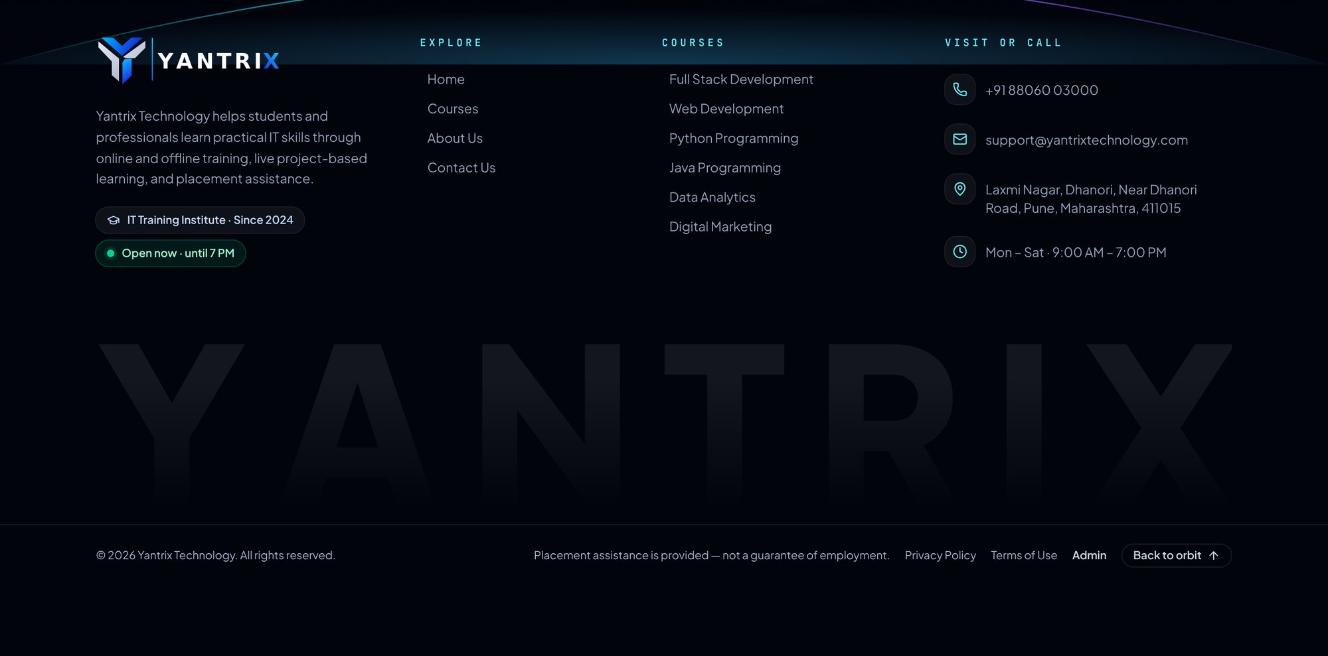
Course detail page poora (neeche scroll karte jaiye) — hissa 3/3
Detail page par course ka description, duration, fees, level, syllabus, FAQs aur related courses dikhte hain. Ye page admin → Courses panel mein us course ko edit karne par badalta hai.

1.7 About page
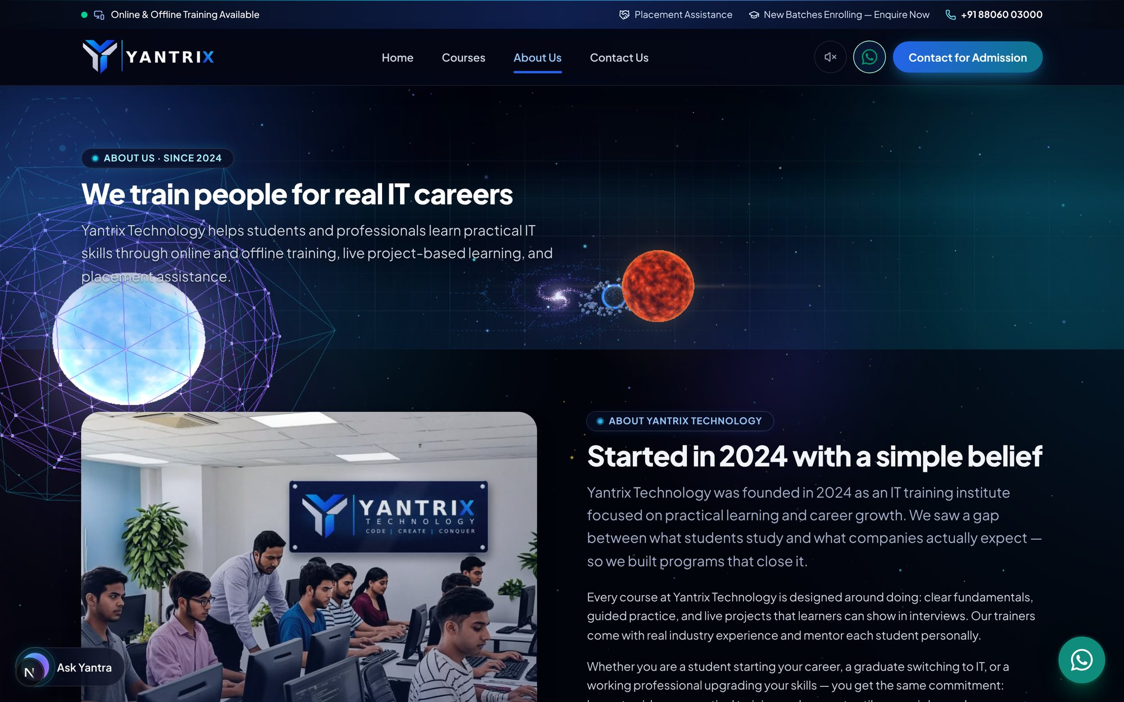
About page ka upari hissa
About page institute ki kahani, values aur team dikhata hai. Iska text admin → Pages & navigation panel ke "about" hisse se edit hota hai.

1.8 Contact page aur enquiry form (sabse zaroori page)
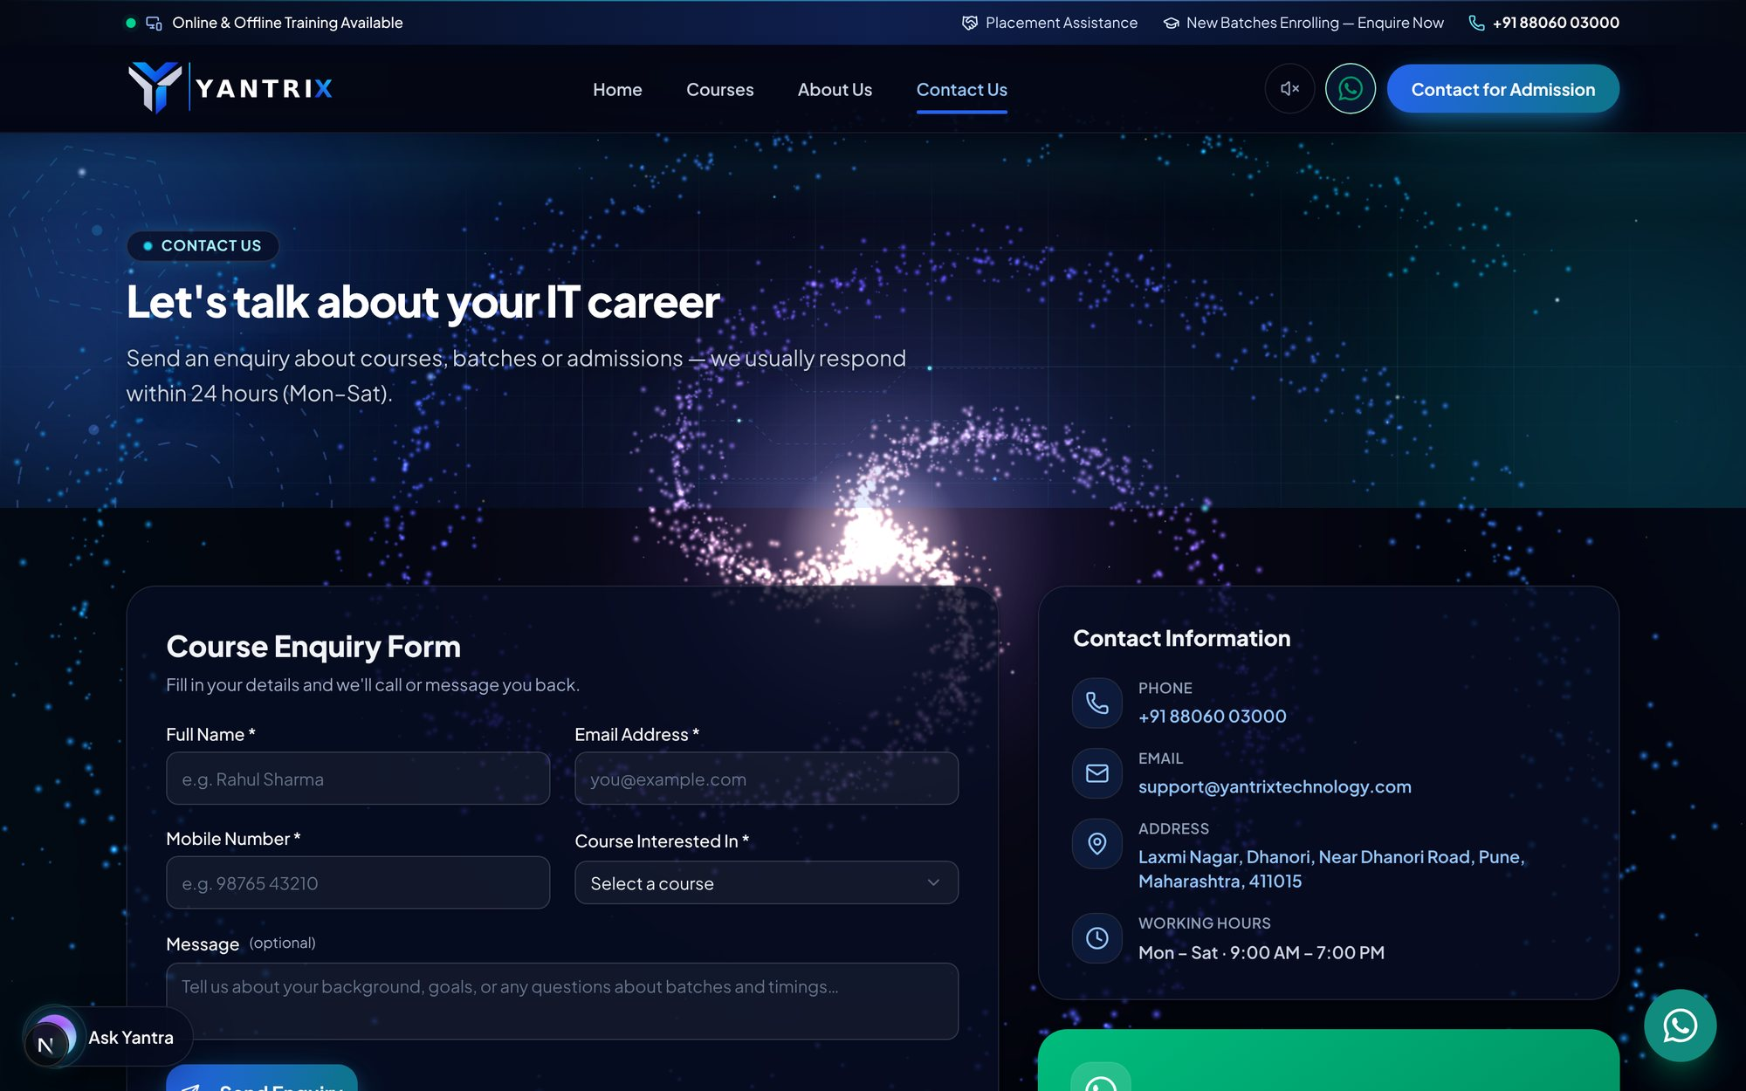
Contact page — form aur contact details
Students yahan se enquiry bhejte hain. Har enquiry seedha admin panel ke Enquiries panel mein pahunchti hai.
Step 1: Name, Email, Mobile bharein.
Step 2: Course dropdown mein se course chunein.
Step 3: Message box mein apna sawaal likhein.
Step 4: "Send enquiry" (submit) button dabayein.
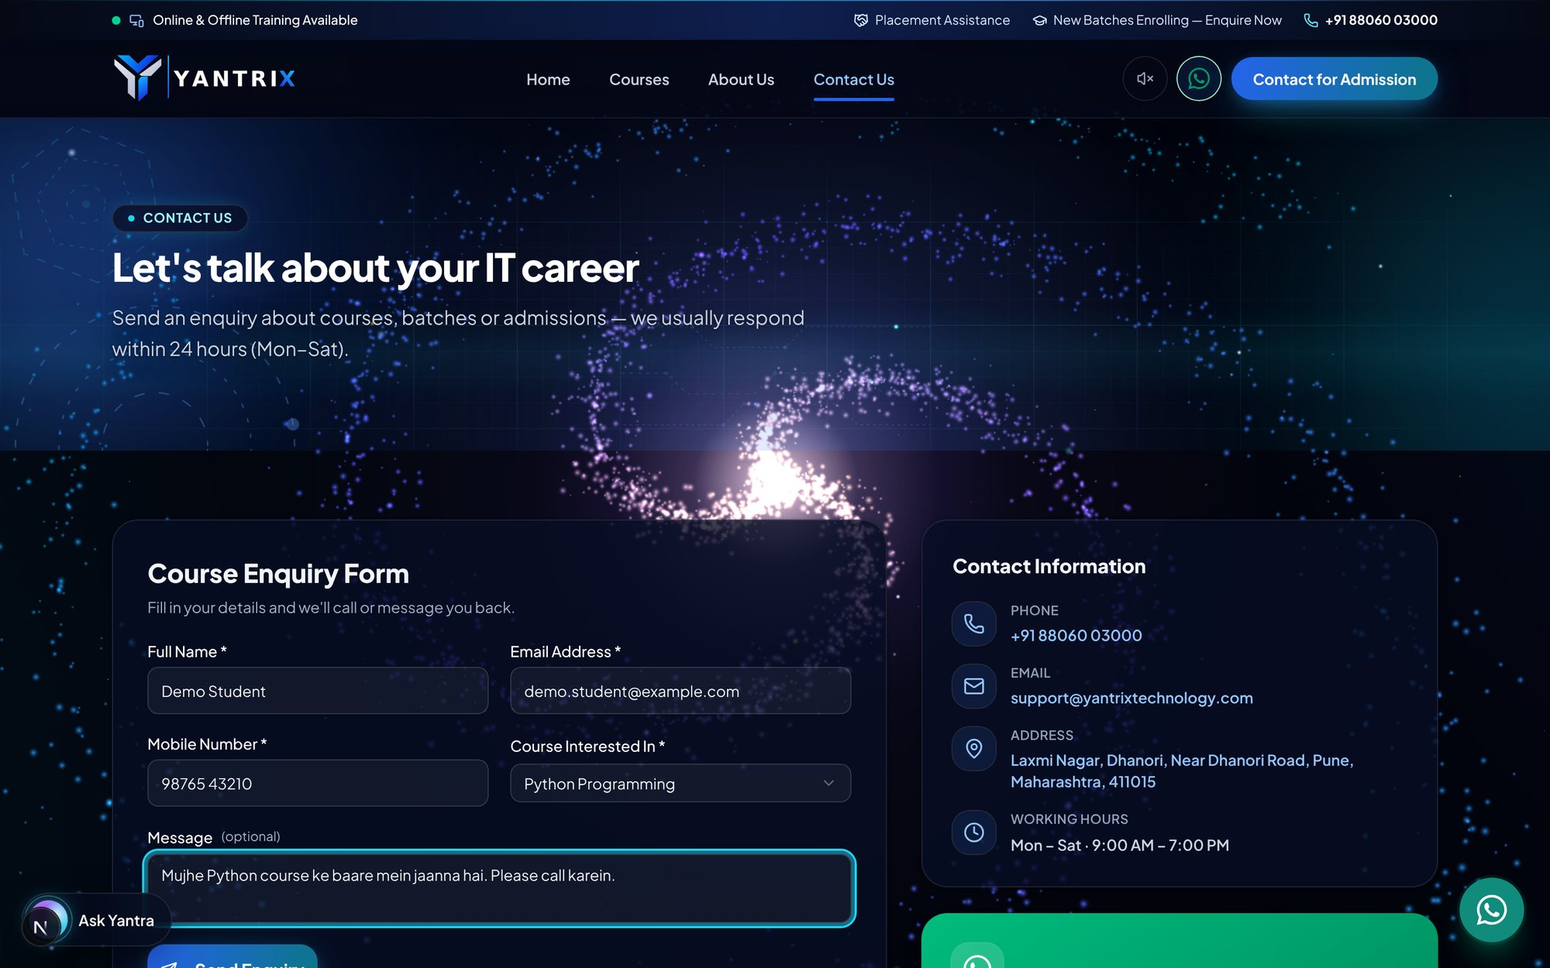
Form bhara hua — submit karne se pehle
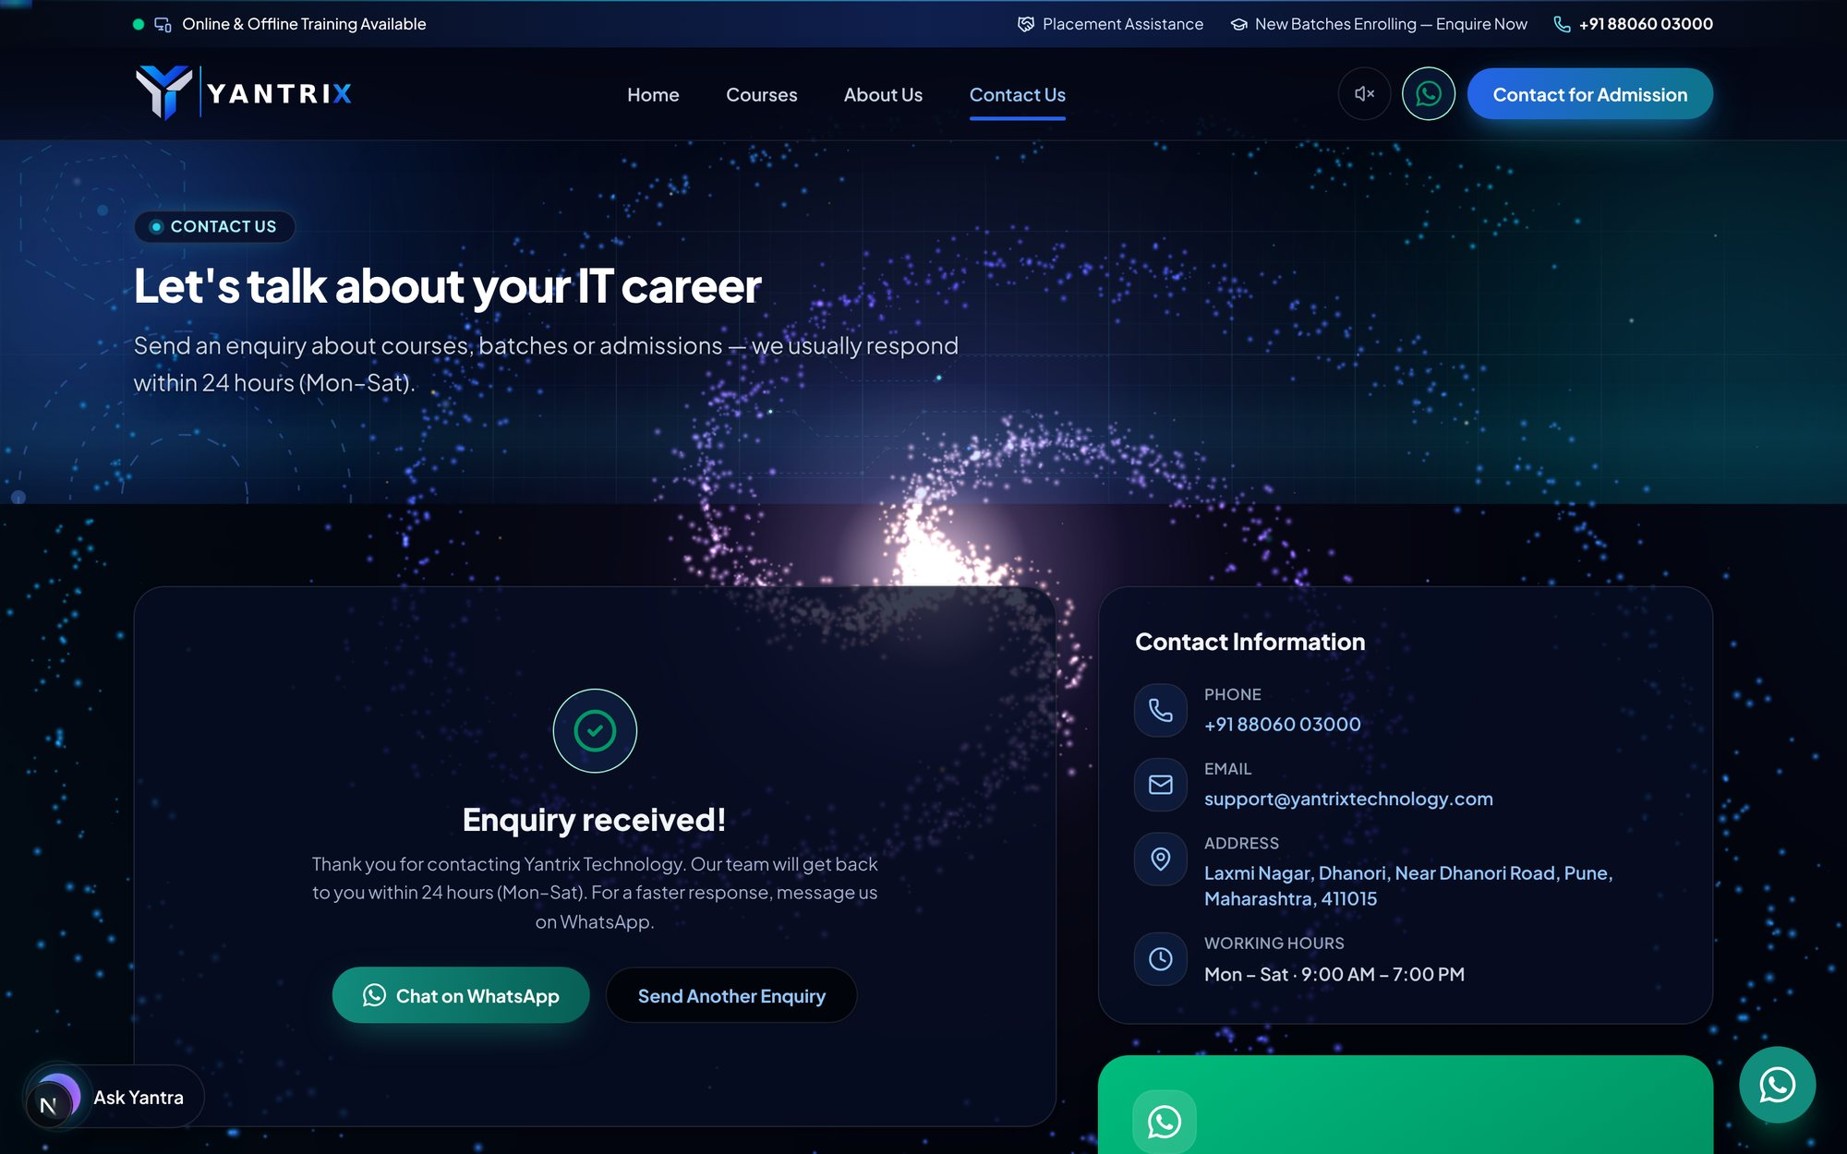
Submit karne ke baad confirmation message
💡 Tip: Enquiry bhejne ke baad admin panel → Enquiries mein wo turant "New" status ke saath dikhti hai (Hissa 3.9 dekhein).

1.9 Privacy Policy aur Terms of Service
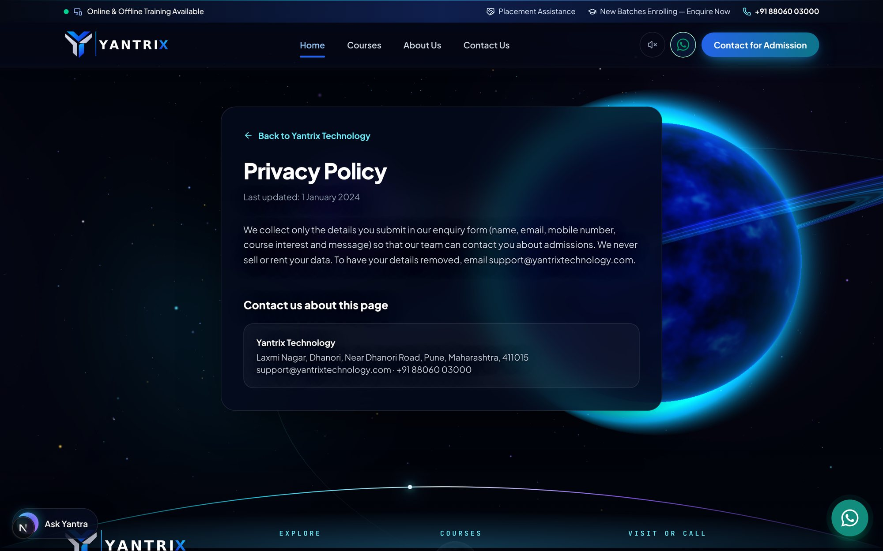
Privacy Policy page
Footer ke links se Privacy Policy aur Terms of Service khulte hain. Inka legal text admin → Site settings panel mein hai.

1.10 Mobile par website
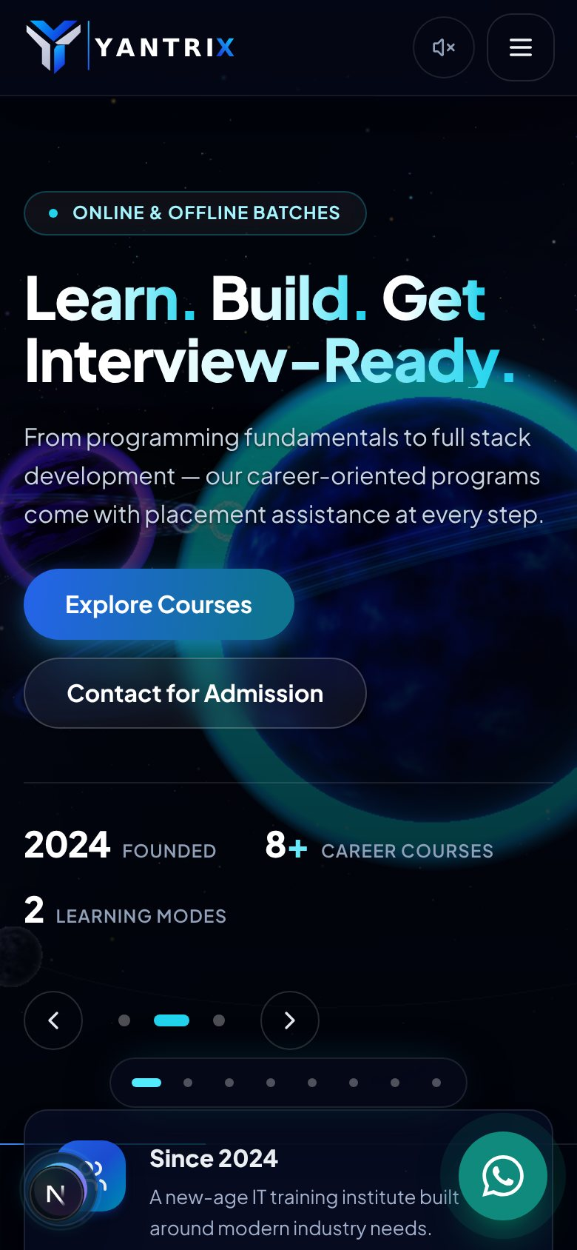
Mobile view — home page
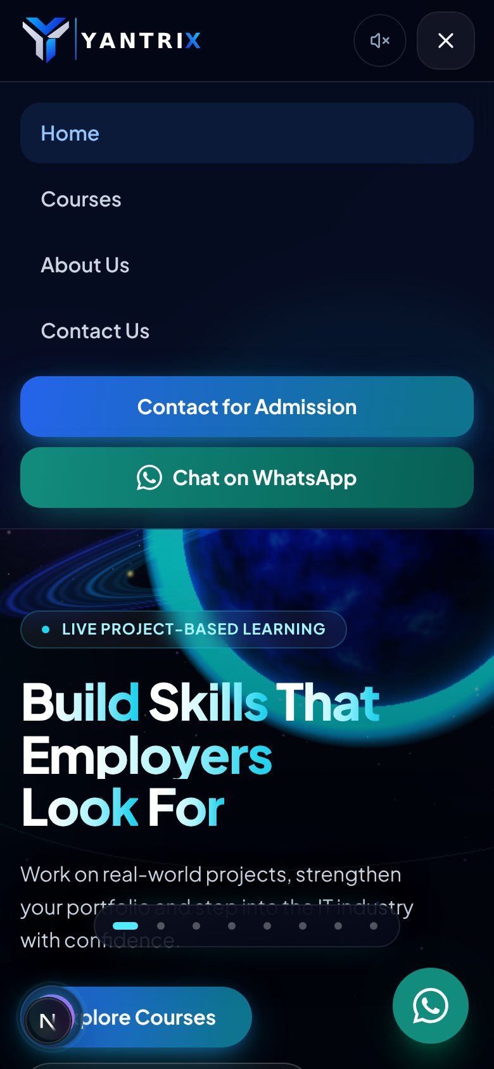
Mobile view — hamburger menu khula hua
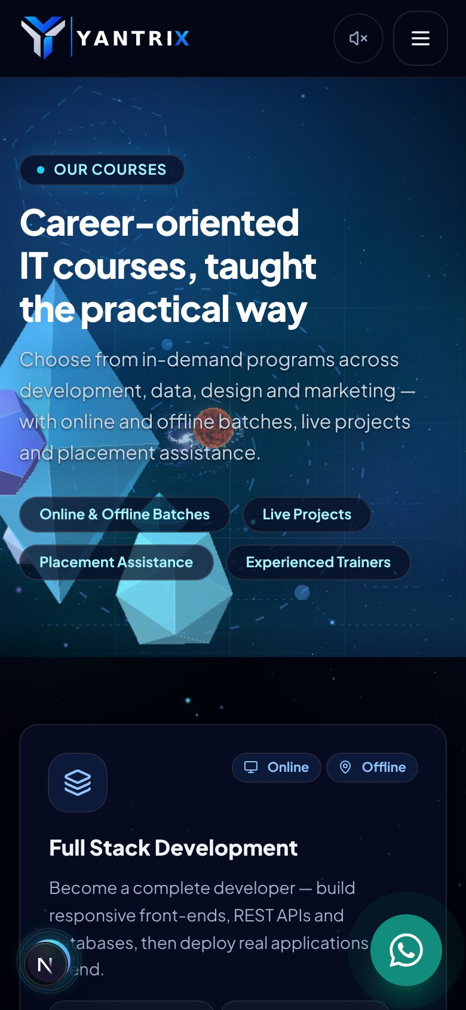
Mobile view — courses page
- Mobile par header mein hamburger (three-line) button hota hai — usse poora menu khulta hai.
- Saare sections mobile par neeche-end stack hote hain; scroll karke padhein.
- WhatsApp aur Ask Yantra ke buttons mobile par bhi dikhte hain.

Hissa 2 — Admin panel mein login karna

2.1 Step 1 — email aur password
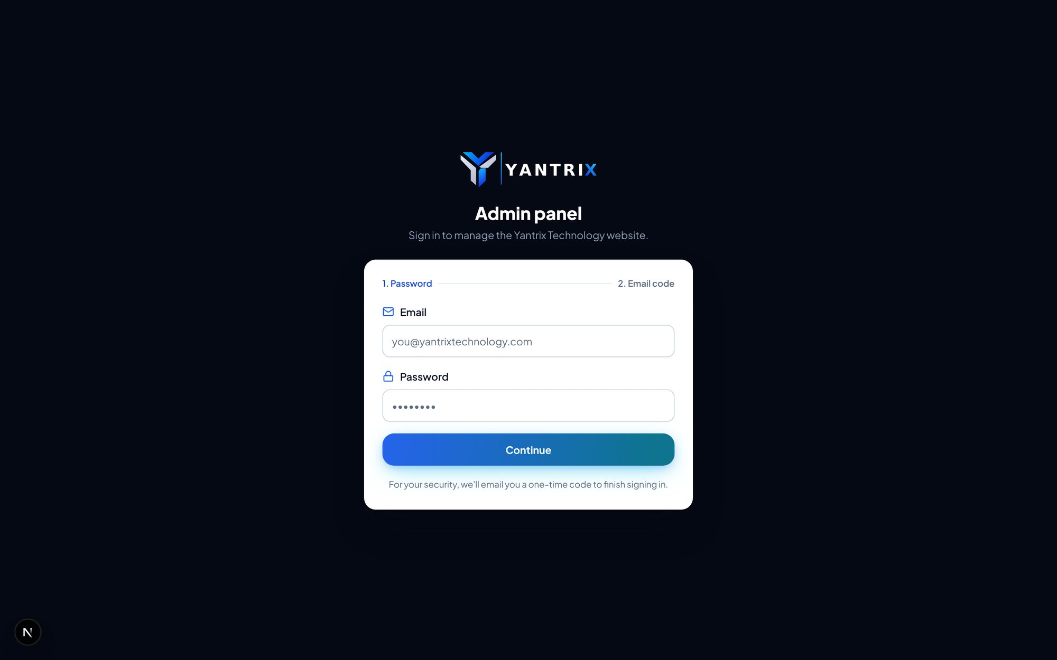
Admin login — pehla step: email + password
Step 1: Browser mein http://localhost:3000/admin kholein — login page khulta hai.
Step 2: Apna email aur password daalein (development mein: admin@yantrixtechnology.com / Yantrix@2024).
Step 3: "Continue" / submit button dabayein.
Password sahi hone par session turant nahi banta — security ke liye doosra step hota hai: 6-digit code.

2.2 Step 2 — 6-digit one-time code (OTP)
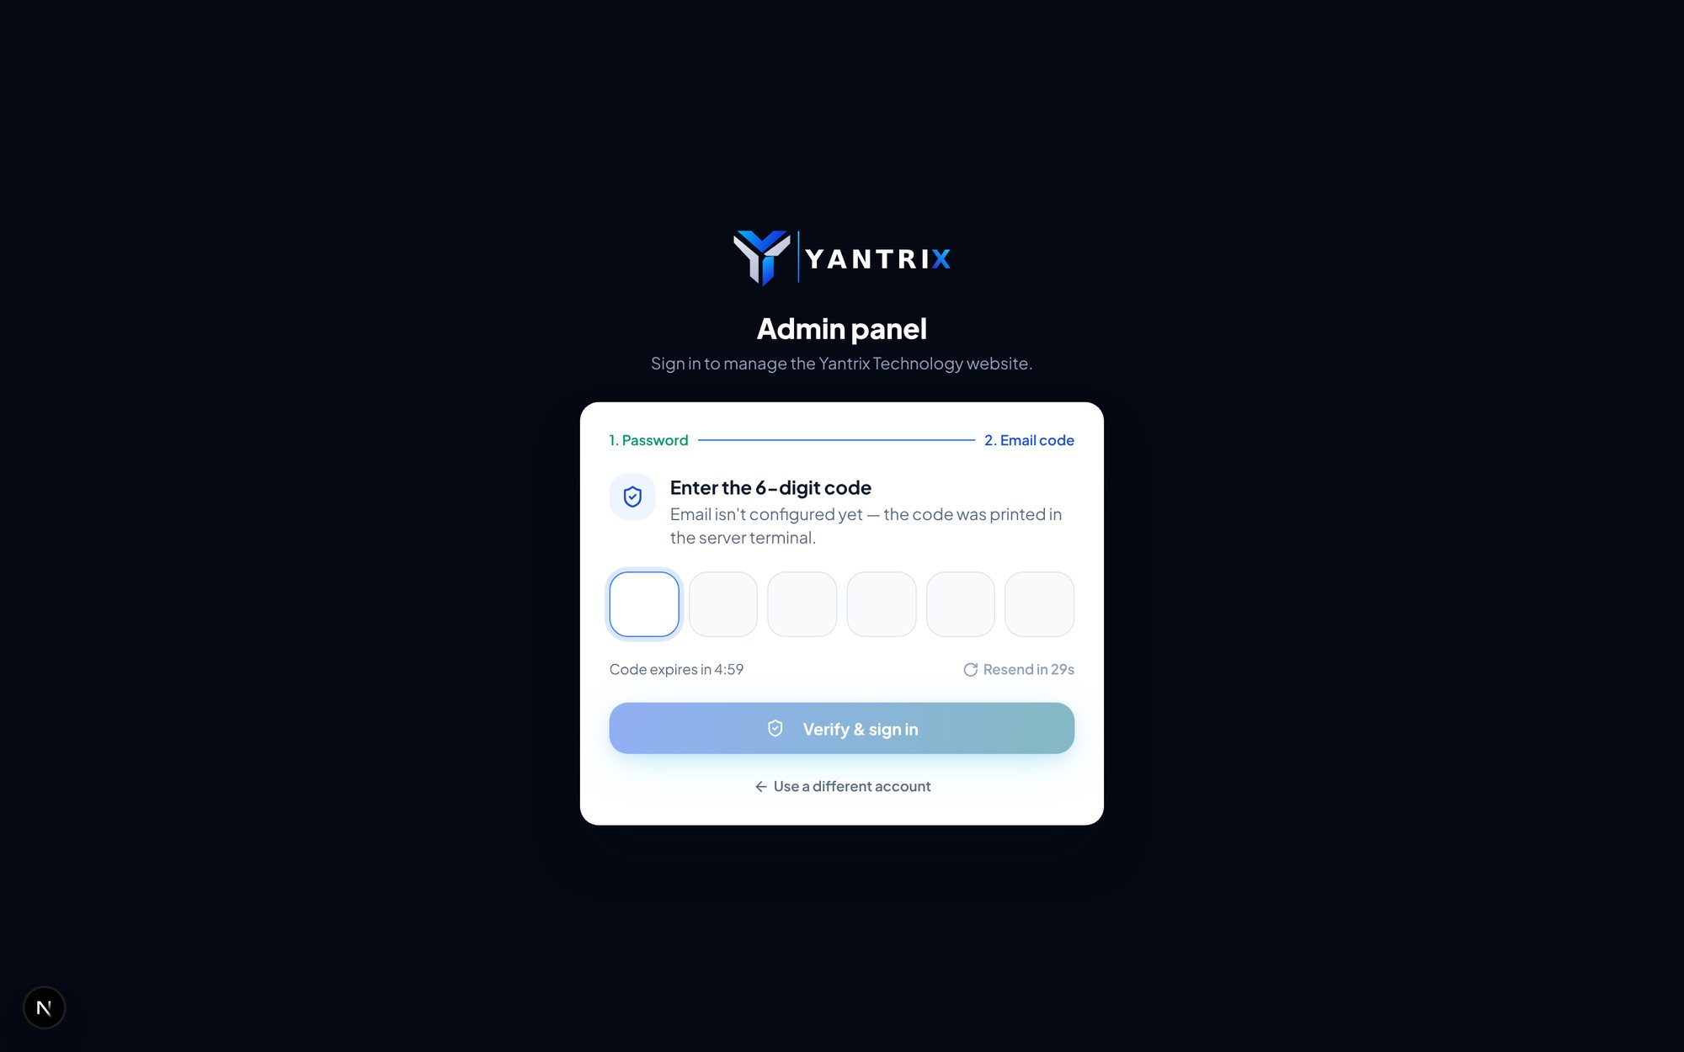
Login ka doosra step: 6-digit code bharne ki screen
- Code aapke email par bheja jaata hai (production mein). Development mein SMTP nahi hota isliye code server ke terminal mein print hota hai.
- Chhah khane (boxes) mein code bharie — 6th digit bharne par ya "Verify & sign in" dabane par login poora hota hai.
- Code 5 minute mein expire ho jaata hai; "Resend code" se naya code milta hai (30 second rukna padta hai).
- Galat code 3 baar daalne par step 1 par lautna padta hai.
⚠️ Dhyan rakhein: Galat password baar-baar daalne par 10 minute ke liye login block ho jaata hai (brute-force se bachaav).

2.3 Login ke baad — Dashboard
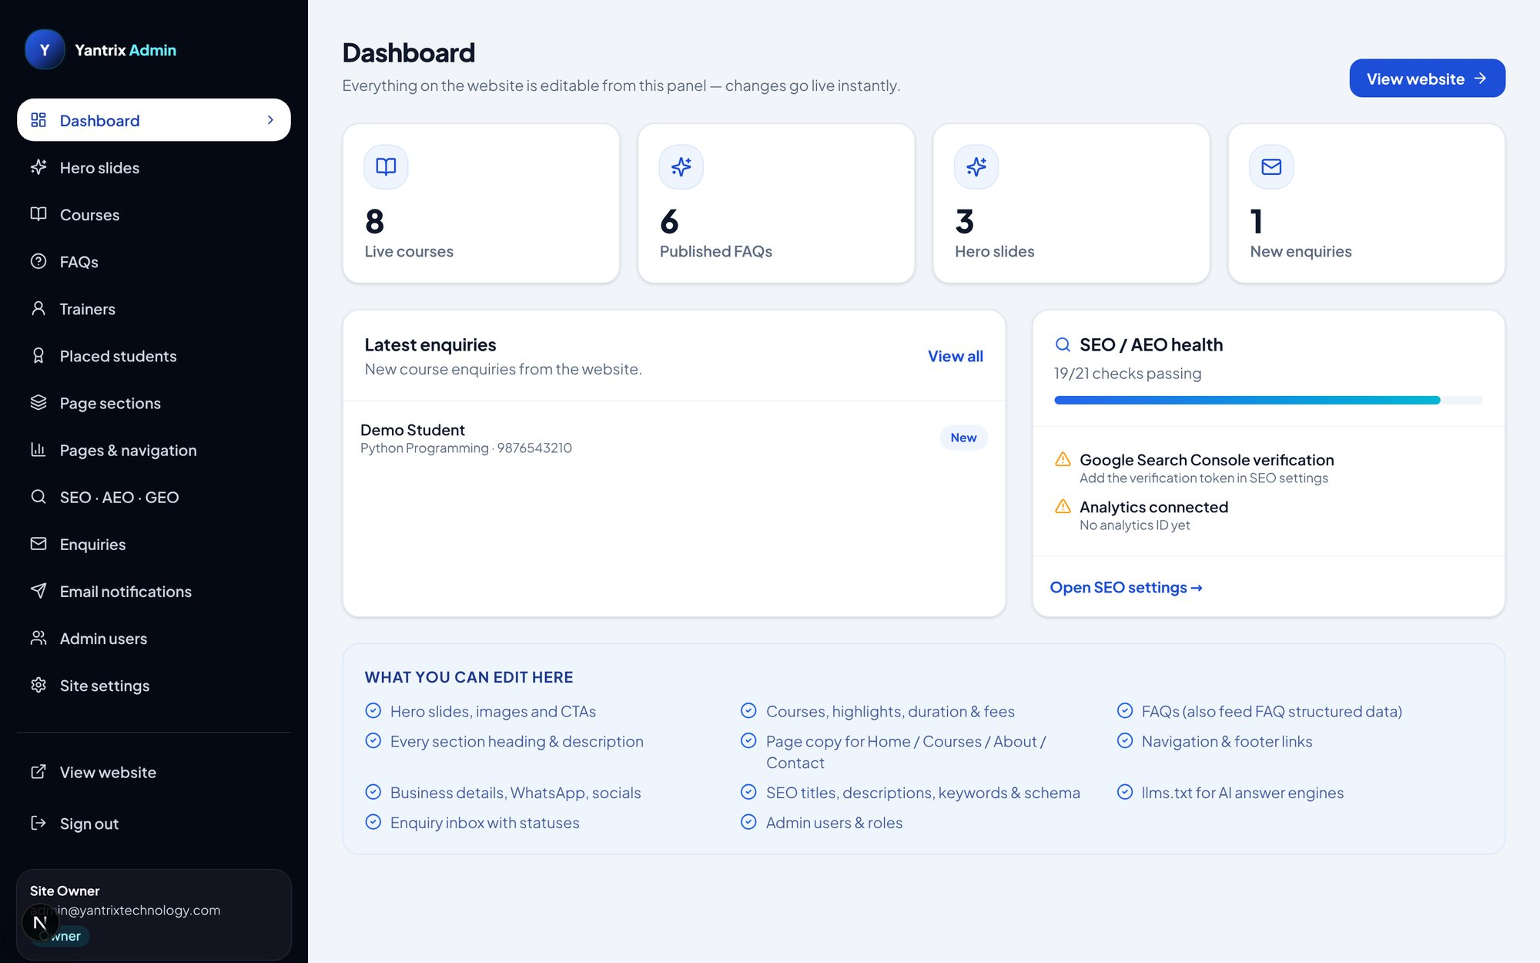
Admin dashboard — counters, latest enquiries aur SEO health
- Bayiñ taraf kaala sidebar har panel tak le jaata hai; sabse neeche "View website" aur "Sign out" hain.
- Upar ke cards: kitni courses live hain, kitni FAQs published hain, kitni hero slides, kitni nayi enquiries.
- "Latest enquiries" mein website se aayi taaza enquiries dikhti hain — naam par click karke detail khulti hai.
- Dayiñ taraf "SEO / AEO health" card checks dikhata hai (jaise Search Console verification, analytics).
- Sidebar mein jo panel viewer role mein chhup jaata hai wo editor/owner ko hi dikhta hai.

Hissa 3 — Admin panel ke saare panels (ek-ek karke)
Har panel ka apna screenshot aur neeche uske istemaal ke steps hain. Common baatein jo har panel par laagoo hain:
- List mein har item ke saath dayiñ taraf icons hote hain: ↑ ↓ (order badalna), 👁 (website par dikhayein/chhupayein), ✏️ (edit), 🗑 (delete).
- Edit karne par ek dialog (popup form) khulta hai; neeche "Save changes" dabate hi website par live ho jaata hai.
- Upar dayiñ neela button (jaise "Add course", "Add slide") naya item banata hai.
- Viewer role mein ye sab buttons chhupe hote hain.

3.1 Hero slides — home ka banner
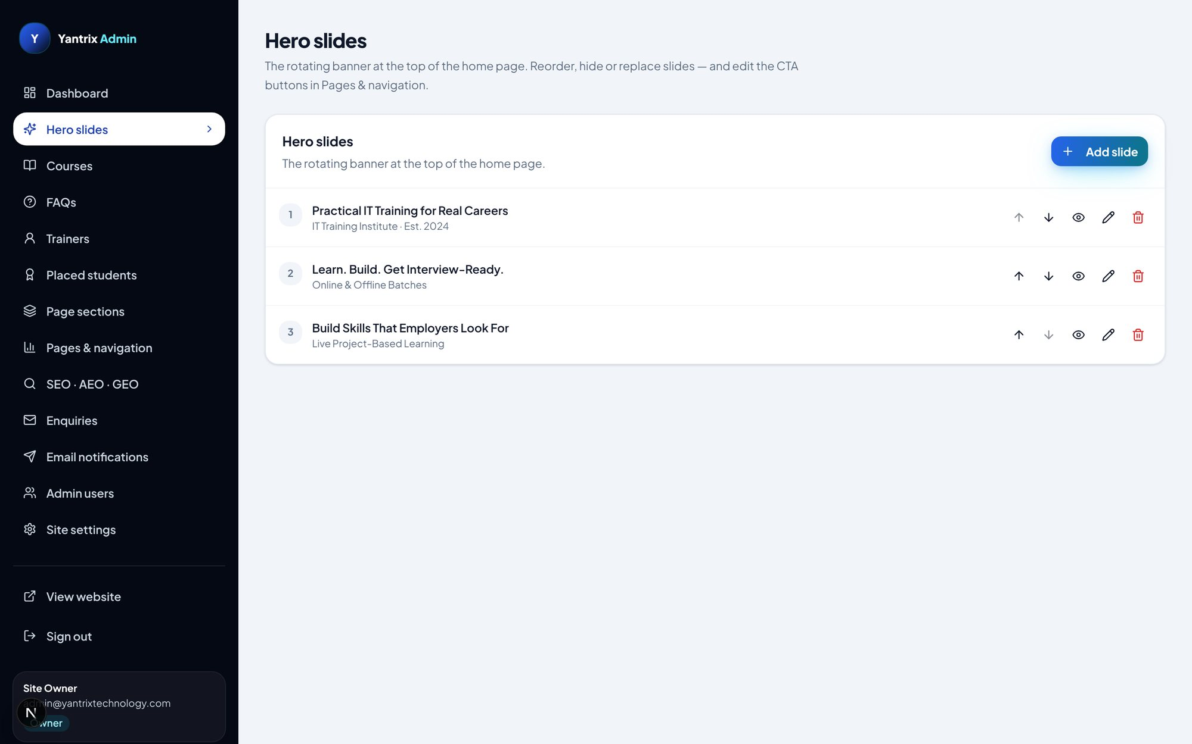
Hero slides panel — slides ki list
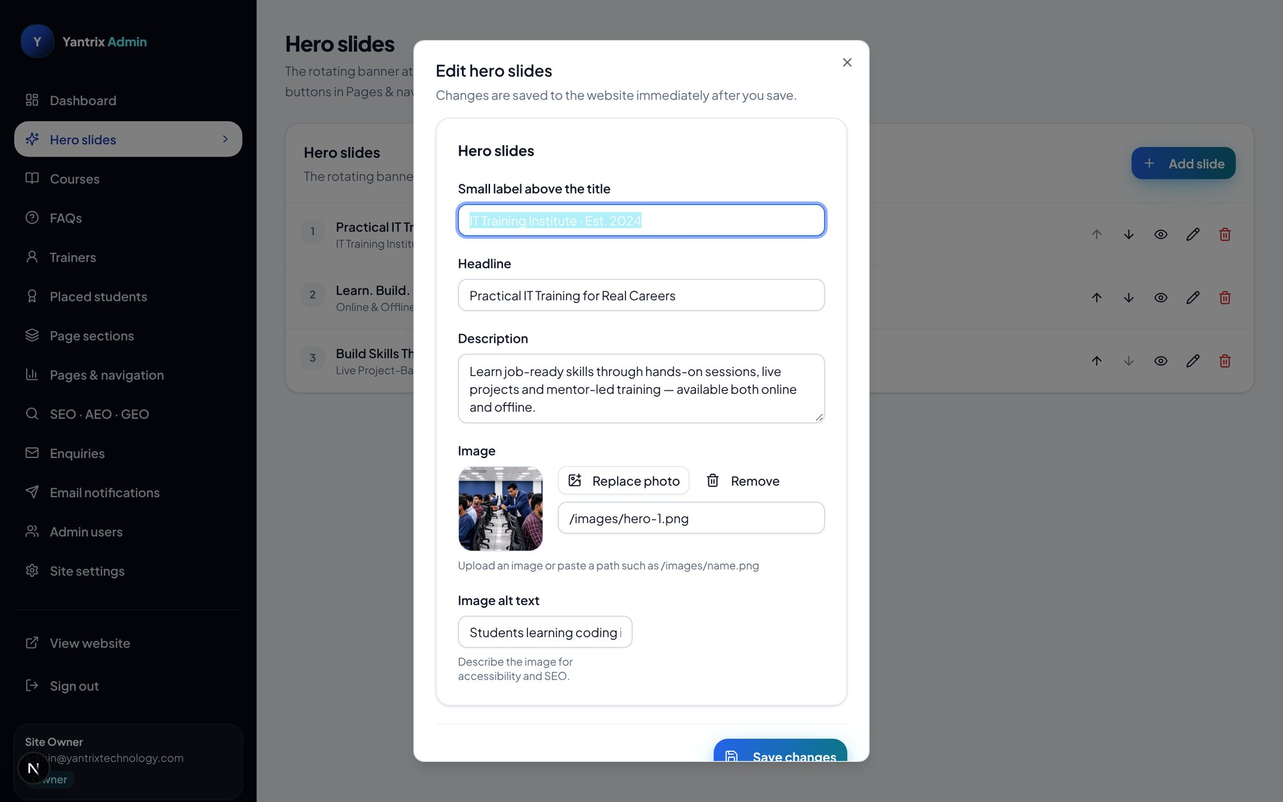
Slide edit karne ka dialog (form)
Step 1: Sidebar → "Hero slides" kholein.
Step 2: Nayi slide ke liye "Add slide" dabayein; purani badalne ke liye pencil (edit) icon.
Step 3: Dialog mein: chhota label (eyebrow), headline, description, image (upload ya path), image alt text, CTA buttons aur trust chips bharein.
Step 4: "Save changes" dabayein — home page ka banner turant badal jaayega.
Step 5: Order badalne ke liye ↑ ↓ arrows; slide chhupane ke liye eye icon; hatane ke liye delete icon.

3.2 Courses — course cards ka control room
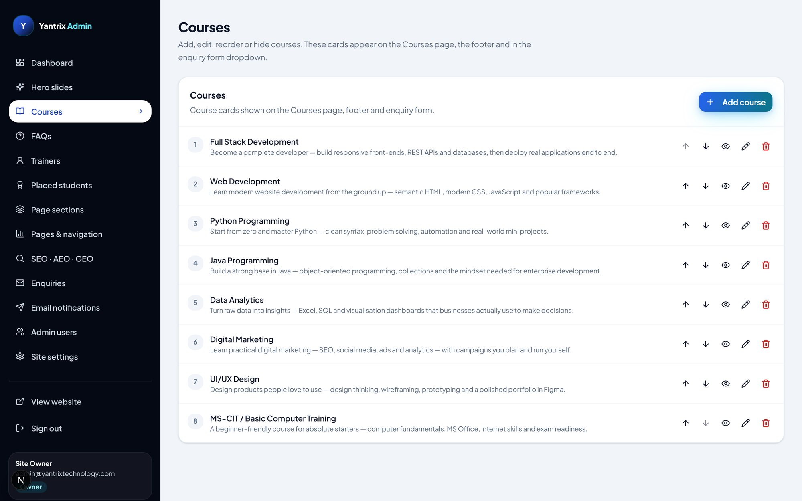
Courses panel — saari courses ki list
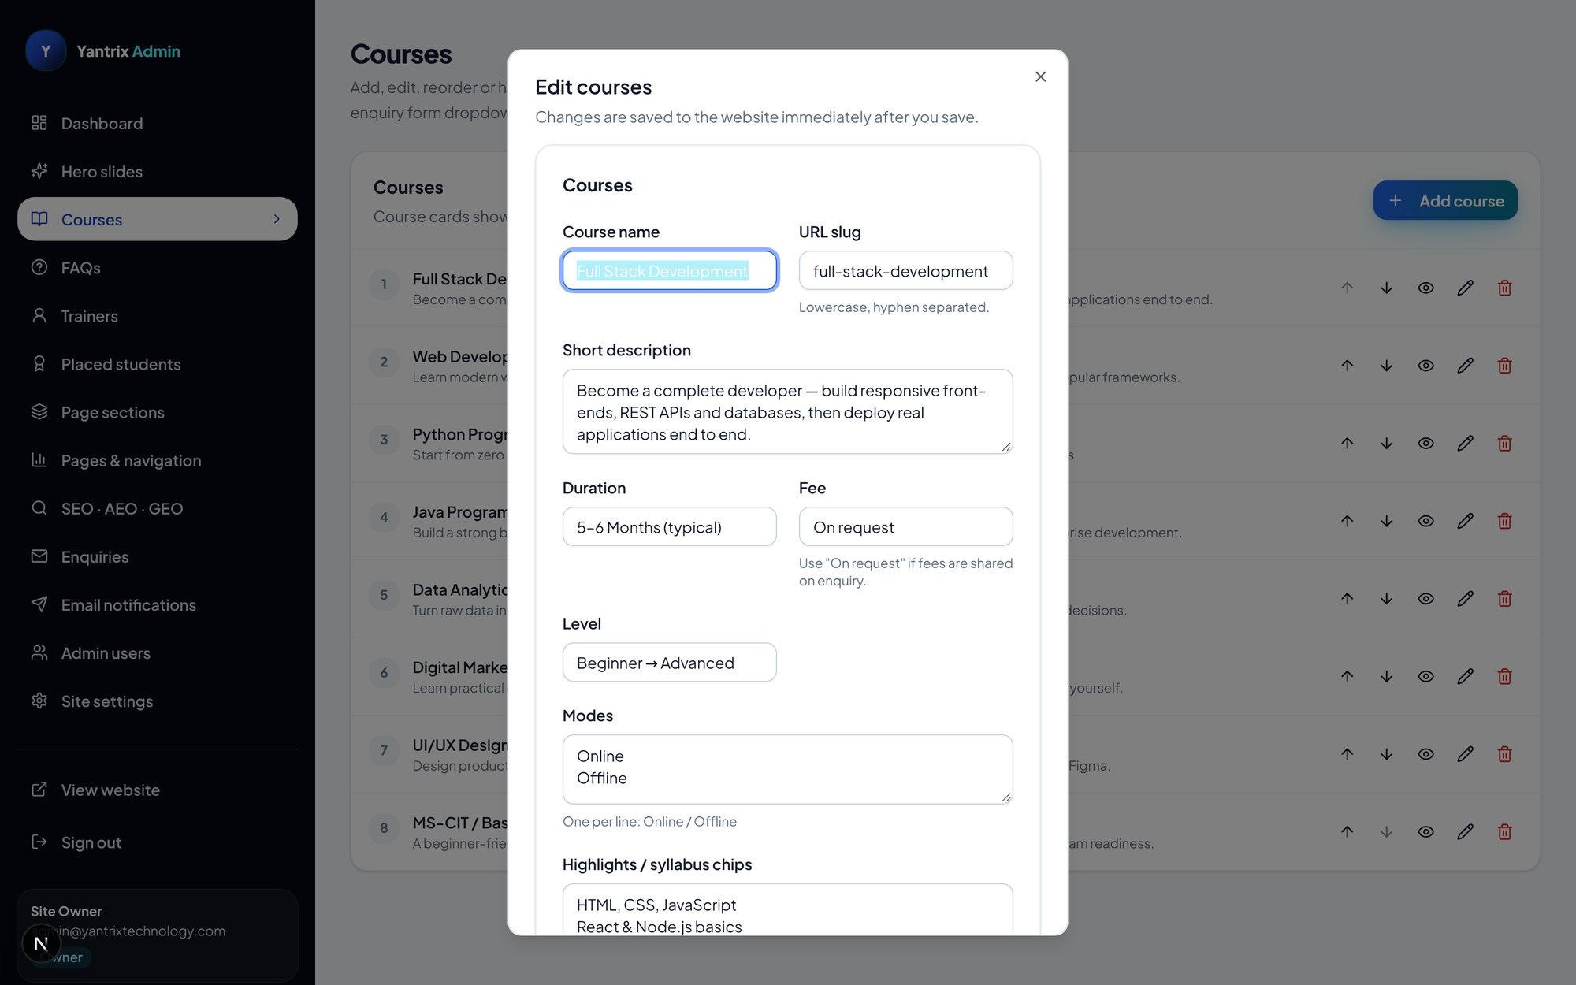
Course edit dialog — naam, slug, description, duration, fee, level, modes, chips
Step 1: Sidebar → "Courses". List mein har course number ke saath dikhti hai (website par isi order mein).
Step 2: "Add course" se nayi course; pencil se edit.
Step 3: Dialog mein: Course name, URL slug (apne aap banta hai), short description, duration, fee, level, modes (Online/Offline), highlights/syllabus chips.
Step 4: Save karte hi courses page aur course detail page par live ho jaati hai; llms.txt bhi update hota hai.
Step 5: Eye icon se course website se temporary chhupayein (delete kiye bina).

3.3 FAQs — sawaal-jawaab
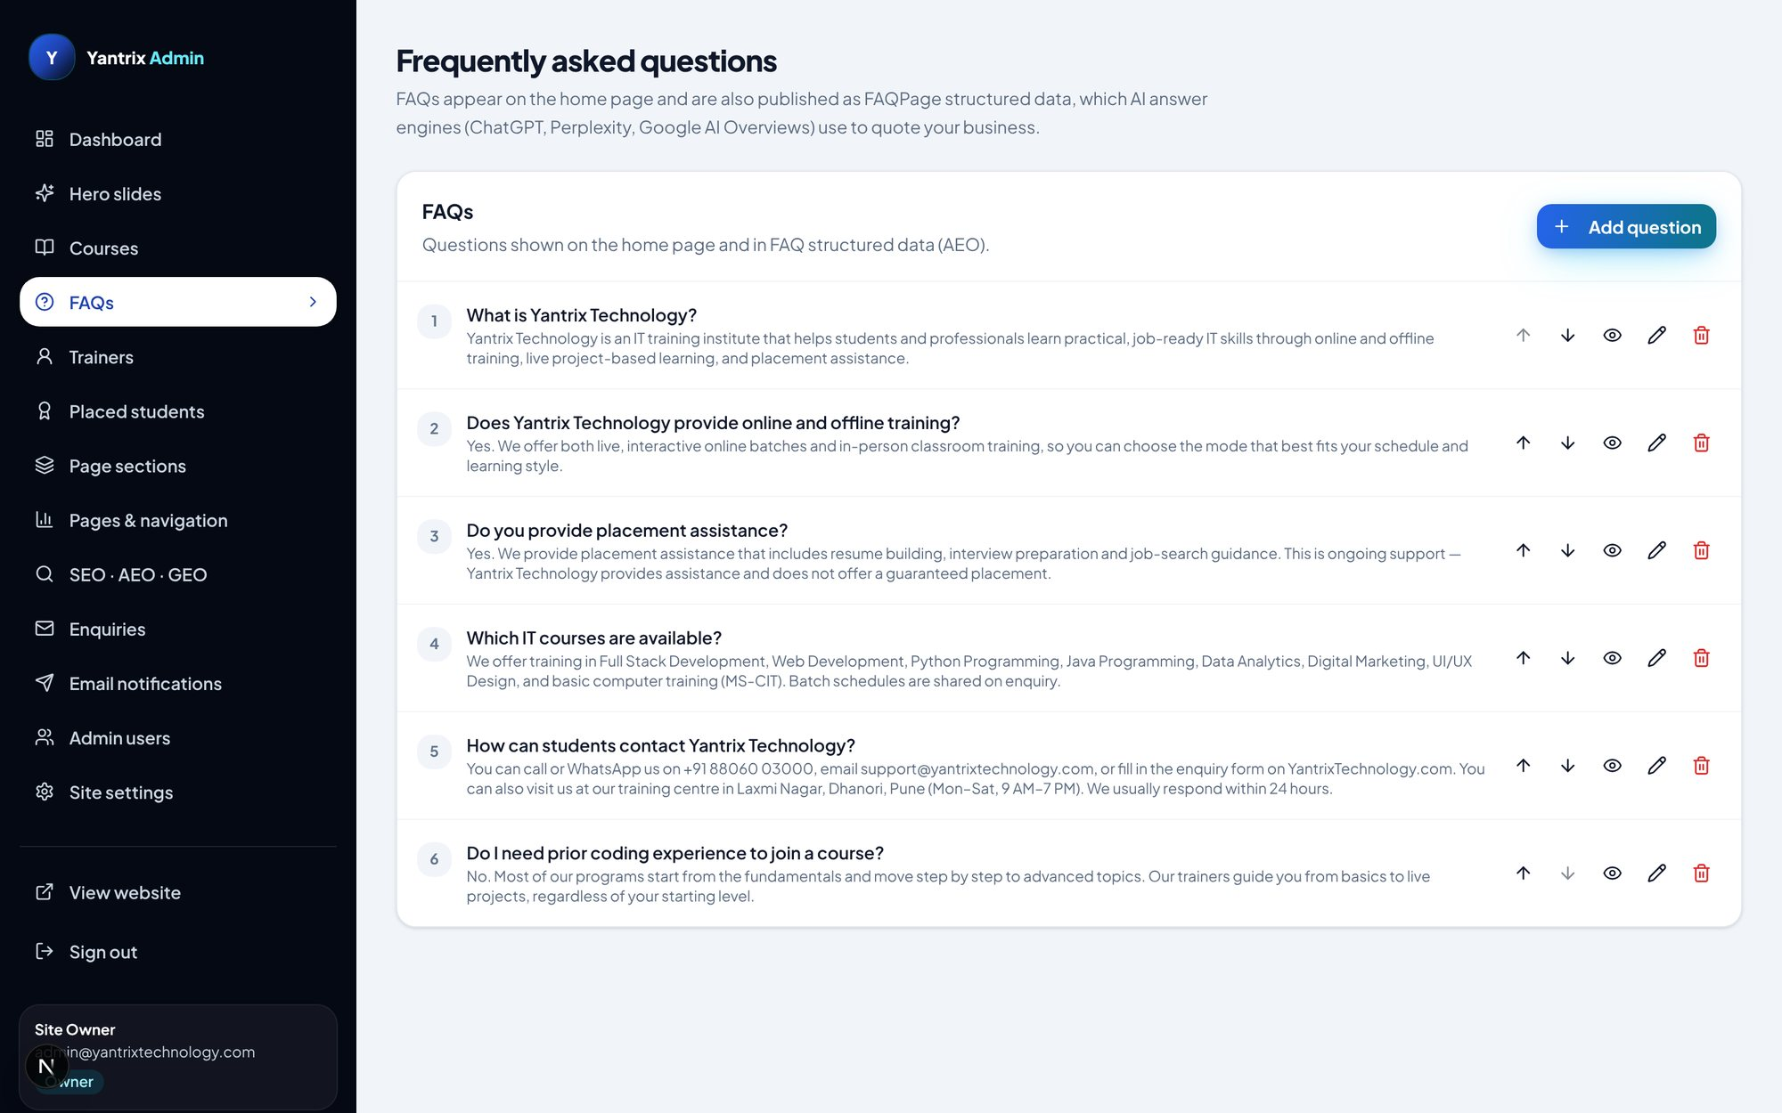
FAQs panel
Step 1: Sidebar → "FAQs".
Step 2: "Add FAQ" se naya sawaal; pencil se edit; order ↑ ↓ se.
Step 3: Sirf active (eye on) FAQs website ke home FAQ section mein dikhti hain aur Google ke FAQPage schema mein bhi jaati hain.

3.4 Trainers — team cards
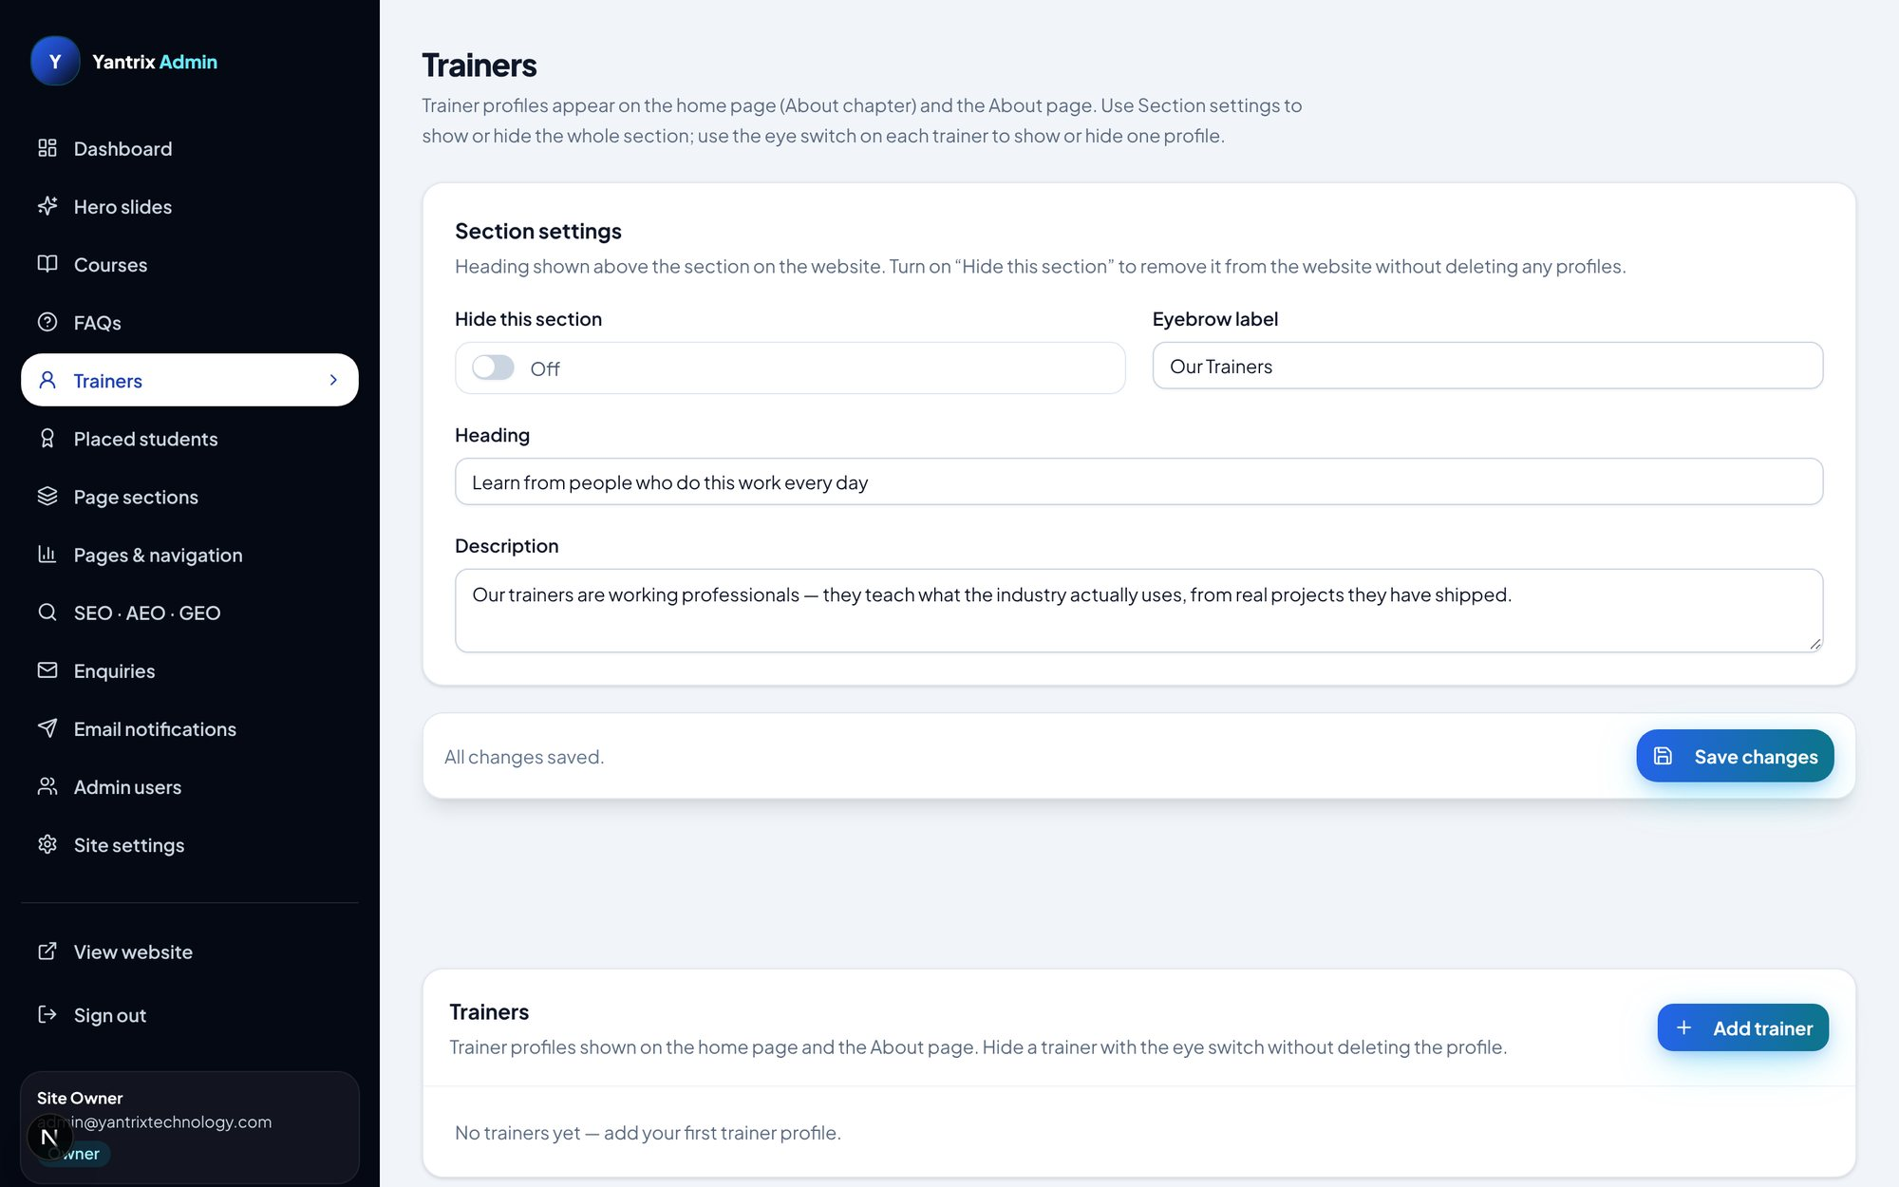
Trainers panel — team members ki list
Yahan institute ke trainers/mentors ke cards bante hain: naam, role, photo, social links. Website ke trainers section mein yahi dikhte hain.

3.5 Placed students — placement wall
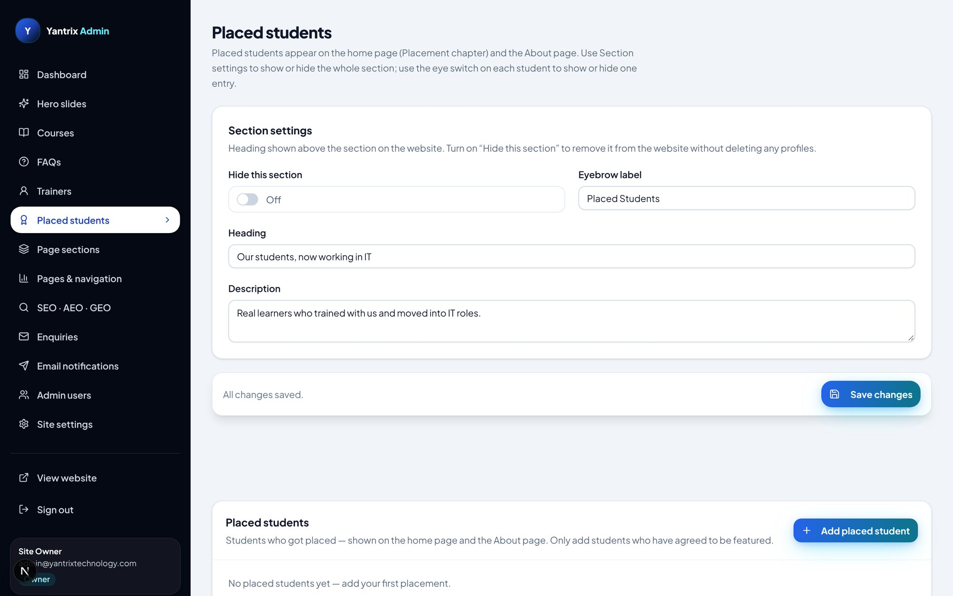
Placed students panel
Placement paane waale students ke records: naam, company, package, batch, photo. Website ki placement wall aur home ke placement section mein yahi data dikhta hai.

3.6 Page sections — har section ka text
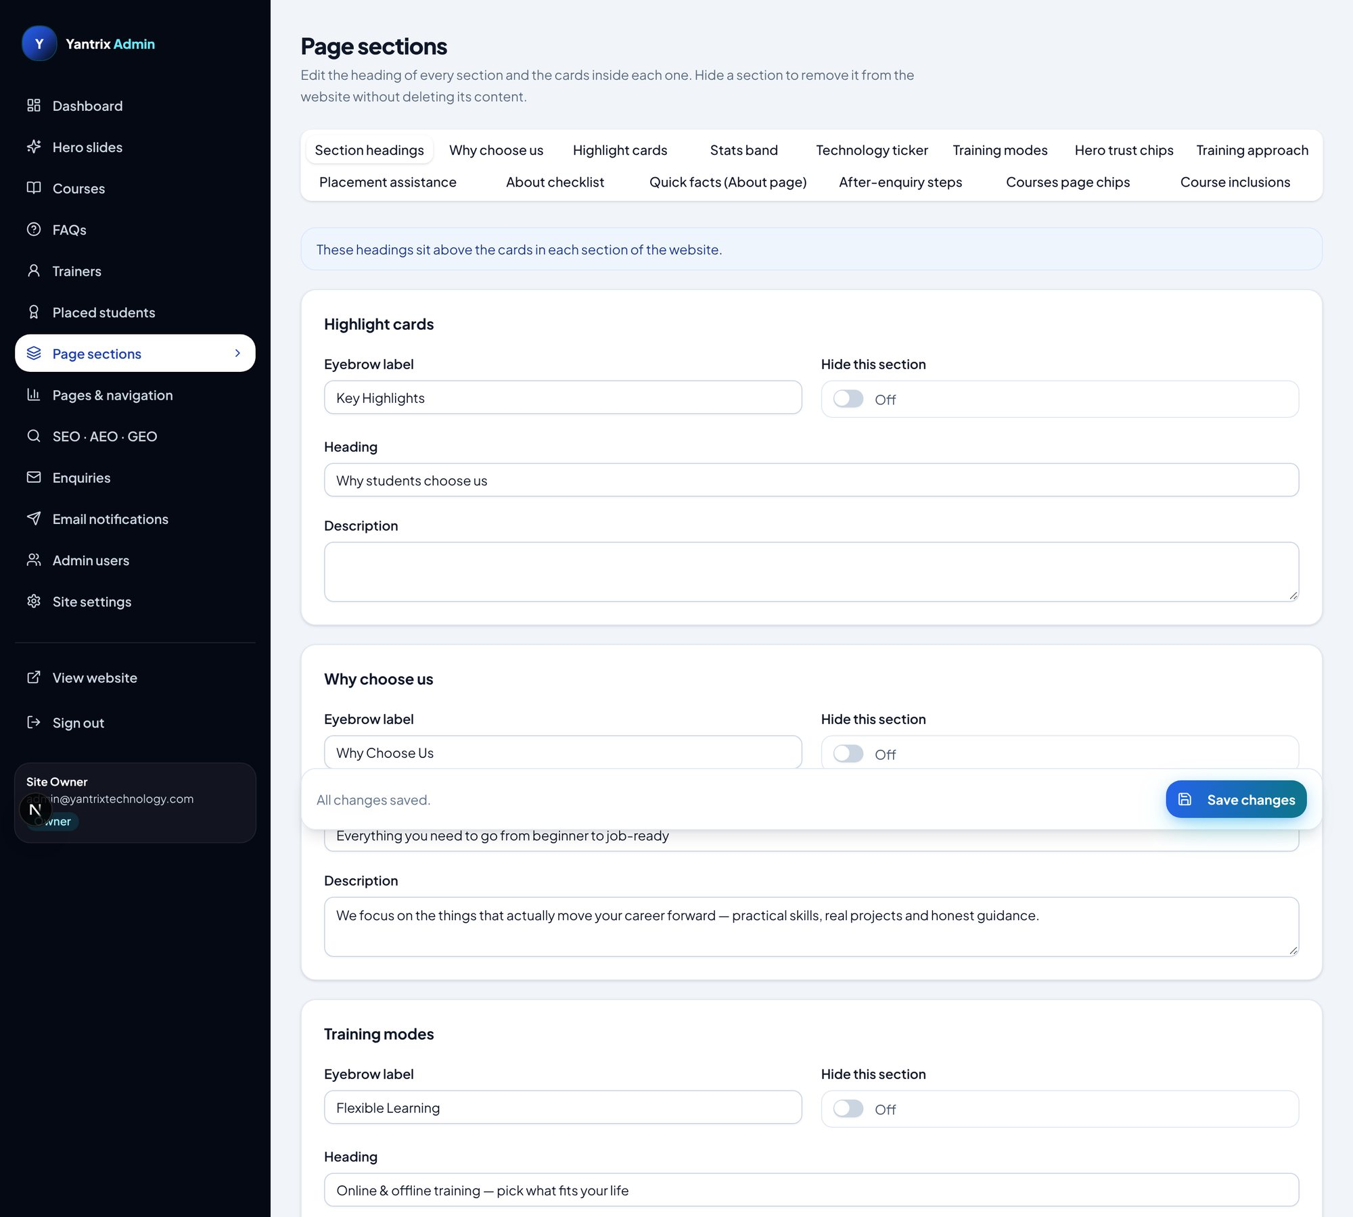
Page sections panel (poora, neeche scroll karte jaiye) — hissa 1/5
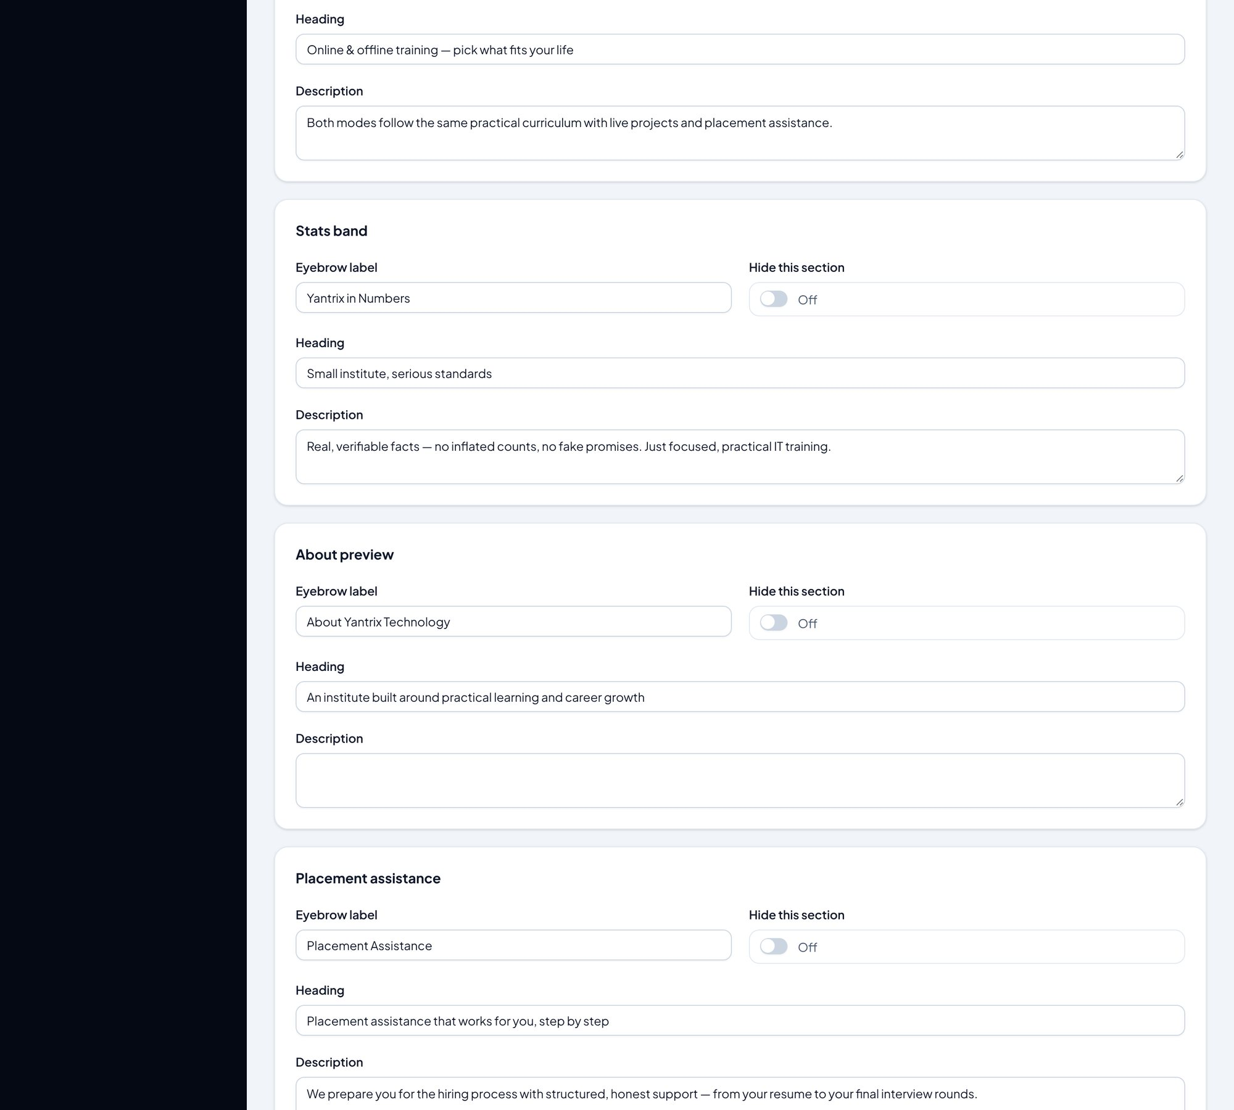
Page sections panel (poora, neeche scroll karte jaiye) — hissa 2/5
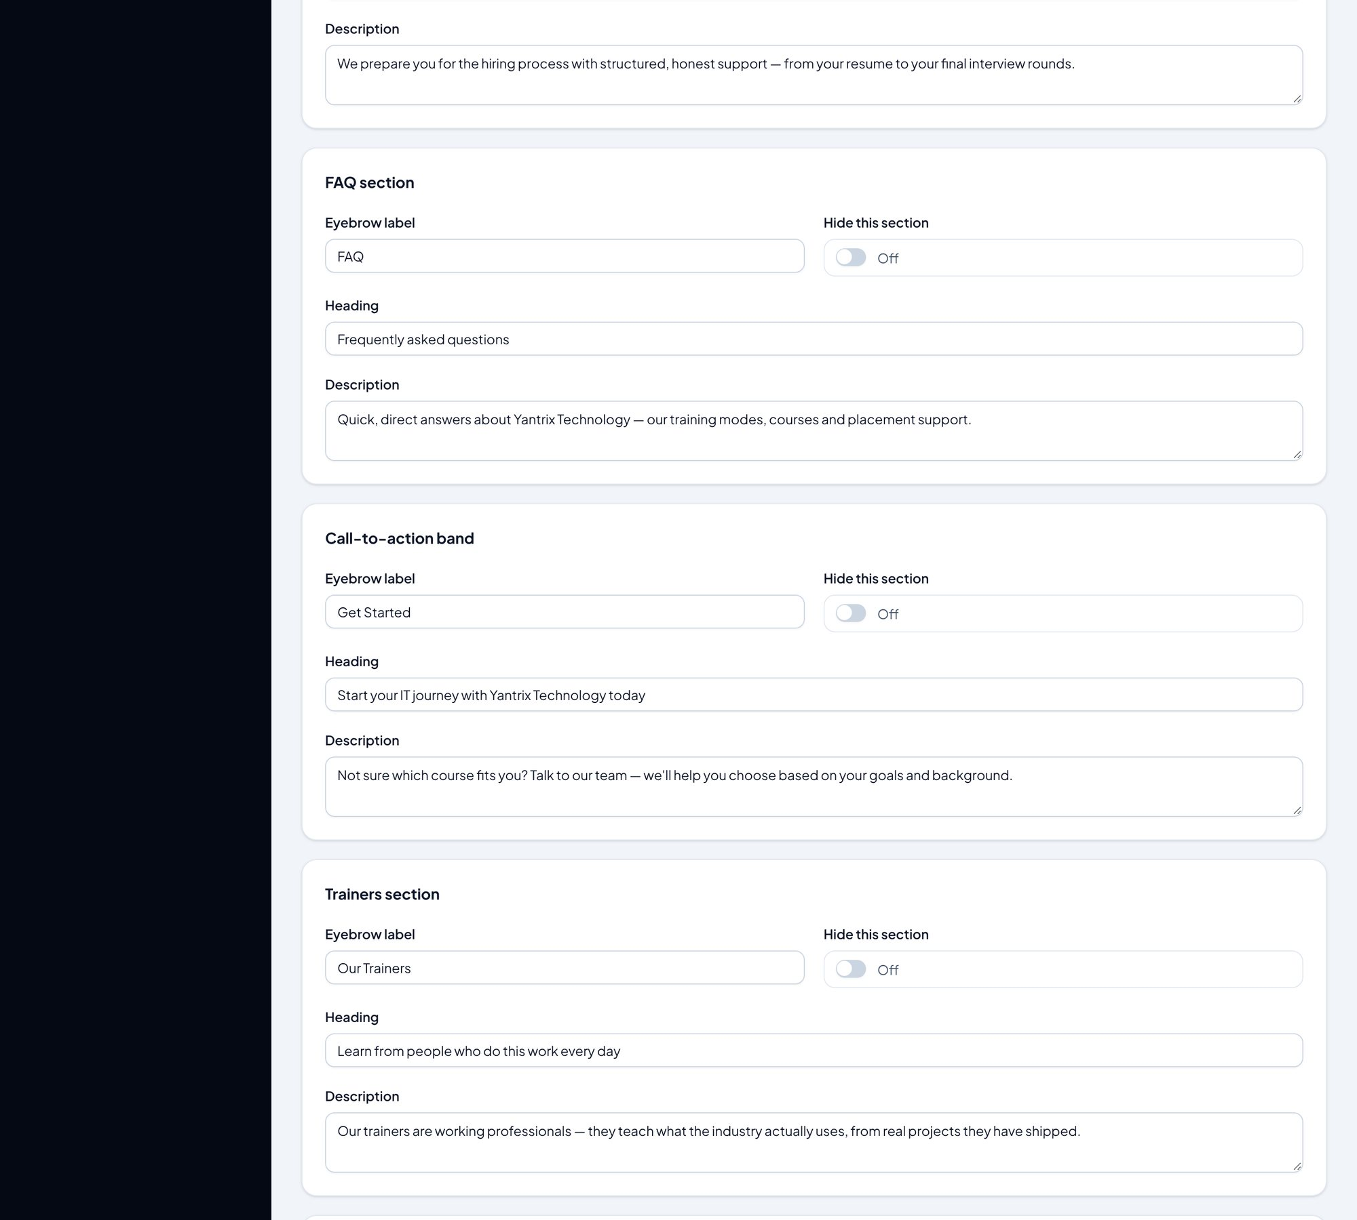
Page sections panel (poora, neeche scroll karte jaiye) — hissa 3/5
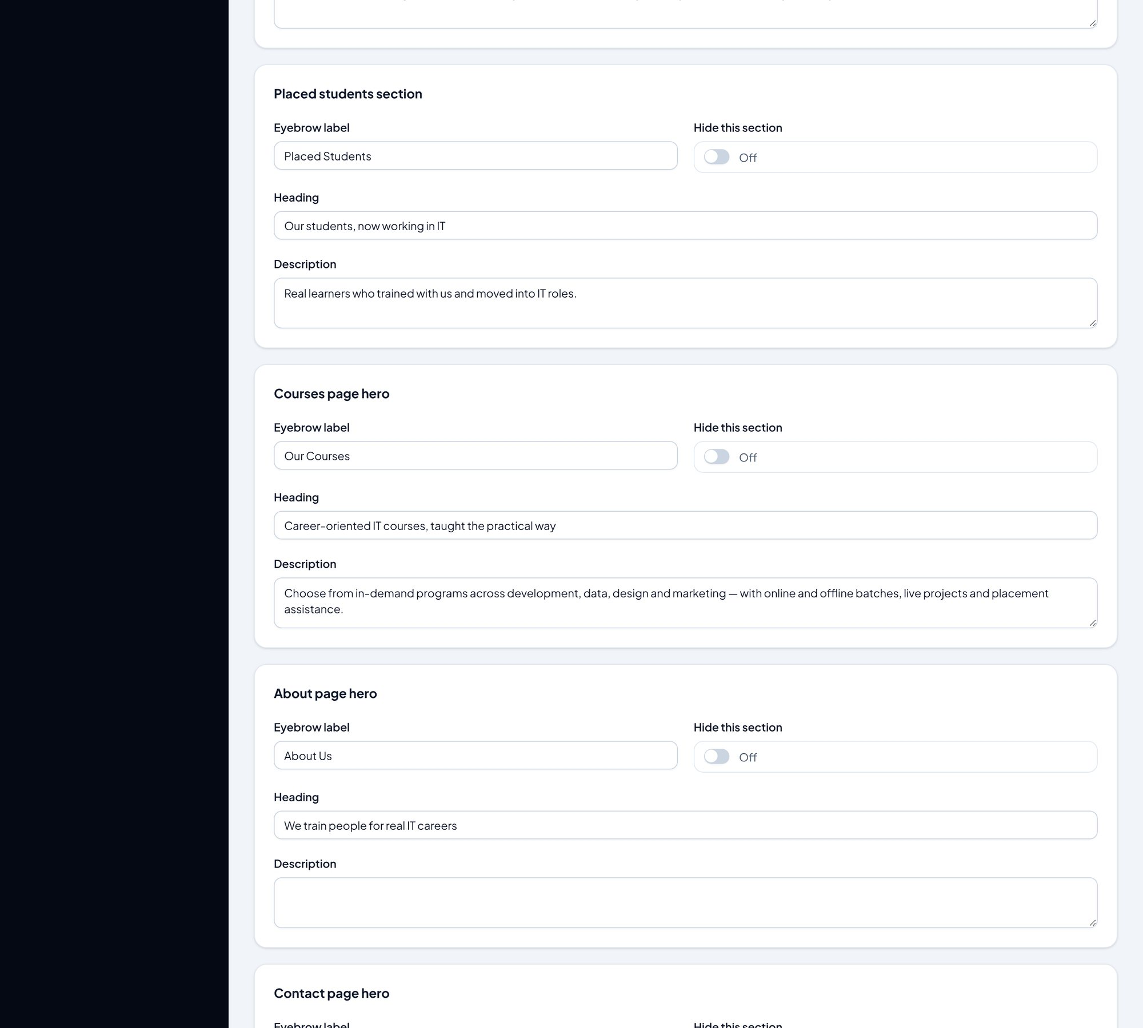
Page sections panel (poora, neeche scroll karte jaiye) — hissa 4/5
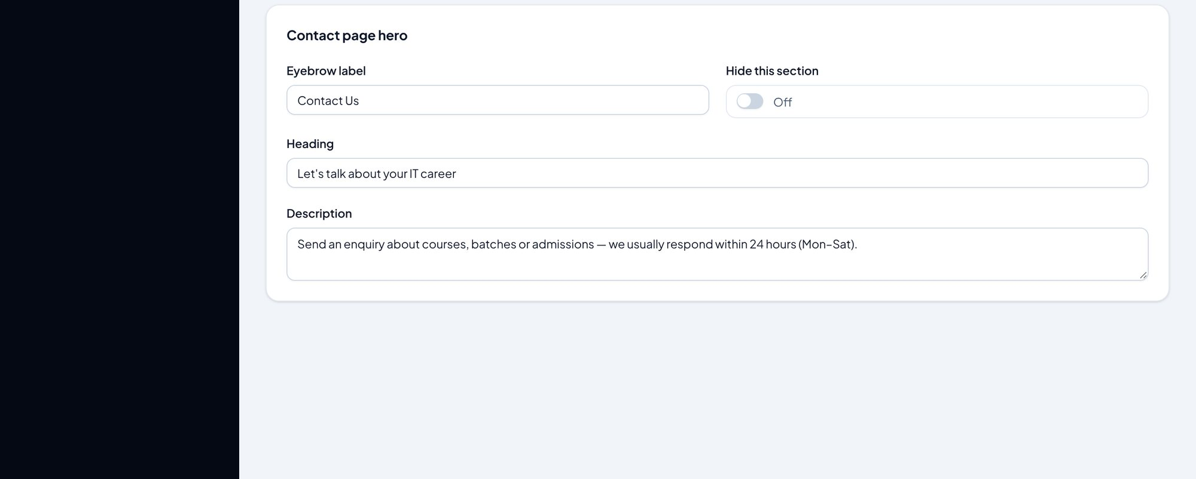
Page sections panel (poora, neeche scroll karte jaiye) — hissa 5/5
Step 1: Sidebar → "Page sections".
Step 2: Har section (skills, why, modes, placement, about, faq, cta…) ka apna card hai: Heading, chhota eyebrow text, description.
Step 3: Kisi section ko website se hatana ho to uska "hide" switch on kar dein — content delete nahi hota.
Step 4: Section ke andar ke cards (feature cards, stats, tech ticker, placement points, quick facts…) bhi yahin edit hote hain.

3.7 Pages & navigation — page copy aur menu links
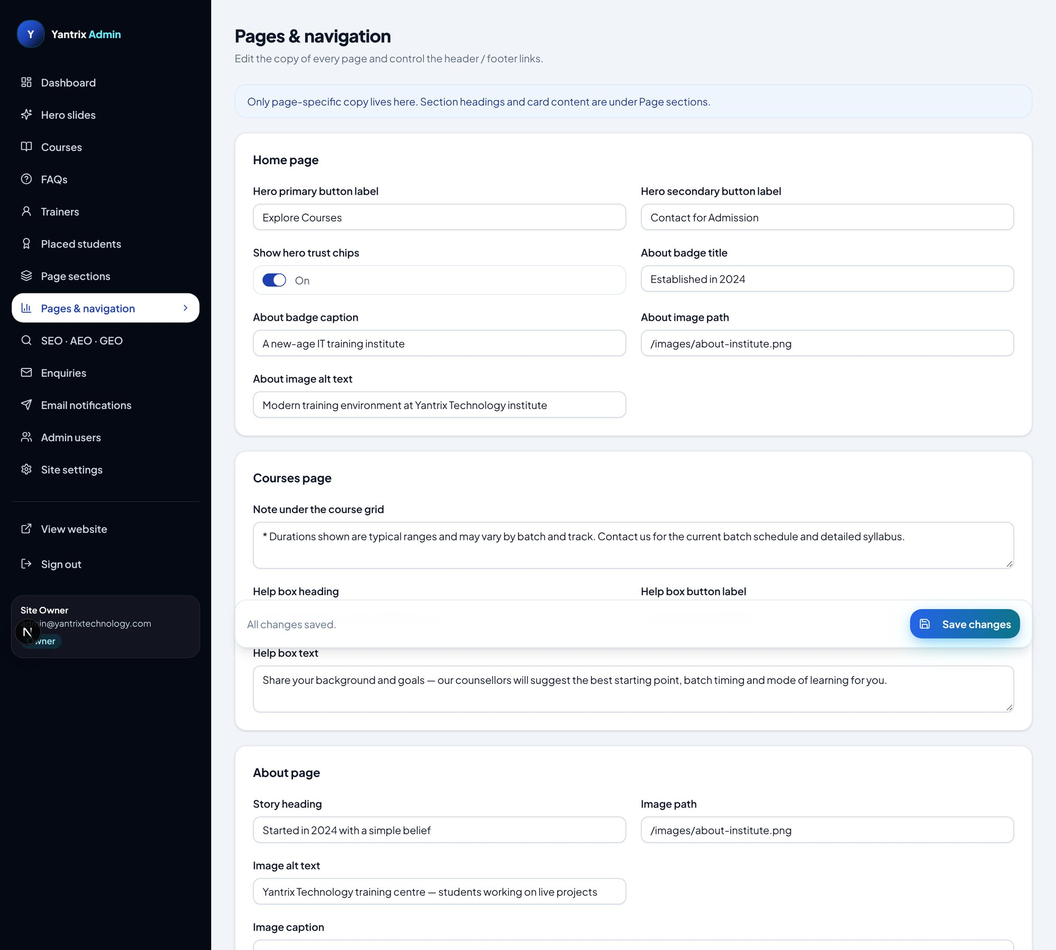
Pages & navigation panel (poora) — hissa 1/3
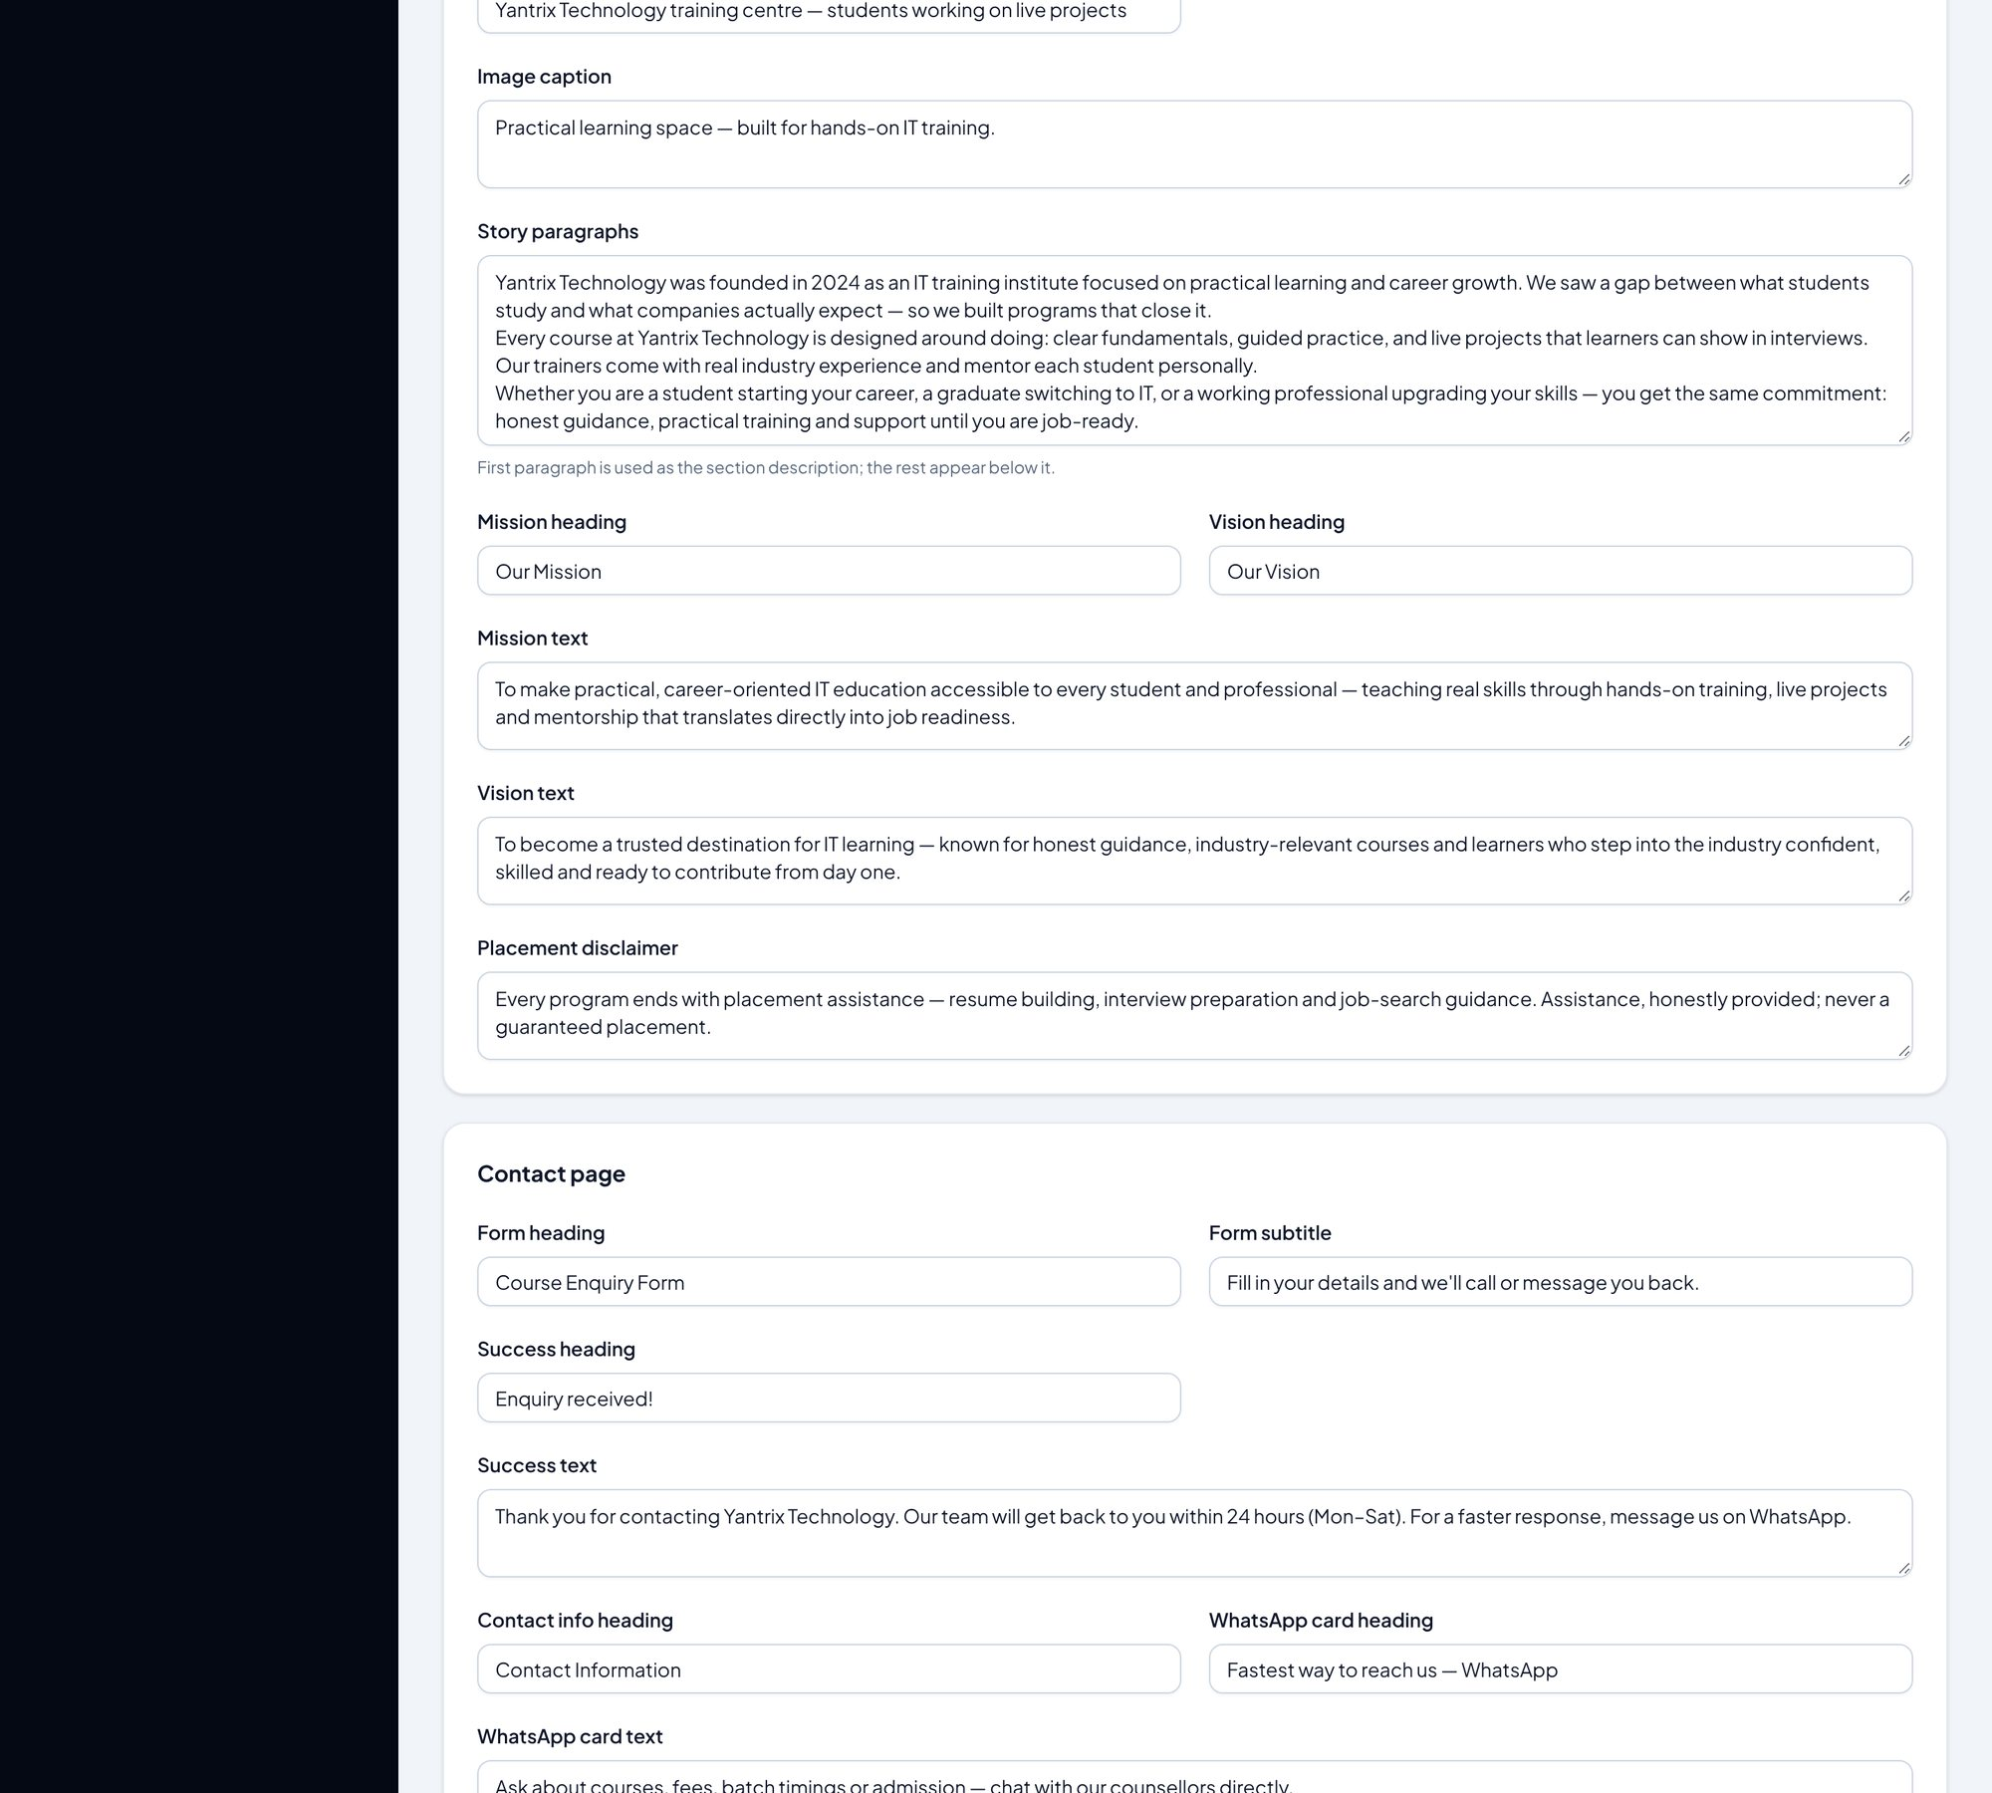
Pages & navigation panel (poora) — hissa 2/3
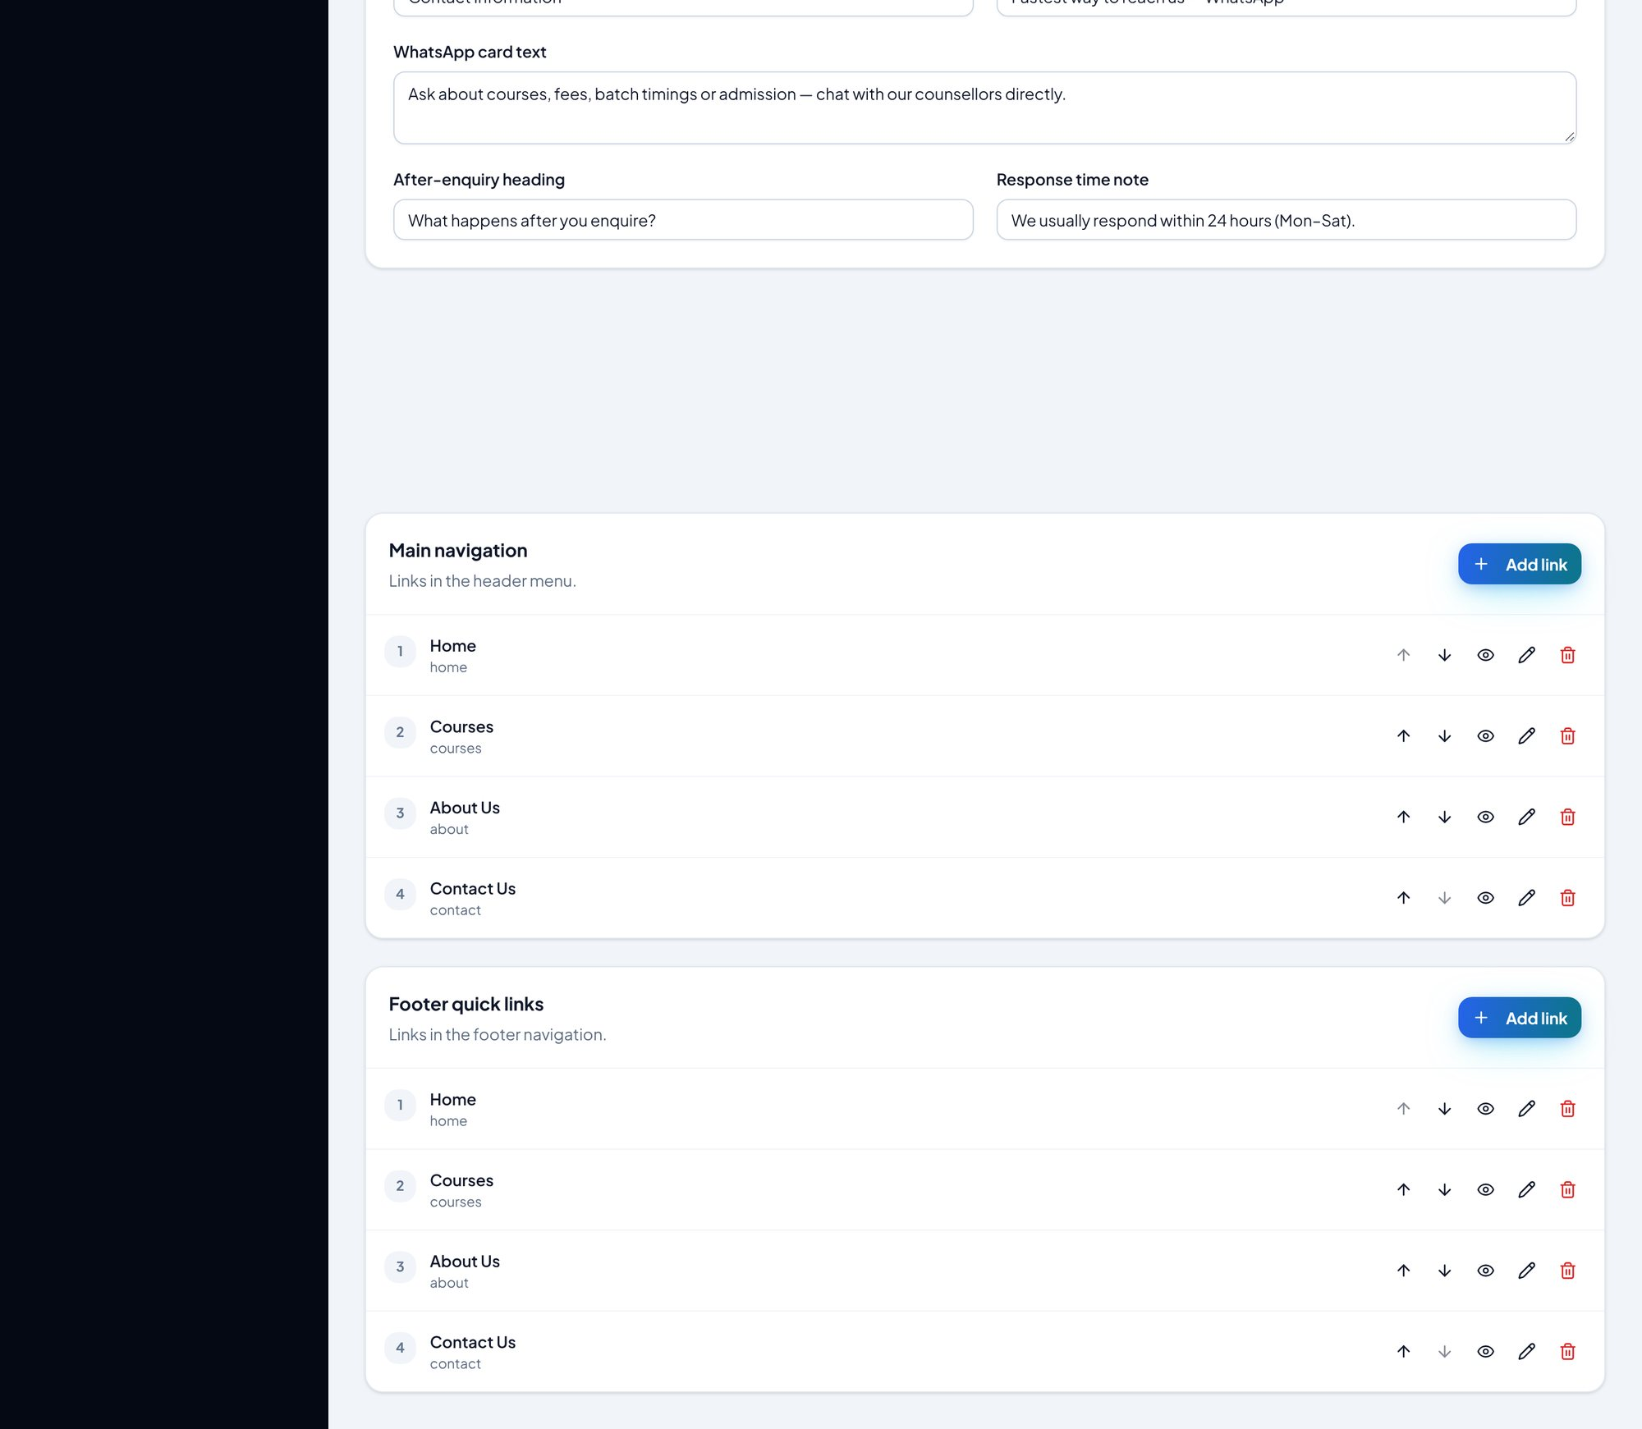
Pages & navigation panel (poora) — hissa 3/3
- Home / Courses / About / Contact — har page ka apna copy block (heading, paragraphs) yahin edit hota hai.
- Header ke menu links aur footer ke link groups bhi yahin bante/badalte hain.
- Save karte hi navigation turant update hoti hai.

3.8 SEO · AEO · GEO — Google aur AI search ke liye
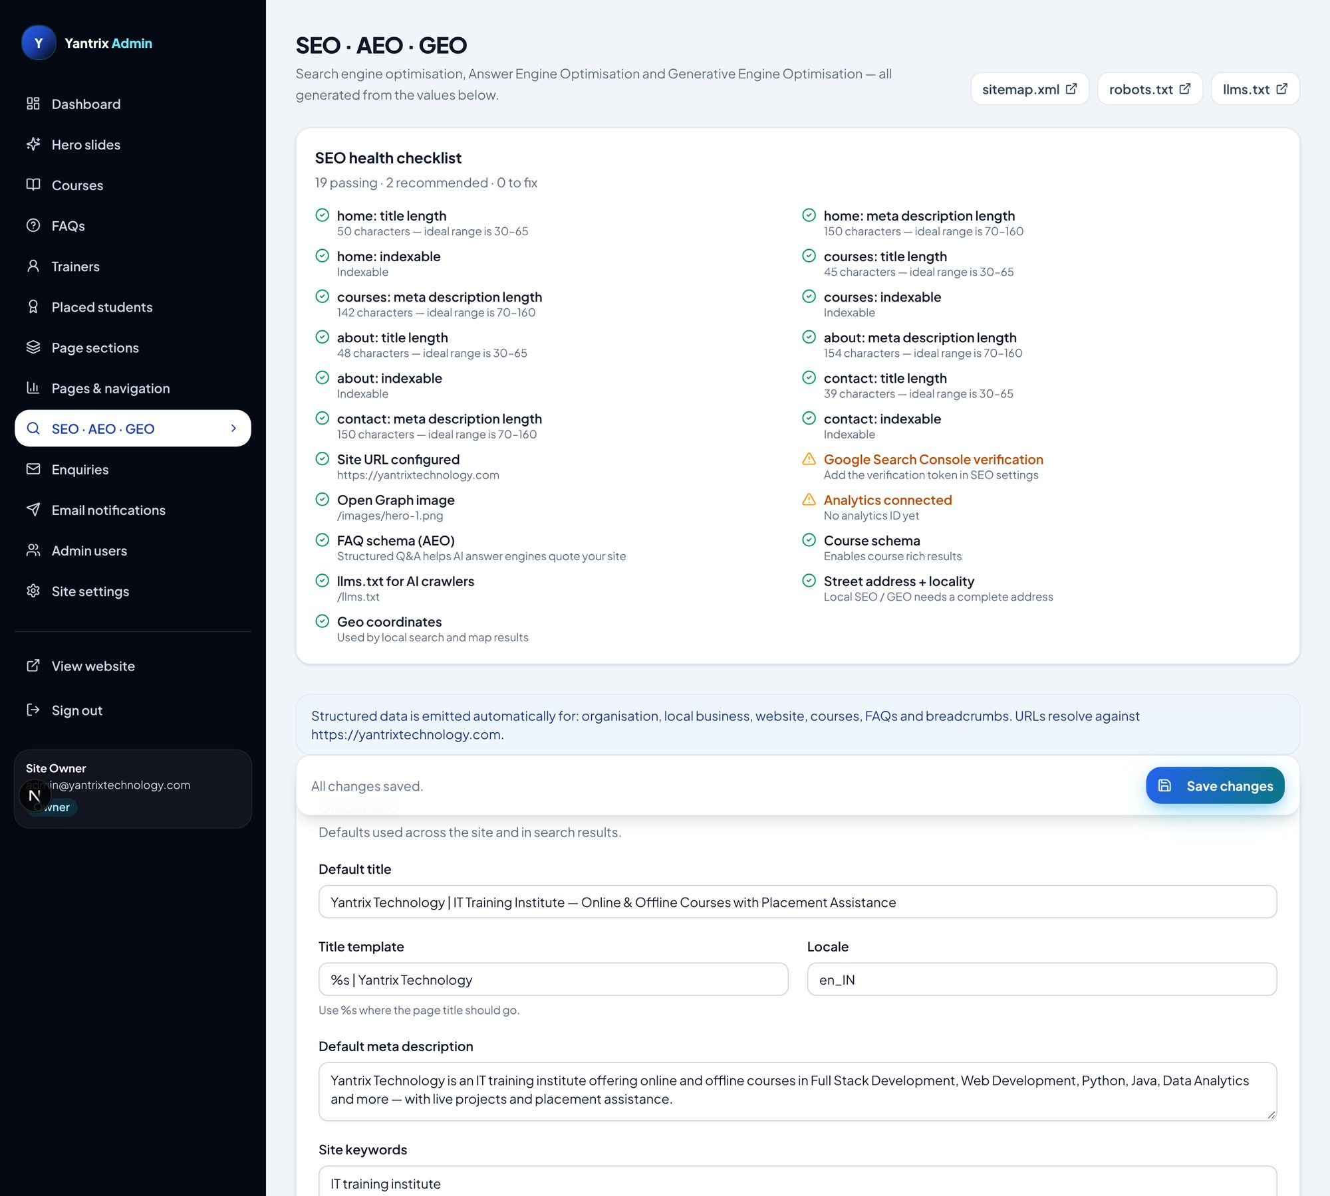
SEO · AEO · GEO panel (poora) — hissa 1/6
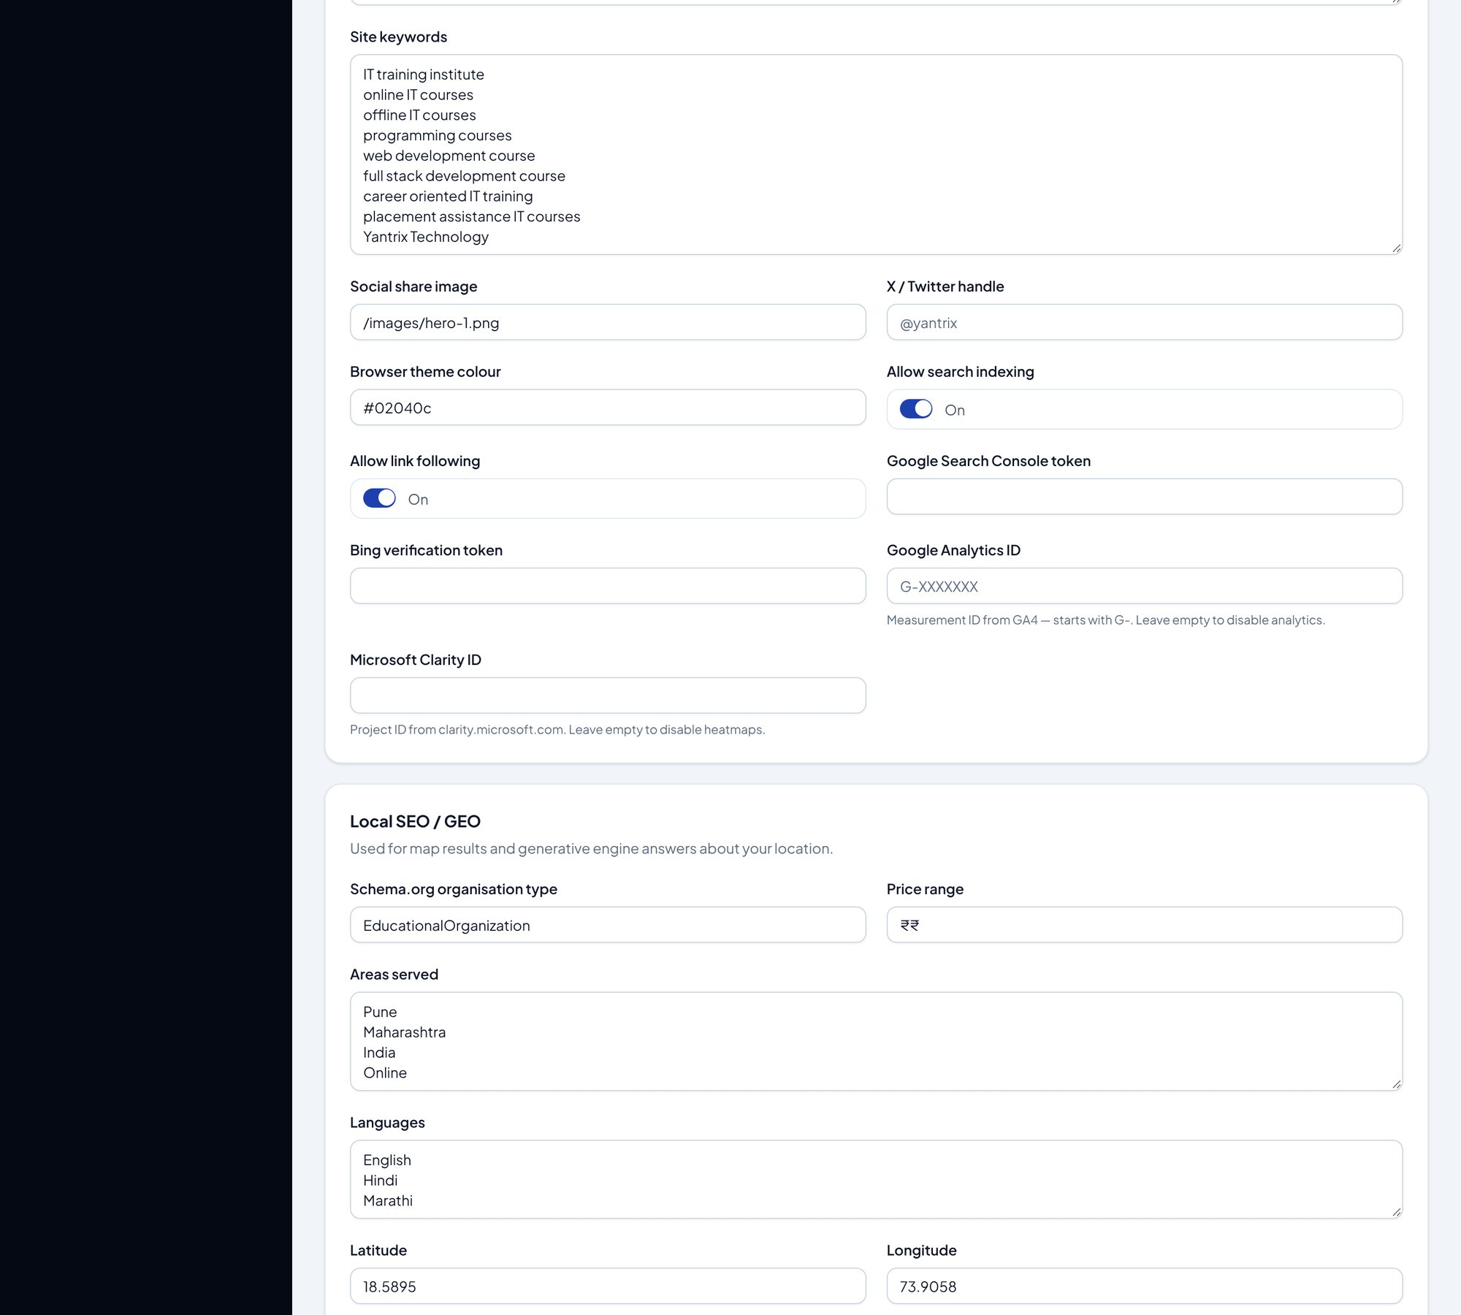
SEO · AEO · GEO panel (poora) — hissa 2/6
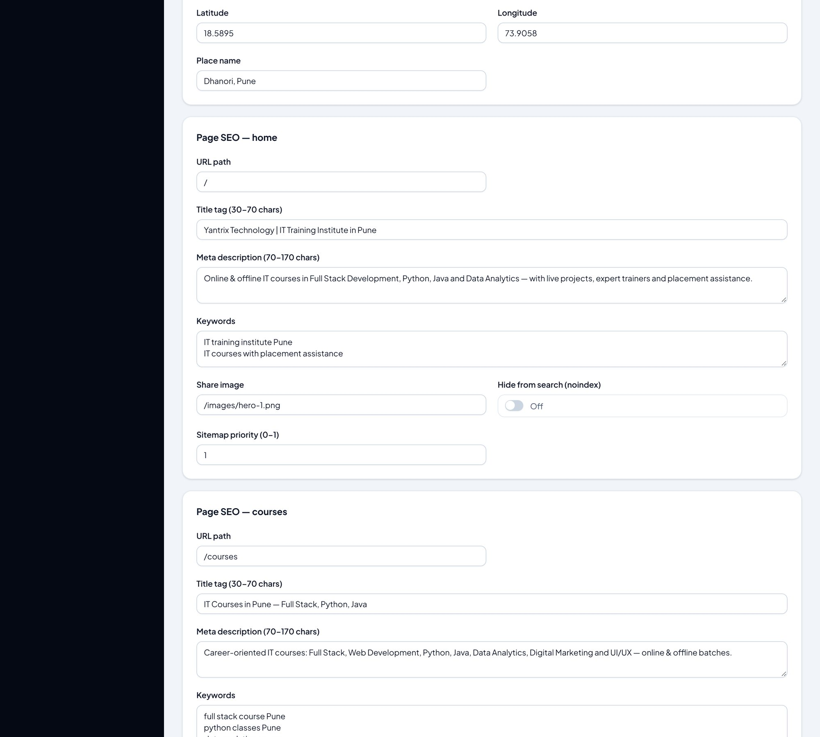
SEO · AEO · GEO panel (poora) — hissa 3/6
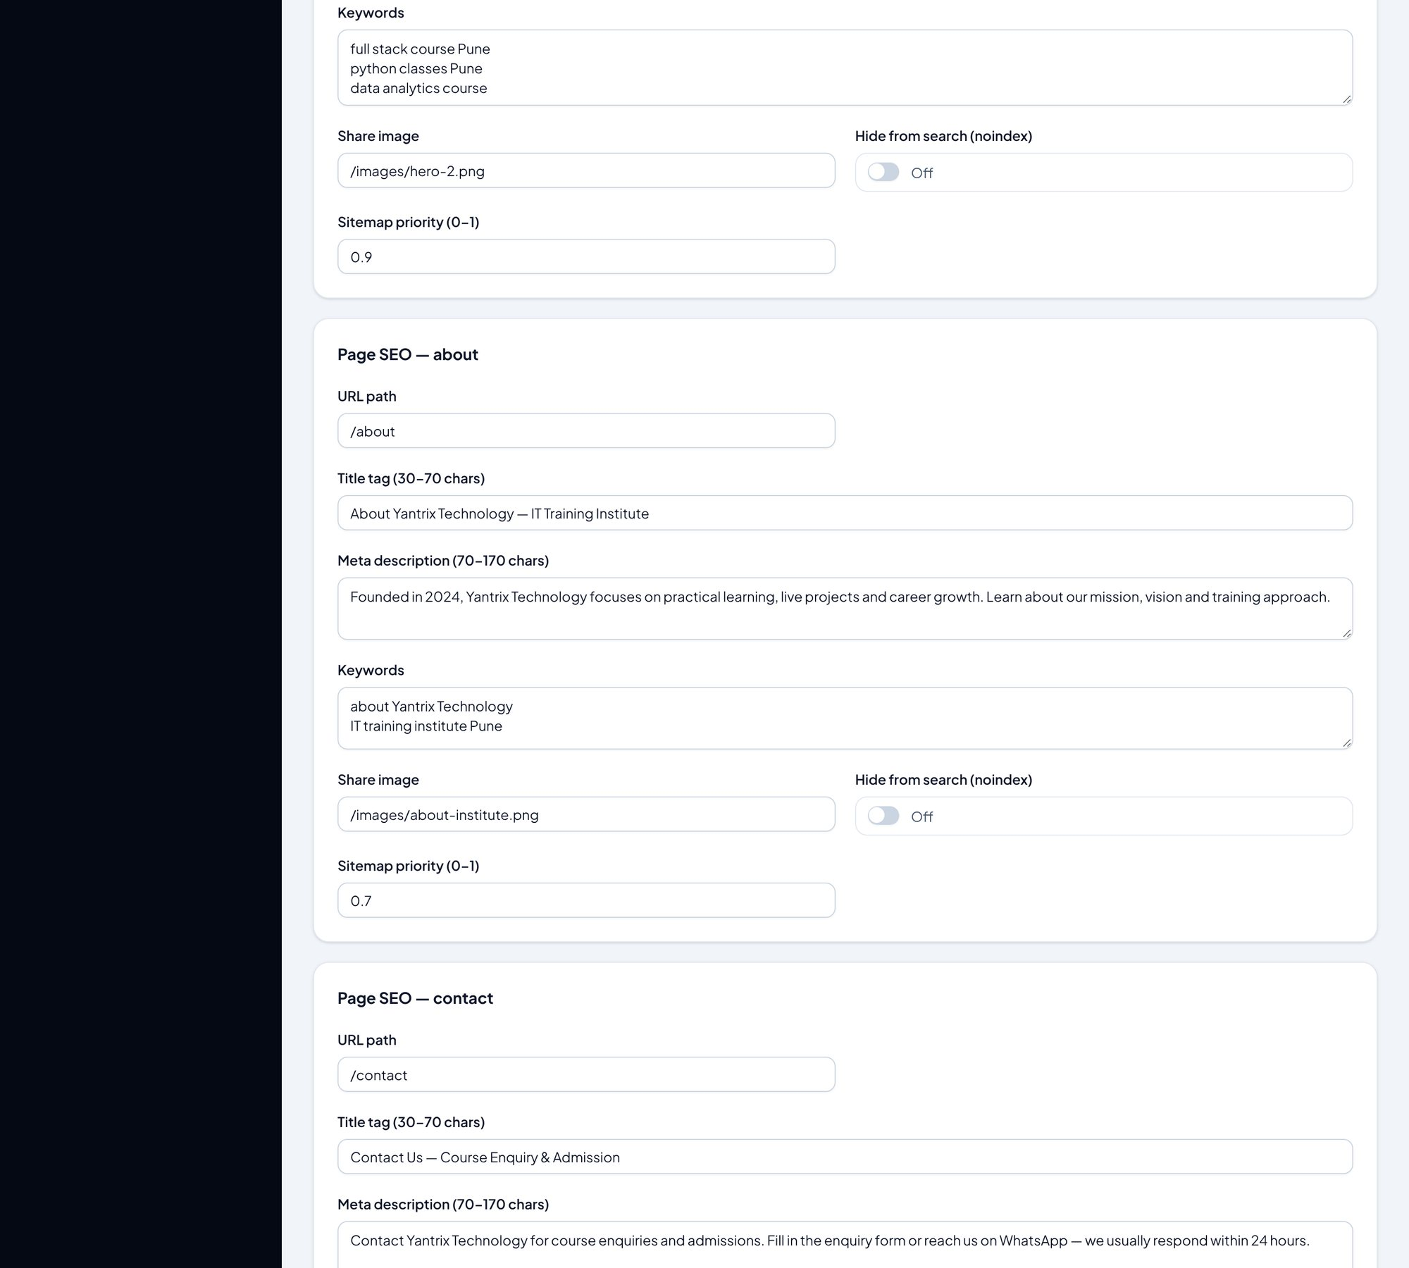
SEO · AEO · GEO panel (poora) — hissa 4/6
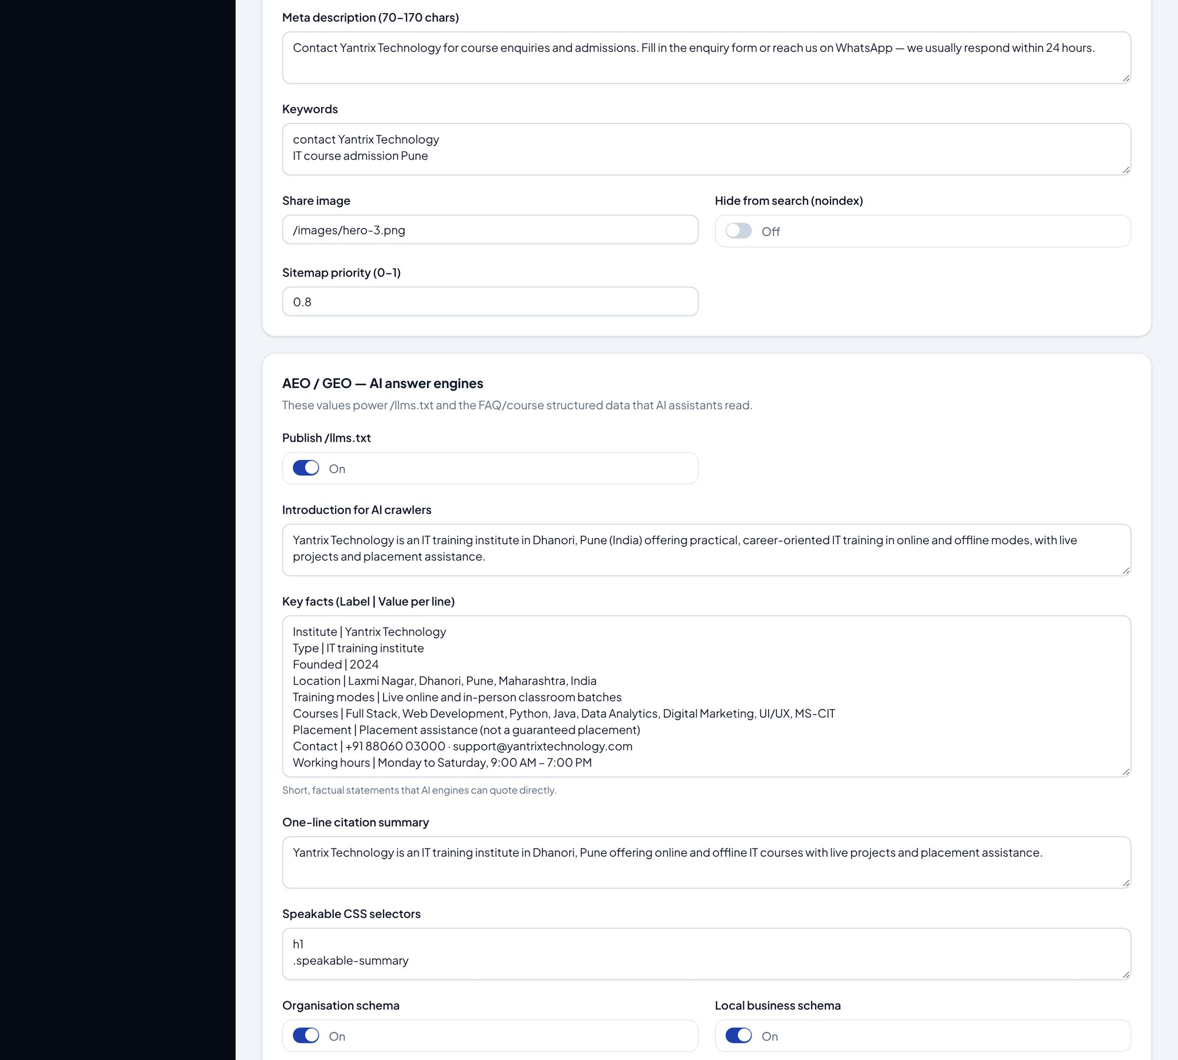
SEO · AEO · GEO panel (poora) — hissa 5/6
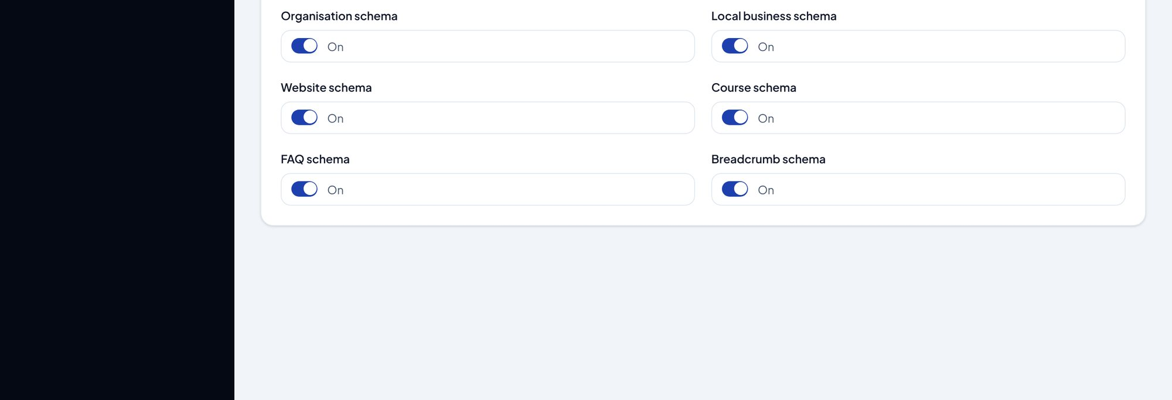
SEO · AEO · GEO panel (poora) — hissa 6/6
- Har page ka title, meta description, keywords, canonical URL aur OpenGraph/Twitter image yahin set hota hai.
- Google Search Console / Bing verification tokens aur GA4 / Clarity IDs bhi yahin.
- Local SEO: coordinates, opening hours, address — LocalBusiness schema mein jaate hain.
- JSON-LD toggles aur llms.txt ke key facts (AI answer engines ke liye) bhi isi panel mein hain.
- Dashboard ka "SEO / AEO health" card isi panel ki settings check karta hai.
⚠️ Dhyan rakhein: Title/description badalne ke baad Google ko dikhne mein time lag sakta hai; website par turant lagoo hota hai.

3.9 Enquiries — students ke messages ka inbox
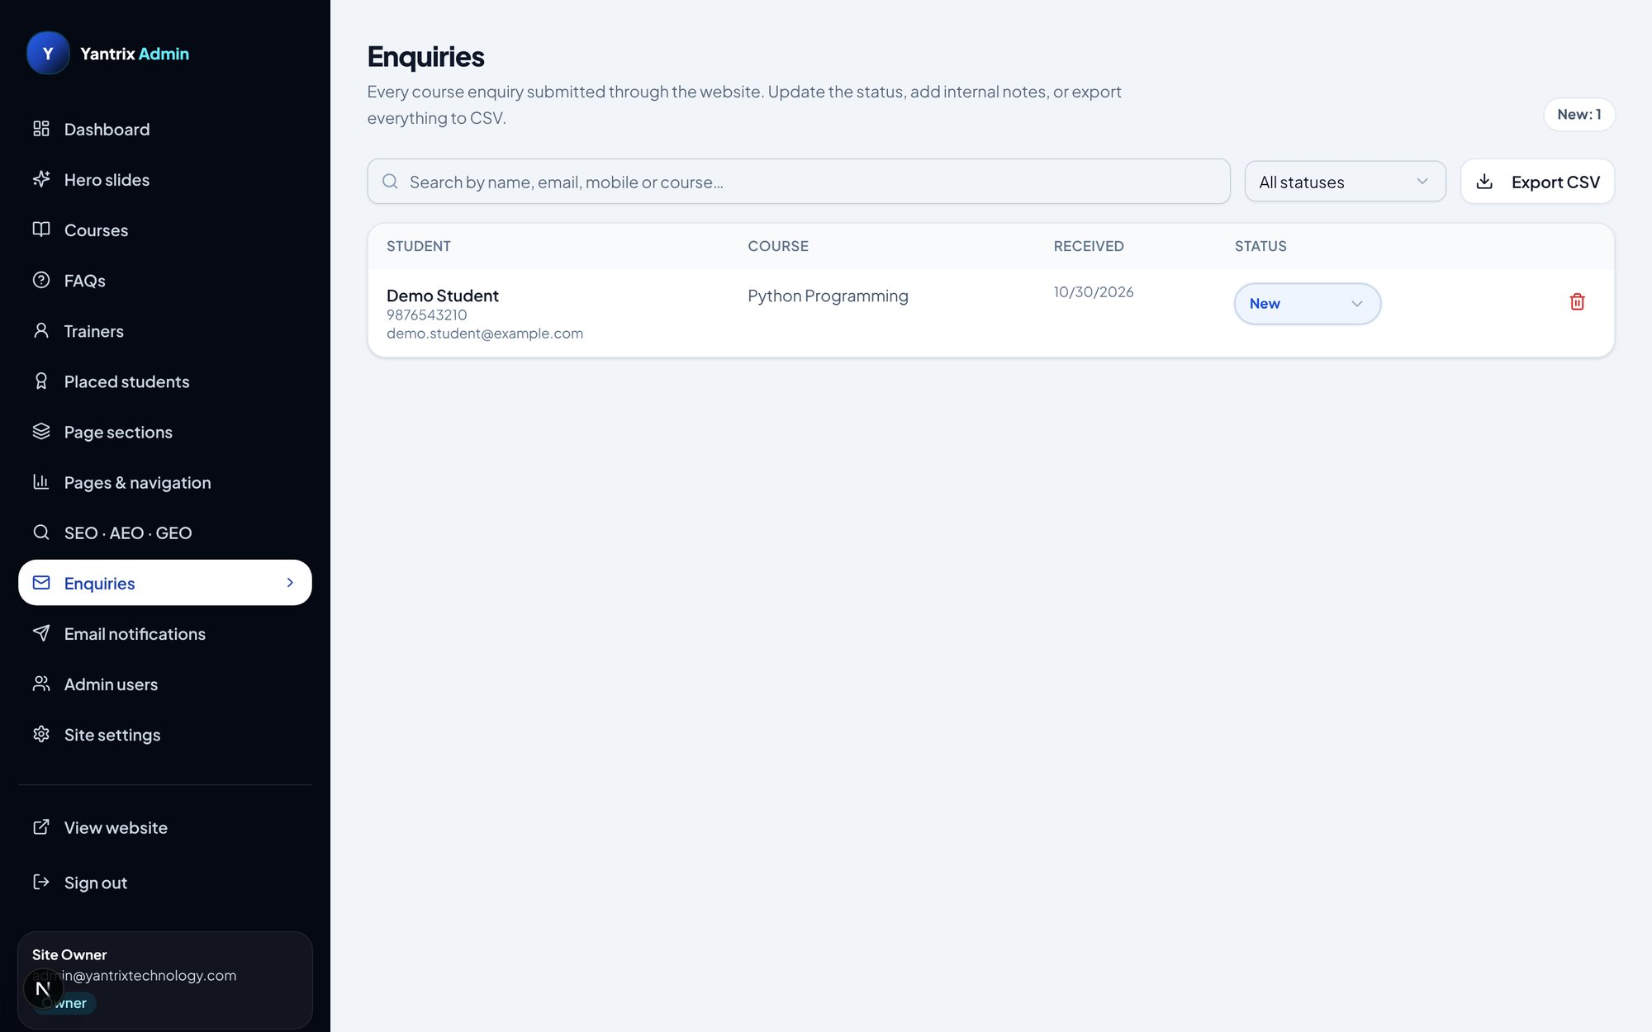
Enquiries panel — search, status filter, Export CSV
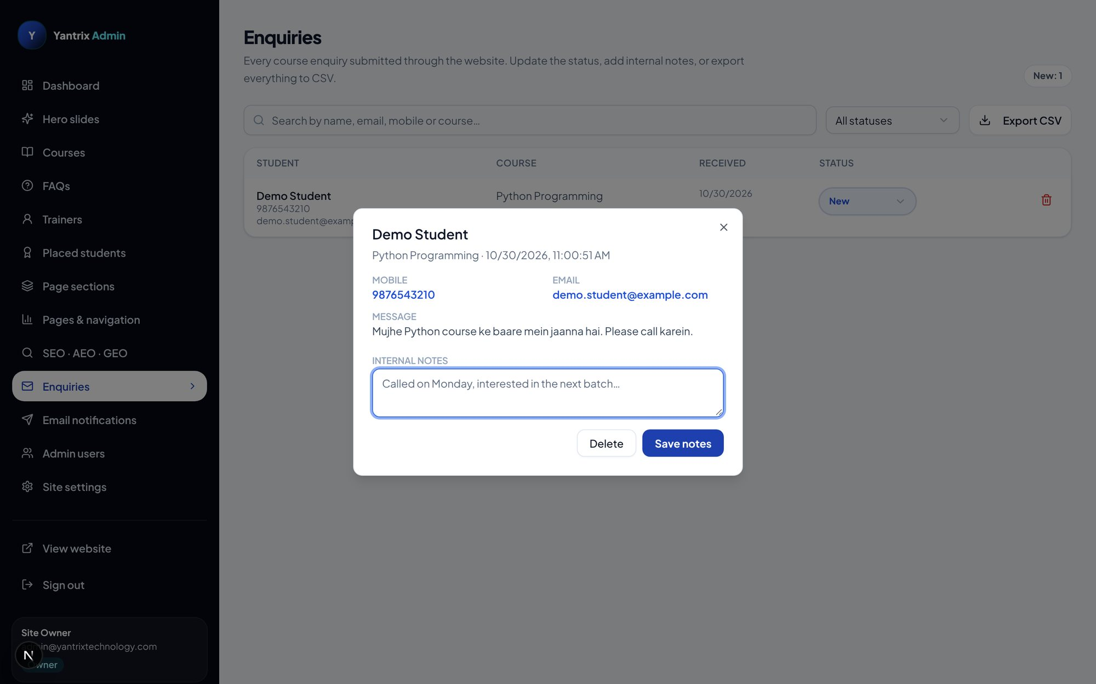
Enquiry kholne par detail dialog — mobile, email, message, internal notes
Step 1: Sidebar → "Enquiries". Har enquiry mein student ka naam, mobile, email, course, date aur status dikhta hai.
Step 2: Upar search box mein naam/email/mobile/course se dhoondhein; status dropdown se filter karein.
Step 3: Naam par click karein → dialog khulta hai: poora message, internal notes likhne ki jagah, "Save notes", "Delete".
Step 4: Row ke status dropdown se status badlein: New → Contacted → Enrolled → Closed.
Step 5: "Export CSV" se poori list Excel mein nikal sakte hain.
💡 Tip: Status ka matlab: New = abhi aayi hai; Contacted = baat ho gayi; Enrolled = admission ho gaya; Closed = kaam khatam.

3.10 Email notifications
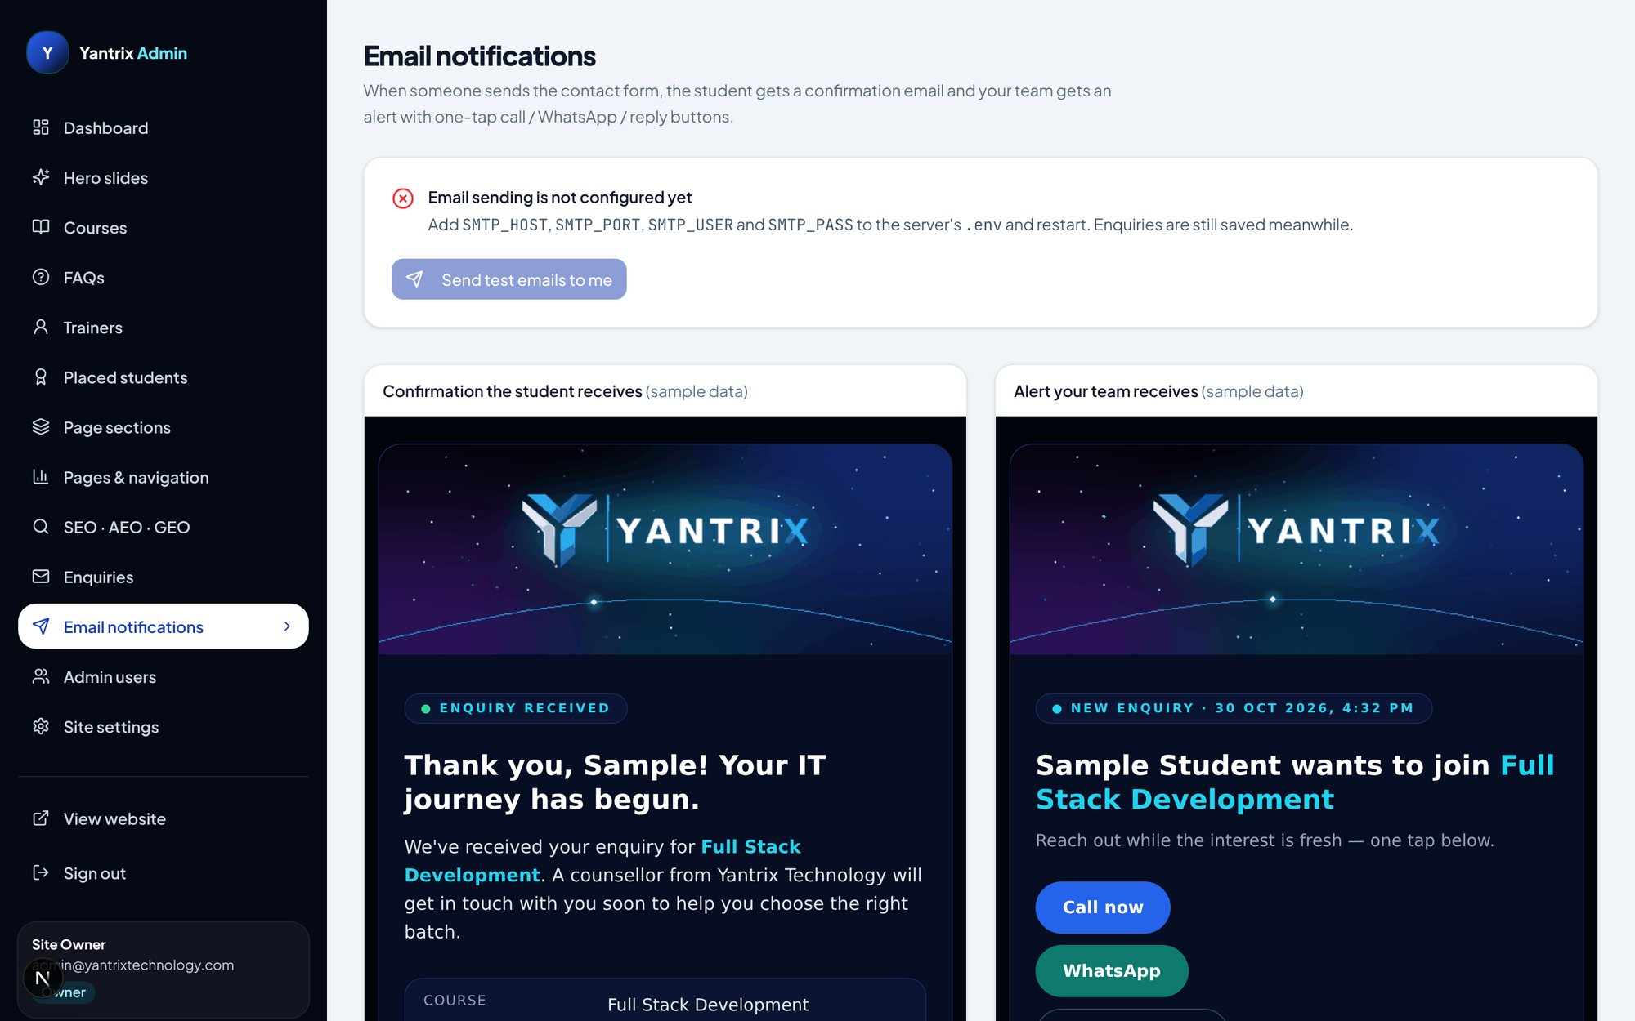
Email notifications panel — templates ka preview
- Enquiry confirmation (student ko) aur alert (institute ko) emails ke templates yahin dikhte hain.
- "Send test email" button se SMTP settings test kar sakte hain.
- SMTP settings .env file mein hoti hain (SMTP_HOST, SMTP_PORT, SMTP_USER, SMTP_PASS); panel mein templates ka preview hota hai.

3.11 Admin users — team ko access dena
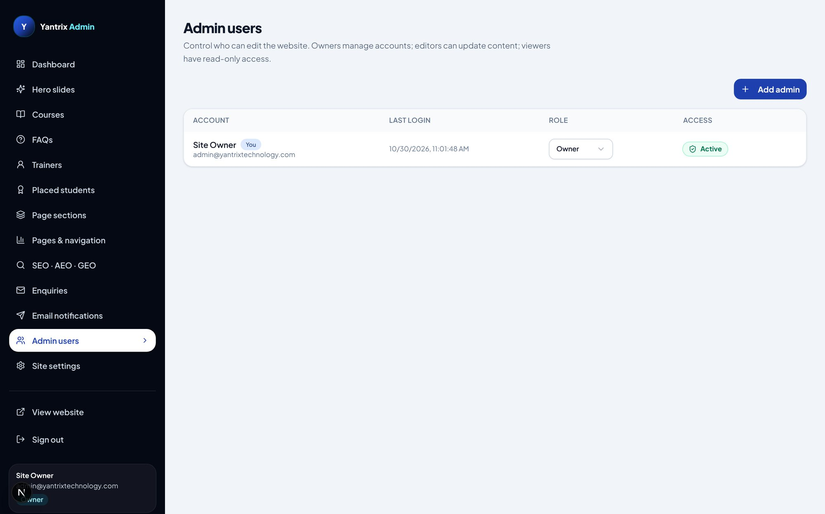
Admin users panel (sirf owner role dekhta hai)
Step 1: Sidebar → "Admin users" (ye panel sirf owner ko dikhta hai).
Step 2: "Add admin" se naya account: naam, email, password aur role (owner / editor / viewer) chunein.
Step 3: Kisi admin ka role badalna ho ya account band karna ho to usi list mein controls hain.
Step 4: Har admin ko login par OTP bhi lagega.

3.12 Site settings — brand, contact, WhatsApp, legal, password
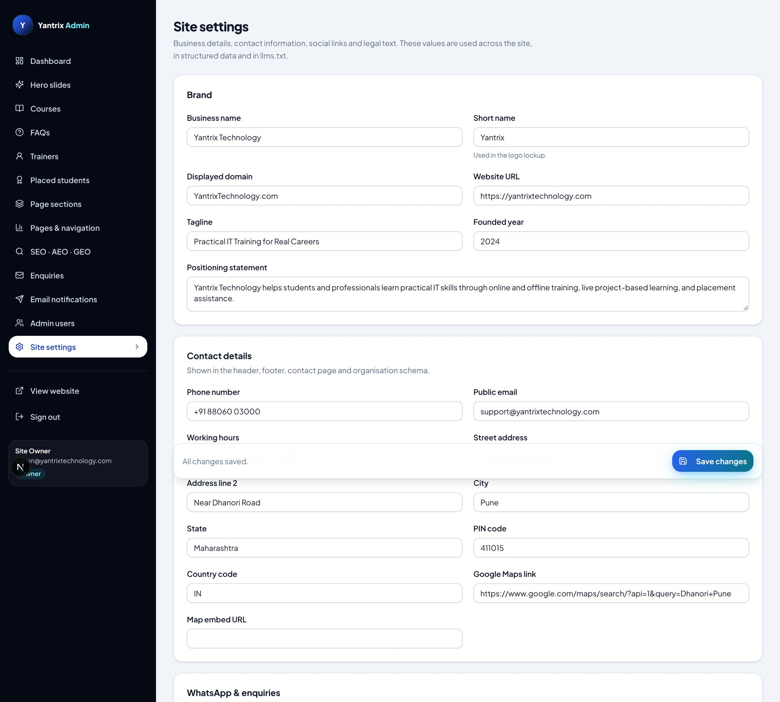
Site settings panel (poora) — hissa 1/3
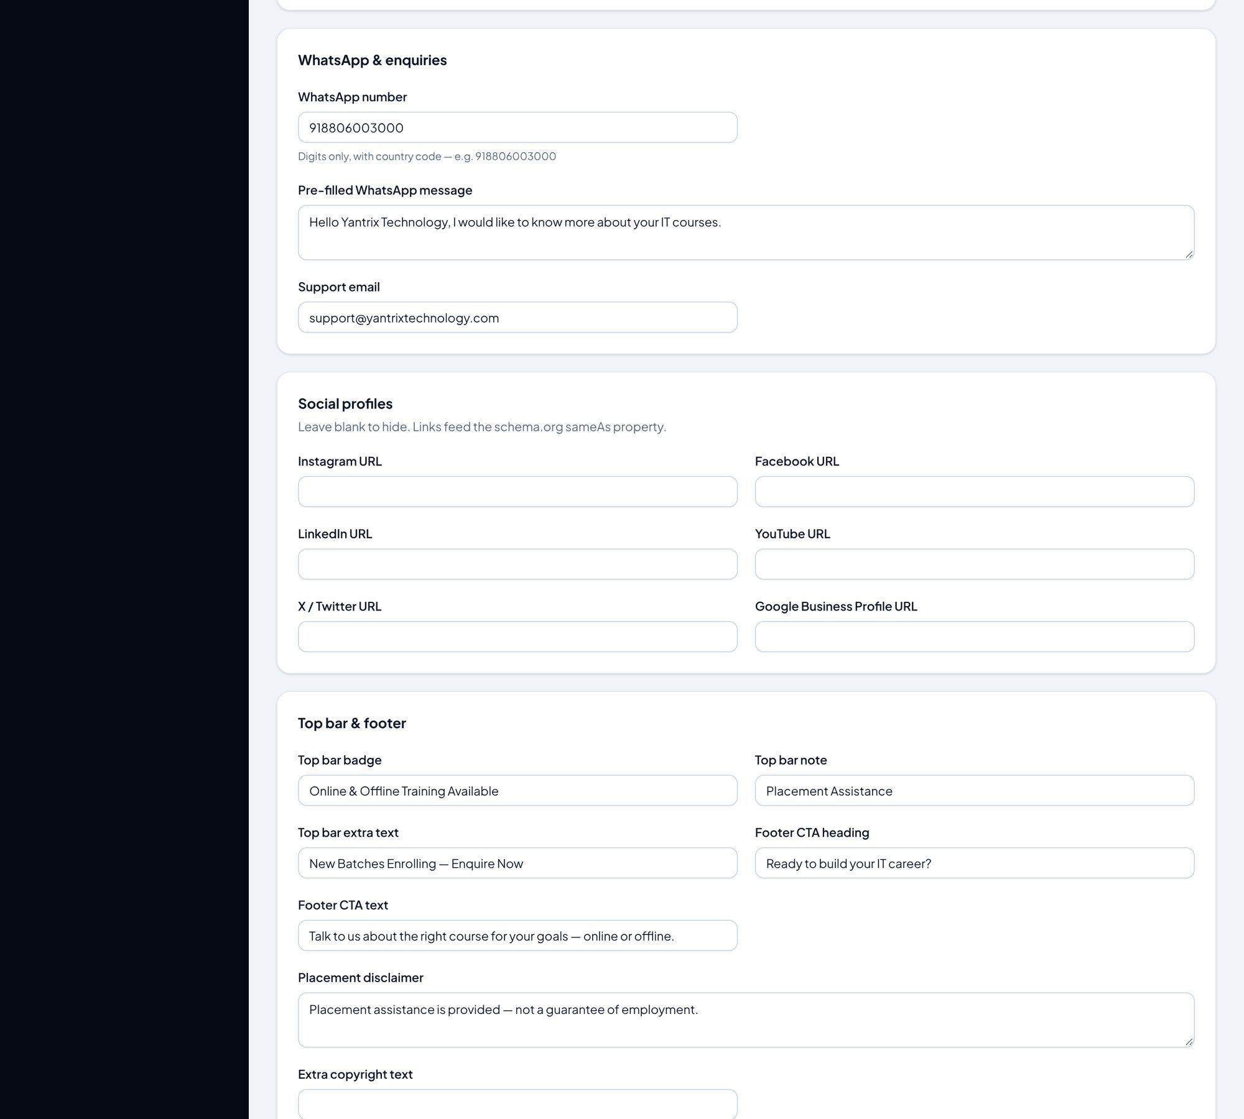
Site settings panel (poora) — hissa 2/3
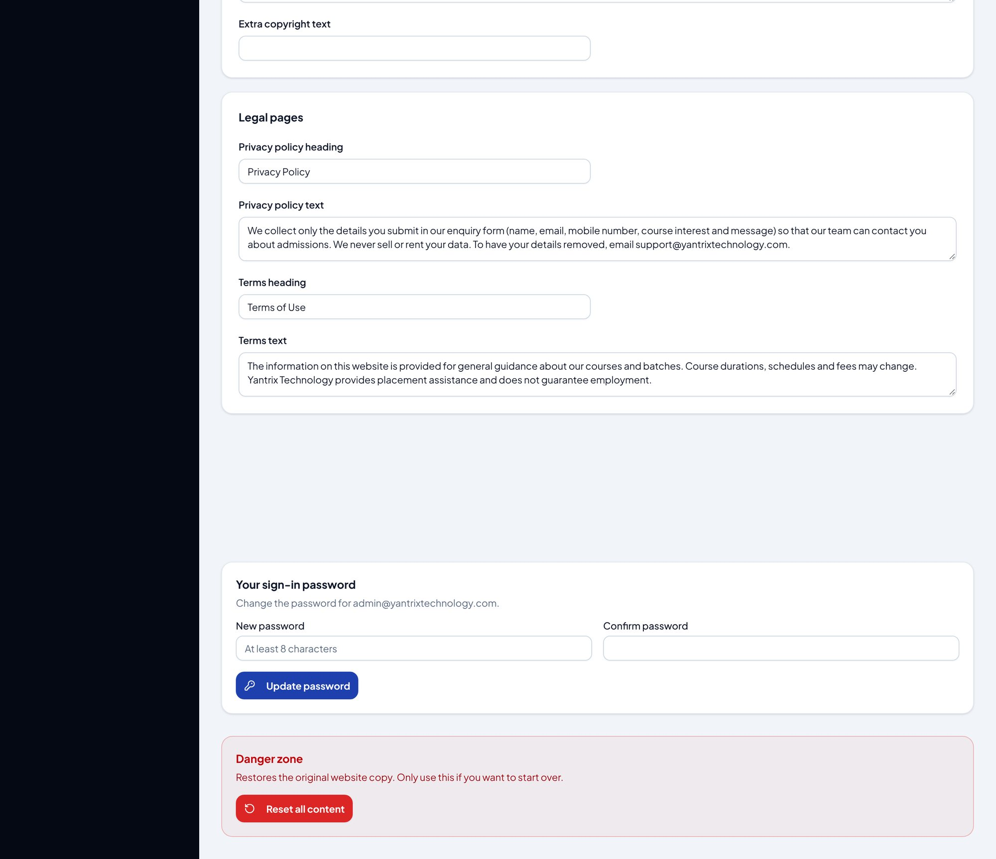
Site settings panel (poora) — hissa 3/3
- Brand: business name, short name, domain, website URL, tagline, founded year.
- Contact: phone, email, working hours, poora address, Google Maps link.
- WhatsApp: number aur pre-filled message — website ka WhatsApp button isi se chalta hai.
- Social: Instagram, Facebook, LinkedIn, YouTube URLs.
- Top bar / footer / legal text (privacy, terms) bhi yahin.
- Sabse neeche: password change form aur Danger zone (content reset — sirf owner, soch-samajh kar!).
⚠️ Dhyan rakhein: Danger zone ka "content reset" saara content default par lautaa deta hai — ye wapas nahi aata.

Hissa 4 — Rozmarra ke kaam (quick recipes)

4.1 Nayi course add karna
Step 1: Admin → Courses → "Add course".
Step 2: Naam likhte hi URL slug ban jaata hai (zaroorat ho to badlein).
Step 3: Description, duration, fee, level, modes bharein; syllabus chips mein ek-ek line likhein.
Step 4: "Save changes" — course website ke courses page par dikhne lagti hai.

4.2 Aayi hui enquiry par kaam karna
Step 1: Admin → Enquiries → naye student ka naam kholein.
Step 2: Message padhein, "Internal notes" mein apni baat likh kar "Save notes".
Step 3: Status dropdown se "Contacted" karein; admission ho jane par "Enrolled".
Step 4: Mahine ke ant mein "Export CSV" se report nikalein.

4.3 Home ka banner (slide) badalna
Step 1: Admin → Hero slides → pencil icon.
Step 2: Headline/description badlein ya "Replace photo" se nayi image chunein.
Step 3: "Save changes" — website kholkar dekhein, banner badla hua milega.

4.4 Naya admin banana (owner)
Step 1: Admin → Admin users → "Add admin".
Step 2: Naam, email, password dein aur role chunein (editor = content badal sakta hai, viewer = sirf dekh sakta hai).
Step 3: Naye admin ko pehli baar login par email/terminal wala OTP lagega.

4.5 Apna password badalna
Step 1: Admin → Site settings → sabse neeche password change form.
Step 2: Purana password, naya password daal kar save karein.
Step 3: Agli baar login naye password se hoga (OTP phir bhi lagega).

Hissa 5 — Problems aur solutions
Problem | Solution
Login par "Incorrect email or password" | Development mein default admin@yantrixtechnology.com / Yantrix@2024 use karein. Production mein .env ke ADMIN_EMAIL/ADMIN_PASSWORD se pehla owner banta hai.
OTP email nahi aa raha | Development mein code server terminal mein print hota hai. Production mein SMTP_HOST/SMTP_USER/SMTP_PASS settings zaroori hain.
"This server cannot send sign-in codes" | Production mein SMTP configure nahi hai — .env mein email settings daalein aur server restart karein.
"Too many attempts. Please wait 10 minutes." | Galat password/code baar-baar gaya hai — 10 minute ruk kar dobara koshish karein.
Edit buttons dikh hi nahi rahe | Aap viewer role mein login hain. Owner se role editor/owner karwaayein.
Changes website par nahi dikh rahe | Browser mein hard refresh (Ctrl+Shift+R) karein. Item "hidden" (eye off) to nahi hai, check karein.
Server chalu nahi ho raha | npm install dobara chalayein; port 3000 kisi aur process mein to nahi, dekhein; Node version 18+ hona chahiye.
Data save nahi ho raha | CONTENT_STORE dekhein: mysql par DB chalu hona chahiye, warna auto/json use karein (./data folder writable ho).

5.1 Kuch suraksha niyam jo software khud maanta hai
- Login do-step hai (password + OTP) — sirf password kaafi nahi.
- Production mein ADMIN_SESSION_SECRET ke bina session banta hi nahi.
- Har badlaav audit log mein darj hota hai (kaun, kab, kya).
- Enquiry CSV export mein formula-injection se bachaav ke liye cells quote hote hain.

— Guide yahi khatam hoti hai. Ab aap website ke saare pages samajh chuke hain aur admin panel ke har panel mein kaam kar sakte hain. Koi bhi badlaav karne se pehle chhota test karein, save karein, aur website kholkar check karein.

