



**32_pyspark_transformation**

Write a pyspark code to transform the DataFrame to display each student's marks in Math and English as separate columns.

**Difficult Level :** EASY

**DataFrame:**

**data=[**

**('Rudra','math',79),**

**('Rudra','eng',60),**

**('Shivu','math', 68),**

**('Shivu','eng', 59),**

**('Anu','math', 65),**

**('Anu','eng',80)**

**]**

**schema = StructType([**

**StructField("Name", StringType(), True),**

**StructField("Sub", StringType(), True),**

**StructField("Marks", IntegerType(), True)**

**])**

|  |
| --- |



**INPUT**

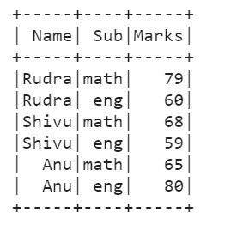

**OUTPUT**



