## horizontal line



Wireless Charging System

Designed by Akash Sonowal

# 

# Overview

**Design of a Static Vehicle Wireless Charging System**

The following report outlines the design and functionality of a static vehicle wireless charging system. This system is intended to wirelessly charge electric vehicles using a combination of electronic components. The primary components used in this system include:

* **Arduino UNO:** The Arduino UNO serves as the central control unit for the wireless charging system. It coordinates the operation of various components and ensures efficient charging.
* **16x2 LCD Display:** A 16x2 LCD display is incorporated into the system to provide real-time information about the charging process, including voltage, current, and charging status.
* **Ultrasonic Sensors (Two):** Two ultrasonic sensors are utilized to detect the presence and position of the vehicle. These sensors play a critical role in aligning the charging coils accurately with the vehicle's receiver coils.
* Relays (Two): Two 5V relays are employed to control the power supply to the Mini Tesla Coils. These relays enable the system to switch the coils on and off as needed.
* **Mini Tesla Coils (Two):** Mini Tesla coils are responsible for generating an electromagnetic field that facilitates wireless energy transfer to the vehicle's receiver coil, enabling wireless charging.
* **Jumper Wires:** Jumper wires are used to establish connections between the various components, ensuring proper communication and power distribution throughout the system.
* **5V, 2A Adapter:** A 5V, 2A adapter is employed to supply power to the Arduino and the Mini Tesla Coils, ensuring they receive an adequate power supply for their operation.

# Circuit Diagram

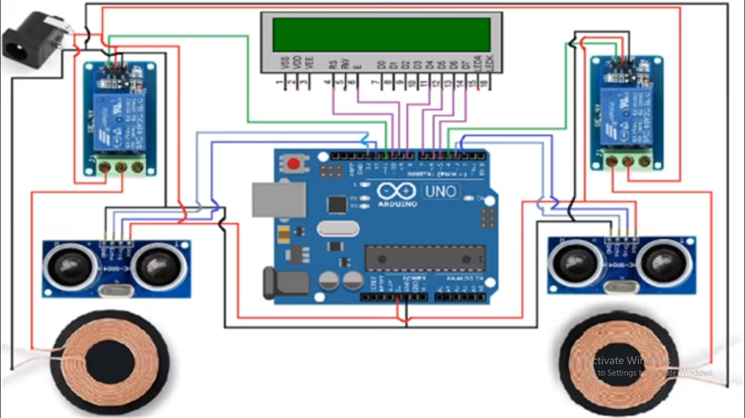

# Operations :

# 1. Vehicle Detection:

# The system continuously monitors the area designated for vehicle parking using two ultrasonic sensors. These sensors provide distance data to the Arduino. Upon detecting the presence of a vehicle within the charging area, the system proceeds to the next phase.

# 2. Coil Alignment:

# Utilizing the data from the ultrasonic sensors, the Arduino adjusts the position of the Mini Tesla Coils to ensure precise alignment with the receiver coil on the vehicle. This alignment is crucial to ensure efficient wireless energy transfer during the charging process.

# 3. Charging Control:

# To initiate the charging process, the system utilizes the two 5V relays. When the coils are accurately aligned with the vehicle's receiver coil, the Arduino activates the relays, enabling power to flow to the Mini Tesla Coils. The electromagnetic field generated by these coils facilitates wireless energy transfer to charge the vehicle's batteries.

# 4. Display Information:

# A 16x2 LCD display integrated into the system provides real-time information regarding the charging process. This information includes details such as voltage, current, and the overall charging status. The display allows users to monitor the progress of the charging process.

## 