* 1. **Inferential Statistics**

**5.2.1 Cramér’s** **V analysis**

|  |  |
| --- | --- |
|  | Cramér’s V is a statistical measure that shows how strongly two categorical variables are associated. It is based on the Chi-Square test, but instead of just saying whether two variables are related (p-value), it quantifies the strength of the relationship (ranges from 0 to 1).  0 → No Association (independent variables)  Between 0 and 1 → Partial Association  1 → Strong Association (fully dependent variables)  NOTE: Cramer's V only detect if there is an association, but not "how they related". To test "how they related" or direction of relationship do Spearman's rank correlation. |

|  |  |
| --- | --- |
| **Variable Pair** | **Cramér's V** |
| ph value well Vs satisfaction with water taste | 0.406111 |
| noticeable contamination Vs satisfaction with water taste | 0.215111 |
| pipeline water chlorinated belief Vs confidence in safety | 0.142605 |
| willingness to pay for better drinking water services Vs confidence in safety | 0.140102 |
| monthly household income Vs willingness to pay for better drinking water services | 0.155017 |
| monthly household income Vs sec | 0.402064 |
| sec Vs waterborne diseases last year | 0.169714 |
| sec Vs confidence in safety | 0.30765 |
| septic tank or wastewater presence nearby primary water source Vs confidence in safety | 0.023539 |
| water purifying techniques Vs waterborne diseases last year | 0.037346 |
| ever noticed broken pipelines in house or public places Vs waterborne diseases last year | 0.078982 |
| confidence in safety Vs noticed any changes in health after using current drinking water | 0.042265 |

Variable pairs with high Cramer’s V value (red highlighted in Table) indicates the likely association between those pairs.

**5.2.2 Spearman Correlation matrix**

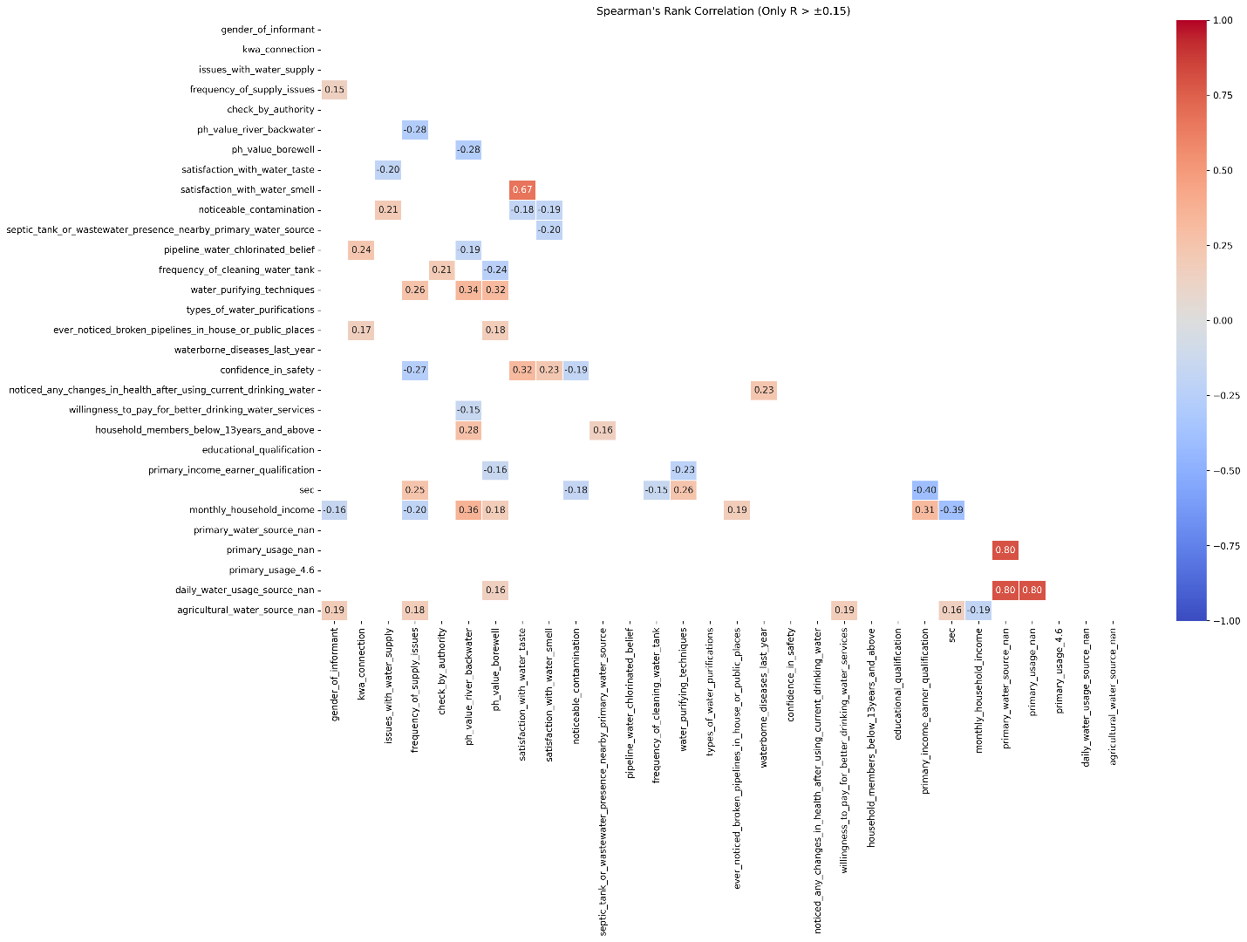

Correlation heatmap plot above represent the correlations with possible strong relationships only. That means that pairs are inter-related significantly.

## Preliminary results conclusion

The figures and tables are the data analysis outputs. Analyst have not inferred outputs thoroughly to made a result and conclusion.

|  |
| --- |
| Notes to client |
| * As mentioned in the conclusion, there are no inferences made from the data analysis plots and tables. * Please go through the plots and tables, and let me know of any errors or confusions. |